HUMAN RIGHTS COMMITTEE

130th session 12 October to 6 November 2021
Online session Report

New Family Visitation Promotion Organization
(新しい親子交流Promotion Organizaton)
https://www.oyako-koryu.net/
info@oyako-koryu.net
Feb,10, 2021
1.Abstract

Our “New Family Visitation Promotion Organization” is an organization started by mothers who live apart from their children. We have over 20 active members and about 270 followers on social media. Most of our members are mothers who have loved and cared for their children without any problems. However, after the marriage fell apart, the father suddenly took the child away from their mother without her consent (parent-child abduction). The children suddenly lost their mother.

This is because Japanese people have a low awareness of human rights especially children rights and even mothers are often separated from their infant children and unable to see them. The following press conference by The Parents and Children's Network ( 親子ネット：親子の面会交流を実現する全国ネットワーク) shows that even mothers are sometimes separated from their infant children and deprived of their parental rights. This is a violation of children's rights (parent-child non-separation) and parents' right to love their children (human rights).

One of the issues we want to address in this opinion is that in Japan, there are mothers who have no problem caring for their children that are unable to live with them or see them because of the unilateral wishes of the father, who takes and lives with them. The second is for the world to recognize that human rights and the child's desire to be loved by his or her mother are not protected by law in Japan.

We declare four recommendations from this report.
1. Prohibition of the removal of children (child abduction)
2. Establishment of a joint custody (shared custody) system
3. Establishing the frequency and duration of visitation that is appropriate for the child and establishing enforcement rights in visitation.
4. Introduction and promotion of joint parenting

The details are described below.
1. Prohibition of the removal of children

In Japan, there have been a number of cases where children have been taken away without the consent of their spouses, regardless of age, even if they are not the primary caregivers, and have lost custody. The following is a report by The Parents and Children's Network ( 親子ネット：親子の面会交流を実現する全国ネットワーク) on the situation of 50 mothers who are unable to see their children due to removal or divorce. In addition, there is a report on the viciousness of removal, where mothers lost custody of their children after they were taken away, even though they had sufficient visitation with their fathers.

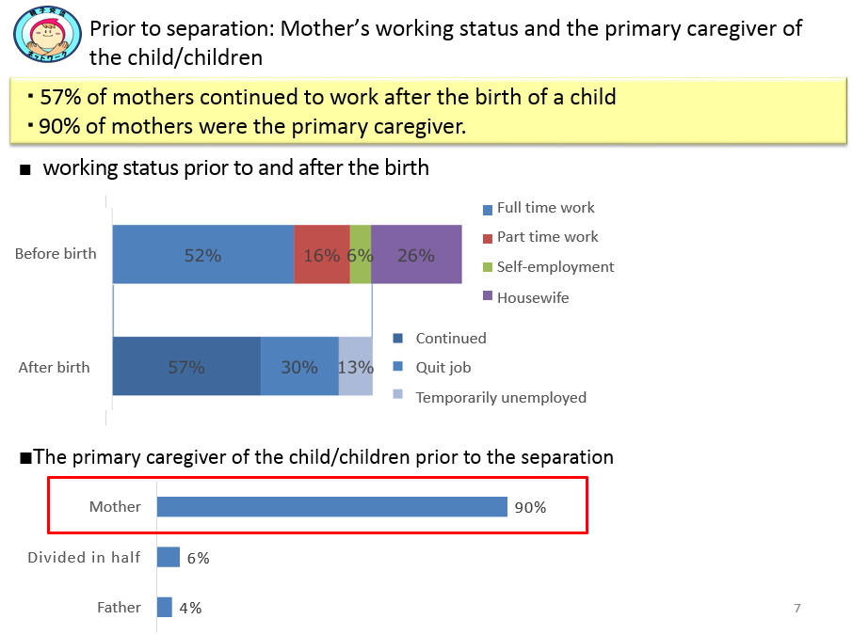
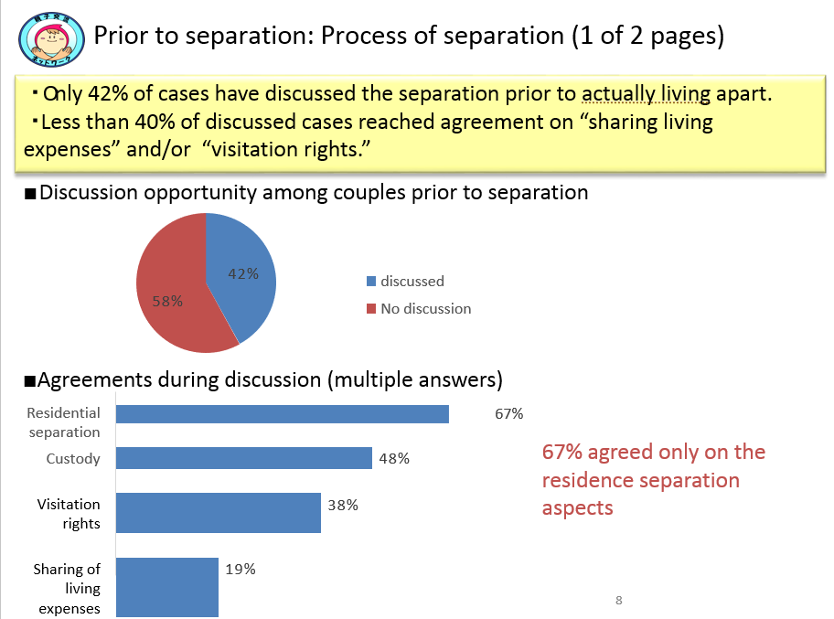
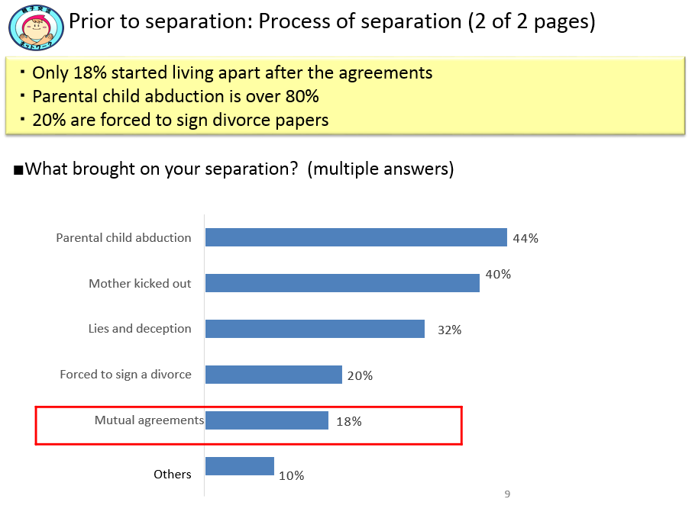
~ Various comments regarding the removal of child(Child abduction) ~

-My husband abruptly woke me up one night after midnight and forced me to sign divorce papers. That continued every night. In the end, I signed the divorce agreement in order to release my suffering.
-I could not go back home due to the threats, abuse, and intimidation from my husband and mother-in-law.
-My husband and parents-in-law expelled me from the house.
-My husband forced me to sign divorce papers. Then, he submitted it to authorize his custody. On a later meeting day, my mother-in-law lied about taking my child to the bathroom and instead took her to her own home.
-My husband said he was going to a movie with our children during our separation time and instead took them away.
-My husband took the child away and told the police he would bring him back in three days. However, he had already changed the child’s nursery and official residence address on the first day.
-Even though the children did not want to go my husband’s parents’ house, he took them, saying he would bring them back soon, but never did.

As you can see, in Japan, there are many cases of child abduction and parent-child disconnection.
Individual parties whose visitation is being interfered by the other party via the family court have filed a lawsuit against the state, asking for legislation to be enforced and to realize more visitations. In addition, there are six class action lawsuits pending in Japan to protect the rights of the child in relation to joint custody and parent-child abduction, which are unconstitutional. However, on August 13, 2020, the Tokyo High Court ruled for one of the cases that the right to visitation is not constitutionally guaranteed and that the provisions of the current law do not violate the Constitution. This is an unbelievable ruling, which is unlike a country that has ratified the Convention on the Rights of the Child. Even the relationship between mothers and children who live separately are not guaranteed the freedom of exchange.
In cases where a child is taken without consent, it is necessary that the child be promptly returned to his or her place of origin and that discussions regarding the child's upbringing begin in good faith in the existing environment. Now the Legislative Council is currently consulting on the issue of abduction and removal of children (parent child abduction), But domestic trends alone are not enough, so we also need UN recommendations. that alone will take time to review, so we also need recommendations from the United Nations for the country.

2. Establishment of a joint custody (shared custody) system
We strongly urge to introduce a joint custody system (shared custody) after divorce to guarantee the rights of parents and children as parents and children after divorce. This is because in Japan, many mothers who have no problems with their children being taken away because they have sole custody now lose custody (see document below). After that, there are many mothers who could not raise of their children or hardly see them despite her willness.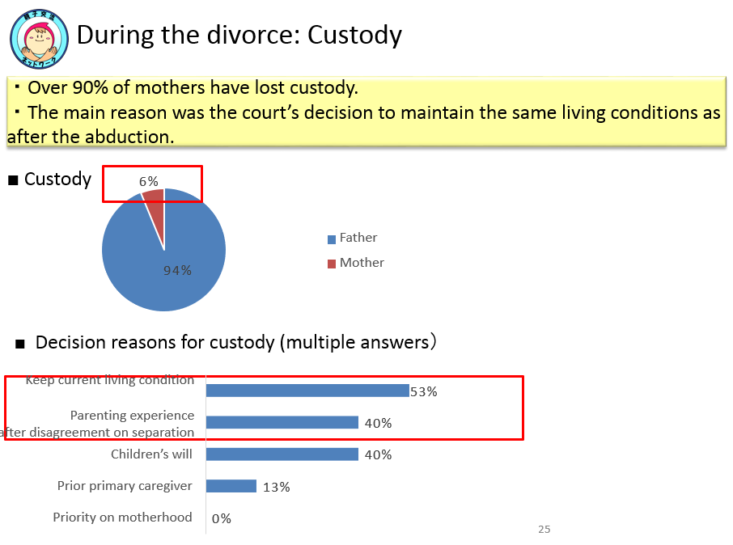~Various comments on the court’s opinions and decisions regarding final custody~
-The children’s living condition with the father does not reveal any problems.
-The lawyer advised me there was no chance to win the case.
-The current living condition is solid, and the children want to live with their father.
-Moving the home burdens the children.
- My husband’s accusations of child abuse and neglect were denied. However, the father won the custody because his current parenting was satisfactory, and the children wished to continue living with him.
-If I got custody, the children would have to move homes and change schools. That seemed difficult for them, so I gave up the fight for custody.
-The children currently live with the father’s family and go school from there. Even though it was acknowledged that my parenting ability was not an issue, they decided that moving the household and changing schools was not good for the children. I insisted that the children need not change their school as I live in the same neighborhood, but the judge did not listen to me.

The cause of this unfortunate state of mothers and children stems from the inadequacies of Japanese law, which does not guarantee the rights of the current child/parents (shared custody).
The custodial parent in Japan's sole custody system has the power to strongly restrict the access of the separated parent and the child.

We seek family court rulings for improvement, visitation mediation and petitions for divorce and custody, but they are often seen as a detriment to the stable custodial environment of the live-in parent, and the law enforcement system is woefully inadequate to correct this problem.

The scheduling and arrangements for visitation at the time of divorce are set out in Civil Code Article 766. However, there are many cases of divorce without an agreement in place. There is no law to punish a live-in parent who breaks the agreed-upon rules.
Currently, legislation for joint custody is being developed domestically, but we are again seeking recommendations from the United Nations and international organizations for an early resolution.

3. Establishing the frequency and duration of visitation that is appropriate for the child and establishing enforcement rights in visitation.
Third point we urge is the right to visitation should be clarified in cases where parents and children live apart, and parents who live apart should be able to see their children on a frequent and continuous basis. In Japan, the child's right to visitation is not clearly defined in Japan, so no one cannot be forced visitations against the will of the person with parental authority.
The mother of one of our members is only able to see her two children, ages 4 and 6, who live nearby, “once a month for four and a half hours.” The situation has not improved for over a year and a half, even though visitation mediation has been conducted. The children want to see their mother more, but their rights are not being protected.
The other party, the other party's lawyer, the mediator, and the judge all give consideration to the "feelings of the cohabiting parent," but they do not listen to the rights of the child. Not only that, but in some cases, as a result of the trial, the court has ruled that the mother and the child should not see each other when the child is a minor, and that the mother should only exchange letters with the child.

One of the reasons for such an astonishing precedent is the lack of awareness of children's rights among lawyers and the judicial system in Japan. Of course rather than just accepting this situation, our mother members are desperately trying to submit academic articles about child care, videos of their children which show the child needs their mother. But the more we insist on visiting the child in court, the more we are prejudiced as "the parent who is likely to have trouble with the cohabiting Parents” and " and "the parent who defies the cohabiting Parent.". In addition, even if a trial court decides to grant visitation, if the cohabiting parent reneges on the promise or files a lawsuit accusing the cohabiting parent of interfering with visitation, it will only be a financial settlement and not actual visitation.

If that's the way the judiciary is looking at it, you may need to proceed with careful discussions with the opposing attorney. However, in reality, attorney ethics regarding parent-child exchange is even lower than that of the judiciary.

The mother, who has a good relationship with her children and has not caused any domestic violence or infidelity to her husband or his child partner, the opposing lawyer, Mr. Morishige of Urawa Sogo Law Office, stated the following
-It is in the best interest of the children to have a four-hour exchange once a month.
-The mother is not allowed to have Visitation with overnight stay with the children who are 2 and 4 years old (currently 4 and 6 years old).
-The other party is not obligated in response to the mother's concern and anxiety about the children who live apart from her especially not obligated to inform the mother of the children's condition (crying, daily growth, etc.).
-Divorced mothers and their children should not meet endlessly.
-If mediation is already pending, there is no obligation to maintain discussions outside of mediation.

In addition to the above, the lawyer Morishige further distorted the facts and testified at the mediation and even ignored the rights of the child and refused to have a sincere discussion with the parties. The mother strongly informed Morishige of the Convention on the Rights of the Child and Japan's Civil Code on visitation and asked her for visitation in line with the best benefits of the child, but her decision did not change. This case shows the child's rights are not being respected as well.

The Saitama Bar Association, to which Morishige belongs, has several committees related to children's rights, such as the "Human Rights Protection Committee" and the "Children's Rights Committee. The Saitama Bar Association also has "autonomy to guide and supervise lawyers independently from the state (lawyer autonomy)" and "activities to protect basic human rights and realize social justice".
So the mother asked the Saitama Bar Association about Morishige's response and whether it was appropriate for the Saitama Bar Association to meet with him for four hours once a month.
But they said the lawyer Morishige's opinion depends on each individual case, so it is not a collective opinion of the association." This was the only reply I received, and nothing improved.
And When the mother asked for autonomy (education and training of the lawyers belonging to the association) within the bar association, the association only said, “We accept opinions,” and did not make any improvements.
In the end, the Saitama Bar Association denied all associations, including the Human Rights Committee and the president of the association, to solve the problem and questions about human rights, saying that they would not answer questions about the problem in low-frequency visititation right with children, nor about answering questions or holding study sessions with citizens.
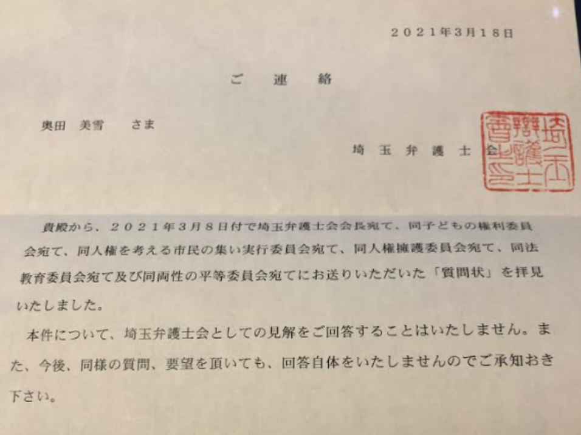

As a major problem, the Committee on the Rights of the Child within the Saitama Bar Association only deals with bullying and abuse and does not discussing the rights of children to not be separated from their parents and to maintain direct contact with their parents, as stated in the Convention on the Rights of the Child, which Japan ratified in 1994.

Also the mother asked three vice presidents of the Saitama Bar Association about the four times UN recommendations regarding to children's rights and the alart of children abducation from European Parliament. But they said not know well.
In such a situation of low awareness of children's rights, which is out of step with the international community., even in mediation, it is not possible to enforce visitation against the wishes of the person with parental rights, so parents living apart in Japan withe children can easily experience parent-child disconnection depending on the wishes of the other party, no matter how much they talk to the judiciary/court/other party/other party's lawyer. In contrast, the city government has a better understanding of children's rights than the mediation system, as it is still considering the idea of visitation in elementary and junior high schools. We need to raise awareness not only in the judiciary and family courts, but also at the lawyer level.

Furthermore, even if visitation is decided through mediation, the recommendation for implementation issued in the case of non-performance/delayed implementation of visitation is now a formality and has been reduced to a letter with no enforcement power whatsoever. It should have the meaning of a “demand” or “reminder” and be effective. I would like the courts to be aware of their responsibility in issuing these letters. There have been many lawsuits claiming damages.

In light of the above, it is extremely important to clarify the right to visitation and establish the means to ensure the effectiveness of visitation in families facing divorce, the law, family courts, and lawyers.

4.Introduction and promotion of joint parenting
In Japan, joint parenting and visitation after divorce is often hindered by the feelings of the cohabiting parent, even after judicial proceedings and mediation. This is because the concept of “raising children alone after divorce” is common in Japan, and the concept of “joint parenting” is not widely accepted. In the case of co-parenting, there are unique Japanese ideas such as “if the parents disagree with each other, it will affect the child and be detrimental to the child” and “since a new partner will exist at the time of remarriage, the intervention of the biological parent will have a negative impact on the new family.”

In Japan, even mothers and children who have had such a good relationship can have less than four hours of visits once a month due to the intentions of their parents.
It is necessary to encourage and educate people on children's rights regarding marriage and divorce at the local government level in order to raise awareness about the relationship between the parents as well, which is necessary for the joint parenting, and to raise awareness about cooperating when raising children after divorce for the sake of the children. Parents who live apart from their children should be required to prepare a “childcare plan” that clearly states the arrangements for visitation and childcare expenses for a reasonable number of days per year. Furthermore, we look forward to recommendations for judicial procedures such as court cases and mediation, as well as schools, educational institutions, and administrative bodies to uphold the Convention on the Rights of the Child and establish standards for parent-child exchanges and effective joint upbringing in Japan from the standpoint of children. In this case, it is analogous to the fact that if they had been able to discuss joint childcare before and after the divorce, they would have been able to care for the children without making them cry.
Because of sole custody, there is a competition for the children, and in order to keep the children's feelings to themselves, they are not allowed to see one parent. And unfortunately, both family courts and lawyers issue rulings that focus more on “not causing problems or trouble” than on “parent-child interaction as a right of the child.
Now, Okuda is requesting the family court to implement co-parenting in the visitation mediation but has not been able to achieve it because the other party says it is not necessary. But However, Okuda's child said, "I want to spend time with both Mom and Dad. I can't choose." We are working to gain the understanding of the other party, the judiciary and the government by appealing to them that the current situation is not good enough and not in the best interest of the child.

5.Conclusions
In summary, in order to resolve the current issue of separation of parents and children after divorce, the rights of children in the future should be given top priority. It is necessary to pressure Japan to enact legislation in Japan that clearly mandates “prohibition of unauthorized removal of a child upon separation” , "Establishment of Visitation rights" and “joint (Shared) custody obligations” regarding divorce, both at an early stage and at home.
Parties involved in the separation of parents and children in Japan are working for children's rights while enduring the pain of being separated from their children through lobbying the national and local governments, providing information to the general public, and lobbying the judiciary. However, the progress of legal reform is slow, and recommendations from the international community are needed.

We strongly urge you to send the United Nations Special Rapporteur, in preparation for the consideration of the Government Report to Japan by the Committee on the Civil Liberties, which contains our recommendations.

