The Rights of Intersex Women and Girls in Zimbabwe

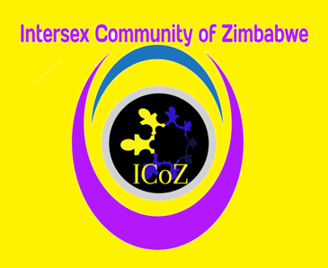ZIM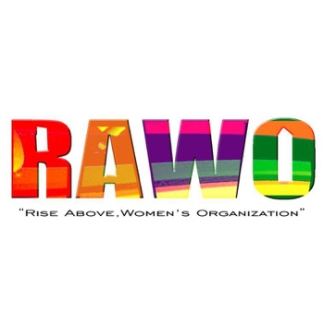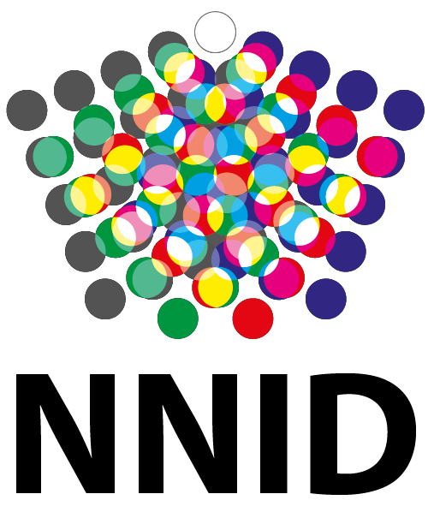

NGO submission for the 75th session of the Pre-Sessional Working Group of Committee on the Elimination of Discrimination Against Women

List of Issues Prior to Reporting for the Republic of Zimbabwe

Joint NGO submission by:
Intersex Community of Zimbabwe - ICOZ
Zimbabwe Intersex Movement - ZIM
Rise Above, Women’s Organisation - RAWO
NNID Foundation

June 2019
Table of Contents

Executive summary 1
Introduction 2
Discrimination against intersex women and girls 3
Harmful practices 4
Attachment 1: Statements 7

Executive summary

Intersex women and girls in Zimbabwe live hidden lives. There have been cases infanticide, children being confined within the home, and children being abandoned and disowned. Many do not have identity documents or access to schooling, and therefore struggle to integrate into society and find employment. When open about being intersex they suffer from discrimination and hate speech. As a solution to the issues faced by young intersex girls and women, at least two state hospitals offer ‘corrective’ genital surgery and medical treatments to intersex children. The NGO’s are concerned that the offered treatments include non-emergency genital surgeries and medical procedures to adjust sex characteristics at an age that these young girls and women are unable to provide prior, free, and fully informed consent themselves. Intersex girls and women in Zimbabwe seek protection under Articles 1, 2, 3, 10, and 15 of the Convention General Recommendations No. 19; No. 24; No. 31; No. 36.

The NGO’s respectfully requests the Committee to seek further clarification from the government regarding the medical treatments offered to intersex women and girls at state hospitals.

Introduction

- This NGO report is a joint submission by ICoZ, ZIM, RAWO and NNID Foundation aimed at informing the Committee on the Elimination of Discrimination Against Women about domestic issues regarding intersex people that may be relevant for the adoption of the List of Issues Prior to Reporting. ICoZ, ZIM, RAWO, and NNID Foundation would appreciate the consideration of these issues by the Committee Elimination of Discrimination Against Women for the drafting and adopting of the List of Issues Prior to Reporting.

- Intersex Community of Zimbabwe (ICoZ) is a community-based organization aimed at providing support to intersex persons and parents of intersex children, as well as create awareness and gather data to help establish an identifiable presence of intersex people in Zimbabwe. Zimbabwe Intersex Movement (ZIM) is a coalition of several intersex-led organisations in Zimbabwe. Rise Above, Women’s Organisation (RAWO) is an inclusive women’s organisation that advocates for the full and equal right of LBTQI+ persons. RAWO provides temporary shelter, advice, counselling, and mentorship, and organises Wellness Circles where members come together to learn and heal. NNID Foundation is an intersex-led human rights organisation working for the equality, rights, and visibility of intersex people, and is based in the Netherlands. (hereinafter: the NGO’s)

- This joint submission for the List of Issues Prior to Reporting does not provide information on all issues faced by intersex people in Zimbabwe.

Discrimination against intersex women and girls

- The NGO’s very much appreciate the Republic of Zimbabwe, and especially the Ministry of Health and Child Care’s awareness and concern regarding issues surrounding intersex girls and women and the government’s aim to improving the quality of life of intersex people currently expressed in their collaboration with Harare Central Hospital and Mpilo hospital in Bulawayo.

- Intersex girls and women in Zimbabwe seek protection under Articles 1, 2, 3, 10, and 15 of the Convention on the Elimination of All Forms of Discrimination against Women, and General Recommendations No. 19 Art. 7, 11; No. 24 Art. 15, 22; No. 31 Art. 15, 16, 19; No. 36, Art. 40, 45, 46.

- Article 1 of the convention clearly defines discrimination against women as “any distinction, exclusion or restriction made on the basis of sex which has the effect or purpose of impairing or nullifying the recognition, enjoyment or exercise by women, irrespective of their marital status, on a basis of equality of men and women, of human rights and fundamental freedoms in the political, economic, social, cultural, civil or any other field.” This statement is further elaborated in General Recommendation No. 19 Article 7(a, b, d, g) which states that gender-based violence which impairs or nullifies the human rights and fundamental freedoms of women fall under article 1 of the Convention. These rights include the right to life, the right not to be subject to torture or to cruel, inhuman or degrading treatment or punishment, the right to liberty and security of person, and the right to the highest standard attainable of physical and mental health.

- Intersex persons are born with bodies that do not meet the normative definition of male and female. However, most intersex people identify as either female or male.

- Intersex people in Zimbabwe mainly stay hidden. Local intersex organisations have received reports of infanticide, children being confined within the home, and children being abandoned and disowned. The Chronicle, a Zimbabwean newspaper reports: ‘Some intersex children are reportedly permanently hidden at home, with some being killed at birth, as families feel that their conditions would bring bad luck to a whole clan as they are considered to be a sign of bad omen.’ These practices are contrary to the right to life and the right to liberty and security of person as listed in General Recommendation no. 19 Article 7 (a, d).

- Local intersex organisations have received reports many intersex women and girls have no identity documents and have not been able to access formal education, due to the isolation and other conditions that these women and girls are raised in. When discovered, they suffer daily from being stigmatized, discriminated against, and hate speech. The result of this has been an inability to integrate socially and to find employment for many intersex women. Many intersex people have resorted to a life of crime, drugs and substance abuse, and sex work which then puts their lives at risk as they are faced with high levels of gender-based violence (GBV) and of contracting many STIs, HIV, and AIDS. Access to healthcare services is a challenge for many intersex girls and women due to the fear for stigma and discrimination in healthcare settings due to the lack of knowledge of healthcare professionals regarding intersex. This is opposed to the Convention Articles 1, 2, 3, on discrimination, Article 10 on discrimination in the field of education, Article 12 on discrimination in health care, and Article 15 on the right to legal equality. Furthermore, it is opposed to General Recommendation No. 24 Article 31 which requires respect of dignity and sensitivity, and is contrary to the right to education as described in General Recommendation No. 36 art. 40, 45, 46.

Harmful practices

- As a solution to the issues faced by intersex girls and women at least two state hospitals, Harare Central Hospital and Mpilo hospital in Bulawayo, offer ‘corrective’ genital surgery to intersex children. In May 2019 Mpilo Hospital announced the development of an intersex registry and offering genital surgery to ‘return to normalcy’ to those born with ‘ambiguous’ genitalia, or genitalia that do not fit with societies understanding of how female or male genitalia should look. As part of government policy, Mpilo hospital will offer free surgical interventions to ‘normalise’ the genitalia of intersex children under the age of five.

- Intersex organisations have not been included in discussions about these initiatives. The NGO’s are concerned that the offered treatments include non-emergency genital surgeries and medical procedures to adjust sex characteristics at an age that these girls and women are unable to provide prior, free and fully informed consent themselves.

- In 2013, the Special Rapporteur on torture and other cruel, inhuman or degrading treatment or punishment called on states to repeal any law allowing intrusive and irreversible treatments, including forced genital-normalizing surgery, involuntary sterilization, “reparative therapies” or “conversion therapies”, when enforced or administered without the free and informed consent of the person concerned. He also called upon them to outlaw forced or coerced sterilization in all circumstances.

- Health professionals often believe that the sex assignment of intersex children, especially those with XX-chromosomes and Congenital adrenal hyperplasia (CAH), is not an issue. However, several studies show that about 5 to 15 percent of the children with CAH raised as girls, question the assigned sex. Recent European research has shown that five percent of all intersex children, including those with forms of sex diversity that are usually not recognized at birth, change sex before puberty.

- Consequences of surgical and medical interventions can be severe: unnecessary surgery at a young age often leads to lifelong physical and mental health issues due to the irreversible character. When children grow older, and their identity becomes clear, they might be confronted with a body that goes contrary to their identity, as a consequence of medical interventions. They will never be able to alter this. These adverse effects can also be observed in the statements in attachment 1.

- The effects of non-necessary ‘normalising’ treatments are comparable to the effects of female genital mutilation described in General Recommendation No. 31 Article 19. Non-necessary medical treatments to adjust sex characteristics of intersex girls and young women that can be safely deferred until an age that autonomous, prior, free and fully informed consent can be given falls under harmful practices as described in General Recommendation No. 31 Article 15 as grounded in discrimination on the basis of, among other things, sex, gender and age, and General Recommendation No. 31 Article 16(d) which states that harmful practices ‘are imposed on women and children by family members, community members or society at large, regardless of whether the victim provides, or is able to provide, full, free and informed consent’. Furthermore, these practices fall under the description of discrimination against women in the field of health care as described by Article 12 of the Convention, further elaborated in General Recommendation No. 19 Article 7(b, g) which clearly states the right not to be subject to inhuman treatment and the right to the highest standard attainable of physical and mental health. These practices are also not in compliance with General Recommendation No. 24 Article 31 which describes that acceptable services are those that are delivered in a way that ensures that a woman gives her fully informed consent, respects her dignity, guarantees her confidentiality and is sensitive to her needs and perspectives.

- Since intersex persons are not legally recognized in Zimbabwe. They have no legal recourse to address these issues of discrimination as is required by General Recommendation no. 31 art. 40 and 41.
The NGO’s respectfully requests the Committee to seek further clarification from the government regarding the medical treatments offered to young intersex women and girls in state hospitals.

Attachment 1: Statements

Yvonne* (age 25)
Yvonne had genital reconstructive surgery in their teens had this to say: “I do not blame my parents for consenting to have me surgically corrected, my mother was made to believe that I was an abnormal child and without this surgery I would live a lonely, miserably and abnormal life for the rest of my life. She was not given the correct information to help her make an informed decision on what was best for me. Therefore, my parents agreed to have me surgically corrected with the hope that I would become a “normal girl” who would get married one day and have a “normal life”, but look at me today I have many medical complications, I do not feel or identify as a girl that they made me into, I feel more like a boy. I also have no sexual sensation on my genitals as a result of the surgery. I cannot have a relationship with anyone as I do not feel normal, and I live an isolated and lonely life.”

Bennie* (age 40)
Bennie had genital reconstructive surgery and assigned female after surgery but now identifies as male. “All we have to decide is what to do with the time given to us”. “Who said I am not “normal” before surgery because right now, I feel very abnormal with their medical intervention that I was subjected to without my consent. They have mutilated very important parts of my body without my consent, and it is affecting me both physically and emotionally. I will never be normal or natural again because of this surgery.”

Chipo*
Chipo is the mother of a 31-year-old intersex person. “When I gave birth to my child, I was told that my baby was born with an abnormality and this would affect my child in social integration with society and cause many other health complications if left to grow up with this ambiguity. At first I was hesitant to let my newly born baby go through surgery, but I was made to believe that it was all for the best for my baby, so that she could grow up as a normal child, and she would be able to find a man to marry her once she was grown up. The surgery was done to reconstruct female sexual organs for my baby. I was asked to dilate her private organs using a metal object while she was crying, and it was a very traumatic experience for the family, including my baby. I raised my baby as a female, but as the baby grew up, he showed signs of being male and when he reached puberty, he started developing some male features. This caused the community to start calling my child gay (ngochani), and it traumatized him more and affected his entire life. He became rebellious and started abusing alcohol and drugs at a very tender age until he ran away from home. Now my child lives in South Africa as a gender-neutral person and he swears never to come back to his own county because of the discrimination and suffering that was caused on him. It breaks my heart.”

Carl Collison. Cast aside at birth for being intersex. Mail & Guardian. 27 October 2016. (https://mg.co.za/article/2016-10-27-00-cast-aside-at-birth-for-being-intersex).
The mystery of ambiguous genitalia. The Chronicle. 28 May 2019. (https://www.chronicle.co.zw/the-mystery-of-ambiguous-genitalia/).
Child with male, female genitals operated on. Bulawayo24 News. 22 March 2019. (https://bulawayo24.com/index-id-news-sc-national-byo-158761.html).
The mystery of ambiguous genitalia. The Chronicle. 28 May 2019. (https://www.chronicle.co.zw/the-mystery-of-ambiguous-genitalia/).
Report of the Special Rapporteur on torture and other cruel, inhuman or degrading treatment or punishment, Juan E. Medez, Human Rights Council, 1 February 2013 (A/HRC/22/53).
E.g.: “For physicians it is obvious and unequivocal that a person with CAH and an XX karyotype has a female gender identity,” Binet A, Lardy H, Geslin D, Francois-Fiquet C, Poli-Merol ML. Should we question early feminizing genitoplasty for patients with congenital adrenal hyperplasia and XX karyotype? Journal of Pediatric Surgery. 2016;51(3):465-468.
Binet A, Lardy H, Geslin D, Francois-Fiquet C, Poli-Merol ML. Should we question early feminizing genitoplasty for patients with congenital adrenal hyperplasia and XX karyotype? Journal of pediatric surgery. 2016;51(3):465-468. (https://doi.org/10.1016/j.jpedsurg.2015.10.004). de Vries A, Doreleijers T, Cohen-Kettenis P. Disorders of sex development and gender identity outcome in adolescence and adulthood: understanding gender identity development and its clinical implications. Pediatric Endocrinology Reviews. 2007;4(4):343-351. Falhammar H, Claahsen-van der Grinten HL, Reisch N, Slowikowska-Hilczer J, Nordenstrom A, Roehle R, et al. Health status in 1040 adults with disorders of sex development (DSD): a European multicenter study. Endocrine Connections. 2018. (https://doi.org/10.1530/ec-18-0031).
Falhammar H, Claahsen-van der Grinten HL, Reisch N, Slowikowska-Hilczer J, Nordenstrom A, Roehle R, et al. Health status in 1040 adults with disorders of sex development (DSD): a European multicenter study. Endocrine Connections. 2018. (https://doi.org/10.1530/ec-18-0031).
Falhammar H, Claahsen-van der Grinten HL, Reisch N, Slowikowska-Hilczer J, Nordenstrom A, Roehle R, et al. Health status in 1040 adults with disorders of sex development (DSD): a European multicenter study. Endocrine Connections. 2018. (https://doi.org/10.1530/ec-18-0031).

