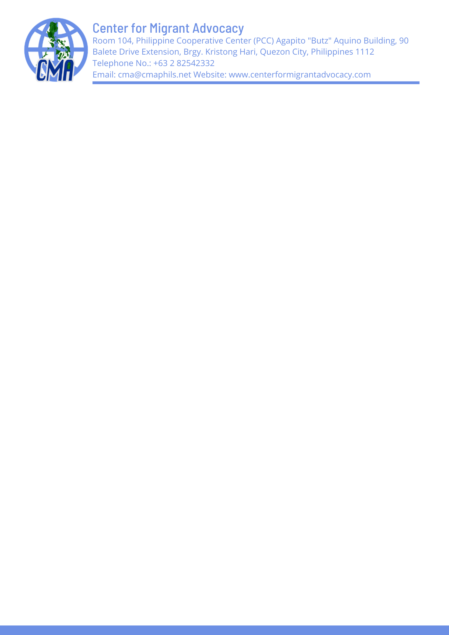

SUBMISSION BY THE CENTER FOR MIGRANT ADVOCACY PHILIPPINES (CMA) TO THE COMMITTEE ON THE ELIMINATION OF DISCRIMINATION AGAINST WOMEN (CEDAW) FOR THE NINTH PERIODIC REPORTING OF THE PHILIPPINES

11 September 2023

Introduction

- The Center for Migrant Advocacy Philippines (CMA) is an independent Civil Society Organization (CSO) in the Philippines that works for the rights and welfare of Overseas Filipino Workers (OFWs) and their families through policy advocacy, facilitation of assistance to distressed OFWs, information, research and education work, networking in the country and abroad, and capacity building for migrant organizations and local government units.

- An online consultation with relevant stakeholders in the country and overseas was convened to prepare for this report. CMA also cited several sources and past research to add more context to the report.

Situationer

- In 2024, the Philippines’ overseas employment program will mark its 50th year. With this in mind, the State Party assures that the State is not promoting migration as part of the country’s economic development. However, past and present administrations have admitted that Filipinos tend to choose labor migration out of necessity and not necessarily out of choice. This desperate circumstance puts OFWs at greater risk and vulnerability since they believe they must hang on to their jobs even at the expense of trading off some of their basic human rights. This is especially the case for women workers who are not able to secure decent jobs in the country for many reasons, including time poverty. This is in part because they have to do ⅔ of the unpaid household work and therefore have little to no time at all to look for paid jobs. It could also because of the increasing demand abroad for care and service workers because of changing demographics and thus the preference for women migrant workers.

- This situation results in millions of Filipino migrant workers leaving their families in search of better opportunities abroad. This is particularly the case for women migrant workers who are distinctively employed in low-wage and low-skilled work abroad despite their higher educational profile than their male counterparts. The job mismatch abroad, particularly for women migrants, the countless cases of abuse and exploitation experienced by the OFWs, and the social costs to their families left behind should compel the State to exert serious efforts to improve the economy and its reintegration programs. This is the only way to keep the workers in the country.

Principal subjects of concern and recommendations

Discrimination in Law - Section 4(m) of Republic Act (RA) 11862 or the Expanded Anti Trafficking in Persons Act 2022

- RA 11862 was lauded by the government as it seeks to strengthen efforts to combat trafficking in persons. Sec. 4 of RA 11862 states that it shall be an act of trafficking in person: “(m) To recruit, transport, obtain, transfer harbor, maintain, offer, hire, provide, receive, or adopt a child for deployment abroad as a migrant worker. ..Provided further, that in the case of overseas domestic work, a ‘child’ means a person below twenty-four (24) years old.” CMA strongly objects to the last phrase which relegates a migrant domestic worker as a child if she is below 24 years old.

- The Philippine Overseas Employment Administration (POEA) issued Advisory No. 43-2022 to align its policy with Section 4(m) thereby increasing the minimum age for a migrant domestic worker from 23 years old to 24 years old. With RA 11862 taking effect, it is estimated that it will affect 1,000 to 2,000 domestic workers who are ready for deployment.

- This section is particularly relevant to women OFWs considering that 60.2% (1.10 million) of deployed OFWs as of 2021 are women, wherein 64.8% (712,800) of whom are engaged in elementary occupations including domestic work. Moreover, 2.6% (28,600) of these women OFWs are aged 24 years old and below.

- It will be recalled that in 2006, the State Party through the POEA promulgated the Household Service Workers Policy Reform Package which set the minimum age for migrant domestic workers at 23 years old. Now with section 4(m), the minimum age was set to 24 years old. CMA has since questioned these changes as these are not aligned with international standards.

- Section 4(m) directly contravenes CEDAW Article 2, which was also reaffirmed by General Recommendation 26, items 23(a) and 24 (a). It discriminates against young women migrant workers, specifically women domestic workers, who make up a considerable number of the deployed workforce. It disempowers young women, restricts their agency, and does not protect their fundamental rights. Furthermore, it will have unintended consequences that contradict the initial purpose of the Law. It incentivizes young women workers to use informal channels as the law blocks them from formal ones, leaving them more exposed and vulnerable as it undermines their formal protection. Hence, it does not address ‘the root causes’ of trafficking but exacerbates it. The academic literature on women’s migration also argues that deployment bans do not work.

- Section 4 (m) contravenes the United Nations (UN) Convention on the Rights of the Child (CRC), the International Labour Organisation (ILO) Convention on Minimum Age and the ILO Convention 189 on Decent Work for Domestic Workers, all of which, the Philippines has ratified, and assert that a child is a person under 18 years old.

- CMA requests the State Party to revoke the last phrase of section 4 (m) of RA 11862 which redefined a migrant domestic workers as a “child” if below 24 years old. CMA further recommends to the State Party to revisit the minimum age of 23 years old under the HSW Policy Reform Package and to give proof that this change will benefit and protect OFW domestic workers..

Discrimination in Travel - Revised Inter-Agency Council Against Trafficking (IACAT) Guidelines for international-bound Filipino passengers

- IACAT recently revised its guidelines on departure formalities for all international-bound Filipino travelers last August 2023. The revision entails that “In addition to the inspection of basic travel documents, the Immigration Officers (IO), may propound relevant clarificatory questions and require the passenger to show additional supporting documents” (Section I. 2.2.).

- The revised guidelines received backlash from the public which urged IACAT to clarify that “seasoned travelers” only need to present basic documentation. The guidelines were set to take effect last September 3, 2023 but its imposition has been temporarily suspended.

- These guidelines affect all Filipino travelers and directly affect OFWs, a majority of whom are women. OFWs departing for the first time are particularly vulnerable as they do not have migration history nor much familiarity with the immigration process.

- These guidelines contravene Article 13 of the Universal Declaration of Human Rights (UDHR) which champions every individual’s freedom of movement and right to travel. They create unnecessary bureaucracy and confer additional burdens on the OFWs who need to compile, sometimes even pay for, their own documentation. A participant in the consultation pointed out that some documents may be impossible to obtain by OFWs who experienced abuse from past employers, have run away, or were unjustly fired. OFWs who cannot comply with the guidelines may also opt for illegal channels that they deem easier, therefore defeating the intended purpose of the revised guidelines. In other words, the directive, just like deployment bans, will not address the problem of human trafficking.

- CMA therefore requests the State Party to suspend indefinitely the implementation, pending the convening of consultations with relevant stakeholders. At the same time, ensuring that relevant agencies of government including the Bureau of Immigration (BOI) are clear on their respective mandates to promote, protect, and fulfill the human rights of passengers and travelers. Attention must be given to the pre-departure stage where women migrant workers must be duly informed and empowered not intimidated or burdened.

- CMA also requests the State Party to always consult with migrant groups, civil society, and all migration stakeholders in coming up with policies. This ensures that policies reflect the lived experiences of migrants, rather than knee-jerk response to problems.

Efficacy of Bilateral Labor Agreements (BLAs)

- RA 10022 states the significance of the State Party entering into BLAs with the destination countries of OFWs. Section 3 also reiterates that the State party will only deploy migrant workers to countries where their rights are protected. However, even with several BLAs in place, abuse, and maltreatment of OFWs continue to be rampant especially towards women domestic workers who commonly live in the same household as their employers.

- The gruesome deaths of Filipina domestic workers “JD” in 2018, “CLD” and “JV” in 2019, and “JR” in 2023 all happened in Kuwait, a country that has a long-standing agreement with the Philippines. In fact, the Memorandum of Understanding (MOU) between Kuwait and the Philippines is even hailed as a model document as it was the result of the two countries’ negotiations after the deployment ban that followed the discovery of “JD’s” body in a freezer in 2018.

- However, even with this model bilateral in place, there continues to be a staggering number of migrant welfare cases and complaints in Kuwait. Between 2017-2022, 61,339 welfare cases of migrants were reported. The complaints included contract violations, illegal confiscation of identity documents, illegal terminations, refusal of issuance of exit visas, and several counts of physical abuse. From these numbers, 939 were cases of sexual abuse and 225 were rape cases. The years 2021 (13,351) and 2022 (24,539) saw the highest number of reported cases. According to the Overseas Workers Welfare Administration (OWWA), the first semester of 2023 already saw 6,005 welfare cases specifically from women migrants in Kuwait.

- “JR’s” death also brought to light several gaps in current BLAs such as the lack of provisions concerning the protocols of investigation and prosecution of criminal offenses against OFWs and their access to justice. Another concerning gap is the lack of provision that explicitly prohibits the confiscation of travel and identity documents of migrant workers.

- CMA therefore requests the State Party to reevaluate and closely monitor the efficacy of already established BLAs/ MOUs and to ensure that the existence of these is indeed protecting our migrant workers, specifically women migrant workers. Moreover, the State Party should consider onboarding relevant stakeholders like civil society organizations and trade unions in the negotiations of bilaterals and MOUs ensuring that mechanisms to monitor and for effective implementation are clearly spelled out.

Feminization of migration, Gender-based Violence, Continued Abuse Suffered by Women OFWs

- The concept of the feminization of migration concerns the increasing trend where a growing number of women from their home countries are choosing to relocate and work in foreign nations. This phenomenon is particularly evident in the Philippines, where the majority of OFWs are women.

- The influence of traditional gender roles and societal expectations in the Philippines can significantly impact women's decisions to pursue migration. The pressure to provide for their families and the prevailing belief that women are primarily suited for caregiving roles can drive women to seek employment opportunities abroad such as domestic work and other elementary occupations, regardless of their educational attainment in the Philippines.

- Most Filipina migrant domestic workers live in the same household as their employers, which makes them particularly vulnerable to different types of abuses which range from sexual, physical, emotional, verbal, and mental abuse. Other mistreatments such as wage theft, overwork, and changes in contract/employment conditions upon arriving in the destination countries are also common.

- During the CMA consultation, around thirteen (13) participants including Filipina former migrant domestic workers and members of OFW Family Circles (OFCs) shared stories of abuse, two (2) of which shared stories of being raped or sexually harassed by their own employers and were repatriated without recourse and without any of their belongings. Neither of them received psychosocial support after their repatriation.

- Another common abuse shared during the consultation was concerning sudden changes in contract and employment conditions once the Filipina domestic worker arrives in the destination country. Around five (5) participants shared experiences with contract / employer changes where they themselves or the Filipina domestic worker they know were either transferred to another employer without their prior consent or were “borrowed” or taken to their employer’s extended family to do additional work. Reports of having additional employers to work for and additional work not stated in the initially signed contract are quite common.

- Wage theft or unpaid, partial, and delayed wages also top CMA’s received cases from distressed women OFWs in 2020. This was followed by overwork, verbal abuse, physical abuse, and insufficient food and poor living conditions. CMA also saw an increase of 101% in the cases received in 2020 compared to 2019.

- CMA recommends that the State Party address the negative aspects of the feminization of migration by developing new policies and legislation specifically tailored to address the unique challenges women migrants face. CMA advocates the empowerment of women OFWs by properly educating them about their rights even before they leave the country.

- CMA also requests the State Party, specifically the newly established Department of Migrant Workers (DMW), to prioritize the safety of Filipina domestic workers in all stages of migration and to adapt a whole of society approach to better support our women migrant workers especially in the stage of repatriation and reintegration. CMA recommends that the State Party ensure that gender-responsive and gender-sensitive programs and services are consistently rendered to the women OFWs until they are safely reintegrated into their communities. This therefore means that the Local Government Units (LGUs) and other concerned stakeholders (church, Civil Society Organizations (CSOs), etc.) must have a proper and clear referral system that responds to the needs of women OFWs and their families.

- Additionally, CMA advocates for the DMW to equip its personnel with the necessary sensitivity and expertise to address cases involving OFW domestic workers who have endured abuse and provide the necessary help to OFWs, including proper psychosocial support and recourse.

- CMA also recommends to the State Party a survivor-centered approach with a defined and itemized process specifically for women migrant workers who are victims of abuse. It must embody the core principles of safety, respect, confidentiality, and nondiscrimination which are all instrumental in ensuring a do-no-harm approach when dealing with survivors.

E. Access to Justice for Migrant Domestic Workers

- A CMA preliminary study saw that per data from the National Labor Relations Commission (NLRC) , 73.22% of the administrative and money claim cases filed at POEA and NLRC between 2015-2017 were disposed of through settlements and not through the merits of the cases.

- This means that the compensation paid to aggrieved migrant domestic workers was much less than they demanded. This system of mandatory conciliation- mediation institutionalized through the Single Entry Approach (SEnA) which is also implemented at the Philippine Overseas Labor Offices (POLO–now called Migrant Worker Offices) may result in unintended consequences of decimating the provision of the law for joint and several liability between the Philippine-based recruiters and the foreign employers.

- Thus CMA respectfully urges the State Party to revisit the SEnA to ensure that it strengthens the workers’ access to justice and not vice versa.

F. Data Collection for Evidence-based Policy

- A glaring gap in migration governance of the State party is the availability of up-to-date sex-disaggregated data on the many facets of labor migration –not only in terms of deployment data but also skills and data on their human and labor rights abuses. RA8042 of 1995 provides for a Shared Government Information System on Migration (SGISM) that will collect comprehensive data on men and women OFWs, land-and-sea-based, covering all stages of the migration cycle – to develop and put in place evidence-based policies, programs and services. To date, apart from one-off initiatives in the past, the SGISM has not been implemented.

- CMA therefore recommends to the State Party, through the Department of Migrant Workers to invest in the setting up of an efficient, up-to-date SGISM for data collection that may be shared as needed for informed policy and program development.

This submission may be posted in the OHCHR webpage for CEDAW public information purposes.
The online consultation took place last August 29, 2023. It was participated in by some 26 individuals representing migrant organizations in the country and overseas, migrant workers, and other relevant stakeholders.
“…It is our wish that one day foreign employment will be driven by choice, not by necessity. It remains a noble calling that our OFWs have answered, requiring great sacrifice from them, their families, and their communities…” President Ferdinand Marcos, Jr. State of the Nation Address. July 24, 2023.
PIDS Discussion Paper Series No. 2019-02 titled “Counting Women’s Work in the Philippines” written by Michael R.M. Abrigo and Kris Francisco-Abrigo https://pidswebs.pids.gov.ph/CDN/PUBLICATIONS/pidsdps1902.pdf
https://www.officialgazette.gov.ph/2022/06/02/republic-act-no-11862/. Underscore by CMA.
https://www.sunstar.com.ph/article/1935128/manila/local-news/2000-household-service-workers-seen-stranded-due-to-new-age-limit
https://psa.gov.ph/statistics/survey/labor-and-employment/survey-overseas-filipinos
UN Convention on the Elimination of All Forms of Discrimination Against Women, Article 1 which elaborates on “discrimination against women" shall mean any distinction, exclusion or restriction made on the basis of sex which has the effect or purpose of impairing or nullifying the recognition, enjoyment or exercise by women, irrespective of their marital status, on a basis of equality of men and women, of human rights and fundamental freedoms in the political, economic, social, cultural, civil or any other field. Article 2f To take all appropriate measures, including legislation, to modify or abolish existing laws, regulations, customs and practices which constitute discrimination against women https://www.ohchr.org/en/instruments-mechanisms/instruments/convention-elimination-all-forms-discrimination-against-women; Further, under CEDAW General Recommendation 26 on Women Migrant Workers, Paragraph 24a recommendation to countries of origin states are urged to lift discriminatory bans or restrictions on migration: States parties should repeal sex-specific bans and discriminatory restrictions on women’s migration on the basis of age, marital status, pregnancy or maternity status. They should lift restrictions that require women to get permission from their spouse or male guardian to obtain a passport or to travel (article 2 (f)); https://tbinternet.ohchr.org/Treaties/CEDAW/Shared%20Documents/1_Global/CEDAW_C_2009_WP-1_R_7138_E.pdf
Convention on the Rights of the Child, Article 1 states that “a child means every human being below the age of eighteen years unless under the law applicable to the child, majority is attained earlier.” https://www.ohchr.org/en/instruments-mechanisms/instruments/convention-rights-child
ILO Convention on Minimum Age Article 3, 11. The minimum age for admission to any type of employment or work which by its nature or the circumstances in which it is carried out is likely to jeopardise the health, safety or morals of young persons shall not be less than 18 years. The Philippines specified 15 years old as the working age when it ratified C138 in June 1998. https://www.ilo.org/dyn/normlex/en/f?p=1000:11200:0::NO:11200:P11200_COUNTRY_ID:102970
ILO Convention 189 on Decent Work for Domestic Workers Article 4 states: 1. Each Member shall set a minimum age for domestic workers consistent with the provisions of the Minimum Age Convention, 1973 (No. 138), and the Worst Forms of Child Labour Convention, 1999 (No. 182), and not lower than that established by national laws and regulations for workers generally. 2. Each Member shall take measures to ensure that work performed by domestic workers who are under the age of 18 and above the minimum age of employment does not deprive them of compulsory education, or interfere with opportunities to participate in further education or vocational training. https://www.ilo.org/dyn/normlex/en/f?p=NORMLEXPUB:12100:0::NO::P12100_ILO_CODE:C189
https://www.officialgazette.gov.ph/downloads/2023/08aug/2023_Revised_IACAT_Guidelines_on_Departure_Formalities_for_International-Bound_Filipino_Passengers.pdf?fbclid=IwAR2F9TgmPCtXLPuIbhFPaqwwpX85jhaZiaU6WfT03N1XPXSOTmCnUy2By68
https://www.rappler.com/nation/doj-apologizes-failed-communication-revised-immigration-requirements/
https://www.un.org/en/about-us/universal-declaration-of-human-rights
https://www.officialgazette.gov.ph/2010/03/10/republic-act-no-10022-s-2010/
https://www.rappler.com/nation/overseas-filipinos/ofws-died-hands-employers-kuwait/
Committee Report of the Senate Committees on Migrant Workers and Foreign Relations on the public hearing conducted on February 8, 2023 on the case of Jullebee Ranara.
Philippine Dissemination of the World Development Report 2023: Managing the Social Impacts of Labor Migration: The Philippine Experience on the Feminization of Migration. Atty. Melanie H. Quino, OWWA Deputy Administrator for Operations. July 10, 2023.
https://www.pna.gov.ph/articles/1194540
Center for Migrant Advocacy,“Translating Rights: A Study on Bilateral Labor Agreements Between the Philippines and Saudi Arabia, Jordan, and Lebanon,” 2020, Available at: https://centerformigrantadvocacy.files.wordpress.com/2021/01/bla-study-v.-2.pdf
https://centerformigrantadvocacy.com/migrant-domestic-workers-access-to-justice-2018/

