

JAPAN

International Convention on the Elimination of All Forms of Racial Discrimination
96 Session (06 Aug 2018 - 30 Aug 2018)

NGO: HAPPINESS REALIZATION RESEACH INSTITUTE（HRRI）

Webpage: https://hrri777.wordpress.com/
Email: hrri2016@gmail.com

Written Argument on the ‘Comfort Women’ Issue
Submitted to the CERD 96 Session

(1) Main Points
- A recent trend, which has fabricated the history of Japan, spread a wrong version of history, and denigrated the Japanese people, has been intensifying. Specifically, the idea that ”comfort women” are “sex slaves”’, which the Japanese government has renounced as its official view, has been generated widely, and, as a result, the Japanese people who have been targeted and their children are suffering severe mental harm.
- The human race should never allow anyone to carry out racial discrimination by generating a wrong version of history that is not based in fact, or to commit human rights violations by spreading those untruths. Such violations should never be ignored.
- Although the Japanese government explicitly denied the idea that ‘“comfort women” are “sex slaves”’ as its official view in the United Nations’ Committee on the Elimination of Discrimination Against Women in February 2016, the government’s efforts to spread this view have been insufficient. As a result, the discriminatory treatment of Japanese people has been left unresolved. Based on its investigation, the Japanese government should propagate the correct historical facts immediately, widely and strategically, both in Japan and abroad.
- At the same time, the Japanese Foreign Ministry, diplomatic missions abroad and the Ministry of Justice should strive to grasp the current situations in various nations and be vigilant in the protection of human rights to guarantee the safety and security of the Japanese people and their children living abroad.

- Relevant Article of ICERD

＜Article6＞
States Parties shall assure to everyone within their jurisdiction effective protection and remedies, through competent national tribunals and other State institutions, against any acts of racial discrimination which violate his human rights and fundamental freedoms contrary to this Convention, as well as the right to seek from such tribunals just and adequate reparation or satisfaction for any damage suffered as a result of such discrimination.

(2) Background

① Statues and Monuments of ‘Comfort Women’
- The movement to install statues and monuments of ‘comfort women’ all over the world is a clear example of fabricating history and perpetuating the idea that ‘“comfort women” are “sex slaves”’. It is a well-known fact that the majority of the movement is supported by Chinese and Korean private organisations. Most of the information that those organisations generate is not based on historical facts.
- For instance, a Chinese private organisation installed a statue of ‘comfort women’ on private land in San Francisco and donated it to the City of San Francisco in September 2017. In November the same year, the city council of San Francisco passed a resolution to accept the donation. While the epigraph states, ‘Several hundreds of thousands of women and young girls were made “sex slaves” by the Imperial Japanese Army’, this is contrary to fact. In the United States, five statues of ‘comfort women’ have been installed so far, including the one in San Francisco.
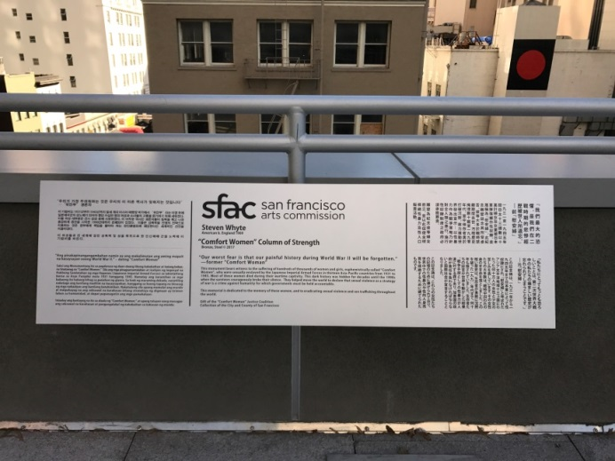

San Francisco Comfort Women memorial

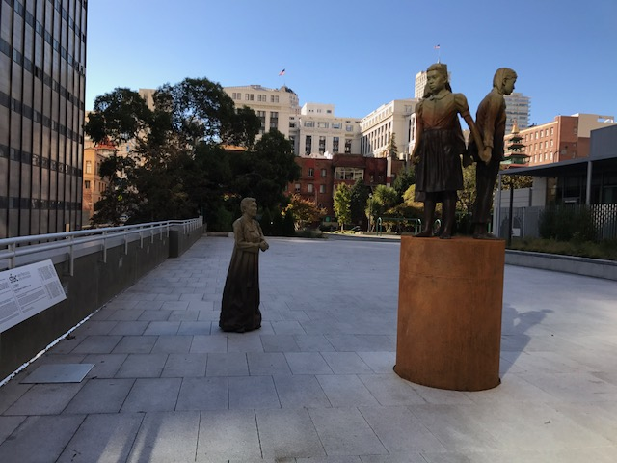
San Francisco Comfort Women Statue

- In May 2018, the fourth monument of ‘comfort women’ was installed in Fort Lee City, New Jersey, and it has become the eighth monument in the United States.
https://www.northjersey.com/videos/news/2018/05/24/comfort-women-memorial-unveiling-ceremony/639355002/

② Negative Impact through the Infiltration of the Issue into the School Education
- In the United States, it is recommended that school students visit the statues and monuments of ‘comfort women’ as part of their educational field trips. As a result, racial discrimination and violation of human rights against Japanese people has been increasing. Chinese and Korean organisations have been approaching school teachers and advising them how to teach the so-called ‘comfort women’ issue, including visiting the statues and monuments that disparage the Japanese people.
- This trend is particularly notable in school education. For example, the California Department of Education passed a resolution in July 2016 to include the ‘comfort women’ issue in the text book for 10th grade students in ‘the Guideline for the curricula for History and Social Sciences.’ In HISTORY SOCIALL SCIENCE FRAMEWORK (p.353), there are statements that the phrase ‘“Comfort Women” is a euphemism that describes women who were forced into sexual service by the Japanese Army in occupied territories before and during the war’ and that ‘Comfort Women can be taught as an example of institutional sexual slavery.’

HISTORY SOCIAL SCIENCE FRAMEWORK FOR CALIFORNIA PUBLIC SCHOOLS
https://www.cde.ca.gov/ci/hs/cf/documents/hssfwchapter15.pdf

- Further, racial discrimination and human rights violations against Japanese children have been accelerated through such approaches as misusing the ‘comfort women’ issue in school lessons, which deal with contemporary social problems such as human trafficking and sexual exploitation. A school in the City of San Francisco even held a video production competition on the ‘comfort women’ issue.

Movie ‘THE COMFORT WOMEN – The Story of What Japan Did to Korea’
https://youtu.be/uicdRsUoD6s

- This intentional adoption of a distorted history into school education in the United States has influenced the text books and curricula in other countries. It has generated prejudice against pure and innocent Japanese children, and, as a result, the possibility of consolidation of racial discrimination and violation of human rights is emerging.

③ Enacting the Day of Comfort Women
- In some cities, ‘Anti-Japan memorial halls’, ‘The day of Comfort Women’ and ‘The Day of Nanjing Massacre’ have been enacted and the news was covered widely by the mass media. As a result, Japanese people have been labelled repeatedly as ‘atrocious people’ and, under these circumstances, many Japanese people fear the ‘Comfort Women’ and ‘Nanjing Massacre’ days, and are also afraid to visit the areas around the statues and monuments of ‘comfort women.’

“Resolution declaring September 22, 2017, as Comfort Women Day in the City and Country of San Francisco.”
https://sfbos.org/sites/default/files/r0358-17.pdf

“Canadian province to observe Nanjing Massacre Memorial Day.”
https://gbtimes.com/canadian-city-to-observe-nanjing-massacre-memorial-day

(3) Conclusions

- In February 2016, at the Committee on the Elimination of Discrimination, one of the United Nations’ Human Rights Treaty Bodies, Mr. Shinsuke Sugiyama – the Senior Deputy Minister for Foreign Affairs – announced the Japanese government’s official views as follows: ‘the government of Japan conducted a full-scale fact-finding study on the comfort women issue in the early 1990s. However, “forceful taking away” of comfort women by the military and government authorities could not be confirmed in any of the documents that the Government of Japan was able to identify in this study.’ ‘“200,000 persons” as the number of comfort women also lacks concrete evidence.’ ‘The expression “sex slaves” contradicts the facts.’
- Nevertheless, on 12 May 2017, the United Nations’ Committee Against Torture, one of the United Nations’ Human Rights Treaty Bodies, recommended that the Korean government review the agreement between Japan and South Korea. This recommendation was full of mistaken facts, such as that ‘comfort women are the victims of the sex slave system’, and wrongly criticised the Japanese government as ‘denying the fact of the Japanese army’s sex slaving.’
- On 22 May 2017, the Japanese government submitted a written counterargument, claiming that it has no intention of reviewing the agreement between Japan and South Korea, since the recommendation, which assumes comfort women were ‘sex slaves’, is contrary to the facts.
- In its written counterargument, the Japanese government pointed out that the past reports by the United Nations’ special rapporteur, as well as the condemnations and recommendations by the Human Rights Treaty Body, present one-sided arguments without backing. Specifically, it has been argued that the Asahi Shinbun, a Japanese newspaper, withdrew its articles on the ‘comfort women’ and apologised, admitting that the remarks of the only witness, Mr. Seiji Yoshida, who had claimed that ‘the Japanese government took comfort women forcibly’, were false. The newspaper was actively reporting Mr. Yoshida’s remarks. The newspaper also apologised for wrongly reporting the number of the comfort women as ‘two hundred thousand’. It has admitted that the newspaper mixed up the ‘comfort women’ and ‘women’s volunteer corps’, which seems to have been the basis of the figure, ‘two hundred thousand.’ These identifications are adequate and the Japanese government should actively demand correct understanding from the city council of San Francisco, educational institutions and private organisations.
- In 2016, the U.S. Army’s record of an oral statement by a North Korean POW was found at the American National Archives and Records Administration, and a description that ‘the comfort women were “volunteers” or “sold by their parents”’ was found in the statement.
- In circumstances where statues and monuments of comfort women are being installed all around the world, resolutions to condemn Japan are passed in many assemblies, and violations of the human rights of Japanese people are occurring, the Japanese government must spread its view actively and strategically to ensure the fact that ‘comfort women were not sex slaves’ is recognised widely, based on its official views and the facts, which have been proven recently.

(4) Recommendations

- The State Party should recognise the fact that the Japanese people and their children in Japan and abroad are receiving discriminatory treatment through the instalment of statues and monuments of comfort women, the day of comfort women, and educational curricula on the comfort women issue, grasp the ongoing human rights violations and inform the Japanese people of the present situation and provide proper care and support for them.
- The State Party should remove the statues and monuments of comfort women, which have already been installed. At the same time, it should take necessary measures at the planning stage, and block the installation of the statues and monuments of comfort women to prevent the violations of human rights caused by racial discrimination.
- The State Party should recommend that educational institutions outside Japan offer a proper education on history, based on the Japanese government’s official views on the comfort women issue, as well as correct any misunderstandings on the issue.
- The State Party should spread the Japanese government’s official views strategically in order to correct the series of misunderstandings on the comfort women issue.

