Annex to the 9th Periodic Report of Hungary
to the Committee on the Elimination of Discrimination against Women

Table provided by the Ministry of Foreign Affairs and Trade to Article 8 (>see paragraph 72).

Concerning the provisions set out by Article 8 of the Convention, the Table below indicates the percentage of female and male employees with regard to various positions (Ministers, State Secretaries, Deputy State Secretaries, Heads of Department, Deputy Heads of Department, Heads of Unit, non-leading positions and Heads of Missions) at the central administration units of the Ministry of Foreign Affairs and Trade (Capital); at the diplomatic and consular missions; national experts delegated to international organisations, relative to the total number of personnel of the Ministry of Foreign Affairs and Trade, and disaggregated by gender.

Table 1
 |  | Capital |  | Diplomatic and Consular Missions
 |  | Women | Men | Women | Men
 | Minister | 0.0% | 100.0%
 | State Secretary | 0.0% | 100.0%
 | Deputy State Secretary | 18.2% | 81.8%
 | Head of Department | 48.4% | 51.6%
 | Deputy Head of Department | 42.6% | 57.4%
 | Head of Unit | 64.7% | 35.3%
 | Head of a Mission |  |  | 13.2% | 86.8%
 | Non-senior officials | 64.3% | 35.7% | 48.0% | 52.0%

Table 2
 | National experts
 | Women | 35.7%
 | Men | 64.3%

Table 3
Central Unit | Women | Percentage (%) | Men | Total
Deputy State Secretary | 2 |  | 9
Head of Department | 31 |  | 33
Deputy Head of Department | 24 |  | 32
Head of Unit | 46 |  | 26
Senior positions | 103 | 51% | 100 | 203
Total number of employees | 539 | 61.6 % | 336 | 875
Missions
Head of Mission | 17 |  | 105 | 122
Diplomatic, consular and administrative personnel | 575 | 48.5 % | 609 | 1184

Presentation of the legal framework with reference to Articles 11 and 29 of the CEDAW Convention

Hungary shall ensure fundamental rights to every person without any discrimination on the grounds of race, colour, sex, disability, language, religion, political or other views, national or social origin, financial, birth or other circumstances whatsoever. This provision is laid down by the Fundamental Law of Hungary.

Act on the Labour Code (hereinafter referred to as the Labour Code) also sets forth provisions concerning this issue in the context of employment. Section 12(3) of the Labour Code on the principle of equal treatment specifies the generally applicable provision, that in connection with employment relationships and with the remuneration of work in particular, the principle of equal treatment shall be observed, meaning that the principle of “equal pay for equal work” shall be applied.

The Labour Code also provides a definition for wage, under which wage shall mean any remuneration provided directly or indirectly in cash or in kind, based on the employment relationship. Furthermore, it determines the features that shall be taken into account when determining the equal value of work, namely, the nature of the work performed, its quality and quantity, the working conditions, the required vocational training, physical or intellectual efforts expended, experience, responsibilities and labour market conditions. [Section 12 (2) and (3) of the Labour Code].

Act CXXV of 2003 on Equal Treatment and the Promotion of Equal Opportunities provides detailed information regarding the principles set forth by the Labour Code, when identifying some of the priority areas affected by the violation of the principle of equal treatment and – within that – cases of such violations revealed in relation to employment. [Section 5(d) of the Act on Equal Treatment and the Promotion of Equal Opportunities]. The Act stipulates the cases, which shall be considered as forms of indirect or direct negative discrimination in the field of employment [Section 8(r) of the Act on Equal Treatment and the Promotion of Equal Opportunities.], moreover, it lists cases which shall be considered as a particular violation of the principle of equal treatment, when the employer inflicts direct or indirect negative discrimination upon an employee, [Section 21(a)-(i) of the Act on Equal Treatment and the Promotion of Equal Opportunities] and cases, when the principle of equal treatment is not violated by the employer [Section 22 of the Act on Equal Treatment and the Promotion of Equal Opportunities].

Furthermore, it is considered to be a violation of the principle of equal treatment if the employer inflicts direct or indirect negative discrimination upon an employee regarding
- access to work, especially in public job advertisements, hiring, and regarding the conditions of employment;
- provisions related to procedures facilitating the establishment of an employment relationship;
- the establishment and termination of employment relationships;
- any training before or during the work;
- the determination and provision of working conditions;
- the establishment and provision of benefits due on the basis of the employment relationship, especially concerning the establishment and provision of wages;
- membership or participation in employees' organisations;
- the promotion system;
- the enforcement of a liability for damages or of a disciplinary liability; and
- the reconciliation of the person’s obligations as a parent and as an employee and the request for and use of parental leave promoting an increase in the amount of time that could be spent on childcare [Section 21(1) of the Act on Equal Treatment and the Promotion of Equal Opportunities].

The Equal Treatment Authority is the body responsible for monitoring the implementation of the principle of equal treatment. Within its scope of responsibilities set forth by this Act, the Authority may not be subject to any instructions. Upon request and in cases set out by this Act the Authority carries out an investigation ex officio in order to determine whether the principle of equal treatment has been violated. Apart from that and upon request, the Authority shall also investigate whether the equal opportunities plan has been accepted by the employers obliged to do so, and based on the results of the investigation, it makes a decision. Pursuant to its right to enforce a claim of public interest, the Authority may initiate a lawsuit with a view to protecting the rights of persons and groups whose rights have been violated, it reviews and shares its comments on the drafts of legal acts, other legal instruments of state governance and reports concerning equal treatment and makes proposals concerning governmental decisions and legislation pertaining to equal treatment [Section 14(1) of the Act on Equal Treatment and the Promotion of Equal Opportunities].

The Fundamental Law of Hungary dedicates a separate article for setting it forth that our legal system shall adopt individual measures to ensure the protection of young people and parents at work (Article XVIII (2) of the Fundamental Law of Hungary).

Therefore, Hungarian labour law takes into account the needs of certain vulnerable groups stemming from their special situation, and defines alternative provisions for them compared to the general regulations, which is justified by the increased demand for protection of the groups concerned. Accordingly, specific provisions are defined within the group of employed women concerning pregnant women, women who have recently given birth or are raising children.

The labour regulations on employed women are contained in the Labour Code on the one hand, and in the legal provisions relating to workplace health and safety, and occupational safety on the other hand. The appropriate provisions aimed at assisting employees with family obligations in fulfilling their tasks related to having and raising children and enabling them to comply with the obligations related to childcare are set forth by the Labour Code.

The Labour Code involves atypical forms of employment (e.g. call for work, job sharing, employee sharing) aimed at facilitating the reconciliation of family obligations and work.

Pursuant to Section 51(1) and (3) of the Labour Code, employers shall employ their employees in accordance with the rules and regulations pertaining to contracts of employment and employment regulations, and, unless otherwise agreed by the parties, provide necessary working conditions. Workers shall be employed for work of such nature only which is not considered harmful with a view to their physical condition or development.

In November 2017 Hungary amended the provisions of the Labour Code concerning the transfer of employees to other positions or their discharge, in order to protect pregnant women, women who have recently given birth and nursing mothers. In order to be able to avoid the exposition of pregnant employees and employees raising young children to risks at work, the amended legal act prescribes that the employer must rearrange first of all the affected employees’ working conditions and/or work schedule, and only if there are objective obstacles to this is the employer obliged to offer the employee a position suiting her state of health [Section 51(3) and Section 60(51) of the Labour Code]. The amended provisions entered into force on 1 January 2018.

Pursuant to the provisions of the Labour Code, employers shall be entitled to temporarily reassign their employees to jobs and workplaces other than what is contained in the employment contracts or to another employer. However, the employee may not be transferred to work at another location without the employee’s consent in the following cases: from the time her pregnancy is diagnosed until her child reaches three years of age; until the child reaches sixteen years of age, if a single parent, or if providing long-term care for a close relative in person [Section 53(1) of the Labour Code].

Employees with family obligations are granted protection concerning termination by notice as well, under the following terms: The employer may not terminate the employment by notice during pregnancy, parental leave, a leave of absence taken without pay for caring for a child and in the case of women, while receiving treatment related to a human reproduction procedure for up to six months from the beginning of such treatment. In the case of pregnancy and treatments related to a human reproduction procedure, the provision above shall apply only if the worker has informed the employer thereof before the notice was given. The employer may withdraw the termination in writing within 15 days upon the receipt of such information following notice of termination.

In the case of withdrawal and in respect of the entitlement arising following the reinstatement of the employment relationship and linked to the length of employment, the period between the termination and reinstatement of the employment relationship shall be regarded as time spent in employment. The employee’s outstanding wages and other emoluments shall be paid as well as the damages in excess of these. The employee’s absentee pay shall also be taken into consideration as part of the outstanding wages. [Section 65 (3) and (6) of the Labour Code].

The Labour Code also sets forth more favourable provisions concerning termination, when it derogates from the rule of the notice period beginning on the day following the date of the notice of termination at the earliest. Where employment is terminated by the employer, the notice period shall begin at the earliest on the day after the last day of the absence from work without pay for the purpose of caring for a sick child or providing home care for a close relative [Section 68 (1) and (2) of the Labour Code].

According to the Labour Code, in terms of entitlement for severance pay, any period of at least 30 consecutive days for which the employee did not receive any wages shall not be taken into consideration, with the exception of maternity leave and any leave of absence without pay for nursing or caring for a child [Section 77 (2) of the Labour Code].

The rules concerning the organisation of working time also place employees with family obligations in a privileged position. With regard to rest periods and working time, the law provides that from the time the employee’s pregnancy is diagnosed until her child reaches 3 years of age (in the case of single parents, until their child reaches 3 years of age) an irregular work schedule may be used only upon the employee’s consent, weekly rest days may not be allocated irregularly and overtime work, stand-by duty or night work cannot be ordered. An employee caring for his/her child as a single parent may be required to work overtime or in stand-by duty only with his/her consent as from the time his/her child reaches three years of age up to the time when the child reaches four years of age. [Section 113 (1)-(5) of the Labour Code].

The law provides that employers are obliged to amend the employment contract based on the employee’s proposition to part-time work covering half of the daily working time until the child reaches the age of three (or, in the case of employees with 3 or more children, until the child reaches the age of five). [Section 61 (3) of the Labour Code]

In respect of working time reduction offered to mothers nursing their children, the Labour Code provides that such employees are exempt from the fulfilment of their availability and working obligations for one hour twice daily, or two hours twice daily in the case of twins, during the first six months of nursing, and thereafter for one hour daily, or two hours daily in the case of twins, until the end of the ninth month. [Section 55 (1) of the Labour Code].

The Labour Code lays down special provisions for employees with family obligations with regard to leave of absence as well. Mothers shall be entitled to a maternity leave of 24 consecutive weeks, out of which they shall use at least 2 weeks, and which should be allocated so as to commence at least four weeks prior to the expected time of birth.
Maternity leave as determined by law shall also be provided to a woman who has been given custody of a child for the purpose of adoption [Section 127 (3) of the Labour Code]

Employees shall be entitled to an extra vacation of 2 working days for one child, 4 working days for two children and a total of 7 working days for more than two children, concerning children under 16 years of age. [Section 118 (1) of the Labour Code]

Employees shall also be entitled to unpaid leave for the purpose of taking care of their child, until the child reaches the age of three. The duration of such a leave shall be no less than six weeks following the date of birth. [Section 128 (1) and (2) of the Labour Code].

Apart from that. employees may take unpaid leave for providing care for their child in person until the child reaches the age of ten, during the period of receiving childcare allowance [Section 130 of the Labour Code].

Pursuant to Act XCIII of 1993 on Labour Safety, employees in vulnerable groups must be protected in accordance with specific other legislation against the dangers which specifically affect them [Section 50/A of the Labour Safety Act]. For the purposes of this law, a “vulnerable group” shall refer to employees with special physical or mental characteristics who are thereby exposed to increased risks and dangers which specifically affect them at work, and who themselves represent an extra risk factor in their employment (e.g. young people, pregnant women or women who have recently given birth, women providing mother’s milk and nursing mothers, elderly people, workers with any degree of incapacity) [Section 8/A of the Labour Safety Act].

Convention No. 45 adopted by the 19th session of the General Conference of the International Labour Organisation, according to which the Members States that have ratified the documents are obliged to prohibit the employment of women for underground work in any mine, was transposed into Hungary’s legislation in force by Act I of 1939. However, during the European Union’s legal harmonisation process, there was a need for arranging Hungarian occupational health rules according to up-to-date criteria; such rules included, in particular, restricting the employment of women and men in underground mines for health reasons, which was accomplished by adopting Decree No. 33 of 1998 (VI. 24.) of the Minister of Welfare on the medical examination of and report on occupational, professional and personal hygienic aptitude.

With regard to the position of the General Court of the European Union, according to which the rules of Convention No. 45 of the International Labour Organisation on the employment of women for underground work were contrary to the Community’s rules on equal opportunities and equal treatment, Hungary – similarly to all other EU Member States – had to denounce the Convention. As our occupational health legislation in force provides appropriate protection in case the Convention is repealed, following the above judgement of the European Court of Justice Hungary denounced the Convention on 30 May 2008.

The legal act in force does not prohibit underground work in mines performed by women, while at the same time it provides for appropriate protective measures with regard to the group of persons involved in such activity. Annex 8 to Decree 33 of 1998 (VI. 24.) NM of the Ministry of Welfare sets out due restrictions concerning the underground work of men and women for medical purposes and the medical examination of/report on occupational, professional and personal hygienic aptitude.

Hungary’s employment legislation in force sets out appropriate protective rules to protect employees exposed to lead, benzene, ionizing radiation, high temperatures, vibrations or antivirals. Annexes 8 and 9 to Decree 33 of 1998 (VI. 24.) of the Ministry of Welfare – which Hungary has already described in detail in its previous national report – set out due employment restrictions for medical purposes and the medical examination of/report on occupational, professional and personal hygienic aptitude concerning the persons affected.

Supplementary data of the Central Statistical Office

In the 2016 microcensus 624,000 people claimed to belong to one of the ethnic groups in Hungary. Roma people continued to constitute the largest ethnic minority group in the country with 310,000 members (out of which 153,000 were women), followed by the German community with 179,000 people (90,000 women). The population of Romanian, Slovak and Croatian ethnic groups was approx. 20-40,000 (with 12,000-19,000 women), while the members of the Serbian, Ukrainian and Polish communities were made up of approx. 10,000 people (out of which 5,000-6,000 were women).

The presence of the Roma population – four fifths of whom have no more than primary school qualification, while the ratio of the same is one fifth among non-Roma people – on the labour market is characterised by lower rates and less favourable jobs. Apart from the low levels of qualifications, the geographical distribution of the community and the lower rates of female employment also contribute to the low unemployment rates of the Roma. The majority of the Rome live in settlements situated in regions characterised by disadvantageous labour market positions and/or unfavourable transport conditions, which do not only offer few local employment opportunities, but fail to offer appropriate jobs within a commuting distance as well. Moreover, the employment of Roma women is hindered not only by traditions, but by the number of children which is usually higher in Roma than in non-Roma families. The differences between the employment rates of men and women are considerably bigger in the case of people claiming to be of Roma origin in the Labour Force Survey, than those characterising the majority of the population, and no positive changes have taken place in this sense yet. In 2017 54.6% of the Roma men aged between 15 and 64 were employed, still, this number was only 35.9% among women, nevertheless, the latter means an increase of almost 10 percentage points compared to the data of 2014. The unemployment rate among the Roma population, which is still considerably higher than the rate characterising the non-Roma, decreased to 18.5% from 30.1% between 2014 and 2017. Thanks to the public employment scheme, which has played an important role concerning the employment of Roma people, the rate of long-term unemployed Roma people was lower than that of long-term unemployed non-Roma people in 2017. As the result of the improvement of the employment rate and the decrease in the unemployment rate, in the period between 2014 and 2017 the share of people aged 18-59 and living in households without employed persons reduced to about 20% among Roma people.

Main employment indicators of Roma and non-Roma population aged 15-64, gender disaggregated

Table 4
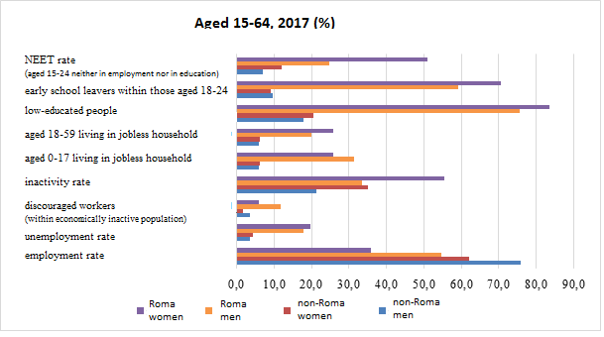
Source: Labour Force Survey

The regular monitoring of the living standards characterising Hungarian households is conducted within the framework of the Household Budget and Living Conditions survey. 19.6% of the whole population, almost 1,887,000 people were at the risk poverty or social exclusion in 2017. The people concerned included one fifth of all women and a bit less, 18.7 % of men. Young people, single-parent households, large families, unemployed people, people living in disadvantaged regions and the Roma population were among the groups most at risk. In 2017 the role of the improving trends of the country (as compared to previous years) could be also observed concerning the improvement of the living standards of Roma people. Nevertheless, the rate of people at the risk of poverty or social exclusion was still 67.8% (and 69.3% among women).

Table 5

Rate of people aged between 19-64 having experienced negative discrimination, in groups mostly affected by negative discrimination
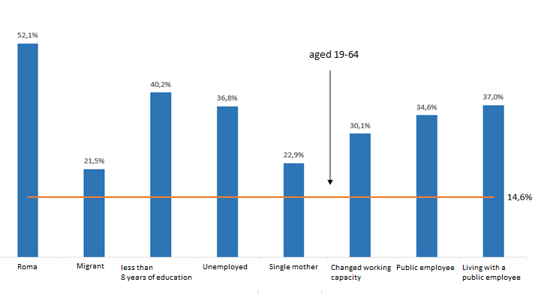
Source: Employment survey, 2015. I. quarter (Disadvantaged groups on the labour market)

Table 6
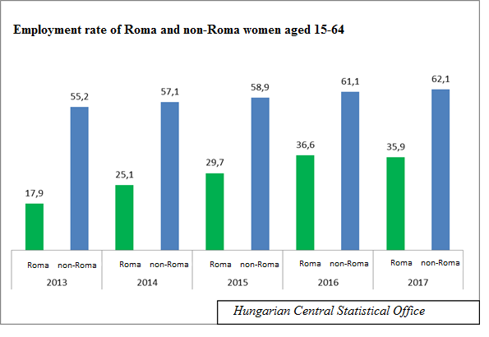

Table 7
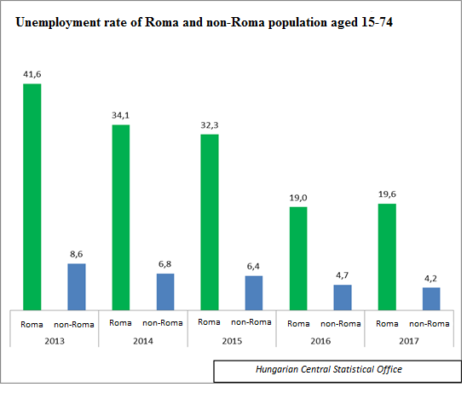

The beneficiaries of Women 40 program (>see paragraph 228.)
Table 8


