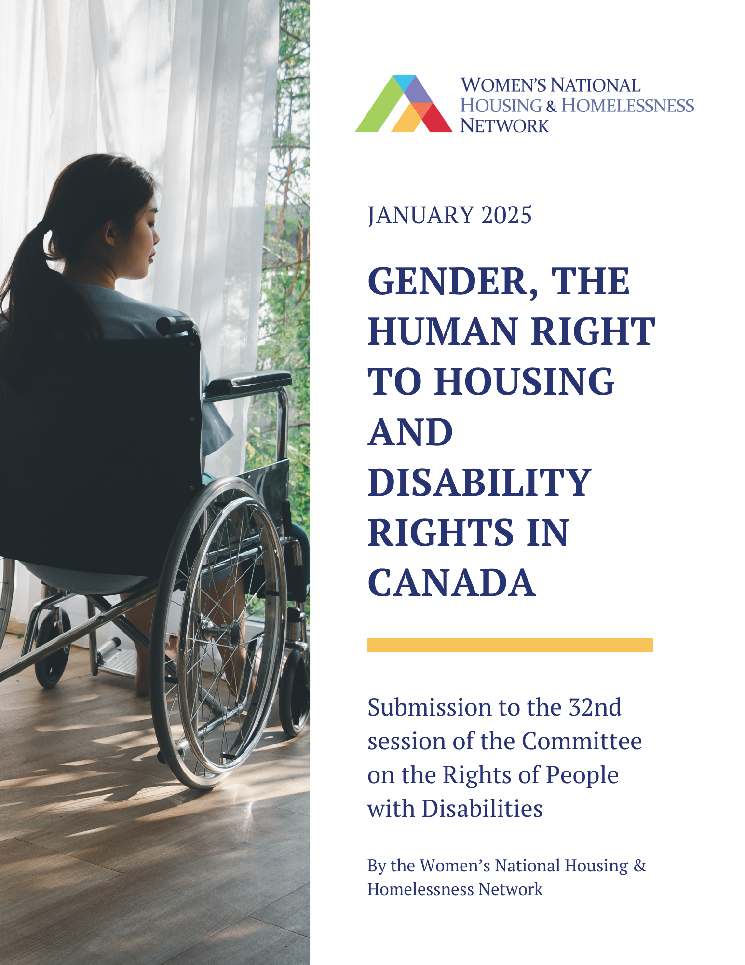

Systemic gaps and ableist policies in housing create an array of vulnerabilities for individuals living with disabilities. Particularly, women and gender-diverse people with disabilities, are multiply marginalized when trying to access safe, affordable housing that meets their unique needs. Inadequate income and supports systems, gaps in policies, and inconsistencies across jurisdictions are creating egregious violations to the rights of people with disabilities, disproportionately impacting women and gender diverse people. Our submission highlights key areas of disparities and outlines recommendations. We contend that the current state of housing violates Articles 6 and 9 of the convention.

For women with disabilities, gender inequities create additional social and economic barriers, including with respect to housing. Women with disabilities are twice as likely to experience homelessness of any kind than women without a disability. Statistics Canada data paints a vivid picture of the housing inequities experienced by women with disabilities. Startlingly, nearly half (46%) of all Canadian women who report having ever experienced homelessness have a disability.

Importantly, Statistics Canada reports: “Having a disability is associated with hidden homelessness. Out of the 7.2 million Canadians aged 15 and over who reported having a disability, 13% also reported having experienced hidden homelessness, compared with 6% of Canadians without a disability. With regard to the different types of disabilities, those who reported having a mental or psychological illness (21%) or a learning disability (20%) had the highest likelihood of also reporting an experience of hidden homelessness”. Women’s National Housing and Homeless Network’s Pan-Canadian research on women’s housing noted an even higher number, with 79% of women who had reported housing insecurity or homelessness, reporting experiences with some form of disability, with almost half of the sample
(46.4%) reporting a psychiatric or mental health disability of some kind.

Available data also indicates that women with disabilities are twice as likely to experience homelessness compared to women without disabilities. With regards unsheltered homelessness (i.e., living in a shelter or on the street), women with a disability are 4 times more likely to have experienced this at some point in their life than women without a disability.

- Accessible Housing Access Challenges

Unaffordable and inaccessible present two convergent barriers for individuals, particularly women and gender-diverse people, when accessing housing. Individuals with physical, mobility or sensory impairments face distinct challenges when finding affordable housing that meets their accessibility needs. For example, not having access to buildings that are wheelchair accessible, or limited units within the building that feature wheelchair accessible bathrooms, kitchen, etc. Modifications in addition to being expensive are often prohibited by landlords further restricting people with people with disabilities from living independently in their communities.

A 2017 study found that 40% of Canadian households with at least one person with a disability report that their homes are not fully accessible. A 2006 study found that “people with “emotional” disabilities are more likely to be in core housing need than the non-disabled population and people with other types of disabilities”. Toronto, Canada’s largest and most diverse city has recently added increasing the supply of accessible, affordable housing to the city's agenda in recognition of the increased barriers residents with diverse abilities face including inconsistent standards and a lack of universal design features. Access to affordable, accessible housing is a critical need for individuals with disabilities due to higher rates of poverty and unemployment. Women and gender-diverse participants with physical disabilities reported that they had difficulty finding suitable housing due to accessibility issues 16% of the time, a rate which is 16 times greater than those without physical disabilities.

- Affordable Housing

In a 2024 report by the Canadian Disability Rights Council (CDRC), noted that housing affordability remains a key barrier, with over 30% of people with disabilities in Canada reporting their income is insufficient to access adequate housing. This is especially acute for people with both physical and cognitive disabilities who require additional modifications. People with disabilities experience increased rates of income inequality and poverty which further exacerbate their risk of homelessness or chronic housing insecurity. 11 A report developed by a coalition of Ontario municipalities found that “between 2016 and 2024, the estimated number of people experiencing known homelessness rose from 53,930 to 81,515—a 51% increase...from 2023 to 2024, known homelessness increased by an estimated 12%”. Poverty and housing unaffordability are the primary causes of homelessness and people with disabilities are “almost three times more likely than those without a disability to be living in poverty”.

This is particularly pressing for women and gender-diverse people as research indicates that women and gender-diverse people with disabilities are more likely to experience affordability issues, with data indicating that with persons with multiple disabilities had greater affordability issues. Women and gender-diverse people with disabilities are also more likely to be impacted by evictions, with data indicating that with persons with multiple disabilities had a greater likelihood of experiencing eviction.
Housing insecurity, and homelessness figures fail to capture the full breadth of women and gender-diverse folks as they often experience hidden insecurity. “It is well recognized that women are more likely to rely on relational, precarious, and dangerous supports to survive housing instability, and are less likely to appear in mainstream shelters, drop in spaces, public spaces, or other homeless-specific services”. For women and gender-diverse people with a disability they are further marginalized as many cannot afford safe, consistent, secure, housing with another individuals income leaving them more vulnerable to abuse, and ableism.

- Accessibility in Shelters

Shelter spaces which remain Canada’s primary response to epidemics of violence, inequality and unaffordability remain shockingly inaccessible for women and gender-diverse people with disabilities. People with physical disabilities reported being unable to access shelters 65.1% of the time, roughly twice the rate of those without disabilities. For people with mental health disabilities, 43.1% of them reported being unable to access shelter beds versus 18% for those without. A DAWN Canada study reports that only “75% of homeless shelters have a wheelchair accessible entrance, 66% provide wheelchair accessible rooms and bathrooms, 17% provide sign language, and 5% offer braille reading materials”. Shelters in their current state are unable to meet the needs of women and gender-diverse people with various disabilities. One study found:

“Notably, even when controlling for other factors, a history of homelessness remained associated with an increased risk of violent victimization for women with a disability. The odds of being a victim of violent crime were more than twice as high for women with a disability who had ever been homeless compared to those without a history of homelessness, other factors being equal. Homelessness was not a significant predictor of the risk of violent victimization for men with a disability when keeping other factors constant”.

- Legal and Policy Gaps

Canada ratified the Convention on the Rights of Persons with Disabilities (CRPD) in 2010. However, while some progress has been made such as the Accessible Canada Act to address how the Government of Canada and organizations with the federal jurisdictions address accessibility, the approach remains inconsistent at a provincial, and municipal level. There are significant issues not only with the creation of policy and legal stances, but their respective implementation. A report by DAWN Canada found that women and gender diverse people with disabilities faced a myriad of legal issues surrounding their housing and housing rights. In their qualitative study they found that many participants noted that it is “sometimes easier to give up and move on” than to fight” thus speaking to the frequency of these issues. According to the Canadian Human Rights Commission (CHRC), people with disabilities did worse in every area of inadequate housing and homelessness than people without disabilities.

- Experiencing Violence and Abuse

Women and gender-diverse individuals with disabilities are at a heightened risk of experiencing violence and abuse. Women with disabilities are far more likely to report experiencing various forms of intimate partner violence (IPV), which includes control of one’s reproductive health, stalking, rape, sexual, and physical violence. The presence of a disability increased some women’s vulnerability to experiencing IPV. Furthermore, women with disabilities are at an increased risk of experiencing isolation or financial reliance on their partners, which makes them more susceptible to IPV.

“People with disabilities are more likely to experience homelessness because of violence or abuse. In 2018, 53% of people with disabilities who experienced homelessness in their lifetime said it was because of violence. This is compared to 36% of people without disabilities.”

For example, studies have shown that women who have disabilities are “particularly targeted by perpetrators of violence because they often live in situations that heighten the risk of experiencing violence owing to poverty, social isolation, lack of economic independence, and dependence on other”.

- Social Isolation

Women and gender-diverse individuals with disabilities living in Canada face social exclusion and isolation due to challenges accessing housing and locating supportive community support. When faced with inaccessible housing and barriers and a lack of access to transportation individuals are faced with further isolation from their friends, family, and their community. A lack of community support leads to disconnection experienced both physically and emotionally. “A 2019 study found that people with physical disabilities were twice as likely to be socially excluded than people without disabilities, with 38% reporting high levels of loneliness and isolation. Approximately 25% of women with disabilities live alone, making isolation a particular concern.” Social isolation exacerbates feelings of exclusion and marginalization. The barriers experienced by individuals with disabilities include an inability to form meaningful connections and have access to communal spaces. Targeted interventions are required to remove barriers that continue to isolate vulnerable populations and exclude them from society.

- Health Disparities

Research also discusses how the lack of community-based resources affects employment and sustainable income opportunities for women and gender-diverse individuals with disabilities, contributing to their experiences of homelessness. The complex issue is due to the notion that “psychosocial disabilities predispose people to homelessness, at the same time housing insecurity and lack of affordability can cause, trigger and aggravate one’s psychosocial state.”

- Recommendations
- Increase the rates of Canada Disability Benefit to ensure recipients can afford adequate housing and maintain a decent and dignified quality of life.
- We echo calls from other disability justice groups calling for universal design principles to be incorporated in the National Building Code to make universal design mandatory in all new multi-unit residential buildings, both rental and ownership.
- Allocate funding to retrofit existing shelters and housing stocks to meet accessibility standards, addressing physical, sensory, and cognitive needs.
- Increase the availability of specialized services for those experiencing homelessness and living with disabilities, through investments in supportive housing and support programs.
- Develop and fund training for shelter and housing staff to better understand and support individuals with disabilities.
- Involve women and gender-diverse individuals with lived experience of disabilities in the development, implementation, and evaluation of housing policies and programs.
- Establish advisory committees or focus groups to ensure meaningful participation and accountability.
- Develop new funding streams to create accessible, supportive housing options tailored to their needs.
- Establish mechanisms for ongoing evaluation of accessibility and affordability in housing programs to ensure policies remain responsive and effective.
- Collect and analyze disaggregated data to monitor how interventions impact women and gender-diverse people with disabilities.

Schwan, K., Versteegh, A., Perri, M., Caplan, R., Baig, K., Dej, E., Jenkinson, J., Brais, H., Eiboff, F., & Pahlevan Chaleshtari, T. (2020). The State of Women’s Housing Need & Homelessness in Canada: A Literature Review. Hache, A., Nelson, A., Kratochvil, E., & Malenfant, J. (Eds). Toronto, ON: Canadian Observatory on Homelessness Press https://womenshomelessness.ca/wp-content/uploads/State-of-Womens-Homelessness-Literature-Review.pdf
Schwan et al. (2020)
Schwan, K., Vaccaro, M., Reid, L., Ali, N., & Baig, K. (2021). The Pan-Canadian Women’s Housing & Homelessness Survey. Toronto, ON: Canadian Observatory on Homelessness. https://womenshomelessness.ca/wp-content/uploads/EN-Pan-Canadian-Womens-Housing-Homelessness-Survey-FINAL-28-Sept-2021.pdf
Schwan et al. (2020)
Statistics Canada. (2017). Canadian Survey on Disability: A demographic, employment, and income profile. Government of Canada. https://www.statcan.gc.ca
Donaldson, J., Wang, D., Escamilla, C., & Turner, A. (2025). Municipalities under pressure: The human and financial cost of Ontario’s homelessness crisis. HelpSeeker, p. 18. https://www.amo.on.ca/sites/default/files/assets/DOCUMENTS/Reports/2025/2025-01-08-EndingChronicHomelessnessinOntario.pdf
Housing Secretariat, (2024), Increasing the City's Supply of Accessible Affordable Housing, City of Toronto. https://www.toronto.ca/legdocs/mmis/2024/ph/bgrd/backgroundfile-248678.pdf
ibid.
Schwan, et al. (2021). P.51
Statistics Canada. (2017). Canadian Survey on Disability: A demographic, employment, and income profile. Government of Canada. https://www.statcan.gc.ca
Homeless Hub, (n,d.), People with Disabilities. https://homelesshub.ca/collection/population-groups/people-with-disabilities/#:~:text=For%20instance%2C%20in%202017%2C%20one,reported%20having%20experienced%20hidden%20homelessness.
Schwan et al. (2021)
ibid
ibid
ibid.
ibid
ibid.
ibid. P.53
Cotter, A. (2018). Violent victimization of women with disabilities, 2014. Statistics Canada. p.12 https://www150.statcan.gc.ca/n1/pub/85-002-x/2018001/article/54910-eng.htm
Abbas, J., Alimi, S,. (2021), A Qualitative Look at Serious Legal Problems for People with Disabilities in Central Canada, DAWN Canada. P. 15 https://www.justice.gc.ca/eng/rp-pr/jr/pwdcc-phcc/docs/RSD_RR2021_Persons-with-Disability-Central-Canada-EN.pdf
Ibid. P. 16
Canadian Human Rights Commission and the Office of the Federal Housing Advocate, (2025), Monitoring the right to housing for people with disabilities. https://www.chrc-ccdp.gc.ca/resources/publications/monitoring-the-right-housing-people-disabilities
Breiding, M. J., & Armour, B. S. (2015). The association between disability and intimate partner violence in the United States. Annals
Canadian Human Rights Commission. (n.d.). Monitoring the right to housing for people with disabilities. Retrieved from https://www.chrc-ccdp.gc.ca
Survey of Safety in Public and Private Spaces (2018): Homelessness
Schwan et al. (2020)
Live Work Well Research Centre. (2020). COVID-19's Impact on People with Disabilities in Canada. Retrieved from. https://liveworkwell.ca/sites/default/files/pageuploads/FS01_Sharing%20Experiences%20of%20Diverse%20People%20with%20Disabilities_AODA_protected.pdf
Rajan, D. (2018). Women with Disabilities & Housing. Learning Network Brief (35). London, Ontario: Learning Network, Centre for Research and Education on Violence Against Women and Children. www.vawlearningnetwork.ca
Munn-Rivard, L. (2014). Current Publications: Health.

