BRIEFING ON NIGERIA FOR THE COMMITTEE AGAINST TORTURE, SESSION 72- Nov/Dec 2021
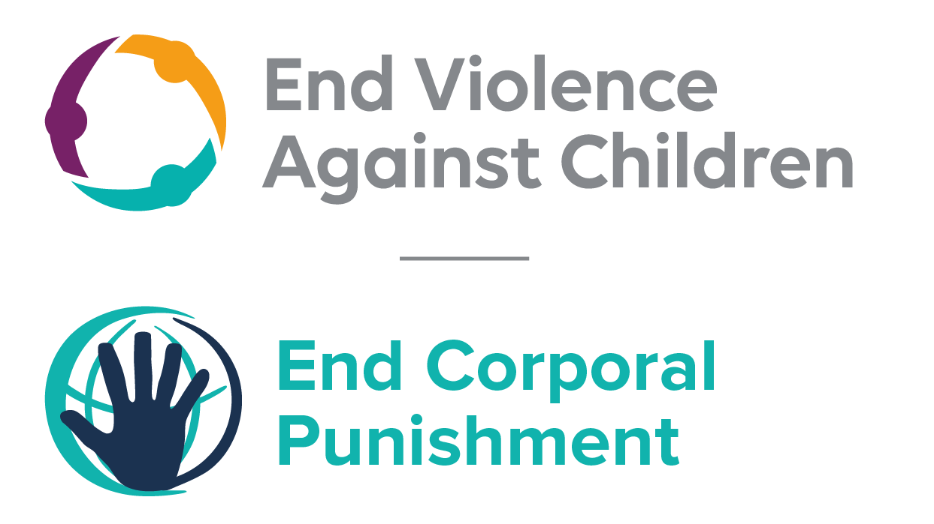
The Global Partnership to End Violence Against Children, October 2021

This briefing describes the legality of corporal punishment of children in Nigeria. In light of the obligation under international human rights law to prohibit all corporal punishment of children, the recommendation of the UN Secretary General’s Study on Violence against Children, the repeated recommendations to prohibit all corporal punishment made to Nigeria by the Committee on the Rights of the Child and the African Committee of Experts on the Rights and Welfare of the Child, as well as the global commitment to ending all violence against children in the context of the 2030 Agenda for Sustainable Development, we hope the Committee will:
• in its concluding observations in the absence of a report from Nigeria, recommend that legislation is immediately enacted to explicitly prohibit corporal punishment of children, in all settings including the home, and to repeal all legal defences for its use.

Summary of necessary legal reform to achieve full prohibition
Prohibition is still to be achieved in the home, alternative care settings, day care, schools, penal institutions and as a sentence for crime.
Article 295 of the Criminal Code (South), article 55 of the Penal Code (North) and the Shari’a penal codes in the Northern states confirm the right of parents to use force to “correct” their children. The near universal acceptance of a degree of violence in childrearing necessitates clarity in law that all corporal punishment is prohibited, however light. These provisions should be repealed and prohibition enacted of all corporal punishment by parents and others with parental authority.
Alternative care settings – Prohibition should be enacted in legislation applicable to all alternative care settings (foster care, institutions, places of safety, emergency care, etc).
Day care – Corporal punishment should be prohibited in all early childhood care (nurseries, crèches, kindergartens, preschools, family centres, etc) and all day care for older children (day centres, after-school childcare, childminding, etc).
Schools – Prohibition should be enacted in legislation applicable to all education settings, public and private, together with repeal of the provisions for the use of force by teachers in, article 295 of the Criminal Code (South), article 55 of the Penal Code (North) and the Shari’a penal codes in the Northern states.
Penal institutions – Prohibition of corporal punishment should be enacted in relation to disciplinary measures in all institutions accommodating children in conflict with the law.
Sentence for crime – All provisions for judicial corporal punishment of persons under 18 should be repealed, including under Shari’a law.

Note: The legal system in Nigeria is a mix of Islamic law, English common law and customary/native law. In the southern states, criminal laws dating from before Independence in 1960 remain in force; in the northern states, criminal laws enacted during the settlement of 1960 are still in force, together with Shari’a laws enacted following the adoption of the 1999 Constitution. The Shari’a laws in the north were passed by individual states, mostly based on the first ones enacted in Zamfara. A Harmonised Shari’a Penal Code and a Harmonised Shari’a Criminal Procedure Code have been drafted but have not been widely adopted. In 2003, the National Assembly passed the federal Child Rights Act, but this is in force only in the Federal Capital Territory of Abuja and in states that have explicitly enacted it, a process in which it may also be modified. Child legislation in states that have not yet adopted the 2003 Act is based on the Children and Young Persons Law, enacted originally in 1943 and extended to the Northern Region in 1958. By March 2014, 26 of the 36 states have enacted child rights laws pursuant to the Child Rights Act.
The 1999 Constitution is under review and in this context proposals have been made to make the Child Rights Act 2003 automatically applicable in all states. Draft legislation based on the Act has been under consideration in a number of states. Other laws under review include the Children and Young Persons Laws, the Penal Code, the Criminal Procedure Code and the Shari’a Penal Code.

- Current legality of corporal punishment in Nigeria
1.1 Home: Corporal punishment is lawful in the home. Article 295 of the Criminal Code (South) states: “A blow or other force, not in any case extending to a wound or grievous harm, may be justified for the purpose of correction as follows: (1) a father or mother may correct his or her legitimate or illegitimate child, being under sixteen years of age, for misconduct or disobedience to any lawful command; (2) a master may correct his servant or apprentice, being under sixteen years of age, for misconduct or default in his duty as such servant or apprentice;… (4) a father or mother or guardian, or a person acting as a guardian, may delegate to any person he or she entrusts permanently or temporarily with the governance or custody of his or her child or ward all his or her own authority for correction, including the power to determine in what cases correction ought to be inflicted; and such a delegation shall be presumed, except in so far as it may be expressly withheld, in the case of a schoolmaster or a person acting as a schoolmaster, in respect of a child or ward.” Article 55 of the Penal Code (North) states: “(1)(a) Nothing is an offence which does not amount to the infliction of grievous hurt upon any person and which is done: by a parent or guardian for the purpose of correcting his child or ward, such child or ward being under eighteen years of age.” These provisions are also confirmed in the Shari’a penal codes in the Northern states. Article 11 of the Child Rights Act 2003 states that every child is entitled to respect for the dignity of his person and no child shall be “subjected to physical, mental or emotional injury, abuse, neglect or maltreatment, including sexual abuse, (…) torture, inhuman or degrading treatment or punishment”, but these provisions are not interpreted as prohibiting all corporal punishment in childrearing. Similarly, child rights laws at state level prohibit corporal punishment that reaches a certain threshold of severity but are not interpreted as prohibiting all corporal punishment by parents.
1.2 Nigeria is a Pathfinder country with the Global Partnership to End Violence Against Children, which was established in 2016. This commits the Government to three to five years of accelerated action towards the achievement of Target 16.2 of the Sustainable Development Goals. A Roadmap for Ending Violence Against Children was published in October 2016, ahead of Nigeria’ accession to Pathfinder status; it did not refer to the issue of corporal punishment of children. Although a National Action Plan was planned for publication in early 2017, it is yet to be published. In November 2020, the Katsina State House of Assembly adopted a Child Protection Bill. The Bill does not prohibit corporal punishment in any setting. It also provides for the supremacy of the Sharia law with respect to a Muslim child. We are trying to find out if the Bill has been signed by the Governor of Katsina State.

1.3 Alternative care settings: Corporal punishment is lawful in alternative care settings under the Criminal Code (South), the Penal Code (North) and the Shari’a Penal Codes in the north. It is not explicitly prohibited in the Child Rights Act.

1.4 Day care: Corporal punishment is lawful in early childhood care and in day care for older children under the Criminal Code (South), the Penal Code (North) and the Shari’a Penal Codes in the north. It is not explicitly prohibited in the Child Rights Act.

1.5 Schools: Corporal punishment is lawful in schools under article 295(4) of the Criminal Code (South), which states that “a schoolmaster or a person acting as a schoolmaster” is automatically considered as having been entrusted with “authority for correction, including the power to determine in what cases correction ought to be inflicted”, and article 55 of the Penal Code (North), which states: “Nothing is an offence which does not amount to the infliction of grievous hurt upon any person and which is done by a schoolmaster for the purpose of correcting a child under eighteen years of age entrusted to his charge.” The Government has stated that the Child Rights Act prohibits corporal punishment in schools. Article 11 of the Act states that every child is “entitled to respect for the dignity of his person” and that no child shall “be subjected to torture, inhuman or degrading treatment or punishment”, but it does not explicitly prohibit corporal punishment in schools.

1.6 Penal institutions: Corporal punishment is presumably prohibited as a disciplinary measure in penal institutions under article 221 of the Child Rights Act (see under “Sentence for crime”), but to our knowledge there is no explicit prohibition applicable in all states. We have no details of provisions in the federal Prisons Act 1990.

1.7 Sentence for crime: Law reform has not fully prohibited corporal punishment as a sentence for crime. Article 221(1)(b) of the Child Rights Act states that “no child shall be ordered to be subjected to corporal punishment”. In states which have adopted the Act without modifying this provision or the definition of the child, it would be unlawful to sentence a person under 18 to corporal punishment. At least two states have modified the definition of the child: in the southern Akwa-Ibom, a child is defined as 16 and under and older children are presumably sentenced as adults, including to corporal punishment under the Criminal Code 1916 and the Criminal Procedure Act 1945 (see below). In northern Jigawa, a child is defined with reference to puberty, so a Muslim child from the age of puberty may be sentenced to corporal punishment under the Shari’a Penal Code 2000 and the Shari’a Criminal Procedure Code Law 2001 (see below).
1.8 With regard to states which have not adopted the Child Rights Act, article 9 of the Children and Young Persons Law states: “Where a juvenile charged with any offence is tried by a court, and the court is satisfied of his guilt, the court may ... (f) order the offender to be whipped”. Article 11(2) states: “No young person shall be ordered to be imprisoned if in the opinion of the court he can suitably be dealt with in any other way whether by probation, fine, corporal punishment, committal to a place of detention or to an approved institution or otherwise.”
1.9 In the southern states that have not yet enacted the Child Rights Act, children may be sentenced to corporal punishment under the Children and Young Persons Law (as above). In addition, the Criminal Code Act 1916 states that when a male person under 17 has been found guilty of any offence “the court may, in its discretion, order him to be caned in addition to or in substitution for any other punishments to which he is liable” (art. 18). The Criminal Procedure Act 1945 states that when a child or young person (aged 7-16) is charged with an indictable offence other than a capital offence, the magistrate may deal with the case summarily, inflicting the specified punishment including, for boys, corporal punishment (art. 302). It states that no young person (aged 14-16) shall be imprisoned “if he can be dealt with in any other way whether by probation, fine, corporal punishment or otherwise” (art. 419(2)), and lists the measures available when a child or young person has been convicted of an offence, including “by ordering the offender to be whipped” (art. 427). Under the Criminal Code Act 1916, persons aged 17 and over are tried as adults and males may be sentenced to caning, including for rape and other sexual offences, and endangering life (arts. 27, 218, 219, 221, 222, 225A, 330, 334, 358 and 359). Caning may also be ordered for any offence punishable by imprisonment for six months or more (Criminal Procedure Act 1945, art. 387). According to the Criminal Procedure Act, a maximum of 12 strokes shall be inflicted with a light rod or cane or birch (art. 386(1)). It must be carried out as soon as possible after sentencing or after the decision on appeal of the sentence (art. 388). Females may not be caned (art. 385).
1.10 In the north, the 11 Shari’a states that have not enacted the Child Rights Act provide for corporal punishment (caning, retribution and amputation) of Muslim children from the age of puberty under the Shari’a penal codes. Lashing or caning is a punishment for certain offences relating to alcohol, drugs, sex, theft, murder and hurt; amputation is a punishment for theft, kidnap of a child, embezzlement and robbery; the punishment of retaliation for hurt may involve amputation, blinding and other serous wounding. Many Shari’a Penal Codes allow for offences which are not specified in them to be punished by flogging, and other laws prescribe caning for particular offences. In 2004, the Government informed the UN Committee on the Rights of the Child that several persons under 18 had been sentenced to amputation and flogging under the northern Shari’a Penal Codes, but that between 2001 and 2004 none had been carried out as they had been quashed on appeal. A 2004 report by Human Rights Watch states that several boys under 18 were sentenced to amputation in Sokoto in 2003, and lawyers and NGO visitors to Sokoto prison in 2002-3 estimated that the majority of the 10 prisoners sentenced to amputation were under 18; at least one boy under 18 was sentenced to amputation in Katsina State. The most common form of corporal punishment carried out under the Shari’a laws is flogging, inflicted frequently and in public and often on teenagers.
The Harmonised Shari’a Penal Code provides for punishments of caning, retaliatory wounding, and amputation (art. 93). Caning is specified as punishment for virtually every offence in the Code and it may be ordered by any court on any offender in addition to or in lieu of any other punishment except death (art. 100). A person aged 7-17 may be sentenced to caning up to 20 lashes instead of the punishment specified in the Code (art. 95(1)). The Code punishes the offence of causing grievous hurt with qisas (retaliation) (arts. 215 and 219), theft and hirabah with amputation (arts. 144 and 152).
Non-Muslims in northern states may be sentenced to corporal punishment (caning) under the Penal Code 1960 and the Criminal Procedure Code 1960. Up to 12 strokes may be passed by any court on a male offender in lieu of or in addition to any other punishment except capital punishment (Criminal Procedure Code). Flogging is commonly inflicted on child offenders for a range of offences.

Recommendations by human rights treaty bodies and during the UPR
  - CRC: On three occasions, the Committee on the Rights of the Child has recommended to Kyrgyzstan that legislation be enacted to explicitly prohibit corporal punishment in all settings: in its concluding observations on the state party’s initial report in 1996, on the second report in 2005, and on the third-fourth report in 2010.

  - ACERWC: In its concluding observations on the state party’s initial report in 2009, the African Committee of Experts on the Rights and Welfare of the Child recommended that Nigeria include information about corporal punishment in schools, in its next periodic report.

27 March 2014, A/HRC/25/2 Advance Unedited Version, Draft report of the Human Rights Council on its twenty-fifth session, para. 280
5 January 2009, CRC/C/NGA/3-4, Third/fourth periodic report to the Committee on the Rights of the Child, para. 7.1.6
CRC/C/RESP/72, Written replies to the Committee on the Rights of the Child
“Political Shari’a”? Human Rights and Islamic Law in Northern Nigeria, New York: Human Rights Watch
30 October 1996, CRC/C/15/Add.61, Concluding observations on initial report, paras. 15, 36 and 38
13 April 2005, CRC/C/15/Add.257, Concluding observations on second report, paras. 38, 39, 79, 80 and 81
21 June 2010, CRC/C/NGA/CO/3-4, Concluding observations on third/fourth report, paras. 5, 6, 40 and 41
19 November 2009, Concluding observations on initial report, recommendation 5

