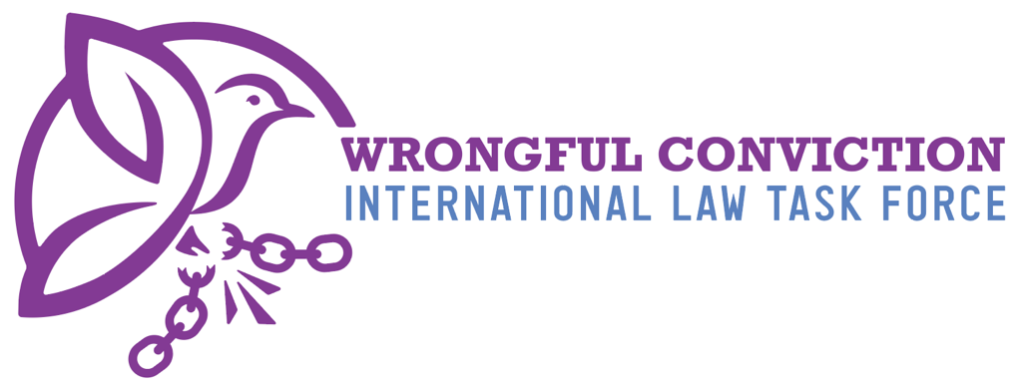

List of Issues for Samoa Prior to Reporting
United Nations Human Rights Committee
Submitted on January 6, 2025

- Authors
The Wrongful Conviction International Law Task Force (WCILTF) is a global coalition of law professors, attorneys, and activists working together to fill the “Innocence Gap” in international law. The WCILTF is supported by a pro bono legal team at the international law firm Proskauer Rose (www.proskauer.com/) located in New York City.
In the past twenty-five years, wrongful conviction of the innocent has emerged as a major problem in criminal justice systems around the world. Research indicates that the problem has always existed but has only come to light in recent decades due to forensic advancements allowing for post-conviction DNA testing of crime scene evidence. Wrongful convictions occur because of human limitations in investigation and evidence collection, such as memory weaknesses and malleability (leading to misidentifications by eyewitnesses), unreliable or faulty forensic evidence, false confessions, confirmation bias or tunnel vision on behalf of investigators, inadequate defense lawyering, and many other human problems. Thus, wrongful convictions exist in all legal systems around the world, as all nations use the same types of evidence and investigation techniques regardless of the precise legal procedures employed in their courtrooms.
NGOs called “Innocence Projects” have sprung up around the globe to combat this problem, and now entire networks of innocence projects exist in Asia, Europe, North America, and South America. Innocence Projects are often housed at law schools and are operated by law professors and law students. In one member state, for example, more than 3,000 innocent people have been released from prison in recent years due to the work of NGOs like Innocence Projects. Exonerations of the innocent have occurred across the globe in the past three decades.
For a brief video overview of the global problem of wrongful convictions and the efforts of Innocence Projects to combat the problem, please view: https://youtu.be/jMATkuFaRU8?si=fO0wXGhPr-oCyhBA
As the innocence movement has developed a global presence in recent years, it has become apparent to legal scholars that an “Innocence Gap” exists in international law. The WCILTF formed to combat this problem and help fill the Innocence Gap. The WCILTF is comprised of more than twenty-five law professors and Innocence Project leaders from across Asia, Europe, North America and South America.

- Filling the Innocence Gap
Due to the relatively recent discovery of wrongful convictions, international law covenants and treaties predate awareness of this problem and thus do not speak directly to the issue. In recent years, however, the United Nations Human Rights Committee (HRC) has identified key rights to the benefit of incarcerated person claiming innocence to be derived from the right to a fair trial and other existing rights. For example, in Abdiev v. Kazakhstan, 2023, the HRC stated that the right of incarcerated persons to re-open a criminal case in order to present new evidence of innocence after conviction and appeal have concluded, in order to achieve exoneration and freedom, is essential to the right to a fair trial under Article 14(1) of the ICCPR. Similarly, on October 3, 2023, in Concluding Observations on the Fifth Periodic Report of the Republic of Korea, the HRC observed that South Korea should “provide adequate legal and financial assistance to enable individuals sentenced to death to re-examine convictions on the basis of newly discovered evidence, including new DNA evidence.”
Likewise, on July 25, 2024, in Concluding Observations on the Second Periodic Report of Maldives, the HRC expressed concern “about the lack of information on the existence of a procedure enabling individuals sentenced to death to seek a review of their convictions and sentences based on newly discovered evidence of their innocence, including new DNA evidence, and, if wrongfully convicted, to provide them with compensation.” The HRC recommended that Maldives take all necessary measures to ensure that “death sentence can be reviewed based on newly discovered evidence of their innocence, including new DNA evidence, adequate legal and financial assistance is provided to enable this review and, if wrongfully convicted, individuals have access to effective remedies, including compensation” para. 28(e). See Brandon Garrett, Laurence Helfer, and Jayne Huckerby, Closing International Law’s Innocence Gap, S. Cal. L. Rev. 95 (2021), available at: https://papers.ssrn.com/sol3/papers.cfm?abstract_id=3803518#
- Rights of Innocent Incarcerated Persons in Samoa
Samoa constitutional changes and potential threat to rights to innocence
Our understanding is that the introduction of the Constitution Amendment Act 2020, Judicature Bill 2020, Lands and Titles Act 2020, and the Judicature Act 2020 (the ‘Acts’) had the combined effect of eroding the legal and judicial rights of Samoans – with one consequence being uncertainty and the lack of protection of fundamental rights connected to post-conviction innocence rights. The Acts were hurried through in March 2020 during the pandemic, with the Samoan population and Samoan Judiciary Law Society unaware of the developments and other stakeholders not having been properly consulted.
As a result of the Acts, the Supreme Court of Samoa is no longer the ultimate authority responsible for protecting the Constitution of Samoa and the fundamental rights of its people. These fundamental rights include the right to life, right to personal liberty, right to a fair trial, protections under criminal law, and the ability to seek remedies to enforce these rights as outlined in Part II of the Constitution of Samoa. Instead, an elevated Lands and Titles Court (‘LTC’) has been established as a standalone judiciary co-equal to the Supreme Court. Notably, the fundamental rights guaranteed under the Constitution, which fall under the Supreme Court’s jurisdiction, do not apply to matters brought before the LTC. To support this dual judicial system, the Acts expressly state that decisions of the Supreme Court and Court of Appeals are not binding on the LTC (Section 57), and LTC decisions are not subject to review by any other court (Section 56).
Village councils handled many criminal matters before they reached any court. However, as the U.S. Department of State noted, the “councils varied considerably in decision-making styles and the number of matai (family chiefs) involved in decisions. The law recognizes the decisions of village councils and provides for limited appeal to the LTC. The nature and severity of a dispute determines which court receives an appeal”. Even when there is a criminal appeal made to the LTC, there is no protection of fundamental rights, including the right to personal liberty, right to a fair trial, or right to life because, as set out above, the LTC is not bound by the Constitution of Samoa. Beyond the initial punishments that village councils may impose, imprisonment sentences can also be imposed for offenses relating to matai titles by the LTC (Division 7, LTC Act) and for disobeying orders of the LTC (Division 5, LTC Act), again with no protection of fundamental rights.
The Acts also had the impact of undermining judicial independence by “reducing the requirements that allow for the removal of Judges, and removing protections for their tenure, salaries and conditions and their independence. The changes made now increase the ability of government to influence or interfere with their ability to act with ‘impartiality’ or ‘fear or favour’”, as described to the United Nations Human Rights Periodic Review of Samoa by a Samoan NGO and community group.
The Samoan people have two separate systems of justice, with two separate appeal courts, with one route having the benefit of the Constitution of Samoa and its fundamental rights, with the other of the LTC no longer providing the Samoan people with such protection. This is overlaid with a judiciary which has significant impartiality concerns. Whilst there are useful criminal procedure requirements in the Criminal Procedure Act 2016 that may support those with post-conviction rights to innocence, these do not appear to be applicable to the village councils or the LTC, both of which handle criminal cases and punishments.
Accordingly, there does not appear to be a consistent approach to allow innocent incarcerated persons to achieve exoneration and freedom in Samoa.
- Questions to Samoa
- Do fundamental rights under the Constitution of Samoa—including the right to life, right to personal liberty, right to a fair trial, protections under criminal law and others, and the right to seek remedies for enforcing these rights apply to criminal convictions made by village councils or the LTC?
- What are the rights of individuals wrongly convicted by village councils or the LTC to appeal? What is the process that should be followed?
- What are the rights of individuals wrongly convicted by village councils or the LTC to seek remedies? What is the process that should be followed?
- Does the Criminal Procedure Act of 2016 apply to the village councils and LTC? If not, what are the equivalent rules or procedures?
- How can a judge be challenged regarding the outcome of a criminal case, for example, when it is believed they may lack impartiality or demonstrate a bias towards the government following the introduction of the Acts?
- Have there been any incarcerated persons exonerated and freed based on existing legal provisions in Samoa, whether under the Supreme Court branch or the LTC branch? Have courts in Samoa denied any such motions?
- If so, is there a deadline by which such a motion must be brought, or may an incarcerated person bring such a legal motion at any time?
- If so, what is the legal standard that the incarcerated person must meet to re-open the case based on new evidence of innocence?
- Have any post-conviction motions presenting new evidence of innocence been successfully granted by a court in Samoa, resulting in the incarcerated person’s exoneration and freedom?
- Does Samoa maintain a DNA database related to criminal convictions? If so, which offenses qualify for inclusion in the database?
- Whose DNA profiles are included in such a database? How long are DNA profiles retained in such a database?
- Does Samoa have a law allowing incarcerated persons to petition for post-conviction DNA testing of crime scene evidence to prove innocence and seek relief?
- Does Samoa have a legal procedure requiring biological evidence collected from the crime scene to be preserved for future DNA testing?
- If so, how long must the biological evidence be preserved?
- Does Samoa have a “sunshine law” or “public records law” granting defense attorneys, NGOs, journalists, or incarcerated persons access to police files and documents of an incarcerated person’s case post-conviction?
- Does Samoa have a legal standard requiring the police and prosecution to disclose to the defense pre-trial any exculpatory evidence or other information helpful to the defense or that might lead to new avenues of pre-trial investigation that might be conducted by the defense? For the avoidance of doubt, this should cover all evidence, not only witness statements covered in section 46 of the Criminal Procedure Act 2016.
- If so, what is the legal standard pertaining to this disclosure requirement?
- Has Samoa ever provided compensation to a wrongfully convicted person?
- Does Samoa have laws or regulations requiring the recording of police interrogation of suspects? If so, please outline the requirements of such laws or regulations.
- Does Samoa have laws or regulations ensuring that police identification procedures for eyewitnesses adhere to best practices devised by the scientific community, such as the double-blind eyewitness identification requirement? See https://www.ojp.gov/ncjrs/virtual-library/abstracts/double-blind-sequential-police-lineup-procedures-toward-integrated

This document created by the following members of the WCILTF:

Rachel Lowe
Special Regulatory Counsel
rlowe@proskauer.com

Luca Lupária Donati
Full Professor of Criminal Procedure
At the University of Milan
Director of the Italy Innocence Project
luca.luparia@unimi.it

Martina Cagossi
Criminal Attorney in Milan
Program Manager at the Italy Innocence
Project
martina.cagossi@gmail.com

To contact the WCILTF generally, please email:
Prof. dr. mr. G.J. Alexander Knoops. Professor Mark Godsey
Advocaat/Attorney at law University of Cincinnati College of Law
Professor Politics of International Law Director, Ohio Innocence Project
alex@knoopsadvocaten.nl markgodsey@gmail.com

JS4_UPR39_WSM_E_Main.pdf, page 5
https://www.state.gov/reports/2022-country-reports-on-human-rights-practices/samoa
JS4_UPR39_WSM_E_Main.pdf, page 6

