August 28th, 2023

To the Secretariat of the Committee on Economic, Social and Cultural Rights

Joint Civil Society Parallel Report on Brazil, submitted for the consideration of the Committee on Economic, Social and Cultural Rights in its 74th session
(25 Sep. to 13 Oct. 2023)

Distinguished Committee members,

The Instituto de Desenvolvimento e Direitos Humanos (IDDH) is a Brazilian Civil Society Organization that for 19 years has sought to strengthen democracy in Brazil and Latin America through international advocacy for human rights, especially with two programs focused on the United Nations: a) Civil society and the UN; and, b) Youth in the UN. The IDDH has consultative status with ECOSOC/UN (since 2016) and is part of the UN NGO Working Group on Human Rights Education and Learning (NGO WG on HREL).
The Instituto Aurora has the mission to defend and promote Human Rights Education. Aligned with the UN 2030 Agenda, the organization contributes to constructing a socially just society free of discrimination and prejudice. Since 2018, Aurora Institute has released three unprecedented researches about the Brazilian Human Rights education public policy, called An Overview of Human Rights Education in Brazil, which is also presented in a database format. The organization holds a position in the Human Rights Commission of Curitiba and is also a member of the Coalition For The End Of Violence Against Children And Teenagers. Aurora Institute also received the APERGS/Jacques Alfonsin Prize for Human Rights (2023), dedicated to recognizing organizations and projects with relevant work in Brazil's Human Rights Education field.

Considering both organizations’ work to promote Human Rights Education (HRE) in Brazil, we prepared the present report assessing Brazil’s implementation of Article 13 of the International Covenant on Economic, Social and Cultural Rights (ICESCR):

I. Article 13 - Right to Education

1. This report aims to assess Brazil's implementation of Article 13 of the ICESCR by Brazil. It mainly concerns the Human Rights Education aspects, an essential component of the right to education, which should be understood as both a human right per se and an indispensable means of realizing other human rights (E/C.12/1999/10), 1).
2. Regarding the aims and objectives of education, the Brazilian Federal Constitution is very much in line with the CESCR prevision of an education “directed to the human personality’s “sense of dignity”, it shall “enable all persons to participate effectively in a free society”, and it shall promote understanding among all “ethnic” groups, as well as nations and racial and religious groups. Of those educational objectives which are common to article 26 (2) of the Universal Declaration of Human Rights and article 13 (1) of the Covenant, perhaps the most fundamental is that “education shall be directed to the full development of the human personality” (E/C.12/1999/10), 4):

Art. 205. Education, a right of all and a duty of the State and the family will be promoted and encouraged with the collaboration of society, aiming at the full development of the person, his preparation for the exercise of citizenship and qualification for work (Article 205 of Brazil’s Federal Constitution).

3. In the same sense, the four essential features - which are common to education in all its forms and at all levels of education - availability, accessibility, acceptability and adaptability (E/C.12/1999/10), 6), are also present in the Brazilian National Education Plan - PNE (Law n. 13.005/2014) and especially concerned in the guiding principles of HRE of the National Plan for Human Rights Education - PNEDH (public policy established in 2004):

• education must have the function of developing a culture of human rights in all social spaces;
• the school, as a privileged space for building and consolidating a human rights culture, must ensure that the objectives and practices to be adopted are consistent with the values ​​and principles of human rights education;
• human rights education, due to its collective, democratic and participatory character, must take place in spaces marked by mutual understanding, respect and responsibility;
• education in human rights must be based on cultural and environmental diversity, guaranteeing citizenship, access to education, permanence and completion, equity (ethnic-racial, religious, cultural, territorial, physical-individual, generational, gender, sexual orientation, political choice, nationality, among others) and the quality of education;
• education in human rights must be one of the fundamental axes of basic education and permeate the curriculum, the initial and continuing training of education professionals, the school's political pedagogical project, didactic-pedagogical materials, the management model and evaluation ;
• school practice must be oriented towards education in human rights, ensuring its transversal character and the dialogical relationship between the different social actors (PNEDH, p. 19-20).

4. Regarding the fundamental aspect of the right to education, all Brazilian documents mentioned above (Federal Constitution, Brazilian National Education Plan - PNE, and the National Plan for Human Rights Education - PNEDH) are aligned with extending that the right to education cannot be limited by age or gender, and should be extended to children, youth and adults, including older persons, as an integral component of adult education and life-long learning (E/C.12/1999/10), 24).
5. It is also worth mentioning another important guiding document for HRE in Brazil, the National Guidelines for Education in Human Rights (Resolution n. 1, CNEDH, May 30rd, 2012). These important Guidelines contributed to strategies for implementing the HRE in the country, from the National Plan for Education in Human Rights (PNEDH) mentioned above, and the National Plan for Human Rights (PNDH). Back in 2012, the Opinion elaborated in an interinstitutional commission, coordinated by the National Council of Education (CNE) to guide the development of the HRE Guidelines already pointed out the following challenges for HRE, unfortunately very current:

- Training, based on issues about Human Rights, for all education professionals in different areas of knowledge;
- Valuing the education professionals who should be understood and treated as subjects of rights, which implies guaranteeing dignified working conditions that meet basic needs and professional practice;
- Socialization of studies and successful experiences developed in the area of ​​Human Rights carried out in teaching institutions and independent centers, such as institutes and non-governmental organizations;
- Respect for diversities as a fundamental aspect in the reflection on the various forms of violence that lead to the denial of Human Rights;
- Need to create policies for the production of didactic and para didactic materials, with the guiding principles of respect for human dignity and cultural and socio-environmental diversity;
- Recognition of the importance of Education in Human Rights and its relationship with the media and information and communication technologies; and,
- Implementation of the theoretical-practical frameworks of intercultural dialogue at the local and global level, in order to guarantee the recognition and appreciation of sociocultural diversities, the fight against multiple oppressions, the exercise of tolerance and solidarity, with a view to building a human rights culture capable of constituting citizens committed to democracy, justice and peace (Opinion CNE/CP No.: 8/2012, p. 16-18).

6. Although not mentioned in the Covenant, the Committee already interpreted that the right to education can only be enjoyed if accompanied by the academic freedom of staff and students (E/C.12/1999/10), 38-40). In this regard, the Federal Supreme Court also interpreted the freedom of thought/academic freedom as not just a grant from the State, but a fundamental right of the individual who can even oppose the State (STF, ADPF 548).
7. Finally, besides the CESCR's interpretation of the Covenant and the national obligations to respect, protect and promote HRE as an essential component of the right to education, Brazil assumed other international commitments related to the HRE, such as:
- United Nations Declaration on Human Rights Education and Training (A/RES/66/137 - Resolution adopted by the General Assembly on 19 December 2011);
- World Program for Human Rights Education - WPHRE (2005-ongoing) - General Assembly’s resolution 59/113 (10 December 2004);
- SDG 4 of the 2030 Agenda for Sustainable Development, especially is target 4.7:

4.7 By 2030, ensure that all learners acquire the knowledge and skills needed to promote sustainable development, including, among others, through education for sustainable development and sustainable lifestyles, human rights, gender equality, promotion of a culture of peace and non-violence, global citizenship and appreciation of cultural diversity and of culture’s contribution to sustainable development (A/RES/70/1 - Transforming our world: the 2030 Agenda for Sustainable Development).

- 1974 UNESCO’s Recommendation concerning Education for International Understanding, Cooperation and Peace and Education relating to Human Rights and Fundamental Freedoms, which is being reviewed and has the active engagement of the current Brazilian Government;
- Brazil is part of the Platform for Human Rights Education and Training, an informal cross-regional governmental grouping in support of human rights education and training. It comprises the following UN Member States: Brazil, Costa Rica, Italy, Morocco, Philippines, Senegal, Slovenia, and Thailand.

8. As described above, Brazil has already adopted some Executive, Legislative and Judiciary measures to progressively fully realize the rights recognized in the Covenant, as expressed in the ICESCR article 2.1. However, as the data presented below, it still lacks concrete public policies, bodies and budgets for the implementation of these rights, especially human rights education.

II. Human Rights Education in Brazil

9. Unfortunately, the Brazilian State is not completely fulfilling these international obligations. From the early 2000s until April 2023, at least 24 attacks on schools have been recorded, with 12 occurring during 2022 and the first four months of 2023, as a report carried out by Sou da Paz Institute points out. Many of these attacks share the far-right ideological motivation, revealing an emergency problem in Brazil. The school itself and minority groups, especially women, black and LGBTQIA+ people, are often the target. “[…] as they advance in the conquest of their rights, they are perceived as threats by those who move in the environment promoting violent extremism” (BRAVOS, 2023).
10. According to Human Rights Watch, initiatives such as Escola Sem Partido and movements against the so-called “gender ideology” have left a legacy of laws and threats to teachers, who, until today, fear to promote debates about themes directly related to human rights. Violent extremism, radicalization, and violence against schools must now be part of the vocabulary of Brazilian specialists concerned about the youth and the present and future of the country. Until 2022, only one state (Rio Grande do Norte) had a team already talking about violent extremism as a subject to be included in the HRE agenda.
11. This current scenario points out the important and still relevant role of HRE as a path to promote critical thinking, appreciation for differences, and respect for others. For this reason, on the next pages, it will be presented an overview of HRE public policy in Brazil aiming to leverage the debate on this Committee.
12. According to researches led by Aurora Institute, the Human Rights Education (HRE) public policy in Brazil was strongly dismantled between 2019 and 2022, a period related to the Bolsonaro government, reinforcing events of the last decade, in which several state committees on the subject no longer had activities, as noticed by Fernanda Calderaro. Among the disruptions, it is worth mentioning that the Secretariat for Continuing Education, Literacy, Diversity and Inclusion (SECADI), established in 2004, was closed; the University Pact for HRE, which had 326 signatory universities, was discontinued; and the National HRE Committee was extinguished, thus putting an end to a work begun in 2003 and to a space for social participation.
13. Considering a weakening of the Human Rights field as a whole, the displacement of the HRE portfolio exclusively to the Ministry of Women, Family and Human Rights (MMFDH) was also representative. Once being no longer within the sphere of action of the Ministry of Education, HRE was restricted to non-formal education.
14. During two interviews, taken separately in each biennium (2019-2020 and 2021-2022), with the person responsible for the HRE department at the MMFDH at the time, Natamy Bonissoni, it is possible to comprehend the intentions of the former government for the subject and what was or was not accomplished.

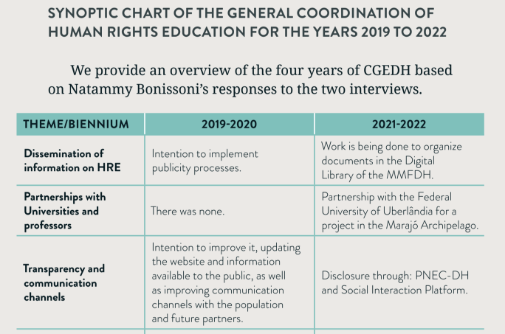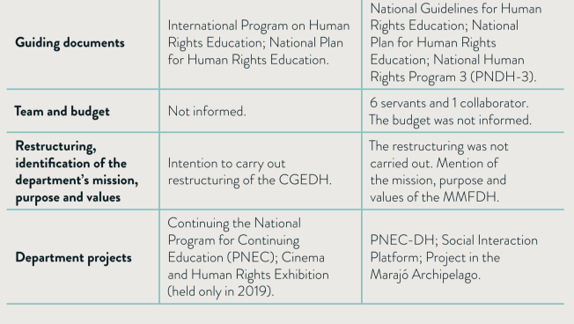
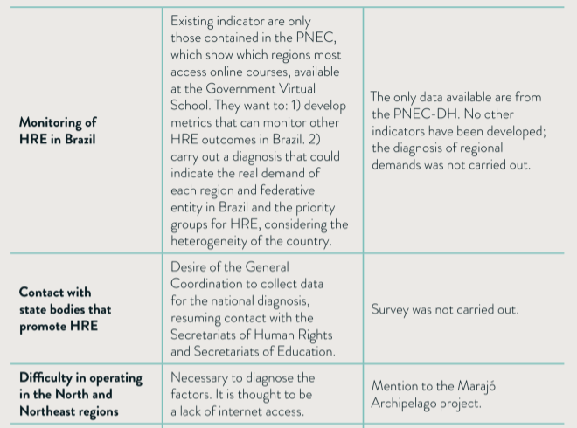
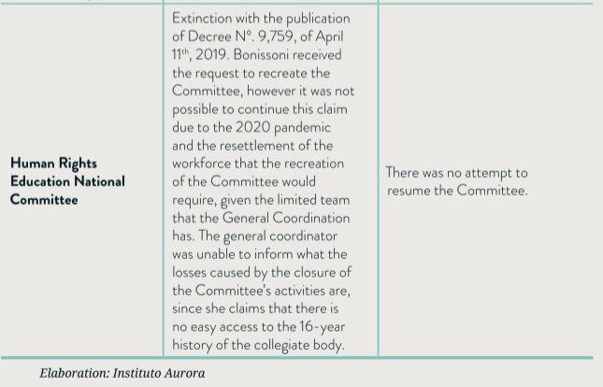
Source: An Overview of HRE: the biennium 2021-2022/ Aurora Institute

15. The lack of commitment at the federal level to the institutionalization of HRE public policy directly reflected the situation of the Brazilian states. At the end of 2022, at least 14 states, out of the 26 states and the Federal District, without a consistent HRE public policy. The criteria evaluated were: the existence of a government body responsible for the portfolio, the existence of a collegial body; existence of a guiding state document. The last criterion is highlighted here: by the end of 2022, 8 states had a State Plan for Human Rights Education, and another 5 states affirmed to be in the process of articulation or elaboration.
16. It was also possible to observe a notable difficulty in accessing information, which violates a principle of transparency concerning the commitment of public bodies to publish information about public policies' progress on their websites. The research revealed greater difficulty in collecting and checking data in the North Region. Of the 27 federative units, only 3 had easy access to information from their websites, and 7 had a reasonable level of access to information, with some information on the websites, but availability to obtain information by email or telephone.

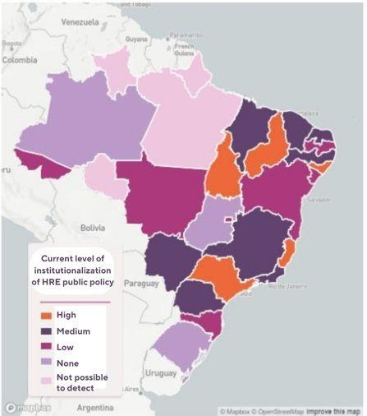
Source: Brazilian Human Rights Education Database/ Aurora Institute

17. In-depth research led by the Aurora Institute carried out with 34 public managers responsible for HRE portfolios from 22 federative units shows that half of them (11) mentioned the National Plan for Human Rights Education as a guide for their practices and only 5 mentioned the National Guidelines of Human Rights Education. Following this pattern, the expression “education in human rights” is present in only 11 State Plans for Education.
18. On the Human Rights Education concept adopted at the state level, there are multiple understandings from Northern to Southern Brazil, although there are convergences. It was possible to observe that the HRE is very much focused on demystifying and understanding what are human rights, with the intention of increasing respect for diversity. Therefore there is still an opportunity and a need for the HRE to be developed from the perspective of an education WITH human rights and FOR the promotion of a culture of human rights.
19. From the interviews taken, it was possible to verify how the practice of HRE addresses different themes according to each context, as well as the transversality with other agendas, especially those related to minority groups, as shown in the following table.

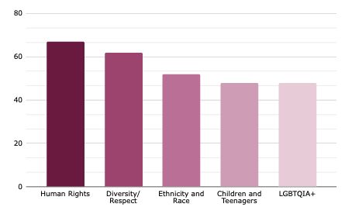

20. Considering this scenario, the new government faces many challenges in rebuilding the portfolio and updating it to overcome current needs. The following table helps to understand the steps taken in the first months of 2023 in a favorable direction for the HRE in an institutionalized perspective compared to the previous government.

HRE in the first six months of the current government
Lula Government | Bolsonaro Government
Reestablishment of Secadi, from the Ministry of Education (MEC)/ Return of HRE to MEC | Extinction of Secadi, from the Ministry of Education (MEC)/ HRE is no longer part of MEC
HRE portfolio is part of the ministries of Education and Human Rights | HRE portfolio restricted to the ministry of Human Rights
The HRE department leads dialogues with society and participates and organizes events on HRE open to the public. | Extinction of the University Pact for HRE and lack of partnerships with universities and professors specialized in the theme
Announcement of the plan to reestablish the National Committee for Human Rights Education and Culture. | Extinction of the National Committee on Human Rights Education (2003-2019).
HRE is considered a fundamental pillar of the Ministry of Human Rights. Planning for a National Plan for Digital Citizenship; proposal to confront violence in schools; and revision of the National Plan for HRE (2003). | It did not have specific propositions arising from the new government for the theme of HRE.
Planning of the 1st Seminar on HRE and Democracy, held in the 2nd semester, with the intention of drawing up a national diagnosis of HRE. | There was no national diagnosis.
Source: Aurora Institute

21. Regarding the first steps already taken and the symbolism of this year, 2023, in which is celebrated 20 years of the establishment of the National Committee for HRE (discontinued in 2019) and the release of the National Plan for HRE (the guiding document for this public policy), it's important to reinforce the existence of the document Charter of Proposals for HRE to the Brazilian Government, which contains 6 emergency requests on HRE in Brazil. This Charter was presented to the federal government in April 2023 and endorsed by 220 signatures (among individuals from the field, civil society organizations and social movements).
22. concerning all these challenges presented above and looking forward to better understanding the priorities Brazil should face in the next years, IDDH and the Movimento Nacional de Direitos Humanos (MNDH) organized during April and May of 2023, a public consultation with Brazilian HRE professionals asking for current challenges and potential priorities for HRE policies within the country. The consultation had the partnerships of UNESCO in Brazil and Rede Brasileira de Educação em Direitos Humanos (ReBEDH).

III. Public consultation on HRE

23. The public consultation on HRE was firstly organized to be submitted as a report to the OHCHR’s Campaign with views from different stakeholders on target sectors, focus areas, and thematic human rights issues for the fifth phase of the World Programme for Human Rights Education, which report will be presented during the 54th session of the Human Rights Council in September 2023.
Coordination: 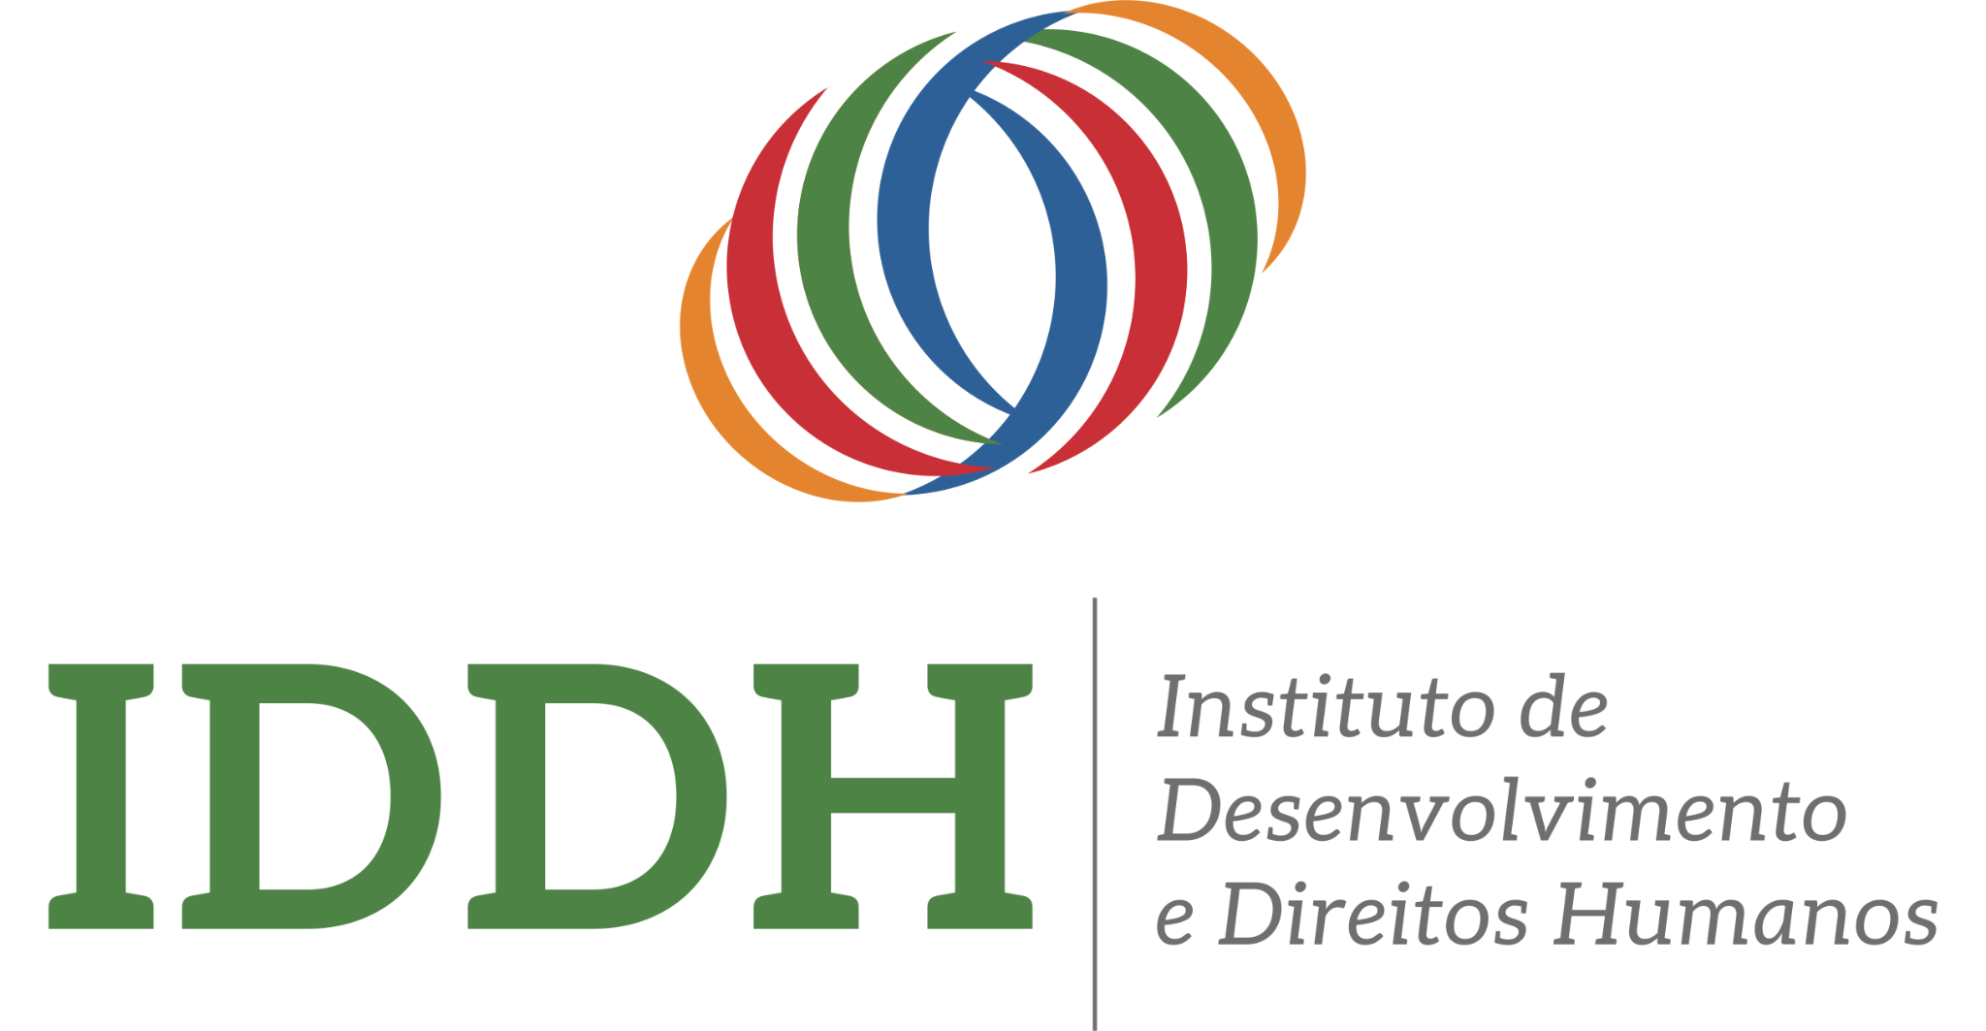
Partnership: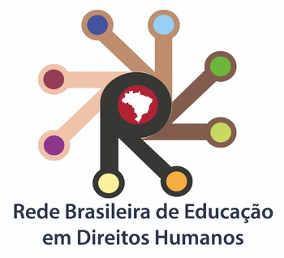 Institutional support: 

24. Public Consultation Context: From April 20th to May 15th, the public consultation listened to educational organizations and professionals focusing on human rights education about possible themes and priority groups for the 5th phase of the WPHRE.(2025-2029). The consultation was performed at the national level, through social media and ReBEDH disclosure, seeking to embrace all Brazilian states, and engaging formal and informal educators on human rights. Some results to synthesize the suggestions provided by the participants and sent to the Office of the High Commissioner for Human Rights as a contribution of the Brazilian civil society for the fifth phase of WPHRE:

25. Results: The Consultation received contributions from forty ReBEDH representative educators, of all levels and from 4 of the 5 regions of Brazil (Northeast, Southeast, Central-West, and South). The questionnaire asked the participants which could be potential target groups and human rights that should be prioritized for the fifth phase of WPHRE.

26. The following groups were suggested in their respective order of indications:
- Youth (19),
- Judiciary/Executive/Legislative professionals or Public officials (7),
- Scholars/Teachers (5), Health professionals (3),
- HRE promoters from social movements (3),
- Persons with disabilities (2),
- all answers (1).

27. Additionally, participants were asked to highlight the major challenges concerning HRE in Brazil:

- Prejudice towards LGBTQIA+, migrants, People of African Descent, indigenous peoples, and women;
- Invisibility and attention to the continuous diffusion and ongoing training for the utilization of digital media, also raising awareness about the lack of regulation of these vehicles of communication that disseminate fake conceptions concerning human rights;
- Social media disclosure of fake news, compromising democracy and the peaceful coexistence among socially diverse groups;
- Social invisibility of the less favored that require more knowledge about their rights and thus have them respected;
- Lack of public policies aiming to reduce social inequality, rendering a more extensive human rights education unrealistic for some sectors of society;
- Free individuals from radical and alienating ideologies that oppose human rights;
- Knowledge about the history of colonized countries and its direct impact nowadays for the population;
- Cope, based on the principles of human rights, with violence in schools and universities stimulated by extremist right-winged individuals and hate speech;
- Lack of human rights education in the foundations of the new Brazilian High School curriculum, especially in public schools;
- The resistance of Legislative and Executive representatives to the development of human rights-based agendas; and
- The impact of the climate crisis on vulnerable groups (relation between racism and climate migrants).

28. Moreover, some thematics and groups were highlighted in which States should take more into account when developing policies:

Thematics:
- Illiteracy;
- Human rights culture;
- Democracy in education;
- Social inequality;
- Discrimination;
- Hate speech;
- Quality of information;
- Racism;
- Digital media regulation;
- Education sector professionals’ appreciation;
- Police violence
- Media visibility.

Groups:
- Youth;
- LGBTQIA+;
- Migration and refugee;
- Women;
- Civil society participation;
- Persons with Disabilities;
- Homelessness;
- People of African Descent;
- Indigenous people;

29. The Consultation also questioned possible spaces of action for the fifth phase of WPHRE:
- Digital spaces (19),
- Schools/Universities (11),
- NGOs or Civil Society (6),
- Governmental organizations (4).

30. Conclusion and proposal: Based on the sample of the IDDH and MNDH’s Consultation results, the final report for the 5th phase of the WPHRE sent for the OHCHR addressed that the States should continue to focus on the Youth paying particular attention to the present challenges, such as the increased use of digital platforms and the growing wave of disinformation and hate speech that has heightened violence, especially against less favored social groups.

IV. Questions and recommendations

31. As current Brazilian State Representatives are highlighting at many official meetings that Human Rights Education is now a public policy, some questions remain:

- How does the Brazilian government intend to outline a strategy for updating and subsequent monitoring and evaluation of the HRE public policy for the coming years, given that 20 years after its main milestones, the main public policy, National Plan on HRE, has not yet been updated or monitored and evaluated?

- How does the Brazilian government intend to outline a strategy for institutionalizing the HRE public policy, creating conditions for states that still do not have any level of institutionalization (no specific government body for the subject, no collegial body, no state guiding document) to meet at least one of these criteria?

32 Taking into account all the information presented above, IDDH and Instituto AuroraI would like to suggest some recommendations to the Brazilian State:

a) Brazil should rebuild the National Committee on HRE, this time to a specific law, to not be subject to extinction in case of future changes in government, as happened with the former National Committee for Human Rights Education (CNEDH);
b) This CNEDH should be responsible for the revision of the National Plan on HRE (PNEDH), to include action plans, with responsible bodies, budget, monitoring indicators and improving its transparency aspects;
c) Brazil should highlight in this National Plan on HRE specific obligations to respect and fulfill all international human rights recommendations and decisions from the global and regional systems, integrated and coherent with the National Mechanism for Reporting and Follow-up, that Brazil says is developing;
d) The State must include combating all manifestations of violent extremism and radicalism in HRE public policy guidance documents.


Fernanda Brandão Lapa
Executive Director
flapa@iddh.org.br

Movimento Nacional de Direitos Humanos (MNDH), network that unites hundreds of organizations that work on Brazilian territory for over 40 years, aims to organize communities and articulate institutions to promote and defend human rights and democracy. The organization focuses on formulating and overseeing the implementation of human rights public policies. Actively participated in national conferences and the elaboration of the National Education of Human Rights Plan (Plano Nacional de Educação em Direitos Humanos). MNDH has a powerful presence in many mechanisms of the international protection of the human rights system.
ReBEDH is a non-profit, non-partisan and supra-religious civil society organization for articulation and cooperation between people, groups, social movements, civil society entities and institutions that work in Human Rights Education. Website: https://www.rebedh.com.br/

