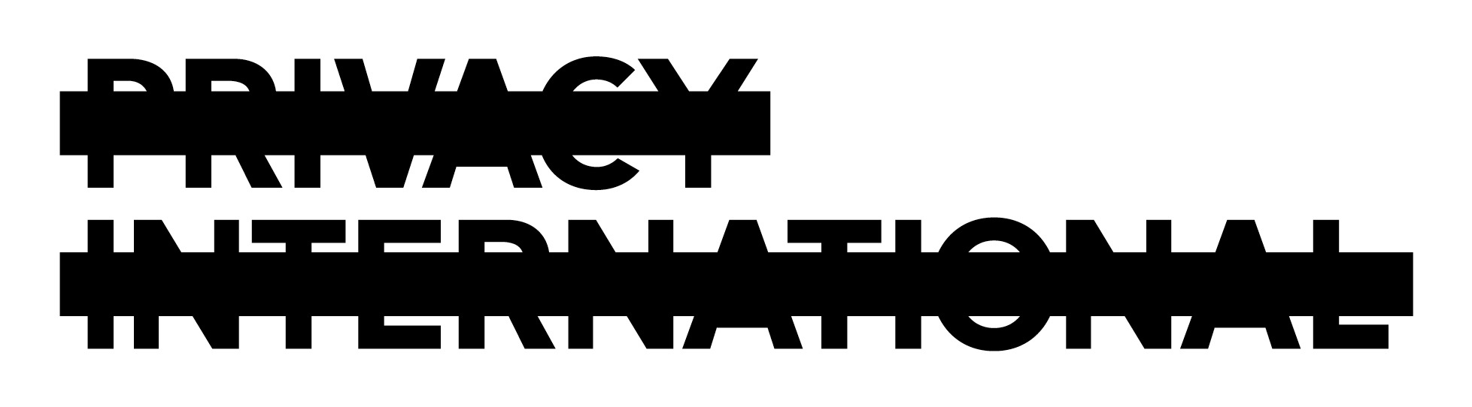

Suggestions for privacy-relevant questions to be included in the
List of Issues on Uzbekistan, Human Rights Committee, 112th Session

The right to privacy
The right to privacy is protected under Article 17 of the International Covenant on Civil and Political Rights. Article 17 provides for the right of every person to be protected against arbitrary or unlawful interference with his privacy, family, home or correspondence as well as against unlawful attacks on his honour or reputation.
Any surveillance activity, including the interception of communications, is an interference with the right to privacy and can only be justified if it is in accordance with the law, has a legitimate objective and is conducted in a way that is necessary and proportionate. The aim of surveillance activities must not be to target political opponents and human rights defenders, or to suppress the right to freedom of expression. Surveillance activities must only be conducted when they are the only means of achieving a legitimate aim, or when there are multiple means, they are the least likely to infringe upon human rights.

Uzbekistan is failing to uphold the right to privacy
Government surveillance and control over the internet infringes on the right to privacy and the right to freedom of expression. The government of Uzbekistan has systematically put in place laws, policies and structures that ensure control over the internet and employs extensive surveillance measures to monitor the population of Uzbekistan. The state-owned telecommunications network, private internet service providers, and mobile phone companies are required to assist the security services in intercepting citizens’ communications and accessing user data. Due to a provision in the Law on Telecommunications that prohibits service providers from disclosing details on surveillance methods, there is no transparency on the number of government requests and the extent of assistance provided by companies.
There is a widespread use of “spyware” (malicious software that can, for example, monitor a user’s internet activity and track websites visited) in cyber cafés, which are patrolled by security service agents. The communications and online activities of political activists have been especially targeted by the intelligence services. There are reports of political activists’ personal emails and social media pages being hacked and claims of people who have posted controversial content being beaten or arrested. Knowledge of the security services’ surveillance activities has caused fear and resulted in self-censorship by activists and journalists, as well as the wider internet community. Sensitive issues relating to human rights and politics are avoided, which significantly limits public discourse on these topics.
In December 2012 Uzbekistan became the last country of the former Soviet Union to adopt a law on surveillance activities, which had previously been largely unregulated. The law on “Operational and Investigative Activity” fails to provide necessary protections against arbitrary interference with the right to privacy and the right to freedom of expression. In particular, there is no system of independent oversight, heightening the risk that surveillance powers will be abused and unlawful interception will occur, and enabling the intelligence services to operate outside public scrutiny; additionally, surveillance activities are not subject to judicial authorisation and there is no notification regime.

Based on these observations, Privacy International proposes the following questions for the List of Issues:
Articles 17 and 19
- What laws, policies and practices are in place to ensure that communications interception, as well as all other forms of surveillance, are only conducted in pursuit of a legitimate aim, and are conducted in a way that is necessary and proportionate? Are there any public or internal codes that restrict the discretion of the secret services in the interception of communications and online activities?
- What measures have been taken to ensure accountability for unlawful surveillance and transparency about the operations of the intelligence services? What measures are being taken to provide for independent oversight over the surveillance operations conducted by the intelligence services?
- What policies and laws are in place to ensure free use of the internet? What measures have been taken to enable anonymous online communication and participation?

Human Rights Committee General Comment 16, para. 8 ; see also Malone v United Kingdom (1985) 7 EHRR 14 [67].
See, International Principles on the Application of Human Rights to Communications Surveillance, available at https://necessaryandproportionate.org

