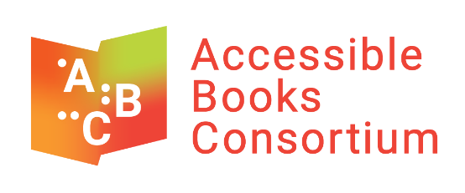

Statement of the World Intellectual Property Organization (WIPO)
32nd Committee on the Rights of Persons with Disabilities
Geneva, March 3, 2025

The World Intellectual Property Organization (WIPO) is the United Nations specialized agency that administers the Marrakesh Treaty to Facilitate Access to Published Works for Persons Who Are Blind, Visually Impaired or Otherwise Print Disabled. This humanitarian treaty allows for both the production and exchange of accessible books across national boundaries for the benefit of people who are print disabled.

This treaty was adopted in Morocco in 2013 and as of today, 125 countries have joined the Treaty, with Colombia depositing its instrument of ratification just last week.

The Accessible Books Consortium (ABC) is a public private partnership led by WIPO that seeks to deliver books in accessible formats around the globe by implementing the objectives of the Marrakesh Treaty at an operational level. It includes the World Blind Union; libraries for the blind; the DAISY Consortium and organizations representing authors, publishers and collective management organizations.

ABC celebrated its 10th anniversary last year. We are proud to mark a decade of action and delivery of accessible books in braille, audio and e-text for people with print disabilities around the world.
As WIPO’s Director General recently stated, ABC’s mission is simple but far-reaching: to breathe life into a legal framework, to turn aspiration into action, and to get accessible books into the hands of those who need them.
ABC meets its goals through three main activities:

ABC Global Book Service
Ten years ago, ABC had 11 participating libraries for the blind, and around 200,000 accessible titles in the ABC Global Book Service, which is an online catalogue of accessible books. We now have 145 participating libraries for the blind, with more than half located in low-income countries, and over one million titles in 80 languages, all available for cross-border exchange under the framework of the Marrakesh Treaty. Participating libraries for the blind delivered a total of 225,000 accessible format books from the ABC catalogue to persons with print disabilities in 2024.
The ABC catalogue will soon be made available through Dolphin EasyReader, a free reading app, to people who are print disabled who are living in countries that have both ratified and implemented the Marrakesh Treaty.

Training and Technical Assistance
The ABC model for training and technical assistance aims to equip organizations in low income countries with the ability to produce educational materials to be used by primary, secondary and university students who are print disabled. ABC provides training in the latest accessible book production techniques through an online platform that incorporates interactive sessions with expert trainers.
Once participants complete the ABC Online Course in Accessible Book Production, ABC provides funding to the partner organization so that its personnel can utilize their recently acquired skills to produce educational titles in accessible formats for students who are print disabled.
Through ABC’s training and technical assistance 22,000 textbooks have been made accessible in over 40 countries, improving access to education for thousands of young people.

Accessible Publishing
ABC promotes the production of “born accessible” works by publishers, i.e., books that are usable from the start by persons who are print disabled. In particular, all publishers are encouraged to include descriptions of the accessibility features of their products in the information they provide to distributors, retailers and others in the book supply chain.
Within the context of the European Union’s Directive on accessibility, ABC continues to collaborate with rightsholders to maximize awareness amongst publishers and distributors of the need to comply by June 28, 2025 with the respective national provisions implementing the Directive’s accessibility requirements for digital publications.

Future work
While the Marrakesh Treaty remains the fastest growing treaty at WIPO, there is still much work to be done. Ratifying the Treaty is but the first step, what is critical is that the provisions of the Treaty need to be transposed into national law, so that people who are blind or otherwise print disabled can fully benefit from the treaty.
Many people who are print disabled cannot search and downloading accessible books from the ABC catalogue because they live in countries that have either not ratified the Treaty or have ratified, but not implemented, the provisions into national law.
WIPO is ready to work with Member States to have them join the treaty or provide legislative advice for implementation of the provisions into national law. ABC is also ready to speak to partners who may wish to benefit from ABC activities.
For further information, please contact Accessible.Books@wipo.int

