(b) Child marriage;
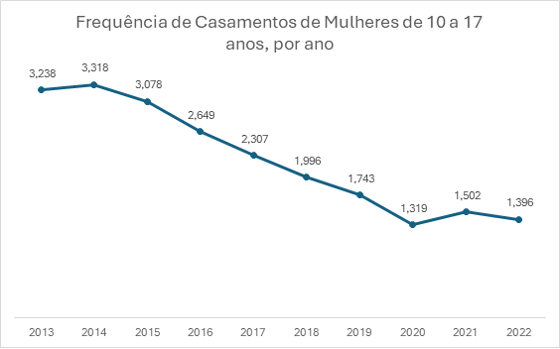 Source: IBGE - Civil Registry Statistics Survey

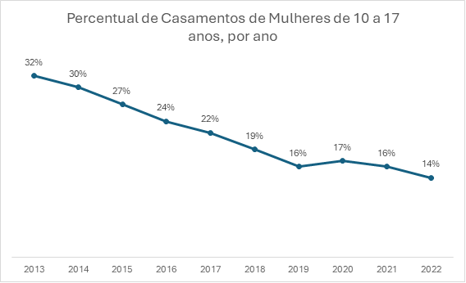Source: IBGE - Civil Registry Statistics Survey

(c) Child and adolescent victims of disappearance;
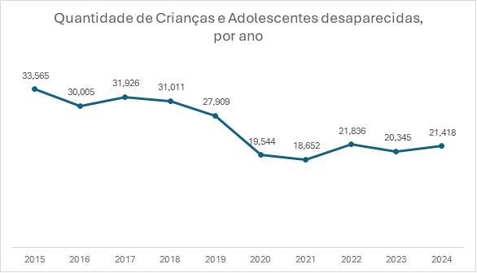 Source: National Registry of Missing Persons (CNPD).

(d) Child victims of police violence;
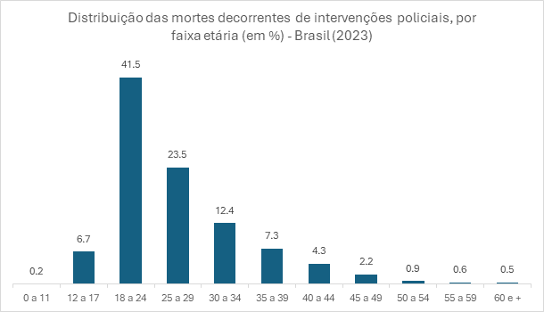 Source: Analysis based on microdata from police records and State Secretariats of Public Security and/or Social Defense. FBSP, 2024.

(e) Child victims of torture or other cruel, inhuman or degrading treatment or punishment and the number of such cases reported to the authorities, and on the number of prosecutions of perpetrators and their punishments;
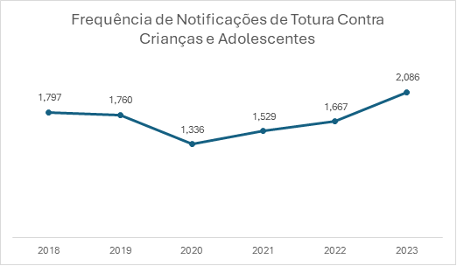
Source: Information System for Notifiable Diseases – Sinan
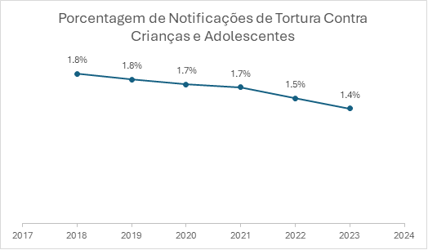
Source: Information System for Notifiable Diseases – Sinan

(f) Children who committed suicide and self-mutilation;
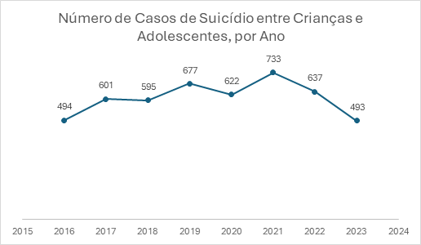
Source: Information System for Notifiable Diseases – Sinan

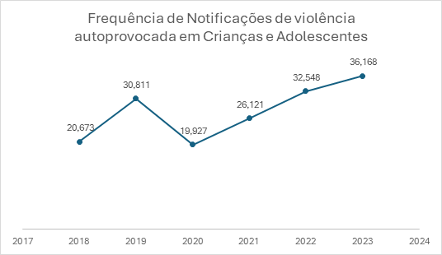
Source: Information System for Notifiable Diseases – Sinan

(g) Child pregnancy;
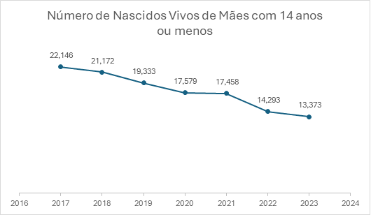
Source: Live Birth Information System (SINASC)
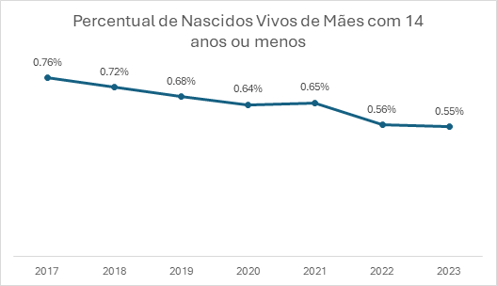
Source: Live Birth Information System (SINASC)

Children living with AIDS


