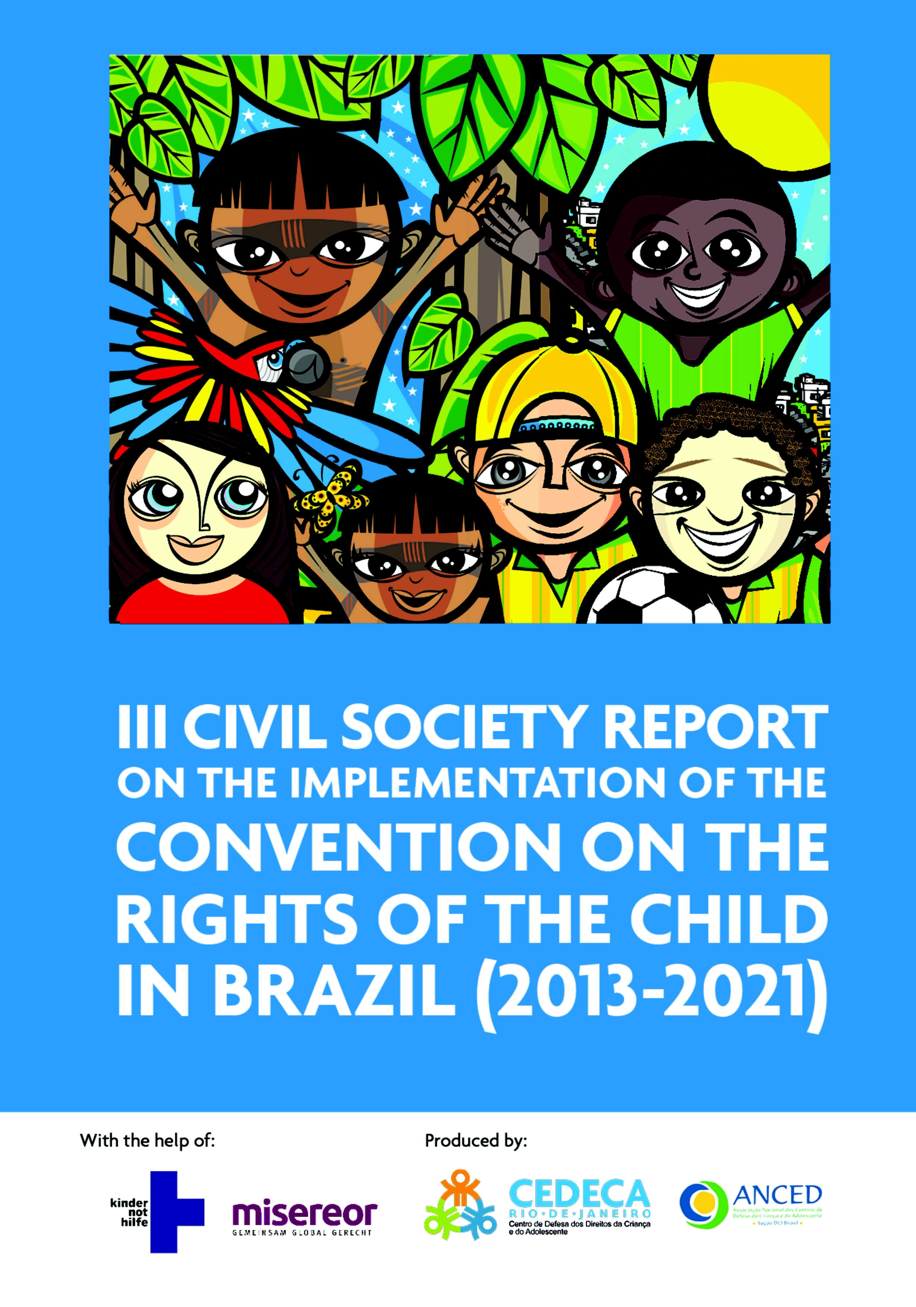

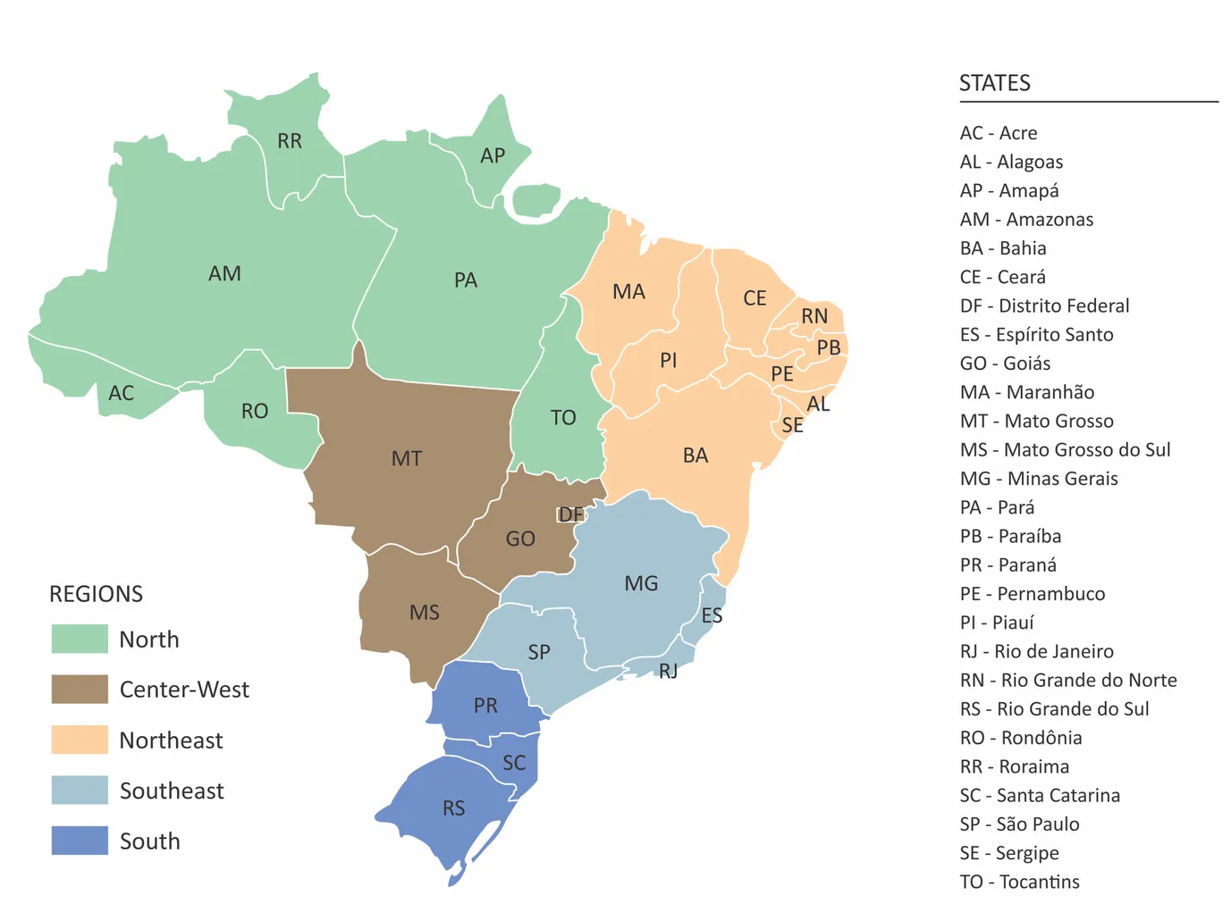

SUMMARY

INTRODUCTION………………………………………………………………………………………………………………………05
1. GENERAL MEASURES OF IMPLEMENTATION AND GENERAL PRINCIPLES…………………………………06
1.1. Principle of the right to life, survival and integral development: multidimensional poverty in Brazil….….06
1.2. Principle of non-discrimination: Brazilian childhoods………………………………………………………………………………….08
1.2.1. Girls…………………………………………………………………………………………………………………………………………………….09
1.2.2. Indigenous childhoods……………………………………………………………………………………………………………………….09
1.2.3. LGBTQIA+ Childhoods……………………………………………………………………………………………………………………….10
1.2.4. Children living on the streets ….……………………………………………………………………………….………….………...10
1.2.5. Children who live in vulnerable territories: slums, public security and human rights……….………… 11
1.2.6. Children in a migrant situation or migrants……….…………………………………………………………………………….12
1.2.7. Institutional sheltered children………………………………………………………………………………………………………….13
1.3. Principle of the best interest of the child: public policies
(administrative, legislative and budgetary measures) ………………………………………………….………………………….15
1.3.1. Child budget: reduction policies……………………………………………………………………………………………………….15
1.3.2. SGDCA: challenges and possible solutions ........…………………………………………………………………………….16
1.3.2.1. Garantee system for the rights of children who are victims or witnesses to violence .….16
1.3.3. National Plan for the Human Rights of Children: the implementation of the “Ten Year Plan”…….17
1.3.4. The business sector: impact on children’s rights……………………………………………………………………………17
1.4. PRINCIPLE OF THE RIGHT TO PARTICIPATE……………………………………………………………………………………..……….18
1.4.1. Children’s Hearing: The Judiciary………………………………………………………………………………………………………18
1.4.2. Protagonism: participation of children in society……………………………………………………….…………………….19

2. VIOLENCE AGAINST CHILDREN ………………………………………………………………………………………….20
2.1. VIOLENCE AGAINST LIFE: INTENTIONAL VIOLENT DEATH (IVD)....…………………………………………………………20
2.2. Sexual violence…………………………………………………………………………………………………………………………………………….21
2.3. Mistreatment, negligence and bodily injury in the framework of domestic violence…….…………….……………23
2.4. VIOLENCE, MINORITIES, CHILDHOOD AND YOUTH..…………………………………………………………………………………24
2.4.1. Indigenous peoples……………………………………….……………………………………………………………………………………24
2.4.2. Negros……………………………………………………..…………………………………………………………………………………………25
2.4.3. Girls…………………………………………………………………………………………………………………………………………………….25
2.5. Conclusions and recommendations………………………………………………………………………………………………………………26

- HEALTH AND WELLNESS 27
  - Hunger and food insecurity 27
  - Child malnutrition and obesity 28
  - Vaccination 29
  - MENTAL HEALTH AND CHILDHOOD 30
  - USE AND ABUSE OF ALCOHOLIC BEVERAGES AND OTHER DRUGS……… 31
  - Water and sanitation 32
  - Sexual health: sexual and reproductive rights 32
  - Children with disabilities 32
- EDUCATION AND CULTURE 34
  - Federal regulatory framework in the pandemic context 34
  - EDUCATION FINANCING: EXPENDITURE CEILING AND FUNDEB 34
  - Homeschooling: a non-policy 34
  - EDUCATIONAL DATA MANAGEMENT 35
  - ANALYSIS OF THE BASIC EDUCATION DEVELOPMENT INDEX (IDEB) 35
  - School evasion: a multicausal problem 36
  - RURAL SCHOOLS 36
  - Recommendations and notes 37
- ECONOMIC EXPLOITATION 38
  - THE SOCIAL AND ECONOMIC DEPROTECTION OF FAMILIES AND THE EXTENSION OF POVERTY AND CHILD LABOR IN BRAZIL 38
  - Official Report and Alternative Report: the setback in the
policy to eradicate child labor in Brazil 39
    - III Child Labor Eradication Plan – PNETI (2019 – 2022): 39
    - Budget 40
    - Illegal business and indigenous people in the north of the country 40
  - Recommendations 41
- JUVENILE JUSTICE 42
  - THE NATIONAL CONGRESS AND THE LOWERING OF THE CRIMINAL AGE 42
6. 2. SINASE - APPLICATION AND IMPLEMENTATION OF SOCIO-EDUCATIONAL MEASURES 43
6.2.1. Adolescent Profile 43
    - THE JUSTICE SYSTEM AND CHILDHOOD 43
    - THE SYSTEM FOR IMPLEMENTING SOCIO-EDUCATIONAL MEASURES 44
      - Management 44
      - Financing, structure and services 44
      - Health and education 44
      - Repeat Offenders 45
  - The dismantling of socio-educational policy and budget execution 46
  - Recommendations 46
ANNEX 1: Participatory report on children’s rights in Brazil .......................................................................................... ANNEX 2: Partnerships………………………………………………………………………………………………………..………48

INTRODUCTION

This III Alternative Report covers the period 2013-2021, marked by political events that affected the country’s institutions, such as the demonstrations in June 2013, the presidential impeachment in 2015, the illegal arrest of the then presidential candidate in 2018 and the rise of the extreme right, from 2019 to 2022. The pandemic, whose greatest power occurred in 2020 and 2021, deepened the crisis already in place, with repercussions on the implementation of human rights, including those of children.
In this differentiated context, permeated by so many challenges, this report was conceived, which comprises seven thematic areas related to children’s rights: general implementation measures, general principles, health and well-being, education and culture, economic exploitation, violence and juvenile justice. These are themes integrated into the legal norms that regulate the rights of children, such as the CDC and the ECA. In addition to the rights provided for in the CDC, ECA and other rules applicable to the country, the content of the Recommendations issued in 2015. The choice of topics reported was made by civil society organizations, and the violations portrayed based on reliable data, from public institutes and civil society.
In this III Report we sought to face challenges such as regional disparities, socioeconomic and cultural inequalities that particular to Brazil, as well as to give visibility to the different “childhoods” that live in the country, in order to reveal violations, denaturalize oppression and injustices, in order to contribute to inclusive human and social development in the country.
O Participatory Report on the Rights of Children Organized by Civil Society, prepared by testimonies of children in various states and regions, is attached to this III Report, for which we intend to contribute to the exercise of the right to participation, and to the understanding of children’s rights as a whole, and the best way to implement them in our country.

GENERAL IMPLEMENTATION MEASURES AND GENERAL PRINCIPLES
CDC:
Articles 2, 3, 4, 6, 12, 42 and 44(6)
Recommendations (2015): 6, 8,
10, 16, 22, 24, 26, 28, 30

  - Principle of the right to life, survival and integral development: the
multidimensional poor in Brazil

The vulnerability of the child to the violation of rights is related to that of the adult, on whom he is dependent and must be understood from the perspective of his integral subjective development, in all its dimensions, material and immaterial, and also to the family and social group to which he belongs.
Therefore, in order to assess the effectiveness of the rights that comprise the integral development of the child, we supported our analysis on the concept of multidimensional poverty, whose indicators include access to material goods and quality of life such as being well nourished, being in good health, having a reduced threat of premature death, as well as more complex goods such as happiness, self-respect, feeling like a member of a community or decision making.
The conception of multidimensional and not unidimensional poverty must lead to appropriate state responses to the effectiveness of rights for the population in general, and, especially, for the most vulnerable, such as children.
However, in this section, we begin by analyzing this theme from the point of view of unidimensional poverty in the country, for the population in general, according to international parameters associated with per capita income due to its relevance for access to the satisfaction of human rights, such as food and housing, among others.

As for the age group most affected by poverty, according to official data gathered by Unicef, among the entire Brazilian population, poverty is higher among children. In 2019, it reached 63.1% of the population aged 0 to 17 in the country, a percentage that corresponds to 32 million children, out of a total of 50.8 million. In this group, in 2021, 64.8% of children aged 0 to 6 years lived in 40% of the poorest households in the country, while 4.4% lived in 10% of the richest households. The variation between 2013 and 2021, according to the research, reveals an increase from 41.1% in 2013 of children aged 0 to 6 years living in poverty, to 44.7% in 2021. Of these, 12.7% are in extreme poverty (against rates of 28.3% and 8.2% for the general population, respectively).

Studies on the subject follow the lines suggested by the World Bank and indicate that the contingent of people with per capita household income up to R$497 per month or US$5.50 per day, reached 62.9 million Brazilians in 2021, around 29.6% of the country’s total population. This figure in 2021 corresponds to 9.6 million more new poor people than in 2019 that emerged during the pandemic. The study points out that poverty has never been as high in Brazil as in 2021 since 2012. Of this total, there are 5.4 million for the US$ 3.20 line and 3.4 million for the US$ 1.90 line. In 2019, the percentage of the population included in this line was 27.4 % and in 2021, it was eq u al to 29.6%.
Poverty is concentrated in the states of the North and Northeast regions of the country, a situation that has not changed over the last decade. While states in the North and Northeast have poverty rates around 40% to 50% of the population, without major variations between 2013 and 2021, states in the South and Southeast have rates that vary between 10% and 20% of the population.
In 2021, more than half (50.2%) of children under 14 lived in households with monthly per capita income up to half the minimum wage. In absolute numbers, we are talking about 22,326,889 million children.
It appears from these data that child poverty is greater than the average poverty of the population, in 2021, given that this is 1.57 times general poverty and that child poverty levels exceed the general population figures by more than 50%.
In a brief mention to the racial issue, the survey informs that among black children, the poverty rate was almost 68% higher than that of white children and for extreme poverty it was almost twice as high, 98% higher. In 2013, 4.6% of white children aged 0 to 6 years and 12.3% of black children lived in extreme poverty, and, in 2021, 8.2% of white children and 16.3% of black children were living in this group, revealing a substantial increase and deepening of racial inequality in this domain, which constitutes a profile for the greatest victim of poverty in the country, which is the black or black child.
Child poverty for the 0-6 age group follows the trend of the general population with some percentage particularities, concentrated in the North and Northeast regions of the country, without variation from 2013 to 2021, but increasing. As for location, the poverty rate for children living in rural areas was 69.7%, against 40.2% for those living in urban areas in 2021, while the aggregate rate for all was 44.7%.
During the pandemic, during the duration of the Emergency Aid, in 2020, the child poverty rate, which was 41.5% in 2019, fell to 36.1% in 2020, and rose again to 44.7% in 2021, given the interruption of this policy.
The deprivation of financial resources, which is one of the many dimensions of poverty, is associated with the deprivation of fundamental rights, based on official data from 2015. In addition to family income, access to six fundamental rights is contemplated: education, information, water, sanitation, housing and protection against child labor. The absence of one or more of these rights configures a state of “multiple deprivations”.
The data reveal that 61% of Brazilian children are poor, either because they are in families that live with insufficient income – monetary poverty – or because they do not have access to one or more rights. The deprivation that most affects this group is sanitation (13.3 million), followed by education (8.8 million), water (7.6 million), information (6.8 million), housing (5.9 million) and protection against child labor, with 2.5 million children directly affected.

The association between education and poverty is linked, like other rights that children are deprived of, in a way that creates a repetitive cycle that feeds and reproduces itself. In families of children below the poverty line, the reference adult had an average of 8.8 years of schooling (against 11.9 in families above the poverty line). Also, the percentage of reference adults with completed the school education cycle was 35.9% (against 71.3% in families above the poverty line).
Despite the number of deaths of children under one year of age from preventable causes decreasing over the years, having gone from 46,490 in 1999 to 23,212 in 2019, Brazil is far from meeting National Target 3.2 of the SDGs. Regional differences and the concentration of deaths from preventable causes suggest that the achievement of Target 3.2 is still far away, even in 2022.
We also highlight, in light of this principle, Brazil is a high-risk country with regard to exposure of children to climatic and environmental shocks: almost 60% of children in the country are exposed to more than one of the risks analyzed in the study. In absolute numbers, there are more than 40 million children.
Finally, and based on these data, the following is recommended:
- racial inequality: public policies are implemented that face the greater exclusion of black children and families, especially in the North and Northeast regions, as they are more affected by multidimensional poverty, with emphasis on access to water and basic sanitation;
- families: due to the dependence of children on adults, in particular their families, it is necessary to develop public policies for the population in general;
- indigenous peoples: specific studies are needed, not merged with the black segments;
- budget: include children as a priority group in the planning of the Union’s spending budget.

  - Principle of non-discrimination: the Brazilian childhoods

Official data on childhood in Brazil for 2020 indicate that the population of children aged 0 to 17 comprised 61,536,644 million in a universe of 210,727,174 million residents in the country.
In addition to measuring the child population in numbers, which comprises almost 30% of the population in the country and in the states, we understand that it is important to collect data on the vulnerabilities created by the needs of the childhoods in Brazil, with a view to access to rights, both for each municipality, state and region, as a result of their identity, social situation, housing, family, health, cultural and economic situation. From these data, a policy can be constructed for all Brazilian childhoods, which includes the identification of social markers, such as class, gender, sexual orientation, race, ethnicity, territory and other conditions of social and economic belonging.
As for the gender issue, the variation is one percentage point, which is insignificant: in 2018 and 2021, the percentage distribution was equal to 48.9% of men and 51.1% of women in the country.

In relation to race and ethnicity, there is a predominance of blacks (classified as blacks and browns) as a pattern since 2018, for the population, around 58%, as in 2021, 57.8%, contingent that resides the majority, in the regions North, 79% and Northeast, 74.7%, Midwest, 62.5%, followed by the Southeast, 48.7%, South, 25.8%. The study points out that administrative records, such as schools and hospitals, are dissociated from research classifications, such as those mentioned.

Therefore, it is recommended that a single national classification system for color and race by age group be developed for the country.

    - Girls

Social organizations point out that the federal government (2019-2022) undermined the effectiveness of girls’ rights because the country lives under an anti-gender ideology as government policy. There are at least 21 laws that directly or indirectly prohibit education on gender and sexuality in force in Brazil, one state and 20 municipal.

During this period, black girls began to assume more domestic responsibilities and were the ones who had less access to pedagogical didactic material and 8% of girls dedicated at least 6 hours to studying, while 15% of boys did. Of the children aged 14 to 17 who presented themselves as the “heads of the family”, 75.7% were black and 24.3% were white. Black girls spent 72% of their time caring for other people and white girls spent 27.5% of their time.
For that, the Special Rapporteur on the rights of indigenous peoples, on his mission to Brazil (2016), recommended particular and urgent attention to the situation of indigenous children, youth and women, especially in relation to the alarming suicide rates in indigenous communities, the increase in violence against indigenous women and the illegal adoption of indigenous children. It was also highlighted that sexual violence in this population is often underreported and women and girls are the target of conflicts over land appropriation.

    - Indigenous childhoods

The Inter-American Commission on Human Rights has classified how serious the situation of the indigenous peoples and communities of Brazil is. According to official data, from 2018 to 2021, 3,126 deaths of indigenous people were recorded, with about 72% of babies under one year old.
Proportionally, in Brazil, children of indigenous mothers are 98% more likely to die from preventable causes, when compared to children of white mothers. According to data from
the National Food and Nutrition Surveillance System, in 2021, only 9% of indigenous children aged between two and four years had at least the three main meals of the day.

    - LGBTQIA+ Childhoods

There is a disregard for the production of data for the LGBTQIA+ population, most of which are produced by non-governmental institutions. Between 2000 and 2021, 5,362 LGBTQIA+ people died in the country. In 2021, 316 deaths were recorded. Of this total, 6.96% were between 10 and 19 years old.
Although sexual orientation reversal methods are prohibited by the CFP since 1999, in Brazil, sexual and gender conversion tactics still exist and most are carried out against the will of children, causing immediate or long-term physical and mental harm.

In the field of education, 27% of adolescent students who attended the school environment claim to have been bullied at school, 48% often heard LGBT-phobic comments and 73% were verbally abused, according to research in 2016.
Schools without Homophobia, identified good practice for this Committee project, came to be classified as a “Gay Kit” by religious neoconservatives and right-wing political actors in the country, as it became notorious on social media.

    - Children living on the streets

The last data survey was carried out in 2010 and identified 23,973 children living on the streets, the majority composed of working children, family-based, male, black, aged 3 to 17 years, concentration between 12 and 17 years. Given this contextual framework, we reiterate some conclusions and recommendations from civil society:
- Data: a National Census of Children living on the streets should be carried out by official nationwide institute.
- Vulnerabilities: street children in the Midwest and North regions accumulate conditions of vulnerability due to belonging to other minorities such as migrants and indigenous people and, therefore, attention to this situation is recommended in public policies to be developed in the country.
- Protection policies: the Union, states and municipalities must jointly develop urgent policies for the reduction and protection of the homeless population, children and their families, suitable for the following groups, in particular:

  - Child street workers,
  - Homeless / runaway children
- Education: a study is recommended on the school trajectories of street children, and measures that promote public school insertion.
- Financing of public services: education, assistance for access to rights, primarily in education, inclusion and active school search.

    - Children who live in vulnerable territories: slums, public security and human rights

The invisibility of favela children is doubled and stems from two factors: territorial, resulting from the State’s negligence in promoting rights to residents of these areas, and self- perception as people excluded from society, devoid of the ownership of rights by the social actors and institutions with which they coexist with.

It is argued that invisibility is perpetuated by the absence of data on these territories, which prevents the planning of public policies. There is a flagrant deficit of data on populations living in favelas. The available demographic information about childhood is included in the IBGE platforms, where few favelas are catalogued, with the exception of the very populous ones, which are classified as neighborhoods. The available data, however, are not stratified by neighborhoods, points out the study.
Many of these violations are silenced and hidden within their families, communities and institutions in the country, not only because of the lack of data, but because of the stigma that falls on these populations. The negative, marginalized self-perception feeds a chain of silencing and naturalization of violence against children and their families.
Some recommendations emerge from studies, such as:
- The role of schools: not only, but especially in favelas, the school must be integrated with public protection services for the referral of cases in which they are identified as necessary.
  - Own school model: the school in the favela must be adapted to its various structural problems, public security and social protection and include families that may need social assistance, as well as professionals with adequate training, and operate full time, so that the State can provide greater assistance.
- Planning and construction of schools and kindergartens: the inclusion in the planning of municipal policies and budgets is a recommended measure for this purpose, in conjunction with the Departments of Education and Public Security.
- Emergency situation and priority: in addition to assuring places for everyone, the school must promote the maintenance of the child in school and offer quality education on an emergency basis, due to the current context of insecurity and evasion.
- Training and protection: special training for professionals working in territories affected by armed conflicts and protection should be promoted.
- Health equipment: professionals, families and students from schools in areas of armed conflict must have access to free mental health care.
- Integration of the school community: measures must be taken to integrate education professionals, families and students into the educational project, affirming the importance of education for building a better future for all. Topics such as children’s rights, the importance of listening and the legitimacy of their speech, fear of communicating, teenage pregnancy, child protagonism and the importance of family interactions that do not involve violence should be included in integration activities.
- The inclusion of the population of these slums and conflict territories in the population census that promotes access to data that provide public policies consistent with the needs of these groups.
- Necessary preventive and protective measures must be taken to pacify these territories and, while this is not achieved, protect children who live there.

    - Children in migration situation or migrants

In Brazil, according to official data on regular migration, the population of migrant children is 16% of the resident migrant population, close to the world average, 14%. This share in the country has been increasing, from 5.5% in 1990 to 16% in 2019, which goes against the global trend, for causes, such as the Mercosur residence agreement, the bilateral agreement with Bolivia in 2005 and the migratory amnesties of 1988, 1998 and 2009, aligned as factors that may have favored family migration.
In the national panorama, the risk of exposure to situations of exploitation and violence due to the situation of movement stands out, especially when children are separated from their parents or unaccompanied and undocumented.
There was a change in the immigration legislation in the country in 2017, by the Brazilian Law of migrations. However, the application for a humanitarian visa for young children faces obstacles related to the required documentation, which is frequent in the community of Afghans residing in the country. and goes against the principle of the best interest of the child, in the form of General Comment Nr. 22 of this Committee, which declares (it is) the responsibility of States for children who are not yet in their territory.
Data collection, also on migrant children, as recommended by the Committee, is insufficient, as it does not include all the rights they are entitled to. In this sense, the study concludes and recommends:
- Appropriate measures for full protection of the child in all phases of the migratory cycle is due, even before the child arrives in Brazil, in the form of international guidelines and standards, such as OC nr 21 of the Inter-American Court of Human Rights, 2014.

- Data collection on migrant children, including those unaccompanied and separated from guardians, with a diagnosis of cases of violence and risk to which they are subjected.
- Regularization of migrants in irregular situation, in particular children and their guardians, with special attention to children in refugee situations.
- Training of professionals who work with children, on issues related to migration and refuge, with special attention to child counselors.
- Education: develop and disseminate good practices in integrating migrant children into school, including assessing prior knowledge and grade assignment, ensuring adequate funding so that schools can provide a quality education for all children, training education professionals to deal with diverse and multilingual classes.

    - Institutional sheltered children

The right to family and community coexistence for children who are at risk is supported by Law nr. 12.010/2009, which regulates the reception system in a way that meets the principles and rights of the CDC and ECA, giving priority to efforts to strengthen the bonds with the natural family.
We reiterate the importance of the legal framework relating to the matter, the National Plan for the Promotion, Protection and Defense of the Right of Children to Family and Community Coexistence of 2006 and the National Social Assistance Policy 2004, which places the family at the center of social policies for this purpose. The reorganization of reception services according to these norms is still a project under construction.
In this section, we intend to bring analyses and data on the impact of this new legal paradigm on the Brazilian reality, with effects on reception services, in 2013 and in 2020, throughout the corona virus pandemic.
The survey, concluded in 2011, comprising 2009 and 2010, after the period portrayed in the last Alternative Report, after the visits of researchers to 2,624 reception services located throughout the country and published in 2013, reveals that they react in different ways, regarding the promotion of family reintegration. This study indicates that shelter services are still occupied by the poorest Brazilian population.
Negligence, which is a form of violence against children, is at the root of the problems that lead children to foster care. This is a negligence not only of the family, but also of the State and society towards the poorest families, since there is a lack of policies for them. Therefore, the State must create conditions for the permanence of children with their natural families, so that institutional care is a last care option.
Access to daycare centers and full-time schools is recommended, as well as basic family support policies, in addition to basic health care and integrated public policies, in areas such as education, sports, culture, housing and sanitation.

With regard to the quality of care, for the effectiveness of children’s rights, the evaluation of the institutional care system can be done by checking the parameters that determine the maximum time of institutionalization, the maximum number of children per institution, the adequacy of the space and the training and qualification of the professionals who work in these spaces. To this end, the system’s data collection is fundamental and must be improved in order to facilitate policy planning.
The national reality stands out for the lack of data and planning, points out the survey, which leads to a concentration of reception units in the South and Southeast, despite the needs of reception in other regions. At the time of data collection, there were 52,587 vacancies for children, although 36,929 children were accommodated. In conclusion, this can mean poor distribution at the national level, as needed, and also the creation of vacancies outside the minimum standards required by law and not the excess of vacancies. In 2019 there were 3,181 shelter services for children, including the institutional and family shelter system, distributed in 2,010 municipalities located in the five regions of the country, sheltering 33,032 children. Brazil is made up of 5,570 municipalities, according to official data for 2020, and, of these, only 2,010 have reception services, that is, less than half of Brazilian municipalities.

Based on this study, which lists weaknesses found in network operations in the 2009/2010 biennium, but which portray the current reality, we list the recommendations:
- Judicial power: urgent or priority processing in relation to processes involving the reception of children in order to comply with the principles of exceptionality and brevity of reception measures.
- Inspection of reception services by the competent bodies (Public Prosecutor’s Office, Children’s and Youth Court and Tutelary Council): it must be constant and permanent.
- Social control of civil society (through the rights councils): promoted and universalized in the country’s municipalities.
- Financial resources: these must be non-politicized and proportional to the needs of each municipality and region, in addition to being stable.
- Training of professionals in the social assistance network: overcoming the precariousness of training and the voluntarist tradition for institutional reception.
- Structure and quality of service: implement article 90, paragraph 2 of the ECA, which guarantees the responsibility of health, education and social assistance for the operationalization of the assistance offered to sheltered children.
- Prevention: the implementation of public policies aimed at children, and their families, for the preservation of the natural family, including the permanent collection of data that subsidize them.

  - Principle of the best interest of the child: public policies (administrative, legislative and budgetary measures)
    - Child budget: reduction policies

From 2016 to 2019, about 70% of federal government spending on children was expanded. However, Brazil allocated, on average, only about 3% of federal public resources to policies aimed at children. In that same period, the federal government spent around R$4.70 per day on each child and adolescent, less than US$1.00 per day and almost four times less than the base poverty line for countries with low levels of development similar to that of Brazil, according to the World Bank.

In addition, the group of children at risk stands out, because, when compared to 2012, the federal budget stopped transferring funds to 27 actions, reducing the actions to three, with 95% of the resources. Early childhood abandonment stands out, as actions for this group represent just over 1% of the total social spending on early childhood for 2021.
Constitutional Amendment Nr. 95/2016 (EC Nr 95) instituted a new fiscal regime lasting 20 years in which no investment in social areas will exceed the inflationary adjustment in that period, preventing the budget allocation from following demographic growth, as well as the needs of the population and the real fluctuation of prices, which exceed inflation, in addition to not being possible to improve the supply of public services, which was already extremely deficient in 2016. The country has been impacted by this budget restriction measure, in essential areas such as education and public health, a context aggravated by the coronavirus pandemic. The repeal of this rule is an urgently recommended measure, so that social investments can once again keep up with the emerging needs for economic and social development and for inclusion.
Based on a study developed by Inesc, Recommendations on the budget policy for children for the years 2019, 2020 and 2021 will be listed, with emphasis on the latter:
- Develop public policies specific, quality services for children who were orphaned by Covid-19.
- Allocate R$ 107 billion to Early Childhood Education in Brazil – considering resources from Fundeb and FNDE, according to Fineduca’s proposal.
- Insert into the LDO (Budget Guideline Law), along the lines of the Women’s Budget, the Children’s Budget with a ban on contingency and blocking of resources and an obligation to render accounts annually by the Executive.
- Insert specific budget items for children in the departments of culture, sport and leisure policies.
- Develop identification mechanisms of budgetary resources destined exclusively for children.
- Double the contribution of resources in primary care for children’s health in order to reach more municipalities and, therefore, more children with prevention and health promotion actions.

    - SGDCA: challenges and possible solutions

Among the main strategies of the SGDCA (Sistema de Garantia dos Direitos da Criança e do Adolescente - Child and Adolescent Rights Guarantee System) are the enforcement of laws and other legal norms, the implementation of public bodies and the facilitation of access to protection bodies so that judicialization is reduced, preventive action is enhanced, the punitive model is overcome, defined the attribution and responsibility of institutions and agents guaranteeing the rights of children. The improvement of the SGDCA faces challenges to be solved by some measures such as:
- Participation: the incentive to protagonism through the institution of spaces and methodologies for the engagement of the child in the SGDCA.
- Public transportation: access to public policies, such as school, is often impeded by the scarcity of public transport in several municipalities in the country and, therefore, must be promoted.
- Education and training of public agents that work in the promotion, defense and social control over the rights of the child.
- Coordination: the public bodies and programs for the integral protection of children that make up the SGDCA must be coordinated so that their efficiency is achieved.
- Municipal Fund for Children’s Rights: strengthening through transparent management.
- Sipia: registration in the system must be compulsory.
- Information: access to information about rights, violations and public services must be promoted, to prevent violations and promote access to rights.

      - Garantee system for the rights of children who are victims or witnesses to violence

Established by Law nr.13.431/2017, this new system creates mechanisms and actions that need to be implemented, such as special testimony, specialized listening, training of professionals in the rights guarantee system, such as the collegiate management committee of the care and social protection network for children who are victims or witnesses of violence. Therefore, we recommend:
        - Record of situations of violence, preferably through the Sipia platform of the federal government. Sipia reveals the municipal reality, but has been underutilized due to the lack of data inclusion by the authorities, which leads to the invisibility of violence.
        - Public funds for the implementation of new system resources, such as specialized listening and special testimony and specialized courts for crimes against children (Veca), which are still being implemented in the country.
        - Communication: the scarcity of informative material with content suitable for children is a problem to be overcome, as well as public spaces that favor dialogue and guidance on topics such as sexual and reproductive health, alcohol use and dependence, licit and illicit drugs, violence institutional sexual and psychological.

        - Service protocols in-school space: the development and application of protection protocols based on this system, for cases of violence at school.
        - Conflict mediation and human rights education: peaceful solutions to conflicts involving violence and its prevention, through human rights education, must be encouraged and materialized in concrete actions, on a municipal basis, so that the naturalization of violence and the cycles that reproduce it are interrupted.

    - National Plan for the Human Rights of Children: the implementation of the “Ten Year Plan”

The National Plan for the Human Rights of Children, known as the “Ten- Year Plan”, aims to implement public policies that implement the human rights of children. It was approved in 2011 by Conanda and brings together strategies and goals for a period of 10 years, considering the adoption of action plans in states and municipalities. Therefore, we have gathered some considerations on its implementation, over the period covered in this report, 2013 to 2021.

It is recommended that the federal government monitor the adoption of action plans in states and municipalities by Conanda, as well as their execution, through data collection, in coordination with the rights councils of states and municipalities, in order to identify challenges and measures to be implemented for the universalization of the implementation of the rights of children throughout the country.

    - The business sector: impact on children’s rights

The construction of a culture of social responsibility in the country is a commitment made internationally by Brazil through the Post-2015 Agenda, which includes the Sustainable Development Goals (SDGs), including goal 17 (Strengthen the means of implementation and revitalize the partnership for sustainable development), which opens up a panorama for the issue of the importance of public, public-private and civil society partnerships.
The company must be integrated into a system of social responsibility shared with the public sectors to prevent and remedy negative impacts on the environment, society and children’s rights. Based on studies on this topic, we recommend that the State adopt measures to:
- Fulfill commitments assumed by the country internationally, such as the SDGs, for sustainable development.
- Build a culture of social responsibility in the country, through the implementation of a national policy of social responsibility with partnerships between public and private agents and civil society organizations.
- Control the impact of the actions of private companies on human rights that include the production chains, because partners and suppliers are the main actors in direct contact with child labor and other direct or indirect violations of the rights of children and their families, with actions in the form of ISO 26000:

  - Verify the adoption of a clear hiring policy that defines a minimum age for work that is in accordance with national legislation.
  - Verify that processes are in place to monitor, report and manage any identified cases of child labor.
  - Evaluate whether measures are used to offer a living wage in accordance with the location in which it operates.
  - valuate the adoption of specific actions to support broader efforts by community, industry and social organizations to prevent and eradicate child labor.

  - Check if there is a formal ombudsman mechanism to receive, process, investigate and respond to complaints of violations related to the employment of children under the legal minimum age for work.

  - PRINCIPLE OF THE RIGHT TO PARTICIPATE

There are strong “adultcentric” and “minoristic” mentality and practices in the country, which reduce the subjectivity of the child, regulated by law, especially those who need special protection, a situation that interferes with the effectiveness of the right to participation.

    - Children’s Hearing: The Judiciary

Among the new policies aimed at listening to children within the scope of the Judiciary, the Child and Adolescent Rights Guarantee System Victims or Witnesses to Violence created in 2017, establishes specialized listening, before police or judicial authorities for the purpose of producing evidence. Special testimonial manual for children belonging to traditional peoples and communities was published in 2022 by the CNJ.
There is no uniformity of listening methodologies in the country, for all cases in which children are involved in legal proceedings. The protocol most used by the courts is the PBEF. All situations provided for in this Protocol are restricted to cases of physical, emotional and/or psychological violence, negligence or other situation of violation of rights. All other cases involving children are excluded, such as the regulation of family life, the removal of family power, the adoption of children, among others. The only exception is the manual of concentrated hearings for the reassessment of the socio-educational measures of semi-freedom and confinement.
In 2022, in the country, there are only 103 courts with exclusive jurisdiction for children, 566 courts with cumulative jurisdiction, proving to be important to expand those. Of these, 74.29% adopt a special deposition procedure and 74.7% of the exclusive courts stated that they have the appropriate physical structure designed to carry out the special deposition, while the cumulative ones reach the percentage of 53.8%.

In the courts of cumulative jurisdiction, the average age at which the procedure begins to be adopted is three years and six months. As for the courts with exclusive competence, this age increases to four years and two months and in both up to 16 years. As for the training of professionals, 62.7% of the courts (exclusive and cumulative) received training in listening.
In 80.4% of courts with cumulative jurisdiction and 69.9% of courts with exclusive jurisdiction, children from traditional peoples and communities who do not communicate in Portuguese are not heard. Anthropological expert examination is not carried out in 91% of courts with cumulative jurisdiction and 77.7% of courts with exclusive jurisdiction, in cases involving children from traditional peoples and communities.
In the light of the principles of the best interest of the child and the right to participation, we defend that the child should be heard by the judge not as a “means of evidence”, but in respect of his legal personality, especially in family actions (custody and coexistence) and in childhood and youth actions (placement in a foster family, adoption).

    - Protagonism: participation of children in society

In Brazil, initiatives related to child protagonism are still scarce, including in councils for the rights of children, at municipal, state and national levels. Resolution Nr. 159/2013 of Conanda encourages the participation of children in rights councils, which was not carried out, and, consequently, their voices are marginalized.
Finally, it is noted that the opportunities that children in institutional care services have to express themselves and participate in decisions made about their lives are few. It is recommended that the three powers should lead efforts in this regard.

We recommend that:
- Exclusive courts should be implemented in all courts in the country, for children, which include proper equipment for listening and adequate protocols.
- That the listening be extended to the processes where the children are affected by the magistrates’ decisions.
- MSE compliance institutions and shelters develop protocols for listening and participation of children.
- Public authorities develop mechanisms for political participation of children in compatible public institutions, such as rights councils.

VIOLENCE AGAINST CHILDREN

CDC:
Articles: 19 and 39, 24(3), 37(a) and 28(2), 34.
Recommendations (2015): 34, 36, 38, 40, 42, 44.

Violence against children is an issue that crosses the field of public security and private relations. It affects not only physical integrity, but moral, emotional and sexual integrity, as well as to life itself. We gathered data on violence in Brazil, considering the 27 subnational realities that exist in the states of the Federation, different from each other due to socioeconomic, demographic, racial, cultural, organizational and institutional capacities, as well as criminal dynamics and different patterns of violence, such as that pointed out by the FBSP. In 2022, 129,844 cases of violence against children were registered in the country, or 136.8 cases per day. Of this total, in the range of 0 to 17 years, there are cases of: 1. rape: 56.6%, 2. abuse: 21.6%, 3. intentional bodily injury in the context of domestic violence: 18.1%,
4. intentional violent deaths: 2.9% and 5. sexual exploitation: 0.8%, reported below.

  - VIOLENCE AGAINST LIFE: INTENTIONAL VIOLENT DEATH (IVD)

In 2017, Brazil reached the peak of IVD, 30.9 for each group of 100 thousand inhabitants. In 2018 and 2019, there was a decrease so that in 2020, the downward trend was reversed, with a 4% growth compared to the previous year, points out a study by the FBSP and highlights the intensification of violence in the North Region and in the country’s small towns, largely originating from organized crime. Brazil has 138 municipalities with a population of over 100,000 inhabitants with IVD rates above the national average, which together correspond to 37.3% of these. Thus, there is a concentration of IVD in the national panorama, where Rio de Janeiro and Bahia stand out, the latter with 17 and the other with 24 municipalities with more than 100,000 inhabitants with rates above the national average. That is, proportionally, the 138 municipalities mentioned have much more weight than the other 5,432 Brazilian municipalities in determining trends in IVD. Therefore, any program for coping with IVD must consider this geographic distribution.
The 4% increase in IVD includes the universe of children. In 2020, at least 267 children aged 0 to 11 years and 5,855 children aged 12 to 19 years were victims of intentional violent deaths. In other words, there are 6,122 children who died from violent causes. If compared to 2019, this number means a 3.6% increase in violent deaths, with the 0-11 age group showing an increase of 1.9% and the 12-19 group, a 3.6% increase. For more than two years, therefore, 17 children have been dying every day in Brazil. It is pointed out that, even among younger children, homicides and other types of violent death are not a circumstantial or insignificant problem: 6.9% of the total deaths due to violence in 2020 in the country victimized people between 0 and 17 years.
Aggression becomes less present in victims aged five to nine years (6%), when firearms become the most used instrument in 50% of crimes and melee weapons in 31%. In the 10 to 14 years and 15 to 19 years, the percentage of use of firearms grows dramatically and is the main instrument used in 85% of deaths of children aged 15 to 19 years. Information on the type of place where the crimes occurred is filled in approximately half of the records. In these, violent deaths of children aged 0 to four years occur mostly in homes (43%). As victims age, the percentage of crimes that occur on public roads increases and the percentage that occurs in homes decreases. In the 15 to 19 age group, 39% of the incidents took place on public roads while 14% took place in the victims’ homes.

In 2018, there were 6,220 deaths resulting from police interventions, which means that 11 out of every 100 IVDs were caused by the police. Among the victims, 99.3% are male, 77.9% are between 15 and 19 years old an d 75.4 % of t h is t ot al are b lack. In addition, in 2018, intentional homicides showed a strong concentration among children and young people with a percentage of 23.5% of victims included in the age groups from 0 to 19 years old, considering victims from 0 to 80 years old.In this group, there is a concentration in the 12 to 17 age group, as in the year 2021, in which the main victims of intentional homicides were teenagers.
In 2021, 66.3% of child victims of IVD were black and 31.3% white. And in the age group of 12 to 17 years, this percentage of black victims reaches 83.6% of the IVD against 15.9% of the white race.
As for gender, among children, boys account for 58.9% of cases and for those aged 12 to 17 years, they account for 87.8% of victims of IVD. On the contrary, the arms culture was encouraged by the federal government (2019-2022), leaving an ideological legacy that worships violence, which must be deconstructed.

  - SEXUAL VIOLENCE

Sexual violence can take two forms: sexual abuse or sexual exploitation (in the context of prostitution, pornography, trafficking and tourism).
In Brazil, in 2021, a survey points out 45,076 cases of rape, 1,797 cases of child and adolescent pornography and 733 cases of sexual exploitation of children and indicates that child and adolescent pornography, in 2020 to 2021, was concentrated in the 10 to 14 age group, with 55.07% of cases, and showed an increase. Rape with victims up to 13 years old corresponds to 75.5% of all rape cases in the country and are the majority, with a total of 35,735 victims. Children are victimized at home, while teenagers are victimized on public ways.
In the last four years, more than 22,000 children aged 0 to 4 years, 40,000 aged 5 to 9,
7,000 aged 10 to 14 and 29,000 children aged 15 to 19 have been raped in Brazil. In 2020, the five states with the worst rates were Mato Grosso do Sul, Rondônia, Paraná, Mato Grosso and Santa Catarina.
In this worrisome scenario, the public reporting channel called Disque 100 found that, from 2015 to 2017, reports of sexual violence increased from 17,583 in 2015 to 20,330 in 2017.
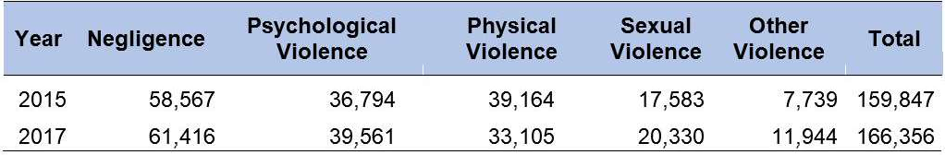

The main victims of sexual violence are girls, brown, black and indigenous, with the highest incidence of crime in the 12-17 age group, without disregarding a significant number of cases among children between 0 and three years of age, revealing that violations against the public permeate early childhood and adolescence, impacting the development of children.
Data from the federal government point out that in the years 2020 to 2021 there was a predominance of cases of sexual violence in the age group of 10 to 14 years old and 15 to 19 years old and with a significant increase among children under one year old:
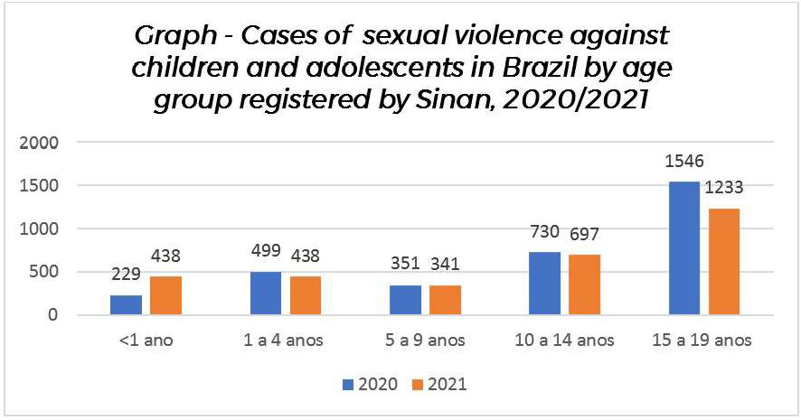
Finally, it is important to highlight that, despite the serious scenario that the data portrays, the federal government, from 2019 to 2022 has limited and made access to official data difficult, which makes the veracity of the Dial 100 Hotline data questionable, considering that there is underreporting and discredit by society in the face of the anti-political, negligent and rights-violating posture of the Jair Bolsonaro government (2019 to 2022) towards the population of children.

  - MISTREATMENT, NEGLIGENCE AND BODILY INJURY IN THE FRAMEWORK OF DOMESTIC VIOLENCE

Mistreatment represents physical, psychological, moral violence, omissions and negligence that negatively impact the development of children. In 2021, 19,136 victims of abuse were registered in the 0-17 age group. Compared to the year 2020 when 15,846 children were victims of the same crime. In this sense, it is possible to observe a significant increase of 21.3%. Thus, it went from a rate of 29.8 victims per 100,000 inhabitants in 2020 to 36.1 in 2021.
In the year 2022, child abuse is the crime against children with the highest number of notifications in police headquarters in Brazil, with 20,000 cases, the largest number of cases being children up to six years old.

As for negligence, the ECA emphasizes that this form of violation involves abandonment, absence or insufficient physical and emotional care. The age group from 0 to nine years old is more vulnerable to the crime of abandonment of the incapacitated :
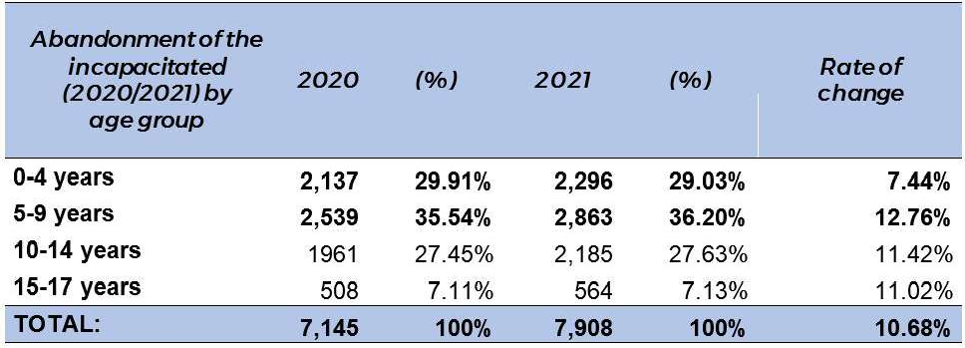
In general, they occur within the domestic environment, making it difficult to identify them and the action of the competent bodies and authorities. In addition, in many situations, the victims, mostly children, remain suffering this type of violence at home for long periods of time until the situation worsens and is identified.
Bodily injury is another crime that has increased in recent years. In the period 2019-2021, of the total of 129,844 records of violation of the rights of children, 23,494 were of intentional bodily harm in the context of domestic violence. Of this amount, girls, with 77% of registered cases, represent the main victims, whereas 51.7% of them are between 15 and 17 years old. In 2020, bodily injury cases are concentrated in the 10 to 14 age group, with 4,604 cases, and in the 15 to 17 age group, with 9,631. In 2021 this pattern repeats itself:

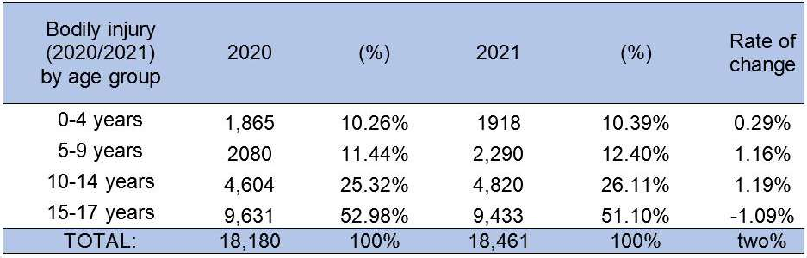
In Brazil, the suspicion or confirmation of physical punishment, cruel or degrading treatment and mistreatment against a child or adolescent must be mandatorily communicated to the Tutelary Council of the respective location.

  - VIOLENCE, MINORITIES, CHILDHOOD AND YOUTH
    - Indigenous Peoples

The original peoples of Brazil have been facing a challenging moment in recent years, due to the action and inaction of the federal government that institutionalized violence, violated rights and favored the action of land grabbers, miners and loggers in indigenous peoples’ lands. The failure of the federal government to implement protective measures means a death sentence for these peoples and encourages the action of criminal groups in indigenous lands, generating the intensification of invasions and contamination by disease, especially in the context of the Covid-19 pandemic.
According to Cimi, in 2021, 14 cases of sexual violence against indigenous people were registered, a number three times higher than in 2020, when five cases were registered. Of the 14 cases presented in this report, three are children, aged between three and five years old, and seven, aged between 13 and 14 years old. The cases occurred in Mato Grosso do Sul (6), Roraima (3), Mato Grosso (1), Amapá (1), Paraná (1), Rio de Janeiro (1) and Rio Grande do Sul (1).
In Roraima, the analysis draws attention to the situation of the Yanomami people, who point to prospectors invading Yanomami indigenous lands as the main agent of this type of crime through tricks such as trading food and alcoholic beverages in order to make victims more vulnerable and thus facilitate the action of these groups of garimpeiros. There are also cases of sexual violence followed by femicide.
A situation of this type confirms the absence of public power, which should adopt a supervisory and prohibitive stance on these types of criminal actions, as well as guide public policies that guarantee the survival and dignity of indigenous people, especially indigenous children. However, what is observed is negligence, omission, misinformation and indifference of the federal government in relation to the indigenous population, in other words, the institutionalization of violence by the Brazilian State is observed.

Among the victims of lethality in Brazil, black boys were the majority of victims in all age groups mentioned and, as age advances, there is a concentration of death among young people aged 15 to 19 years. Black boys are four out of five victims.

    - Negros

The situation of black children in Brazil is alarming, since all the data demonstrate the violence that preferentially affects this group in the country, to the point of pointing to a genocidal agenda. There is a significant increase in lethal violence against children, especially those who are male, black, poor and with low education.
In 2021, Unicef released a study that gathers data from 2016 to 2020, from all over the country, having identified 34,918 IVD of children, through police records and public safety bodies, and demonstrated that the situation of violence against black children has worsened. The majority of victims are between 15 and 19 years old, representing more than 31,000 of these cases. Cases of lethality involving children up to nine years old were 1,070. In 2020, there were 213 IVD in this age group.
It is also black boys in this age group who, in the majority, die as a result of police actions. In Brazil, police officers kill more than two children per day, being responsible for at least 15% of all homicides committed against this group in the period from 2017 to 2020.
Adolescent deaths are predominantly characterized by elements of urban armed violence, according to studies such as the atlas of violence (2021), which follows a global pattern, as per the Report on homicides on the planet of UNODC in 2019.
There are other forms of violence that affect black children, of a sexual nature, as will be described below, and also moral in society, since Brazil is a society where the racist culture is still strong and thus reproduced among children, with practices in bullying and cyberbullying, or social behaviors that use places of social hierarchy to reproduce without penalty or accountability of the racist agent.
It is strongly recommended that policies be implemented to prevent and make the family and child responsible in this regard, with a greater awareness of the importance of integrating respect for racial equality.

    - Girls

In the period from 2017 to 2020, 45,000 children were victims of rape, 80% of which were female. The main victims of sexual violence and bodily harm in the domestic context are black girls, from the outlying poor suburbs, demonstrating a racist and sexist society, which plays down violence and discredits the speech of girls who, in many cases, are blamed for the violence suffered.

These violations seem to be part of an invisible dome, which generates a social movement of denial of these problems, and, therefore, a continuous permanence of violations, which gain different perspectives and characteristics, without due attention and promotion of coping actions. This scenario justifies, for example, the high rates of underreporting of cases of sexual violence against children, especially with regard to sexual exploitation.
The complexity of this theme is based on social and political determinants, in addition to cultural ones, which are mixed with the territorial specificities of a vast country like Brazil.

  - CONCLUSIONS AND RECOMMENDATIONS

Based on the data and analysis gathered, it is recommended that:
- The State must create strategies to prevent violent deaths of children, in addition to repairing their families and holding their agents accountable.
- All cases of lethality of children must be directly monitored by the councils for the rights of children based on the transfer of information compiled by the Brazilian public security system.
- The Brazilian State must transform the protection program against children threatened with death (PPCCAM) into a State policy supported by specific law.
- The Brazilian State must promote policies to prevent sexual crimes against children, protect victims and hold agents accountable, which include training on sexual crimes and gender issues for all public security, health, assistance and social and education agents, in addition to ensuring that occurrences of sexual crimes against children are continuously monitored in a specific database throughout the Brazilian State.
- The deconstruction of the arms culture encouraged by the federal government (2019-2022), leaving an ideological legacy that worships violence.

HEALTH AND WELLNESS
  - Hunger and food insecurity
CDC:
Articles: 6(2), 18, 23, 24, 26, 27, (1) and (3), 33.
Recommendations (2015) : 52, 54, 56, 58, 60, 62,
64, 66, 68, 70.

In 2014 Brazil was removed from the Hunger Map, returning in 2018, according to FAO. At the end of 2019, 19.1 million people were in a situation of hunger in the country and in 2022, 33.1 million. A country enters the FAO Hunger Map when more than 2.5% of the population faces chronic lack of food, which in Brazil reached 4.1% in 2022. Exactly 14 million more Brazilians in a situation of hunger in just over a year.

In Brazil in 2022, only four out of 10 households manage to maintain full access to food – that is, they are in a condition of food security. The other six households are divided on a scale, ranging from those who remain worried about the possibility of not having food in the future to those who are already hungry. According to the 2nd Survey, in absolute numbers, there are 125.2 million Brazilians who have experienced some degree of food insecurity. It is a 7.2% increase since 2020, and a 60% increase compared to 2018.

Food insecurity (41.3% of the total) assumes degrees such as mild food insecurity, when there is uncertainty regarding access to food in the near future and/or when the quality of food is already compromised (28%), moderate food insecurity, when there is insufficient food (15.2%) and severe food insecurity, when there is deprivation in food consumption and hunger, (15.5%).
The most serious forms of food insecurity are concentrated in the North, with 45.2%, and Northeast, 38.4%, followed by the Central-West Region, with 28.4%, Southeast with 27.4% (both with three in every 10 families) and South, 21.7% of the population (two in every 10 families).
As for the color of hunger, from 2020, in 2021/2022, hunger jumped from 10.4% to 18.1% among households headed by blacks and browns. Furthermore, women are more affected, since in households where women are the reference person, hunger went from 11.2% to 19.3%. In households where men are responsible, hunger increased from 7.0% to 11.9%.
Rural areas have been most affected by food insecurity in more than 60% of households, including those who produce food: hunger reached 21.8% of households of family farmers and small producers. The poverty of rural populations associated with the dismantling of support policies for rural, forest and water populations continue to impose shortages.

Extreme poverty grew by 50% in Brazil in 2021, reaching around 18 million people, especially in homes where children under 10 years old live. According to the IBGE, 37.8% of households with children up to 10 years old face serious food insecurity, number 7 points higher than the national average. Hunger doubled in families that have children under 10 years old, making up a total of 18.1%, and with three or more people aged up to 18 years old, this number reaches 25.7% of families.

Food insecurity in Brazil surpassed, for the first time, the simple average of the 122 countries analyzed by the Gallup survey World Poll, which is 35%. The country ranked 63rd During the pandemic period, the Brazilian worsening was four times greater than the average of the countries surveyed in a study in the country.

  - Child malnutrition and obesity

In Brazil, more than 700,000 children under five years of age have a malnutrition problem,which is associated with family income. There are more than 10 million children under the age of 14 who have only R$ 303 (US$ 57.71) per month to spend on food, medication, clothes and others. This situation was aggravated by the pandemic, as the vast majority of children stayed out of school. This relationship is made because it is known that 40.3 million children are fed in public schools in the country.
The ENANI (2019) indicates that 18.6% of children up to five years old are at risk of being overweight, 7% being overweight and 3% being obese in the country. Overweight in children in this same age group increased from 6.6% in 2006 to 10% in 2019 and that of the 6.4 million overweight children, 3.1 million have already developed into obesity.
Among the families interviewed, the prevalence of consumption of ultra-processed foods reached 93% among children aged 24 to 59 months and 80.5% among children aged 6 to 23 months. The consumption of sweetened drinks reaches 24.5% of children aged 6 to 23 months, 37.7% of those aged 18 to 23 months and 50.3% of children aged 24 to 59 months.
In addition to often having a lower cost than in natura food, industrialized foods are also advertised on television and on the internet with very specific marketing for the little ones.
Obesity damages the physical and mental development of children, and creates social stigma. One of the issues identified as very relevant in the process of malnutrition and obesity in children is non-compliance with exclusive breastfeeding up to six months. According to the same study, less than half of babies (45.8%) aged up to six months are exclusively breastfed.
Therefore, malnutrition or malnutrition (inadequate or insufficient intake of nutrients) can lead to obesity or overweight, as these are not synonymous with good nutrition, quite the contrary.

The following actions are recommended:
- Diagnosis on the reality of hunger and food insecurity in the country, which indicates the profile of the subjects in relation to their color, age, gender, disability condition, location, whether they are part of traditional communities of indigenous people, quilombolas, riverside communities and others.
- Immediate removal of people in a situation of food bankruptcy, in addition to their inclusion in income generation programs.
- Establish popular restaurants, community kitchens, popular fairs and a food bank, including the distribution of food and drinking water in the streets.
- In areas of family farming and agrarian reform settlements, or indigenous, quilombola and riverside communities, preference should be given to these groups for the purchase of basic foodstuffs.
- It is urgent to effectively implement the National Food and Nutrition Policy (2012), which includes diagnoses, action plans, allocation of resources, ongoing training of health professionals to deal with situations of hunger, as well as to be able to detect these signs and make the appropriate referrals to the intersectoral service network.

- That the School Meals Program be implemented, particularly with regard to the acquisition of basic and healthy food from family farmers, agrarian reform settlements, indigenous and quilombola communities, and that the School Meals Councils be strengthened with the process of continuing education and that the qualified participation of civil society and parents and guardians is ensured.
- That a survey be carried out by civil society organizations of all bills contrary to the principles of the National Food Policy and Nutrition, mainly those that aim to benefit the food industries, agribusiness that disrespects the rules for protecting the environment and workers’ health, to the detriment of local producers.

  - VACCINATION

Vaccination coverage declined considerably in the reported period. Immunization against measles, mumps and rubella dropped to 71.5% in 2021, and the WHO recommendation is a minimum coverage of 95% of the child population.
Previously eradicated, in 2018, the country has already registered more than 10 thousand confirmed cases of measles and 12 deaths and in 2021.
Brazil is among the 22 countries with the highest number of deaths from tuberculosis, and 75% are in the 0-19 age group. From 2015 to 2019, there was an increase in incidence, higher incidence among black men, in Rio de Janeiro, Amazonas and Acre. In 2019, 4,532 deaths were recorded.
Immunization for HPV by vaccine has been falling for girls and boys. The vaccination rate of boys who were vaccinated with the first dose dropped from 57.9% (2020) to 55.5% (2021) and with regard to the second dose, this percentage is lower, 36% took the second dose . The rates regarding girls also showed a rate of 55%.

These low rates reveal the great prejudice and lack of information that exists around sex education and guaranteeing the sexual rights of children. The anti- vaccination movement in Brazil has been placing children in a vulnerable situation with regard to diseases that had long been eradicated.
Therefore, it is recommended:
- The State must intensify vaccination campaigns for diseases that affect childhood, such as measles, chickenpox, tuberculosis and HPV, and, to this end:
  - keep vaccination rooms open to the public at all times,
  - facilitate access to vaccines by reducing bureaucracy in the vaccination system,
  - disseminate, inform and raise awareness about the vaccination schedule, especially about vaccines for children under one year old and monitor their effectiveness,
  - implement actions to combat any and all misinformation regarding vaccines.

  - MENTAL HEALTH AND CHILDHOOD

In the period 2010 to 2019 suicide death rate among teenagers had a very significant increase of 81%, going from 606 to 1,022 deaths and a rate from 3.5 deaths per 100,000 inhabitants, to a rate of 6.4 suicides per 100,000 children.
Between 2011 and 2014, there were 15,702 reports of suicidal behavior among children,97 76.4% of cases between 15 and 19 years old, 71.6% female and 58.3% white people, home being the most frequent place of occurrences, and 88.5% in the 10 to 14 age group years, with 12,060 hospitalizations due to suicide attempts. From 2009 to 2016, 33,541 reports of cases of self-inflicted violence among children in Brazil were identified.
There was a 107% increase in hospitalizations, for these reasons, in the period 2009 - 2018, in the age group of 10 to 14 years. In total, in the age group of 15 to 19 years, there were more than 130,000 hospitalizations during this period. Most of these hospitalizations were caused by serious mood disorders, stress, anxiety and depression, which doubled during the pandemic among adolescents.
A Unicef survey in Brazil pointed out that half of these adolescents felt the need to ask for help regarding their mental health. However, of this number, 40% of them did not seek anyone; 20% sought out friends; 15% psychologists or psychiatrists; 11% turned to their family and 8% to their girl or boy friends. Only 2% sought out teachers and another 2% for SUS health professionals. The poll also showed that 50% of them do not know which services or professionals are dedicated to supporting adolescents in the area of mental health.

The medicalization of children, or the constant use of medication at this stage, generally for situations of “inadaptability” is worrying, due to the damage to mental health. Medicalization is associated with an expected pattern of behavior that is not compatible with the different behaviors of some children and the diagnosis of disorders (ADHD, ASD, TOD, Tourette syndrome, OCD). It is important to find out whether these manifestations of children could not count on more support and psychotherapeutic, recreational, sports and other interventions, different or in addition to medication.
The following is recommended:
- The implementation of a national child mental health policy that respects diversity, as well as regional and cultures differences, that guarantees spaces for listening, acceptance and support for emotional conflicts and that includes:
  - The implementation of psycho-affective training practices with children in schools, which encourage self-knowledge and knowledge of the other and of the relationships established between all.
  - The inclusion of material on mental health in school curricula.
  - The continuing education of mental health education professionals, so that they can identify signs and symptoms of mental disorders or others, such as anxiety and depression.
  - The creation of non-hospital psychotherapy care spaces.
  - Family support for the exercise of healthy authority.
  - The integration of actions between the areas of education, health, assistance, sport, culture and leisure for the implementation of the mental health policy for children.
  - The child’s participation in the process of discussion and deliberation of proposals, as well as in the stages of mobilization, implementation and monitoring of policies and strategies.

  - USE AND ABUSE OF ALCOHOLIC BEVERAGES AND OTHER DRUGS

The use and abuse of alcohol among adolescents grew from 52.9% in 2012 to 63.2% in 2019, higher among girls, from 55% in 2012 to 67.4% in 2019, with boys increasing from 50.4% to 58.8%. Regarding experimentation or exposure to illicit drug use, the rate rose from 8.2% in 2009 to 12.1% in 2019. The following is recommended, based on Sisnad:
    - The implementation of preventive policies, which include children and their families, and promote information and awareness about the harmful effects of alcohol and illicit drug consumption, as well as the risks of criminalizing the consumer.
    - Increased repression and accountability of retailers selling alcohol to children.
    - The implementation of care and treatment policies for children who consume or are addicted to alcohol and/or illicit drugs.

  - WATER AND SANITATION:

In 2018, 14.3% of children in Brazil did not have access to treated water and 6.8% had no water system inside the house.
The following is recommended:
    - The adoption of measures to make access to treated water universal in the country.
    - Diagnosis on the sewage disposal from all homes, as well as from companies and other commercial establishments in accordance with the laws and implementation of the corresponding adjustments.
    - Creation of a municipal sanitation system, even providing for the establishment of a special fund for this, with control by society.
    - The inclusion of the issue of access to drinking water in municipal and state health and child and adolescent conferences so that they can jointly establish an action plan to meet the principles of the national basic sanitation policy.
    - Regarding the families in their territories, that a public policy be deliberated and implemented to encourage the construction and installation of individual sewage treatment systems, in accordance with ABNT norms and the relevant sector regulation codes.

  - SEXUAL HEALTH: SEXUAL AND REPRODUCTIVE RIGHTS

The rates of sexually transmitted infections (STIs) grew by 64.9% in the population aged 15 to 19 years in 10 years, from 2010 to 2020, with one in four girls having an STI. The following is recommended:
    - Sex education in schools as a preventive practice.
    - Eradicate the culture of rape in Brazilian society, based on sexism, by valuing and respecting women.
    - Include in education, health and care policies, programs, actions and activities for information on STIs.
    - Develop awareness about responsible fatherhood and the role and responsibilities of men in cases of pregnancy, especially with regard to prevention.

  - CHILDREN WITH DISABILITIES

In 2010, the prevalence of at least one of the disabilities by age group was also investigated, and found that it was 7.5% in children aged 0 to 14 years. The PNS/IBGE 2019 revealed that in Brazil, that year, there were 17.3 million people aged two years or more with disabilities in at least one of their functions. The number corresponded to 8.4% of the population in this age group. Of the total number of people with disabilities, 14.4 million lived in urban households and 2.9 million in rural areas; 10.5 million were women and 6.7 million were men; 7.8 million were brown (8.5%), 7.1 million white (8%), and 2.1 million black (9.7%). By

region, the highest percentage of people with disabilities was found in the Northeast (9.9%), followed by the Southeast (8.1%), South (8%), North (7.7%) and Midwest (7.1%). According to the IBGE, all states in the Northeast Region had percentages above the national average, with emphasis on Sergipe (12.3%). In Brazil, people with disabilities were considered, 23.9% of the population in 2019. With regard to children with disabilities, IBGE classified them as follows: 7.5% are in the 7 to 14 age group and 12.9% in the 15 to 29 age group. This Census did not present the age group exactly like the ECA, which defines children as people aged 0 to 12 years old, and adolescents aged 12 to 18 years. The following is recommended:

    - Conduct the IBGE survey of children (0-17) with disabilities in the country, to be included in the population census.
    - Carry out research that includes children with disabilities in situations of vulnerability, social risk and violence, having as a study bias the intersectionality of gender, social class, color, location and specific groups and communities (indigenous, quilombola, riverside and traditional peoples).
    - Implement in the municipalities the policy of comprehensive care for children with disabilities, which include care, diagnosis, prevention and treatment, ensuring easier and faster access to orthoses, prostheses, wheelchairs, devices and equipment for hearing and visual corrections, as well as such as assistive technologies that favor greater inclusion.
    - Ensure in municipalities the promotion of broad, unrestricted accessibility for people with disabilities, identifying architectural, urban, communication and transport barriers in spaces, institutions and public bodies; and promoting the necessary adaptations for the inclusion of people with disabilities.
    - Promote and guarantee accessibility in schools, in accordance with legislation related to the subject, for the urgent implementation of inclusive education.

EDUCATION AND CULTURE
CDC:
Articles: 28, 29, 30, 31.
Recommendations (2015): 74, 76

  - FEDERAL REGULATORY FRAMEWORK IN THE PANDEMIC CONTEXT

Throughout 2020 and 2021, the federal government adopted measures to adapt the education system in the country, due to the compulsory isolation required by the pandemic, such as Ordinance nr. 343/2020, which exceptionally authorized the replacement of in- classroom classes with remote classes, Provisional Measure nr. 934, which waived the mandatory total number of effective days of school work in basic education, as provided for in the Law of Guidelines and Bases of National Education, among others.
Such flexibility measures were not accompanied by the implementation of alternative policies, which favored the adoption of fragile criteria for student approval, which reached close to 100% in many networks, without observation of real learning. In short, there was no effective systematic action at the federal level to help states and municipalities in the development of health and pedagogical strategies. Nor was there any robust action to transfer resources for structural reforms, purchase of cleaning products, data plans for teachers, students and managers, or any other form of support. The negligence that characterized federal action with health was repeated with education.

  - EDUCATION FINANCING: EXPENDITURE CEILING AND FUNDEB

It is possible to observe a reduction in primary expenditures, as a result of Constitutional Amendment nr. 95 and in the participation in discretionary expenses, in the participation in total education expenses, marking a policy of contraction of investments before the country reached a level of excellence.

  - HOMESCHOOLING: A NON POLICY

From the demand for changes in the laws that deal with the education of children, and under the argument to fthe constitutional right to religious freedom, politicians associated with religious groups began to demand the regulation of homeschooling. Although it is not an urgent issue on the horizon of challenges in the Brazilian education agenda and there is no data on which and how many families have benefited from homeschooling, without the mediation of a trained professional, there are several bills that deal with this issue in progress in the Chamber of Deputies.

This is a risk of regression in access to education in the country, which would affect, if approved, the rights of the child, in their entirety, affecting their integral development. The family’s obligation to promote access to education for their children must be reinforced as a State policy, and not the opposite, which homeschooling represents in Brazil.

  - EDUCATIONAL DATA MANAGEMENT:

The analysis of the role of the public power in education is based on the way in which its data and guidelines are available and accessible. Every public institution is required by law to disclose non-confidential information about its operations in Brazil. Of course, specific data are only made available via a formal request that is regulated by the Law on Access to Information (LAI). However, the way in which elementary data is arranged by the federal government is worrying.

As of 2019, several complaints of political interference in Inep emerged and several technical staff came forward to complain about the way the institute has been conducted. Among the indications of interference in Inep is the preparation of the Enem test, the interruption of the dissemination of data from the School Census and Enem. It is expected that appropriate measures will be adopted for the management of education data by Inep, as well as that the independence of this body will be respected.

  - ANALYSIS OF THE BASIC EDUCATION DEVELOPMENT INDEX (IDEB)

The Ideb is a synthetic indicator calculated from the school approval rate and the result of students in the SAEB with assessments of mathematics and Portuguese language. Every two years, the evaluation is carried out in all schools, public and private, and the index is calculated for the fifth and ninth year of elementary school, in addition to the third year of high school, that is, the entry and exit points.
Brazil established a note of 6 in the Ideb with the OECD as a goal by 2022. Ideb data for the last year of high school, however, do not show a significant improvement trend for public and private systems.
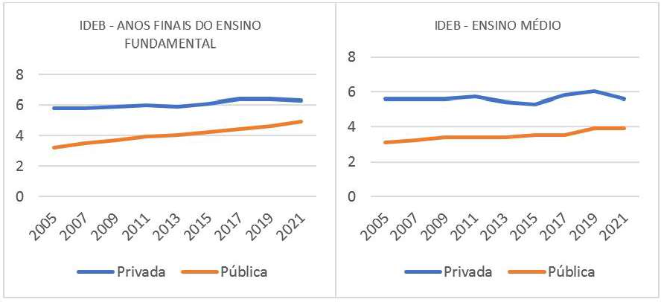

Source: Inep.

The persistence of an average note of less than 4 for the public system and 6 for the private system among graduating students is a serious indication of the structural problems of education in the country.
These results have been constant over the last decade, and the fact that Ideb evaluates performance only in Portuguese and mathematics, elementary and fundamental knowledge that enables students to exercise citizenship and enter the job market, makes this scenario of extreme gravity not only for childhood, but for the entire Brazilian society.

  - SCHOOL EVASION: A MULTICAUSAL PROBLEM

School evasion occurs when a student stops attending school for a certain period during the school year. It differs from school dropout, when the student, for whatever reason, stops attending school and does not renew his enrollment for the following school year.
There are many intrinsic and extrinsic elements to school life that alienate the student: quality of transport, distance between home and school, need to work to make up the family income, addictions, difficulty in keeping up with content, among others, in Brazil.107 In absolute numbers, approximately 340,000 young people were no longer linked to school in the country in 2021.
In high school, school evasion is more frequent, due to individual student issues, added to external problems and learning delays, given the lack of prospects of expected benefits from completing education.
The evasion of students in the final years of high school tends to be an indication of the student’s integration into the dynamics of teaching and learning, as well as a reflection of the perspectives that these students and their families have on the benefits of formal education. The national average of 1.2% is impacted by the high evasion rate in the Southeast Region, which concentrates the largest number of students in the country.
In this spectrum, in the country, male evasions are 20 to 30% higher than female ones, occur on a larger scale in high school and stand out in the South Region, although it is present in all regions. The country’s regions have very different characteristics. These data reinforce the need for an in-depth look at local realities.

  - RURAL SCHOOLS

Rural schools are neglected in analyses of education in Brazil, which leads to a complete lack of knowledge of this reality. The current data available from Inep indicate a curious scenario, where the number of enrollments grows while the number of schools drops, a constant trend over the last decade, a consequence of the school closure in rural areas. The limited budget of small towns and the lack of funds transfers from states and the federal government have promoted this situation.

There is a widespread understanding in the country that schools in the countryside should be aimed at the qualification of rural workers, which compromises the universalization of a pedagogical project that meets all individuals’ potential. In this sense, it is important to recognize the differences between urban and rural schools, so that pedagogical projects compatible with each reality are developed, but which expand and do not diminish the potential of the student.

  - RECOMMENDATIONS AND NOTES

- Strengthen Inep with more budgetary and technical funds to enable consistent performance with the country’s objectives in the field of education.
- Develop studies on what form of homeschooling adjusts to Brazil, so that its implementation does not pose risks to the formation and integrity of children.
- The adoption of educational policies for rural schools, aimed at multiplying them with an adequate structure and pedagogical project compatible with the objectives of the country’s educational policy.
- The planning of an inclusive educational policy in the country, suited to regional, rural and urban issues, and which also meets the needs of minorities of children.
- The promotion of compensatory policies for a generation of students who suffered losses in their educational process due to the pandemic.
- Considering the results of Ideb for the last few years, offer complementary courses in the school system to provide improvement and qualification of recent graduates, supporting them in the transition to university or the job market.
- Provide more funds to finance quality education for the population with the review of the spending ceiling provided for in EC nr. 95.
- Ensure that the production of educational data is continuous and diagnose problems of access to education, age-grade distortion, evasion and school dropout, by understanding regional particularities, as well as pointing out the special needs for inclusion of minority groups, in addition to to be transparent to society as a whole.

ECONOMIC EXPLOITATION
CDC:
Art. 32, 33, 36.
Recommendations (2015): 22, 42, 80, 81, 82,
84, 86.

  - THE SOCIAL AND ECONOMIC DEPROTECTION OF FAMILIES AND THE EXTENSION OF POVERTY AND CHILD LABOR IN BRAZIL

The slowdown in production, unemployment, low social protection coverage, lack of access to social security and high rates of impoverishment are conditions that promote the increase in child labor. Public spending in all social areas, especially in education and social assistance, was significantly reduced by the federal government during the pandemic, between 2020 and 2021, which contributed to the current situation.
Spending on the Bolsa Família program (income distribution), for example, was reduced, and the budget for “citizenship” was the most affected between 2016-2019 (-27%).

In December 2020, 55.2% of Brazilian households were in conditions of food insecurity112 and 9% or 19 million people lived with hunger. This percentage increased to 15.5% of the population or 33.1 million people in a situation of hunger in 2021, indicating that 14 million Brazilians were displaced to this condition in one year. Also according to data from the federal government, between 2016 and 2022 the number of children aged 2-9 who eat three meals a day plummeted, from 76% to 26%. In addition to being an issue that affects children’s health, food insecurity is linked to economic exploitation.
Specifically with regard to child labor in Brazil, official data point out that in 2019 around 1.8 million children worked in the country before the pandemic, the majority, 66.1%, black (black or brown), and 706,000 doing the worst types of work, which include housework, sexual, in the countryside, on the streets and in jobs considered dangerous.
Of these, 21.3% are between 5 and 13 years old and 78.7% between 14 and 17, and the highest concentration is in Minas Gerais and São Paulo, followed by Bahia, Pernambuco, Pará, Maranhão, Paraná and Rio Grande do Sul. Of the total number of working children, 70% are in agriculture, 20% in the service sector and 10% in industry (IBGE).
Some research focused on local situations of child labor pointed to an increase in this pattern in vulnerable families, in 2020, due to the pandemic, such as the case of girls and young people, in 10 capitals of the country, whose involvement with more household chores increased 55% and who started to work, mostly informally, in a fraction of 18.6%.
Official data record that In rural areas, child labor takes place in: charcoal ovens, stone extraction, mining, subsistence agriculture, sisal processing, mate tea, coconut breaking, sugarcane agroindustry, salt extraction, agave harvesting, cotton, vegetable extraction, tobacco, horticulture, flour mills, citriculture, fishing and activities related to the extraction of wood and in the urban environment, in the informal sector, there are records of work in dumps, street trade (fairs, street vendors, auto washing and guarding, newspaper distribution, etc.), provision of construction services civil, and in some industrial activities such as fireworks, footwear, weaving, clothing, food, furniture, wood lamination, bricks/ tiles and ceramics.

In addition, children are also subjected to illegal and high-risk activities, such as sexual exploitation and marketing of illicit substances, often involved in forced labor.
According to IBGE data, the majority (70%) of children (between 5-17 years) in child labor are in the agriculture and livestock sector. The National Prevention and Eradication of Child Labor Forum developed research with official data which quantifies the population of children under 14 years old in child labor and elaborates the profile of this activity in agricultural establishments in Brazil. In 2017 of the 15.1 million workers in agriculture, 580,052 were children under the age of 14, a figure that represents a 50% reduction in children under the age of 14 working in the agricultural sector between 2006-2017. The only states that did not have a decrease were Roraima and Amapá, where there was an increase of 81.8% (more 3,807 cases) and in Amapá of 81.3% (more 1,030 cases).
The highest concentration of child labor is in family farming (72.6%) and in the case of non- family farming, more than half (56.3%) is in the North and Northeast regions of the country. The largest reduction occurred in the family farming sector (50%), compared to non-family farming (8.5%), possibly due to social policies aimed at the family farming public that were implemented between the years 2006-2017.
Regarding sexual exploitation, the NGO Liberta presented the following data produced by the Brazilian State and civil society: about 500,000 children are exploited in Brazil, the majority between 7-14 years old, and every 24 hours, 320 children are sexually exploited in Brazil, which may be higher, as only seven out of every 100 cases are reported. Furthermore, 75% of the victims are girls and most of them are black.
Between 2019 and 2020 3,651 points vulnerable to the sexual exploitation of children were found on Brazilian federal highways, 470 of which were classified as critical, which represents a 47% increase in relation to the previous biennium. Sexual exploitation and human trafficking mostly affect girls and women, profile of workers rescued in conditions analogous to slavery, in the period from 2003 to 2018: 53% were black (42% brown and 11% black), 62% did not complete elementary school and 71.3% were rescued in rural work.

  - Official Report and Alternative Report: the setback in the policy to eradicate child labor in Brazil

    - III Child Labor Eradication Plan – PNETI (2019 – 2022):

III PNETI120did not yet begin, contrary to what the Brazilian State points out in its Report (items 184-205). With the cuts insocial spending, there is a difficulty in executing the plan, in addition to the new place that this policy has come to occupy in the structure of the Brazilian State, with the downgrading of the Ministry of Labor and Social Security. It is expected that the delay in the production and implementation of the III National Plan for the Prevention and Eradication of Child Labor and Protection of Adolescent Workers (2019- 2022) will be overcome, which has not been put into practice so far.

    - Budget

Between 2019 and 2021, the State reduced 95% of the execution of PETI funds compared to the previous period121 and, in addition, of the R$ 1.9 million made available for actions to combat child labor and encourage learning, only R$ 331.9 thousand were executed, that is, only 17.7% of the funds available for the year.
Added to this what was reduced from the budget for social assistance, health and education, which significantly affects the life of poor children in the country, which also interferes with the increase of children in child labor, contrary to the Recommendations of this Committee for Brazil in 2015.

    - Illegal business and indigenous peoples in the North of the country
The negligent conduct of the State allowed, in the reported period, the development of illegal businesses in the North of the country, especially since 2019, which has been violently affecting the indigenous population, contrary to what the report of the Brazilian State to the Committee says, which states that care is being offered to indigenous people.122
The publication of Normative Instruction nr. 09/2020,123 of the Ministry of Justice and Funai allowed the “certification of private properties within indigenous territories that have not yet been ratified”, which increased invasions of territories and violence against indigenous people, including in the Covid-19 pandemic.
In this context, it is necessary to call attention to the situation of indigenous children in Brazil, because in addition to the fact that in recent years indigenous lands have not been demarcated. There was an articulation by the Brazilian State so that the monitoring and repression of illegal miners and loggers was reduced in the Amazon region, which placed the indigenous population in a situation of extreme vulnerability. This scenario makes indigenous girls and boys increasingly vulnerable, for example when it is not safe to go to school, or there is difficulty in getting medication and medical care, having a significant impact on the guarantee of rights. In the case of girls, there is also an aggravating factor related to sexual violence.
The withdrawal of budgetary funds for policies aimed at indigenous peoples also places them in a situation of greater vulnerability. Funai’s total budget, which represents 0.02%of the Union’s budget, was also not executed: R$ 3.6 trillion was earmarked for 2020, but only R$ 640 million was authorized for all its expenses.
As a consequence, for example, at least 110 communities of the Yanomami Indigenous Lands (TIY) are directly affected, in the maintenance of their agricultural system due to the violence of prospectors and drug traffickers, in addition to the pollution of rivers caused by illegal predatory mining, the restriction of traffic between communities, which were isolated. Taking all these circumstances into account, this created a situation of vulnerability and external dependence, even to receive food.
There are reports recounting how prospectors have been enticing young people into mining, creating a problem in communities, as they provide access to drugs, weapons and alcohol. There are records of internal conflicts involving gun fights that ended in death and records of children dying from malnutrition (today there are around 3,000 children with nutritional deficits) and diseases such as malaria.
According to official data,124 in 2020, there were 776 deaths in the 0-5 age group, which corresponds to 20.1% of the 3,861 deaths of indigenous people registered by the agency, with 21 children dying due to lack of assistance. At least 145 peoples from 201 indigenous lands suffered some type of aggression against their territory.

In addition, there is the sexual exploitation of indigenous girls. The reports present situations in which prospectors offer food in exchange for sex with indigenous teenagers, due to the destruction of the Yanomami’s source of survival, which is agriculture, fishing and hunting, as rivers and forests are being invaded, exploited, burned and polluted with mercury. Due to hunger and the difficulty that indigenous people are having to survive, they end up hostages to this type of situation, and indigenous children are victims of sexual exploitation carried out by prospectors. Alcoholic beverages are also offered as a strategy for exploitation. As a result of sexual abuse, in 2020, three girls aged around 13 died.125
This situation promoted by the Brazilian State goes against the grain of what the Committee on Children’s Rights suggested in the 2015 Recommendations, which showed deep concern about guaranteeing the rights of the indigenous population with regard to health, education and adequate living standards, emphasizing the physical and sexual violence that children suffer from criminals who exploit the environment.

  - RECOMMENDATIONS

- Repeal of Constitutional Amendment nr. 95/2016.
- Higher budget and execution of PETI, especially in rural areas, where there is a concentration of child labor.
- Creation of a universal children’s benefit and/or children’s basic income, focused on the subjects of “children’s rights”.
- Expansion of professional apprenticeship programs, with an increase in the floor for quotas for hiring apprentices.
- Expansion of the number of beneficiaries and amounts of the federal government’s income transfer program.

- Fulfillment of PNE target 20: reach, by 2024, 10% of GDP in investment in education, with the inclusion of indigenous children.
- Protect the current law that defines the minimum age for work in Brazil.
- Accomplish the demarcation of indigenous lands, resuming the work of inspection bodies such as Ibama and expanding the budget for the protection and guarantee of the rights of indigenous populations.
- Adopt social protection measures for adolescents engaged in the trafficking of illegal substances to the detriment of simple criminalization through internment in the socio-educational system, resizing socio-educational measures for this infraction.

JUVENILE JUSTICE
CDC:
Art. 37, 38, 39 and 40
Recommendations (2015): 88

  - THE NATIONAL CONGRESS AND THE LOWERING OF THE CRIMINAL AGE

Between 1990 and 2020, 338 legislative proposals (PL) were presented in the National Congress on the criminal accountability of children in the country.
Of this total, the propositions are distributed by three main themes: increase in length of internments 29.3% (99), reduction in the age of criminal responsibility 24.3% (82) and others 17.55%. Of these, 58 proposals were classified as having a punitive nature, that is, of increasing rigidity in the law applied to adolescents in compliance with a socio-educational measures. In the 2015-2019 five-year period, 32 proposals were presented to increase the length of internment.

The study indicates that there is a progressive increase in the number of PLs (Legislative Projects) on this topic over the period studied, with emphasis on 2015 to 2020:
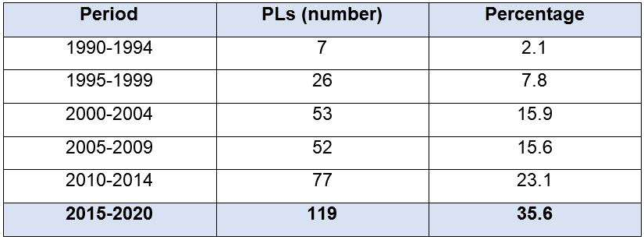
In 2021, only 36 projects were still pending, seven referring to the increase in length of stay, six aimed at reducing the age of criminal responsibility and four referring to the prohibition of intimate visits. In addition, nine projects classified as “others”, dealt with the creation of a national bank of search and seizure warrants against adolescents, as well as a project that regulates the application and execution of socio-educational measures while the pandemic caused by Sars-COV-2 virus lasts. Of the other 10 projects underway, two referred to the expansion of procedural guarantees and individual rights, two to schooling, professionalization and work for hospitalized adolescents, two to the exclusivity of female employees in female detention units, two to the guarantee of the right of defense, one to carrying weapons for socio-educational agents and one that aims to include an infraction on a criminal record.
One concludes that punitive lust it is imperative as an ideology in the treatment of this issue in the country, which follows the line of making the victim of socioeconomic injustice accountable as a public policy.

  - SINASE - APPLICATION AND IMPLEMENTATION OF SOCIO-EDUCATIONAL MEASURES
    - Adolescent Profile
Socio-education (reform institutions) has color: it is black or brown. Despite some differences in available data, the national average between 2013 and 2017, it is around 50%. From a regional viewpoint, in December 2021, the state of São Paulo was 70% between brown and black and Pernambuco, 87% of adolescents deprived of liberty. The three main reasons for internment are theft, robbery and involvement in drug trafficking.
The type of involvement of adolescents with drug trafficking is not clear in the surveys, but we understand that it occurs as a form of employment. The activity is on the list of the worst forms of child labor, regulated by law in the country, but little enforcement is seen in sentences handed down by the justice system.
The largest number of adolescents in compliance with socio-educational measures is found in the age group between 15 and 17 years old. Low schooling and age-grade gap predominate.
Girls represent about 5% of the total in closed environment and 11% in open environment. The difficulties are the same in terms of managing the units, plus sexist and sexist practices that establish limiting standards. For example, professional education initiatives for girls focus on courses in the area of care, reinforcing proposals that restrict possibilities for professional training and education. The patriarchal character that guides Sinase reinforces stereotypes created as acceptable from a moral point of view, and that delimit female behavior. In this sense, the sexual rights of girls are marginalized or made invisible.

    - THE JUSTICE SYSTEM AND CHILDHOOD

The ECA provides for the creation of specialized and exclusive courts for children and youth. The CNJ by Provision Nr. 36/2014, along the same lines, emphasizes the importance of specialized courts exclusively for children and youth, in the proportion of one court for every 200,000 inhabitants. Conanda for Resolution Nr. 113/2006 points to the need to create a specialized court for each district. However, to date, there is a low installation of specialized courts. Of the total of 3,148 justice units, the majority, about 65.75%, is a single court, where the processing is joint with several other matters. Exclusive jurisdiction courts were 142 in number or 4.51% of the total. There is a concentration in the Southeast Region.
In the courts of exclusive competence, the processes are processed in a shorter time. There are more qualified civil servants compared to the cumulative courts, and their expansion is recommended, as well as exclusive public prosecutors and public defender nuclei.

    - THE SYSTEM FOR IMPLEMENTING SOCIO-EDUCATIONAL MEASURES

      - Management

Sinase’s National Coordination produces few regulatory guidelines for measures restricting freedom. The distribution of Sinase management in the states, in different administrative areas, such as social assistance, human rights, education and others, makes it difficult for the Sinase Intersectoral Commission, created in 2017, to assess it. The disconnection of these guidelines to the administrative structures that carry out the service weakens the political coordination of the system. There is no administrative entity that centralizes and is responsible for the articulation and execution of socio-educational measures in the country, which must be implemented.
The open and closed environments lack greater coordination, planning and national monitoring by Sinase. Measures in an open environment are concentrated in the social assistance policy, which sought to regulate the specific practices of this service. Measures in a closed environment are spread across the 27 federal units, which denotes the fragmentation of a national socio-educational policy.

      - Financing, structure and services

With high costs and without co-financing, the structural and service conditions in the units are affected by lack of maintenance, abandonment, to the point that some are not in working order. This is also reflected in the training of professionals, in the weakening of hiring personnel, encouraging precarious work contracts and boosting turnover among professionals, in the architectural design of the units, in the psycho-pedagogical references of care, in the flow between the open system and closed, among others.

With regard to socio-educational care in particular, it is an area with little specialized training. In addition to the precarious employment relationship, there is a record of professionals leaving for health reasons, the second cause in the rest of the country, and the first, physical illnesses.

Finally, the problem of overcrowding in the units stands out, which has persisted over the decades, even though it goes against the legislation for the protection of children. In 2020, the STF, from a habeas corpus Espírito Santo collective, prohibited overcrowding, in an exemplary measure in the country.

      - Health and education
Resolution Nr. 3/2016 of the CNE defines national guidelines for the school attendance of adolescents and young people in compliance with socio-educational measures, but march without implementation.

      - Repeat Offenders

The lack of data directly impacts the possibility of monitoring recidivism, egress mortality and passage to the adult prison system. Official data point to a 17.4% rate of repeat offenders, but this assessment did not include information from São Paulo, the Federal District, Mato Grosso do Sul and Santa Catarina. The highest number of recurrences occurs in the first six months after exiting the system. CNJ initiatives, together with the justice system, have helped to fill part of this data gap.
An NGO study identified that, in 2017, 65% of the adolescents in Fundação Casa, socio- educational care unit in the state of São Paulo, were repeat offenders; blacks and browns, 76% and 60% between 16 and 17 years old. Only 8.9% committed acts against life. Dropping out of school and breaking family ties are strongly linked to the first offense, in addition to aspects related to precarious economic conditions and the discrimination suffered.

  - THE DISMANTLING OF SOCIO-EDUCATIONAL POLICY AND THE BUDGET EXECUTION

Within the scope of the national coordination of the MMFDH, the decrease in resources was impactful in the reported period. Comparing the years 2019 and 2021, there was a 70% reduction in resources executed in this area, under the coordination of Sinase. The execution in 2021 was committed to remaining payable in investment expenses for the construction of custodial units, previous agreements and current expenses. Investment in pedagogical actions remains at very low levels.
The socio-educational service policy was directly affected by the effects of the pandemic. There was a low testing rate and inadequate treatment in case of a positive diagnosis. Sinase’s National Coordination did not have systematized national information, resources to implement preventive actions and difficulty in accessing family members online.
According to a survey by the Alana Institute, until July 2021, of the total number of new Covid-19 infections, 2,575 were teenagers and 7,962 servers. 97 registered deaths to date, all public servants.
With the beginning of the pandemic cycle, pedagogical activities in the detention and semi-liberty units were suspended.
With Recommendation nr. 62, of March 17, 2020, of the CNJ, the socio-educational service was urged to review the decisions for compliance with the measures in a closed environment. This fact, associated with the decision of the STF to prohibit overcrowding, made it possible to reduce a significant number of internments in semi-liberty and internment.

The open medium suffered a strong impact in the pandemic period due to the suspension and reduction of funding. In the same way, there was a delay in the progress of legal proceedings, with no definition foreseen.

The funding of socio-educational care in an open environment was located almost exclusively in social assistance policy. With the general budget decrease, it was impossible to establish reference centers specialized in Open Medium measurements.
The National Coordination of Sinase has its action reduced, expressed in the budgets themselves, reflecting the dismantling of the policy and reducing the role of the national coordination.
The dysfunctionality of Sinase functioning can be expressed in two aspects. The first on the administrative political division between open and closed environment. Despite being a single execution system, this division did not favor the management of the system, on the contrary, it reinforced its dysfunctionality. The second is budgetary, there is no mandatory co-financing between the three federative entities.

  - ECOMMENDATIONS

    - Single management in all instances with planning, action, articulation and standardization of procedures.
    - Co-financing for all types of socio-educational assistance.
    - Ongoing and mandatory training for all socio-education professionals.
    - Job and salary plan for all professionals, based on local legislation and, if necessary, national regulation of socio-education professionals.
    - Overcoming the temporary hiring format.
    - Discourage processes aimed at privatizing care.
    - Mischaracterize any aspect that brings the socio-education professional closer to police activity.

    - Investment of the courts of justice in expanding the number of specialized courts and consequent developments in other organs of the justice and security system.
    - Specialized training for those who work in specialized justice with a focus on concepts of inter-sectoriality and inter-institutionality.
    - Stimulate practice of active participation by professionals in judicial decisions on the application of socio-educational measures.
    - Stimulate participation, elaboration, revision and permanent updating of the socio- educational service plans of each instance.
    - Ensure individualization and respect for the characteristics of each adolescent in the pedagogical proposals for assistance.
    - Develop, together with the actors of the Rights Assurance System, the performance benchmarks of the various bodies.
    - Guarantee the right of adolescents to participate, as a preponderant factor in the educational process.
    - Implement pedagogical proposals that overcome sexism, the cultural limitations of certain roles reserved for women and sexism.
    - Do not admit inappropriate and unhealthy spaces.
    - Create quick mechanisms for receiving and investigating complaints about any type of violence committed.
    - Regulate the right of adolescents not to commingle with any professional who has been accused of violent acts.
    - Facilitate and encourage the presence of external control bodies and organizations.
    - Always keep data and information on socio-educational services up to date with the rights councils.
    - Ensure social legal assistance to adolescents and their families, victims of institutional violence.

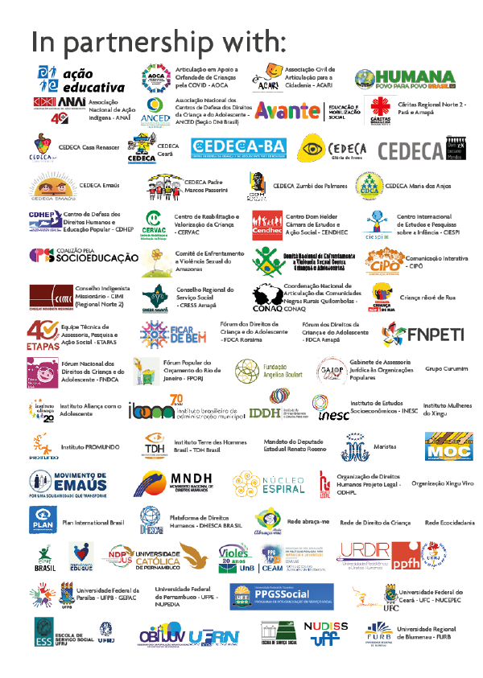

The concept of multidimensional poverty is associated with social justice, freedom and autonomy of the individual, together with the functionalities of social well-being, as elaborated by Amartya Sen.
NERI, M. C. Mapa da nova pobreza. Rio de Janeiro: FGV Social, 2022.
UNICEF. As múltiplas dimensões da pobreza na infância e na adolescência no Brasil. 2022
UNICEF. Pobreza na infância e adolescência no Brasil. Paz e Arévalo, 2018.
PNAD.
According to the Ministry of Health, “deaths from preventable causes” are classified when they can be reduced by immunization actions, care for women during pregnancy, adequate care for women during childbirth, diagnosis and adequate treatment, health promotion actions. linked to Primary Health Care.
FUNDAÇÃO ABRINQ. Cenário da infância e adolescência no Brasil. 2022.
UNICEF. The climate crisis is a child rights crisis: Introducing the children’s climate risk index. New York, 2021.
PLAN INTERNATIONAL. Realizing every girl’s right to flourish: A review of progress on the 10th nniversary of the International Day of the Girl. 2022.
Abia, Ação Educativa, Gênero e Educação, ABGLT, Antra Brasil, CLADEM, CONECTAS, IPAS. Ofensivas Antigênero no Brasil, Políticas de Estado, Legislação, Mobilização Social. Relatório Submetido ao Mandato do Perito Independente das Nações Unidas sobre Orientação Sexual e Identidade de Gênero e Direitos Humanos. 2022.
HUMAN RIGHTS WATCH. “I became scared, this was their goal”: Efforts to ban gender and sexuality education in Brazil. 2022.
Gender and number. Teenage pregnancies are down, but among black girls the drop is just 3.5% in three years. 2021.
Report of the special rapporteur on the rights of indigenous peoples on her mission to Brazil. 2016
INTER-AMERICAN COMMISSION ON HUMAN RIGHTS. Situation of human rights in Brazil. 2021.
The data from Sesai, from the Ministry of Health, could only be accessed via the Access to Information Law, requested by a project led by Transparência Brasil and Abraji.
REBOUÇAS, P. et al. Ethnoracial inequalities and child mortality in Brazil: A nationwide longitudinal study of 19 million newborn babies. The Lancet Global Health, [Ps], v. 10, no. 10, p. 1453-1462.
https://sisaps.saude.gov.br/sisvan/relatoriopublico/index.
FBSP. Anuário Brasileiro de Segurança Pública. Lutas por reconhecimento e os indicadores de racismo e LGBTfobia no Brasil em 2021. 2022.
Dossiê de mortes e violências contra LGBTQIA+ no Brasil. 2021. Available at: https://www.cartacapital.com.br/wp-content/ uploads/2022/05/Dossie-de-Mortes-e-Violencias-Contra-LGBTI-no-Brasil-2021-ACONTECE-ANTRA-ABGLT -1.pdf.
FRÓES, A.; BULGARELLI, L.; FONTGALAND, A. Entre curas e terapias: práticas de conversão sexual e de gênero no Brasil. São Paulo: All Out and Instituto Matizes. 2022. p. 52.
ASSOCIAÇÃO BRASILEIRA DE LÉSBICAS, GAYS, BISSEXUAIS, TRAVESTIS E TRANSEXUAIS; SECRETARIA DE EDUCAÇÃO. Pesquisa nacional sobre o ambiente educacional no Brasil 2015: Curitiba: ABGLT, 2016.
FOLHA DA SÃO PAULO NEWSPAPER. 2022.
PELLANDA; FROSSARD (Coord). 2022.
Idem.
Data from the United Nations Department of Economic and Social Affairs.
PELLANDA; FROSSARD (Coord.)2022.
MANTOVANI; PASSION, 2021, apud PELLANDA; FROSSARD, 2022.
PELLANDA; FROSSARD (Coord.)2022.
Although 3,150 children lack material resources as an explicit reason and, among them, 875 have poverty as the only reason for shelter, other reasons related to the condition of poverty were observed, justifying institutional and family shelter. This indicates the permanence of the pernicious and antiquated solution of removing the poorest children from their family and community life, considered incapable of providing the essential protection for their development.
Data from the National Social Assistance Secretariat of the federal government.
National survey on shelter services for children in times of Covid-19: Results presentation. v. 1. The research was designed to learn about the demands and responses offered in this scenario and to support the reception services in the implementation of full protection in this challenging context.
The complete analysis is found in the study, p. 356-357.
The study points out that existing difficulties in reception services and in the network result in 13.2% of the children sheltered not having administrative procedure in the Childhood’s and Youth Court. P. 356.
IPEA; UNICEF. Gasto social com crianças e adolescentes (GSC&A) Descrição metodológica. Brasília: 2021
Agenda 227: Plano País para a Infância e Adolescência, 2022.
INESC. 2022.
Comissão Interinstitucional da Frente Parlamentar Mista da Primeira Infância. Medição do Gasto Social com Primeira Infância para 2021. 2022.
CLÉVE, J. P. A EC 95/16 e o impacto no Plano Nacional de Educação.
INESC. 2021.
Idem.
Agenda Pública, UNICEF. Diagnóstico do Sistema de Garantia de Direitos da Criança e do Adolescente, 2021.
www.sipia.gov.br
FUNDAÇÃO ABRINQ. O monitoramento da cadeia produtiva como estratégia de prevenção e combate ao trabalho infantil.
CNJ Manual de depoimento especial de crianças e adolescentes pertencentes a povos e comunidades tradicionais. Brasília: CNJ/PNUD, 2022.
CHILDHOOD BRAZIL; CNJ; UNICEF. Protocolo brasileiro de entrevista forense com crianças e adolescentes vítimas ou testemunhas de violência. Brasília, 2020.
CNJ. Destituição do poder familiar e adoção de crianças. Brasília: CNJ, 2022.
. Proteção da criança na dissolução da sociedade conjugal/Conselho Nacional de Justiça. Brasília: CNJ, 2022.
CNJ. Manual sobre audiências concentradas para reavaliação das medidas socioeducativas de semiliberdade e internação. Brasília: CNJ, 2021
CNJ. Estrutura judiciária e gestão administrativa de políticas públicas para a infância e juventude. Brasília: CNJ, 2022
CNJ Diagnóstico nacional da primeira infância. Painel do diagnóstico da situação da atenção à primeira infância no sistema de justiça.
RIZZINI, I.; TABAK, J.; SAMPAIO, E. O bem-estar da criança e o direito à participação na América Latina. In: IV Simpósio Luso- Brasileiro de Estudos da Criança PUC-Goiás: Por uma luta sem fronteiras na defesa dos Direitos das Crianças. Goiânia: Editora Vieira, 2019. v. 4. p. 853-863.
CERQUEIRA, C.; RIZZINI, I. Espaços de escuta e participação no contexto de acolhimento institucional. Rio de Janeiro: Ciespi, 2020.
FBSP. Anuário Brasileiro de Segurança Pública. 2018-2021. Edição Especial Eleições 2022.
FBSP. Anuário Brasileiro de Segurança Pública. 15. Anuário Brasileiro de Segurança Pública, 2022.
Idem.
FBSP. Anuário Brasileiro de Segurança Pública, 2021.
Idem.
Idem.
Anuário Brasileiro de Segurança Pública. 2019.
Idem.
ECPAT BRASIL. Cenário das violências sexuais contra crianças e adolescentes no brasil em tempos de pandemia. Relatório comparativo: 2021 e 2021.
FBSP. Anuário Brasileiro de Segurança Pública. 2022.
Relatório Disque Direitos Humanos ou Disque 100.
Sinan Net: https://portalsinan.saude.gov.br/.
FBSP. Anuário Brasileiro de Segurança Pública. 2022.
Idem.
FBSP. 2020, 2021.
Idem.
Idem.
VISÃO MUNDIAL. Raio-X da infância e da juventude vulnerável do Brasil. 2021.
CIMI/CNBB. Relatório violência contra os povos indígenas no Brasil. 2021.
Idem.
UNICEF. Panorama da violência letal e sexual contra crianças e adolescentes no Brasil. 2021.
UNICEF; FBSP.
UNODC. Estudo global sobre homicídio. 2019.
According to Overview of lethal and sexual violence against children carried out by Unicef in partnership with the FBSP.
FAO, 2016.
PENSSAN. 2. Inquérito Nacional sobre Insegurança Alimentar no Contexto da Pandemia da Covid-19 no Brasil.
Idem.
NERI, M. Insegurança alimentar no Brasil – pandemia, tendências e comparações internacionais. Rio de Janeiro: FGV Social, 2022.
REDE PENSSAN, 2022.
INSTITUTO DESIDERATA, 2022.
INSTITUTO DE NUTRIÇÃO JOSUÉ DE CASTRO, da Universidade Federal do Rio de Janeiro (UFRJ).
MINISTÉRIO DA SAÚDE. SINAN.
SECRETARIA DE VIGILÂNCIA EM SAÚDE. Boletim Epidemiológico, n. 33.
FIOCRUZ. Violência autoprovocada na infância e adolescência.
Idem.
BRITO, F. A. M. de et al. Violência autoprovocada em adolescentes no Brasil, segundo os meios utilizados. Cogit. Enferm., 2021
UNICEF. U-Report.
IBGE. Pesquisa nacional de saúde do escolar. 2019.
CFP. Referências técnicas para atuação de psicólogas(os) em políticas públicas de álcool e outras drogas. 2019.
HEALTH SURVEILLANCE DEPARTMENT. Ministry of Health. Special Edition. 2021
The autarchy is linked to the Ministry of Education (MEC) and is responsible for educational assessments and exams; statistical surveys and educational indicators; and knowledge management and studies.
INEP, 2021
SIAFI.
PENSSAN. National Survey on Food Insecurity in the Context of the Covid-19 Pandemic.
IBGE. 2016-2019.
SRTE regional management of Labor and Employment (GRTE) and regional agencies are service units in the states responsible for the execution, supervision and monitoring of actions related to public labor and employment policies
Trabalho infantil na agropecuária brasileira: uma leitura a partir do Censo Agropecuário de 2017.
https://liberta.org.br/.
Polícia Rodoviária Federal. Mapping 2019/2020
INSTITUTO ALANA/NEV. Coordination Bruna Gisi. Parliamentary speeches on adolescence and offences (eBook); Sao Paulo-SP. 2022.
The maximum time allowed for compliance with the detention measure is three years.
MINISTÉRIO DA JUSTIÇA. SINASE. Levantamento nacional. 2018.
FUNDAÇÃO CASA.
FUNASE. Sinase annual survey.
Decree Nr. 6,481, of June 12, 2008.
MECANISMO NACIONAL DE PREVENÇÃO E COMBATE À TORTURA. 2019.
IBAM. 2021.
“Medium size” is considered to be those municipalities between 50 and 100 thousand inhabitants and “large” those between 100 and 900 thousand. In: Juvenile justice: current situation and improvement criteria. IPEA, 2012.
CNJ, 2022.
BRASIL. SNDH/UFRGS. Pesquisa de avaliação do Sinase. 2020.
BRASIL. Ministério da Cidadania. Relatório da pesquisa nacional das medidas socioeducativas em meio aberto. 2018.
BUENO, C. D. C. et al. Panorama nacional da política de atendimento socioeducativo em meio aberto (2017 e 2018). In: VISÃO MUNDIAL; GAJOP. Diagnóstico da política de atendimento socioeducativo em meio aberto. Brasília: Visão Mundial e Gajop, 2021.
BRASIL. Conselho Nacional do Ministério Público. 2019.
MINISTÉRIO DA JUSTIÇA. Avaliação do Sinase. 2020.
INSTITUTO SOU DA PAZ. “Aí eu voltei para o corre” – estudo da reincidência infracional do adolescente no estado de São Paulo. 2017.
INESC. 2021.
Monitoring report on the socio-educational system in the context of the pandemic.
INSTITUTO ALANA.2020.

