In the reporting period of 2021/2022 – 47% of all religiously aggravated hate crime was directed towards the Catholic community a religious group often conflated with Irish ethnicity.
The following quote is taken from the 1923 Menace of the Irish Race to the Scottish Nation Report. The impacts of this report remain relevant to Scotland in 2024 and the Scottish Government and others continue to refuse to recognise the very Scottish phenomenon of anti-Irish racism and anti-Catholic bigotry that is unique in its frequency and stubbornness to Scotland.
“The question of the Scottish Roman Catholic population has not arisen, nor is there any reason why it should arise. They have a right to call Scotland their country, in common with their fellow-countrymen of the Protestant Faith.........The problem (is) of the Irish Roman Catholic population in Scotland. They cannot be assimilated and absorbed into the Scottish race. They remain a people by themselves, segregated by reason of their race, their customs, their traditions, and, above all, by their loyalty to their Church, and gradually and inevitably dividing Scotland, racially, socially, and ecclesiastically”.
Irish community organisations in Scotland welcome the announcement by the CERD that they intend to ask the Scottish Government for
“Information on measures taken to prevent and address instances of racist incidents against Irish persons in Scotland”.
Ongoing policy context
- The Scottish Government and Police Scotland presently refuse to recognise the aligned and very specific issues of anti-Irish racism and anti-Catholicism in Scotland beyond their generic policy to ‘tackle Sectarianism’
- Between March – July 2020 199 ethnic Irish deaths were recorded as a result of covid or other deaths. The highest of any CERD A1 minority ethnic group. Between July 2020 and September 2021 the number increased to 1041. The next highest specific ethnic group was Pakistani with 412 deaths.
- The Scottish Governments main pandemic legacy policy response to interrogate the reasons for disproportionate pandemic impacts via creating an anti-racism infrastructure and anti-racism observatory for Scotland has thus far excluded the Irish community on the basis that they are ‘White’.
- Via the imposition of racial classifications the multigenerational Irish community had been consumed into the enforced homogeneity of ‘white’. The experience of the Irish community in Scotland as an ethnic minority recognised and protected under the international human rights regime has been extinguished

- As a consequence of been structurally ignored for generations and not recognised as a community identified under the comprehensive scope of Article 1 of the ‘International Convention on the Elimination of All Forms of Racial Discrimination’ (ICERD) has resulted in ongoing inequalities in Scotland for the multigenerational Irish community in relation to health, poverty, hate crime and criminal justice.
- As a direct consequence of not specifically instigating policy responses to deal with anti-Irish racism and anti-Catholic bigotry in education, tackling hate crime, health, culture and lack of funding the misrepresentation of our community continues
- The Irish in Scotland is multi-generational and many are descendants of people who arrived as refugees during An Gorta Mor 1845-50, in the years between 1918 and 1936 and those came to Britain post WW2 to help rebuild the country’s infrastructure and work in the National Health Service.
- By using the language and conceptualisation of anti-Irish racism and anti-Catholicism as ‘Sectarianism’ the Scottish Government conveniently empower themselves with ability to mask the multi-generational racialisation of Irish Catholics in Scotland as an inter-Christian issue of Catholic vs Protestant
- In doing so the Scottish Government fail in their responsibilities to our community to recognise specifically the issues that we experience
- As a consequence the Scottish Government refuse to properly engage with us and exclude us from policy development that affects us, fail to name and recognise the very specific issues we face and fail in their legal duties to protect us from racial and religious discrimination.
- The Irish community in Scotland should be given equal recognition alongside the other cultural and ethnic minorities of Scotland. This includes our fellow citizens of Scotland identifiable within the census data such as multi-generational Scottish Pakistani’s, Indians, Poles, Chinese, Africans (various) and others. This also includes the religious communities attached to various cultural and ethnic minority communities such as Muslims, Jews, Sikhs, Hindus and other dynamics of Christianity. Where inequalities are evidenced and identifiable we should share equal application of rights and recognition. We reject the false equivalence and current practice of the Scottish Government and local authorities who only recognise the multigenerational Irish community via the enforced classification of ‘sectarianism’.
- We call on CERD to recognise the specific ability of the Irish Catholic community in Scotland to self-identify independently under the international human rights regime without being instantaneously connected to other social and political opinions.
- We call on CERD to recommend to the Scottish Government that the Irish community are engaged in the anti-racism in the curriculum, tackling hate crime strategy, the anti-racist observatory and the Race Equality Framework for Scotland 2016 – 30 as the Irish Community as are our rights under Article 1 of CERD and not as a community who are victims of or part of a generic “sectarianism” problem.
Irish community in Scotland
The multi-generational Irish community in Scotland like all other communities are not a homogenous block. However, there are key cultural, social, political, faith and sporting organisations around which the community congregates and identifies.
Organisations like the Gaelic Athletic Association (sport), Conrad Na Gaeilge (language), Comhaltas Ceoltoiri Eireann (music), St. Patricks Festivals, An Gorta Mor Commemoration Committee, Cairde Na Eireann and Celtic fans groups with strong records of anti-Racist activism. Some these community organisations have been active in our community Scotland since our community arrived as refugees due to an enforced starvation in Ireland. There are multiple generations of families, oral history, experience and relationships with the state and power that have informed our lives.
There is a unanimous agreement within and between these groups for decades that anti-Irish racism has existed in Scotland, they have experienced it directly and that we should draw attention of CERD TO the very specific issues of anti-Irish racism and anti-Catholic bigotry and the intersectionality between them.
Sectarianism – why we reject the use of this word
Our community rejects the use of the word “Sectarianism” in social policy and in talking about us for the following reasons.
- The ‘sectarianisation’ of our community occurs when cultural aspects of our identities such as St. Patricks Day, the Irish national flag, Gaelic athletic tops, and other visible or verbal expressions of Irish cultural identity are perceived as problematic and sectarian. These perceptions are used to undermine and intimidate our community.
This happens regularly.
- Sectarianism reinforces long held miss-conceptions about the historical nature of hatred in Scotland in relation to the Irish community and how this manifest in present day Scotland.

- “Sectarianism” is not a problem Scotland has inherited from Ireland, sectarianism has its roots in British Imperialism and history and the perception and of the Irish in Scotland, as an inferior or menacing ‘race’.
Examples of anti-Irish Racism and anti-Catholic Bigotry hidden by ‘Sectarianism’
These examples illustrate a multi-generational issue that had not been adequately responded to by Scottish Governments present conceptualisation of these experiences as ‘Sectarianism’.

1983 – 2024
Incident | Date | Name / Age | Nationality / Ethnicity | Location of Incident
Murder | 1983 | JMcC (20) | Irish | Glasgow / Scotland
Murder | 1996 | MS (16) | UK / Scottish | Glasgow / Scotland
Serious Assault | 1998 | SOC (19) | Irish | Glasgow / Scotland
Murder | 1999 | TMF (16) | Scottish / Irish Ethnicity | Glasgow / Scotland
Serious Assault | 1999 | KMG (20) | Scottish / Irish ethnicity | Glasgow / Scotland
Serious Assault | 2003 | NL (31) | Irish | Glasgow / Scotland
Serious Assault | 2009 | NL (37) | Irish | Glasgow / Scotland
High Profile Race Hate Crime | 2009 | Multi-generational Irish Community.  Famine Song found to be racist in The Justiciary Appeal Court in Edinburgh | Irish | Scotland
Death Threat (Bullets In Post) | January 2011 | NMG (23) | Irish | Glasgow / Scotland
Death Threat (Bullets in Post) | January 2011 | PMC (26) | Irish | Glasgow / Scotland
Death Threat Bullets in Post | January 2011 | NL (39) | Irish | Glasgow / Scotland
Viable Bomb sent in post | April 2011 | NL (39) | Irish | Scotland
Viable Bomb sent in post | April 2011 | PMB | UK / Scottish  Lawyer of Celtic FC. | Scotland
Viable Bomb sent in post | April 2011 | PG  (Wore Celtic jersey on final day in parliament) | Scottish / Labour MSP | Scotland
Viable Bomb sent in Post | April 2011 | Cairde Na Éireann Political Campaign Group for a United Ireland | Irish Community Organisation | Scotland
Serious Assault – Live on Television | May 2011 | NL (39) | Irish | Edinburgh
Journalist Threatened on Radio – ‘Taig of the Day’ | September 2012 | AH | Scottish / Irish Ethnicity | Scotland
Attack on Priest and parishioners | July 2018 | CTW | Scottish | Glasgow
Serious Assault – Lost sight in 1 eye. | Sept 2018 | CP | Irish | Irvine Scotland
Famine Song march through Glasgow - The racist chant refers to the 19th century mass starvation which killed over one million people in Ireland. | June 2021 | Irish community | Irish | Glasgow
Famine Song March | August 2021 | Irish Community | Irish | Glasgow Scotland
Serious Assault | May 2022 | PC | Irish | Glasgow

Education
The enforcement of a sectarianism narrative in Scotland has highly detrimental and prejudiced outcomes in fields such as education for Scotland’s multigenerational Irish Catholic youth. This is displayed in the creation and use of mainstream educational resources that accuse the national flag of Ireland as “having nothing to do with Scotland” and that songs which pertain to the movement of Irish refugees to Scotland as a consequence of An Gorta Mor (The Irish Famine) are questionable.
Ironically the Scottish Government and other duty bearers fund much of this work that in practice is discriminatory.
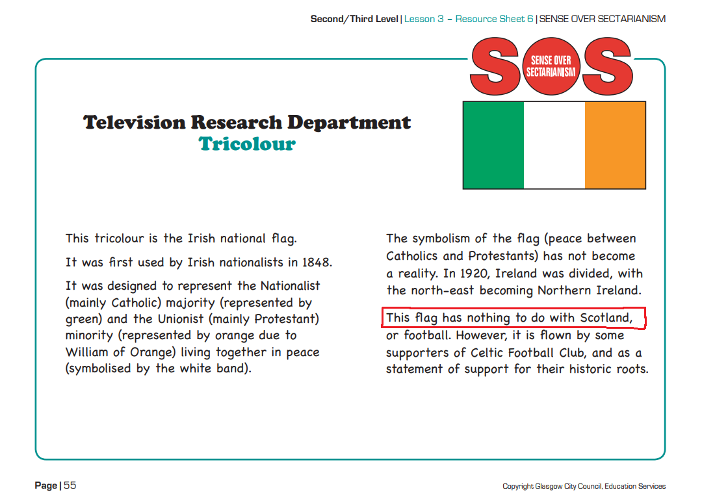

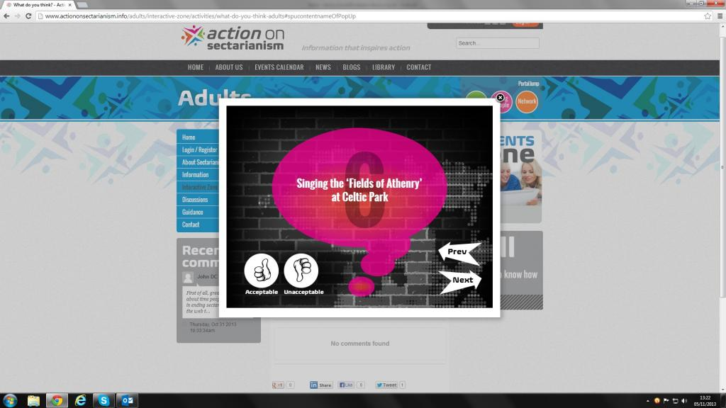

- The Irish community object in the strongest possible terms to educational resources which question our communities’ validity and cultural heritage. We call on the Special Rapporteur to remind Scotland’s statutory authorities that in seeking to respond to hatred towards our community we must not be identified as part of the problem because of our existence.

- The Irish community demand that resources which blame the Irish Catholic community in Scotland and their cultural characteristics for being in some way responsible for hatred towards our community and hate crime in general are removed immediately as appropriate resources to be used in Scotland’s schools.

- The Irish community endorse the recommendation put forward by the UN Committee on the Elimination of All Forms of Racial Discrimination that Scotland’s school curriculum should;
“Ensure that the school curricula across its jurisdiction contain a balanced account of the history of the British Empire and colonialism, including of slavery and other grave human rights violations”.
- This would include appropriate education resources which cover the history of An Gorta Mor and the movement of Irish refugees to Scotland.

- It must also recognise that Ireland was a colonial and imperial conquest of the British Empire in the same way as many other nations around the globe.

- At present the Scottish Government anti-racism in Education work to decolonise the curriculum and take account of grave human rights violations has had zero engagement with the Irish community despite repeated requests
Health and Justice
In 2016 and in relation to criminal justice, Catholics, a religious classification routinely conflated with Scotland’s multi-generational Irish diaspora, made up 14% of the national population but represented 23% of the prison population. This confirmed a trend identified by the Scottish Parliaments ‘Public Petitions Committee’ as far back as 2011.To support the links between socio-economic disadvantage, imprisonment and death those of Irish ethnicity in 2017 are significantly more likely to die from long term alcohol abuse. In short the issues facing individuals and communities who have self-identified under article 1 of ICERD to which Scotland has an international obligation cannot be progressed coherently via the imposition of misleading racial classifications predicated on a black / white binary or consumed into an enforced “sectarian” narrative predicated on a Catholic / Protestant binary.
- The Irish Community call on CERD to remind the Scottish Government of the specific institutionalised and structural nature of anti-Catholicism and anti-Irish racism in Scotland that is clearly identifiable in our communities continual experience of socio / economic disadvantage.

- The Irish Community call on CERD to recognise the Scottish specific issues of poverty, health and criminal justice inequalities faced by the Irish Catholic community clearly evidenced in independent academic and institutional research. In addition that to deal with these societal problems our community must be independently engaged and spoken to as with any other community in the creation and implementation of law and policy which directly affects our community.
- Experience during the Pandemic
On the 8th of July 2020 the National Records of Scotland published a report into rates of deaths as a result of covid and other deaths that had occurred in the period 12th March to the 14th of June 2020.
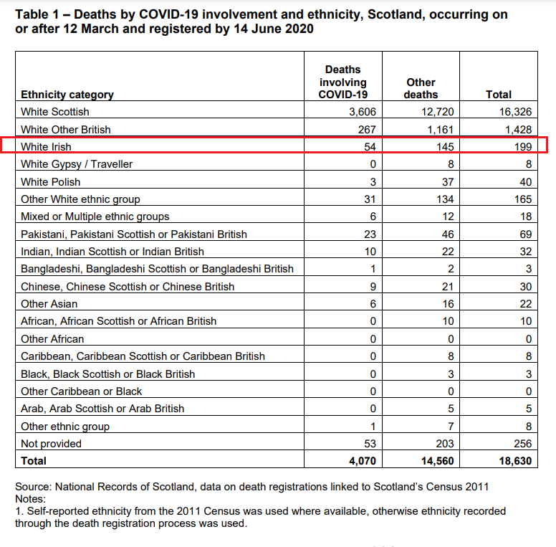

In late 2021 the Scottish Government published a further update on Covid mortality rates, excess deaths and disproportionate risks.
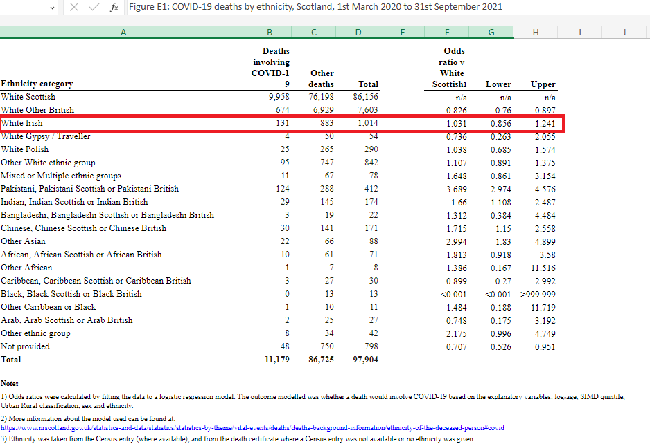

What is clearly identifiable in these figures is that the mortality rate from covid deaths and other deaths within the Irish community as this time was higher than any other ethnic minority group.
The methodology note in the report outlines that these figures were either derived from death registration certificates or 2011 census records. That is to say that either the individual themselves recorded their ethnicity as Irish in the 2011 census OR their family or health professional knowing them deeply or at the end of their life recorded their ethnicity as Irish on the death registration certificate.
The Irish mortality rate figures caused significant concern for The Irish community from both a health mitigation and social perspective. Our knowledge of the increased mortality risk for the elderly and isolated enhanced this concern. In addition, the Irish community were aware of pockets of elderly and isolated Irish and of Irish descent who reside across the city and particularly in areas that traditionally had huge Irish influx in the 1960’s,70 and 80’s.
On the 13th of July 2020 Ross Greer MSP asked a parliamentary question to the Scottish Government on the concerning covid mortality rates within the Irish community.
“To ask the Scottish Government what its response is to the findings of the National Records of Scotland that the Irish community has the highest COVID-19 fatality rate of any minority group in Scotland, and whether it plans further analysis to ascertain for what reasons this is the case”.
The Scottish Government Minister answered,
“We are deeply concerned by reports showing that people from some minority ethnic backgrounds have been disproportionately affected by COVID-19.
In order to improve our understanding of and respond to the risks and impacts, we have established an Expert Group Reference Group (ERG) on COVID-19 and Ethnicity, involving academic and experts, to consider the data and evidence and to challenge, inform and shape the Scottish Government’s future work. This will include how analytical partners across the Scottish Government, National Records of Scotland, Public Health Scotland and the NHS can improve and make the best use of data.
The recent report from National Records of Scotland on COVID-19 deaths by ethnicity, published on 8 July, starts to give us a better understanding. However, as highlighted in its methodology note , due to the degree of inconsistency in how individuals have reported, or have had reported on their behalf, their ethnicity, specifically between the “White Irish” and “White Scottish” categories over time and between datasets, it was not possible to carry out an analysis which would enable robust conclusions to be drawn on COVID-19 related mortality for the White Irish ethnic group”.
As the minister’s answer illustrates the Irish community covid mortality rates were disregarded because of what the Scottish Government considered to be a “degree of inconsistency in how individuals have reported”.
That is to say that the word of the deceased or close relative or health professional presumably following a conversation with their patient was not robust enough evidence.
Following these events Irish community organisation such as Call it Out, Comhaltas, Conradh na Gaeilge, GAA and Irish Traveller community reps wrote to the Scottish Government to demand recognition, further interrogation of the evidence and a guarantee that they would be consulted in Scottish Government policy development to mitigate the social, economic and cultural impact of the pandemic. The only further correspondence from the Scottish Government on Irish Covid mortality rates was a short email including a link to a further NRS publication that distanced NRS from their initial report.
As a result, the 199 Irish deaths between May and July 2020 catalysed no formal policy response of any kind.
Between July 2020 – September 2021 the number of deaths or excess deaths as a consequence of covid within the Irish ethnic group increased by over 800 individuals, the largest number of any ethnic group protected under CERD A1
- The Scottish Government thus far has excluded the Irish community from their main covid and ethnicity policy response to create an ‘Anti-Racism Observatory for Scotland’ on the basis that the Irish are ‘white’
- The Scottish Government has not commented publicly on these figures

The Menace of the Irish Race to the Scottish Nation – Church Nation and Committee Report 1923
List of themes in relation to the combined twenty-fourth to twenty-sixth periodic reports of the United Kingdom of Great Britain and Northern Ireland – Available here - https://tbinternet.ohchr.org/_layouts/15/treatybodyexternal/Download.aspx?symbolno=CERD%2FC%2FGBR%2FQ%2F24-26&Lang=en
Patricia Walls & Rory Williams (2003) Sectarianism at work: Accounts of employment discrimination against Irish Catholics in Scotland, Ethnic and Racial Studies, 26:4, 632-661 – Pg. 663 Para 2. “Much of the post-war academic and policy discussion around discrimination against Britain’s minorities has focused on racist discrimination from which the experiences of white groups such as the Irish are routinely excluded. This has resulted in the official and strategic submerging of Irish identity within a seemingly homogeneous ‘white’ ‘ethnicity”
Neeraj Bhala Genevieve Cézard Hester J.T. Ward Narinder Bansal Raj Bhopal, “Ethnic Variations in Liver- and Alcohol-Related Disease Hospitalisations and Mortality”: “The Scottish Health and Ethnicity Linkage on behalf of the Scottish Health and Ethnicity Linkage Study” (SHELS) Collaboration Alcohol and Alcoholism, Volume 51, Issue 5, 1 [2016], Pages 593–601: “Our data suggest that those of Irish ethnicity have persistently higher rates of alcohol and associated liver disease harms that require concerted action”.
Scottish Government, ‘Equality Evidence Finder’ (Summary: Ethnicity, May 14 2018) <https://www.gov.scot/Topics/People/Equality/Equalities/DataGrid/Ethnicity> accessed September 2018
Scottish Parliament 2011 (Offender Demographics and Sentencing Patterns in Scotland and the UK) Public Petitions Ctte. “there is strong evidence that Catholic disproportionality is primarily a result of the fact that most prisoners come from areas of deprivation and that Catholics in Scotland tend to be concentrated there”
https://www.youtube.com/watch?v=-ISrXeztkGE&t=1s
1923 Church and Nation Report – The Menace of the Irish Race to the Scottish Nation
These examples are high profile examples. Overwhelming amounts of anecdotal evidence has been provided to Call It Out by community members via email and at public meetings.
Patricia Walls & Rory Williams (2003) Sectarianism at work: Accounts of employment discrimination against Irish Catholics in Scotland, Ethnic and Racial Studies, 26:4, 632-661 – Pg. 663 Para 2. “Much of the post-war academic and policy discussion around discrimination against Britain’s minorities has focused on racist discrimination from which the experiences of white groups such as the Irish are routinely excluded. This has resulted in the official and strategic submerging of Irish identity within a seemingly homogeneous ‘white’ ‘ethnicity”
Neeraj Bhala Genevieve Cézard Hester J.T. Ward Narinder Bansal Raj Bhopal, “Ethnic Variations in Liver- and Alcohol-Related Disease Hospitalisations and Mortality”: “The Scottish Health and Ethnicity Linkage on behalf of the Scottish Health and Ethnicity Linkage Study” (SHELS) Collaboration Alcohol and Alcoholism, Volume 51, Issue 5, 1 [2016], Pages 593–601: “Our data suggest that those of Irish ethnicity have persistently higher rates of alcohol and associated liver disease harms that require concerted action”.

