Lawyers HK Limited
Room 2507, Tower 1, Lippo Centre, 89 Queensway, Hong Kong



Written Submissions by Lawyers HK for the 85th Session of the Committee on the Elimination of Discrimination Against Women – Hong Kong, China

Background of Lawyers HK

Lawyers HK is a volunteer group with over 400 solicitors, barristers, in-house counsels and other members of the legal industry based in Hong Kong. Our main objective is to uphold the rule of law in Hong Kong through education and other means. We are also a registered charitable organization with the objective of relieving poverty and helping the underprivileged.

This written submission is based on the personal experience of members of Lawyers HK: including an Executive Director of a well-established Chinese financial institution and the other being a partner of an international law firm. The focus of this submission is naturally on gender equality of the legal sector in Hong Kong and how the implementation of the Convention on the Elimination of All Forms of Discrimination against Women (CEDAW) by the Hong Kong Government has enabled women to develop careers in the legal sector irrespective of their gender and family status, while protecting reproductive rights.

Gender Ratio in the Legal Sector in Hong Kong

The legal sector in Hong Kong has traditionally been dominated by male, especially at the senior level of the profession. The main reason was insufficient work flexibility for women practitioners to simultaneously cope with the demands of long working hours and the need to take care of family. Another reason was that older generation females generally had a smaller chance of receiving education when they were young. Among the female population in Hong Kong aged 15 and over in 1991, 56.5% had attended secondary education and above, as against 65.3% for their male counterparts. The corresponding proportion for females and males in 2021 were 79.4% and 85.4%. Along with the increase in educational opportunities for females in Hong Kong, the difference in educational attainment between females and males had narrowed in the past 3 decades or so. Interestingly, student admission in universities in Hong Kong in recent years has shown a higher proportion of females. For example, in the academic year 2021/2022 for the University of Hong Kong, the gender ratio of female to male was 1 : 0.7

The proportion of admission of female solicitors is also on a rising trend. In 2012, the proportion of admission of female solicitors to male solicitors was 52% to 48%, and the proportion in 2021 was 64% to 36%. The proportion of female solicitors as Partners in law firms is on a clear rising trend from 26% in 2016 to 30% in 2021.

Admission of Solicitors (2012 – 2021)

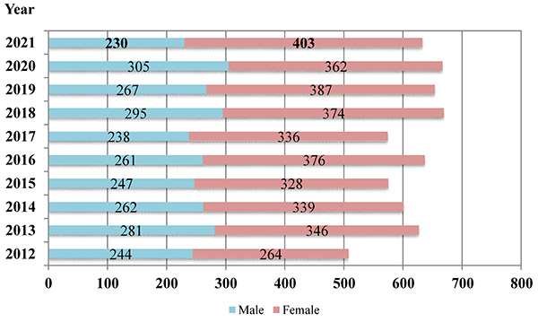

Gender Ratio – Solicitors Holding a Practising Certificate (2014 – 2021)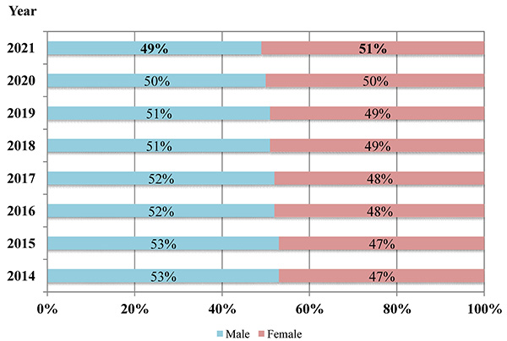

Gender Ratio – Partners (2016 – 2021)

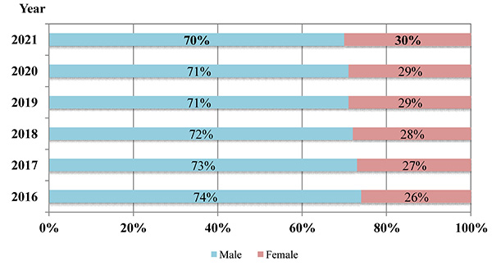

Reasons for Increased Opportunities for Women in the Legal Sector in Hong Kong

- Increased education opportunities – Hong Kong has extended our 9-year free education (which was put in place under British colonial government in 1978) to a 12-year free education to cover senior secondary education (which was put in place since 2008 by the post-1997 government of the Hong Kong Special Administrative Region). Furthermore, schooling is compulsory between the ages 6 to 15 (primary to junior secondary school). This created a more equal education foundation for females to compete in what a traditionally male-dominant society. As can be seen in the statistics of the University of Hong Kong, student admission in universities in Hong Kong in recent years has shown a higher proportion of females.

- Legal framework – various legislations are in place in Hong Kong to empower females to develop their career and while taking care of their families:
  - Family Status Discrimination Ordinance – the Ordinance addresses the needs of workers with family responsibilities such as taking care of children and elderly parents. To alleviate the difficulties in trying to balance the demands of work and family, the Ordinance makes it unlawful for anyone or any organization to discriminate against a person on the basis of family status. Employment is one of the 7 protected areas.
  - Extended maternity leave. In 2020, the period of statutory maternity leave has been increased from 10 weeks to 14 weeks. Many international firms operating in Hong Kong offer longer period of maternity leave.
  - Sex Discrimination Ordinance – it is unlawful under the Ordinance to discriminate a person on the grounds of sex, marital status, pregnancy in employment and education, amongst other prescribed areas of activities.
  - Since 19 June 2021, amendment to the Sex Discrimination Ordinance came into effect making it illegal to discriminate against breastfeeding women in the workplace. It is unlawful for an employer to treat a female employee less favourably because she is breastfeeding in specified situations under the law.

- Awareness on the importance of maintaining gender equality – many international and also local law firms operating in Hong Kong have zero tolerance for gender discrimination, and there are in place policies on gender equality and equal opportunities at the workplace. As gender imbalance historically has been, and remains, in favour of men (in labour intensive industry and entries to professions that required extensive and sometimes expensive schooling, including in the legal industry), many law firms have policies on empowering female career advancement. As described by one of our members, in the firm that she is working at, there are policies in place to increase female representation at all levels, particularly for admission into the law firm partnership; to apply gender balance principles across lawyers’ life-cycle for recruitment, performance reviews, talent identification, development and succession planning; to run business-led sponsorship programmes and mentoring to build and progress female talent. She has had personal discussions with the female talents at her firm at all levels and was glad to hear that none of them feel that they had been disadvantaged at workplace because of their gender.

- Support by domestic helpers – In Hong Kong, it is possible to find domestic live-in help at affordable prices. Similar to other jurisdictions in Asia (including Singapore and Malaysia etc.), Hong Kong is open to foreigners who wish to come to work including to provide domestic assistance, which includes household duties and caring duties for the young and the old. The domestic helper has traditionally been credited for boosting female participation in the workforce, and whilst the majority of foreign domestic helpers coming are female, this also empowers female in foreign countries to find gainful employment and international work experience.

Personal Experience of Working Moms in Hong Kong

Motherhood itself is often described as a full-time job. Add employment (full-time or otherwise) into the mix often results in a challenging set of circumstances that often lead to stress, reduced career aspirations or outright burn-out. The below does not purport to represent all working mothers in the legal profession, but from personal experience of our members, the legal profession has been relatively supportive of gender equality for young mothers trying to juggle children and a career. Based on personal experiences, Hong Kong is one of the friendliest places to work (comparing amongst major international cities like London, Tokyo and Hong Kong) as a young mother. There are a few reasons for this:

- As mentioned above, Hong Kong mothers benefit from being able to find live-in help at relatively affordable prices. This is the essential building block that permits a young female lawyer to continue to develop her career, even whilst being a mother at the same time. The benefit of and contribution by empowered imported female workers also transcends into and help female in other professions and industries.

- Hong Kong is a compact city, so it is very convenient for getting around and meeting clients and attending events and home chores, and it is possible to achieve a lot with less time, thanks to the public transportation and smart infrastructure of the city.

- Hong Kong’s culture is where East meets West, with influences from western values as well as traditional Chinese values. Whilst traditional Chinese culture with a large population and thousands of years of farming-based economy was male-centric, in Hong Kong, this has evolved over the years with increased respect towards female, beyond female’s traditional role as a mother and carer in the family, but as an equal partner in family and in society.

- Generally speaking, the legal profession is quite progressive in supporting working mothers. At international law firms, multi-national and large local corporates / financial institutions in Hong Kong, maternity leave of up to 4 months is not uncommon, with the workplace willing to accommodate flexibility in working hours and work from home arrangements, etc.

Whilst the above is not prescribed by the law, it is nevertheless demonstrative that at a certain cultural and social level, there is no impediment (and there is indeed support) to providing support to working mothers as a means to support gender equality.

Conclusion

Hong Kong has evolved a lot in terms of gender equality over the years. With improved access to higher education for females over the years, this has led to the flourishing of the legal sector where female participation has been on a steady rise in the past years. The Hong Kong Government has implemented various legal bills to promote and support equality between genders in the city. These changes in law also reflect practices in the market: companies in Hong Kong (large and small, with or without international presence) are known for the progressive policies towards support for women’s rights. It is a reflection of the development of the Hong Kong society as a whole that the city’s culture and attitudes are generally friendly towards women rights.

Lawyers HK Limited
Dated this 11th day of April 2023



Gender issues | Hong Kong Lawyer (hk-lawyer.org)
Paragraph 3.3 of Women and Men in Hong Kong Key Statistics, 2022 Edition published by the Census and Statistics Department of the Hong Kong Government (Women and Men in Hong Kong Key Statistics 2022 Edition 香港的女性及男性 主要統計數字 2022 年版 (censtatd.gov.hk)
Overview - 綜覽 | QuickStats | The University of Hong Kong (hku.hk)
Profile of the Profession | The Law Society of Hong Kong (hklawsoc.org.hk)

