PERU
SUBMISSION TO THE uNITED nATIONS COMMITTEE ON ECONOMIC, SOCIAL AND CULTURAl RIGHTS
77th session, 10 to 28 february 2025
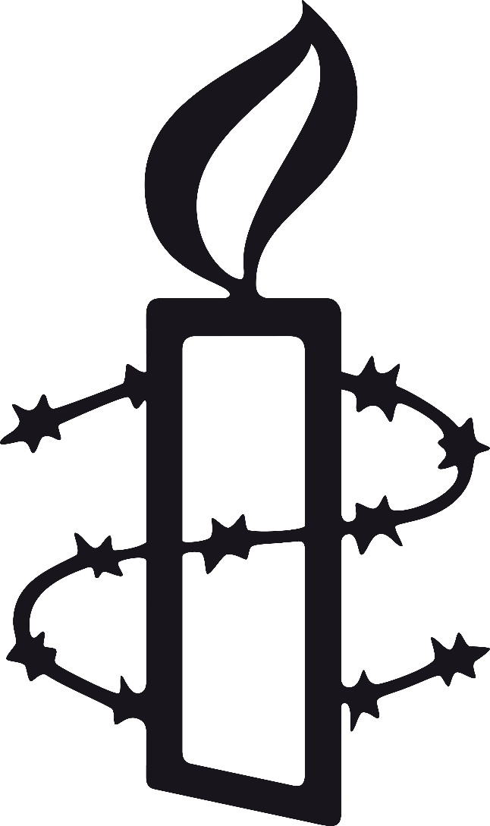
CONTENTs

1. introduction 3

2. MáximUM AVAILABLE reSOurCEs (art. 2.1) 3
2.1 Resources allocated to the health system 3
2.2 Tax collection and inequality 4
2.3 Recommendations 4

3. RIGHT TO PHYSICAL AND MENTAL HEALTH (art. 12) 5
3.1 Availability 5
3.2 Accessibility 6
3.3 Quality and acceptability 7
3.4 Recommendations 8
Amnesty International is submitting the following information to the United Nations Committee on Economic, Social and Cultural Rights ahead of the February 2025 fifth periodic review on Peru. It sets out the organization's key concerns regarding access, protection and guarantee of certain economic and social rights within the country, in particular the right to health.

- introducTIOn
Amnesty International is submitting the following information to the UN Committee on Economic, Social and Cultural Rights ahead of the February 2025 fifth periodic review on Peru. It sets out the organization's key concerns regarding access, protection and guarantee of certain economic and social rights within the country, in particular the right to health. This is not an exhaustive list of issues.
- MAximUM AVAILABLE reSOURCEs (art. 2.1)
  - RESOURCES ALLOCATED TO THE HEALTH SYSTEM
Over the past 25 years, Peru's public sector has increased its share of total health expenditure from 51% in 2007 to 61% in 2022. However, this amount is not enough: according to the latest World Health Organization (WHO) data for 2021, government spending, both directly and through social security, is equivalent to only 4% of GDP (see Figure 1), 2% below the minimum recommended by the WHO and the Pan American Health Organization (PAHO) to ensure universal coverage.
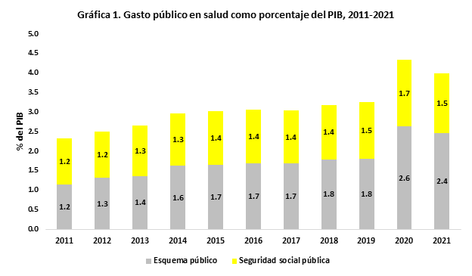
In its report Peru: The right to health, a privilege for the few, Amnesty International identified important gaps in the investment of budgetary resources at the regional and system levels. Although the number of people covered by the Ministry of Health's comprehensive health insurance scheme (Sistema Integral de Salud, SIS) is three times greater than those covered by EsSalud, public spending on government subsidiary schemes is only 1.6 times greater than on public social security.

  - TAX COLLECTION AND INEQUALITY
The Peruvian tax system does little to reduce inequality. The reasons for this include low revenue collection, taxes that are not sufficiently progressive, and institutional health and social protection policies that are not designed to significantly reduce inequality. This is reflected in the fact that pre-tax inequality is practically the same as inequality after tax collection and public spending allocation by the government. In terms of the Gini coefficient, the redistributive effect of social policy comparing market and disposable income after taxes and transfers is approximately 1%, which explains the low impact on economic inequality. While this reduction is within the average for Latin America and the Caribbean, it is also almost half of what Brazil, Argentina and Uruguay managed to reduce in 2014.
In terms of fiscal progressivity, Peru relies on indirect taxes, which have a disproportionate impact on lower-income earners, the majority of whom are women, while wealth taxes, which have a greater redistributive potential, are not used to mobilize the maximum available resources. In 2021, Peru collected 17.9% of GDP in taxes. Of this, almost half (8.5% of GDP) were taxes on consumption, while income tax and property tax were only 7.3% and 0.4% respectively, the latter being a highly progressive tax that contributes 1% of GDP on average in Latin America.
This makes for a high concentration of wealth in the Peruvian economy. According to the latest available figures, 1% of the population enjoys almost a third of the country's income, while the poorest 50% holds only 6% of total income.
  - RecoMmendaTions
Amnesty International recommends that Peru, through its Ministry of Economy and Finance, should:
- Take the necessary budgetary measures, gradually and based on equity criteria, to ensure that public spending on health, particularly that of the Ministry of Health which serves the majority of the population, reaches the minimum level recommended by the WHO for Latin America, namely 6% of GDP in public spending on health.
- Adopt fiscal and budgetary measures to ensure, based on progressivity criteria, that fiscal policy has a greater redistributive impact, and guarantee that public spending is consistent with the objective of allocating the maximum available resources.

- RIGHT TO PHYSICAL AND MENTAL HEALTH (art. 12)
Amnesty International believes that there are clear inequalities in access to health services in Peru in terms of availability, accessibility, acceptability and quality, particularly affecting people from historically marginalized groups and those living in the country's rural communities. In its report Peru: The right to health, a privilege for the few, the organization analysed these four elements of the right to health with the aim of providing a comprehensive assessment of the Peruvian health system, focusing especially on the departments of Lima and Ayacucho.
  - AVAILaBILITY
In terms of availability, Amnesty International considers that Peru has the opportunity to achieve a level of progress similar to that of other countries with a comparable level of human development and in line with the standards set by the WHO. The organization based its analysis on indicators such as available beds, medicines and medical staff, and compared these with other countries at similar levels of human development.
According to the WHO, Peru has 16 hospital beds per 10 000 population, similar to other countries of the region with a comparable level of development, such as Ecuador, Dominican Republic or Colombia. However, its bed availability is relatively low compared to countries such as Brazil or Cuba and much lower than other Asian or European countries with similar levels of human development, such as Macedonia, Sri Lanka or Moldova. In recent years, the number of beds in Peru has grown only slightly, from 15.4 in 2011 to 16 in 2021.
At the regional level, there are disparities in the availability of hospital beds. According to the same report, while the national average is 9.4 beds per 10 000 inhabitants, the department of Tumbes has less than one bed per 10 000 inhabitants and Cusco only 2.7, while the department of Callao has 15.7 beds per 10 000 inhabitants.³
Using the Unique National Health Information Repository (REUNIS) from the Ministry of Health (MINSA), Amnesty International found significant disparities in the availability of hospital beds at department level. While the national average registered is 9.4 beds per 10 000 inhabitants, departments such as Lima concentrate 43% of all registered beds, despite having only 33% of the national population, while other departments such as Ayacucho register an average of 8.6 beds per 10 000 inhabitants, which is lower than the national average.
Based on data from the Ministry of Health, Amnesty International calculated the number of facilities by type of care at the department level and found that a significant percentage of the more specialized facilities with inpatient services (secondary and tertiary care) are concentrated in the department of Lima. In the case of the more specialized tertiary services, there are 16 departments with no available facilities (including Ayacucho), where the population may face problems of access and referral to these services.
In the case of the department of Ayacucho, information gathered from interviews conducted by Amnesty International consistently showed that the lack of specialized hospitals and medical specialists was a major barrier affecting not only the availability of health services in the community, but also the quality of services and waiting times.
In terms of human and material resources, according to those interviewed by Amnesty International, the lack of availability of medicines, treatments and/or equipment is one of the main barriers to accessing health services. Health workers interviewed confirmed that shortages not only of medicines but also of health equipment mean that patients are forced to seek services in the private sector through out-of-pocket payments rather than through insurance schemes, which affects the availability and affordability of health services.
As a result of such barriers to the availability and supply of medicines, one of the most common strategies used by those interviewed is to resort to self-medication or to seek treatment from medical professionals in pharmacies. This practice often arises as a response to the immediate need to treat symptoms of illness.
Finally, with regard to health professionals, Amnesty International carried out a comparative analysis of the number of medical and nursing staff per 10 000 inhabitants. In 2021, Peru had only 16.2 doctors per 10 000 inhabitants, which is relatively low compared to countries of the region with a similar level of development, such as the Dominican Republic, Ecuador, Brazil or Colombia.
  - AccesSibiliTY
Amnesty International analysed physical accessibility at national and department level, using the Demographic and Family Health Survey (ENDES) and the Regional System for Decision Making of the National Institute of Statistics and Informatics. A geographical analysis of physical accessibility at department level revealed significant disparities between regions. In the department of Lima, a lower percentage of women report problems of distance (39.9%) and transport (37.9%) to the health facility than in Ayacucho, where almost half of all women (45%) report problems of distance and transport. This difference is greater when considering only the metropolitan area of Lima, where the percentage for both indicators drops significantly due to the concentration of services at different levels of care.
The existence of remote communities, often located several hours away from the nearest health facility, is a significant barrier to accessing health care. Access to health in hard-to-reach geographical areas presents significant challenges that directly affect the ability to provide adequate care to the population. Interviews with health providers conducted by Amnesty International in the city of Ayacucho highlighted the difficulty of accessing diverse and remote geographical areas. In this sense, inadequate access to health care results from the significant geographical isolation that characterizes these areas.
Barriers to physical access are also linked to social and economic inequalities. While nationally only 4.6% of patients who did not seek health care cited distance to the health centre as a reason, this percentage rises to almost 18% in less densely populated rural areas and to 12.8% for people living in extreme poverty.
Amnesty International has also analysed access to health care in Peru from a financial perspective. Despite the existence of a universal insurance law that covers a range of medicines, illnesses and treatments specified in the Essential Health Insurance Plan, the reality for many people in Peru is that treatment and tests for a number of conditions must be paid through out of pocket, either because of barriers to access within the system or because their insurance does not cover such conditions.
Pursuant to the interviews carried out by Amnesty International, one of the main concerns is that this financial burden can limit access to essential services, especially for those with limited financial resources. Health expenditure can become a significant barrier, affecting equity in access to medical care.
According to the latest data on the Sustainable Development Goals, the proportion of households reporting expenditure of over 10% of their total income on health has increased in recent years, from 8% in 2017 to 12.6% in 2021. Similarly, the proportion of households reporting expenditure of more than 25% of their income on health has increased from 0.8% to 2% of the population over the same period.
There are significant inequalities in terms of out-of-pocket expenditure. Based on the qualitative and quantitative analysis carried out for the report Peru: The right to health, a privilege for the few, Amnesty International considers that the principle of equity is not met in terms of economic access, as the poorest households face higher expenditure as a proportion of their income. Moreover, the lack of availability of medicines that should be free of charge under national legislation results in significant expenses for Peruvian households.
  - QUALITY AND ACCEPTABILITY
On the issue of quality and acceptability, Amnesty International found several barriers affecting access to health services based on a lack of gender awareness. Those interviewed by Amnesty International for its report Peru: The right to health, a privilege for the few describe issues in the way women are treated in centres for the diagnosis and treatment of diseases such as cervical cancer. In addition, there is a perception of mistreatment and minimization of the concerns of women patients in both the private and the public sectors.
Gaps remain in the diagnosis of illness affecting women. Only 44% of women aged 30-59 have been screened for cervical cancer in the last three years, despite the high incidence of this cancer in the country. The department of Lima has one of the highest rates for this indicator (with 50% of women screened), but other departments – including Ayacucho – have lower screening rates than Lima (both the department and the capital).
Amnesty International has found, on the basis of the interviews it has carried out, that there are significant barriers in terms of awareness in health services. Respondents provided examples of lack of gender awareness, in breach of the Peruvian state's international obligations to eradicate all forms of discrimination against women.
On the issue of discrimination, as one of the findings of the above-mentioned report, Amnesty International received several testimonies of perceived racism and discrimination against people who were injured or had family members injured during the Ayacucho protests. The constant presence of the military, not only during the political crisis of December 2022, but throughout the lives of those interviewed in Ayacucho, reveals a situation of deep-rooted fear and mistrust among the population. According to the National Survey on Perceptions towards Cultural Diversity and Ethnic-Racial Discrimination carried out by the Peruvian Ministry of Culture, it is most frequently in public hospitals or health centres that people suffer discrimination, with 22% of respondents reporting that they had been discriminated against there.
The working conditions of health workers were mentioned as one of the most common barriers by those interviewed, with testimonies that salary levels, lack of job security and the need for training undermine the commitment of health workers by forcing them to undertake other activities, potentially affecting patient care.

  - RecoMmendaTions
Amnesty International recommends that Peru should,
Through its Ministry of Health:
- Ensure that health services, and the underlying determinants of health, such as racial and gender equity, education, housing and food and nutrition, are available and accessible without discrimination to marginalized groups, in particular women, Indigenous or racialized populations and older persons, among others.
- Take appropriate action to develop a medium-term strategy for public investment at the department level in strategic areas that can provide specialized services (particularly level III-E) to several departments.
- Increase and strengthen collaboration agreements between the main insurance schemes, SIS and EsSalud, to progressively integrate patient demand and referrals in rural areas or areas with high levels of poverty and marginalization.
- Take steps at the national level to improve the accessibility, availability, and acceptability of services for women, in particular cancer screening services.
- Review SIS and EsSalud training programmes and protocols for health staff, both in terms of design and implementation, to ensure that the quality and acceptability of health services for marginalized populations such as women and Indigenous, rural and peasant populations are based on the needs of patients.
- Take appropriate measures to train medical staff with a view to reducing and mitigating racism and discrimination in access to health services, which constitute a barrier to accessing acceptable and quality health care.
Through its Ministry of Health and Ministry of Economy and Finance:
- Take appropriate programme, budgetary and fiscal measures to reduce the disproportionate burden of out-of-pocket expenditure on the poorest households and facilitate access to medicines, treatments and studies, as contemplated under the Essential Health Insurance Plan.


Amnesty International is a movement of 10 million people which mobilizes the humanity in everyone and campaigns for change so we can all enjoy our human rights. Our vision is of a world where those in power keep their promises, respect international law and are held to account. We are independent of any government, political ideology, economic interest or religion and are funded mainly by our membership and individual donations. We believe that acting in solidarity and compassion with people everywhere can change our societies for the better.


info@amnesty.org

facebook.com/
AmnistiaAmericas

@AmnistiaOnline

Except where otherwise noted, content in this document is licensed under a Creative Commons (attribution, non-commercial, no derivatives, international 4.0) licence (see creativecommons.org/licenses/by-nc- nd/4.0/legalcode).
Where material is attributed to a copyright owner other than Amnesty International, this material is not covered by the Creative Commons licence.
For more information, visit the permissions page on Amnesty International's website.
amnesty.org

Amnesty International
Peter Benenson House
1 Easton Street
London WC1X 0DW, UK

Contact

Index: AMR 46/8866/2024
Publication: December 2024
Original language: Spanish
© Amnesty International 2024

Amnesty International. Perú: Derecho a la salud, Privilegio de pocos: Análisis del sistema de salud desde un enfoque de derechos humanos [Peru: The right to health, a privilege for the few. Analysis of the health system from a human rights perspective]. AMR46/ 8603/2023. 29 October 2024. Available at: https://www.amnesty.org/es/documents/amr46/8603/2024/es/. p. 29.
Pan American Health Organization. Fiscal Space for Health in Latin America and the Caribbean. 2020. https://iris.paho.org/handle/10665.2/52410, pp. 11-12. See also: WHO, Exploring the thresholds of health expenditure for protecting against financial risk. 2010. https://cdn.who.int/media/docs/default-source/health-financing/whr-2010-background-paper-19.pdf
Amnesty International. Perú: Derecho a la salud, Privilegio de pocos, previously cited, pp. 26-32.
Amnesty International, Unequal and Lethal (Index AMR 01/5483/2022), 27 April 2022, https://www.amnesty.org/en/documents/amr01/5483/2022/en/, p. 69. See also: Nora Lusting, Inequality and Fiscal Redistribution in Middle Income Countries: Brazil, Chile, Colombia, Indonesia, Mexico, Peru and South Africa in de Gruyter JGD 2016. Vol 7. pp. 17-60, https://www.bing.com/ck/a?!&&p=f1bcba4d234ac7f46d2f8f9fbbfb56677bcbad044e75a2a38b341261e3cf087bJmltdHM9MTczMjQ5MjgwMA&ptn=3&ver=2&hsh=4&fclid=26bb7490-987a-6f93-0582-604b99d46e67&psq=Lustig+2016+inequality+gini&u=a1aHR0cHM6Ly93d3cuZGVncnV5dGVyLmNvbS9kb2N1bWVudC9kb2kvMTAuMTUxNS9qZ2QtMjAxNi0wMDE1L3BkZg&ntb=1
The Gini coefficient is the measure of inequality within a country. The coefficient is measured on a scale of 0 to 1: a greater concentration of income is shown by values closer to 1, while a more equal distribution of income is shown by values closer to 0.
Amnesty International, Unequal and Lethal (Index AMR 01/5483/2022), 27 April 2022, https://www.amnesty.org/en/documents/amr01/5483/2022/en/, p. 69. See also: Juan Pablo Jiménez. Desigualdad, concentración del ingreso y tributación sobre las altas rentas en América Latina [Inequality, income concentration and taxes on high income in Latin America], April 2015, https://www.cepal.org/sites/default/files/publication/files/37881/S1420855_es.pdf, pp. 25, 26.
OECD. OECD Data. Accessed on 27 November 2024. Available at: https://data-explorer.oecd.org/vis?tenant=archive&df[ds]=DisseminateArchiveDMZ&df[id]=DF_RS_GBL&df[ag]=OECD&dq=...&lom=LASTNPERIODS&lo=5&to[TIME_PERIOD]=false
CEPAL. CEPALSTAT. Portal of inequalities in Latin America, Share of the 1% with the highest income and the 50% with the lowest income in the Gross National Income. Accessed on 25 November 2024. Available at: https://statistics.cepal.org/portal/inequalities/incomes.html?lang=en&indicator=4665
Amnesty International. Perú: Derecho a la salud, Privilegio de pocos, previously cited, p. 4
World Health Organization, The Global Health Observatory. Hospital beds (per 10 000 population), estimates calculated by Amnesty International using the source database, https://www.who.int/data/gho/data/indicators/indicator-details/GHO/hospital-beds-(per-10-000-population) (accessed 16 May 2024).
World Health Organization, The Global Health Observatory. Hospital beds (per 10 000 population), estimates calculated by Amnesty International using the source database, https://www.who.int/data/gho/data/indicators/indicator-details/GHO/hospital-beds-(per-10-000-population) (accessed 16 May 2024).
Ministry of Health. Unique National Health Information Repository, https://www.minsa.gob.pe/reunis/data/Monitoreo_Sistema_HISMINSA.asp (accessed 20 May 2024).
Ministry of Health. Unique National Health Information Repository, Availability of hospital and ICU beds dashboard. Available at: https://www.minsa.gob.pe/reunis/data/Monitoreo_Sistema_HISMINSA.asp (accessed 20 May 2024).
World Health Organization, The Global Health Observatory. Medical doctors (per 10 000 population), estimates calculated by Amnesty International using the source database, https://www.who.int/data/gho/data/indicators/indicator-details/GHO/medical-doctors-(per-10-000-population) (accessed on 16 May 2024).
National Institute of Statistics and Informatics, Regional Information System for Decision Making, https://systems.inei.gob.pe/ SIRTOD/app/consulta (accessed 24 May 2024)
Ibidem.
United Nations Development Programme, Peru: Sustainable Development Goals: 3 Health and well-being, https://peru.un.org/es/sdgs/3/progress#sdg-tab-content (accessed 25 May 2024).
Amnesty International. Perú: Derecho a la salud, Privilegio de pocos, previously cited, pp. 58-63.
Amnesty International. Perú: Derecho a la salud, Privilegio de pocos, previously cited, pp. 68-72.
Based on information from the Regional Information System for Decision Making.
Amnesty International. Perú: Derecho a la salud, Privilegio de pocos, previously cited, p. 5.

