Submission to the Committee on the Elimination of Racial Discrimination (CERD) on Iran’s Measures for protecting children's rights and eliminating discrimination against them
The Islamic Republic of Iran
113th Session (05 Aug 2024 - 23 Aug 2024)

Presented by: Institute of Sustainable Development
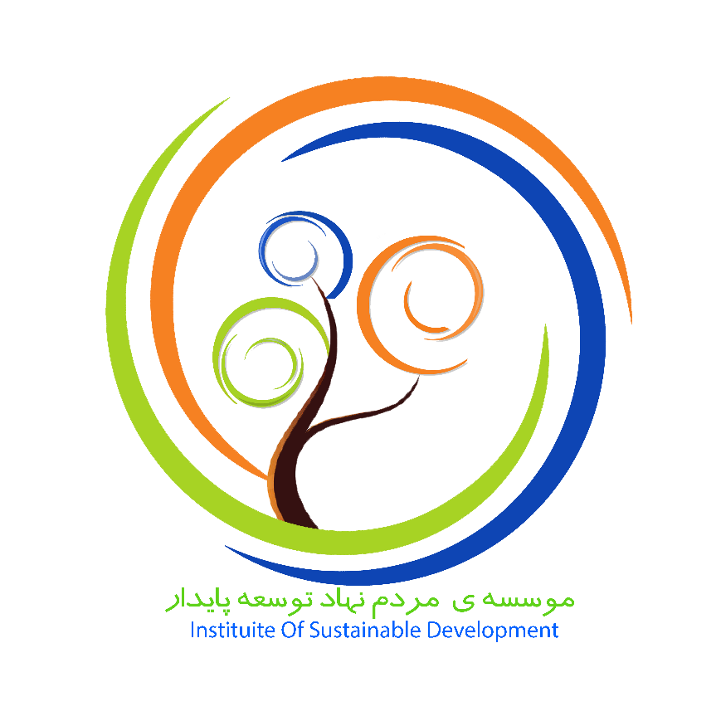
Email: info@isdngo.com
Website: www.isdngo.com
Executive Director: Zahrasadat Malekjafarian

About ISD:
Institute of Sustainable Development (ISD), as an NGO working in the field of human rights and Sustainable Development, has prepared this report to submit to the 113th meeting of the Committee on the Elimination of Discrimination.

Introduction
The protection of children's rights is a fundamental responsibility that transcends borders and cultures, requiring comprehensive legislation, dedicated actions, and special measures. Recognizing the intrinsic value of children as the foundation of a thriving society, it is imperative to establish and enforce laws that safeguard their well-being and promote their development. This report emphasizes the critical need for tailored interventions to protect children’s rights, ensure their access to quality education, and provide robust support for street children and etc.
In recent years, the importance of children's rights in Iran has gained significant attention. The government, particularly under the administration of the Thirteenth President, has undertaken substantial efforts to enhance the legal and protective framework for children. These initiatives reflect a deep commitment to fostering a safe and nurturing environment for every child.
To combat violence against children, numerous policies and programs have been implemented, aiming to create a secure atmosphere both at home and in educational institutions. Ensuring access to education has also been a priority, with strategic plans to increase school enrollment and reduce dropout rates. Furthermore, specific measures have been introduced to support street children, providing them with essential services and opportunities to reintegrate into society.
It underscores the urgent need for ongoing attention to children's rights and the significant progress made in Iran. By examining these efforts, this report highlights the positive strides taken and identifies areas where further improvements are necessary to ensure that all children can enjoy their rights to the fullest.
Iran’s Measures in the Field of Children’s Rights under Article 5
Iran’s Efforts and Initiatives in the Past Four Years to Support Children’s Rights
In the past four years, Iran has made significant strides in supporting children's rights through a range of initiatives and efforts. These actions have focused on creating a safer environment for children, ensuring their access to education, and providing specialized support for vulnerable groups such as street children. In the following, some of these efforts and initiatives will be highlighted.
- Issuance of the "National Document on the Rights of Children and Adolescents" by the President: The President of the Supreme Council of the Cultural Revolution has officially issued the "National Document on the Rights of Children and Adolescents," which was approved in the 806th session of the Supreme Council of the Cultural Revolution on April 10, 2018. This document addresses the necessity of having a unified and cohesive framework that outlines the principles, policies, and legal foundations regarding children’s rights in educational, cultural, health, judicial, and legal dimensions. It aims to create consensus and unity among officials and the Islamic system.
- Bill for the Special Police for Children and Adolescents: The bill for the establishment of a Special Police for Children and Adolescents, consisting of 49 articles and 6 chapters, was drafted and approved by the Cabinet on April 25, 2021. This bill was subsequently submitted to the Islamic Consultative Assembly (Parliament) on May 16, 2021, for further approval by the Judicial Commission. The bill has been referred to a specialized working group for more detailed examination. According to the spokesperson of the Judicial Commission of the Islamic Consultative Assembly, approximately half of the bill has already been reviewed by the commission.
- Initiatives to Protect Children in the Digital Space: The Secretary of the National Authority for the Convention on the Rights of the Child emphasized the importance of how children utilize digital spaces, noting that the risks they face online are no less significant than those in the physical world. The issues of child bloggers and child models in these spaces highlight the direct and indirect violations of their rights, with some children becoming victims in the digital environment. To address these concerns, a working group for the protection of children in cyberspace was established in collaboration with the Social Affairs and Crime Prevention Deputy of the Judiciary and the Supreme Council of Cyberspace. Comprehensive studies were conducted, resulting in the drafting of a bill with about 12 detailed articles aimed at filling the legal gaps in the domain of cyberspace.
- Organizing and Supporting Street Children: Street children are among the most prominent examples of the lack of effective parental care and are highly vulnerable to various social harms. These children either lack families or come from economically and culturally deprived backgrounds. To support working and street children, The Secretary of the National Authority for the Convention on the Rights of the Child stated that a pilot project was conducted with the assistance of volunteer groups, academic institutions, and non-governmental organizations. This initiative has successfully provided coverage and support to approximately four thousand children.
- Amendment of the Executive Regulations for the Law on Orphaned and Abandoned Children: The Secretary of the National Authority for the Convention on the Rights of the Child identified the strategic support for at-risk and vulnerable children as one of the major policies in the field of children's rights. He emphasized that the support chain for children and adolescents is deeply connected to issues of orphanhood and inadequate parental care. Thus, addressing orphanhood is the first priority, followed by inadequate parental care. The Deputy Minister of Justice noted that the executive regulations for the Law on Orphaned and Abandoned Children have been amended in collaboration with the Welfare Organization and the Ministries of Interior and Cooperatives, Labor, and Social Welfare. According to the amendments, the Welfare Organization is now authorized to place orphaned children, who have been referred to the organization by the judiciary, into families under specific conditions during their stay in care centers.
- Establishment of Educational Justice Centers in the Ministry of Education: The Secretary of the National Authority for the Convention on the Rights of the Child emphasized the right to education for children and supporting those who have survived education gaps. He highlighted that the enrollment rate of children in primary schools exceeds 98%, with a dropout rate of less than 2% in primary education. This demonstrates that with continued educational support, these children can easily continue their education until the end of secondary school. He further stated that non-discrimination in enrollment and education are two crucial pillars for supporting children in realizing their right to education, both of which must be addressed to achieve educational justice. In this regard, Educational Justice Centers have been established within the Ministry of Education to facilitate this goal.
These efforts represent notable initiatives by the Islamic Republic of Iran in support of children's rights. These endeavors must continue and further proposals should be presented to enhance conditions for children. Continued commitment to these goals is essential to ensure ongoing progress and safeguard the rights of all children effectively. Here ten recommendations are presented:

Recommendations:
- Enhance Support for Street Children: Iran has initiated programs to support street children, collaborating with volunteer groups and NGOs. Continued efforts are necessary to expand coverage and improve services for these vulnerable children.
- Promote Family-Centered Support: Iran has emphasized family-centric support as a fundamental principle in protecting children's rights. Policies should continue to prioritize strengthening family support systems and preventing child neglect and abandonment.
- Enhance Legal Frameworks for Children's Rights: The development of comprehensive legal frameworks, such as the National Document on the Rights of Children and Adolescents, reflects Iran's commitment to children's rights. Continuous updates and enforcement are essential to address evolving challenges and ensure compliance with international standards.
- Expand Access to Quality Education: Efforts to increase school enrollment and reduce dropout rates have been successful in primary education. To maintain progress, ongoing measures are needed to enhance educational infrastructure, curriculum development, and teacher training.
- Support Children with Disabilities: Initiatives to support children with disabilities in accessing education and healthcare services have been initiated. Efforts should be intensified to provide inclusive education and improve accessibility to essential services for all children with disabilities.
- Community-Based Support Programs: Implement community-based programs supported by NGOs to provide holistic support for vulnerable children, including those from disadvantaged backgrounds or affected by crises.
- Safe Spaces for Children: Establish safe spaces in communities in partnership with NGOs, where children can access recreational activities, counseling services, and protection from violence, exploitation, and abuse.
- Research and Data Collection: Support collaborative research projects between academic institutions, and government agencies to gather data on child welfare issues, inform evidence-based policies, and monitor progress in achieving children's rights.
- Training for Child Welfare Professionals: Provide specialized training programs for social workers, educators, and healthcare professionals on child rights, protection, and effective intervention strategies.
- Nutrition and Health Programs: Continue to run the program Implement nutrition and health programs targeting children, especially in underserved areas, to ensure adequate access to nutritious food, healthcare services, and preventative care.
Iran has made significant strides in safeguarding children's rights through various legislative measures, community initiatives, and partnerships with NGOs. These efforts underscore Iran's commitment to enhancing the well-being and protection of its children, ensuring access to education, healthcare, and a safe environment. However, ongoing challenges such as child labor, digital safety risks, and disparities in access to services necessitate continuous vigilance and proactive measures. It is imperative to sustain these efforts, strengthen existing frameworks, and consider further reforms to better protect and promote the rights of all children across the nation.

https://www.isna.ir/news/1400062216104/
https://farsnews.ir/news/14020428000369/
https://www.irna.ir/news/85249180/C
https://www.irna.ir/news/85249180/
https://www.irna.ir/news/85249180/
https://www.irna.ir/news/85249180/

