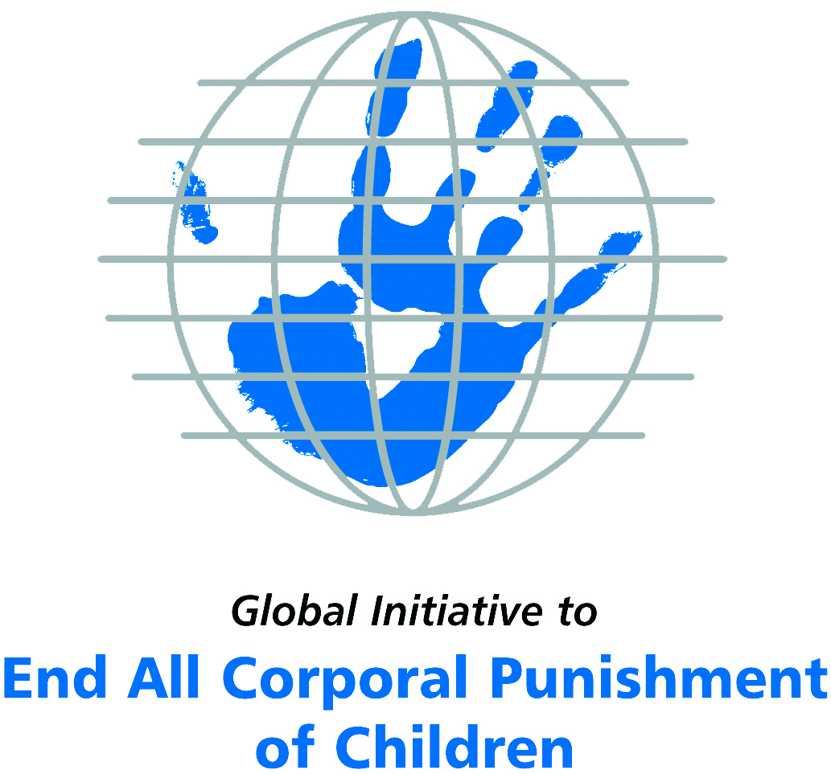
Briefing on Cuba for the Committee on the Rights of Persons with Disabilities, 9th Pre-Sessional Working Group, March 2018
From the Global Initiative to End All Corporal Punishment
of Children, January 2018

(a) About the Global Initiative to End All Corporal Punishment of Children
1. The Global Initiative (www.endcorporalpunishment.org) promotes universal prohibition and elimination of corporal punishment in fulfilment of states’ obligations under the UN Convention on the Rights of the Child and other international treaties. Our aims are supported by UNICEF, UNESCO, human rights institutions and international and national NGOs. Since 2002, the Global Initiative has regularly briefed the Committee on the Rights of the Child on this issue, and since 2004 has similarly briefed the Committee Against Torture, the Committee on the Elimination of Discrimination Against Women, the Committee on Economic, Social and Cultural Rights, the Human Rights Committee and the Human Rights Council; we have briefed the Committee on the Rights of Persons with Disabilities since the beginning of its work.

(b) Summary
2. Corporal punishment of children in Cuba is unlawful in schools and in the penal system, but it is not yet fully prohibited in the home and in alternative care and day care settings, in violation of the fundamental right of all children to protection from corporal punishment and other cruel or degrading forms of punishment.
3. With reference to articles 7, 15, 16 and 17 of the Convention on the Rights of Persons with Disabilities, and in light of the particular vulnerability of children with disabilities to corporal punishment by adults, the jurisprudence of the UN treaty bodies, the emphasis on eradicating this form of violence given by the UN Secretary General’s Study on Violence against Children and the importance of the issue to achieving target 16.2 on ending violence against children in the 2030 Sustainable Development Goals, we hope the Committee on the Rights of Persons with Disabilities will:
- include the issue of corporal punishment in its List of Issues for Cuba, in particular asking: “what progress is being made on the enactment of the new Family Code to repeal the provision for “adequate and moderate correction” and explicitly prohibit all corporal punishment of children?”
- recommend to the Government of Cuba, in the Committee’s concluding observations on the initial report, that “an explicit prohibition of all corporal punishment of children, however light, in all settings, is drafted and enacted as a matter of priority and that measures are put in place to ensure the law is properly implemented”.

(c) Detailed briefing
The right of children with disabilities not to be subjected to corporal punishment
4. The Convention on the Rights of Persons with Disabilities confirms that children with disabilities should enjoy all human rights and fundamental freedoms on an equal basis with other children (art. 7). The Convention also states that all persons have the rights to freedom from torture or cruel, inhuman or degrading treatment or punishment (art. 15), to freedom from exploitation, violence and abuse within and outside the home (art. 16) and to respect for their physical and mental integrity (art. 17). The jurisprudence of treaty monitoring bodies, led by the Committee on the Rights of the Child monitoring the Convention on the Rights of the Child, is clear that these rights put an obligation on states parties to prohibit and eliminate all corporal punishment of children, including within the family. Although Cuba’s initial state report refers to the prohibition of corporal punishment in the penal system, it does not touch upon corporal punishment of children which is the most prevalent form of violence against children.
5. As confirmed in the UN Secretary General’s Study on Violence against Children, children with disabilities are particularly vulnerable to violence, including corporal punishment, and corporal punishment is a significant cause of impairment among children. Yet the obligation to prohibit corporal punishment is frequently ignored or evaded by governments. The near universal acceptance of violence in childrearing together with deeply held views that parents and other adults have a “right” to physically punish children can challenge efforts to achieve prohibition. It also means that corporal punishment – at least to some degree – is not readily perceived as violence in the same way as, for example, sexual and other socially unacceptable forms of violence.
6. The newly adopted Sustainable Development Goals under the 2030 Agenda include target 16.2 on ending all forms of violence against children. Violent punishment is the most common form of violence against children: ending it through the adoption and implementation of legislation prohibiting it in all settings including the home is critical.

The legality of corporal punishment of children with disabilities in Cuba
7. In Cuba, corporal punishment of children is unlawful in schools and in the penal system, but children with disabilities may lawfully be subjected to physical punishment in the home and in some alternative care and day care settings. Prohibition in institutions requires confirmation.
8. Corporal punishment is lawful in the home. The Family Code 1975 permits “adequate and moderate correction” of children by parents (art. 86) (unofficial translation): “Parents are empowered to reprimand and moderately and adequately correct children under their guardianship.” There is a similar provision in relation to guardians (art. 152): “All children under guardianship must give respect and obedience to the tutor. He/she will rebuke and correct them moderately.” Provisions against violence and abuse in the Family Code, the Criminal Code 1987, the Children and Youth Code and the Constitution do not include prohibition of all corporal punishment in childrearing. In 2011, in response to the recommendations on the issue by the Committee on the Rights of the Child, the Government asserted that “corporal punishment is not allowed in any law, or lower-ranking legal rules, or family practice, school or social institutions”. In fact, there is no explicit prohibition in current law of all corporal punishment in childrearing and it appears that the “right of correction” was still on the statute books.
9. Corporal punishment is lawful in alternative care settings under the right of correction of parents and guardians in articles 86 and 152 of the Family Code 1975. In 2011/2012 the Government stated to the Committee on the Rights of the Child that corporal punishment is prohibited in institutions but cited only the Resolution relating to education (see below).
10. Corporal punishment is lawful in early childhood care and in day care for older children, including for children with disabilities under the right of correction of parents and guardians in articles 86 and 152 of the Family Code 1975. In 2011/2012 the Government stated to the Committee on the Rights of the Child that corporal punishment is prohibited in institutions but cited only the above mentioned Resolution relating to education. We have been unable to examine the text of this Resolution but any prohibition would presumably apply only to educational provision (preschools, etc) and not to all forms of early childhood care and day care for older children.
11. Corporal punishment is unlawful in schools. The Government has stated that corporal punishment is prohibited in schools, but we have yet to verify that prohibition is explicit. In commenting on recommendations issued in 2011 by the Committee on the Rights of the Child, the Government stated that Resolution 165/2006 of the Ministry of Education approving the Regulations on the discipline of work in educational activities (Resolución 165 de 2006 del Ministerio de Educación que aprueba el Reglamento Ramal de la disciplina del trabajo en la actividad educacional) prohibits corporal punishment in schools.
12. Corporal punishment is unlawful as a disciplinary measure in penal institutions under article 6 of the prison regulation. Article 30(11) of the Criminal Code 1987 states that “those sanctioned may not be subjected to corporal punishment, nor is it admissible to employ against them any measure entailing humiliation or a loss of dignity”.
13. Corporal punishment is unlawful as a sentence for crime under article 30(11) of the Criminal Code 1987 (see above).
14. Opportunities for law reform. The Government has indicated its commitment to prohibiting all corporal punishment of children. In 2011, the Government reported that a draft new Family Code was under discussion that would remove the provision for “adequate and moderate correction”. In the same year, the Regional Roadmap on Violence against Children was adopted by the Central American Governments of Cuba, Mexico and the Dominican Republic: it includes a recommendation to adopt national legislation to explicitly prohibit all corporal punishment and to repeal provisions allowing for “moderate” punishment/correction.

Recommendations by human rights treaty monitoring bodies
15. In 1997, the Committee on the Rights of the Child expressed concern with the insufficient child protection system in Cuba and recommended the development of a widespread public information campaign for the prevention of corporal punishment of children. Then in 2011, it recommended the explicit prohibition of corporal punishment, urging Cuba to prioritise the adoption of the draft Family Code.

Briefing prepared by the Global Initiative to End All Corporal Punishment of Children
www.endcorporalpunishment.org; info@endcorporalpunishment.org

Pinheiro, P. S. (2006), World Report on Violence against Children, Geneva: United Nations. See also Krug E. G. et al (eds) (2002), World Report on Violence and Health, Geneva: World Health Organisation
20 June 2011, CRC/C/CUB/CO/2 Advance Unedited Version, Concluding observations on second report, paras. 36 and 37
Opiniones del Gobierno de la República de Cuba sobre el documento CRC/C/CUB/CO/2 contentivo de las Observaciones finales del Comité de los Derechos del Niño sobre el segundo Informe periódico de Cuba (?2011), pp. 7-8
http://www.gacetaoficial.cu/html/codigo%20de%20lafamilia.html#T2, accessed 28 March 2014
http://www.gacetaoficial.cu/html/codigo%20de%20lafamilia.html#T2, accessed 28 March 2014
http://www.gacetaoficial.cu/html/codigo%20de%20lafamilia.html#T2, accessed 28 March 2014
http://www.gacetaoficial.cu/html/codigo%20de%20lafamilia.html#T2, accessed 28 March 2014
27 April 2011, CRC/C/CUB/Q/2/Add.1, Written replies to the Committee on the Rights of the Child, para. 36
Regional Road Map on Violence against Children, adopted in 2011, 1 and 2 December in Santo Domingo, as a follow-up to the recommendations of the UN Study on Violence against Children, available at http://srsg.violenceagainstchildren.org/sites/default/files/political_declarations/Hoja%20de%20Ruta%20Final%20EVCN%20Centroamericano%20Dic%202012.pdf, accessed 21 February 2015
18 June 1997, CRC/C/15/Add.72, Concluding observations on initial report, paras. 19 and 35
3 August 2011, CRC/C/CUB/CO/2, Concluding observations on second report, paras. 36 and 37

