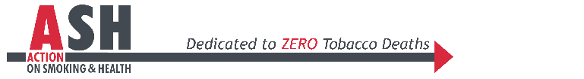
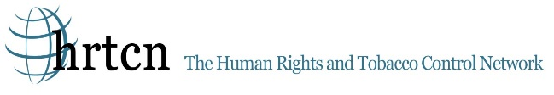
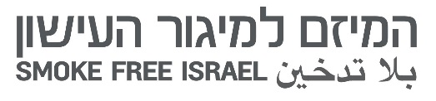
Submission to the Committee on Economic, Social and Cultural Rights
64th Session, 11-15 March 2019

Tobacco Control and the Right to Health - Israel
Tobacco will kill an estimated one billion people in the 21st century in the absence of aggressive action by governments to advance tobacco control and smoking cessation. Eighty percent of these deaths will be in developing countries – those least able to manage this epidemic. One in two people with a lifetime history of smoking will die from a tobacco related disease and 50% of these deaths will be in middle age. The human stories behind these statistics are so often heartbreaking. Not only illness and death, but also the impact on families due to loss of primary breadwinners, the toxic exposures and lost educational opportunities for children who work in tobacco farming, environmental degradation through deforestation and runoff of pesticides into rivers and streams, and the contribution of tobacco purchases to increased poverty and malnutrition. The World Health Organization projects increasing numbers of people who smoke, particularly as populations grow, over the next 20 years, with women in low- and middle-income countries being a particular target of tobacco marketing.
A broad evidence base supports a combination of legal, policy, medical, environmental and behavioral interventions that governments can take to control tobacco and improve health. Tobacco taxes, clean indoor air laws, comprehensive bans on advertising and promotion, public information campaigns, graphic warning labels on tobacco products and smoking cessation have all been shown to reduce tobacco consumption and dependence. As such, States Parties to the Convention on Economic, Social and Cultural Rights are obligated to pursue tobacco control under their duties to respect, protect and fulfill Article 12: the Right to the Highest Attainable Standard of Health.
The following submission to the 64th Pre-Sessional Working Group of the Committee on Economic, Social and Cultural Rights has assessed the tobacco control content within each State Party report. Each submission concludes with three-six key recommendations for improvement that the Committee can raise to country representatives to encourage stronger tobacco control policies. HRTCN-ASH USA believes that these tobacco control strategies and recommendations sit at the heart of government obligations to respect, protect and fulfill the right to the highest attainable standard of health.
HRTCN/ASH works to advance a human rights-based approach to tobacco control – utilizing the legal remedies and reporting requirements of current treaties and conventions, including the recent Framework Convention on Tobacco Control, the Convention on the Rights of the Child (CRC), the Convention on the Elimination of Discrimination Against Women (CEDAW) and the Covenant on Economic, Social and Cultural Rights. HRTCN/ASH will educate on and utilize measures that are currently accessible and will encourage adoption of new measures in order to decrease the morbidity and mortality of the people with the least agency to claim their rights.

Tobacco Control and the Right to Health in Israel
The Human Rights and Tobacco Control Network (HRTCN/ASH) has reviewed Israel State report to the Committee on Economic, Social and Cultural Rights with respect to tobacco control and the right to health as part of the obligation to safeguard and defend human life. Israel is to be commended for ratifying the Framework Convention on Tobacco Control in August 2005, pioneering smoke free legislation in 1983 and amending those laws numerous times; for subsidizing cessation medications and other cessation services to all citizens since January 2010, and for passing a National Tobacco Control Plan in 2011. In 2016, the secondhand smoke law was strengthened to eliminate exposure in educational institutions. Most recently, the Israel Knesset overwhelmingly approved new regulations that increases the ban on tobacco advertising, tobacco products must be out of plain sight at the retailers; plain packaging needs to be implemented; a ban on all electronic cigarettes with high levels of nicotine, and electronic cigarettes will also be covered under cigarette regulations. Unfortunately, in negotiations, advertising prohibitions were weakened in order to allow advertising in newspapers - a major method of tobacco industry communication.
According to the Social Survey conducted by the Israeli Central Bureau of Statistics in 2017, 23% of those aged 20 and over (about 1.3 million people) are smoking tobacco products. Men (30%) twice the rate of women (15%); Arabs (26%) more than Jews (21%). The proportion of men who smoke is 48% among Arabs, compared to 26% among Jews. 23% of the smokers started smoking before the age of 16. Unfortunately, there is no recent tobacco surveillance data in youth.
Despite new and old regulations, Israel needs to make sure that their new laws are effectively implemented - in spite of very significant interference by the tobacco industry. One such intervention caused the exclusion of newspapers in the advertising ban. Another improvement would include graphic health warnings, such as occur in >105 other countries. Although Israel’s cigarette tax is relatively high, the taxes on RYO (roll your own) and other tobacco products are not, and therefore, these taxes must be increased. Although the State Annex report acknowledged youth education about tobacco control in grades 6 and 7, this is very inadequate and should increase to all years from 6th grade up, and include knowledge about the new products (like e-cigarettes) and marketing tactics of the tobacco industry on the social media to be recognized by teens.
In light of the above, we would ask the representative of Israel to address the following issues:
- Ban all advertising of tobacco and smoking products (which includes e-cigarettes) in newspapers and establish graphic warning labels on tobacco products in their plain packaging.
- Raise the tax on all smoking products comparable to the tax on cigarettes – and allocate a substantial portion to fund tobacco control and establish a National Tobacco Control Plan
- Strict enforcement of national smoke free laws particularly in all educational institutions.
- Increase healthcare provider knowledge and interventions for tobacco cessation
- Improved tobacco use prevalence surveys that include all products in all populations on a regular basis to provide data to guide interventions, including regarding exposure to secondhand smoke.
References
- Rosen L, Peled-Raz M. Tobacco policy in Israel: 1948–2014 and beyond. Israel Journal of Health Policy Research 2015;4(12) doi: DOI 10.1186/s13584-015-0007-x
- Yigal Eisenman, Data Collection on Smoking, Social Survey 2017. Israel Central Bureau of Statistics, November 2018. https://www.cbs.gov.il/he/mediarelease/DocLib/2018/343/19_18_343b.pdf
- Report of the Minister of Health on smoking in Israel 2017, May 2018. https://www.health.gov.il/PublicationsFiles/smoking_2017.pdf
- The Restriction of Advertising and Marketing of Tobacco Products Law (Amendment No. 7), 5769 – 2019. https://www.justice.gov.il/Units/Reshomot/publications/Pages/BookOfLaws.aspx

