ASSEDEL (Association européenne pour la défense des droits et des libertés)
11, rue de Bruxelles, 67000 Strasbourg, France | assedel.org, info@assedel.org

September 2024

SUBMISSION TO THE UN HUMAN RIGHTS COMMITTEE
142ND SESSION, 14 OCTOBER - 8 NOVEMBER 2024, THIRD PERIODIC REVIEW OF GREECE
“Violations at the Greek Borders: The Ongoing Crisis of Pushbacks and International Scrutiny”
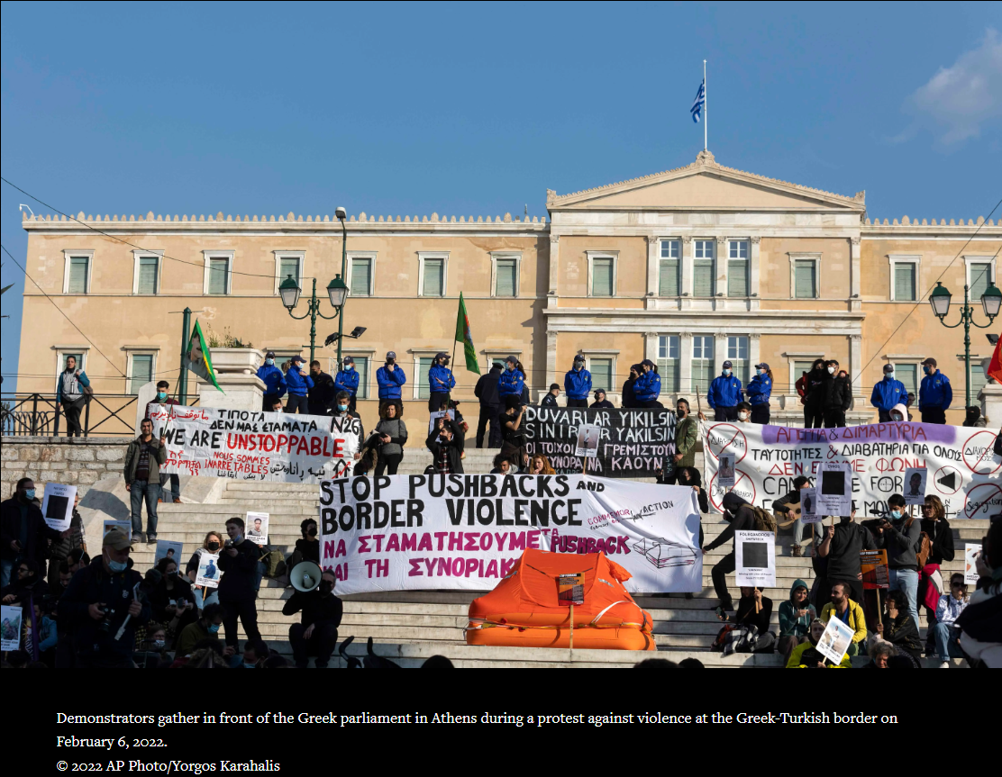
Table of contents
List of Abbreviations 4
Executive Summary 5
1. Introduction 6
2. International Legal Framework 7
2.1. International Covenant on Civil and Political Rights 7
2.2. 1951 Refugee Convention and the Principle of Non-Refoulement 8
2.3. European Convention on Human Rights 8
3. International Reports on Pushbacks 10
3.1. Working Group on Arbitrary Detention: Findings on Pushbacks and Arbitrary Detention Practices 10
3.2. Reports of the Special Rapporteur 11
3.2.1. Report of the Special Rapporteur dated 12 May 2021 11
3.2.2. Report of the Special Rapporteur dated 26 April 2022 11
3.3. European Committee for the Prevention of Torture and Inhuman or Degrading Treatment or Punishment Report on Pushbacks 12
3.4. The Commissioner’s Letter to Greek Authorities on Pushbacks 14
4. NGOs Reports on Pushbacks 16
4.1. Amnesty International: “Caught in a Political Game” 16
4.2. Amnesty International: “Greece: Violence, Lies, and Pushbacks” 17
4.3. Human Rights Watch: “Their Faces Were Covered” 18
4.4. European Center for Constitutional and Human Rights: “Analyzing Greek Pushbacks: Over 20 Years of Concealed State Policy Without Accountability” 20
4.5. Stockholm Center for Freedom: “Pushback of Turkish Asylum Seekers from Greece to Turkey” 21
4.6. Peace § Justice: “Pushbacks Report: The case of Turks at Greek borders” 22
5. International Legal Proceedings and Mechanisms Addressing Pushbacks 24
5.1. Pushbacks Before UN Mechanisms 24
5.2. Pushbacks Before the European Court of Human Rights 24
6. Human Rights Committee Reviews and Greece's Compliance 26
6.1. Concluding Observations on the Second Periodic Review 26
6.2. Greece’s Non-compliance with the Concluding Observations 26
6.3. List of Issues Prior to the Third Periodic Report 27
6.4. Analysis of Greece’s Responses in its Third Periodic Report 28
7. Conclusion 29

List of Abbreviations
BVMN – Border Violence Monitoring Network
CPT – European Committee for the Prevention of Torture and Inhuman or Degrading Treatment or Punishment
ECHR – European Convention on Human Rights
ECtHR – European Court of Human Rights
EU – European Union
Frontex – European Border and Coast Guard Agency
HRC – United Nations Human Rights Committee
ICCPR – International Covenant on Civil and Political Rights
NGOs – Non-governmental organizations
Special Rapporteur – Special Rapporteur on the Human Rights of Migrants
UN – United Nations
WGAD – Working Group on Arbitrary Detention

Executive Summary
This shadow report, submitted for the Third Periodic Review of Greece before the United Nations Human Rights Committee (HRC), focuses on the persistent and systematic violations of human rights at Greece's borders, particularly in relation to pushbacks of migrants and asylum seekers. Despite previous recommendations by international bodies, including the HRC, Greece continues to engage in practices that violate core international legal obligations, including the principle of non-refoulement and the right to seek asylum.
Greece is bound by several international treaties, including the International Covenant on Civil and Political Rights (ICCPR), the 1951 Refugee Convention, and the European Convention on Human Rights (ECHR). These instruments prohibit collective expulsions, arbitrary detention, and inhumane treatment, and guarantee the right to seek asylum. However, Greece's pushback practices, particularly at the Evros land border and in the Aegean Sea, blatantly contravene these obligations. Reports from international bodies and non-governmental organizations (NGOs) have documented numerous instances where asylum seekers were denied access to asylum procedures, detained under unlawful conditions, and forcibly expelled to Turkey, often with violence and inhumane treatment.
International monitoring bodies such as the Working Group on Arbitrary Detention (WGAD), the Special Rapporteur on the Human Rights of Migrants (Special Rapporteur), and the European Committee for the Prevention of Torture and Inhuman or Degrading Treatment or Punishment (CPT) have consistently raised concerns regarding Greece’s pushback operations. These reports highlight the systematic nature of these practices, the involvement of state and non-state actors, and the lack of accountability for the violence and ill-treatment inflicted on migrants. The reports from NGOs such as the Amnesty International, the Human Rights Watch (HRW), and the European Center for Constitutional and Human Rights (ECCHR) also provide substantial evidence of widespread violations. These reports emphasize that migrants, including Turkish nationals fleeing political persecution, are at significant risk of refoulement and further human rights abuses upon return to Turkey.
Numerous legal actions have been brought before the HRC and the European Court of Human Rights (ECtHR), challenging Greece's pushback practices. These cases reveal violations of the rights to life, liberty, and security, and highlight the lack of effective remedies for those subjected to pushbacks. Greece has consistently denied these allegations, but the overwhelming body of evidence from third-party interventions, NGOs reports, and individual testimonies suggest that these practices are part of a broader, state-sponsored policy of deterring migration at any cost.
The HRC's Concluding Observations from the Second Periodic Review (2015) urged Greece to investigate allegations of pushbacks and ensure compliance with international human rights standards. However, reports indicate that Greece has failed to address these concerns. Pushbacks have become more frequent, and the Greek government has not implemented adequate mechanisms to prevent human rights abuses or to hold perpetrators accountable.
This report concludes that Greece's pushback practices remain a serious human rights issue, violating international legal standards. Despite international scrutiny, these practices continue unabated, demonstrating a chronic failure to address the human rights concerns raised by the UN, the ECtHR, and numerous civil society organizations. Stronger international oversight and enforcement mechanisms are urgently needed to ensure that Greece complies with its obligations under international law and ends the systematic violation of the rights of migrants and asylum seekers at its borders.

Introduction
This shadow report is submitted as part of Greece’s Fourth Periodic Review before the HRC. It addresses the persistent violations of human rights at Greece’s borders, specifically focusing on the widespread and systematic practice of pushbacks against migrants and asylum seekers. Despite Greece’s obligations under the ICCPR and other international legal instruments, evidence from various international bodies and NGOs highlights ongoing breaches of human rights, including the denial of the right to seek asylum, arbitrary detention, and violent expulsions.
Since the Second Periodic Review in 2015, Greece has been repeatedly criticized for its border management practices, particularly the unlawful return of individuals to Turkey without proper access to asylum procedures. The Concluding Observations from the 2015 review included clear recommendations to address these violations, urging Greece to investigate pushbacks and ensure compliance with international law. However, as this report demonstrates, these recommendations have not been implemented, and pushbacks have become more frequent, affecting thousands of individuals attempting to cross into Greece.
This report draws on extensive documentation from international organizations such as the WGAD, the CPT, the Special Rapporteur, as well as NGOs reports from the Amnesty International, the HRW, and the ECCHR. These sources consistently indicate that Greece's border management practices violate core human rights principles, including the principle of non-refoulement and the prohibition against inhuman and degrading treatment.
Moreover, this report examines Greece’s responses to the List of Issues raised prior to the submission of its Third Periodic Report. It analyses Greece's failure to address the pushback allegations outlined in Paragraph 16 of the list and critiques the government’s statements in the Third Periodic Report (2023) under paragraphs 157-165, which are inconsistent with documented evidence on the ground.
The findings presented in this shadow report illustrate the ongoing nature of Greece’s non-compliance with international human rights obligations. It concludes with a call for stronger accountability measures and increased international scrutiny to ensure that Greece adheres to its commitments under the ICCPR and other relevant legal frameworks.

International Legal Framework
- The issue of pushbacks at the Greek borders raises significant concerns regarding Greece’s compliance with international legal obligations. Pushbacks, particularly when conducted without proper legal assessment, directly contravene key principles of international law, including the protection of human rights and the rights of refugees. Greece is bound by several international treaties that prohibit practices like collective expulsions and ensure the right to seek asylum. These legal instruments impose obligations on states to respect and protect the rights of individuals at their borders, ensuring they are not returned to situations where their life or freedom is at risk.

International Covenant on Civil and Political Rights
- The ICCPR, to which Greece is a state party, establishes crucial protections for the treatment of migrants, refugees, and asylum seekers. Key provisions relevant to pushback practices at Greece's borders include Articles 6, 7, 9, 12, 13, and 24, which protect the rights to life, freedom from inhumane treatment, liberty, and security, as well as the rights of migrants and children to be treated with dignity and fairness.
Article 6: Right to Life
- Under Article 6, states are obligated to protect the right to life, and no one should be arbitrarily deprived of their life. Pushbacks, particularly in maritime contexts, pose a significant risk to the lives of migrants and asylum seekers. Many reports, which will be detailed below, have documented instances where migrants were left in dangerous conditions at sea or abandoned on uninhabited islands without adequate safety measures, directly endangering their lives. These practices amount to a violation of Greece’s obligations under Article 6, as pushbacks frequently place individuals in life-threatening situations without proper legal assessments.
Article 7: Prohibition of Torture and Inhuman or Degrading Treatment
- Article 7 of the ICCPR prohibits torture, cruel, inhuman, or degrading treatment or punishment. Numerous NGOs reports, including those by HRW and the Border Violence Monitoring Network (BVMN), detail how migrants have been subjected to physical violence, degrading treatment, and abuse during pushback operations. Migrants reported being beaten, stripped of their belongings, and forcibly expelled without due process. Such treatment, often conducted by masked men or border guards, clearly violates the protections enshrined in Article 7 of the ICCPR.
Article 9: Right to Liberty and Security of Person
- Under Article 9, individuals have the right to liberty and security, and they should not be subjected to arbitrary arrest or detention. Migrants subjected to pushbacks in Greece are frequently detained in informal facilities without legal justification, and they are denied access to legal counsel or procedural safeguards.
Article 12: Right to Freedom of Movement
- Article 12 guarantees the right to freedom of movement and the right to leave any country, including one's own. Pushback practices restrict this right by forcibly returning individuals who have crossed the border into Greece to seek asylum.
Article 13: Procedural Guarantees for Aliens
- Article 13 of the ICCPR provides that any alien lawfully in the territory of a state shall not be expelled without a lawful procedure that includes the opportunity to have the case reviewed and submit reasons against expulsion. Pushback operations bypass these procedural guarantees by expelling migrants without assessing their asylum claims, denying them the right to due process. This has been a persistent issue raised by both UN mechanisms and civil society organizations in relation to Greece’s handling of asylum seekers at its borders.
Article 24: Protection of Children
- Article 24 affords special protection to children, requiring that they receive the care and protection they need. Many pushback operations in Greece have involved families with children, often subjecting minors to the same dangerous and inhumane treatment as adults.

1951 Refugee Convention and the Principle of Non-Refoulement
- The 1951 Refugee Convention, ratified by Greece, establishes the fundamental principle of non-refoulement, which is codified in Article 33(1). This principle prohibits states from returning refugees "to the frontiers of territories where their life or freedom would be threatened" on account of race, religion, nationality, membership of a particular social group, or political opinion. As a state party, Greece is obligated to ensure that refugees and asylum seekers are not expelled or returned to places where they face serious risks.
- The principle of non-refoulement is central to international refugee law and applies to all individuals seeking protection, regardless of their legal status or how they entered the country. This protection is reinforced by international human rights mechanisms that affirm the need to protect individuals from being sent back to places where they could face persecution or torture.
- Greece’s practice of pushbacks has raised significant concerns regarding its compliance with the non-refoulement principle. Reports from the Amnesty International, the HRW, and other NGOs document numerous cases where migrants and asylum seekers were forcibly returned to Türkiye without any opportunity to apply for asylum. These forced returns, conducted without legal assessment or protection measures, are in clear violation of Article 33(1) of the convention.

European Convention on Human Rights
- The ECHR, to which Greece is a party, provides crucial protections relevant to the treatment of migrants, refugees, and asylum seekers, particularly in the context of pushbacks.
Article 2: Right to Life
- Article 2 of the ECHR requires that states protect the right to life. Greece’s pushback practices, particularly in the maritime context, pose a direct threat to this right. There have been numerous documented instances where migrants were placed in unsafe, overcrowded boats, left stranded at sea, or abandoned on unsafe islands. The failure to take necessary precautions to protect the lives of those intercepted at sea constitutes a violation of Article 2.
Article 3: Prohibition of Torture and Inhuman or Degrading Treatment
- Article 3 of the ECHR prohibits torture, as well as inhuman or degrading treatment or punishment. Pushbacks frequently involve acts of violence, intimidation, and degrading treatment against migrants. Migrants are often subjected to beatings, forced into unsafe situations, stripped of their possessions, and expelled without access to any legal procedures. Such treatment violates the dignity of individuals and constitutes inhuman or degrading treatment under Article 3. The ECtHR has repeatedly ruled against states for failing to protect individuals from such treatment, particularly in the context of asylum seekers and refugees.
Article 4 of Protocol No. 4: Prohibition of Collective Expulsions
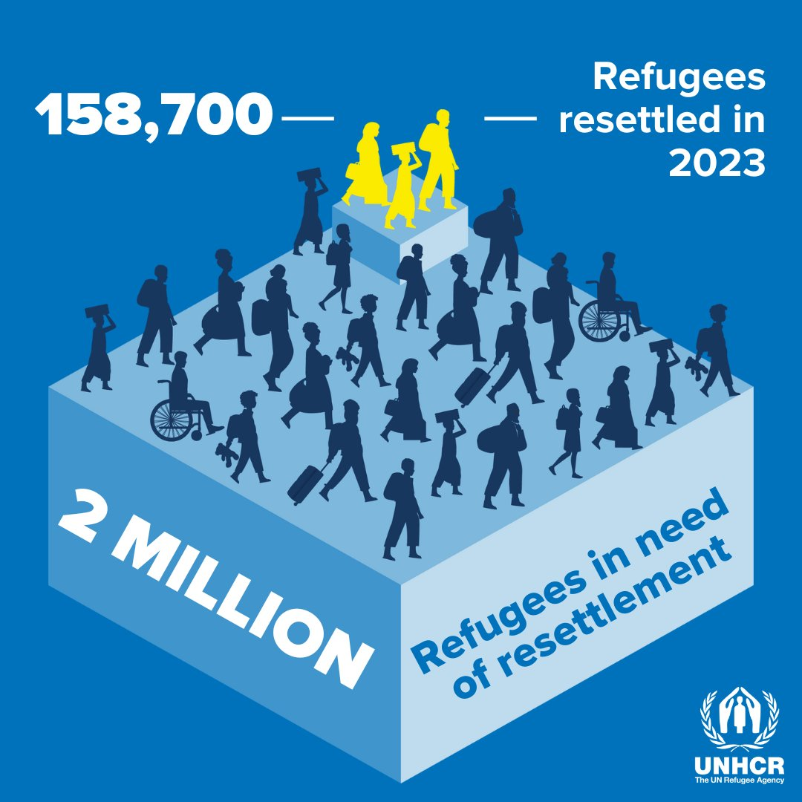
- Article 4 of Protocol No. 4 of the ECHR explicitly prohibits the collective expulsion of aliens. Collective expulsions, which occur when groups of individuals are removed without any individual assessment of their case, are at the heart of Greece’s pushback practices.

International Reports on Pushbacks
- International bodies and human rights organizations have consistently reported on the ongoing issue of pushbacks at Greece's borders, highlighting serious concerns about violations of international law. These reports provide detailed documentation of systematic pushback practices, which involve the expulsion of migrants and asylum seekers without proper legal assessment, often accompanied by violence and inhumane treatment. Their findings emphasize the need for Greece to align its border enforcement policies with international human rights standards and end the unlawful pushbacks that jeopardize the lives and rights of migrants. The following sections will explore these reports and their key observations.

Working Group on Arbitrary Detention: Findings on Pushbacks and Arbitrary Detention Practices
- The WGAD conducted a visit to Greece in December 2019 and issued its report, "Report following its Visit to Greece", on 29 July 2020 (A/HRC/45/16/Add.1). This report included serious concerns regarding the treatment of migrants and asylum seekers, particularly in the context of pushbacks. The report includes serious concerns regarding pushbacks at Greece's borders with Türkiye, particularly in the Evros region.
Pushbacks and Lack of Access to Asylum Procedures
- In paragraph 87, the Working Group was informed that numerous individuals arriving in the Evros region were arrested, detained, and summarily returned to Türkiye without being given the opportunity to apply for international protection in Greece. It was also noted that some of these individuals had made multiple attempts to cross the border, only to be forcibly returned each time. Pushbacks of this nature are explicitly prohibited under Greek law and violate the fundamental right to seek asylum. The Working Group emphasized that detaining individuals for the purpose of such pushbacks lacks any legal basis. As a result, the Working Group called on the Greek Government to promptly and thoroughly investigate all allegations of pushbacks, including any acts of violence or ill-treatment, and to ensure that such practices are halted.
Complaints Mechanism and Investigations
- In paragraph 88, the report highlighted the existence of an anonymous complaints mechanism established by the European Border and Coast Guard Agency (Frontex), designed to enable individuals to report irregular pushbacks. The Greek Government indicated that no complaints were submitted through this mechanism in 2019. However, the Working Group viewed this mechanism as potentially useful for ensuring that any pushback allegations are properly received and investigated by the relevant authorities, even though its current usage appeared to be minimal.
Broader Challenges in Protecting Migrants' Rights
- In paragraph 104, the report identified broader challenges in ensuring the protection of human rights in the context of mass migration. These challenges included a lack of information provided to detainees about their right to apply for international protection, the inappropriate detention of unaccompanied minors, and deficiencies in vulnerability assessments. Additionally, the paragraph reiterated concerns regarding pushbacks in the Evros region, highlighting them as a critical issue that needed urgent attention alongside other procedural obstacles to challenging detention and removal decisions.
Recommendations to End Pushbacks
- Finally, in paragraph 110(f), the Working Group made a specific recommendation to the Greek Government, urging it to investigate all allegations of pushbacks thoroughly and promptly. This recommendation emphasized that any acts of violence or ill-treatment occurring during such pushbacks must be investigated and that the government must take concrete steps to ensure these practices are not repeated.
- In summary, the WGAD report sheds light on the persistent and unlawful pushback practices in Greece, urging the government to take immediate action to address these violations and ensure that individuals seeking asylum are not unlawfully expelled without due process.

Reports of the Special Rapporteur
- The Special Rapporteur has provided critical insights into the ongoing pushbacks at Greece's borders, addressing the legal, humanitarian, and human rights implications of these practices. The following sections summarize two key reports, detailing his findings, observations, and recommendations concerning pushbacks.

Report of the Special Rapporteur dated 12 May 2021
- The report titled "Rapport sur les moyens de répondre aux conséquences" (A/HRC/47/30/Add.2) was issued by the Special Rapporteur. In this report, the Special Rapporteur highlighted the widespread practice of pushbacks, particularly at Greece’s land and sea borders with Türkiye. The report documents multiple cases where migrants, including asylum seekers, were subjected to forced returns without a fair hearing or proper legal procedures. The Special Rapporteur emphasized that such pushbacks are in direct violation of international human rights law and the principle of non-refoulement.
- The report further explains that pushbacks are often carried out in inhumane conditions, where migrants are not only denied the right to seek asylum but are also exposed to violence and mistreatment. These included cases of migrants being forcibly removed to Türkiye after crossing into Greece, often under threat or use of violence by border authorities.
- The Special Rapporteur strongly condemned these actions, recommending that the Greek government ensure that independent investigations are conducted into all allegations of pushbacks and that migrants are given access to proper legal channels for applying for asylum. The report also called for increased oversight by both Greek and European authorities to prevent further violations at the border.

Report of the Special Rapporteur dated 26 April 2022
- The report titled "Report of the Special Rapporteur on the human rights of migrants" (A/HRC/50/31) was presented to the Human Rights Council. This report provides a thematic study on human rights violations at international borders, focusing particularly on pushbacks and their impact on migrants. The Special Rapporteur noted that pushbacks have become an established practice at Greece’s borders, both at sea and on land, despite clear obligations under international law.
- The report describes pushbacks as being legitimized through national legislation and executive orders, allowing these unlawful practices to continue as part of Greece’s broader migration policy. The Special Rapporteur expressed deep concern over the lack of accountability for these violations and the absence of proper legal procedures to protect the rights of migrants seeking asylum.
- One of the most troubling findings in the report is the use of excessive force during pushback operations, where migrants are frequently subjected to violent treatment, denied food and water, and forcibly expelled without due process. The Special Rapporteur emphasized that such actions severely undermine the rights of migrants, including the right to asylum and protection from refoulement.
- The report concludes with recommendations for Greece and other European states to end these unlawful pushbacks and to implement transparent mechanisms for monitoring border practices. It also highlights the need for the European Union (EU) to play a more active role in ensuring compliance with human rights obligations at its borders.

European Committee for the Prevention of Torture and Inhuman or Degrading Treatment or Punishment Report on Pushbacks
- The CPT published its report titled "Report to the Greek Government on the visit to Greece" (CPT/Inf(2020)35) on 19 November 2020, following an ad-hoc visit in March 2020. The report provides a detailed examination of pushbacks across Greece’s land and sea borders with Türkiye, highlighting significant concerns regarding the treatment of migrants and asylum seekers.
Detention, Confiscation, and Pushbacks (Paragraphs 53–55)
- The CPT report highlights credible allegations from detained migrants regarding pushback operations conducted by Greek authorities across the Evros River. Migrants described being detained, having their belongings confiscated, including mobile phones and personal items, and then being pushed back across the river to Türkiye without any formal processing or opportunity to apply for asylum. These pushbacks primarily occurred before March 2020, but were part of an ongoing pattern. The report emphasizes that this practice violates both Greek law and international human rights standards, including the principle of non-refoulement.
- The CPT delegation expressed concern over the lack of record-keeping in detention facilities such as Poros, where migrants were held briefly before being expelled. Migrants were not properly registered, and no records were kept of their detention, making it impossible to track the movements or verify the treatment of those who were pushed back. This lack of transparency and accountability raised serious concerns about the legality of the detention and expulsion processes.
Human Impact of Pushbacks (Paragraph 56)
- The report recounts a particularly harrowing case involving a two-and-a-half-year-old girl who, along with her brother, was separated from her parents and other siblings during a pushback operation. The family had crossed into Greece in February 2020 and was apprehended in the Evros region. The parents and some of the children were pushed back across the river, while the young girl and her brother were detained at Feres Police Station and later transferred to the Filakio Reception and Identification Centre. The CPT highlighted the anguish experienced by the family and used this case as a tragic illustration of the devastating human impact of pushbacks, particularly when families are forcibly separated.
Pushback Practices and Accountability (Paragraphs 57–58)
- The CPT concluded that the evidence supporting the systematic pushback of migrants to Türkiye by Greek authorities is credible. These pushbacks were carried out without any of the fundamental legal guarantees required under international law, such as access to asylum procedures or protection from refoulement. The report calls on the Greek government to immediately halt pushback practices and ensure that any officers involved in such actions, whether police or military, are held accountable. The CPT also reiterated the need for proper documentation of all individuals held in detention to prevent arbitrary detention and expulsion.
- In paragraph 58, the CPT urged the Greek authorities to take proactive measures to prevent pushbacks, including providing clear instructions to border officials to ensure that all migrants entering Greece are properly identified and registered, and given the opportunity to seek asylum. The report emphasized that these steps are essential to protecting migrants from the risk of refoulement, including the possibility of chain refoulement.
Allegations of Pushbacks at Sea (Paragraphs 59–60)
- The CPT also received credible allegations of pushbacks at sea involving the Greek Coast Guard. In one case, a boat carrying nearly 50 migrants was intercepted by the Coast Guard in March 2020. The Coast Guard reportedly removed the fuel from the boat and left it adrift for several hours before towing it to Lesbos Island. In another case, migrants who had arrived on Samos Island were allegedly forced back onto a dinghy by Greek officers and towed back to Turkish waters, where they were left adrift until rescued by the Turkish Coast Guard the next day.
- The CPT expressed serious concerns about these actions, noting that under international law, Greece has an obligation to protect the rights and freedoms of all individuals within its jurisdiction, including those at sea. The committee called on the Greek authorities to investigate these allegations and ensure that the Greek Coast Guard operates in full compliance with human rights standards.
Role of Frontex and EU Involvement (Paragraphs 60–61)
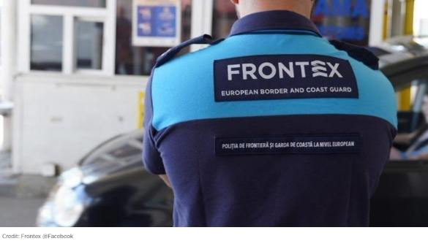
- The report acknowledges the presence of the Frontex in Greece, particularly through Operation Poseidon, which supports border surveillance and search-and-rescue operations. However, the CPT noted that human rights monitors were not involved in Frontex operations at the time, raising concerns about the lack of oversight in ensuring that migrant rights are protected during these operations. The CPT called on Frontex and the Greek government to provide further details on how respect for human rights is being monitored and the specific rules of engagement for Frontex vessels when encountering boats carrying migrants.
Broader Concerns and Recommendations (Paragraphs 62–64)
- In its concluding remarks, the CPT acknowledged the significant challenges faced by Greece in managing large numbers of migrants but stressed that these challenges do not absolve the government of its international human rights obligations. The report reiterated the need for Greece to reform its immigration detention policies, ensure decent conditions for detained migrants, and stop pushbacks.
- The CPT also highlighted the inhumane conditions in several migrant detention centers, particularly in the Evros region and on Samos Island, where overcrowding, poor hygiene, and inadequate access to medical care were prevalent. These conditions, combined with the lack of legal safeguards for migrants subjected to pushbacks, amounted to inhuman and degrading treatment in violation of Article 3 of the ECHR.
- The committee concluded by urging Greece to address the structural deficiencies in its immigration detention system and called for decisive action to prevent further human rights violations. The CPT emphasized that the Greek government must seek support from the EU and the Council of Europe to bring its policies in line with European standards.
- In conclusion, the CPT report presents a detailed and alarming account of pushback practices in Greece, documenting how these operations violate both Greek and international law. The report provides clear recommendations for halting these unlawful actions and ensuring accountability for those involved, while also calling for urgent reforms in Greece’s immigration detention policies to protect the rights and dignity of all migrants.

The Commissioner’s Letter to Greek Authorities on Pushbacks
- The Council of Europe Commissioner for Human Rights, Dunja Mijatović, sent a letter on 3 May 2021 to the Greek Ministers of Citizens' Protection, Migration and Asylum, and Shipping and Island Policy. This letter addressed the ongoing concerns regarding pushbacks at Greece’s borders with Türkiye, particularly focusing on pushbacks at sea. The Commissioner raised significant human rights concerns, based on her previous visits to Greece in 2018 and 2019, and other credible reports. The letter highlighted key issues, including the persistence of pushbacks despite extensive documentation, the treatment of civil society organizations working on refugee and migrant rights, and the poor conditions in reception centers.
Allegations of Pushbacks
- The Commissioner expressed deep concern over the consistent and credible allegations of summary returns (pushbacks) from Greece to Türkiye, both at the land and sea borders. Despite previous calls to halt these practices, the Commissioner noted that pushbacks had continued for more than two years since the publication of her 2018 report. The Evros River pushbacks were well-documented, not only by international media and civil society organizations, but also by national human rights bodies and international organizations, such as the CPT and the HCR. The Commissioner referenced the Greek Ombudsman’s interim report (April 2021), which detailed those pushbacks appeared to follow a standardized practice. These involved individuals dressed in uniform, without identification, arresting migrants, detaining them briefly, confiscating their belongings, and forcibly returning them across the Evros River into Türkiye.
- The Commissioner underscored those pushbacks had been accompanied by acts of violence and degrading treatment. She emphasized that such practices violate international law, including Article 3 of the ECHR, which prohibits torture and inhumane or degrading treatment. Furthermore, migrants returned through pushbacks were denied the right to apply for asylum or seek protection, which violated the non-refoulement principle in the UN Refugee Convention.
Pushbacks at Sea
- In addition to the land pushbacks, the Commissioner expressed concern over pushbacks at sea. According to UNHCR, over 100 pushback incidents at sea between Greece and Türkiye were recorded in 2020, with more than 20 reported in the first quarter of 2021. Migrants who had reached Eastern Aegean islands from Türkiye by boat were sometimes even registered as asylum seekers before being embarked on life-rafts by Greek officers and pushed back to Turkish waters. This method of pushback, the Commissioner noted, not only endangered the lives of migrants but also violated their human rights by preventing them from making asylum claims. These practices have led to family separations and increased vulnerability of migrants, as they are left in precarious conditions without legal recourse.
Call for Independent Investigations and End to Pushbacks
- The Commissioner strongly urged the Greek authorities to end pushback operations and conduct independent and effective investigations into all allegations of pushbacks and associated ill-treatment by security forces. She also referenced statements from UNHCR and IOM, both of which had repeatedly called for thorough investigations into the pushbacks and for Greece to put an end to these practices. Furthermore, the Commissioner encouraged the Greek authorities to consider the proposals made by the Greek Ombudsman regarding the investigation of pushback allegations by the Greek police.
Challenges Facing Civil Society Organizations
- The Commissioner also highlighted the increasingly challenging environment for civil society organizations (CSOs) working to protect the rights of refugees, asylum seekers, and migrants in Greece. She expressed concern over attempts to discredit their work and the burdensome registration procedures that risk weakening CSOs' ability to provide essential services to migrants. The Expert Council on NGO Law and three UN Special Rapporteurs had raised similar concerns, urging Greece to review its NGO laws to ensure a more conducive legal and political environment for civil society to operate.
Reception Conditions and Detention Concerns
- Lastly, the Commissioner addressed the substandard living conditions in Greece’s Reception and Identification Centres, particularly on the Aegean islands. While acknowledging efforts to decongest the islands, she noted that the conditions remained poor and raised concerns over the government's plans to establish closed reception centers, which could lead to large-scale deprivation of liberty for migrants. The Commissioner warned that detaining migrants, especially vulnerable groups such as children, would have detrimental effects on their mental health, urging the Greek government to reconsider the closed nature of these facilities and ensure that they meet Council of Europe standards.
- In conclusion, the Commissioner’s letter underscores the serious human rights violations occurring in the context of pushbacks at Greece’s land and sea borders with Türkiye. The letter calls for the immediate cessation of these practices and for the Greek government to conduct independent investigations into all allegations. The Commissioner also highlighted the importance of protecting civil society organizations and ensuring that Greece’s reception conditions and immigration policies comply with European and international human rights standards.

NGOs Reports on Pushbacks
- Numerous NGOs have extensively documented the widespread and systematic practice of pushbacks at Greece’s borders, focusing on the severe human rights violations that accompany these operations. These reports highlight incidents of violence, unlawful expulsions, and the denial of access to asylum procedures.

Amnesty International: “Caught in a Political Game”
- The Amnesty International report, "Caught in a Political Game: Asylum-Seekers and Migrants on the Greece/Turkey Border Pay the Price for Europe’s Failures" published in 2020, provides a detailed account of the challenges faced by asylum seekers at the Greece-Türkiye border, focusing on pushbacks and violence at the hands of Greek border authorities.
- The report highlights that from late February to March 2020, following the Turkish government's announcement to open borders with the EU, thousands of asylum seekers, including families from countries like Afghanistan, Iraq, and Syria, were lured to the Greece-Türkiye border with false promises of unrestricted passage. Many of these individuals, misled into believing they could enter the EU, faced severe consequences upon arrival at the Greek border.
Pushbacks, Beatings, and Detentions
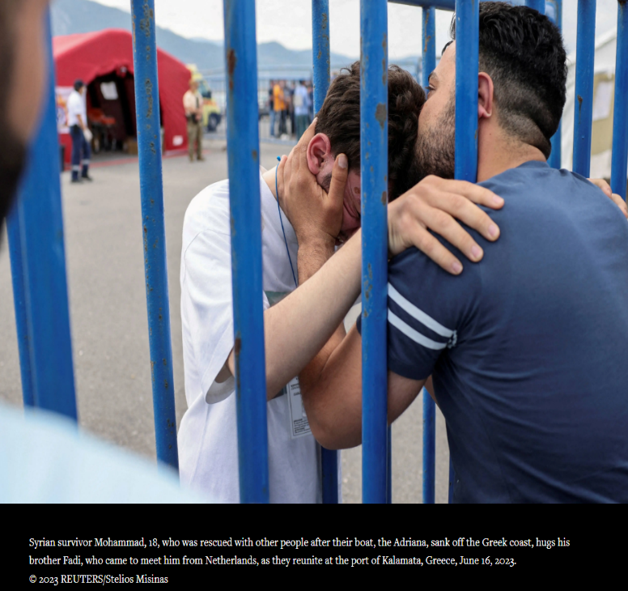
- The report details widespread unlawful pushbacks by Greek authorities. Asylum seekers were often detained after crossing the border, physically abused, and returned to Türkiye across the Evros River without being given the opportunity to seek asylum. Greek forces were reported to confiscate personal belongings such as phones, money, and identification documents, leaving individuals stranded without essentials.
- Those apprehended often faced physical violence, including beatings with truncheons and gun butts, and were held in detention centers in overcrowded, unsanitary conditions without access to legal support. In some instances, families were separated during pushbacks, resulting in harrowing experiences like that of a Syrian mother and her six children, who were split between detention centers and deported at different times. Similar practices were observed at sea, where Greek Coast Guards reportedly abandoned boats with asylum seekers, removing fuel and leaving them adrift in Turkish waters.
Conditions in Türkiye
- Once forcibly returned to Türkiye, asylum seekers encountered equally harsh conditions. Many were left without shelter, food, or access to basic hygiene, with inflated prices for basic goods adding to their suffering. Some refugees recounted how Turkish authorities initially facilitated their journey to the Greek border, even providing free transportation, only to abandon them later when it became clear they could not cross. By the end of March, Turkish authorities cleared informal refugee camps near the border, leaving asylum seekers in precarious conditions.
Turkish Authorities' Role
- The report is critical of both the EU and Turkish authorities. While Türkiye allowed and encouraged asylum seekers to approach the border, the Greek authorities, supported by the EU, responded with force, pushing asylum seekers back without proper assessment of their protection needs. Amnesty International also emphasizes that Türkiye's role in facilitating these movements was politically motivated, seeking to pressure the EU for financial and political support in Syria.
- This report provides a stark account of the systematic violations of international law committed by Greek authorities and highlights the human cost of Europe's failure to address the refugee crisis responsibly. It also illustrates the cycle of abuse that asylum seekers endure at the hands of both Turkish and Greek authorities.

Amnesty International: “Greece: Violence, Lies, and Pushbacks”
- The Amnesty International’s second report “Greece: Violence, Lies, and Pushbacks” published in 2021 provides a detailed investigation of Greece's use of pushbacks as a de facto policy to control its borders. The report documents multiple instances of refugees and migrants being forcibly returned to Türkiye, including specific cases where victims were subjected to violence, arbitrary detention, and lack of due process.
Key findings of the report include:
- Greece has implemented a coordinated policy of pushbacks, involving both state and non-state actors. Migrants and refugees are apprehended, detained without proper legal procedures, and expelled across the Evros River back to Türkiye, often with violence and inhumane treatment.
- Migrants pushed back into Türkiye also face harsh treatment by Turkish authorities. Amnesty documented cases where Turkish border forces used threats and violence, sometimes forcing people back towards Greece or detaining them arbitrarily.
- Despite widespread evidence and international attention, Greek authorities have consistently denied involvement in pushbacks, and the EU has failed to hold Greece accountable for these violations. Victims have limited access to justice or remedies, and there is little investigation into these abuses.
- The report emphasizes the impact of pushbacks on vulnerable groups, including children and families, and calls for immediate cessation of these practices by both Greece and Türkiye.
- The report includes testimonies from people who experienced pushbacks, some of whom reported being assaulted or subjected to inhumane treatment, including strip searches and physical violence. Türkiye's role is also criticized, with allegations that Turkish forces failed to rescue people stranded after being pushed back or even forced them back towards Greece.
- This report's findings are crucial for understanding the scope and scale of human rights violations occurring at the Greek-Turkish border, with broader implications for EU border policies and international accountability.

Human Rights Watch: “Their Faces Were Covered”
- The HRW report “Their Faces Were Covered: Greece’s Use of Migrants as Police Auxiliaries in Pushbacks” published in April 2022 provides a comprehensive analysis of the illegal pushbacks conducted at Greece’s borders. The report is based on interviews with Afghan migrants, other asylum seekers, and key informants who were involved in or witnessed these operations between November 2021 and March 2022. It sheds light on the increasing use of migrants as auxiliaries in carrying out these pushbacks, the abuses committed during these operations, and the legal implications of declaring Türkiye as a "safe third country" for migrants and asylum seekers.
Systematic Pushbacks and the Use of Migrant Auxiliaries
- A significant focus of the report is how Greek authorities, primarily along the Evros River, have systematically engaged in pushbacks, violating EU asylum law and international human rights standards. Migrants, particularly from Afghanistan, Pakistan, and Syria, were frequently intercepted by Greek police or coast guard forces after crossing into Greece, only to be forcibly returned to Türkiye without any formal asylum procedures.
- One of the report’s more alarming findings is the involvement of migrant auxiliaries – men of Middle Eastern or South Asian descent who were coerced into assisting Greek authorities in conducting pushbacks. These auxiliaries were reportedly promised travel documents or asylum in exchange for their participation. Masked and armed, they played key roles in detaining other migrants, confiscating their belongings, and leading them to the Evros River, where they were forced to return to Türkiye. The title of the report, “Their Faces Were Covered,” refers to these auxiliaries, who would cover their faces to remain anonymous during the operations.
Violence and Abuse during Pushbacks
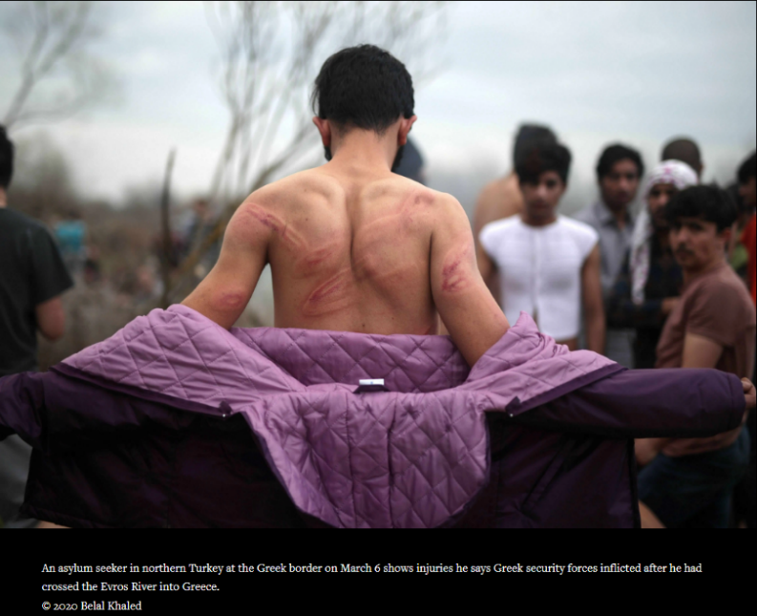
- The report documents extensive physical abuse and mistreatment during these pushback operations. Migrants were often stripped of their clothes, beaten with batons, and subjected to verbal abuse by Greek officials and migrant auxiliaries alike. They were routinely deprived of personal belongings such as mobile phones, money, and identity documents, which made it difficult for them to seek help or attempt to cross the border again. The report cites numerous testimonies from Afghan migrants who were victims of beatings, robbery, and forced expulsions, describing their experiences of being left in precarious situations on the Turkish side of the river.
- In many cases, migrants were transported in overcrowded vehicles, sometimes by Greek officials but often by the migrant auxiliaries themselves, to secret detention facilities near the Evros River. These detention centers were frequently unrecorded, making it nearly impossible for victims to seek legal recourse or lodge complaints.
Türkiye as a “Safe Third Country”: Legal and Humanitarian Concerns
- One of the key legal issues addressed in the report is Greece’s designation of Türkiye as a "safe third country" for asylum seekers from Afghanistan, Pakistan, Bangladesh, Somalia, and Syria. This designation implies that migrants could be returned to Türkiye under the assumption that they would be safe and able to seek asylum there. However, HRW challenges this claim, arguing that Türkiye does not meet the legal requirements of a safe third country under EU law.
- The report outlines several reasons why Türkiye is not a safe destination for migrants. First, it points out that Türkiye’s asylum system is overwhelmed and inadequate for handling the number of asylum seekers it receives. Migrants pushed back to Türkiye often face deportation to their countries of origin, where they may be at risk of persecution or harm. For example, Afghan nationals deported from Türkiye risk persecution by the Taliban, while Syrians may face arrest, detention, or worse if returned to Syria.
- Additionally, Türkiye's treatment of migrants has come under scrutiny. Migrants who are pushed back into Türkiye frequently face arbitrary detention, lack of access to legal remedies, and poor living conditions in detention centers. The report documents several instances where migrants deported from Greece to Türkiye were subsequently detained or subjected to forced deportation to countries where they faced significant risks.
The Role of Frontex and Lack of Accountability
- The report also examines the role of the Frontex in the ongoing pushback practices. Despite Frontex’s presence at the Greek border, HRW found that the agency has done little to prevent or document the abuses occurring at Greece’s borders. Frontex has been criticized for failing to intervene in cases of pushbacks or ensure that human rights are protected during its operations. The report calls for increased transparency and accountability within Frontex, urging the EU to ensure that Frontex’s mandate is aligned with human rights obligations.
Specific Issues Faced by Turkish Nationals
- While the report focuses primarily on migrants from Afghanistan, Pakistan, and Syria, it also touches on the challenges faced by Turkish nationals who attempt to cross the Greek border. These individuals, often fleeing political persecution in Türkiye, are equally subjected to pushbacks and face similar hardships upon their forced return. Turkish nationals who are expelled from Greece risk being detained upon re-entry into Türkiye and face persecution by the Turkish government.
Recommendations
- The HRW report concludes with several recommendations for the Greek government, EU authorities, and Frontex:
- Greece must end all pushback practices at both land and sea borders and comply with international and EU law by allowing asylum seekers access to legal processes and protection.
- The Greek government should conduct independent investigations into allegations of pushbacks and prosecute any officials or auxiliaries involved in these illegal operations.
- The designation of Türkiye as a safe third country should be revoked, and asylum seekers should be allowed to have their claims processed in Greece without the risk of being returned to a country that cannot provide adequate protection.
- Frontex should strengthen its oversight mechanisms and ensure that its operations in Greece do not contribute to human rights violations. The European Commission must ensure that Frontex is held accountable for its actions at the border.

European Center for Constitutional and Human Rights: “Analyzing Greek Pushbacks: Over 20 Years of Concealed State Policy Without Accountability”
- The ECCHR report titled “Analyzing Greek Pushbacks: Over 20 Years of Concealed State Policy Without Accountability” last updated February 2022 provides an extensive overview of the systematic and organized pushback operations conducted by Greek authorities at both land and sea borders. This practice has been ongoing for over two decades, involving a consistent pattern of illegal expulsions, arbitrary detention, and ill-treatment of migrants and asylum seekers.
Systematic and Widespread Pushbacks
- The report highlights that pushbacks in Greece are not isolated incidents but are a part of an organized state policy. Pushbacks have occurred regularly since at least 2008 at the Evros land border and in the Aegean Sea, affecting tens of thousands of migrants and asylum seekers each year. These operations involve multiple state agencies and are carried out under the direction of the Greek Ministries of Public Order and Shipping.
Elements of Pushbacks
- Migrants are often detained in unregistered facilities with no record-keeping, where they are held in unsanitary and inhumane conditions. Detention centers like those in the Evros region are described as overcrowded, lacking basic necessities such as food and water, and often characterized by racial profiling.
- Migrants are frequently subjected to physical violence, including beatings, and other forms of degrading treatment during their detention and forced removal. Greek law enforcement and paramilitary forces involved in these pushbacks often wear balaclavas to hide their identities, exacerbating the sense of impunity.
- The report documents that expulsions are carried out without any formal legal process, denying migrants the opportunity to seek asylum or access basic legal rights. This includes not being registered or processed according to any legal framework.
No Accountability
- Despite the widespread nature of these pushbacks, there has been little to no accountability for the state agencies involved. The Greek authorities consistently deny the existence of such practices, and there are no effective mechanisms in place to investigate or punish those responsible.
Impact on Migrants
- The report specifically addresses the hardships faced by migrants, including those from Türkiye, who are forcibly returned to Türkiye. These individuals are often left in perilous situations, with no legal recourse or protection, and are at risk of further human rights violations in Türkiye, where they may face persecution or other forms of mistreatment.
- To summarise, the ECCHR report emphasizes that pushbacks are a deliberate and systematic policy of the Greek state, aimed at deterring migration and violating fundamental human rights, including the right to seek asylum and protection against refoulement. The report calls for urgent action to hold Greek authorities accountable and to end these illegal practices.

Stockholm Center for Freedom: “Pushback of Turkish Asylum Seekers from Greece to Turkey”
- The Stockholm Center for Freedom's report, “Pushback of Turkish Asylum Seekers from Greece to Turkey” published in January 2023, provides a detailed examination of the pushback practices that have affected Turkish asylum seekers, particularly those fleeing persecution in the aftermath of the 2016 coup attempt in Türkiye. The report highlights that pushbacks of Turkish nationals began primarily in 2019 and have increased steadily since then, with a growing number of Turkish asylum seekers facing arrest, imprisonment, and further human rights violations upon their return to Türkiye.
Pushbacks of Turkish Asylum Seekers
- The report documents various instances of Turkish asylum seekers being forcibly returned to Türkiye. These individuals often face imprisonment, persecution, and inhumane treatment upon their return. Greek authorities are accused of violating the principle of non-refoulement, a core tenet of international refugee law that prohibits returning individuals to a country where they risk persecution. Despite asylum seekers' requests to enter asylum procedures, they are subjected to collective expulsions.
Case Examples: Detention and Violence
- Turkish asylum seekers, including families with children, often endure violent treatment during pushbacks. One detailed case involved Hüsniye, a former teacher, who was detained by Greek authorities, stripped of her belongings, and sent back to Türkiye in freezing conditions. Upon return to Türkiye, many pushback victims face arrest, torture, and imprisonment. For example, Mehtap Karpuzcu, another Turkish asylum seeker, was jailed upon her forced return. Her family had faced severe persecution in Türkiye due to alleged links with the Gülen movement.
Non-refoulement Violations
- The report stresses the importance of the non-refoulement principle under international law, which Greece consistently breaches in these pushback operations. The report further underscores that Greece's pushbacks of Turkish nationals, who are political dissidents, result in severe human rights abuses, including torture and imprisonment in Türkiye. The systematic nature of these pushbacks suggests a de facto policy of preventing asylum seekers, especially those of Turkish origin, from entering Greece.
Violent Practices and Inhumane Treatment
- The report provides accounts of brutal physical assaults during pushbacks. Asylum seekers describe being subjected to strip searches, physical abuse, and humiliation. For example, one Turkish woman recounted being assaulted by Greek officers while her child watched. The report highlights that these violent practices violate international human rights standards, including the prohibition of torture.
Recommendations
- The SCF urges Greece to cease its illegal pushback practices and calls on international organizations and the EU to investigate these violations. The report also suggests that Türkiye cannot be considered a "safe third country" for Turkish asylum seekers due to the well-documented persecution they face upon return.

Peace § Justice: “Pushbacks Report: The case of Turks at Greek borders”
- The Peace & Justice report, “Pushbacks Report: The Case of Turks at Greek Borders” published in October 2021, provides an in-depth analysis of pushback practices at the Greece-Türkiye border, particularly focusing on the plight of Turkish asylum seekers. The report underscores how Turkish nationals, fleeing persecution following the 2016 coup attempt, have faced significant human rights violations when attempting to cross into Greece.
Context of Turkish Asylum Seekers
- The report begins by discussing the political context in Türkiye, where following the failed 2016 coup attempt, the Turkish government has aggressively persecuted individuals alleged to be affiliated with the Gülen movement, as well as other political opponents. Thousands of Turks have sought asylum in neighboring countries like Greece. For these individuals, returning to Türkiye poses serious risks, including arrest, torture, and imprisonment. Despite this, many have been subjected to pushbacks by Greek authorities, contrary to the principle of non-refoulement.
Pushback Operations at the Greek Border
- The report documents numerous instances of pushbacks of Turkish nationals. It describes the illegal nature of these operations, where asylum seekers are detained without due process, subjected to violence, and forcibly returned to Türkiye. These operations often involve masked, uniformed officers who strip migrants of their belongings, detain them in makeshift facilities, and then expel them across the Evros River under cover of darkness.
Testimonies of Turkish Asylum Seekers
- The report highlights several first-hand testimonies from Turkish asylum seekers who experienced pushbacks. Many of these individuals, including women and children, recounted being detained by Greek police or border guards, physically abused, and denied the opportunity to apply for asylum. For example:
- Testimony No. 1 describes a Turkish woman fleeing persecution who was detained by Greek police and forced back into Türkiye. Upon her return, she was arrested and imprisoned for over 28 months.
- Testimony No. 2 recounts the ordeal of a Turkish businessman whose wife was pushed back to Türkiye, where she was jailed again after being accused of links to the Gülen movement. Despite severe health problems, she received no medical care while in detention.
- These testimonies illustrate the brutal conditions faced by Turkish asylum seekers during pushbacks, including beatings, forced separations of families, and arbitrary detentions. The report stresses that these pushbacks violate international law and put Turkish nationals at risk of inhumane and degrading treatment upon their return to Türkiye.
Türkiye Is Not a Safe Country for Asylum Seekers
- A central argument of the report is that Türkiye does not meet the criteria of a safe third country for asylum seekers, particularly for Turkish nationals fleeing political persecution. The Greek government's designation of Türkiye as a "safe third country" is heavily criticized, as returnees face serious human rights violations in Türkiye. The Turkish government has repeatedly used counterterrorism laws to prosecute and imprison political dissidents, leaving those pushed back to Türkiye vulnerable to long prison sentences, torture, and unfair trials.
Worse Treatment for Turkish Nationals
- The report emphasizes that Turkish asylum seekers often face harsher treatment than other refugees. Once pushed back into Türkiye, they are not only denied asylum but are often immediately imprisoned. The report points out that Turkish authorities actively search for Turkish nationals among asylum seekers, and their capture leads to serious human rights abuses, including prolonged detention, torture, and politically motivated trials.
Recommendations
- The report concludes with several key recommendations, calling for:
- An immediate end to pushbacks at Greece's borders.
- Better asylum procedures that ensure that Turkish nationals are properly processed and given access to protection.
- Accountability measures for Greek authorities involved in illegal pushbacks.
- The EU to increase oversight of Greece’s border practices and ensure compliance with international human rights standards.
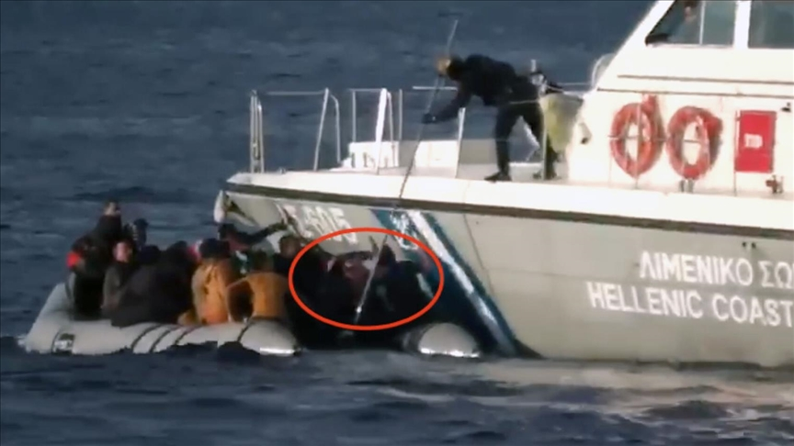
- In conclusion, the Peace & Justice report offers a compelling account of the systematic pushbacks faced by Turkish asylum seekers attempting to escape persecution in their home country. It documents harrowing testimonies of individuals subjected to violence, mistreatment, and forced returns, calling for urgent action to stop these illegal practices and protect the rights of asylum seekers. The report stresses the need for accountability and adherence to international law, particularly the principle of non-refoulement, which Greece is consistently violating through its pushback operations.

International Legal Proceedings and Mechanisms Addressing Pushbacks
- Pushbacks undermine fundamental human rights and often involve violence, arbitrary detention, and lack of access to asylum procedures. Pushbacks at the Greek borders have attracted widespread international scrutiny, leading to several legal proceedings and investigations by both United Nations mechanisms and the ECtHR.

Pushbacks Before UN Mechanisms
- Greece’s practice of pushbacks has prompted numerous urgent appeals and communications to United Nations mechanisms by civil society organizations and human rights groups. These appeals highlight widespread violations of international law, particularly concerning the principle of non-refoulement, which prohibits returning individuals to countries where they face persecution. UN bodies such as the Special Rapporteur and the WGAD have been consistently urged to address these violations.
- Civil society organizations have submitted urgent appeals to the UN, detailing multiple incidents where asylum seekers, including those fleeing political persecution, were subjected to violence, arbitrary detention, and denial of the right to seek asylum. These appeals emphasize that many of the individuals forcibly returned to Türkiye faced immediate risk of imprisonment, torture, and other human rights abuses upon their return. The appeals point to consistent patterns of abuse, with individuals often detained without due process and expelled across the Evros River or at sea, sometimes with the assistance of masked officers. These actions are clear violations of international refugee law and Greece’s obligations under the ICCPR.
- In addition to the urgent appeals, cases have been brought before the HRC, challenging the legality of Greece’s pushback practices. One such case addresses the collective expulsion of asylum seekers without proper individual assessments of their asylum claims, which contravenes Article 7 of the ICCPR, prohibiting torture or inhuman treatment. These cases highlight Greece’s failure to provide adequate legal protection and access to asylum procedures for individuals fleeing persecution, resulting in ongoing investigations and legal proceedings by the HRC.
- Through these legal proceedings and urgent appeals, UN mechanisms are being asked to hold Greece accountable for its persistent pushbacks and to ensure that asylum seekers receive the protection to which they are entitled under international law.

Pushbacks Before the European Court of Human Rights
- Pushbacks at the Greek-Turkish border have led to multiple legal challenges before the ECtHR. These cases revolve around alleged violations of the ECHR, particularly Article 3 (prohibition of inhuman or degrading treatment), Article 5 (right to liberty and security), and Article 13 (right to an effective remedy). Numerous asylum seekers have submitted complaints to the ECtHR, arguing that Greek authorities engaged in pushbacks without due legal process, thus breaching their fundamental rights. These cases illustrate the broader legal struggle to hold Greece accountable for its pushback practices.
A.D. v. Greece and G.R.J. v. Greece
- The cases of A.D. v. Greece (no. 15067/21) and G.R.J. v. Greece (no. 15783/21) are among the prominent examples of individuals challenging Greece’s pushback policies.
- In the A.D. v. Greece case, the applicant, an Afghan minor, claimed that he reached the island of Samos in September 2020 and immediately expressed his desire for international protection. Despite this, the applicant alleged that the next day, Greek coastguard officers forced him onto a raft and abandoned him in the Aegean Sea, where he was rescued by the Turkish coastguard. He claims his detention was arbitrary, and the authorities violated his right to seek asylum.
- In the G.R.J. v. Greece case, the applicant, a Turkish national, entered Greece after crossing the Evros River in May 2019. She alleged that despite her request for international protection, Greek authorities detained her, stripped her of her belongings, and expelled her back to Türkiye. After being arrested by Turkish authorities, she was imprisoned. The ECtHR communicated these cases to the Greek government, raising concerns over violations of Articles 2, 3, 5, and 13 of the ECHR, questioning whether the applicants’ rights had been upheld during their time in Greece​.
Chamber Hearing in G.R.J. v. Greece and A.E. v. Greece
- On June 4, 2024, the ECtHR held a chamber hearing concerning the cases of G.R.J. v. Greece and A.E. v. Greece (applications nos. 15067/21 and 15783/21)​. The applicants argued that Greek authorities subjected them to inhumane treatment, forcibly returning them to Türkiye despite their attempts to claim asylum. In this hearing, the applicants relied on Articles 2, 3, and 13, with A.E. also invoking Article 5 due to the arbitrary nature of her detention before her expulsion to Türkiye. Both cases underscore the lack of procedural safeguards during pushbacks, particularly the absence of individual assessments and legal recourse. The hearing allowed the Court to explore the alleged collective expulsions and violations of due process, as well as the broader implications of these actions on asylum seekers in Greece.
Third-Party Intervention: Border Violence Monitoring Network
- The BVMN has submitted third-party interventions in several cases concerning pushbacks at the ECtHR, offering critical evidence on the systemic nature of these violations. One such intervention, documented in the Third-Party Intervention submission, outlines the widespread use of masked officers, detentions without legal basis, and violent expulsion tactics used by Greek authorities. BVMN’s interventions underscore that these practices violate Articles 3 and 13 of the ECHR, stressing that the Greek authorities have consistently failed to investigate and address these abuses. In the case discussed in their submission (application nos. 15067/21 and 15783/21), BVMN highlighted specific incidents of violent pushbacks, including instances where asylum seekers were forced onto rafts and abandoned at sea.
- The ECtHR cases on Greek pushbacks illustrate the serious legal and human rights issues at the heart of Greece’s border practices. Applicants in these cases allege violations of international human rights standards, with collective expulsions and violent treatment being central to their complaints. These cases represent a critical legal battle, with the outcomes likely to set important precedents for the protection of asylum seekers across Europe.

Human Rights Committee Reviews and Greece's Compliance
- The HRC serves as a pivotal mechanism in monitoring state compliance with obligations under the ICCPR. As part of Greece's periodic reviews, the HRC evaluates the country’s human rights practices, particularly in relation to migrant and asylum seeker treatment. The committee's observations, recommendations, and follow-up reviews aim to ensure that Greece addresses and rectifies systemic issues such as the widespread pushbacks occurring at its borders, emphasizing the need for legal compliance with international human rights standards.

Concluding Observations on the Second Periodic Review
- In its Concluding Observations on the second periodic report of Greece (CCPR/C/GRC/CO/2) dated 3 December 2015, the HRC raised several concerns about Greece’s treatment of asylum seekers, migrants, and refugees, particularly in relation to pushbacks. These concerns are specifically addressed in paragraphs 33 and 34 of the document.
- Paragraph 33 highlights the Committee's concern regarding reports of informal returns, commonly known as pushbacks, conducted by Greek authorities at both land and sea borders with Türkiye. The Committee expressed particular concern that these pushbacks were carried out without sufficient safeguards ensuring compliance with the principle of non-refoulement, which prohibits returning individuals to countries where they may face persecution. The Committee also noted allegations of ill-treatment during expulsions, which violate the protections guaranteed under Articles 6 and 7 of the ICCPR.
- In Paragraph 34, the Committee urged Greece to ensure that all individuals seeking international protection have access to a fair and individualized assessment procedure and are protected from refoulement. It also recommended that Greece establish safe entry points for migrants to access asylum procedures and ensure that informal returns do not occur. The Committee further stressed the need for prompt, effective, and independent investigations into all allegations of ill-treatment during expulsions, with a focus on holding perpetrators accountable and compensating victims where appropriate.
- These observations reflect the Committee's deep concerns about Greece’s pushback practices, particularly the lack of safeguards and the potential violations of international human rights standards.

Greece’s Non-compliance with the Concluding Observations
- Despite the HRC's clear recommendations in paragraphs 33 and 34 of the Concluding Observations on the Second Periodic Review (2015), Greece has largely failed to comply with these international obligations. Reports from various international bodies and NGOs demonstrate that the problematic practices highlighted by the Committee, particularly pushbacks and related human rights violations, have not only continued but have intensified.
Continued Pushbacks and Informal Returns
- One of the key issues raised in the 2015 Concluding Observations was the practice of informal returns or pushbacks at both land and sea borders. Reports from Amnesty International and HRW, as summarized in “Greece: Violence, Lies, and Pushbacks” and “Their Faces Were Covered”, respectively, document continued incidents of collective expulsions and violent pushbacks carried out by Greek authorities. These reports demonstrate that, contrary to the Committee’s recommendation to ensure safe entry points and individualized assessments, asylum seekers, particularly those crossing the Evros River or the Aegean Sea, are forcibly returned to Türkiye without having the opportunity to submit an asylum claim.
Violation of Non-Refoulement
- The principle of non-refoulement was a central concern in the Committee’s observations. Despite Greece’s obligations under international law, numerous reports, including those from the ECCHR, have highlighted Greece’s failure to protect asylum seekers from refoulement. The ECCHR report, “Analyzing Greek Pushbacks: Over 20 Years of Concealed State Policy Without Accountability,” provides evidence of asylum seekers being returned to Türkiye, where they face detention, imprisonment, and possible persecution. This practice continues to occur, directly contradicting the Committee’s recommendations.
Lack of Investigation and Accountability
- In Paragraph 34, the HRC urged Greece to conduct independent investigations into allegations of ill-treatment during expulsions and to hold perpetrators accountable. However, reports from the BVMN and Amnesty International point to a lack of transparency and failure to investigate such incidents. Despite numerous well-documented cases of abuse, including physical violence, theft of personal belongings, and forced expulsions, there is little evidence that Greek authorities have taken significant steps to investigate or punish those responsible.
- As detailed in the section on International Legal Proceedings and Mechanisms Addressing Pushbacks, there have been numerous applications submitted before UN mechanisms and the ECtHR concerning Greece's pushback practices. These legal actions, involving both individual cases and third-party interventions, highlight the systemic nature of the problem and demonstrate that, rather than being addressed, the issue has become chronic. The persistence of these cases underscores the ongoing failure to resolve the situation, reflecting a broader pattern of non-compliance with international human rights obligations.
Worsening Conditions for Asylum Seekers
- The reports also highlight the deteriorating conditions for asylum seekers in Greece, particularly those subjected to pushbacks. Testimonies in reports from Stockholm Center for Freedom and Peace & Justice reveal how Turkish nationals and other vulnerable groups are subjected to inhumane treatment, including detention in overcrowded facilities and exposure to violence. These accounts directly conflict with the Committee’s call for humane treatment and access to asylum procedures for all individuals, including those fleeing political persecution.
- In conclusion, the evidence clearly demonstrates that Greece has failed to implement the recommendations made by the HRC in its Concluding Observations. The continued use of pushbacks, the violation of non-refoulement, the lack of accountability, and the worsening treatment of asylum seekers all point to Greece’s non-compliance with its international obligations. The persistent nature of these practices highlights the need for stronger international oversight and enforcement mechanisms to ensure that Greece upholds its commitments under the ICCPR.

List of Issues Prior to the Third Periodic Report
- In paragraph 16 of the "List of issues prior to submission of the third periodic report of Greece" (CCPR/C/GRC/QPR/3) dated 2 December 2021, the HRC highlighted several concerns regarding Greece’s practices at its borders. The paragraph specifically addressed issues related to allegations of pushbacks and mistreatment of migrants and asylum seekers, particularly in the context of Greece’s obligation under international law to protect those seeking asylum.
- The Committee requested detailed information from Greece on how it has investigated and addressed these allegations, especially those involving violence and the lack of access to asylum procedures. Additionally, the Committee sought clarification on Greece's measures to ensure compliance with the principle of non-refoulement and its efforts to provide migrants with access to justice and remedies against potential violations of their rights.

Analysis of Greece’s Responses in its Third Periodic Report
- Under the "Reply to paragraph 16 of the list of issues" section in Greece's Third Periodic Report (CCPR/C/GRC/3, dated 13 September 2023), the Greek government outlines its position regarding the pushback allegations. The response from paragraphs 157 to 165 primarily focuses on justifying the state's actions along its borders, particularly emphasizing the extraordinary circumstances during the February/March 2020 mass movements at the Greek-Turkish border, which Greece describes as orchestrated. The Greek government denies the establishment of pushbacks as a de facto policy and asserts that both the Hellenic Police and the Hellenic Coast Guard follow legal and procedural frameworks in line with human rights obligations, including referral to national authorities for asylum claims.
- However, this position starkly contrasts with numerous credible international and NGOs reports. In particular, the WGAD, CPT, and Special Rapporteur reports, alongside findings from organizations such as Amnesty International and HRW, have consistently documented instances of pushbacks, often highlighting patterns of violence, confiscation of belongings, and violations of procedural safeguards during these incidents. Greece’s claim that pushbacks are not part of operational practices is therefore difficult to reconcile with the substantial body of evidence collected by external monitoring bodies, which indicates systematic pushback practices both at land and sea borders.
- The Greek authorities also state that all allegations are investigated promptly and thoroughly through various national and EU mechanisms, including Frontex’s Serious Incident Reporting and Complaints Mechanism. Yet, reports from Frontex, independent NGOs, and international bodies suggest that these investigations often fail to substantiate claims, pointing instead to a lack of effective oversight and accountability.
- Additionally, Greece refers to the 2016 EU-Türkiye Statement, framing Türkiye as a safe third country where irregular migrants should be returned. This stance is heavily contested in reports, including HRW's 2022 report, which argues that Türkiye is not a safe third country, particularly for individuals at risk of deportation, where returned migrants face violence, detention, and refoulement.
- In summary, the evidence presented by independent observers and civil society organizations consistently challenges Greece’s official narrative, suggesting that the country’s responses under paragraphs 157-165 of its Third Periodic Report are not fully aligned with the realities documented by various actors on the ground. Greece's continued denial of pushback practices stands in direct contradiction to widespread reports of human rights violations, reinforcing concerns about the lack of accountability and transparency in border management.

Conclusion
This shadow report has documented serious and ongoing violations of human rights at Greece’s borders, particularly regarding the practice of pushbacks against asylum seekers and migrants. Despite repeated recommendations from international bodies, Greece continues to engage in actions that violate its obligations under the ICCPR and other international treaties. Reports from international organizations and NGOs reveal a troubling pattern of refoulement, arbitrary detention, and inhumane treatment of individuals seeking international protection.
The findings presented in this report highlight that Greece has failed to comply with the Concluding Observations of the HRC following its Second Periodic Review. Pushbacks continue to occur, often accompanied by violence, confiscation of personal belongings, and denial of access to asylum procedures. Greece’s response in its Third Periodic Report (2023) inadequately addresses these concerns and remains inconsistent with the overwhelming evidence gathered by international and non-governmental organizations.
Moreover, the persistent lack of accountability for border officials involved in these practices remains a significant issue. Despite Greece’s assurances of investigations into pushback allegations, there is little evidence to suggest that meaningful steps have been taken to prevent future violations or hold perpetrators accountable. This continued impunity allows for the recurrence of these human rights abuses.
Given the chronic nature of these violations, it is clear that Greece’s internal mechanisms for addressing pushbacks are insufficient. The international community, including the HRC, must strengthen its oversight to ensure that Greece complies with its legal obligations under the ICCPR and other human rights frameworks. Regular and independent monitoring, along with transparent investigations, is critical to addressing the root causes of these violations and ensuring the protection of asylum seekers at Greece’s borders.
To resolve these persistent issues and uphold its international obligations, the following recommendations are made to Greece and the broader international community:
- Greece should take immediate steps to cease all pushback operations at its land and sea borders. This includes halting the arbitrary expulsion of asylum seekers and migrants without due process or access to asylum procedures.
- Greek authorities must fully respect the principle of non-refoulement by ensuring that no individual is returned to a country where they may face persecution, torture, or inhumane treatment. Asylum seekers should have access to fair and individualized assessments of their protection claims.
- Greece must create independent mechanisms to investigate allegations of pushbacks and other human rights violations. These investigations should be transparent, impartial, and lead to accountability for those found responsible. Regular reports should be provided to the United Nations and other international bodies to ensure transparency and compliance with human rights standards.
- Conditions in detention centers for migrants and asylum seekers must be brought into compliance with international standards. This includes addressing issues such as overcrowding, lack of access to basic hygiene, and denial of legal assistance. Vulnerable groups, including women, children, and persons with disabilities, should receive special protections.
- Greece should ensure that all asylum seekers have effective access to the asylum system, including legal representation and the right to appeal negative decisions. Clear guidelines should be provided to law enforcement and border guards to ensure that migrants are not denied their right to seek international protection.
- Greece should cooperate fully with international monitoring mechanisms, including the HRC, Special Rapporteurs, and the European Court of Human Rights, by providing timely responses to inquiries and implementing their recommendations. Engagement with civil society organizations should also be strengthened to ensure broader transparency.
- Given the complexities of managing migration at the EU’s external borders, Greece should seek greater cooperation and support from regional partners and the EU to develop sustainable and humane migration policies. This includes sharing best practices for border management and ensuring that migration policies respect fundamental human rights
By implementing these recommendations, Greece can address the human rights violations occurring at its borders and bring its policies in line with its international obligations. The international community should continue to monitor Greece’s actions closely to ensure that the necessary reforms are implemented and sustained.

https://documents.un.org/doc/undoc/gen/g20/193/72/pdf/g2019372.pdf
https://documents.un.org/doc/undoc/gen/n21/212/05/pdf/n2121205.pdf
https://documents.un.org/doc/undoc/gen/g22/328/57/pdf/g2232857.pdf
https://rm.coe.int/1680a06a86
https://rm.coe.int/letter-to-mr-michalis-chrysochoidis-minister-for-citizens-protection-o/1680a256ad
https://www.amnesty.org/en/documents/eur01/2077/2020/en/
https://www.amnesty.org/en/documents/eur25/4307/2021/en/
https://www.hrw.org/sites/default/files/media_2022/04/greece0422_web_0.pdf
https://www.ecchr.eu/fileadmin/user_upload/Analyzing_Greek_Pushbacks-_Over_20_years_of_concealed_state_policy_without_accountability.pdf
https://stockholmcf.org/wp-content/uploads/2023/01/Pushback-Report.pdf
https://www.flipsnack.com/peaceandjustice/pushbacks-report-the-case-of-turks-at-greek-borders.html
https://hudoc.echr.coe.int/eng?i=001-214647
https://hudoc.echr.coe.int/eng?i=001-214585
file:///C:/Users/o.bahadir/Downloads/Chamber%20hearing%20in%20the%20cases%20G.R.J.%20v.%20Greece%20and%20A.E.%20v.%20Greece.pdf
https://documents.un.org/doc/undoc/gen/g15/274/36/pdf/g1527436.pdf
https://tbinternet.ohchr.org/_layouts/15/treatybodyexternal/Download.aspx?symbolno=CCPR%2FC%2FGRC%2FQPR%2F3&Lang=en
https://tbinternet.ohchr.org/_layouts/15/treatybodyexternal/Download.aspx?symbolno=CCPR%2FC%2FGRC%2F3&Lang=en

