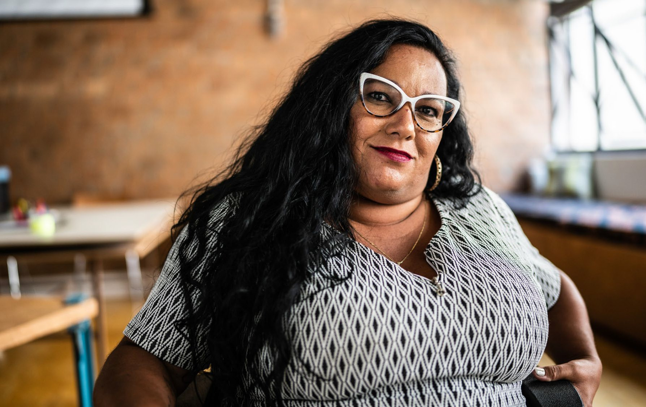

Invisible and Unequal: Reflection on the Position of Women with Disabilities
in the Netherlands

2

Inhoud
Preliminary remarks
A. General
4
5
1
Data on women with disabilities 5
B. National machinery for the advancement of women
5
2
Measures taken to ensure adequate funding for organizations of women with disabilities and ensure their participation in policy development processes 5
C. Temporary special measures
6
3
Temporary special measures regarding women with disabilities 6
D. Stereotypes and harmful practices
6
4
5
Stereotypes of women with disabilities in the media 6
Intersex children 7
E. Gender-based violence against women
7
6
7
Protect and support victims of violence, in particular (..) women with disabilities 7
Systematically collect data on all forms of violence against women with disabilities 8
F. Participation in political and public life
8
8
Representation in political and public life 8
G. Education
9
9
Ensure inclusive, quality education for girls and women with disabilities throughout the educational system 9
H. Employment
9
10
Measures taken to ensure the right of women with disabilities to earn a living through work and to ensure access to the labour market and work environment that is open and inclusive 9
I. Health
9
11
Medical gender-based discrimination 9
J. Disaster risk reduction and climate change
10
12
Involvement of women in Disaster Risk Reduction 10
K. Disadvantaged groups of women
10
13
14
15
16
Women with disabilities in detention 10
Sexual and reproductive health 11
Sexual education for girls with disabilities 11
Institutionalisation of women and girls with disabilities 12
L. Marriage and family relations
13
17
Personal contributions 13
3

Preliminary remarks
In this shadow report, Ieder(in) highlights several key issues, many of which are recurring concerns regarding the situation of women and girls with disabilities. They have been brought to the UN Committee on the Rights of Persons with Disabilities in August 2024 during the review of the Dutch State. This alternative report is a response to the government report to the CEDAW Committee.
Ieder(in) is a Dutch national umbrella organization representing people with physical or intellectual disabilities and/or chronic illnesses. Based in Utrecht, the Netherlands, it brings together over 240 member associations, making it the largest network in this field in the country. Ieder(in) advocates for the rights and inclusion of more than two million people, guided by the UN Convention on the Rights of Persons with Disabilities (CRPD). The organization works closely with Dutch government bodies, municipalities, and social partners to promote an inclusive society. Its activities include lobbying, supporting local initiatives, and providing information on legislation and accessibility.
Throughout this report, our reference to ‘women’ encompasses women with disabilities in all their diverse identities, including black, migrant and refugee women, bi/multicultural women, lesbian and bisexual women, elderly women, transgender women, non-binary people who are socialised and perceived as women, as well as intersex persons.
One of the main concerns we have is the lack of data on women with disabilities. This data gap is a problem, because without hard data the specific needs of women with disabilities remain out of sight when allocating resources and creating legislation.
Other concerns we have are the financial position of women with disabilities: women with disabilities are less likely to be financially independent and more likely to be unemployed than women without disabilities and men with disabilities. Moreover, women with disabilities are more likely to be unemployed because of caring duties than women without disabilities and men with disabilities. 1 Moreover, these informal caregivers often become overburdened. The inaccessibility of society and the systems surrounding care and funding contribute to this strain.
Another concern is the fact that women with disabilities are not included in the existing strategy for combatting violence against women, even though women with disabilities face a higher risk of experiencing violence.
And lastly, a big concern is women with disabilities in institutions and detention. These women face a higher risk of (sexually) violence compared to women without disabilities and men with disabilities. Moreover, it is estimated that more than 40% of women in detention have a learning disability.
1
Emancipatiemonitor 2024 | CBS
4

A. General
Data on women with disabilities
Hardly any data exists on women with disabilities in the Netherlands, whether in datasets on women, or on persons with disabilities.
1.
a.
The RIVM monitor on disability
The RIVM is working on the development of a monitor on the Convention of the Rights of People with Disabilities, which should collect data on the implementation of the CRPD. It is not clear whether the monitor will differentiate between genders.
b.
The broad prosperity monitor
The Broad Prosperity Monitor researches the progress in various areas of life annually for men and women (not for other genders) but unfortunately does not include disability. It does include “health”.
c .
The Caribbean part of the Netherlands
There is no clear overview of data in the Caribbean Netherlands. Let alone data of women with disabilities in the Caribbean part of the Netherlands. It remains unclear whether and in what way structural collection of qualitative data is organized and in what way organisations of women with disabilities in the Caribbean Netherlands are involved.
B. National machinery for the advancement of women
Measures taken to ensure adequate funding for organizations of women with disabilities and ensure their participation in policy development processes.
There is just one collective of women (and non-binary people) with disabilities in the Netherlands.2 However, the impact of the collective is small, for the collective has no
2.
2
Over ons | Feminists Against Ableism
5

Suggested recommendations:
Expand the Broad Prosperity Monitor with data on women with disabilities and to break it down by age and ethnicity.
Make sure that the RIVM monitor on the UN Convention on the Rights of People with Disabilities is differentiated by gender.

Collect (qualitative) data on poverty, violence, employment, migration status and participation in various areas of life of women with disabilities in the Caribbean Netherlands. Involve Caribbean organisations of women with disabilities structurally.

structural funding and few members. Therefore, they are struggling to organize their activism alongside being disabled in an ableist and inaccessible society.
C. Temporary special measures
Temporary special measures regarding women with disabilities
There are special measures for people with disabilities and there are special measures for women. However, there are no special measures for women with disabilities. Women with disabilities participate way less in the labour market than men with disabilities and less than women without disabilities.3
3.
D. Stereotypes and harmful practices
Stereotypes of women with disabilities in the media
Organisations of people with disabilities stress that the government is failing to address stereotypes and discriminatory images in the media. Women's representation in nonfiction television programs is low (36% overall, with a drop to 23% for politicians or experts).4 These figures are even more dramatic when it comes to the representation of older women, Black women, immigrants and refugees, Muslim women, LGBTQ+ women, and women with disabilities.
4.
3
4
Emancipatiemonitor 2024 | CBS Onzichtbaar op televisie (2024) | CvdM
6

Suggested recommendation:
Integrate a plan to systematically and proactively work on combatting stereotypes in media of marginalised women in general and women with disabilities in particular.

Suggested recommendation:
Put temporary measures in place, to ensure the participation of women with disabilities on the labour market.

Suggested recommendation:
Integrate a plan to systematically involve and financially support organisations of women (and non-binary people) with disabilities.

5.
Intersex children
Intersex children are subjected to medically unnecessary surgery without their own consent.5 Parents provide proxy-consent, which contravenes international law and the Convention on the Right of Persons with Disabilities.
E. Gender-based violence against women
Protect and support victims of violence, in particular (..) women with disabilities. Despite the fact that women with disabilities more often fall victim to (sexual) violence than women in general and more often than men with disabilities,6 women with disabilities are not included in the existing policy aimed at gender equality, and neither is the risk of being subjected to violence when being a woman with a disability explicitly mentioned in policy about persons with disabilities.
The Association for Disability Care in the Netherlands has published guidelines for organisations on how to prevent, identify and act on cases of violence7, and the Dutch inspectorate of healthcare and youth (IGJ) has published factsheets on how to prevent and identify abuse against clients and patients8. However, expert group on violence against women (GREVIO) observes that a gendered perspective on these issues is lacking.9
The government's approach to ending violence against women is called “Stop Femicide” (2024).10 This report refers to long term care dependency as one of the family profiles in which violence can potentially take place. However, the interventions to prevent violence in this setting lack an explicit disability angle.
Moreover, The Netherlands is currently in the process of transposing the EU Directive on combating violence against women. Our organisation has asked questions about the inclusion of women and girls with disabilities in the national legislation, but our organisation has not (yet) been formally consulted in the transposition process.
6.
5
6
Genitale operaties bij kinderen met DSD jonger dan 12 jaar (2022) | Nivel Dubbel benadeeld; Knelpunten en discriminatie van vrouwen en meisjes met een beperking in Nederland vanuit intersectioneel perspectief (2024) | Netwerk VN-Vrouwenverdrag
Aanpak grensoverschrijdend gedrag gehandicaptenzorg (2025) | VGN Brochure Het mag niet, het mag nooit (2023) | IGJ
Building trust by delivering support, protection and justice (2025) | GREVIO Stop femicide! - Plan van aanpak (2024) | Rijksoverheid.nl
7
8
9
10
7

Suggested recommendations:
Provide professionals with training on recognizing gender-based violence within

Suggested recommendation:
Stop non-consensual unnecessary medical treatments for intersex children and do not allow parents of intersex children proxy-consent rights.

7.
Systematically collect data on all forms of violence against women with disabilities Organisations of people with disabilities are concerned about the lack of comprehensive data collection, research and monitoring on the prevalence and nature of gender-based violence, including sexual abuse, against women with disabilities.
F. Participation in political and public life
Representation in political and public life
There is no data on the representation of women with disabilities in political and public life. However, in general, persons with disabilities are highly underrepresented in political and public life. The Dutch Government estimates that less than 0,5% of persons in political or public functions have a disability.11
8.
Women in general are also underrepresented in politics: By the end of 2024, one-third of all elected representatives in the Netherlands were women. Among administrators, such as ministers and municipal executives, this share was even lower, at just over a quarter.12 Together, these statistics indicate clearly that women with disabilities face double challenges to get elected in a public administration function. Existing plans promote political participation of women and persons with disabilities but fail to address the intersectional needs of women with disabilities.
11
12
Actieplan politieke ambtsdragers met een beperking | Politieke ambtsdragers Onderzoek Positie en ervaringen van vrouwen in de politiek | Stem op een Vrouw
8

Suggested recommendation:
Establish an action plan to support women with disabilities to be able to participate in political and public life.

Suggested recommendation:
Establish a comprehensive system to collect and monitor data on all forms of violence against persons with disabilities, including data disaggregated by gender, age, impairment and other relevant factors, and conduct comprehensive disability- and gender inclusive research.

residential institutions where women and girls with disabilities live, as well as in domestic settings, including in their own therapeutic activities.
Address disabled women who are victim of (sexual) violence and domestic violence in mainstream gender equality policies and specifically include a disability angle in interventions to prevent violence.

G. Education
9. Ensure inclusive, quality education for girls and women with disabilities throughout the educational system
Organisations of people with disabilities stress the need for comprehensive data on girls and women with disabilities throughout the educational system – including those in special education, those excluded due to lack of accessible education: the so called “at home sitters” (thuiszitters). The government currently does not collect or provide this information differentiated by gender.
H. Employment
10. Measures taken to ensure the right of women with disabilities to earn a living through work and to ensure access to the labour market and work environment that is open and inclusive
In the Netherlands, women with disabilities have less opportunities on the labour market than women without disabilities and less than men with disabilities.
Approximately 55% of women with disabilities are employed. For men with disabilities, this figure is approximately 66%.13
I. Health
11. Medical gender-based discrimination
Women with disabilities face more discrimination than women without disabilities or men with disabilities, due to stigma. Health and rehabilitation services for women with disabilities are not always accessible. This could be due to an inaccessible building, for
13
Dubbel benadeeld; Knelpunten en discriminatie van vrouwen en meisjes met een beperking in Nederland vanuit intersectioneel perspectief (2024) | Netwerk VN-Vrouwenverdrag
9

Suggested recommendation:
Implement targeted measures to improve labour market access for women with disabilities. Address the employment gap compared to both women without disabilities and men with disabilities. Set clear targets and monitor progress to ensure equal opportunities.

Suggested recommendation:
Collect and provide data on the numbers girls and women with disabilities throughout the educational system, including those in special education, those who do not get any education because of their disabilities and their progression across school careers.

example, or a gynaecologist’s or obstetrician's treatment room that is not suitable for women with disabilities.
A common issue is that psychiatrists often overlook gender differences; for instance, autism and ADHD in women frequently go unrecognised by healthcare professionals. Research by the Gender and Mental Health Alliance shows that 46% of the women in the study were initially misdiagnosed.14 Doctors often fail to pursue an accurate diagnosis for women who are fat, and instead prioratise advising weight loss for a wide range of health issues. In some cases, they even address the patient's partner rather
than the patient herself.
15
J. Disaster risk reduction and climate change
12. Involvement of women in Disaster Risk Reduction
The Dutch government is just starting to involve persons with disabilities in disaster risk reduction-policies.16 However, to our knowledge, so far there are no specific disaster risk reduction-policies for women with disabilities.
K. Disadvantaged groups of women
13. Women with disabilities in detention
A recent report from the Council for the Administration of Criminal Justice and Protection of Youth shows that the position of women with intellectual and/or psychosocial disabilities in detention is extremely vulnerable, because of a higher risk to sexually transgressive behavior.17 This is all the more alarming given that these groups are overrepresented in prisons. There is no data on women with a learning disability in
14 Rapportage - Verkenning sekse- en genderverschillen in de geestelijke gezondheidszorg (2021) | WOMEN Inc.
15 Hoe gender(on)gelijk is Nederland? Hoe zit het met vrouwen en meisjes met een beperking? (2023) | CVRM
16 Disability rights - Mission report: the Netherlands (2024) | EESC
17 Advies over aanpak grensoverschrijdend gedrag in vrouwengevangenissen (2024) | RCGOG
10

Suggested recommendation:
Involve women with disabilities in policy and programs on disaster risk and climate change.

Suggested recommendation:
Take urgent measures to eliminate medical- and gender-based stigma, weight bias and discrimination against women with disabilities.

prison, but approximately 40% of all people in detention in the Netherlands are estimated to have a learning disability.18
14. Sexual and reproductive health
a.
forced contraception
Since implementing the new acts on forced care, (Compulsory Mental Healthcare Act: Wet Verplichte Geestelijke Gezondheidszorg (adopted in 2018, came into effect in 2020) and the Act on Care and Involuntary Treatment: Wet Zorg en Dwang (adopted in 2018, came into effect in 2020)) it became possible to force contraception upon women and girls with mental, or psycho-social disabilities.19
b.
diﬃculties to access support for motherhood
Women with a disability or chronic illness have the right to start a family, just like everyone else. Parents who, due to a disability or chronic illness, are physically less able to handle certain practical aspects of raising a child can apply for support from their municipality (Social Support Act). However, this is not easy, according to a survey by Ieder(In).20 Approximately 70% of those who completed the survey found the process for applying for support from their municipality difficult or very difficult. And just over half of those who submit an application to their municipality are initially rejected.
15. Sexual education for girls with disabilities
Due to persistent prejudices and stereotypes, girls with disabilities often receive inadequate or no sex education. Research by Fiom and Rutgers shows that healthcare professionals frequently overlook the sexuality and reproductive desires of women with disabilities, particullarly those with learning disabilities, who often lack proper education
18
Bijna helft van gevangenen in Nederland heeft een licht verstandelijke beperking (2024)
| NPO Radio 1
Verplichte anticonceptie nu wettelijk mogelijk (2021) | Zorg+Welzijn Onderzoek ‘Had je maar niet aan kinderen moeten beginnen’ (2023) | Ieder(in)
19
20
11

Suggested recommendations:
Guarantee women with disabilities their human rights and do not give them contraceptives against their will.
Ensure that women with disabilities receive the proper support for their family when needed.

Suggested recommendations:
Ensure the rights and safety of women with disabilities in detention.

Support women with mental and/or psychosocial disabilities, make society accessible to them, so they will be able to thrive in society, instead of not being able to participate and eventually end up in prison.

on contraception. In addition, many women and girls with disabilities are coerced into using contraception.21
16. Institutionalisation of women and girls with disabilities
a.
Closed Youth Care
In March 2024, Jason Bhugwandass presented his research report “Eenzaam Gesloten” (Closed in Solitude),22 on the experiences of abuse and neglect of young people in closed youth care (ZIKOS). These ZIKOS care units were highly traumatising for many children, especially girls and gender non-conforming children. Although the ZIKOS units have now been closed, the underlying system and culture have not fundamentally changed, and staff from these units continue to work within youth care.
b.
solitary isolation
Institutions for persons with disabilities need to report on solitary isolation, and even though this is mandatory, institutions do not always provide that information. However, the Health and Youth Care Inspectorate has published data on the use of coercion in healthcare and solitary isolation. These data show that the number of people who have had forced care has increased in recent years with 10%. Furthermore, the cases of solitary isolation also increased in recent years.23 However, these data are not broken down by gender.
21 Dubbel benadeeld; Knelpunten en discriminatie van vrouwen en meisjes met een beperking in Nederland vanuit intersectioneel perspectief (2024) | Netwerk VN-Vrouwenverdrag
22 Eenzaam gesloten – Ervaringen van jongeren met ZIKOS (2024) | Jason Bhugwandass
23 Geestelijke gezondheidszorg: trends in gedwongen zorg | IGJ
12

Suggested recommendations:
Make sure that care institutions comply to the mandatory reporting of instances of solitary isolation and break down these data by gender.

Suggested recommendations:
Implement a thorough cultural and structural reform of the youth care system to eliminate harmful practices and attitudes. Implement strict monitoring and accountability mechanisms to prevent abuse, with special attention to girls and gender non-confirming children.

Suggested recommendations:
Ensure comprehensive, accessible sex education for girls and women with disabilities and enforce strict safeguards against coercive or pressured use of contraception.

L. Marriage and family relations
17. Personal contributions
Individual contributions for care and support are recalculated in case of marriage or cohabitation based on the income and assets of the family. Therefore, this personal contribution can increase from €28 per month to €900 per month if the partner has a paid job. This puts women with disabilities at risk of becoming financially dependent on their partners and thus at greater risk of abuse and gender-related violence.
13

Suggested recommendation:
Reduce the personal contribution and stop interlinking the amount of the contribution to family income.

