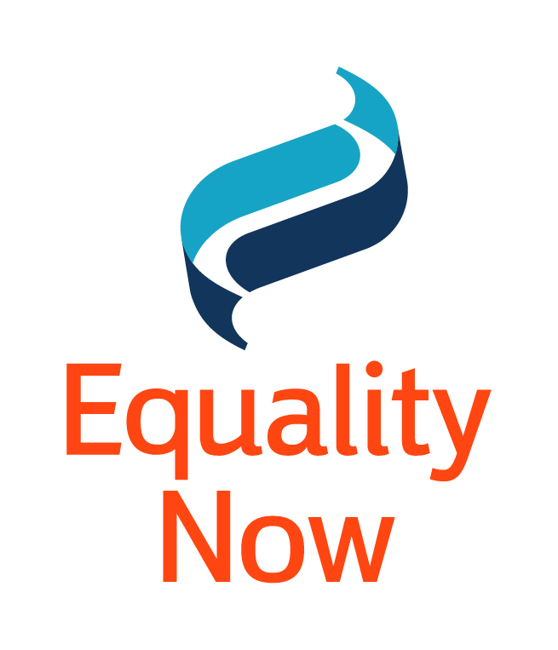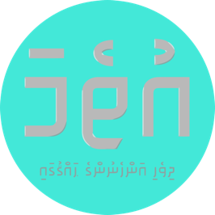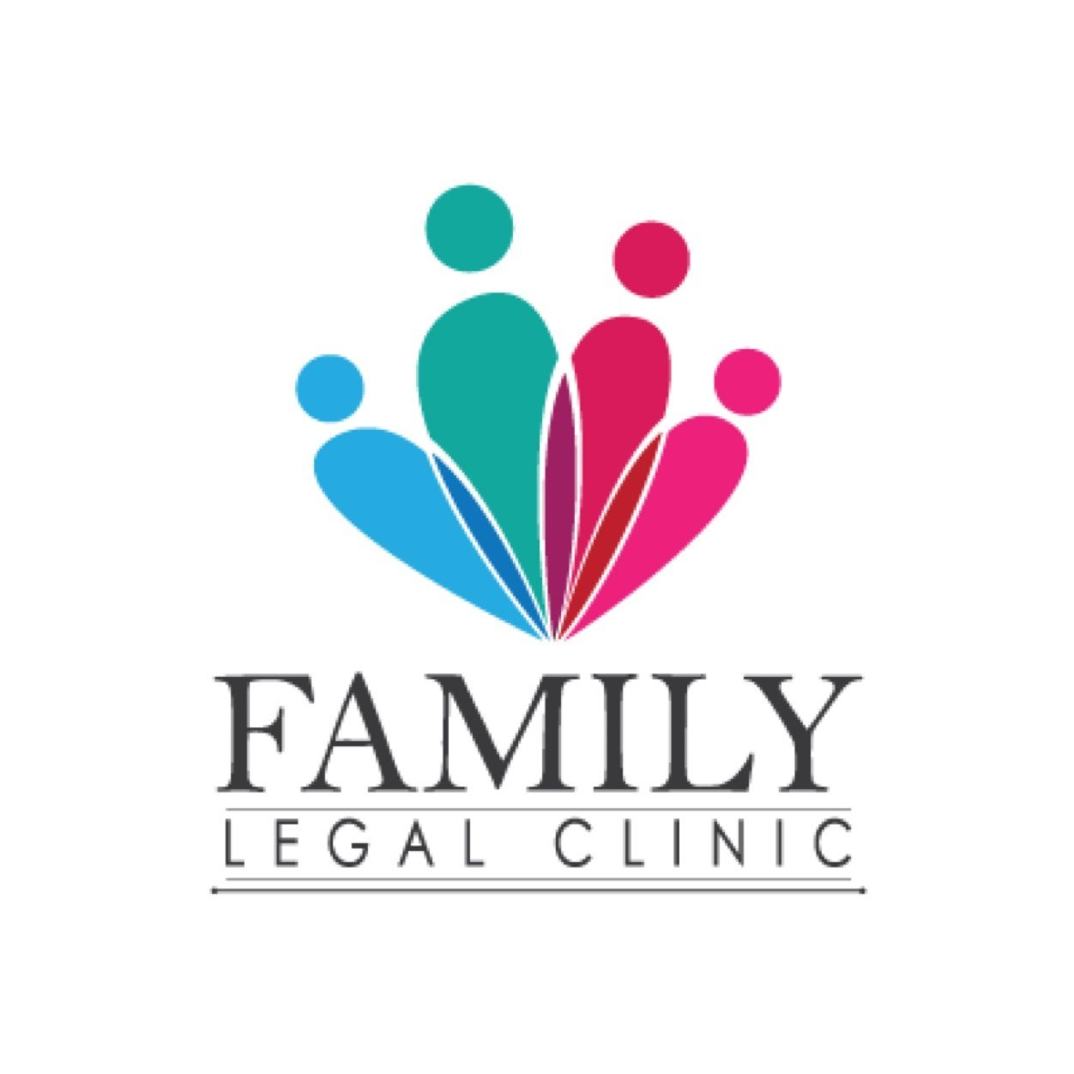

Committee against Torture
Human Rights Treaties Division (HRTD)
Office of the United Nations High Commissioner for Human Rights (OHCHR)
Palais Wilson - 52, rue des Pâquis
CH-1201 Geneva (Switzerland)
Switzerland
By E-mail: cat@ohchr.org and ohchr-cat@un.org

13 June 2022

Information on the Maldives for Consideration of the List of Issues Prior to Reporting by the Committee against Torture at its 74th Session (12 July - 29 July 2022)

Introduction:

- We respectfully submit this letter for consideration for formulating the List of Issues Prior to Reporting for the Maldives’ by the Committee against Torture (‘the Committee’) during its 74th Session (12 July - 29 July 2022). Our joint submission details our concerns with regard to laws related to rape and other forms of sexual violence and procedures and practices which effectively deny access to justice for survivors of sexual and gender based violence (SGBV) and female genital mutilation (FGM) in violation of the Convention against Torture (‘the Convention’).

Information about the authors of the submission

- Hope for Women (HFW) is a civil society organization from Maldives advocating to end all forms of violence against women, promoting gender equality and women’s participation in public life, since 2010. HFW hopes to create a safe space for the empowerment and growth of women and our girl child’s mental well being.

- Family Legal Clinic is a registered NGO providing free legal services in the Maldives since 2014. Family Legal Clinic works to increase access to legal representation and legal services to those impacted by family, domestic violence, sexual harassment and sexual violence issues; and conducts awareness and advocacy activities on these issues.

- Uthema is a women’s human rights NGO registered with the Ministry of Home Affairs in the Maldives in 2016. The primary objective of Uthema is to advocate for gender equality and women's empowerment in the Maldives. Uthema seeks to understand the lived experiences of women in the Maldives and use that knowledge to advocate for positive social, cultural, economic and political change to improve the lives of women.

- Equality Now is an international human rights NGO with ECOSOC status with the mission to achieve legal and systemic change that addresses violence and discrimination against women and girls around the world. Founded in 1992, Equality Now’s main areas of work are ending sexual violence, ending sexual exploitation, ending harmful practices and achieving legal equality.

- We reiterate the Concluding Observations on the initial periodic report of the Maldives and underscore, in particular, the recommendations urging the government of the Maldives to: “ensure the full implementation of the Domestic Violence Act and exercise due diligence, in particular by encouraging victims to file complaints; establish a protection mechanism for victims, including by setting up shelters; investigate, prosecute and punish perpetrators of domestic violence; provide redress to victims and psychological rehabilitation and counseling; and conduct awareness raising campaigns about the negative effects of domestic violence. It should also amend its legislation in order to remove discriminatory provisions governing evidentiary burdens in cases in which men are accused of rape.”

- With this submission, we urge the Committee to reiterate Maldives’ obligations under the Convention, in particular with respect to ensuring access to justice for survivors of sexual violence and Female Genital Mutilation and sexual violence perpetrated in perceived religious ritualistic healing practices and bringing perpetrators to justice by preventing acts of torture (Article 2) and cruel and inhuman treatment (Article 16); conducting a prompt and effective investigation (Article 12); and ensuring the right to a remedy (Article 13) and redress (Article 14).

Legal Provisions hindering Access to Justice for Survivors of sexual violence

- We commend the government’s efforts to improve laws on sexual violence, particularly the passage of the First Amendment to the Sexual Offences Act (Law No. 17/2014) in December 2021, which removed certain discriminatory evidence requirements for proving rape, criminalised marital rape in all circumstances, and made mandatory the use of rape kits for collecting evidence and the use of victim-centered, trauma-informed approaches for investigating cases of rape. The passage of the First Amendment to the Sexual Offences Act also addresses many of the concerns raised by the CEDAW Committee in its concluding observations on the fifth periodic report of the Maldives.

- However, despite the progressive amendments, the laws relating to sexual violence in the Maldives still leave certain gaps which enable impunity for perpetrators. Both the Sexual Offences Act and the Special Provisions Act to Deal with Child Sex Abuse Offenders (Law No. 12/2009) have prescribed burdensome evidence requirements to prove sexual violence offences, which could make it difficult to obtain convictions. Section 52 of the Sexual Offences Act states that at least five types of the specified evidence are “sufficient” to meet the burden of proving an offence of rape, sexual injury or sexual assault beyond a reasonable doubt. The types of evidence specified include results of a scientific test; evidence of eye witnesses; forensic results; statements given by third parties “as related to them by the victim within a short period of time from occurrence of the incident, where there are no probabilities of the victim fabricating the story”; victim’s statement; evidence of physical injuries and material evidence. Many of the types of evidence listed in this section are discriminatory, and based on gender stereotypes/rape myths, such as for example evidence of physical injuries (which implies that the victim ought to have resisted), or requiring there be “no probabilities of the victim fabricating the story” (which begins with the assumption that victims are likely to make false complaints).

- Further, setting a legal standard which could potentially be interpreted to mean that at least five types of evidence are needed is an extremely burdensome requirement which significantly reduces the possibility of successful convictions. This burden is, however, reduced in cases of child sexual abuse, as the law specifies a greater variety of evidence which can be introduced, including the child’s narration of the incident itself in addition to corroborating statements by different parties.

- The Supreme Court of Maldives in a recent case has interpreted Section 47 of the Special Procedures Act related to child sexual abuse in a manner which gives more weight to the child’s testimony. In a decision rendered in March 2020, the Supreme Court held that a verdict can be reached if the testimony of a child is credible beyond a reasonable doubt and the different narrations of the child to various people can count as separate pieces of evidence. However, despite progressive judgments interpreting the provision, based on a plain reading of the law, these burdensome evidence requirements could make it difficult to obtain convictions in rape cases.

- The UN Women Handbook for Legislation on Violence Against Women also recommends that given the difficulties of obtaining evidence in rape cases, legislation should also allow for the prosecution and conviction of an offender based solely on the testimony of the complainant/survivor. This is important because it puts the focus where it should be, that is whether in principle there is evidence beyond a reasonable doubt to justify a conviction, rather than starting from an implied position of distrust and victim-blaming that is discriminatory towards the complainant. The CEDAW Committee in its concluding observations during the fifth periodic review of the Maldives has specifically recommended that the government ​​”[a]mend section 52 of the Sexual Offences Act and section 47 of the Special Provisions Act to Deal with Child Sex Abuse Offenders to remove excessive evidence requirements for victims to prove sexual violence”.

- In line with these recommendations, the Maldivian government must amend both the Sexual Offences Act and the Special Provisions Act to Deal with Child Sex Abuse Offenders to remove burdensome evidentiary requirements for proving rape and sexual assault.

Access to Justice for survivors of sexual violence

- A complete disregard of perpetrator responsibility for their own actions, which is prevalent in society, along with grave inadequacies in law enforcement pose serious obstacles in reporting sexual violence. Lack of protection for women who report rape, fear of re-victimisation and retaliation (including blackmail), lack of women in frontline policing, and poor legal aid and institutional support services (particularly outside the urban capital Malé) are also some of the reasons which contribute to low levels of reporting in sexual violence cases. Similarly, inaction on addressing the socio-cultural norms that contribute to this type of violence and the lack of perpetrator rehabilitation programs also needs to be addressed.

- Even when cases are reported, the data submitted by the Maldives government in its reply to the CEDAW Committee in 2020 demonstrated the difficulties faced by women and girls in accessing justice for sexual violence. The official data on sexual abuse cases between 2015 - 2019 shows that over a five-year period there were 364 reported cases of sexual abuse (326 cases of sexual abuse against children and 38 cases against adults). The true figure is likely to be much higher, as demonstrated by survey data on the extent of sexual violence in the Maldives. Out of the 364 reported cases, there have been convictions only in 49 cases to date, i.e. only around 13.5% of cases.

- One of the major reasons for the low number of convictions is the discriminatory attitudes and poor investigation procedures followed by the police, as most of the cases reported to the police are not sent to the Prosecutor General’s Office for prosecution. Reports show that in many cases police officers view sexual and domestic violence as personal disputes where they should not interfere, and often fail to take any action in such cases despite being aware that the violence has taken place. In fact, the National Gender Equality Action Plan published by the Ministry of Gender, Family and Social Services notes that only 3% of domestic violence/gender based violence cases reported to the police are submitted for prosecution. This means that in a vast majority of cases, perpetrators enjoy complete impunity for crimes of gender-based violence.

- Recent cases of child sexual abuse which came into the public spotlight in 2022 have also revealed the inaction by public authorities and the failure to effectively implement laws on sexual violence. For instance, in one case, the perpetrator of sexual violence against six minors was released by the police. This and other cases have revealed several systemic failures and the grant of impunity to perpetrators.

- Though the Health Sector Response to GBV National Guideline on providing care and prevention for Health Care Providers, 2014 has been developed by the Ministry of Health along with UNFPA Maldives to provide guidelines on medical care of victims of gender-based violence, these guidelines are not adequately implemented. The Human Rights Commission of the Maldives has found “incidents where sensitive medical information of patients were leaked from the health centre”, as a result of which many women do not trust healthcare providers. Combined with judgmental and biased attitudes of healthcare providers, women and girls are reluctant to report sexual violence or are re-victimised when they do report. The case of ZN (which resulted in the first conviction for marital rape), a woman from the island of Gaaf Dhaal Atoll Thinadhoo, who died following injuries sustained after a brutal sexual attack by her estranged husband, exemplifies the total systemic failure in providing medical care for victims of sexual violence in the Maldives. According to news reports, "she did not report the rape to the police, but went to the doctor days after the incident to seek treatment. The doctor recommended she travel to Malé immediately." Despite the fact that Thinadhoo has a second-tier regional hospital, the facility did not have the capacity to attend to her injuries. ZN travelled to Malé City seeking further medical care, but the regional hospital at Thinadhoo failed to give her a referral to the public hospital in Malé. Thus, ZN was forced to waste precious time by going to a private clinic in Malé, after which she was finally referred to the public hospital. She died from her injuries while receiving treatment at the intensive care unit at the Indira Gandhi Memorial Hospital.

- Though the criminalisation of marital rape is an important step to improving access to justice for survivors of rape, the Maldivian government needs to ensure effective implementation of the legislative amendments, including by implementing public awareness programs so that the public, including women and girls, are aware that marital rape is now criminalised in all circumstances and can be reported to the police. The public awareness programs need to be accompanied by training and awareness of law enforcement and criminal justice system officials to ensure that they have knowledge of the changes to the sexual offences laws and are trained to utilise the trauma-informed, victim-centered approach while dealing with survivors of sexual and gender-based violence.

- The right of access to justice is a fundamental element of the rule of law, and it is essential to the realisation of human rights everywhere. This right is multidimensional and comprises six interrelated and essential components: justiciability, availability, accessibility, good quality and accountability of justice systems, and provision of remedies for victims.

- In the Maldives, access to justice by survivors is impeded by lack of availability of lawyers, particularly in the smaller islands where it is difficult to obtain a lawyer. Further, the legal aid programme of the Government only extends to ‘major criminal offences’ which is an obstacle to survivors accessing remedies, as acknowledged by the Maldivian government. In 2021, only 3.7% of women were provided legal assistance in cases of domestic violence and gender based violence. Compounding this is the lack of understanding of the gendered nature of the crime of rape, the negligible number of female judges and magistrates (11%), and lack of gender-sensitive responsiveness of those who work in the justice system. The absence of an effective witness protection programme and under-resourcing of the victim support unit at the Prosecutor General’s Office have also been identified as factors which impede access to justice in sexual violence cases.

- Further, there is a lack of support services for survivors. Though the Maldivian government officially states that there are 4 shelters established for GBV survivors, most of these shelters are not fully functional in practice. The lack of functionality, accessibility and to provide a safe place for survivors of gender-based violence is an immensely problematic issue which needs to be addressed immediately. Furthermore, despite the legal provision for perpetrator rehabilitation in the Domestic Violence Prevention Act (Law No. 3/2012), there has been no initiative to establish programmes to address this key aspect of violence prevention and minimise the prospect of re-offending. Similarly the inaction in addressing harmful social norms that perpetuates and gives impunity to these violence is a huge concern.

Emerging issues on sexual violence against women and girls

- Issues linked to increasing religious fundamentalism and radicalisation, and resulting impacts on women and girls, have been observed in the Maldives context by a variety of concerned stakeholders. Among key issues are the practices of unregistered child-marriage, endorsement and promotion of female genital mutilation/cutting (FGM/C) and most recently, the abuse of the practice of “ruqya” and the practice of prohibited acts such as exorcism and “sihr” or black magic. In 2017, Uthema documented stories of lived realities of violence against women and found that narratives of misogyny propounded by "clerics" have led to justifications of sexual violence against women by the husband in long-standing marital relationships. Such narratives continue to be ignored by State authorities and communities are subject to widespread dissemination of misogynistic preaching leaving women and girls vulnerable to the ensuing violence. These extremist narratives are also propagating the abuse of practices such as "ruqya"; and the use of such practices to effectively prey on the most vulnerable and desperate in communities where healthcare provision is weak and often inaccessible.

- On 24 November 2020, online media reported the case of a woman and her three young girls being subjected to acts of torture, under conditions of confinement and enslavement in their home over a period of 3 months, by the woman’s husband (the children’s stepfather). This prolonged period of physical, sexual and psychological violence and abuse was inflicted with the participation of a second man reported to be a “ruqya” practitioner in the community. While a prompt parliamentary probe was initiated, media reports informed that according to the woman, “her husband believed that her migraines were the result of supernatural possession by 'jinn'”, and that “medical reports had confirmed that [her] seven-year-old child was severely sexually abused.” It is notable that there are public platforms in the Maldives where alleged solutions for medical conditions are provided through the practice of “ruqya”, an emerging phenomenon in the country. On 26 November, media reported the arrest of the two men involved in the aforementioned case, aged 39 and 24 years, under “allegations of psychological, physical and sexual abuse perpetrated against a woman and her three daughters while confined to a house under the premise of ruqya (exorcism)”.

- Notably, reports suggest that efforts by the survivor and her family to alert the authorities failed initially as community-based law enforcement officials as well as social service workers failed to respond. This situation is an indicator of the prevalence of attitudes even among institutional service providers and acceptance of such practices, which enables impunity for perpetrators of violence and endangers the physical and mental safety and security of women and girls. It is pertinent to note that these alternative health practices are completely unregulated and unchecked by the health authorities. In fact, anecdotal evidence suggests that when well respected medical practitioners have questioned such practices in the recent past, they are subject to intimidation, harassment and even death threats. This creates a chilling effect for concerned medical practitioners to respond to such threats to vulnerable patients. The failure of the health regulatory authorities to intervene is particularly problematic.

- In June 2020, media reported the case of a “ruqya” practitioner accused of sexual assault whose identity was disclosed by the Maldives Police Service with an appeal for any other victims to report cases. According to the report, police officials informed that “It [sexual abuse] is inflicted not just in the name of ruqya, but often under the guise of black magic”. While police are reported to have informed media sources that such cases had been investigated and sent for prosecution, no further updates are available on the progress of such cases at the time of this submission.
Action to address Female Genital Mutilation/Cutting

- The 2016-17 Maldives Demographic and Health Survey (MDHS), published in December 2018, for the first time collected information on the incidence of Female Genital Mutilation/Cutting (FGM/C) in the Maldives. The MDHS data indicates that 13% of women aged 15-49 have been subjected to FGM/C in the Maldives. Although the MDHS observed a 'decline' of FGM/C among younger girls, information from activists on the ground indicates that an active revival of the practice has been happening in the country by conservative and fundamentalist elements which endorse the practice as a religious requirement. Recently, prominent public figures have also come out in support of FGM/C which increases the risk of girls being subject to this harmful practice.

- The Maldives does not have any laws which specifically prohibit the practice of FGM/C, though the State has indicated its commitment before the CEDAW Committee to bring about necessary legislative changes to address this issue.

Suggested Questions for the State Party

- We respectfully urge the Committee to raise the following questions with the Maldivian government:

- What are the plans of the Government to amend or repeal section 52 of the Sexual Offences Act and 47 of the Special Provisions Act to deal with Child Sex Abuse Offenders to ensure that evidentiary requirements for proving rape and sexual abuse are not burdensome?

- What is the current status of the government’s proposed law against FGM/C?

- What is the Government doing to effectively implement the provisions of the First Amendment to the Sexual Offences Act?

- What steps is the Government taking to ensure that marital rape is treated as seriously as other forms of rape, to encourage survivors of marital rape to report cases to the police and to address the social stigma associated with intimate partner sexual violence?

- What measures has the Government undertaken to collect disaggregated data on reports of sexual violence registered with the police, as well as rates of prosecutions and convictions in such cases?

- What is the Government doing to improve access to justice for survivors of sexual violence and to ensure that sexual violence investigations and trials are conducted in accordance with human rights standards, including to ensure that complainants are protected against revictimisation and any repercussions of reporting from the community?

- What steps is the government taking to establish victim centered support and healing services; perpetrator rehabilitation programs; and to conduct programs towards changing harmful socio-cultural religious norms that contribute to GBV?

- What steps has the Maldivian Government undertaken to encourage reporting of sexual violence cases, including through raising awareness amongst women and girls on their rights under the law and the availability of legal remedies and support services for survivors of sexual violence?

Committee against Torture, 19 December 2018, CAT/C/MDV/CO/1
President ratifies First Amendment to Sexual Offences Act, 6 December 2021, https://presidency.gov.mv/Press/Article/25918
ARC Welcomes the Landmark Decision by the Supreme Court on Cases of Sexual Abuse against Children, 11 March 2020, https://www.arc.org.mv/arc-welcomes-the-landmark-decision-by-the-supreme-court-on-cases-of-sexual-abuse-against-children/
UN Women, Handbook for Legislation on Violence against Women, 2012, available at https://www.unwomen.org/en/digital-library/publications/2012/12/handbook-for-legislation-on-violence-against-women
CEDAW/C/MDV/CO/6, 15 November 2021.
Maldivian Women's Vision Document, UNDP, 2014; https://www.mv.undp.org/content/maldives/en/home/library/democratic_governance/Publication0.html p.23; 36 cases of female harassment in 5 years: Police, The Edition, 25 November 2019, https://edition.mv/news/13604.
The Women’s Health and Life Experiences (WHLE) study published in 2007, which found that “1 in 3 women (34.6%) aged 15-49 reported experiencing physical and/or sexual violence at some point in their lives, including childhood sexual abuse.”[Maldives Study on Women’s Health and Life Experiences, Ministry of Health, 2007 https://maldivesindependent.com/files/2015/03/Maldives-Study-on-Womens-Health-and-Life-Experiences-2007.pdf]. The Maldives Demographic and Health Survey 2016-17 (MDHS) found that 11% of women and girls aged 15-49 in Maldives had experienced sexual violence. [Maldives - Demographic and Health Survey 2016-2017, https://dhsprogram.com/publications/publication-fr349-dhs-final-reports.cfm]. However, the MDHS survey is not a qualitative study as compared to the WHLE study which is considered to have employed more rigorous data collection methods.
Replies of Maldives to the list of issues and questions in relation to its sixth periodic report, CEDAW/C/MDV/RQ/6, 20 August 2020, pp. 22 - 26.
U.S. Department of State, 2019 Country Reports on Human Rights Practices: Maldives, https://www.state.gov/reports/2019-country-reports-on-human-rights-practices/maldives/
Ahmed Shuhad (Chief Superintendent of Police, Maldives), Violence against Women in Maldives, UNAFEI Resource Material Series No 108 (2018), https://www.unafei.or.jp/publications/pdf/RS_No108/No108_15_IP_Maldives_2.pdf
Ministry of Gender, Family & Social Services, National Gender Equality Action Plan 2022-2026, http://gender.gov.mv/en/wp-content/uploads/sites/1/2022/03/GEAPFinal.pdf
Family Legal Clinic, Hope for Women, Uthema, Transparency International, Joint Statement by CSOs regarding sexual violence against children and women in the Maldives, 10 May 2022, https://transparency.mv/downloads/joint-press-statement-csos-regarding-sexual-violence-against-children-and-women-in-the-maldives/
Lilia Ormonbekova, Study on the Access to Health Services by Domestic Violence Victims in Maldives, Hope for Women, June 2017. http://hopeforwomen.org.mv/wp-content/uploads/2018/05/Study-on-the-Access-to-Health-Services-by-DV-victims-2017.pdf
Submission from Human Rights Commission of the Maldives for the combined Fourth and Fifth Periodic Report of the Republic of Maldives to the United Nations Convention on Elimination of All Forms of Discrimination against Women (CEDAW) Committee, January 2015, p.26.
Lilia Ormonbekova, Study on the Access to Health Services by Domestic Violence Victims in Maldives, Hope for Women, June 2017. http://hopeforwomen.org.mv/wp-content/uploads/2018/05/Study-on-the-Access-to-Health-Services-by-DV-victims-2017.pdf
Hundreds protest over horrific rape case in Thinadhoo, Maldives Independent, 20 December 2015, https://maldivesindependent.com/politics/hundreds-take-to-streets-over-horrific-thinadhoo-rape-case-120795 (accessed: 9 July 2020)
The Violent Lives of Maldivian Women, Maldives Independent, 29 December 2015, https://maldivesindependent.com/feature-comment/the-violent-lives-of-maldivian-women-121044 (accessed: 17 July 2020)
Committee for the Elimination of All Forms of Discrimination against Women 'General Recommendation 33 on Women's Access to Justice' CEDAW/C/GC/33 3 https://undocs.org/pdf?symbol=en/CEDAW/C/GC/33.
Sixth Periodic Report submitted by the Maldives to the CEDAW Committee, 28 October 2019, available at https://tbinternet.ohchr.org/_layouts/15/treatybodyexternal/Download.aspx?symbolno=CEDAW%2fC%2fMDV%2f6&Lang=en
Ministry of Gender, Family & Social Services, National Gender Equality Action Plan 2022-2026, http://gender.gov.mv/en/wp-content/uploads/sites/1/2022/03/GEAPFinal.pdf
Ibid. In 2021, 20 of the country’s 183 judges were women. This is an improvement from 2019, when only 4 of the country’s 200 judges were women. Republic of Maldives, Assessment of Justice Sector Reform Proposals, August 2019, http://agoffice.gov.mv/v4/wp-content/uploads/2019/10/ASSESSMENT-OF-THE-JUSTICE-SECTOR-REFORM-PROPOSALS.pdf
Sixth Periodic Report submitted by the Maldives to the CEDAW Committee, 28 October 2019, available at https://tbinternet.ohchr.org/_layouts/15/treatybodyexternal/Download.aspx?symbolno=CEDAW%2fC%2fMDV%2f6&Lang=en
Sections 2(e) and 53(k), Domestic Violence Prevention Act (Law No. 3/2012)
Authorities unaware of 13-year-old’s alleged marriage, Maldives Independent, 25 November 2019, https://maldivesindependent.com/society/authorities-unaware-of-13-year-olds-alleged-marriage-149463 (accessed: 14 December 2020); Family of four held "hostage", physically and sexually assaulted in the name of rugya. [translated headline], Fazeena Ahmed, Mihaaru.com, 24 November 2020, https://mihaaru.com/report/83327?ref=related (accessed: 14 December 2020)
Fathima Manike’s Story, Uthema, 2017, https://www.youtube.com/watch?v=wd1OZJH3nsI&ab_channel=Uthema
Gender committee launches probe into Ruqya sexual abuse case, Mariyam Malsa, The Edition, 25 November 2020, https://edition.mv/news/20572 (accessed: 14 December 2020)
Healing Through Ruqya, http://htruqya.com/about-2 (accessed: 14 December 2020)
Police make 2 arrests over 'Ruqya' multiple-abuse case, Shahudha Mohamed, The Edition, 26 November 2020, https://edition.mv/news/20611 (accessed: 14 December 2020)
Police reveal identity of 'exorcist' sexual predator, Ahmed Aiham, The Edition, 04 June 2020, https://edition.mv/news/17063 (accessed: 14 December 2020)
ibid
Please note that the MDHS survey uses the term ‘female circumcision’ as opposed to FGM/C.
Maldives - Demographic and Health Survey 2016-2017, https://dhsprogram.com/publications/publication-fr349-dhs-final-reports.cfm
Comprehensive NGO Shadow Report Responding to the 6th Periodic State Report of the Maldives, April 2019 to the UN CEDAW Committee, Uthema, Maldives, 20 April 2020 (paras. 25, 58, 59, 60)
See Joint Statement on Female Genital Mutilation/Cutting, July 2021, https://uthema.org/fgm-joint-eng/
Replies of Maldives to the list of issues and questions in relation to its sixth periodic report, CEDAW/C/MDV/RQ/6, 20 August 2020, para 78.

