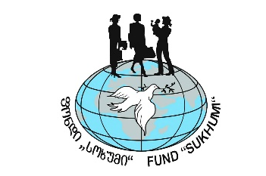

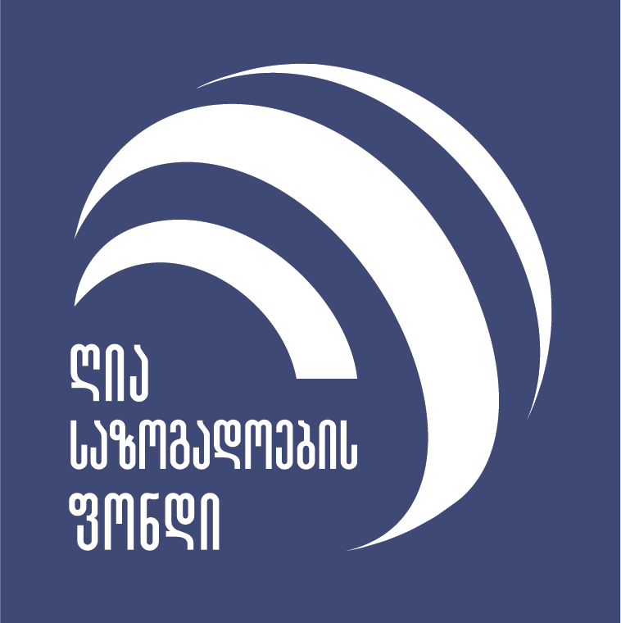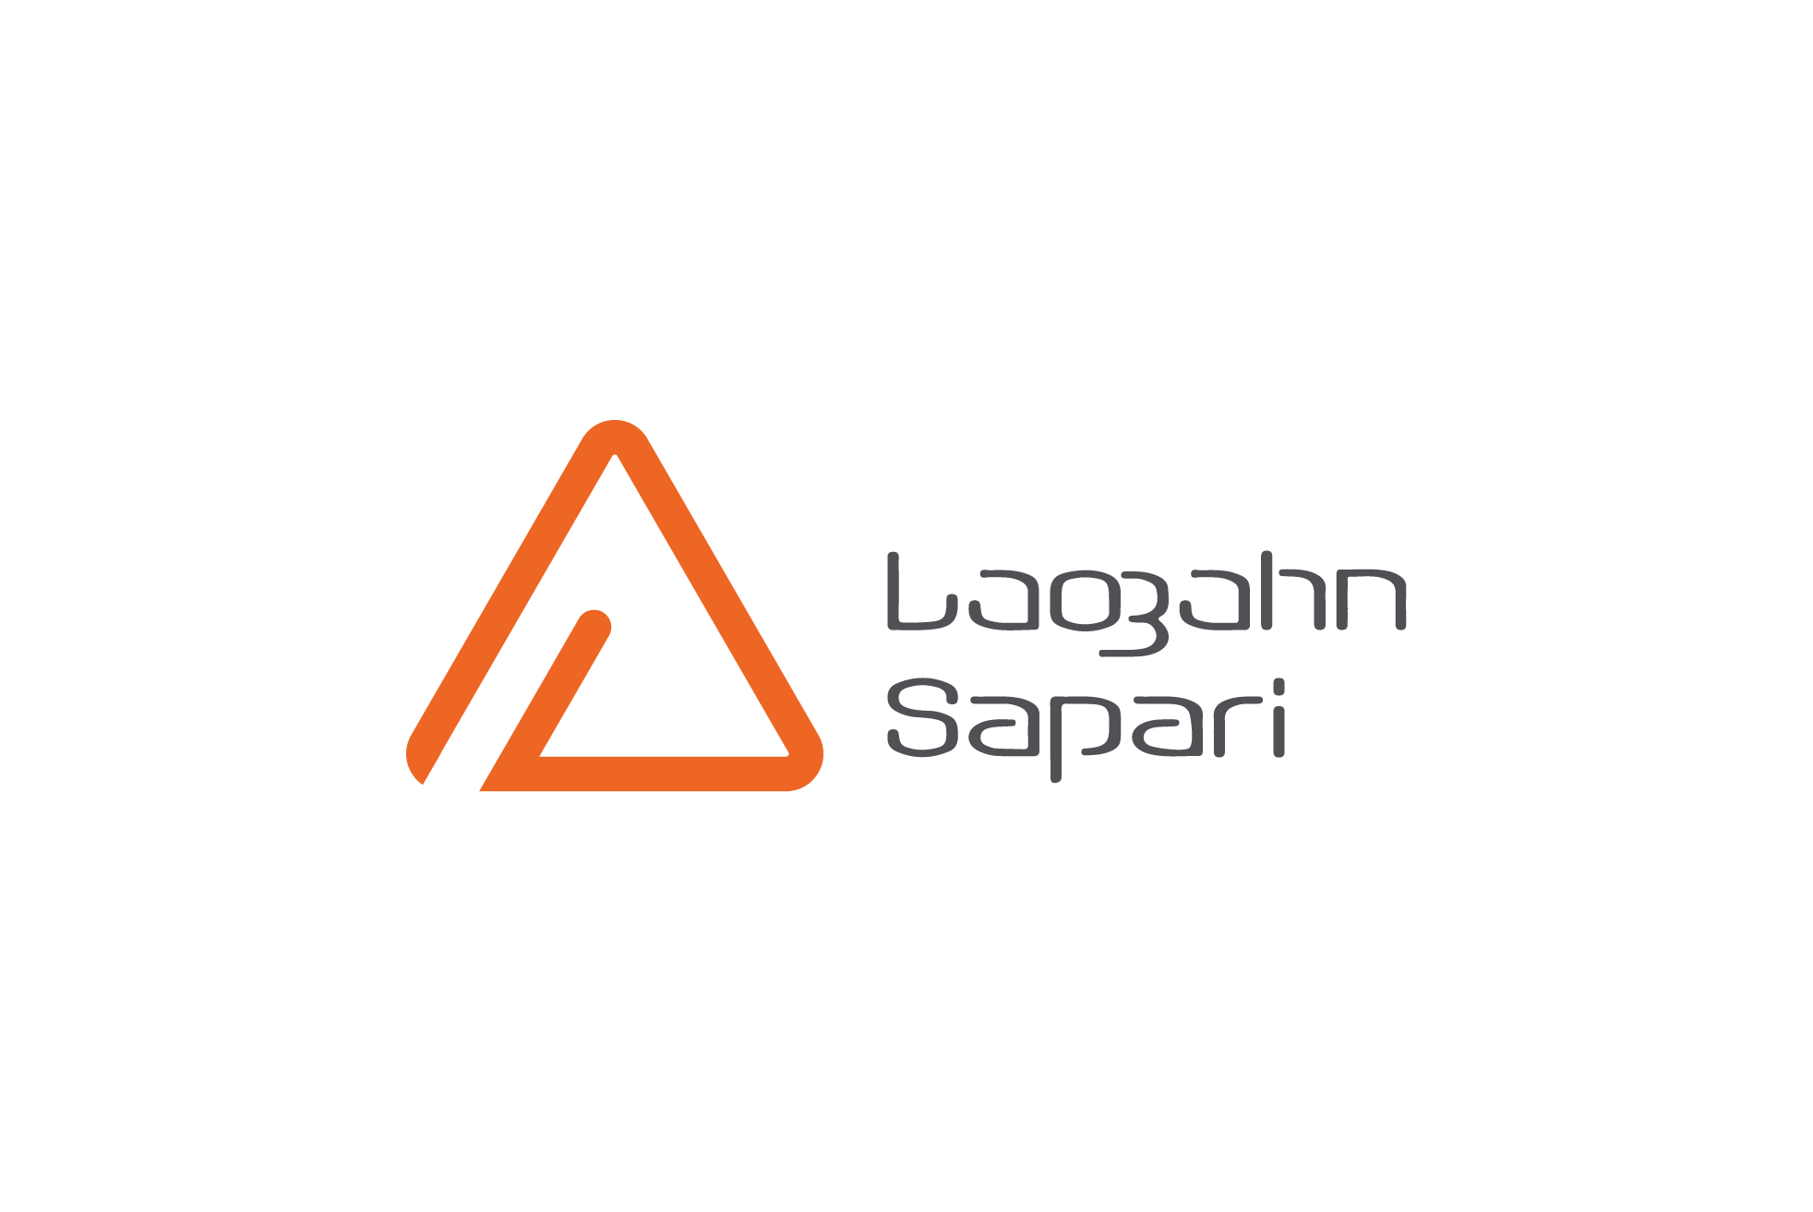`
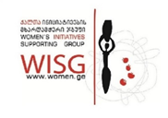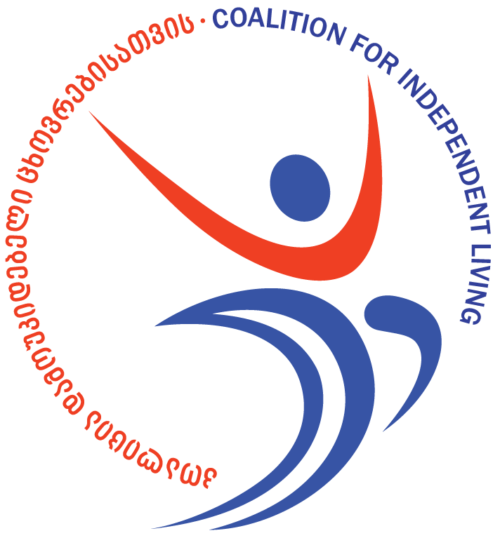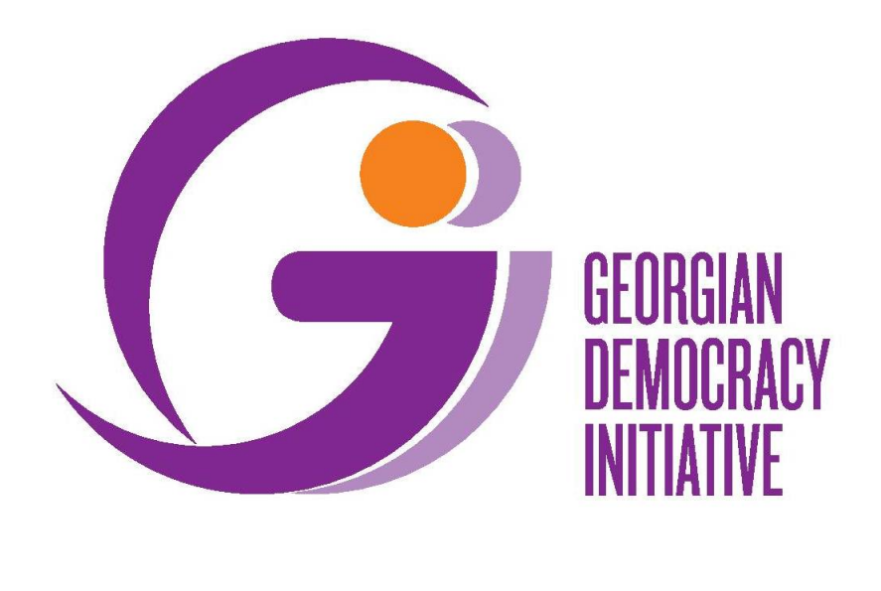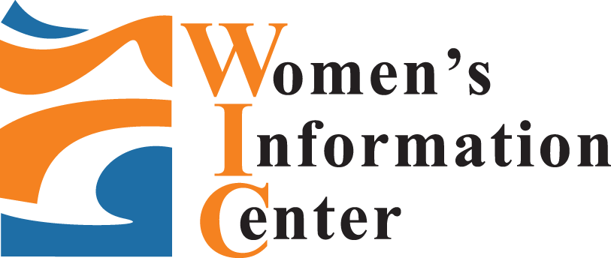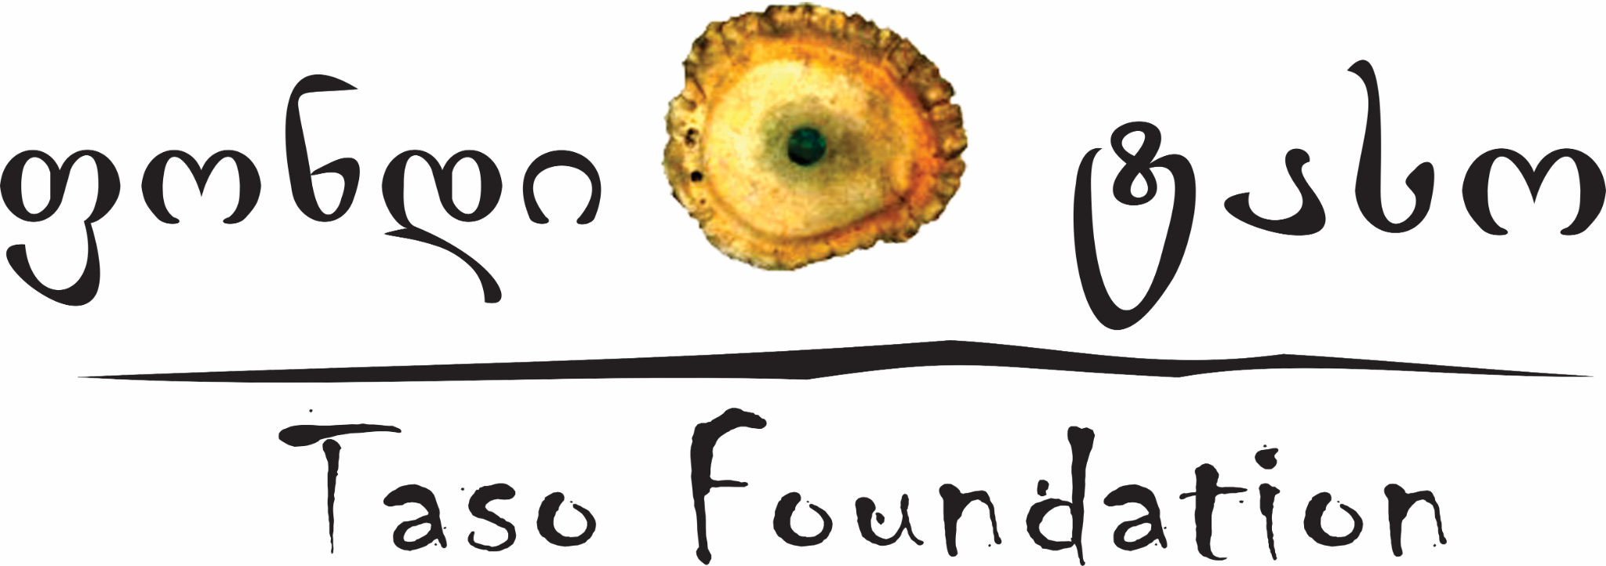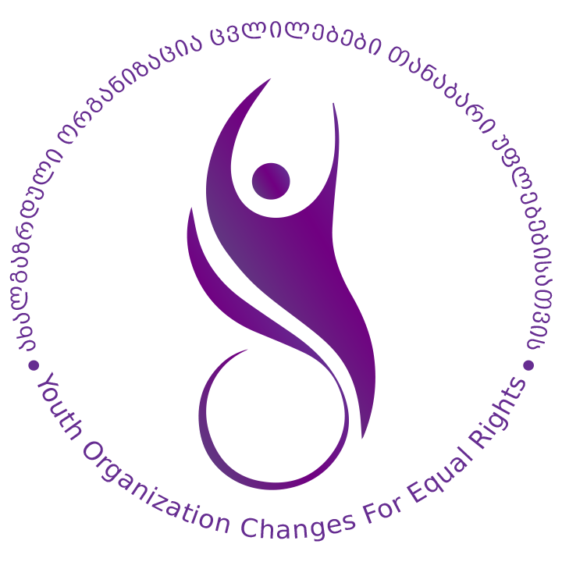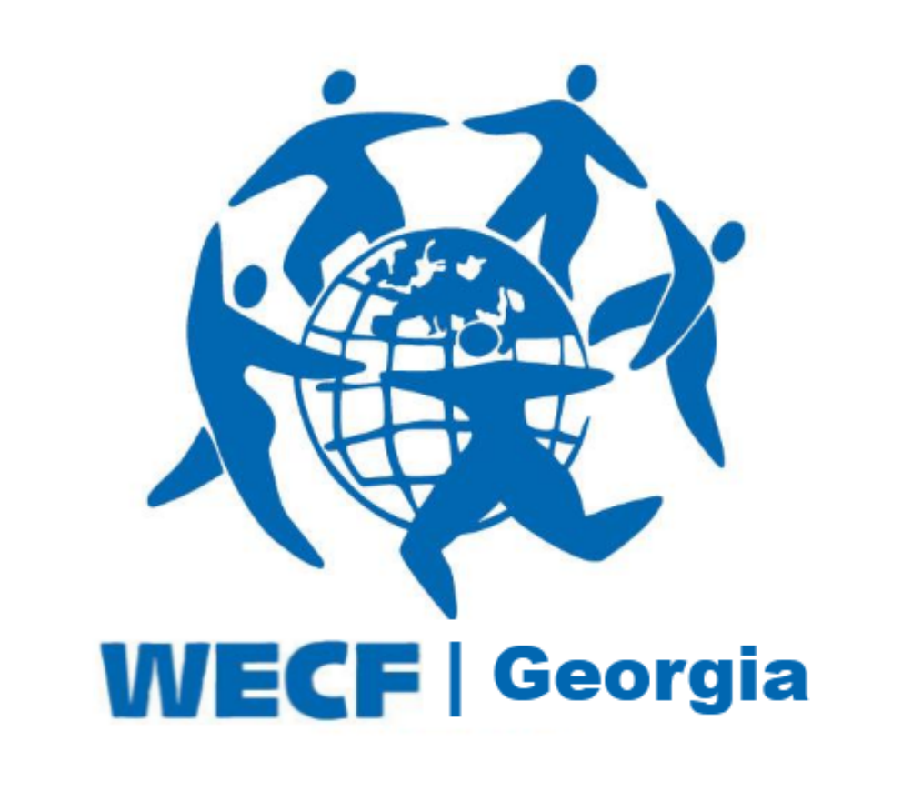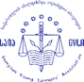
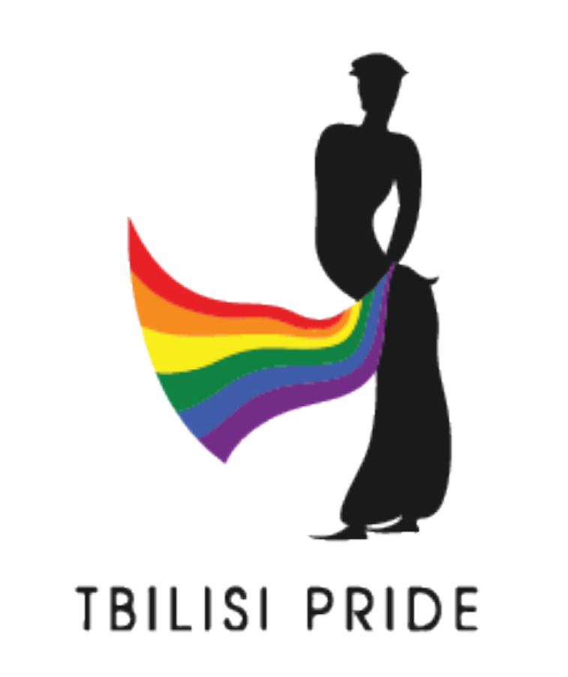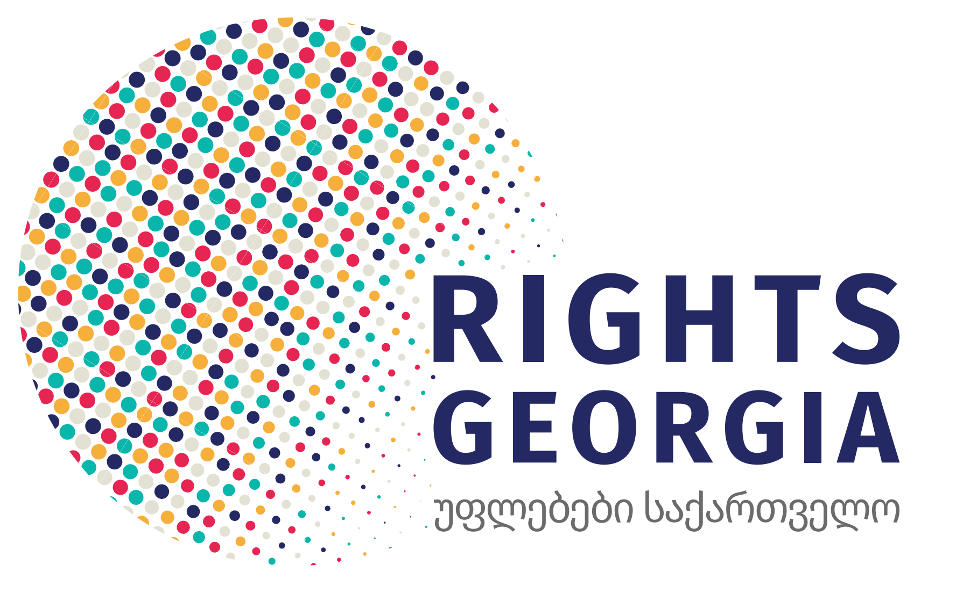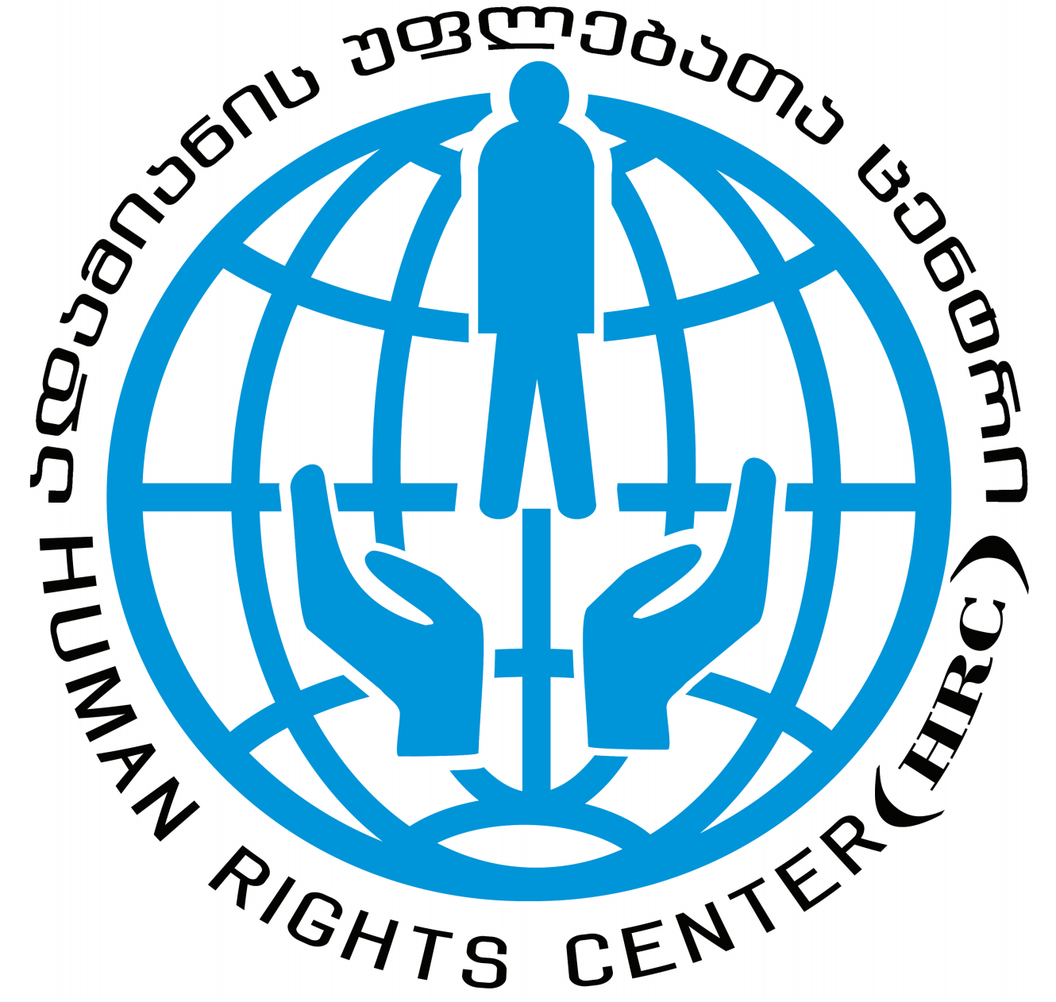

Committee on the Elimination of Discrimination against Women
Human Rights Treaties Division (HRTD)
Office of the United Nations High Commissioner for Human Rights (OHCHR)
Palais Wilson - 52, rue des Pâquis
CH-1201 Geneva
Switzerland
By Email: cedaw@ohchr.org
7 June 2021

Information on Georgia for consideration by the Committee on the Elimination of Discrimination against Women at the Pre-Sessional Working Group of its 81th Session (5 July - 9 July 2021)

Introduction

- We respectfully submit this report for consideration in advance of the pre-sessional working group of the 81th session of the Committee on the Elimination of Discrimination against Women (‘the Committee’) taking place between 5 July - 9 July 2021, for consideration of the List of Issues in relation to the periodic report of Georgia. Equality Now is writing to express our concerns with regard to laws related to rape and other forms of sexual violence and procedures and practices which effectively deny access to justice for survivors of sexual violence in violation of the Convention on the Elimination of All Forms of Discrimination against Women (‘the Convention’). We are recommending questions to be asked to Georgia by the Committee and offering recommendations on the legal and procedural changes required to make sure that perpetrators of sexual violence are brought to justice and that survivors access justice.

- Equality Now submits this report in partnership with: Georgian Young Lawyers’ Association (GYLA), Union Sapari, Human Rights Center (HRC), Women’s Initiatives Supporting Group (WISG), Cultural-Humanitarian Fund “Sukhumi”, Rights Georgia, Social Justice Center (Former EMC), Georgian Democracy Initiative (GDI), Changes for Equal Rights (CER), Coalition for Independent Living (CIL), Tbilisi Pride, Women Engage for a Common Future (Georgia Branch), Women’s Information Center, Open Society Georgia Foundation (OSFG) and Taso Foundation. Please see Annex (page 10) for information about the submitting organisations.

- The legal provisions and practices detailed in our submission highlight the failure of the State to comply with its duty to provide equal protection under the law to survivors of sexual violence (Article 2(c) of the Convention) and failure of law enforcement to protect women from sexual violence (Article 2(c) and (e)). We submit that the root cause of the failures of the State is its non-compliance with the obligation to end discrimination against women in law and practice and address stereotypical and gender-discriminatory attitudes towards women and girls, contrary to Articles 2(f) and 5(a) of the Convention and the obligation to combat violence against women and provide access to justice to survivors, as described in General Recommendations 19, 33 and 35 of the CEDAW Committee.
- In the last few years, the Georgian government has taken a number of steps to address violence against women, including sexual violence that this submission focuses on. The measures include, among others: training of over 60 prosecutors and granting them specialization in prosecuting sexual violence crimes (March 2021, supported by Council of Europe, UN Women and Equality Now); a manual for sexual violence investigation, prosecution and adjudication is being developed (by collaborative effort of Equality Now, Council of Europe, UN Women, Prosecutor’s Office and the Ministry of Internal Affairs), which will assist investigators, prosecutors and judges in examining sexual violence cases against women. In 2020, a law was adopted on combating crimes against sexual freedom and inviolability. Amendments in the Criminal Code of Georgia to introduce a consent-based definition of rape have been discussed internally in the Parliament, however, the draft law has not yet been initiated.
Definitions of sexual violence crimes and sentences are not compliant with international human rights standards
- Contrary to international human rights standards, the definition of rape (Criminal Code Article 137) and other sexual violence crimes (Criminal Code Articles 138 and 139) under Georgian law focuses on the use of force, threat of force, abusing the helplessness of the victim, and various forms of coercion, rather than focusing on the absence of the free and voluntary consent that should be assessed in the context of the surrounding circumstances.
- Under international human rights standards, rape and other sexual violence crimes should be based on the lack of free and voluntary consent of the victim, as provided by the Committee on the Elimination of Discrimination against Women (CEDAW) and other international human rights jurisprudence and standards, including the Istanbul Convention, the European Court of Human Rights, the International Criminal Court (ICC), the Inter-American Court, the International Criminal Tribunal for Rwanda (ICTR), the International Criminal Tribunal for the Former Yugoslavia (ICTY), the Mechanism to Follow Up on the Implementation of the Convention on the Prevention, Punishment and Eradication of Violence against Women (MESECVI), and the Declaration on Violence Against Women, Girls and Adolescents and their Sexual and Reproductive Rights.
Burdensome evidence and corroboration requirements to prove sexual violence
- In Georgia, prosecutors apply overly burdensome evidence and corroboration requirements for bringing charges against perpetrators of sexual violence, while overwhelmingly strict requirements are also applied by judges to issue a judgment of conviction for these kinds of crimes. In particular, in the overwhelming majority of cases, sexual violence crimes are prosecuted, and perpetrators are being convicted, only when physical injuries are found on the body of the victim, as well as biological materials associated with a sexual act. Such practice leaves the vast number of sexual violence acts envisaged under the law (Articles 137-140) to go unpunished in practice, because the authorities are solely investigating sexual violence crimes where the perpetrator used physical force and the victim physically resisted. Such practice is also one of the main causes of the high attrition rate of sexual violence crimes and the reason why a vast number of cases never reach the stage of prosecution.
- In addition, rigid corroboration requirements pose a significant barrier to survivors in Georgia. Legislation is consistently interpreted as requiring two pieces of direct evidence on which to issue an indictment or base a conviction, with the whole testimony of an individual witness considered to be only one “piece.” This strict requirement of “two pieces,” however, means that even if the evidence of women and girls who have been a victim of sexual violence is credible and reliable, unless corroborated by another “piece” of direct evidence, it can never on its own form the basis for conviction. In these cases the “two pieces” threshold avoids a determination on the merits because uncorroborated complaints of women who have been victims tend to not go to court.
- Such practice leaves many forms of sexual violence unpunished and runs contrary to the Committee’s recommendation to ensure that evidentiary rules and other legal and quasi-judicial procedures are impartial and are not overly restrictive, inflexible or influenced by gender stereotypes or prejudice. Furthermore, the Committee specifically recommends that States abolish “corroboration rules that discriminate against women as witnesses, complainants and defendants by requiring them to discharge a higher burden of proof than men in order to establish an offence or to seek a remedy.”
Gender stereotyping and discriminatory investigation procedures
- Gender stereotyping and discriminatory investigation procedures applied in practice constitute a significant barrier to justice for survivors of sexual violence. These include, according to victims’ lawyers, the victim being required to repeat the facts of her traumatic experiences several times, examining the victim’s prior sexual history, examining her mental health to question her credibility, and lack of gender-sensitive questioning during the investigation and court proceedings. Victims of sexual violence further allege humiliating and ridiculing attitudes on the part of law enforcement officials, which, coupled with the lack of adequate infrastructure in police stations, deters victims’ participation in criminal investigation in a number of cases.
- Lawyers of the victims provide that the “investigative experiment”, systematically applied in sexual violence cases, constitutes a discriminatory and degrading practice. Under the “experiment”, the victim has to re-enact the incident of the crime, which involves going to the place where the crime was committed, recalling the facts (or her statement previously given to the investigation is read aloud) and photos of the victim being taken while she points at various specific locations she was taken to when the crime was being committed. In addition to being traumatic, such participation of the victim in this investigative procedure does not add value to the evidence obtained.
- The questioning of the victim during the investigation stage is often conducted in a common/shared space at the police station where other investigators and victims are also present, and the victim’s story can be easily overheard by them. This causes additional fear and humiliation to the victims throughout the process. Victims and their lawyers report that investigative questions and comments made by investigators during questioning implicitly, and sometimes explicitly, judge the victim’s behaviour and are aimed at “sharing” the responsibility with the perpetrator for inducing the sexual violence.
- Victims and their lawyers report that the forensic medical examination of their bodies, conducted by the Levan Samkharauli National Forensic Bureau, the only public body authorised to conduct forensic examinations, is intrusive and often extremely traumatising, especially when conducted by experts of the opposite sex (men constitute the majority of forensic experts while the victims are predominantly female). Stereotypes and drawing negative inferences from the condition of the victim’s hymen also proves to be a problem, since it regularly leads to examining prior sexual history, rather than establishing injuries. Forensic psychological examination is no less problematic since victims are often met with bias and disbelief and are subjected to victim-blaming, unethical and sometimes humiliating questions and comments. Forensic psychiatric examinations implicitly assess whether the victim is prone to lying. Lack of evidence-based, gender sensitive protocols of psychological forensic examinations puts the practice in contravention of human rights standards.
- During the trial, victims are always forced to come face-to-face with the perpetrators and perpetrators themselves can pose questions directly to the victims, which causes victims to feel confused, intimidated and embarrassed. The defendant’s lawyers often express a demeaning attitude toward the victim, which judges do little to prevent. Measures for questioning victims remotely or for avoiding their secondary victimisation are not applied. There are no rules limiting admissibility of evidence on prior sexual history, which is very often applied against the interests of the victim.
- Judges largely fail to uncover the gendered nature of sexual violence crimes. Judgments in sexual violence cases lack a gendered perspective and gendered analysis. Even though committing a crime on the basis of sex or gender is an aggravating circumstance under the law, the rate of identifying the discriminatory gender motive still remains low (despite its recent increase) in relation to all forms of violence against women, in particular sexual violence. During 2015-2019, there has been just one judgment of conviction in relation to sexual violence that the authors of this submission are aware of (concerning Article 139 by the Tbilisi City Court, dated 25.07.2019) where the discriminatory motive of the perpetrator was examined and referred to in sentencing.
Sexual violence against adolescent girls, including in the context of harmful practices (child marriages and bride kidnappings)
- The criminal justice system’s response and government policy against the rape of minors (Article 137.2.d of the Criminal Code) and statutory rape, remain problematic. The authors of this submission note that many times, when rape is committed against a girl under the age of 16, law enforcement chooses to classify the crime as statutory rape (under Article 140 of the Criminal Code), rather than rape (under Article 137). This further stigmatises the child and sticks the label of "instigator" on the child in the eye of the public, rather than classifying her as the victim of violence. In addition, sexual violence in the context of child marriage has still not been fully addressed, despite the Committee’s recommendation to “take urgent measures to prevent [child marriage] among all ethnic groups”.
- Harmful practices, such as child and forced marriages (including bride kidnapping as a form of forced marriage), remain a serious problem in Georgia. Since 2017, the minimum age of marriage in Georgia is 18 years without any exceptions, though informal marriages of girls between the ages of 15-17 and of 13-15 years still persist. Sexual intercourse of an adult with a person under the age of 16 (statutory rape) is a criminal offence (Article 140 of Criminal Code). In many cases, prosecution for statutory rape starts when, as a result of an informal marriage, a girl gives birth and the birth registry reports the incident to the police. Even though statutory rape is a serious crime under the Criminal Code envisaging imprisonment between 7 and 9 years, this punishment is never applied when it comes to statutory rape within ‘marriage’ or committed with the purpose of entering ‘voluntarily’ into marriage. Perpetrators are only given fines and conditional sentences. Moreover, child marriage is not considered as a form of forced marriage and in the absence of physical evidence of sexual intercourse, such as pregnancy, state authorities usually fail to identify such cases. .
- The use of the criminal justice system is not and should never be used as the only measure for combating sexual violence in relation to child ‘marriages’ and bride kidnappings. Comprehensive and multi-sectoral prevention and support programmes, including focusing on economic empowerment, need to also be put in place to holistically tackle this issue. However, the current policy against perpetrators of sexual violence committed within a child ‘marriage’ sets the scene for impunity, downgrades the criminal nature of these acts and fails to have any deterrent effect.
Intersecting forms of discrimination against vulnerable women victims of sexual violence
- Women from vulnerable and marginalised groups experience intersecting forms of discrimination and serious barriers in accessing justice for sexual violence. In particular, women with disabilities, ethnic minority women, LBT women, women in prostitution, drug users and migrant women, all experience specific challenges related to their unique situation. Barriers include the existing legislative regulation preventing women from filing reports for fear of themselves being penalised for their activities (legislation penalising women in prostitution and leaving “buyers” unpunished, repressive legislation on drug use), stigma towards women in prostitution, drug users, LBT women and women with disabilities, lack of reasonable accommodation (for women with disabilities) and language barriers (for migrant and ethnic minorities).
- Women and girls with disabilities, particularly those with psycho-social needs, face a number of barriers in accessing justice for different forms of violence, including domestic and sexual violence. The barriers include the lack of sufficient means (including technical) to report violence to the authorities; absence of guidelines on interviewing victims, particularly of vulnerable groups, for sexual violence which should be tailored to their specific situation; lack of knowledge of law enforcement on how to obtain witness statements from women with disabilities (particularly from women with psycho-social needs); and the intersection of disability and gender-related prejudices throughout the process (for example, discriminatory perceptions that women with disabilities are prone to lying), all perpetuate the culture of impunity for perpetrators.
- Patriarchal norms and structures which define strict gendered roles lead to violence, discrimination and stigma towards LBT women. These stem from various beliefs, including in the need to maintain traditional family units and “traditional values”; the view that diverse sexual orientation and gender identity is abnormal; and rigid expectations about how women and men should look and behave. Stigma and prejudice hinder the employment of effective state measures to combat sexual violence against LBT women and fight intolerance and discrimination.
Suggested Questions for State Party’s List of Issues

26. We respectfully urge the Committee to raise the following questions with the Georgian
government:
- What effort is the Government making to amend the definitions of rape and/or other acts of sexual nature (Criminal Code Article 137 and/or Article 138 and 139), in order for these definitions to be based on free, genuine and voluntary consent in accordance with international human rights standards?
- What plans does the Government have to ensure that all cases of sexual violence against women and girls are investigated, prosecuted and adjudicated with a victim-centred approach and from a gender perspective?
- Will the Government make sure that burdensome evidentiary standards and corroboration requirements are removed in relation to sexual violence crimes?
- Will the Government abolish (or limit to situations where only absolutely necessary) the procedure of conducting investigative experiments, where the victim has to enact the incident of rape, and allow victims to give statements in a confidential manner, rather than in common spaces of police stations?
- What steps will the Government take to ensure forensic medical examinations of the body of the victim of sexual violence are conducted in strict compliance with ethical norms and in a survivor-friendly environment, by professionals of the same sex who are appropriately trained on the specific rules of conducting examination of victims of sexual violence?

- What measures will the Government take to make sure that genital injuries, including in relation to the hymen, can only ever be used to show injury and never to draw evidence of the victim’s prior sexual history (which has no relevance to the crime and undermines the gravity of the abuses the victim suffered)?

- Will the Government ensure examinations of the victim’s mental health are conducted only when relevant and necessary, that such examinations are not used for the purposes of establishing victims’ unreliability or questioning their credibility and that specific guiding methodology is put in place to guide mental health professionals?
- Will the Government take concrete steps towards addressing statutory rape committed as a result of child ‘marriage’ and ensure that the strict criminal policy is complemented with comprehensive and far-reaching prevention measures and support programmes for adolescent girls?
- What measures is the Government taking to combat rape and sexual violence against vulnerable and marginalised women, particularly LBT women and women with disabilities, and to ensure their access to justice?
Annex
- Equality Now
Europe/Eurasia office
PO Box 77508, London SW1P 9PZ, United Kingdom
Phone: +44 (0)7445 699 371
Email: ukinfo@equalitynow.org
www.equalitynow.org

Equality Now is an international human rights NGO with ECOSOC status with the mission to achieve legal and systemic change that addresses violence and discrimination against all women and girls around the world. Founded in 1992, Equality Now is a global organization with partners and members in every region. Ending sexual violence, ending sex trafficking, ending harmful practices and achieving legal equality are the main areas of Equality Now’s work.

- Georgian Young Lawyers’ Association (GYLA)
#15, Jansugh Kakhidze, 0102, Tbilisi, Georgia
Phone: +995 32 293 61 01
E-mail: gyla@gyla.ge
https://gyla.ge/en

Georgian Young Lawyers Association (GYLA) is a non-governmental organization which aims to protect human rights and promote good governance in Georgia through strategic litigation, advocacy and awareness-raising on human rights. Over the last 20 years, GYLA has been implementing a number of projects dedicated specifically to the recognition and protection of domestic violence victims’ rights, combating domestic and gender-based violence.

- Union Sapari
11/a Akaki Gakhokidze, Tbilisi, Georgia
Phone: +995 322 307 603, +995 599 407 603
Email: unionsapari@gmail.com

Union Sapari is a women’s rights organisation in Georgia established in 2001. The organisation covers all aspects of women’s rights, gender mainstreaming and women’s empowerment. The mission of ‘Sapari’ is to create and sustain an equal, non-discriminatory and non-violent environment. To that end, the organisation engages, inter alia, in strategic litigation, lobbying and advocacy activities, research, capacity building of professionals and awareness raising campaigns.

- Human Rights Center (HRC)
11 A, Ak. Gakhokidze str., III Floor
Tbilisi, 0160 Georgia;
Phone: (+995 32) 237 69 50; (+995 32) 238 46 48
http://www.hridc.org
Online Magazine at: http://www.humanrights.ge
Video Portal on Human Rights: http://www.hridc.tv
A sorry campaign: http://www.apsni.org

Human Rights Center aims to increase respect for human rights, fundamental freedoms and the promotion of peace processes in Georgia. To achieve this, it works towards increasing public awareness and respect for human rights, calling for the government to respect the rule of law, principles of transparency and the redistribution of power.

- Women’s Initiatives Supporting Group (WISG)
29 Pekini ave. 0160, Tbilisi, Georgia
Phone: +995 599 241595
Email: wisg@women.ge www.women.ge

Women’s Initiatives Supporting Group (WISG) is a non-governmental, non-profit organisation defending the human rights of lesbian, bisexual women, trans and intersex persons in Georgia.

- Cultural-Humanitarian Fund “Sukhumi”
#6, Mgaloblishvili str, Kutaisi 4600, Georgia (Head office)
Tel: (+995 431) 27-13-68;
29/29 a, A. Mitskevich str. office space #2, Tbilisi (representative office)
Tel: (+995 5 74) 73 47 57
Email: womansukhumi@gmail.com
fundsukhumitbilisi@gmail.com

Cultural-Humanitarian Fund “Sukhumi”, IDP women NGO based in Kutaisi and Tbilisi with over 20 years of experience in advancing gender equality, women’s political empowerment, fighting against domestic violence and promoting women’s participation in peace-building. Organization strives to promote social, educational, economical, and political development of IDPs and conflict affected women and girls by building their leadership capacities, raising their social and legal awareness, supporting them to develop themselves into equal partners, active citizens and central decision-makers. It advocates for community concerns through which women pursue human rights and peace.

- Rights Georgia
Str. Akaki Gakhokidze 11a, 0160, Tbilisi, Georgia

Rights Georgia is a voluntary entity of persons protecting and promoting human rights and freedoms, increasing human rights awareness, contributing to the harmonization of national legislation with international human rights standards and monitoring state activities in that regard.

- Social Justice Center (Former EMC)
#12b Abashidze Street
Tbilisi, 0180, Georgia
Phone: + 599 65 66 11/ +995 32 2 233 706
Email: info@socialjustice.org.ge
www.socialjustice.org.ge

Social Justice Center (former EMC) is a human rights organization which aims to promote the protection of the rights of marginalized and discriminated groups, including rights of workers, homeless individuals, people with disabilities, religious minorities, Women, LGBTQI persons and others through research, advocacy and strategic litigation. The organization also monitors the ongoing institutional reforms in Georgia and supports the improvement of legal protective mechanisms and strengthening of the legislative framework.

- Georgian Democracy Initiative (GDI)
Chavchavadze Avenue, 2nd Blind Alley,
N4-8, 2nd floor, Apt 6,
0179, Tbilisi
Georgia
Phone: (+995 32) 272 8008
E-mail: info@gdi.ge
https://gdi.ge/en/

Georgian Democracy Initiative (GDI) is a local human rights organization focusing on civil and political rights (and their protection through strategic litigation), equality, judiciary, and civic education. During several years it provided free legal aid for the victims of domestic violence and was involved in the process of reforming criminal justice.

- Changes for Equal Rights (CER)
Batumi, Parnavaz Mepe Str N135

Changes for Equal Rights (CER) is a reputable disability organization based in Batumi, A/R Adjara with experience and expertise in disability issues, run by a 3-member Board consisting of young leaders with and without disabilities who bring innovative strategies to programs in advocacy for PwDs’ rights, independent living and accessible infrastructure and are widely recognized by the disabled communities, organizations and government authorities. CER has strong links with local, regional and national state and non-state actors and a demonstrated capacity to mobilize disabled communities, human rights activists and volunteers and build bridges for effective communication and advocacy between local communities, organizations, and governments, achieving changes in infrastructural, educational and social policies and services on the regional level.

- Coalition for Independent Living (CIL)
Tbilisi, Kedia Str. 7
+995 32 2356609

Coalition for Independent Living (CIL) is the largest and one of the leading disability organizations in Georgia bringing together 26 organizations from all over the country including parents, women with disabilities, deaf, blind, persons with intellectual disabilities, and regional disability communities to advocate for equal opportunities and inclusion of women, men and children with different types of disabilities in the society. CIL is known in the Caucasus region with its extensive expertise in disability issues. It is a membership-based umbrella organization, which is run by a 4-member Board of individuals, elected by member organizations, who are widely recognized disability and development experts in the country. Implementing grants from various donors for almost 20 years, CIL has facilitated and contributed to major policy changes nationwide for better protection of social, political and cultural rights of PwDs, empowered a number local disabled peoples’ organizations and disabled communities and helped establish new grassroots organizations in many regions of Georgia.

- Tbilisi Pride
+995 555 42 42 74. tbilisipride@gmail.com

Tbilisi Pride is a civic movement which opposes homophobia/transphobia and fights to overcome it through exercising the constitutional rights of peaceful assembly and manifestation. The goal of the movement is to contribute to creating an environment, where LGBT people are protected, accepted, free and equal with the other citizens of Georgia.

- Women Engage for a Common Future (Georgia Branch)
Slava Metreveli 4
Tbilisi, Georgia
Phone: +995 595 62 12 80
Email: ida.bakhturidze@wecf.eu

Women Engage for a Common Future (WECF in Georgia) is a branch office of
WECF International and has ECOSOC status. WECF is a worldwide network of
150 women's, health and environmental organisations with a historical focus
on Eastern Europe and Central Asia. WECF's NGO network brings people all over the world together for sustainable development and a healthy environment for all since 1994.

- Women’s Information Center
Tsinamdzgvrishvili str #40, 0102, Tbilisi, Georgia
Email: office@ginsc.net

Women’s Information Center is one of the first organisations which started working on gender issues and improving women’s status in Georgia. Its main priorities are to provide assistance, undertake advocacy and raise awareness of women from different regions, internally displaced persons and ethnic minority women. The organisation actively lobbies and advocates for the inclusion of gender issues in legislative and executive bodies.

- Open Society Georgia Foundation (OSFG)
#10 Chovelidze Street
Tbilisi, 0108, Georgia
Phone: +995 32 225 04 63
Email: contact@osgf.ge
www.osgf.ge

Open Society Foundation Georgia (OSFG) was founded in 1994 as part of the Open Society Foundations’ global network and works to build a vibrant and vocal civil society capable of holding the government to account for its citizens. Over the course of more than two decades of work in Georgia, OSFG has made great efforts to rebuff threats to democratic progress and set high standards in key areas such as human rights protection, rule of law and good governance.

- Taso Foundation
Tabukashvili Street 15, 0108 Tbilisi, Georgia
Phone/Fax: (995 32) 292 05 95
Email: info@taso.org.ge

Taso Foundation is an independent Georgian national women’s fund, established in 2007, developed as a result of the Open Society Foundation Georgia (OSFG) Women’s Program (1998-2006). Its mission was building a women’s movement in Georgia and the first generation of women’s non-governmental organisations were developed and supported through the Program’s grant-making, operational and mixed programs.

Article 137 – Rape: Rape, that is any form of penetration of a sexual nature of the body of a person with any bodily part or object, committed with violence, under the threat of violence or by abusing a helpless condition of a person affected, – shall be punished by imprisonment for a term of six to eight years, with or without restriction of the rights regarding weapons.
Article 138 – Another action of a sexual nature: Another action of a sexual nature, which does not contain elements of crime under Article 137 of this Code, committed with violence, under the threat of violence or a helpless condition of a victim, – shall be punished by imprisonment for a term of four to six years, with or without restriction of the rights regarding weapons. Article 139 – Coercion into penetration of a sexual nature into the body of a person, or into another action of a sexual nature: Coercion into penetration of a sexual nature into the body of a person, or into another action of a sexual nature, committed under the threat of damaging property, disclosing defamatory information, information representing private life or such information that may substantially affect the right of that person, and/or by abusing a helpless condition of a person affected, or material, official or other kind of dependence, – shall be punished by a fine or imprisonment for a term of up to three years, with or without restriction of the rights regarding weapons.
CEDAW Committee, General recommendation No. 35. CEDAW Committee, Vertido v Philippines, Merits, Communication No. 18/2008, UN Doc CEDAW/C/46/D/18/2008 (2010); R.P.B. v Philippines, Communication No. 34/2011, UN Doc. CEDAW/C/57/D/34/2011 (2014).
Article 36 of the Istanbul Convention.
M.C. v Bulgaria (No. 39272/98) para. 181
ICC Rules of Procedure and Evidence; Articles 7(2) and 8(2) of the ICC Elements of the Offences; Article 7 (1) (g)-1, Elements of Crimes, International Criminal Court, 2011; Katanga ICC-01/04-01/07, Decision on the Confirmation of Charges, 30 September 2008, § 440; Bemba ICC-01/05-01/08-3343, 21 March 2016, §§ 105-106
Case of Fernandez Ortega et al v Mexico, Judgment of May 15 2011, Interpretation of judgment on preliminary objection, merits, reparations and costs.
The Prosecutor v. Jean-Paul Akayesu, ICTR-96-4-T, Trial Chamber 1, 2 September 1998 7 Prosecutor v Kunarac, Kovac and Vukovic (No. IT-96-23& IT-96-23/1-A)
Prosecutor v Kunarac, Kovac and Vukovic (No. IT-96-23& IT-96-23/1-A), ICTY, 12 June 2002
Second Hemispheric Report on the Implementation of the Belém do Pará Convention (Apr. 2012);
OEA/Ser.L/11.710 MESECVI/CEVI/DEC.4/14 (19 Sept. 2014).
Public Defender’s Office and Council of Europe, Administration of Justice for Sexual Violence Crimes against Women in Georgia, 2020, pp. 23-25.
Committee on the Elimination of Discrimination against Women, General recommendation on women’s access to justice, 23 July 2015, CEDAW/C/GC/33
CEDAW/C/GC/33, para 25(a)(iii)
Public Defender’s Office and Council of Europe, Administration of Justice for Sexual Violence Crimes against Women in Georgia, 2020, pp. 25-31. . pp. 25-31.
Article 53¹ and Articles 109; 115; 117 of the Criminal Code of Georgia.
Public Defender’s Office and Council of Europe, Administration of Justice for Sexual Violence Crimes against Women in Georgia, 2020, pp. 15-19.
the commission of an offence which envisages sexual intercourse knowingly by an adult with a person who has not attained the age of 16, Article 140 of the CCG
CEDAW/C/GEO/CO/4-5 (see para 19)
2018 annual report of the Public Defender of Georgia on the Situation of Human Rights and Freedoms in Georgia, pp. 117-118, available at: http://www.ombudsman.ge/res/docs/2019101108583612469.pdf; 2020 annual report of the Public Defender of Georgia on the Situation of Human Rights and Freedoms in Georgia, pp. 203-205; Exploring Harmful Practices of Early/Child Marriage and FGM/C in Georgia, Final Report, UNFPA, 2017. Available at: https://georgia.unfpa.org/sites/default/files/pub-pdf/Exploring%20Harmful%20Practices%20of%20EarlyChild%20Marriage%20and%20FGMC%20in%20Georgia_0.pdf; Georgian Young Lawyers’ Association: Forced Marriage - Legislation and Practice, 2020.
Civil Code of Georgia, Article 1108.
See 2020 annual report of the Public Defender of Georgia on the Situation of Human Rights and Freedoms in Georgia, p.203 See Exploring Harmful Practices of Early/Child Marriage and FGM/C in Georgia, Final Report, UNFPA, 2017; UNICEF Child Marriage, Georgia, 2018: https://www.unicef.org/georgia/sites/unicef.org.georgia/files/2019-11/child_marriage_en.pdf
The 2015 Report of the Prosecutor’s Office available at: http://femicide.ge/res/docs/140analizi.pdf Though over the years the situation has not changed. See also See GYLA’s research on Significant Issues of Domestic Violence and Violence against Women, 2019. Available at: https://gyla.ge/files/news/%E1%83%A4%E1%83%9D%E1%83%9C%E1%83%93%E1%83%98/Significant%20Issues%20of%20Domestic%20Violence%20and%20Violence%20Against%20Women%20eng_full.pdf
Administrative Penalties Code of Georgia, Article 1723.
Under Article 273 of the Criminal Code of Georgia, drug use and related offences constitute crimes.
Report of the Independent Expert on protection against violence and discrimination based on sexual orientation and gender identity on his visit to Georgia. A/HRC/41/45/Add.1. 15 May 2019.

