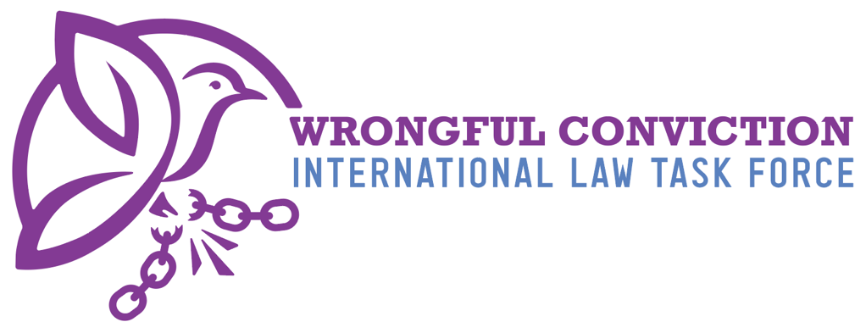

List of Issues for Senegal Prior to Reporting
United Nations Human Rights Committee
Submitted on January 5, 2025
- Authors
The Wrongful Conviction International Law Task Force (WCILTF) is a global coalition of law professors, attorneys and activists working together to fill the “Innocence Gap” in international law. The WCILTF is supported by a pro bono legal team at the international law firm Proskauer Rose (www.proskauer.com/) located in New York City.
In the past twenty-five years, wrongful conviction of the innocent has emerged as a major problem in criminal justice systems around the world. Research indicates that the problem has always existed but has only come to light in recent decades due to forensic advancements allowing for post-conviction DNA testing of crime scene evidence. Wrongful convictions occur because of human limitations in investigation and evidence collection, such as memory weaknesses and malleability (leading to misidentifications by eyewitnesses), unreliable or faulty forensic evidence, false confessions, confirmation bias or tunnel vision on behalf of investigators, inadequate defense lawyering, and many other human problems. Thus, wrongful convictions exist in all legal systems around the world, as all nations use the same types of evidence and investigation techniques regardless of the precise legal procedures employed in their courtrooms.
NGOs called “Innocence Projects” have sprung up around the globe to combat this problem, and now entire networks of innocence projects exist in Asia, Europe, North America and South America. Innocence Projects are often housed at law schools and are operated by law professors and law students. In one member state, for example, more than 3,000 innocent people have been released from prison in recent years due to the work of NGOs like Innocence Projects. Exonerations of the innocent have occurred across the globe in the past three decades.
For a brief video overview of the global problem of wrongful convictions, and the efforts of Innocence Projects to combat the problem, please view: https://youtu.be/jMATkuFaRU8?si=fO0wXGhPr-oCyhBA
As the innocence movement has developed a global presence in recent years, it has become apparent to legal scholars that an “Innocence Gap” exists in international law. The WCILTF formed to combat this problem and help fill the Innocence Gap. The WCILTF is comprised of more than twenty-five law professors and Innocence Project leaders from across Asia, Europe, North America and South America.
- Filling the Innocence Gap
Due to the relatively recent discovery of wrongful convictions, international law covenants and treaties predate awareness of this problem and thus do not speak directly to issue. In recent years, however, the United Nations Human Rights Committee (HRC) has identified key rights to the benefit of incarcerated person claiming innocence to be derived from the right to a fair trial and other existing rights. For example, in Abdiev v. Kazakhstan, 2023, the HRC stated that the right of incarcerated persons to re-open a criminal case in order to present new evidence of innocence after conviction and appeal have concluded, in order to achieve exoneration and freedom, is essential to the right to a fair trial under Article 14(1) of the ICCPR. Similarly, on October 3, 2023, in Concluding Observations on the Fifth Periodic Report of the Republic of Korea, the HRC observed that South Korea should “provide adequate legal and financial assistance to enable individuals sentenced to death to re-examine convictions on the basis of newly discovered evidence, including new DNA evidence.” Likewise, on July 25, 2024, in Concluding Observations on the Second Periodic Report of Maldives, the HRC expressed concern “about the lack of information on the existence of a procedure enabling individuals sentenced to death to seek a review of their convictions and sentences based on newly discovered evidence of their innocence, including new DNA evidence, and, if wrongfully convicted, to provide them with compensation.” The HRC recommended that Maldives take all necessary measures to ensure that “death sentence can be reviewed based on newly discovered evidence of their innocence, including new DNA evidence, adequate legal and financial assistance is provided to enable this review and, if wrongfully convicted, individuals have access to effective remedies, including compensation” para. 28(e). See Brandon Garrett, Laurence Helfer and Jayne Huckerby, Closing International Law’s Innocence Gap, S. Cal. L. Rev. 95 (2021), available at: https://papers.ssrn.com/sol3/papers.cfm?abstract_id=3803518#

- Rights of Innocent Incarcerated Persons in Senegal
The Legal Framework for Addressing Wrongful Convictions
Based on the research of the WCILTF, it is our belief that Senegalese law provides several legal mechanisms through which a wrongfully convicted person may seek to have their conviction reviewed or overturned, although in practice they do not function. The criminal justice system allows an individual to challenge a conviction through appeal, cassation, and, in limited circumstances, revision proceedings based on newly discovered facts.
Following a conviction at first instance, an incarcerated person may file an appeal within one month from the date the judgment is rendered. If the decision on appeal is unsatisfactory, the individual may then lodge a cassation appeal before the Supreme Court within six days of the appellate judgment. These remedies constitute the primary avenues for post-conviction judicial review within the ordinary criminal process.
Beyond these mechanisms, Senegalese law provides for the revision of criminal judgments in cases where new facts or evidence emerge after a conviction has become final. Revision proceedings fall under the jurisdiction of the Supreme Court and are governed by Article 91 et seq. of the Organic Law on the Supreme Court. Such requests may be initiated either by the convicted person or by the Minister of Justice, subject to the statutory conditions set out in the law. The Supreme Court has the authority to examine and adjudicate these revision requests, thereby offering a post-conviction remedy aimed at correcting miscarriages of justice.
In practice, however, legal experts and scholars report that the criminal rules are so strictly construed that they do not properly function. Innocent inmates who have accumulated substantial evidence of innocence are typically provided no avenue in court for an unbiased review.
Evidentiary Preservation and Post-Conviction Review
Senegal’s Code of Criminal Procedure regulates the handling and preservation of evidence throughout the criminal process. The country maintains a scientific police service responsible for forensic analysis, including the examination of physical and biological evidence. In addition, a broader legal framework exists to ensure the preservation of evidence and data during criminal investigations.
Biological and material evidence collected during an investigation is preserved until the conclusion of the investigation and its presentation before the trial court. In cases involving a judicial investigation, the investigating judge retains custody of evidentiary materials and subsequently transfers them to the trial court if the case is referred for judgment. However, there is no specific statutory provision mandating long-term preservation of biological evidence for the purpose of future post-conviction DNA testing, nor is there a distinct legal procedure explicitly allowing incarcerated persons to petition for such testing after conviction.
Access to Case Files and Disclosure Obligations
Senegal does not have a “sunshine law” or public records legislation granting broad post-conviction access to police or prosecutorial files.
Convicted persons are entitled to obtain copies of only the judicial decisions in their cases, while defense attorneys have access to the full case file. By contrast, journalists and non-governmental organizations do not have direct access to criminal case files. There is no post-conviction ability to obtain records in order to complete a post-conviction review for innocence.
With respect to disclosure obligations, Senegalese law does not impose an explicit legal duty on police authorities to disclose exculpatory evidence directly to the defense prior to trial. Instead, police transmit investigative files to the public prosecutor, who is responsible for making the relevant materials available to defense counsel in accordance with the principle of adversarial proceedings.
Compensation for Wrongful Convictions
Senegalese law provides for the compensation of individuals who have been wrongfully convicted. A person who has been erroneously convicted and subsequently exonerated may seek compensation by following the procedure established under the Organic Law on the Supreme Court. While the existence of this compensation mechanism reflects a recognition of the harm caused by wrongful convictions, the precise scope, criteria, and adequacy of compensation are governed by judicial procedures rather than by a dedicated statutory compensation scheme.
Procedural Safeguards and Evidentiary Standards
Police interrogations in Senegal are not audio- or video-recorded, as criminal procedure remains predominantly written in nature. This absence of mandatory recording requirements may raise concerns regarding the verification of interrogation practices and the protection of suspects’ rights.
Furthermore, there are no specific regulations governing eyewitness identification procedures based on scientific best practices, which raises serious concerns regarding wrongful convictions.
- Questions to Senegal
- Can Senegal provide any examples of cases where an incarcerated person presented post-conviction evidence of innocence to the court, and the court actually reviewed the evidence and exonerated the prisoner?
- What is the legal standard that such an incarcerated person must meet in order to re-open the case.
- Does Senegal have a law allowing incarcerated persons to petition for post-conviction DNA testing of crime scene evidence to prove innocence and seek relief?
- Does Senegal have a legal procedure requiring biological evidence collected from the crime scene to be properly stored and preserved for future DNA testing?
- If so, how long must the biological evidence be preserved?
- Does Senegal have a “sunshine law” or “public records law” granting defense attorneys, NGOs, journalists or incarcerated persons access to police files and documents of an incarcerated person’s case post-conviction?
- Does Senegal have a legal standard requiring the police and prosecution to disclose to the defense pre-trial any exculpatory evidence or other information helpful to the defense or that might lead to new avenues of pre-trial investigation that might be conducted by the defense?
- If so, what is the legal standard pertaining to this disclosure requirement?
- Does Senegal have a law providing compensation to the wrongfully convicted after exoneration and release from prison? If so, what do such laws provide?
- Does Senegal have laws or regulations requiring the recording of police interrogation of suspects? If so, please outline the requirements of such laws or regulations.
- Does Senegal have laws or regulations ensuring that police identification procedures for eyewitnesses adhere to best practices devised by the scientific community, such as the double-blind eyewitness identification requirement? See https://www.ojp.gov/ncjrs/virtual-library/abstracts/double-blind-sequential-police-lineup-procedures-toward-integrated
This document created by the following members of the WCILTF:
Michel Mahécor DIOUF
Lawyer admitted to the Senegal Bar
dioufmmichel@gmail.com

Elsa PAINDAVOINE
Law Student, College of Law Cincinnati
paindaea@mail.uc.edu

To contact the WCILTF generally, please email:
Prof. dr. mr. G.J. Alexander Knoops. Professor Mark Godsey
Advocaat/Attorney at law University of Cincinnati College of Law
Professor Politics of International Law Director, Ohio Innocence Project
alex@knoopsadvocaten.nl markgodsey@gmail.com

