SNTUC REPORT

Organisation Name: Singapore National Trades Union Congress (SNTUC)

Submission By: Ms Eileen Yeo, Chairperson of the NTUC Women’s Committee

Submission Date: April 2024

Submission On: Sixth Periodic Report of the Republic of Singapore to the UN Committee on CEDAW (88th Session)

State: Republic of Singapore

For CEDAW Website: Yes

---------------------------------------------------------------------------------------------------------------
About SNTUC

The Singapore National Trades Union Congress (SNTUC) is a national confederation of trade unions as well as a network of professional associations and partners across all sectors in Singapore.

SNTUC's core objectives encompass Singapore’s competitiveness, promoting lifelong employability; enhancing the social status and well-being of our members and workers; and to build a strong, responsible, and caring labour movement. SNTUC is at the heart of the Labour Movement, uniting 58 trade unions, seven trade associations, 12 social enterprises. It strives to create better lives for workers through initiatives that protect our workers at work, transform careers, manage cost of living, help with financial resilience and health, and nurture relationships for families. It champions every worker and works towards better wages, welfare, and work prospects.

In 2020 – 2021, SNTUC played a pivotal role in influencing the Singapore Government’s White Paper on Singapore Women’s Development that focused on 5 key areas and 25 action plans:
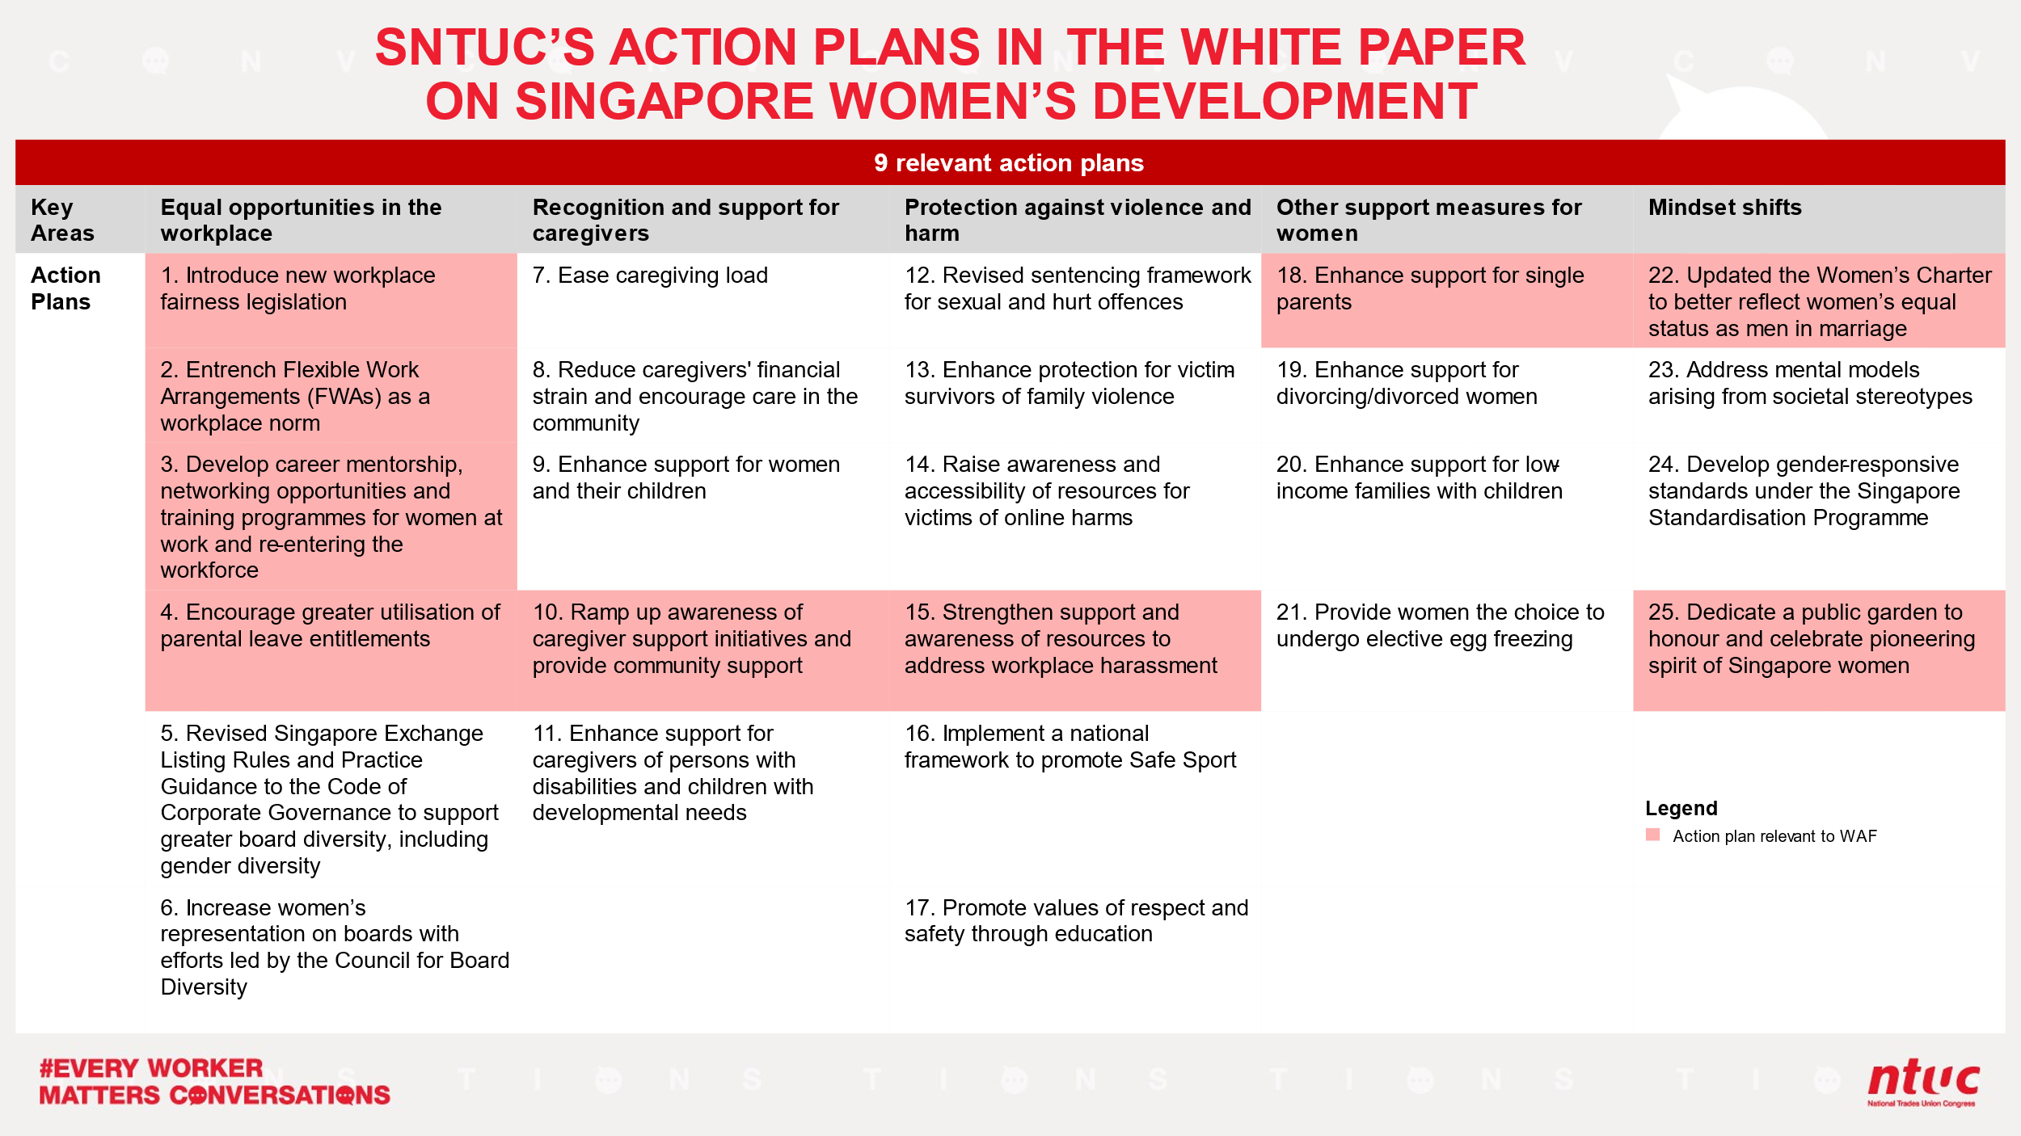
SNTUC notes that 9 of the 25 areas which we have continuously advanced and advocated for have garnered greater attention and are now being prioritised as key issues women face at the workplace. These include workplace fairness legislation, entrenching flexible work arrangements (FWAs) as a workplace norm, encouraging greater utilization of parental leave entitlements (by both men and women), addressing workplace harassment, and providing holistic support for caregivers.

Since the last shadow report submitted by SNTUC, there were changes made by the Government to the relevant policies, notably in the areas of flexible working arrangements, workplace fairness and discrimination, which helped to improve the situation of working women. SNTUC conducted our #EveryWorkerMatters Conversations (#EWMC) from 2022 – 2023, where more than 42,000 workers were consulted to understand their needs, aspirations, and concerns. One key issue that came out of the #EWMC was the burden of caregiving responsibilities for workers. There are still areas for improvement, especially in terms of support for caregivers.
Women workers have to juggle caregiving responsibilities against their career, sometimes resulting in taking a step back from work – either by choice, or out of necessity.

Through this report, we would like to share our views on Articles 5, 7 and 11 of the Sixth Periodic Report of the Republic of Singapore to the UN Committee on CEDAW, which includes providing greater support for women caregivers and women at work.

Article 5: Sex role stereotyping and prejudice

Discrimination at the Workplace

In September 2021, the Singapore Government announced that there would be more equal opportunities at the workplace, with women getting better protection against discrimination or unfair treatment at the workplace, by elevating the Tripartite Guidelines on Fair Employment Practices into law.

MOM's Fair Employment Practices Survey (2022) showed that 24% of resident job applicants experienced discrimination during their job search, of which, discrimination due to age and towards mothers were more common. In Feb 2022, SNTUC conducted a survey on Gender Discrimination in Workplaces. The survey showed that 23% of the 3000 respondents think that there is gender discrimination in the workplace, of which 41% do not have evidence to substantiate it nor do they know how to articulate it. This shows that there is a need to educate the workforce on what constitutes discrimination, in order for women to know how to articulate their discomfort and to better protect themselves.

Motivated by the survey findings, SNTUC collaborated with small and medium enterprises (SMEs) to create positive changes in working environments for women which includes providing a framework for employees, who were subjected to or had witnessed harassment at work, to report the incident. 480 SMEs have signed the enhanced MOU, creating safer workplaces for women across SNTUC’s network.

SNTUC conducted workshops championing safer workplaces where over 150 union leaders learnt how to identify, manage or report workplace discrimination and “Every SME a Safe Workplace” workshop, where over 100 HR managers and employers learnt what constitutes harassment at work and how to manage it appropriately and with sensitivity.

SNTUC would like to call on the Government to support such ground up initiatives to educate the workforce on identifying and managing harassment. Furthermore, the Government can also look at preventative measures. One industry that implemented zero tolerance for harassment is the healthcare sector. In 2022, a Tripartite Workgroup for the Prevention of Abuse and Harassment of Healthcare Workers was formed. After consulting with more than 3,000 healthcare workers and over 1,500 members of the public, the work group recommended adopting a zero-tolerance policy against the abuse and harassment of healthcare workers in any form. In Dec 2023, the work group also launched a framework which provides all healthcare institutions with a common definition of abuse and harassment, and a consistent set of standards to safeguard their workers to:
- Protect healthcare workers who face abuse and harassment;
- Prevent situations that lead to abuse and harassment; and
- Promote positive relationships between healthcare workers and patients/caregivers.
The Healthcare Services Employees’ Union (HSEU), one of the unions under SNTUC, was a part of the Tripartite Workgroup and played an instrumental role in shaping their recommendations. SNTUC suggest that this can be a model for the tripartite partners to scale for other industries. The Government should consider replicating such initiatives especially for sectors that are more female dominated, e.g. education. There can also be more resources provided for women who need support after encountering harassment, such as counselling or therapy.
Article 7: Public and political life

Shaping Public Discourse on Women

SNTUC has a membership base of about 1.3 million members, 48% of whom are women. Five out of the 21 members appointed to the SNTUC Central Committee (the highest policy-making body of the labour movement) for the term 2023 – 2027 are women. This includes our third consecutive female President, Ms K Thanaletchimi.

Female representation in Singapore parliament is almost thirty per cent. SNTUC has seven elected Labour Members of Parliament (MP) that includes, Ms Yeo Wan Ling and one nominated MP, Ms Jean See and cover issues pertaining to women workers, caregivers, self-employed, platform workers, and women returners. Beyond pushing for better working conditions for women workers, Ms Yeo has been advocating for policies that would have a favourable impact on women workers and caregivers.

Article 11: Employment
#EveryWorkerMattersConversations – SNTUC’s Advocacy for Workers and Caregivers

There are about 260,000 women aged between 25 and 64 who are currently not in the workforce, many of whom are stay-at-home mothers or caregivers for their families. Increasingly, workers will face mounting challenges balancing work and caregiving. In a SNTUC online survey of 1,000 workers with caregiving responsibilities, employed respondents most frequently report needing to take time off (52%), take no pay leave (43%), or take leave frequently (42%). Women, who bear a disproportionate share of caregiving, will be most impacted as caregiving increases. With Singapore’s aging population, caregiving responsibilities borne by workers are only set to increase. As such, more must be done to support caregivers, so that they can stay in or rejoin the workforce. Under the refreshed workers’ compact #EveryWorkerMattersConversation, SNTUC called upon the government to provide paid caregiving leave as well as for FWAs to be a workplace norm.

Building a Stronger Caregiving Ecosystem
SNTUC aims to position itself as a top-of-mind resource for working caregivers in the areas of caregiving support, jobs opportunities, upskilling and workplace advice. SNTUC advocates for government support in these areas. SNTUC has been a key player in creating a supporting nation-wide care ecosystem comprising of childcare (SNTUC My First Campus) and eldercare centres (SNTUC Health).

Another source of caregiving support for working women is through the employment of Migrant Domestic Workers (MDWs) to help them care for the young, elderly or infirm at home. However, cultural differences sometimes lead to tense working relationships at home. SNTUC promotes healthy relations between employers and their MDWs by organising events to share useful resources and wholesome bonding activities. One such resource is our “To-Gather: Power of Women Care-nivals” providing useful resources, fun activities and practical gifts for MDWs and their employers in the form of a carnival.

Advocating for Caregiving leave, Flexible Work Arrangements to be a workplace norm and closing the gender pay gap

Enabling caregivers to stay in the workforce, or to make it easier for them to return after a hiatus from work, is one of the key thrusts of SNTUC’s work. In our Survey on FWAs in Workplaces covering 2,711 respondents, 85% chose FWAs as their most preferred form of support. In another survey on Retirement and Re-employment covering 1,471 respondents, 65.9% of seniors agreed that the availability of FWAs will influence their decision to continue working after reaching retirement age. FWAs is therefore critical in keeping caregivers in the workforce. SNTUC has advocated for FWAs since 1992 as a way to enable women caregivers to remain in the workforce, allowing them to retain their financial independence. Amid the 2020 – 2022 global pandemic, companies embraced FWA out of necessity. However, as the situation normalized from 2023 onward, employers began to resist FWA implementation. Therefore, SNTUC is strongly advocating for the widespread adoption of FWAs across industries to become a workplace norm.

Closing the gender pay gap is imperative for achieving gender equality and economic empowerment. In Singapore, the adjusted gender pay gap stands at 6%, even after considering human capital and labour market factors. A key driver of this gap is societal expectation for women to take time off from work for caregiving or parenting responsibilities, resulting in disparities in work experience, career advancement, and ultimately wages. SNTUC recognises the urgency of addressing this issue and has called on the government to introduce measures aimed at narrowing the gender pay gap. These measures include promoting pay transparency through guidelines, as well as establishing a gender pay equality alliance for action to address this issue. This will enable Singapore to foster a more equitable and inclusive workforce, where individuals are compensated fairly based on their skills and contributions, regardless of gender.

Job Redesign and the Adoption of FWA

Our experience in the adoption of FWA with partners across industries, is that job redesign and support from top management are major factors for successful FWAs implementation.

Considering employers feedback and the challenges of women returners SNTUC launched the CUB (C U Back at Work) Programme in April 2023, in partnership with Chye Thiam Maintenance (CTM), a unionized company under the Building Construction and Timber Industries Employees’ Union. The CUB Programme provides flexible training and working arrangements, as well as confidence building, an attractive salary and career progression to attract women with caregiving responsibilities back to the workforce.

Since its launch, SNTUC has engaged over 1,000 women returners. Beyond CTM, SNTUC is expanding this programme to other industries. SNTUC calls on the government to support such initiatives including job redesign for FWAs and leveraging its progressive jobs portal “Yes, Flex Jobs!”, providing more options for women returning to work, and be a part of the larger ecosystem that enables caregivers to stay in the workforce.

Tripartite Relations
SNTUC works closely with the government and the Singapore National Employers Federation to advocate for best results benefiting workers, employers, and the economy. Two main areas are that of FWAs and Work-Life Harmony.

Tripartite Workgroup – Tripartite Guidelines on Flexible Work Arrangements Requests

There have been great efforts by the tripartite partners (Singapore Government, SNTUC and Singapore National Employers Federation (SNEF)) to promote and encourage organisations to adopt FWAs since the last shadow report submitted by SNTUC in 2017. A Tripartite Workgroup was formed in September 2023 to develop the Tripartite Guidelines on Flexible Work Arrangements Requests (TG-FWAR), which will be announced in 2024.

To underscore our advocacy for FWAs, SNTUC developed a Briefing Paper on FWAs comprising key recommendations for companies to implement easy, acceptable and clear requirements derived from behavioural insights research as well as interviews and discussions with companies and employees in our Labour Movement network. SNTUC calls on the government to adopt our recommendations as a practical operational playbook for the effective implementation and maintenance FWAs.

Alliance for Action on Work-Life Harmony (AfA-WLH)

In April 2021, the Tripartite Standard on Work-Life Harmony was introduced to encourage the implementation of other components of Work-Life, i.e., employee support schemes and leave schemes. The Alliance for Action on Work-Life Harmony (AfA-WLH) sought to implement work-life harmony measures to entrench and enhance good work-life practices in the new normal and beyond.

SNTUC worked closely with the tripartite partners to drive the AfA-WLH since February 2021. It aims to embed and improve work-life practices through a network of Work-Life Ambassadors (WLAs) and Communities of Practice (CoP). 116 union leaders from the SNTUC Women’s Committee were appointed as WLAs to develop and promote WLH initiatives supporting sustainable work-life practices, including the adoption of the Tripartite Standard on Work-Life Harmony and the development of two work-life harmony self-diagnostic tools for employers – Work-Life Harmony Self-Assessment Tool and Work-Life Harmony Pulse Survey.

This initiative was further amplified in SNTUC’s ‘Better Workplace’ campaign which was launched as part of International Women’s Day Celebrations 2022. All unionized companies and SME partners who meet the campaign requirements of completing the Work-Life Harmony Self-Assessment tool, adopting the Tripartite Standard on Work-Life Harmony and Implementing a Managing Workplace Harassment Policy, will be rewarded with a fitted wellness corner or lactation space in their company premises. To date, there are 44 progressive employers onboard the campaign, benefitting up to 19,040 workers.

SNTUC urges the government to strongly promote the WLH Self-Assessment toolkit in HR review, facilitating the creation of inclusive workplaces. TAFEP should leverage these tools when helping companies review their WLH policies.

Support for Women Returning to Work

SNTUC Women Supporting Women (WSW) Mentorship Programme is a community mentoring initiative that supports female jobseekers from the community. Female union and community leaders mentor fresh graduates, women-returners, and mid-career switchers. To date, WSW has expanded to 14 locations in Singapore, equipped 200 mentors and 205 mentees.

During the International Women’s Day Celebrations 2024, SNTUC announced SHE Supports, an extension of the WSW that has evolved from traditional one-on-one mentorship to women friendship circles, allowing for a one-to-many approach. This shift upstream accommodates more mentees who may not be ready for individual mentorship. Additionally, it promotes a safe and non-judgmental community of women befrienders who support one another. This initiative reflects SNTUC’s commitment to providing inclusive support for women at various stages of their careers and fostering a strong sense of community and empowerment among them.

The Government can support such ground up initiatives that boost women’s confidence in returning to work through outreach and publicity efforts.

https://stats.mom.gov.sg/iMAS_PdfLibrary/mrsd-Fair-Employment-Practices-2021.pdf
https://www.straitstimes.com/singapore/jobs/flexible-work-arrangements-gig-work-among-issues-tripartism-must-tackle-panel#:~:text=He%20noted%20that%20there%20are,are%20outside%20the%20labour%20force
SNTUC #EveryWorkerMatters Report, pg 53 – 55.
Survey on Flexible Work Arrangements in Workplaces, by NTUC U WAF & PAP WW, June 2023, sample size: 2711
https://stats.mom.gov.sg/Pages/Update-on-Singapores-Adjusted-Gender-Pay-Gap.aspx#:~:text=In%202023%2C%20full%2Dtime%20female,%25%2C%20lower%20than%20in%202018.
https://www.ntuc.org.sg/uwomenandfamily/news/Manpower-Minister-Addressing-the-gender-pay-gap-requires-a-multi-pronged-approach/

