BRIEFING ON THE DOMINICAN REPUBLIC FOR THE COMMITTEE ON THE RIGHTS F THE CHILD, SESSION 94 PRE-SESSIONAL WORKING GROUP- February 2023
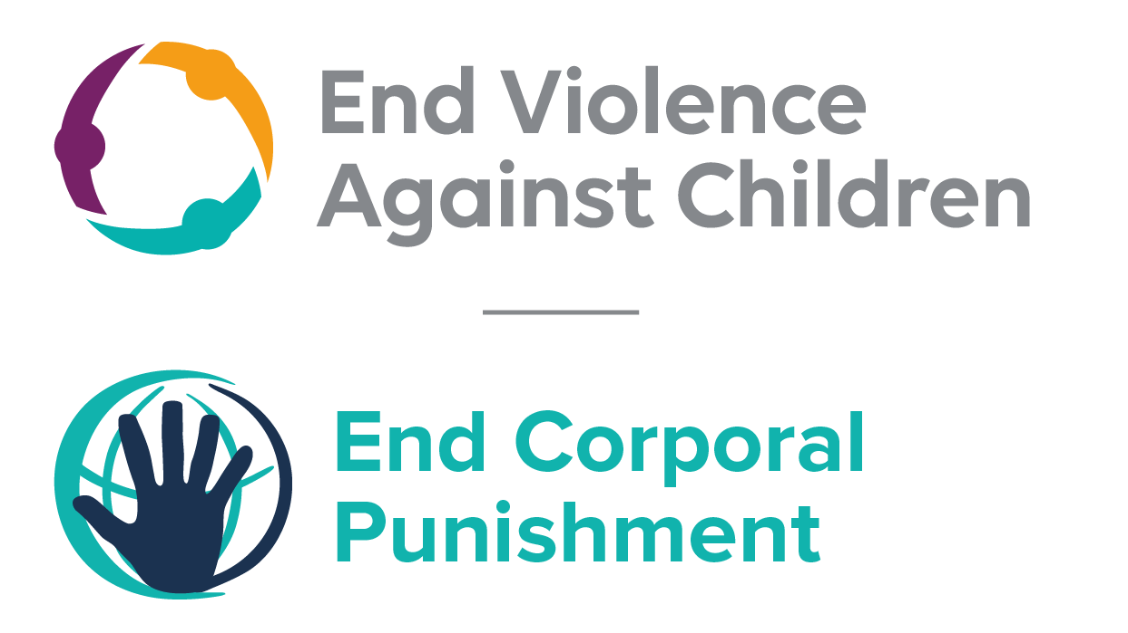
The Global Partnership to End Violence Against Children, October 2022

This briefing describes the legality of corporal punishment of children in the Dominican Republic. In light of the Committee’s General Comment No. 8 on “The rights of the child to protection from corporal punishment of children and other cruel or degrading forms of punishment”, its repeated recommendations on the issue and the importance of eradicating this form of violence given by the UN Secretary General’s Study on Violence against Children. Considering the recommendations to prohibit all corporal punishment made during the Universal Periodic Review in 2009 and 2019, as well as the global commitment to ending all violence against children in the context of the 2030 Agenda for Sustainable Development, we hope the Committee will:
• in its List of Issues Prior to Reporting for the Dominican Republic, raise the issue of corporal punishment of children, in particular in particular asking what progress is being made towards the amendment of the Criminal Code in order to explicitly prohibit corporal punishment of children in all settings; and,
• in its concluding observations on the fifth report of the Dominican Republic, recommend that a legislation is enacted as a matter of priority to explicitly prohibit corporal punishment of children, in all settings including the home and repeal all provisions allowing the use corporal punishment by adults.

The Dominican Republic’s commitment to prohibiting corporal punishment
The Dominican Republic expressed its commitment to prohibiting corporal punishment in all settings by clearly accepting a recommendation to do so made during the Universal Periodic Review in 2009. The commitment was confirmed in 2011 when the Government adopted the Regional Roadmap on Violence against Children, which recommends prohibition. The Criminal Code is under review. It reportedly aims to prohibit all forms of corporal punishment.

Summary of necessary legal reform to achieve full prohibition
Prohibition is still to be achieved in the home, alternative care settings and day care.
There appears to be no confirmation in written law of a “right” of parents to inflict “reasonable” or “moderate” punishment on their children (unconfirmed), but legal provisions against violence and abuse are not interpreted as prohibiting all corporal punishment. The near universal acceptance of a certain degree of violence in childrearing necessitates clarity in law that no degree or type of corporal punishment is acceptable or lawful. Prohibition of all corporal punishment, however light, should be enacted, together with the repeal of any legal defences for its use.
Alternative care – Prohibition should be enacted in legislation applicable to all forms of alternative care (formal foster care, institutions, orphanages, children’s homes, places of safety, emergency care, etc).
Day care – Prohibition should be enacted in legislation applicable to all formal early childhood care (nurseries, crèches, family centres, etc) and all formal day care for older children (after-school childcare, childminding, day centres, etc).

- Current legality of corporal punishment in the Dominican Republic
  - Home: Corporal punishment is lawful in the home. Article 12 of the Code for the Protection of the Rights of Children and Adolescents 2003 confirms the right of all children and adolescents to personal integrity and to respect for their dignity and states that it is the responsibility of the family, the state and society to protect children “against all forms of exploitation, maltreatment, torture, abuse or neglect that may affect their personal integrity” (unofficial translation) – but it does not explicitly prohibit all forms of corporal punishment in childrearing. The Code on Protection of Children and Adolescents 1994, which the 2003 Code repealed, included in its definition of maltreatment “personal injury caused by corporal punishment” (art. 126): this definition is not reiterated in the 2003 Code but there is nothing in the latter to suggest that it is intended to prohibit all corporal punishment of children, however light.
  - Article 303 of the Criminal Code states “Any act carried out as a method of criminal investigation, measure of intimidation, corporal punishment, preventive measure, criminal sanction or for any other purpose that causes injury or physical or mental suffering constitutes torture or an act of cruelty. Equally, the application of substances or methods designed to neutralize the personality or will of persons or to reduce their physical or mental capacity, even if such substances or methods do not cause physical pain or mental suffering, also constitutes torture or an act of cruelty." But this is not interpreted as prohibiting all corporal punishment in childrearing, as indicated by article 303-1 which punishes acts of cruelty by 10-15 years. Provisions against violence and abuse in the Law Against Domestic Violence 1997 do not include prohibition of all corporal punishment.

  - Article 42 of the Constitution 2010 confirms the right of every person to personal integrity and “to live without violence”, stating also that “no one shall be subjected to punishment, torture or degrading treatment involving loss or decline in health or physical or mental integrity” and that “domestic and gender violence in any form is condemned”; article 56 confirms the right of children to protection from “all forms of abuse and violence” (art. 56). There is no evidence that these provisions are interpreted as prohibiting all corporal punishment of children by parents.
  - The Government has signalled its commitment to full prohibition of corporal punishment. In 2009, the Government accepted the recommendation to prohibit corporal punishment in all settings made during the Universal Periodic Review. In reporting to the UPR of the Dominican Republic in 2014, the Government stated that work was under way “on drafting a provision to combat child abuse that covers corporal or physical punishment based on the Guide on Comprehensive Health Care for Children and Adolescent Victims of Violence and Abuse”. The Government reported to the Committee on the Rights of the Child in 2015 that it had adopted a national roadmap on the prevention and elimination of violence against children; this was officially launched on 30 April 2015. This follows the adoption in 2011 of the Regional Roadmap on Violence against Children by the Central American Governments of Cuba, Mexico and the Dominican Republic, which includes a recommendation to adopt national legislation to explicitly prohibit all corporal punishment and to repeal provisions allowing for “moderate” punishment/correction.
  - Current law reform includes the reform of the Penal and Civil Codes, including to ensure compliance with the new Constitution (see above). In 2016, the Government reported that a Family Code was being drafted in order to bring national legislation in line with the state’s international obligations. The Government reported in August 2017 that a workshop had been held by the Inter-Agency Commission for the 2015-2018 Road Map to End Violence against Children where a consensus had emerged to draft a Bill entitled “Positive Parenting (Discipline) and Prohibition of Abuse Act” and that a commission was set up to pursue political advocacy and a communications strategy regarding corporal punishment. The Positive Parenting Bill was introduced to the Chamber of Deputies in 2019. In 2022, it was reported that the Criminal Code was being reviewed to include prohibition of corporal punishment in all settings.

  - Alternative care settings: There is no explicit prohibition of corporal punishment in alternative care settings (formal foster care, institutions, orphanages, children’s homes, places of safety, emergency care, etc). Legal provisions against violence and abuse, in the Constitution and other laws (see under “Home”), protect children from some but not all corporal punishment.

  - Day care: There is no explicit prohibition of corporal punishment in formal early childhood care (nurseries, crèches, children’s centres, etc) and formal day care for older children (after-school childcare, childminding, day centres, etc). Legal provisions against violence and abuse, in the Constitution and other laws (see under “Home”), protect children from some but not all corporal punishment.

  - Schools: Corporal punishment is unlawful in schools under the Code on the Protection of the Rights of Children and Adolescents 2003, article 48 (unofficial translation): “School discipline should be administered in accordance with the rights, guarantees and duties of children and adolescents established in this Code…. In relation to official disciplinary regulations of schools and educational institutes, the following measures must be taken into account: … prohibit corporal punishment and economic sanctions, as well as collective punishment, and corrections that might be considered to threaten or violate the rights of learners.” Article 49 states: “All children and adolescents have the right to be treated with respect and dignity by their educators.”

  - Penal institutions: Corporal punishment is unlawful as a disciplinary measure in penal institutions. Article 246 of the Code for the Protection of the Rights of Children and Adolescents 2003 states that an adolescent in conflict with the law has the right “not to be subjected to torture or to cruel, inhuman or degrading treatment or methods or techniques that induce or affect his free will, his consciousness, or impairment of dignity” (unofficial translation). Article 349 states: “The adolescent has the right … l) not to be subjected to incommunicado in any case, or to the imposition of corporal punishment….”

  - Sentence for crime: Corporal punishment is unlawful as a sentence for crime. There is no provision for judicial corporal punishment in criminal law.

Recommendations by human rights treaty bodies and during the UPR

  - CRC: On two occasions, the Committee on the Rights of the Child has recommended to the Dominican Republic that legislation be enacted to explicitly prohibit corporal punishment in all settings: in its concluding observations on the state party’s second report in 2008, on the state party’s third-fifth report in 2015.
2.2 UPR: At the first cycle of the Universal Periodic Review of the Dominican Republic in 2009, a recommendation to adopt legislation explicitly prohibiting corporal punishment in the home was issued and accepted by the Government. The Government later indicated that prohibition had been achieved:

4 January 2010, A/HRC/13/3, Report of the working group, para. 87(14)
8 November 2013, A/HRC/WG.6/18/DOM/1, National report to the UPR, para. 21
15 January 2015, CRC/C/SR.1932, Summary record of 1932nd meeting, para. 31
NGO Coalition for Children, correspondence with the Global Initiative, 6 May 2015; see also http://www.listindiario.com/la-republica/2015/5/5/366053/Castigaran-a-adultos-que-les-den-pelas-a-los-ninos, accessed 12 May 2015
Regional Road Map on Violence against Children, adopted in 2011, 1 and 2 December in Santo Domingo, as a follow-up to the recommendations of the UN Study on Violence against Children, available at http://srsg.violenceagainstchildren.org/sites/default/files/political_declarations/Hoja%20de%20Ruta%20Final%20EVCN%20Centroamericano%20Dic%202012.pdf, accessed 21 February 2015
27 July 2016, CCPR/C/DOM/6, Sixth state report, paras. 125 and 126
15 August 2017, CCPR/C/DOM/Q/6/Add.1, Reply to list of issues, para. 30
Information provided by UNICEF in the Dominican Republic, April 2022
11 February 2008, CRC/C/DOM/CO/2, Concluding observations on second report, paras. 45 and 46
4 February 2015, CRC/C/DOM/CO/3-5, Concluding observations on third-fifth report, paras. 31 and 32
4 January 2010, A/HRC/13/3, Report of the working group, para. 87(14)
8 February 2011, A/HRC/13/56, Report of the Human Rights Council on its thirteenth session, para. 327

