
st

MEETING

March 11, 2019 - April 5, 2019

CRPD – Convention on the Rights of Persons with Disabilities

ALPE-ACHONDROPLASIA FOUNDATION REPORT (SPAIN)


INTRODUCTION

The ALPE ACHONDROPLASIA Foundation, according to its statutes, pursues the following purposes: the satisfaction of educational needs, early stimulation, school monitoring, social, cultural and occupational integration of people affected by the alteration known as achondroplasia and other common forms of dwarfism. Likewise, the ALPE ACHONDROPLASIA Foundation will aim to solve health and physical and mental development problems, as well as the creation of a legal and social framework that facilitates the development of the aforementioned objectives, promotion of research programs and prevention methods, diagnosis and treatment of the aforementioned alteration called achondroplasia.
Hereafter, throughout this document we will expose the violations and breaches by Spain of the principles and rights contained in the CONVENTION ON THE RIGHTS OF PERSONS WITH DISABILITIES, which directly affect people with achondroplasia (dwarfism).

FIRST
BULLFIGHTING COMIC SHOWS UNDERTAKEN BY PEOPLE WITH DWARFISM

Article 4 - General obligations
1. States Parties undertake to ensure and promote the full realization of all human rights and fundamental freedoms for all persons with disabilities without discrimination of any kind on the basis of disability. To this end, States Parties undertake:

- To adopt all appropriate legislative, administrative and other measures for the implementation of the rights recognized in the present Convention;

- To take all appropriate measures, including legislation, to modify or abolish existing laws, regulations, customs and practices that constitute discrimination against persons with disabilities;

OTHER ARTICLES OF THE CONVENTION THAT ARE VIOLATED WITH THE REGULATION OF THE BULLFIGHTING COMICS

- Art. 5.2 "States Parties shall prohibit all discrimination on the basis of disability and guarantee to persons with disabilities equal and effective legal protection against discrimination on all grounds."

- Art.8.1 b) "To combat stereotypes, prejudices and harmful practices relating to persons with disabilities, including those based on sex and age, in all areas of life”

- Art.27

ALPE ACONDROPLASIA FOUNDATION CONTRIBUTION
In Spain there are bullfighting comic shows performed by people with disabilities, specifically people with dwarfism, which violate the fundamental principles of the UN CONVENTION ON THE RIGHTS OF PERSONS WITH DISABILITIES.
These bullfighting comic shows are hired by public administrations with fairs and festivals as something cultural, funny or fun, and offer their residents shows that are based on mockery, degradation and humiliation of a physical condition, dwarfism.
What people find funny about these shows, at the same time as being shocking and amusing is that the so-called "dwarf", with his short limbs, does not always get away from the heifer and for this reason they often throw themselves to the floor allowing the animal to run over them, and to top it off, the alleged bullfighter is dressed up as a clown or fireman. Put another way: what sells the firefighter bullfighter is the grotesqueness based on the contrast between a person with dwarfism and a runaway heifer, a contrast that is ridiculed by the actors themselves by appearing dressed up in the ring.
An activity that is regulated by the internal regulations of the Kingdom of Spain and one that the rest of the public administrations with competences in the matter have not reformed to prohibit and repeal these norms that violate the most elementary principles of the CONVENTION ON THE RIGHTS OF THE PEOPLE WITH DISABILITIES.
We are facing a clear and resounding example of abandonment of functions by Spain, which after 10 years since the ratification of the Convention continues to protect and regulate shows that denigrate and humiliate the dignity and fundamental rights of people with disabilities.
We can find a clear example of the abandonment of functions by the Government of Spain in the collective national bullfighting agreement in force, Resolution of December 23, 2014, of the General Directorate of Employment, by which the Collective National Bullfighting Agreement is registered and published. BOE-A-2015-342. In the said current regulations, Comic Bullfighting can be found specifically in art. 9. https://www.boe.es/diario_boe/txt.php?id=BOE-A-2015-342

Article 9 - Comic bullfighters
1. The comic group will be constituted by:
a) A Team Leader.
b) A "big" Bullfighter. A "big" bullfighter is understood, for these purposes, to be someone who has self-sufficient physical capacity for the fight.
c) A minimum of five "small" bullfighters, if the show has this kind of comic bullfighter. A "small" bullfighter is understood, for these purposes, to be someone who due to their physical stature cannot fit into the previous section.
d) A sword servant.

A norm protected and ratified by the Government of Spain, which provides legal coverage (against the principles and values of the Convention) to the direct relationship of a physical condition (disability) of the "small bullfighters" with the bullfighter comic, in other words, all that is a "small bullfighter" is funny, and not because of their interpretative or artistic skills, but because of their disability. In other words, a type of disability, achondroplasia (dwarfism), is synonymous with comics.
For its part, in RD 145/1996, included in its article 9, within Chapter I on Professional Registration, the procedure by which comic bullfighters must register is established "1. The comic bullfighters and sword servants must register in Sections VI and VII of the Register of Bullfighting Professionals, respectively.2. Suffice for the registration of comic bullfighters is their presentation by an association of bullfighting professionals with representation in the National Advisory Commission on Bullfighting Matters, by the corresponding entertainment sections of the most representative trade unions, or by a professional from Section I, or from Section VI itself, already registered. The definition of the comic bullfighter is established in article 25.g) as "in which cattle are handled in a funny or comic way"; and Article 90 establishes the requirements and norms of this modality. "Comic bullfighting will conform to the provisions of the previous article with the following provisos: 1. The calves that are the object of the fight cannot exceed two years. 2. They will not kill the cattle in the ring, nor inflict bloody damage. The cattle of these shows will be sacrificed once finished, in the presence of the Governmental Delegate. 3. The comic bullfighting shows cannot be held together with other bullfighting celebrations in which the cattle die."
From the simple reading and analysis of current regulations at both the state and regional levels regarding bullfighting shows, the denial of the artistic character given to this type of bullfighter can be verified. A very significant example is found in the access to the general register of bullfighting professions, which is compulsory for all bullfighting professionals if they wish to participate in bullfighting shows; In all the existing categories they are required to have accredited previous experience to be able to access the superior category, except for the comic bullfighters. They can only be registered as bull-matadors, "if they have previously intervened in twenty-five novice bullfights with "picadores"; for young-bull matadors with "picadores" the "intervention in ten young-bullfights without picadores" is required, or for matadors without "picadores" to accredit "their preparation and knowledge", or "if the interested party has been a student of a registered bullfighting school, such circumstance must be proved together with a certificate from the director".

For its part, to be able to register as a comic bullfighter, "Suffice for the registration of comic bullfighters is their presentation by an association of bullfighting professionals with representation in the National Advisory Commission on Bullfighting, by the corresponding entertainment sections of the most representative trade unions, or by a professional of Section I, or of Section VI itself, already registered." With the simple reading and its comparison with the requirements demanded for the rest of the categories, we can see that any artistic quality or previous experience is not necessary to be catalogued as a comic bullfighter.
One may ask, if the comic bullfighter is an art, as some argue, why is there no prerequisite for experience or technical qualification for all people who want to access this category of comic bullfighter?; and furthermore when the national bullfighting regulations along with the autonomic ones define the comic bullfighter, as when "cattle are dealt with in a funny or comic way", that is, there is a fight with the calves, therefore, it is not understandable from an artistic point of view that comic bullfighters do not have any preparation or training to be able to fight in a comic or funny way. This legal exoneration of the qualification accreditation can be understood only for all the people who want to register as comic bullfighters, and therefore, they can act in comic bullfighting shows, their basis is not found in the art of bullfighting in a comic or funny way but in other qualities of the show such as the physical condition of the comic bullfighters.

In Spain, the competences in matters of bullfighting depend on the Ministry of Culture and Sports of the Government of Spain.

From the ALPE FOUNDATION, we request that Spain be urged to repeal the regulations that protect these shows that violate the principles and values of the Convention.
SECOND
CERTIFICATE REGULATION OF
REDUCED MOBILITY

Article 9 - Accessibility
In order that persons with disabilities may live independently and participate fully in all aspects of life, States Parties shall take appropriate measures to ensure access for persons with disabilities, on equal terms with others, in physical, transport, information and communications, including information and communication systems and technologies, and other services and facilities open to the public or for public use, both in urban and rural areas. These measures, which will include the identification and elimination of obstacles and access barriers, will apply, among other things, to:
a) Buildings, public roads, transportation and other external and internal facilities such as schools, housing, medical facilities and workplaces;
b) Information, communications and other services, including electronic and emergency services.
2. States Parties shall also take appropriate measures to:
a) Develop, promulgate and supervise the application of minimum standards and guidelines on the accessibility of facilities and services open to the public or for public use;
b) Ensure that private entities that provide facilities and services open to the public or for public use take into account all aspects of their accessibility for persons with disabilities;

Article 19 - Right to live independently and to be included in the community
States Parties of this Convention recognize the equal right of all persons with disabilities to live in the community, with options equal to those of others, and shall adopt effective and pertinent measures to facilitate the full enjoyment of this right by people with disabilities and their full inclusion and participation in the community, especially ensuring that:
c) Community facilities and services for the general population are available, on equal terms, to persons with disabilities and take into account their needs.
Article 20 - Personal mobility
States Parties shall adopt effective measures to ensure that persons with disabilities enjoy personal mobility as independently as possible

REDUCED MOBILITY CERTIFICATE
The regulations in force in Spain regarding access to and obtaining the reduced mobility certificate violate the rights of people with achondroplasia (dwarfism) and art.9, 19 and 20 of the Convention.
- Royal Decree 1056/2014, of December 12, which regulates the basic conditions for issuing and using the parking card for people with disabilities. BOE-A-2014-13362.

- Annex II of Royal Decree 1971/1999, of December 23, on the procedure for the recognition, declaration and qualification of the degree of disability. BOE-A-2000-1546
To qualify for the reduced mobility certificate, the competent court assesses people with disabilities based on the following scale, and that does not take into account the specific peculiarities of the disability of achondroplasia (dwarfism), that is, a person with achondroplasia can ambulate autonomously without the help of a cane or wheelchair, but on the contrary cannot access public transport or private parking facilities because they are not adapted to their short stature. This situation generates an enormous vulnerability and discrimination against people with achondroplasia (dwarfism).

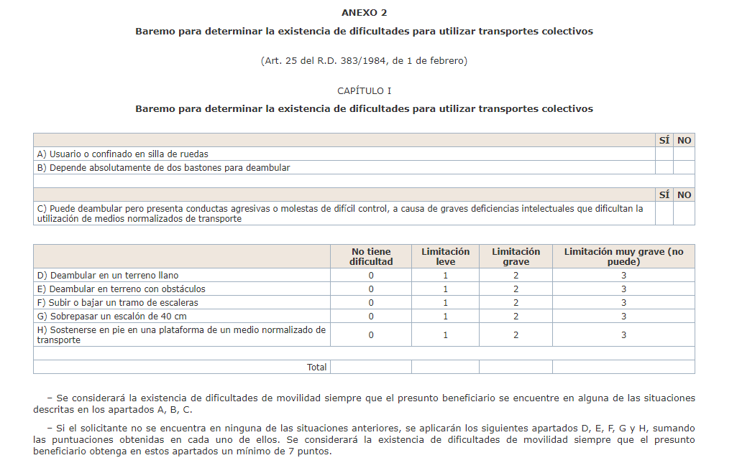

For further knowledge for the members of the court we facilitate two examples where it can be clearly seen that people with achondroplasia (dwarfism) cannot use public and private car parks’ machines. This situation generates huge discrimination since in Spain you can only access the spaces reserved for people with reduced mobility if you have the certificate (whose scales do not take into account short stature), and if in turn, you cannot access public and private parking spaces, being inaccessible in terms of height, you cannot travel in a private vehicle.
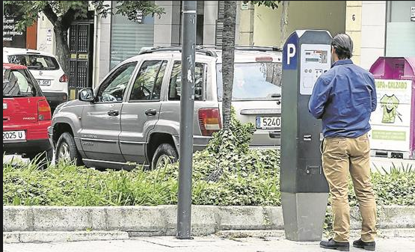


From the ALPE FOUNDATION we request the modification of the current regulations regarding access to the reduced mobility certificate, and that the height scale for the determination and granting thereof be included.

Registered in the Register of Teaching and Cultural Foundations of the Principality of Asturias, CIF G33863515, no. 132, t. 1, folio 33, section 1
C/ Conde del Real Agrado, 2, 33205, Gijón
www.fundacionalpe.org
acondro@fundacionalpe.org
(34) 985 17 61 53

Royal Decree 145/1996, 145/1996, of February 2, which modifies and rewrites the Regulation of Bullfighting Shows (BOE No. 54, of March 2), in its wording given by Royal Decree 1910/1997, of December 19th; by Royal Decree 2283/1998, of October 23; by the Judgment of September 21, 1999, of the Supreme Court and by Royal Decree 1034/2001, of September 21.
According to art. 2.3 3. Royal Decree 145/1996, of February 2, which modifies and rewrites the Bullfighting Show Regulations (BOE No. 54, of March 2) Registration in the Registry will be mandatory, those who do not prove the validity of their registration in the corresponding Section will not be able to intervene in the bullfighting shows in which the professionalism of the participants is required. Those enrolled in a Section may participate in festivals in a lower category than the one performed.
Bullfighters, Novice Bullfighters with “picadores”, Bullfighters without “picadores”, Rejoneadores, Bandarilleros and Picadores, Comedian Bullfighters, Sword Servants.
Arts, 3,4,5,6, 7,8 and 9 of Royal Decree 145/1996, February 2, which modifies and rewrites the Regulation of Bullfighting Shows (BOE No. 54, of 2 March.

