Assessment of Economic and Social Rights Fulfilment in Uruguay
Submission from the Human Rights Measurement Initiative to the United Nations Committee on Economic, Social and Cultural Rights for its 79th Session scheduled to be held in February 2026.
I. Reporting Organisation
1. The Human Rights Measurement Initiative (HRMI) measures the human rights performance of countries around the world, including Uruguay. HRMI is an independent, not-for-profit NGO with its primary base of operations in New Zealand, and a second base in the United States of America at the University of Georgia’s Center for the Study of Global Issues (GLOBIS).
II. Assessment Methodology
2. HRMI uses the award-winning and peer-reviewed SERF Index methodology to measure the fulfilment of economic and social rights (ESRs).
3. This methodology uses bellwether indicator data from international organisations—such as the WHO and UNICEF—and compares each country’s achievement to what other countries at the same income level (GDP per capita) have achieved. HRMI measures progressive realisation of economic and social rights as defined in the International Covenant on Economic, Social, and Cultural Rights (ICESCR). A country’s ‘income adjusted’ HRMI score is thus a measure of how well its government is converting its resources into good human rights outcomes for its people.
4. HRMI supplements these scores with qualitative information sourced by a secure, online survey of in-country human rights experts, such as NGO researchers, journalists, and human rights lawyers and advocates. For more details, please refer to the resources on our website.
5. All HRMI’s data are published annually on the Rights Tracker and are freely available for non-commercial use under a Creative Commons License. The Rights Tracker is a certified Digital Public Good with the Digital Public Good Alliance.
III. Overview of Economic and Social Rights Fulfilment in Uruguay
6. HRMI’s most recent ESR scores for Uruguay measure its achievement on three key rights as well as some component rights as of 2022, and indicate a significant room for improvement in some areas. They are shown in the graph below.
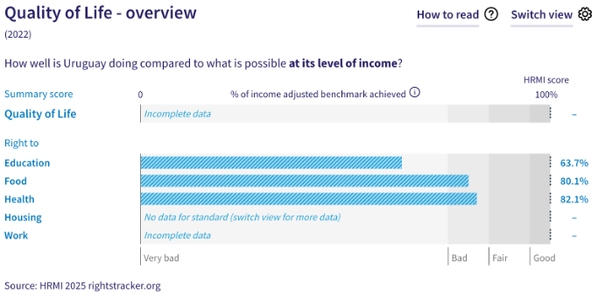
7. Uruguay’s scores for 2022 are as follows:
- Right to education = 63.7% (‘very bad’)
- Right to food = 80.1% (‘bad’)
- Right to health = 82.1% (‘bad’)
- Right to housing = The indicator data necessary to produce an overall score for the right to housing are not available for Uruguay in international databases.
- Right to work = There is insufficient international data for HRMI to produce an overall score, but the score for the component on fair (relative) income is available.
8. The three key scores available for Uruguay fall in the ‘bad’ and ‘very bad’ ranges, with none of the scores reaching the ‘good’ range. This highlights the State Party’s underperformance in using its available resources to fulfil its immediate economic and social rights obligations.
9. We do not have an overall ‘Quality of Life’ score for Uruguay as there are gaps in the international indicator data necessary to produce all the scores. The available scores are measured against an ‘income adjusted’ benchmark, which means that they take into account Uruguay’s existing income and how well it is using them to fulfil the ‘Quality of Life’ rights of its people.
10.The available scores indicate that Uruguay is not achieving what ought to be possible with its current level of resources. Although some scores indicate progress, any ‘income adjusted’ score that is less than 100% indicates that a country is underperforming and not meeting its current obligations under international human rights law. Therefore, our assessment is that while Uruguay is performing ‘close to average’ compared to other high-income countries, it still has some way to go to meet its immediate economic and social rights obligations.
IV. Right to Education
11. HRMI defines the right to education in accordance with ICESCR Article 13 and CESCR General Comments 11 and 13. For high-income countries such as Uruguay, HRMI further breaks down the right to education into four areas of measurement: secondary school enrolment, quality of education for maths, quality of education for reading, and quality of education for science. Our scores show underperformance across all components of this right, especially on quality education for maths, reading, and science, with no score reaching the ‘good’ range.
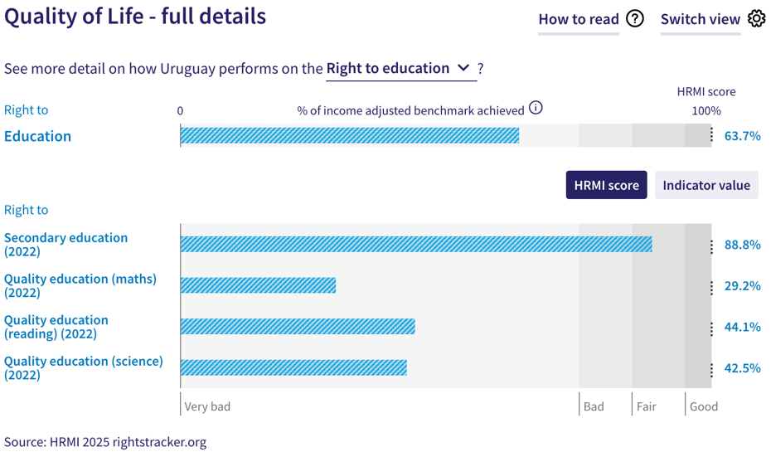
12. Uruguay’s overall ‘income adjusted’ score for the right to education is 63.7%, which means that Uruguay is currently doing only 63.7% of what is possible for it to achieve at its current income levels. This score falls in the ‘very bad’ performance range, and has shown only a slight improvement over the last decade from 54.3% in 2012 to its current score of 63.7% in 2022. Notably, Uruguay stands at 39th place out of 49 high-income countries in our dataset on the overall right to education when measured using the high-income assessment standard.
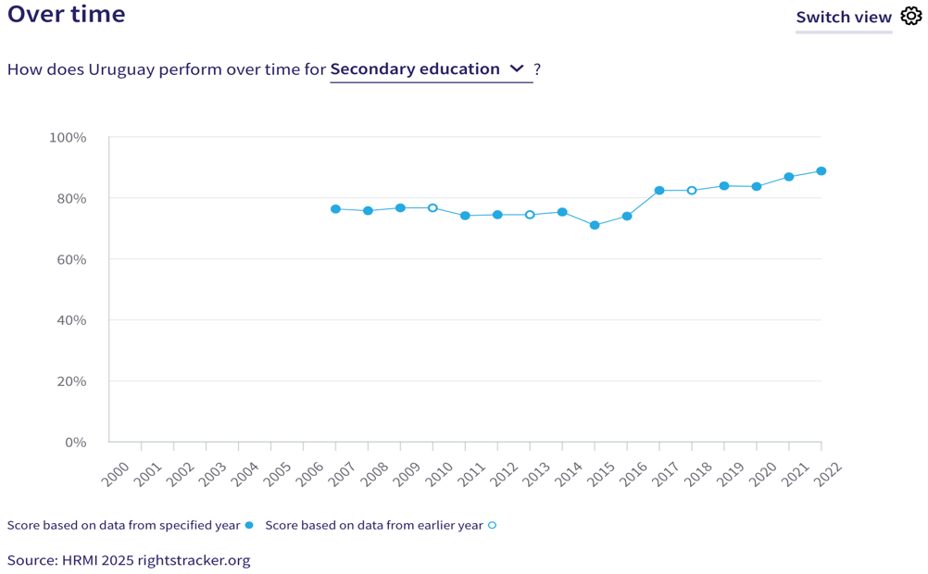
13. Uruguay’s ‘income adjusted’ score for the right to secondary education is 88.8%, and is the only component of this right that falls in the ‘fair’ range. According to the UNESCO database, 90.8% of upper secondary school-aged children in Uruguay were enrolled in school in 2022. While this score has fluctuated over the last two decades, it has also shown an encouraging upward trend after a slow decline from 74.2% in 2011 to 71.1% in 2015, to its current score of 88.8% in 2022. The improvements between 2020 and 2022 have been notable.
14. Uruguay’s scores for the other three components of the right to education stand in a complete contrast with the component on the right to secondary education. Uruguay has an ‘income adjusted’ 29.2% for quality maths education, 44.1% on quality reading education, and 42.5% on quality science education, and all these scores lie in the ‘very bad’ range. Overtime trends for all three areas show a concerning decline over the 2003-2022 period, indicating that immediate action is necessary to prevent any further decline. Particularly, the score for right to quality maths education has shown a much steeper decline over the last two decades. Notably, Uruguay stands among the lowest ranking high-income countries, i.e., 45th out of 49 countries, on this right in our dataset.
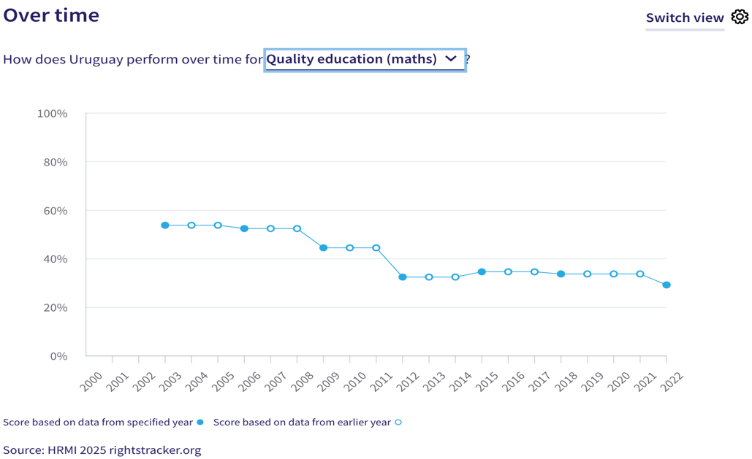
V. Right to Food
15. HRMI defines the right to food in accordance with ICESCR Article 11 and CESCR General Comment 12. For high-income countries, the right to food score is based on the percentage of people in the population who have not experienced food insecurity at moderate or severe levels during the reference period, according to the Food Insecurity Experience Scale from FAOSTAT.
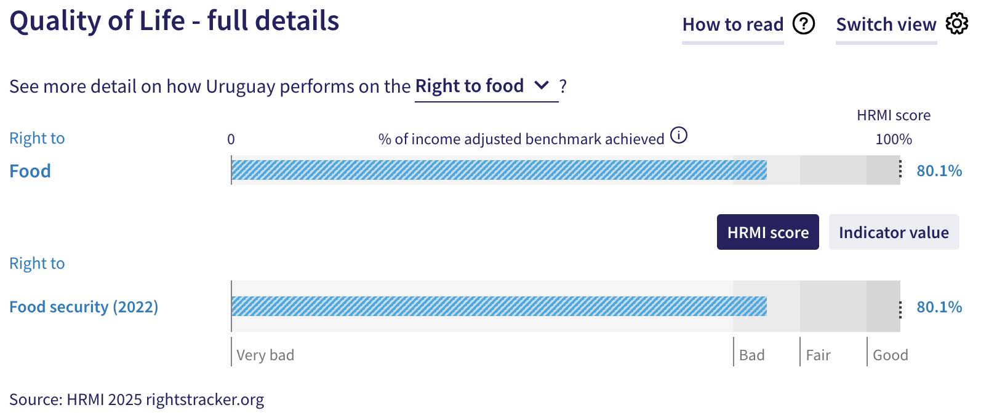
16. Uruguay achieves an ‘income adjusted’ score of 80.1% for the right to food, which falls in the ‘bad’ range. This means that Uruguay is doing only 80.1% of what is possible to achieve with its existing resources to ensure food security for its people. This score has shown a downward trend over the last few years, with a score of 83.9% in 2018 to its current score of 80.1% in 2022.
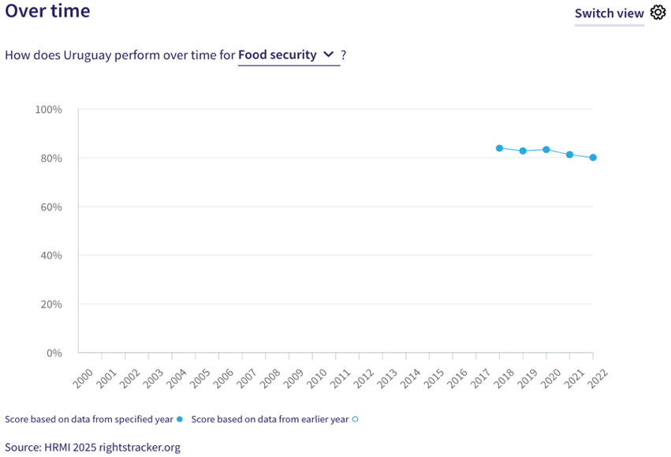
VI. Right to Health
17. HRMI defines the right to health in accordance with ICESCR Article 12.1 and CESCR General Comment 14. For high-income countries such as Uruguay, HRMI uses three indicators to measure the country’s achievement on the right to health: percentage of children surviving to age 5, senior (60-80 years old) survival rate, and percentage of babies who do not have a low birth weight.
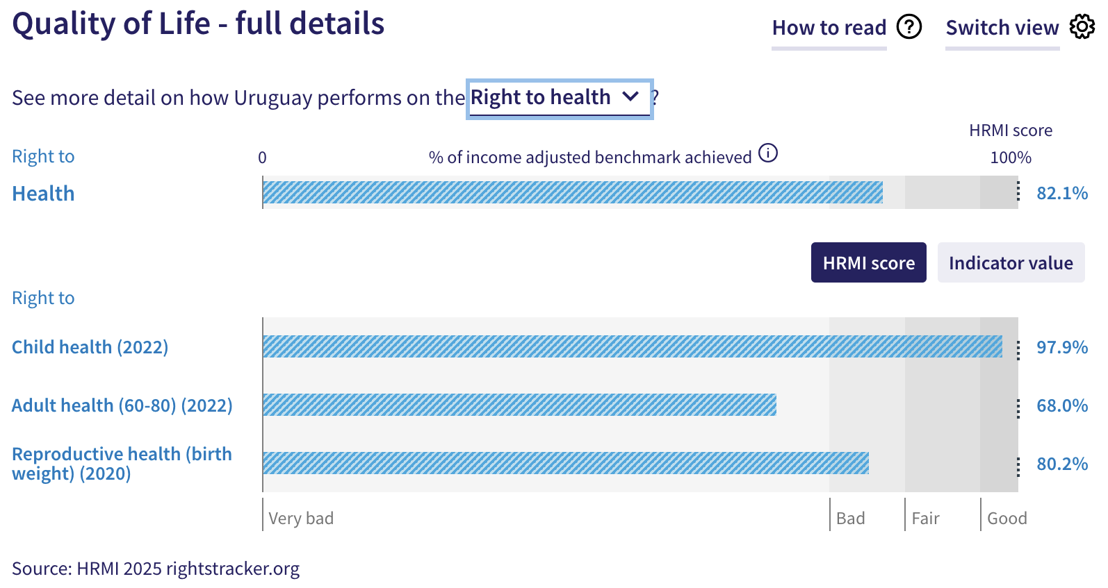
18. Uruguay’s overall ‘income adjusted’ score for the right to health is 82.1%, which means that it is achieving 82.1% of what is possible to achieve with its existing income levels to fulfil the right to health of its people. This score falls in the ‘bad’ range and it has not shown any significant improvement over the last two decades.
19. According to the United Nations Inter-Agency Group for Child Mortality Estimation (UN-IGME), 99.3% of children in Uruguay survive beyond five years of age. This translates to Uruguay’s ‘income adjusted’ HRMI score of 97.9% for the right to child health, and it falls in the ‘good’ performance range. This score has consistently been close to ‘income adjusted’ 100% for the last two decades, and has improved from 93.6% in 2000 to the current score of 97.9% in 2022.
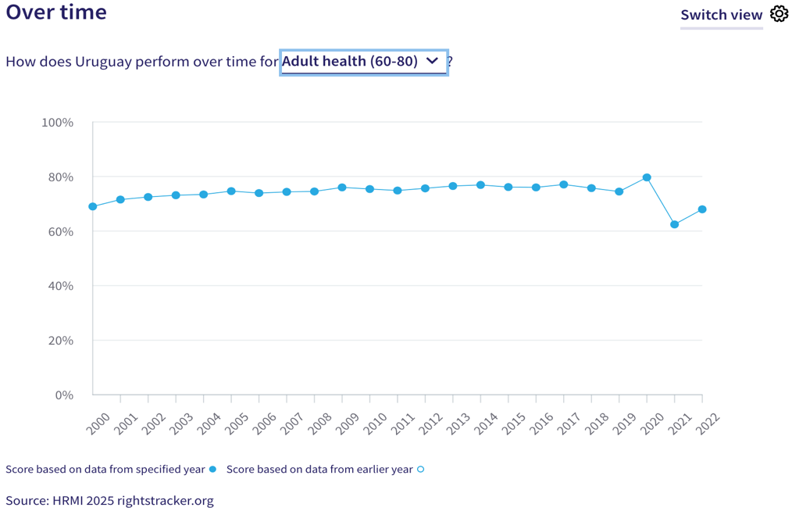
20. The ‘income adjusted’ score for the right to adult health in Uruguay is 68.0%, and falls in the ‘very bad’ range. This score is based on senior survival rate; according to the UNPD and Max Planck Institute Human Mortality Database, 55.3% of 60-year-old people in Uruguay survive to age 80. This score has largely plateaued and has only shown a marginal increase over the years from 69.0% in 2000 to its peak score of 79.7% in 2020. It saw a sharp decline to 62.4% in 2021, coinciding with the COVID-19 pandemic, before rising to its current score of 68.0%. Out of 71 high-income countries in our dataset, Uruguay ranks 57th on the right to adult (60-80) health.
21. Uruguay’s score for the right to reproductive health—based on percentage of babies who do not have a low birth weight—is 80.2%. This score falls in the ‘bad’ performance range. This score has largely plateaued over the last two decades, and has in fact shown a marginal decline from 82.1% in 2020 to its current score of 80.2% in 2020, based on the latest available data.
VII. Right to Housing
22. HRMI defines the right to housing in accordance with ICESCR Article 11.1 and CESCR General Comment 4. For high-income countries such as Uruguay, HRMI measures this right using the two indicators: affordable housing data from Eurostats, and data on access to safely managed sanitation from the WHO UNICEF Joint Monitoring Project (JMP). However, these indicator data that are required to construct the score for the right to housing have not been available for Uruguay in the respective international databases for the last two decades.
VIII. Right to Work
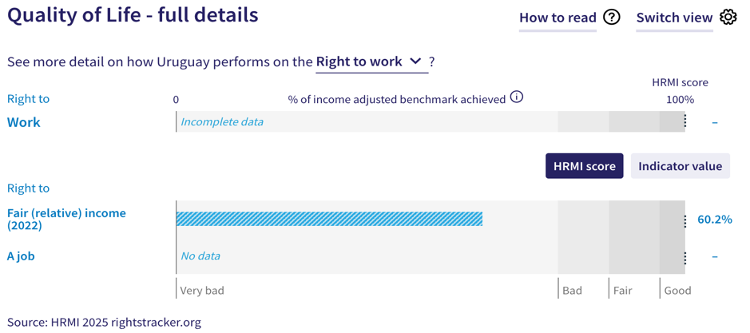
23. HRMI measures the right to work in accordance with ICESCR Articles 6 and 7. For high-income countries such as Uruguay, HRMI measures the right to work based on two indicators: ‘percentage of people who are not relatively poor’ and ‘the percentage of people who have not been unemployed long-term’, drawing on data from the Luxembourg Income Study, the OECD, and World Bank PovcalNet. However, we do not have an overall HRMI score for the right to work, including the overtime graph, due to missing data on the component of ‘long-term employment’ necessary to construct the overall score on the right to work.
24. Uruguay’s ‘income adjusted’ HRMI score for the right to fair (relative) income is 60.2%, and lies in the ‘very bad’ range. According to the Luxembourg Income Study and the OECD databases, 86.3% of people in Uruguay are not ‘relatively poor’. Over time trends indicate that the score for this right has shown slight fluctuation over the years, but has overall remained within a limited bracket, from 56.0% in 2004 to its peak score of 65.3% in 2011, before declining to its current score of 60.2% in 2022.
X. Concluding Remarks
25. Uruguay’s better performing ‘income adjusted’ scores are for the components of the right to secondary education and the right to child health, which fall in the ‘fair’ and ‘good’ performance ranges respectively, and have generally shown a positive performance trend.
26. Uruguay’s most concerning scores are for the three areas of the right to education, i.e., quality maths education, quality reading education, and quality science education; the right to adult (60-80) health; and the right to fair (relative) income. All of these scores fall in the ‘very bad’ performance range, and they have either plateaued or declined over the years.
27. We also note that the raw indicator data for three component rights, i.e., the right to affordable housing, the right to safely managed sanitation, and the right to a job, have not been available for Uruguay for the last two decades. Given this gap in baseline indicator data in the international databases, we are unable to construct scores for the right to housing as well as the right to work for the State Party.
28. Based on the scores that we have been able to construct, our analysis is that Uruguay is not constrained by resources from making considerable improvements in all the component areas, especially those with low and declining scores. Rather, it has the income available to make progress, and can prioritise to put it to use to improve the economic and social rights of its people.
29. We recommend that the Committee assure the State Party concerned that it has the available resources to make significant improvements, especially in the areas of quality of education for maths, reading and science; senior survival rates; and relatively fair income for its people.
30. We also recommend that the following questions be asked of the State Party:
- What steps will the State Party take to enhance quality of education at all levels and prevent any further decline?
- What measures will the State Party take to improve senior survival rate in the country?
- What steps will the State Party take to ensure access to fair income for all?
- What actions will the State Party take to provide updated data on affordable housing, safely managed sanitation, and long-term employment rates?
31. HRMI respectfully submits its data and findings on the fulfilment of economic and social rights in Uruguay. We hope that this submission will serve as a useful resource to the Committee on Economic, Social and Cultural Rights in their review for drafting specific and pertinent questions to the State Party concerned during the CESCR’s 79th Pre-Sessional Working Group.

Visit HRMI’s website to learn more about our mission and work, https://humanrightsmeasurement.org/.
This content represents the opinions of the Human Rights Measurements Initiative. It carries no endorsement of the University of Georgia.
See HRMI’s methodology for measuring economic and social rights: https://humanrightsmeasurement.org/methodology and https://rightstracker.org/page/methodology.
Ibid.
HRMI 2025 Rights Tracker, https://rightstracker.org/.
See Human Rights Measurement Initiative (HRMI) Digital Public Good Certificate, https://app.digitalpublicgoods.net/a/11781. The Digital Public Goods Alliance, endorsed by the UN Secretary General’s “Roadmap for Digital Cooperation”, defines digital public goods as: “open source software, open data, open AI models, open standards and open content that adhere to privacy and other applicable laws and best practices, do no harm, and help attain the SDGs”, https://digitalpublicgoods.net/standard/.
HRMI 2025 Rights Tracker, https://rightstracker.org/country/URY?tab=report-esr
The labels on the country charts of good, fair, bad, and very bad are used to give a general indication of how to understand the scores. HRMI’s income adjusted Quality of Life scores can be broadly interpreted as showing the percentage of the country’s obligation it has met, compared to what the best performing countries have achieved at each income level. A country scoring below 75% with a label of “very bad” is either underperforming to put in place the kinds of structures and policies that help people enjoy the right, or that the structures and policies in place most likely prevent many people from claiming their rights. See HRMI’s methodology for measuring human rights, https://rightstracker.org/page/methodology.
HRMI 2025 Rights Tracker, https://rightstracker.org/country/URY
Ibid.
Ibid.
HRMI 2025 Rights Tracker, https://rightstracker.org/metric/education
HRMI 2025 Rights Tracker, https://rightstracker.org/country/URY?tab=report-esr
Ibid.
HRMI 2025 Rights Tracker, https://rightstracker.org/metric/education?tab=report-esr&qolFdScore=hrmi&income=hi&as=hi
HRMI 2025 Rights Tracke, https://rightstracker.org/country/URY?tab=report-esr
HRMI 2025 Rights Tracker, https://rightstracker.org/metric/pisa-math?tab=report-esr&income=hi
HRMI 2025 Rights Tracker, https://rightstracker.org/metric/pisa-reading?tab=report-esr&income=hi
HRMI 2025 Rights Tracker, https://rightstracker.org/metric/pisa-science?tab=report-esr&income=hi
HRMI 2025 Rights Tracker, https://rightstracker.org/country/URY?tab=report-esr
HRMI 2025 Rights Tracker, https://rightstracker.org/metric/pisa-math?tab=report-esr&income=hi
HRMI 2025 Rights Tracker, https://rightstracker.org/metric/food-security
HRMI 2025 Rights Tracker, https://rightstracker.org/country/URY?tab=report-esr
HRMI 2025 Rights Tracker, https://rightstracker.org/metric/health?tab=report-esr&pb=adjusted&qolFdScore=indicator&income=hi
HRMI 2025 Rights Tracker, https://rightstracker.org/country/URY?tab=report-esr
Ibid.
Ibid.
HRMI 2025 Rights Tracker, https://rightstracker.org/metric/senior-survival?income=hi
Ibid.
HRMI 2025 Rights Tracker, https://rightstracker.org/metric/housing?income=hi
HRMI 2025 Rights Tracker, https://rightstracker.org/country/URY?tab=report-esr
HRMI 2025 Rights Tracker, https://rightstracker.org/metric/work?income=hi
HRMI 2025 Rights Tracker, https://rightstracker.org/country/URY?tab=report-esr
Ibid.

