Shadow Report by Civil Society
On Article 12
For Nepal’s 7th Periodic Review of
Convention on Elimination of All Forms of Discrimination Against Women (CEDAW)

2025 January

Coordinated by:


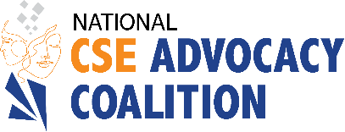

Submitted by:

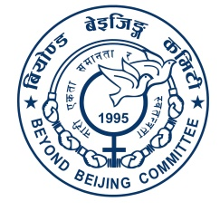

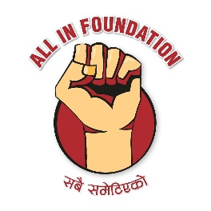
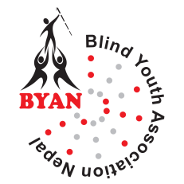

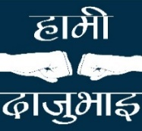
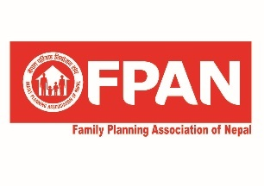
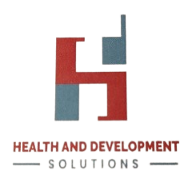
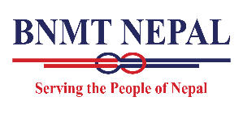


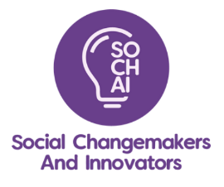
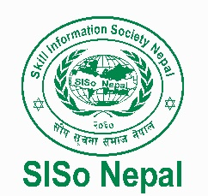
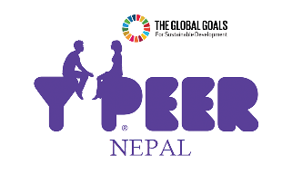

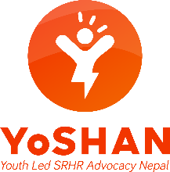
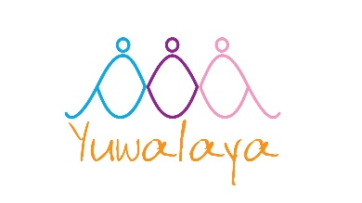
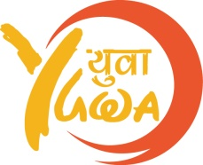

- National CSE Advocacy Coalition
- Visible Impact
- All in Foundation
- Beyond Beijing Committee
- Blind Youth Association Nepal
- Blue Diamond Society (BDS)
- BNMT Nepal
- Family Planning Association of Nepal (FPAN)
- Hami Daju bhai
- Health and Development Solution
- Right Here Right Now (RHRN)
- SISO Nepal
- Social Changemakers and Innovators (SOCHAI)
- Youth Led SRHR Advocacy Nepal (YoShan)
- YPeer Nepal
- YUWA
- Yuwalaya

Introduction

This shadow report is a joint submission of seventeen Civil Society Organizations (CSOs) and networks of Nepal, who came together to underscore the unique challenges and issues faced by diverse women of Nepal in securing their human rights to health under Article 12, in preparation for the 7th periodic review of Nepal on CEDAW. This submission is coordinated by the National Comprehensive Sexuality Education (CSE) Advocacy Coalition, which is a network of organizations advocating and working specifically to ensure CSE adoption, but work on a wide range of issues related to Sexual and Reproductive Health and Rights (SRHR); and by Visible Impact, a young-women-led organization that is the Chair of the Coalition. By presenting this shadow report, we as CSOs, commit to contributing to a transparent and accountable review process.

The Article 12 of CEDAW specifies that State Parties shall take all appropriate measures to eliminate discrimination against women in the field of health care. However, the disparities in accessing health care, especially in realizing the sexual and reproductive health and rights remains significant, and hence warrants a special attention in the CEDAW process.

Developed through an inclusive and consultative process, the report reflects the collective voice of national and grassroots organizations, advocacy groups, community-based networks and individual experts. The report has identified four pressing issues where critical gaps exist, and seeks to provide constructive recommendations to strengthen CEDAW’s implementation in Nepal.

Critical issues of concern

The CEDAW itself, and the Concluding Observation of Nepal in 2018 recommended Nepal Government to take significant steps in ensuring SRHR, including in issues of CSE, safe abortion, menstruation, and the overall realization of SRHR of women and girls. The interplay of legal inadequacies and societal stigma continues to endanger women's sexual and reproductive health rights in Nepal. Nepal's Constitution (2015) and Safe Motherhood and Reproductive Health Rights Act (2018) demonstrate commitments to ensuring sexual and reproductive health rights.

However, their implementation is weak, leaving vulnerable women and girls underserved. Due to lack of focused efforts coupled with geographical barriers, discriminatory attitudes and social norms, stigma in healthcare, inadequate infrastructure, lack of trained personnel, these progressive policies fail to address the needs of the most disadvantaged populations. In the next section, this report highlights critical issues of concern and provides CSO’s recommendations and demands.

1. Comprehensive Sexuality Education

Issues of Concern
- The Concluding Observation on CEDAW’s 6th periodic review of Nepal recommended Nepal to “Incorporate age-appropriate and gender-sensitive comprehensive sexuality education curricula that include information on sexual and reproductive health and rights..” Despite persistent advocacy efforts made by stakeholders, Comprehensive Sexuality Education (CSE) is still an optional subject for grade 9 and 10, where most of the curriculum is covered.
- A comprehensive national CSE Strategic Plan is not formulated yet, which could guide for an effective implementation of CSE at schools and community.
- Recruiting CSE teachers from non-health backgrounds limits their capacity, hindering effective delivery and accountability. The state must strengthen teacher training and allocate sufficient resources for CSE.
- Adolescent girls continue to face violence in the form of child marriage, dowries, witchcraft accusations, trafficking and sex selection. Sexual and Reproductive Health related indicators are worse for these groups. For instance, there is a 30.9% unmet need for family planning among girls aged 15-19 years, early marriage (37% before 18, 10% before 15 years), and a 3.86% HIV infection rate among 15-24-year-olds. Moreover, schools are preferred sources of health information over phones, hotlines, the internet, or religious leader. These highlight the urgent need for age-appropriate, accurate comprehensive sexuality education for both in-school and out-of-school youth.
- The LBT+ community, people with disabilities, and marginalized groups based on caste and ethnicity, also endure stigma and discrimination, undermining their rights and well-being. These challenges highlight the lack of an inclusive education system in Nepal and the persistence of stereotypes in the current CSE curriculum,
- Multi-sectoral coordination and political commitment for the incorporation and implementation of CSE in schools, out of schools, and communities are not adequate.

Recommendations
- Incorporate an age-appropriate, gender transformative, adolescent-responsive and inclusive CSE as a compulsory subject at every grade.
- Develop a CSE National Strategic Plan which guides the incorporation of evidence-based compulsory CSE curriculum, targeting adolescents and including marginalized groups.
- Strengthen educational capacity with recruitment of qualified health or social studies educators, comprehensive teacher training, standardized materials, and support systems to improve CSE delivery in schools and communities. Develop and promote accessible IEC/teaching materials tailored to children and young people with disabilities to ensure inclusive CSE access.
- Encourage the men and boys engagement in advocacy efforts for promoting importance of CSE and SRHR and empowering marginalized young girls and women.
- Promote multisectoral collaboration, local ownership, and accountability through sensitization programs for policymakers, local authorities, and teachers.

2. Safe abortion

Issues of Concern
- The restrictive abortion laws in place pose risks of legal prosecution and imprisonment for women and service providers, leading to the denial of safe abortion services even under legal conditions. Additionally, the Safe Motherhood and Reproductive Health Rights Act (SMRHR) prohibits abortion beyond 28 weeks, even to save a woman's life. The Concluding Observation of CEDAW in 2018 recommended Nepal to amend the SMRHR Act to fully decriminalize abortion in all cases. Despite this, the government has not taken concrete steps to reform the Act to fully decriminalize abortion or to remove abortion-related provisions from the National Criminal Code.
- Despite significant efforts to expand access to legal and safe abortion services, many women—particularly those who are low-income, socially marginalized, or geographically isolated—continue to face barriers to access. Denial of legal abortion care remains prevalent, with women often being refused services even when they are within the legal timeframe for abortion on request or meet the criteria for legal abortion beyond that limit.²
- Knowledge on, access to and use of safe abortion services remains limited, leading to non-legal and often less safe abortion service uptake.,
- Abortion is available at public facilities at no cost and by trained private providers. Yet, over half of abortions are provided outside this legal system.
- Son preference in Nepal, deeply embedded in societal gender discrimination, is perpetuated by religious beliefs that assign greater value to men than women, as well as by inheritance and land rights laws that disproportionately favor men. Furthermore, the dowry system places substantial economic strain on families with daughters. Consequently, despite the existence of laws prohibiting sex-selective abortion, their implementation remains largely ineffective.
- In line with the recommendation of the World Health Organization’s Abortion Clinical Guidelines, the Safe Abortion Service Program Management Guideline, 2021 has provisions related to expanding safe abortion services through self-managed abortion and telemedicine, however, there is generic reluctance on the part of the government to implement these provisions.
Recommendations
- Decriminalize abortion at all cases by amending SMRHR Act and repealing provision of abortion from Penal Code including removing punitive measures against women and alignment of the SMRHR Act with the Penal Code.
- Improve the capacity of local and provincial government in implementing abortion programs and ensuring the health facilities both public and private's readiness in providing Safe Abortion Services (SAS). Ensure extensive focus on increasing the number of trained healthcare providers, capacitating them in providing accessible and inclusive sexual and reproductive health services, and increasing well-equipped service centers, particularly in areas where access to SAS is currently limited.
- Empower women, particularly those experiencing intersecting vulnerabilities such as poverty or young age, along with their families and communities, by providing information and resources through initiatives like value clarification and attitude transformation programs, and integrating age-appropriate safe abortion content into comprehensive sexuality education (CSE) to enable women to seek abortion care earlier and access their desired services promptly, reducing the need for multiple facility visits or resorting to unsafe abortion practices.
- Medical Abortion (MA) self-care has been highlighted by Reproductive, Maternal, Neonatal and Child Health (RMNCH) guideline 2020 as well as SAS program implementation guideline 2021, therefore, planning effective modes of delivery for expansion of MA self-care is recommended at all tiers of government with standard guidelines.
- Amendment of the existing language used in the SMRHR Act which uses terms like ‘mother’ into ‘pregnant person’, alongside acknowledgement that pregnancy is not exclusive to women as transmasculine and gender-diverse individuals who were assigned female at birth or intersex people could also get pregnant.

3. Menstruation

Issues of concern
- Despite criminalization, menstruation stigma is a widespread issue in Nepal wherein socio-cultural taboos have led to extreme menstrual beliefs, practices, and restrictions for menstruating individuals. During their periods, over 89% of these Nepalese women and girls experience some form of limitations and isolation. In addition to being prohibited from entering kitchens, temples, workplaces, religious and significant ceremonies, and many other places, women and girls are also prohibited from having physical contact with their husbands and/or male relatives. Stigma, discriminatory and regressive practices to menstruating individuals due to existent religious, sociocultural beliefs and prejudiced gender norms. In Nepal, women and girls who are menstruating are sequestered in inadequately ventilated menstrual huts for the duration of their menstrual cycle as part of an extreme century-old Hindu ritual known as "Chhapuadi." These menstrual huts have been objected to as filthy and dangerous, devoid of basic human needs, and vulnerable to danger, wildlife, and fatalities. In Nepal, about 60% of women and girls continue to observe the Chhaupadi tradition and/or other forms of isolation and restriction.
- Despite its critical importance, there is no comprehensive national policy dedicated to ensuring dignified menstruation for all.
- While the State provides free sanitary pads in public schools, reports of those pads being sub-standard have been reported nationwide.
- There is a dire need for accessible and inclusive (gender and disability friendly) MHM-friendly WASH facilities and quality menstrual hygiene products in public spaces. Period poverty in Nepal forces girls to miss school, face stigma, and compromise their health and dignity, limiting educational opportunities and overall well-being.
- Effective implementation and monitoring of multi-sectoral coordination for MHM remain weak. Nepal's School Sector Development Plan (2016-2023) aims to improve girls' attendance by addressing MHM needs, but lacks guidelines and monitoring for quality, accessibility, and availability.
- There is a significant lack of up-to-date data and research to identify current gaps in menstrual health. Additionally, the 16th Five-Year Plan includes only two indicators—access to menstrual hygiene products, clean toilet facilities, and tracking absenteeism—failing to address the broader aspects of dignified menstruation.

Recommendations
- The State must enforce ban on all forms of menstrual discrimination, backed up by a comprehensive national policy on dignified menstruation. Alongside legal measures, efforts should focus on strengthening the capacity of local law enforcement agencies, conducting awareness campaigns to reduce harmful stereotypes and bolstering community participation.
- The State must ensure that the quality of menstrual products that are manufactured, imported or distributed in Nepal meet the standards, and the quality of the sanitary pads freely distributed in schools are monitored.
- The State should invest in accessible, inclusive Menstrual Health Management (MHM)-friendly Water, Sanitation and Hygiene (WASH) facilities and ensure the availability of quality menstrual hygiene products in public spaces to combat period poverty. Enhance the capacity of service providers to deliver inclusive SRH services. Integrate menstrual health education into school curricula to capacitate teachers and students.
- The State should encourage a joint review and monitoring mechanism for effective and dignified menstruation, ensured through a multi-sectoral integrated approach.
- Conduct comprehensive research and data collection to identify gaps and challenges in menstrual health, ensuring evidence-based planning and interventions. Expand the indicators in the 16th Five-Year Plan to include broader aspects of dignified menstruation, such as discriminatory practices, awareness levels, inclusivity in services, WASH facilities in school, period poverty, etc.

Access to SRHR

Issues of Concern
- Nepal's health system struggles to provide basic services, with only 1.94 health workers per 1,000 people (2020), far below the 4.45 per 1,000 recommended by the Global Strategy on Human Resources for Health: Workforce 2030 to achieve the SDGs. Consequently, women in rural areas lack access to safe motherhood services, often being forced to give birth in unhygienic conditions., Every day, two women die during childbirth, and four die due to cervical cancer.
- Despite the recommendations from CRC Committees to adopt a sexual and reproductive health policy, the State is yet to take sufficient action, perpetuating critical gaps in education and health services.
- Nepal's Government has developed guidelines for adolescent-friendly and disability-friendly SRHR services, but orientation at local and provincial levels remains inadequate, leading to weak implementation. Despite constitutional provisions against discrimination, marginalized groups such as adolescent girls, rural women, indigenous women, LBT individuals, continue to face significant barriers to accessing these essential services.
- Climate-related events in Nepal, including floods, landslides, and earthquakes, disrupt health services, damage facilities, and limit women’s access to SRHR, exacerbating inequalities, hindering access to basic health services like contraception and maternal health services, and increasing gender-based violence. Women in climate-vulnerable areas, due to increased workload and inadequate care, have reported miscarriages and uterine prolapse.
- Institutional barriers persist in public workplaces, with inadequate breastfeeding spaces, sanitary facilities, and women-friendly environments. The infrastructure in health care centers are not able to preserve the privacy and dignity of women.
- Though the issue of infertility has been rising, the legal provisions for artificial reproduction and surrogacy are not clearly established.
- LBT women's unique needs in healthcare are not fulfilled due to inadequate sensitization among health care providers. Despite allowing same-sex marriage registration, adoption and surrogacy remain inaccessible for this group.

Recommendations
- Deploy dedicated human resources for reproductive, maternal, newborn, and adolescent health to ensure the availability of essential services in rural and remote areas,
- Expedite the adoption of a comprehensive sexual and reproductive health (SRH) policy in line with CRC Committee recommendations.
- The state should strengthen orientation and capacity-building programs at local and provincial levels to ensure effective implementation of adolescent-friendly and disability-friendly SRHR guidelines. Additionally, targeted interventions should address barriers faced by marginalized groups, including adolescent girls, rural women, indigenous women, and LBT individuals, to ensure equitable access to essential services.
- Develop climate-resilient SRHR services, by strengthening emergency response protocols, establishing mobile health units, ensuring continuous supply chains, etc. Enhance a comprehensive emergency preparedness system through strengthened coordination mechanism. Implement targeted programs to address the unique health and safety needs of women in climate-vulnerable regions.
- The state should address institutional barriers by mandating women-friendly facilities in public spaces such as breastfeeding spaces in workplaces, sanitary facilities in schools, upgraded infrastructures in health care centers.
- Formulate a clear regulatory provision for artificial reproduction and surrogacy services as part of healthcare.
- The State should integrate LBT friendly healthcare services, including ensuring equal access to adoption and surrogacy for same-sex couples and transwomen.

The Report’s Drafting Committee:
Aakriti Maharjan, Visible Impact
Medha Sharma, Visible Impact
Mona Giri, Independent Expert
Narayani Tripathi, Independent Expert
Neha Malla, SOCHAI
Ojaswini Shah, YUWA
Shilpa Lamichhane, Visible Impact

For further information, please contact:

Visible Impact
611 Shrijanshil Marga, Basundhara
Kathmandu-3, Nepal
mail.visim@gmail.com

Committee on the Elimination of Discrimination against Women. (2018). Concluding observations on the combined sixth periodic report of Nepal (CEDAW/C/NPL/CO/6, para. 39(a))
Aryal B, Adhikari A, Pokhrel R. (2023). Comprehensive Sexuality Education for Addressing Young People’s SRHR Status in Nepal. Interdisciplinary Research in Education, 8(2), 97-102.
Ministry of Health and Population Nepal, New ERA, ICF. (2022). Nepal Demographic and Health Survey.
Plan International (nd) Ending Child, Early and Forced Marriage in Nepal. https://plan-international.org/nepal/what-we-do/ending-child-early-forced-marriage-nepal/. Accessed on 5 Jan 2025.
National Centre for AIDS and STD Control (NCASC). (2022). National HIV fact sheet 2022.
Teijlingen VE, Simkhada P, Acharya DR. (2012). Sexual and Reproductive Health Status and Health Service Utilization of Adolescents in Four Districts in Nepal. Ministry of Health and Population Nepal.
Government of Nepal. (2018). The Right to Safe Motherhood and Reproductive Health Act. https://reproductiverights.org/sites/default/files/2020-01/Safe%20Motherhood%20and%20Reproductive%20Health%20Rights%20Act%20in%20English.pdf.
Committee on the Elimination of Discrimination against Women. (2018). Concluding observations on the combined sixth periodic report of Nepal (CEDAW/C/NPL/CO/6, para. 39(b))
Ipas Nepal (2024). Barriers to Abortion among Women and Girls in Selected Districts of Nepal. https://nepal.ipas.org/barriers-to-abortion-among-women-and-girls-in-selected-districts-of-nepal/
Puri M, Singh S, Sundaram A, et. al. (2016). Abortion Incidence and Unintended Pregnancy in Nepal. International Perspectives on Sexual and Reproductive Health, 42(4), 197–209. https://doi.org/10.1363/42e2116
Puri MC, Raifman S, Daniel S, et. al (2023). Denial of legal abortion in Nepal. PLOS ONE, 18(3), e0282886. https://doi.org/10.1371/journal.pone.0282886
Wu WJ, Maru S, Regmi K, et. al. (2017). Abortion Care in Nepal, 15 Years after Legalization. Health and Human Rights, 19(1), 221–230. https://www.ncbi.nlm.nih.gov/pmc/articles/PMC5473051/
World Health Organization (2022) Abortion care guideline. https://www.who.int/publications/i/item/9789240039483
Amatya P, Ghimire S, Callahan KE, et. al. (2018) (Chhaupadi) among adolescent girls in far-western Nepal. PLoS ONE; 13(12).
Ghimire B. (2020) Education Minister Launches Sanitary Product without preparation. The Kathmandu Post. https://kathmandupost.com/national/2020/01/01/education-minister-launches-sanitary-pad-distribution-without-preparation. Accessed on 3 Jan 2025
My Republica. (2024) Education ministry to revise procedure on distribution of sanitary pads. https://myrepublica.nagariknetwork.com/news/education-ministry-to-revise-procedure-on-distribution-of-sanitary-pads. Accessed on 2 Jan 2025
Dhakal SB, Sah N, Shrestha S, et. al. (2016). Analysis of menstrual hygiene practices in Nepal: the role of WASH in Schools programme for girls education (Nepal). UNICEF.
Wateraid (2018). Menstruation Hygiene Management in schools in South Asia. UNICEF. https://washmatters.wateraid.org/sites/g/files/jkxoof256/files/menstrual-hygiene-management-snapshot---nepal.pdf
Singh, P. (2023). Bajura mothers delivering babies on remote roads due to lack of access to maternal health services. Retrieved from https://thehimalayantimes.com/nepal/bajura-mothers-delivering-babies-on-remote-roads-due-to-lack-of-access-to-maternal-health-services (Accessed on 6 Jan 2025)
Nepal Times (2022). Born by the roadside in Nepal. Retrieved from https://nepalitimes.com/here-now/born-by-the-roadside-in-nepal (Accessed on 6 Jan 2025)
MoHP, NSO. (2022). National Population and Housing Census 2021: Nepal Maternal Mortality Study 2021. Ministry of Health and Population; National Statistics Office. Retrieved from https://mohp.gov.np/uploads/Resources/Final%20Report-26%20March-%202023-UPDATED.pdf
International Agency for Research on Cancer. Global Cancer Observatory: Nepal Fact Sheet. Lyon: International Agency for Research on Cancer; (2022). Retrieved from https://gco.iarc.who.int/media/globocan/factsheets/populations/524-nepal-fact-sheet.pdf
Committee on the Rights of the Child. (2016). Concluding observations on the combined third to fifth periodic reports of Nepal (CRC/C/NPL/CO/3-5, para. 54).
WOREC (2024). Impact of Disaster on Women’s Sexual and Reproductive Health Rights. https://www.worecnepal.org/publications/191/2024-11-22
Richardson S. (2024). Climate change and its silent impact on sexual and reproductive health in Nepal. Ipas. https://www.ipas.org/news/climate-change-and-its-silent-impact-on-sexual-and-reproductive-health-in-nepal/
GIZ (2020). SRMNAH Workforce Planning and Deployment in Nepal with focus on midwives: A Report. Retrieved from https://www.giz.de/en/downloads/SRMNAH_Workforce_planning_14.pdf
UNFPA (2021). Building a health workforce to meet the needs of women, newborns and adolescents everywhere. Retrieved from https://www.unfpa.org/sowmy (Accessed 6 Jan 2025)

