Discrimination against women from the rural localities
in the Republic of Moldova

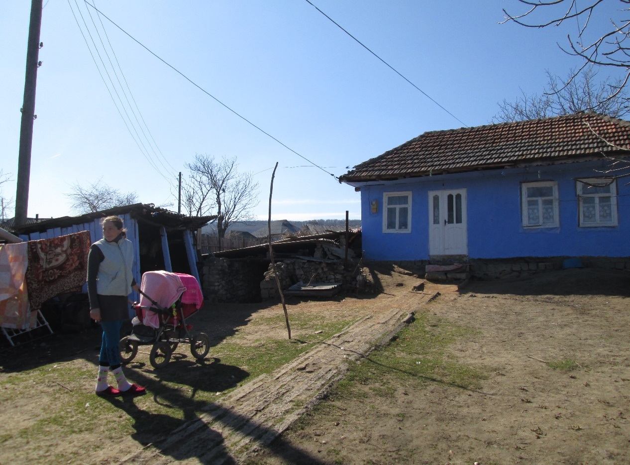

Alternative report on the implementation by the Republic of Moldova of the UN Convention on the Elimination of all Forms of Discrimination against Women in the Republic of Moldova

Submission prepared by PA ”Concordia. Proiecte sociale” NGO for the 75 Pre-session Working Group of the Committee on the Elimination of Discrimination against Women

June, 2019

Contents:

1. Executive Summary 3

2. Introduction 4

3. Background on Moldova and Applicable Provisions of CEDAW 4

4. Key areas of concern in relation to the respect of rights of rural women 6

- Executive Summary
The current report is focused on presenting the main areas of concerns related to the implementation of the UN CEDAW and, mainly, with the regards to the respect of rights of women from the rural area.

In the Republic of Moldova (RM), women in rural areas constitute nearly 30% of the total population of the country and 51% of the resident population in rural areas, but economic and social factors cause them to be vulnerable members of society. Amongst the main issues faced by the women from rural areas, that deepen their vulnerability are: limited access to education and employment opportunities; low quality medical services; also, women from rural areas are more vulnerable to poverty.

Limited access to education and employment opportunities. Lack of education, vocational skills and employment opportunities on labour market impose the rural woman to become a houseworker or to go abroad for employment purposes and settle in families abroad for household work, to take care of the elderly or the sick.

About 46.4% from active women in rural localities graduated higher educational institutions, have a professional or secondary professional background, but this percentage decrease annually. Consequently, 34.5% of women from rural localities have not completed the primary education cycle.

In rural areas, there are no educational institutions that could deliver lifelong learning trainings, vocational education or re-profiling trainings for different specialities.

However, this fact does not relate to the reduced percentage of rural young women to study, but is dictated by the subsequent opportunities to apply their knowledge in the locality where they come from (birthplace).

Out of 10 women that have an occupation in rural areas, 5 women work in agriculture and 5 are employed, receive a salary and interact with the community.

Mainly women are engaged in subsistence farming, which is the main source of food and income in many rural communities. In fact, a considerable number of self-employed women in rural areas are predominantly focused on producing food for their own consumption in household conditions.

Limited access to quality health services. Despite the reform of the health system, the quality and accessibility of medical services did not improve. The main causes of the low quality of medical services are: lack of medical staff/lack of a doctor at the rural level; lack of access to the primary medical services in the locality; lack of local infrastructure investments in hospitals indicates certain inequalities for residents of different regions to receive primary health care in time; lack of financial resources of women to purchase medical services and medicines.

Young women and mothers face social inequalities in: education, health, free access to quality services, lack of preschool institutions - being affected by the impossibility of employment on the labor market and state aid to the further reconciliation of work and private/family life.

Elderly women. Women make up about 52% of the total population in Moldova. With getting on in age, the proportion of women in the total population increases. Women aged 60 years and over represent 61 percent of the population of that age, and in the case of those over 80 years old, their share in the total population percentage is of 68. Elderly women predominantly live in rural areas - 57.6%.

Elderly women that are living in rural areas face major difficulties in accessing social and medical services, utilities infrastructure, being marked by poverty and social exclusion. The problem of elderly women in the Republic of Moldova has not been fully addressed by the legislative changes in the field of social assistance and the development of geriatric and palliative services.

In its Concluding Observations for Moldova (2013) adopted in Geneva on 18 October 2013, on combined fourth and fifth Periodic Report of the Republic of Moldova with regard to the implementation of the Convention on the Elimination of All Forms of Discrimination against Women (CEDAW), the Committee reiterated its serious concern about the situation of women in rural areas, who are more vulnerable to violence and poverty and who have limited access to land, credit, health and social services and participation in decision-making processes at the community level. The recommendations issued by the Committee have not been resolved by the Republic of Moldova, and the current situation of women in rural areas has worsened.

- Introduction

The public association "CONCORDIA. Social Projects" is a non-commercial, non-governmental organization, the main purpose of which is contributing to the harmonious integration of disadvantaged people into society and promotion of their rights, by providing social services and offering methodological and knowledge sharing programmes and support.

CONCORDIA is an international organization, which was founded in 1992 by Georg Sporschill SJ, an Austrian priest. In 2004 the first social service was opened in the Republic of Moldova.

CONCORDIA Moldova currently provides social services in more than 60 localities in the Republic of Moldova for more than 5000 beneficiaries from rural areas.

The presented report is based on recent studies about the situation of women in the Republic of Moldova, as well as on the survey of 100 women in rural areas that was conducted by Concordia Moldova.

- Background on Moldova and Applicable Provisions of CEDAW

In the Republic of Moldova, poverty in rural areas is much more pronounced than in urban areas. Among women, the absolute poverty rate is 15.6% in rural areas, compared with only 4.8% among women in cities.

The main social problems affecting women in rural areas are: poor quality of medical services (57.6%) or lack of medical services (53%), poverty, associated with poor living conditions and reduced possibilities for employment.
The persistence of discriminatory attitudes towards women was confirmed by the research in the field. The stereotypes maintained in Moldovan society continue to assert that the man is the head of the family, while the woman is the one responsible for the household activities, including child care and education. The poor living conditions in villages exacerbates the situation for rural women comparing to women from urban localities.

Women in rural parts of Moldova generally hold the roles of: mother, wife, and housewife. As a result, their involvement in community activities is always limited by the lack of time.

Most problems for women in rural areas are caused by lack of jobs, lack of income, discrimination and domestic violence.

It is also particularly difficult for women from disadvantaged groups, especially women with disabilities, mothers with many children, elderly women, and representatives of certain minorities (ethnic, religious, etc.). Women from these social groups generally have a lower quality of life and less community participation than the larger population of rural women. Social stigmatization, marginalization, poverty, lack of access to many services and opportunities all exacerbate the disadvantages faced by women in these other social groups.

- Key areas of concern in relation to the respect of rights of rural women

4.1 Education and employment of women in rural areas
Women's poverty, women's employment opportunities and income generation opportunities are areas of interest in promoting equality between women and men. In the case of rural women in Moldova, the disadvantages in this aspect are visible. About 60% of all 15 years old women and elderly women living in rural areas are in a predominantly family environment because they are retired, domestic, self-employed or unemployed.

The age seems to be one of the factors that lead to the vulnerability of rural women to living standards. Still affected by poverty in rural areas are elderly women and young women aged between 25 and 44 years. Here there are obvious discrepancies in the opportunities to obtain income in the cities versus the lack of these opportunities in the villages.

Elderly women are affected by poverty due to the health issues and lack of employment that are directly dependent on the level of education of these women. 24 percent of women aged 60 from urban areas have a higher education degree, while in rural areas - only 6 percent. About 61 percent of rural elderly women have only primary or secondary education, which also determines the occupational status of these women until retirement, and finally their welfare and the possibility of providing paid services.

Age is not the criteria that must determine the opportunities for obtaining a degree in education. One of the commitments made by the Republic of Moldova by joining the Madrid International Action Plan on Aging is to promote lifelong learning regardless of age and to adapt the education system to the needs of adult education. Currently, on-going learning is not practiced by the country's population, on average only about 1% of the population aged 25-64 is engaged in lifelong learning activities, and in the EU countries this indicator is 10.7%. The elderly have not only certain knowledge accumulated during the formal education system but also life skills, an extensive professional experience which, as a whole, offers knowledge and skills that can and must be exploited by society.

Gender inequality in the occupational sector is also present among the younger population: the employment rate is about 24.3% among young women. The fact that women are specifying the longer length of studies, marriage at younger age and birth of children, explains the reasons for the smaller and more delayed entry of young women into the labor market. At the same time, although younger than men have higher educational attainment than men, they are less paid than men, even in similar conditions and occupations, more often face discrimination against employers (as a result of stereotypes and demanding family roles). The highest concentration of young people in the labor market is observed in the urban environment, while in the rural area - about 23%. This is due to the small employment opportunities in the rural environment, as well as to the massive migration of young people from the villages, either to the cities of the country or outside the country, in search of a job that would ensure a decent standard of living.

Young women in rural areas in fertile age, young mothers, are affected by the fact that they are unable to work because of the lack of pre-school institutions in the locality they work. This factor is due to the limited access to information and services of rural youth, the lack of comprehensive health education based on compulsory school curriculum and the persistence of gender stereotypes in rural communities that women have to care for children and house.

The vulnerability of rural women to their standard of living is also perceived by their level of education. In the case of women from villages, the level of living is significantly dependent on the level of education, respectively, the lower the level of education, the higher the risk of poverty, with poverty rates more than doubling for women with the lowest level of education in comparison to women with at least general education or specialized studies.

Statistical data at country level shows that women with higher education in the total number of employed women increased by almost 10 p.p. in the last ten years. These indicators suggest the existing reserves of female human capital and the need to encourage 40% women without vocational training to find opportunities and exploit their potential, especially those in rural areas where the percentage of women without secondary or vocational education is much higher than those in urban areas (62% vs. 24%).

Certain employment trends are observed according to the level of education of women. Almost 3/4 of rural women with higher education and half of those with vocational education work in public administration, education, health and social assistance. The next most popular sector is agriculture, which employs 10% of women with higher education, about 30% of those with vocational or professional education, and more than 40% of women with a secondary level of professional education.

According to recent studies, 1/5 of women with secondary education are active in trade. Only slightly more than half of rural women work as employees, compared with over 90 percent of women in cities. Other women from villages, that are considered employed - are self-employed (36.7%) or is employed as an unpaid family worker (6.4%), which generally means that they work the family land.

It is important to note that rural women are mostly engaged in agricultural activities with men, in addition to the activities and occupations that they have as employees or in the household. Applying the skills and knowledge gained remain a challenge for women in the villages.

The particularly low availability of employment opportunities for women in villages is reflected in the percentage of their employment. In this context, the employment rate among 15 year old women from rural areas is 36.2%, which is lower than the 38.6% rate for the same age group in cities.

Potential questions to be raised with the Moldovan Government

What are the measures planned by the Government of the Republic of Moldova to raise the employment rate for women in rural areas?
What are the measures undertaken by the Government of the Republic of Moldova to develop businesses in rural areas for the integration of women into work?
What are the actions planned by the Government of the Republic of Moldova to develop life learning opportunities, integration in the labor market of elderly women in rural areas?
What are the measures undertaken by the Government of the Republic of Moldova to help women to balance their professional and personal lives?

4.2 Access to women's health services in rural areas
Women in rural areas have minimal access to qualitative medical services. Official statistics indicate that access to medical services for women in rural areas is lower than access for women in cities. Women in rural areas have an average of 3.4 medical visits per month, comparing to 4.4 monthly visits for women in urban areas. At the same time, about 20% of rural women describe their health as being bad or very bad compared to only 14.5% of urban women. Such alarming data emphasizes the health issues for women from villages. These issues may be caused by unofficial employment or unpaid work in agriculture, and lack of medical insurance which is a problem of most people from rural areas.

Moreover, in most villages there is a lack of sufficient primary care services, and most of the medical services are inaccessible, or at least are less accessible than in urban areas. As expected, women in rural areas rate the availability of medical services in their localities as unsatisfactory.

About 1/3 of rural women reported limited financial access to health services, out of which 23.3% said they could not afford to pay for such services, and 10.4% said they do not have medical insurance. It is important to note that limited financial resources were reported by about 40% of women aged between 25 and 54. About 8% of women deny the availability of medical services because they do not trust doctors or they consider the services offered to be of poor quality.

Elderly women in rural areas have an increased risk of developing several diseases and are, as a result, more reliant on the medical system.

The need to allocate financial resources for prevention, early diagnosis and treatment of chronic diseases is indisputable. The health system must be able to better manage the problem of chronic diseases, and cognitive diseases among the elderly, in order to ensure the right to a healthy and independent life for as long as possible.

The existing gender imbalance for the elderly, especially regarding lifespan, exemplifies the need to develop specialized social services directed towards the specific needs of the elderly. In the context of the reform of social assistance services at the community level, one of the target groups is the elderly people, who increasingly must live alone and require home care services.

Potential questions to be raised with the Moldovan Government
What actions will the Government of the Republic of Moldova take to develop qualitative primary health services in rural areas?
What measures will the Government of the Republic of Moldova take to raise the availability and quality of social services for women from rural areas?

https://www.undp.org/content/dam/moldova/docs/Publications/01_machet-FEMEILE_rural_2018_ENG.pdf
https://www.undp.org/content/dam/moldova/docs/Publications/02_machet-FEMEILE-migrant_2018_ENG.pdf
Studiu elaborat de AO ”Concordia. Proiecte Sociale” și îndeplinit de femei din localitățile rurale din Republica Moldova
https://www.undp.org/content/dam/moldova/docs/Publications/10_machet-FEMEILE-virstnice_26-08-2016_corectat_FINAL-3.pdf
http://statistica.gov.md/public/files/Cooperare_internationala/PNUD/10_tablouri_femei_RM/prof_1_mediu_rural.pdf
http://statistica.gov.md/public/files/Cooperare_internationala/PNUD/10_tablouri_femei_RM/prof_4_economie.pdf
http://ipp.md/wp-content/uploads/2018/12/Raport_romana-1-compressed.pdf

