GRIPP Submission to CESCR PSWG
by ATD Fourth World, Intisaar, RAPAR and Thrive Teesside

January 2022

Context of this report
Growing Rights Instead of Poverty Partnership (GRIPP) is working together to end poverty across the nations and regions of the UK. We hold four central beliefs:
- We believe that Poverty is a Human Rights Violation, and that poverty and human rights need to be brought together to challenge systemic causes of injustice.
- We believe that Undocumented experience needs to be shared to expose and challenge systemic issues at the root cause.
- We believe that through bringing together lived and learnt experience of poverty and human rights, we can realise knowledge and generate the power to drive real change.
- We believe that by bringing people, groups and communities together, from across the UK, we can build a social movement for change.

This submission is written by 4 grassroots organisations, ATD Fourth World UK, Intisaar, RAPAR and Thrive Teesside who have come together through GRIPP (see Appendix 1 for more info on these groups and GRIPP membership). These four organisations have nearly 100 years of cumulative knowledge of the experience of poverty as a human rights violation. Through GRIPP, we drew together our years of research and work in communities, explored commonalities and differences, and saw how these issues related to ICESCR. During the autumn of 2022 we reviewed the UK State Party Report and then did further outreach and research within our communities to gather fresh evidence for this submission.

The wider GRIPP partners, namely Amnesty UK, Essex University Human Rights Centre (by ESRC Impact Acceleration Account and by the Centre for Public and Policy Engagement) and Just Fair, have provided us space and support to reflect on our lived experience, to generate and collate this knowledge. We have been assisted, at times, by academically located allies and policy professional allies but this work has been developed and created by us, grassroots researchers. Authorship and responsibility for this submission lies entirely with the four organisations: ATD Fourth World, Intisaar, RAPAR and Thrive Teesside.

It is important to note that the process to create this submission has been burdened with the complexities and chaos of living in poverty, as many of the lead researchers and writers continue to grapple with rights being violated on a daily basis. Yet through this process we have discovered how Human Rights is a unifying force under which we can all stand and find solidarity with each other.

Appendix 2 outlines the process we undertook to create this submission.

This report is split into sections:
- Introduction – Poverty is a violation of Human Rights; The importance of Self-Determination and Non-Discrimination
- Article 6 – Right to Work by RAPAR
- Article 9 – Right to Social Security by Thrive Teesside
- Article 10 – Right to the Protection and Assistance to the Family by ATD Fourth World UK
- Article 12 – Right to Health by Intisaar
- Conclusions – Overarching themes; Our questions for the Committee
We understand this report may be a little different to others the Committee will read. That is because we have written it as much for our communities as for the CESCR. We want our members and communities to read this report, recognise their experiences in it and see that it is part of the change we are all fighting for. Most quotations etc have been anonymised to protect victims of human rights violations; however some want their names to be known. One person in particular wanted to be named directly as they wanted to be able to point to it, to own their contribution to this report, so as to recognise their part in ending poverty in the UK.

Introduction
Poverty is a violation of Human Rights
This submission comes directly from 4 grassroots groups – ATD Fourth World UK, Intisaar, RAPAR and Thrive – and the communities we work in. We provide crucial help and assistance to those experiencing violations of the rights to non-discrimination, work, social security, an adequate standard of living, and protection and assistance of the family and health. We want the voices of the people we work with to be heard by the CESCR so that it may understand the turmoil they are going through because of this failure.

We share the belief of ICESCR (International Covenant on Economic, Social and Cultural Rights), where the Committee on Economic, Social and Cultural Rights (CESCR) has stated that “[t]he rights to work, an adequate standard of living, housing, food, health and education, which lie at the heart of the Covenant, have a direct and immediate bearing upon the eradication of poverty.” We believe that present conditions of poverty in the UK are a violation of our human rights.

Since the 2010s, austerity has weakened the UK’s social security and public service systems to a point in which they cannot work effectively to support those that need it most in society (See submission to CESCR PSWG from Just Fair). International human rights bodies and experts have denounced measures of austerity and policies proposed by UK Governments throughout the 2010s as being contrary to the realisation of ESCR under ICESCR. The Glasgow Centre for Population Health and University of Glasgow reports that an additional 335,000 deaths were observed across the UK due to the impact of austerity policies. The National Audit Office stated that funding for local authorities fell in real terms by 49.1% between 2010 and 2018.

Further to this, in May 2022, the Joseph Rowntree Foundation found that: “7 million low-income households were going without at least one essential (such as a warm home, enough food, appropriate clothing or basic toiletries) and over 2 million families were neither eating properly nor heating their home adequately,” due to impact from the Covid-19 pandemic and cost-of-living crisis.

In March 2022, the Resolution Foundation noted that a lack of action from the UK Government on the cost-of-living crisis will see 1.3 million people pushed into poverty in 2023. We, as GRIPP, believe that this failure to alleviate and pull people out of poverty is ultimately a failure of the UK Government in respecting, protecting and fulfilling its obligations under ICESCR as we show in this report.

The Importance of Self-Determination and Non-Discrimination
The first Article of ICESCR is about self-determination – deciding our own destiny. In this submission we explore how this right has been denied to the people in the communities we are part of, both as individuals and as communities of people. We understand that this is not the classic understanding of self-determination in international law, however as communities who experience marginalisation, limitation and exclusion, self-determination, or the lack thereof, is felt on a very personal and individual basis. We believe that the current system in the UK is actually working against people, particularly people seeking asylum and refugees, in accessing their right to self-determination. Displaced people who seek shelter in the UK are often doing so because of the lasting impact of colonial policies, but they cannot access work (including just and favourable conditions), an adequate standard of living, or many other rights in ICESCR.

Another issue that came up, across the diverse groups who wrote this submission, is the discrimination our communities face when trying to access their rights. The second Article of ICESCR tells us that it is the UK Government’s job to make sure people in the UK should be able to access their rights without discrimination of any kind. However, in our communities we found discrimination on the basis of race, colour, social origin, and disability. We found that these discriminations often intersected with cumulative impact. We also found that all our groups had experienced discrimination of the basis of ‘povertyism’. We were happy to see that the current UN Special Rapporteur on Extreme Poverty has picked up on the issue of povertyism – this is a form of discrimination our communities have discussed, and experienced, for many years.

Article 6 – Right to Work by RAPAR
RAPAR (Refugee Asylum Participatory Action Research) brings together those with migrant experiences, practitioners academics in Manchester and the surrounding areas. Though initiator of the StatusNow4All campaign and deeply embedded in work about the rights of those with No Recourse to Public Funds, for this submission RAPAR focused on the Right to Work.

Article 6 defines the right to work as: you have the right to work, to be free to choose your work, and to defend your rights at work. Governments must help people who do not find such work including with education and training.

Right now, most displaced people in the UK are banned from working (Asylum seekers: the permission to work policy) and forced to live in poverty. Instead of allowing displaced people to support themselves by working, they are forced to waste their skills and talents. We argue that all people who are displaced should have the right to work, to be free to choose their work, and to defend their rights at work. Governments must help people who do not find such work by providing education and training.

The work ban is harmful to everyone. It takes the harshest toll on displaced people, but also the UK economy misses out on tax revenue and much-needed skills by leaving people frozen out of work. (End the counter-productive and costly 'work ban' on people seeking asylum)

Moreover, in Article 2 of ICESCR states:” Developing countries, with due regard to human rights and their national economy, may determine to what extent they would guarantee the economic rights recognized in the present Covenant to non-nationals.” The UK is not a developing country thus it does not have the right to limit rights of non-nationals. Doing so is a direct violation of Article 2. (Duties of States towards refugees and migrants under the International Covenant on Economic, Social and Cultural Rights)

Displaced people here have told us:

“If we are allowed to work, it would ease our life”
“It should be a right to work, it would help with our mental health and wellbeing. Just waiting on the government to support us is degrading”
“With the high cost of living now, even if you are allowed to work the job that is offered is minimum wage and this wouldn’t be enough to live by this is not only affecting refugees but others as well. So how come the government expect the financial support of £40 per week would be sufficient for people seeking asylum?”

The UK government is not fulfilling the commitment outlined in Article 6- Right to work by effectively banning most displaced people from working. The policy was changed in 2002 and has remained the same. This has a huge impact on the mental health and wellbeing of displaced people, many of whom, must rely on the government assistance of £40 per week to cover their essentials. We are aware of CESCR’s 2017 statement on rights of migrants and refugees under ICESCR where the Committee make similar points. (para 8, 13 & 15 https://tbinternet.ohchr.org/_layouts/15/treatybodyexternal/Download.aspx?symbolno=E%2FC.12%2F2017%2F1&Lang=en)

For perspective, below is a breakdown of where that weekly assistance could be spent by a single person seeking asylum and living in Manchester
- Bus/ travel card£ 18.50 per week and
- £21.50 left for food, toiletries, sanitary products (if needed), clothing and, and incidentals

The financial support from government is not enough to even cover basic needs. If we add access to the internet, which is important to access health care and legal aid online, then it may become a sacrifice between having access to the internet or food to eat. In hindsight, this might be easy to decide, however, when you must choose between life essentials, it becomes difficult.

Displaced people here have told us:

“We get £40 per week but we always must decide on what to spend. This leads to stress, depression and our health getting worse. Once you are not healthy and are on medication it is gets hard. I feel the government is doing this intentionally. Not allowing us to work, be dependent on the government and keep us in poverty”
“I used to buy bread for £.16pence in the past and now the same bread is £0.35pence, this shows that the cost is rising however we are still getting the same amount of £40 per/week and expected to survive. How can this be?”
“When we are allowed to work after waiting for 1year for our claim to be processed, the job that we can apply is only short occupation however our education, experience and skills are not recognised here so finding the right job is difficult and this means we don’t have a real choice at all”
“I work as a minimum wage for 16hrs, I would like to work more hrs and fully support myself however the more hour I work, I must pay more tax, and this ends up me not having enough money at the end of the month even though I work long hours. The system is designed to make us poor and make us lazy and more dependent”

“Currently, with the cost-of-living crises, I feel like we are all in a Titanic ship. Refuges, people seeking asylum and people with minimum wage are all at the bottom. With this inflation, we are drowning every day. The once on the top they don’t feel it as much as we do, just like the movie they would be given a life saver and we are being condone by the system to stay in poverty”
“Government brings skilled workers from outside of the country by spending millions of pounds in recruitment and processing fee. This doesn’t make any sense as talented and skilled people are already in the country however frozen out of work due to their immigration’s status”

The consequence of not being able to work whilst waiting for your claim to be processed has a bigger impact once you are granted leave to remain. Newly granted refugees are facing higher unemployment due to lack of
UK work experience, gap in the CV and experience and skills not being recognized. This could easily be rectified by allowing all displaced people to work.

Displaced people here have told us:

“We are not only deprived of financial independent whilst waiting for our asylum claim to be processed but we must wait a long time thus we are losing our energy, our hope, and a chance to make our life better. I waited for 18 years for my claim to be processed and for me to be granted leave to remain, now I worry that I would not get a job and be useful. This is depressing”

Article 9 – Right to Social Security by Thrive Teesside
Thrive Teesside, based in the North East of England, advocates for the voice of lived experience in decision-making processes.

“It is important to appreciate and reflect upon the thoughts and comments of people who are suffering due to rising levels of poverty and widening gaps of inequality. The reasons why so many in our forgotten communities are living in challenging circumstances and unable to realise their potential is not a personal choice, nor bad decision making on their part, it is the direct consequence of the system they were born into… it is the ill-informed policies, the lack of funding, support, and investment in people. We can feed the poor, give warmth and shelter in crisis, but we do not enable them to crawl or lift themselves out of poverty. We alleviate the symptom, but the system will make sure they do not advance. It is not the poor people who are at fault but the control of the system by the hierarchy that will make sure that they cannot leave their social standing. Our lives are like flow charts, and if you do not fit the criteria you are lost amongst the multitude of others left by the wayside. Then it is do as I say, or you will receive nothing”
- K. Carter, Thriving Teesside

In Teesside the effects of deindustrialisation and the economic policies of the 1980s left the area extraordinarily vulnerable at the start of the 21st century, and the area would be further devastated by austerity measures introduced in response to the 2008 global financial crisis. Austerity measures reduced local authority budgets across the UK, including Teesside, by 30% between 2008 and 2015 and led to the shuttering of many public services (See NCL submission to Philip Alston Sep2018 final.pdf for more info).
Simultaneously, welfare reform measures most severely impacted the poorest areas in the country (where a higher proportion of the population was in receipt of support), many of which were former industrial communities including those in Teesside. Indeed, the worst-hit local authority areas – mainly located in the North (e.g. Middlesbrough) - lost around four times as much, per adult of working age, as the authorities least affected by the cuts – found exclusively in the South and East of England (e.g. Hart, Hampshire).

Having ratified ICESCR, the UK Government the Right to Social Security means that everyone has the right to social security and the government must make sure there is a social security system in place that provides money or other support to help people who need it.

Universal Credit – a payment to help with living costs, it was introduced in 2013 onwards with the expressed aim to be administratively simple replacing a number of existing benefits. Eligibility criteria not only includes people who are out of work or are unable to work due to health conditions but also for people who may be working and on a low income. However, the reality for recipients has been the very opposite of simple and fair. However, the reality for recipients has been the very opposite of simple and fair.

“We were told that this was a better deal – making us financially more secure and lifting our children out of poverty, getting us used to monthly income to mirror receiving wages and encouraging us take more responsibility. This is supposed to be helpful if we work part time and we will have a seamless source of income when our hours fluctuate. I can assure you this is not the reality. The experience of being on Universal Credit doesn’t even come close to the stated desired outcomes. I have lost count of the times I have been without this entitlement. My hours have ebbed and flowed, short term contracts have played havoc with my income, and I have been left without money for weeks. This has not helped me and my family. We have had to rely on family support, go cap in hand to foodbanks and not put on our heating. I have been dependent on Universal Credit advance payments then had no control over the deductions taken out of my Universal Credit which has meant more tightening of my family budget. How is this helpful?”
- T. Lawson, Thrive

“Administratively simple – what does that mean? I am one of the millions who fear technology and are not digitally connected. I am not tech savvy and get quite anxious when the time comes to try and log on to my Universal Credit account. My only contact with my work coach is via my online account, any updates or information regarding my entitlement is online. If I do not comply in this way, I am at threat of breaching my claimant commitment and hence can be sanctioned. This is inhumane, excludes me from accessing other support, does not consider my needs and reinforces power hierarchies”
- M. Cotterill Thrive

The overall provision of welfare and social security is woefully inadequate and is insufficient to cover basic needs
“I work my entire life away
Barely making enough to live on
Drop into bed at 11.00 up again at 7.00am
Swear I’ll drop dead at 50
From exhaustion, starvation or
The consequences of knife crime
Nowt gets better
Nowt”
- Thriving Women

“Rose again on inflamed feet,
First low paid job of three
Working for the care of others young and old
Feeds kids to provide for her own
Tends to the elderly, smiles and offers
Some company in the days that are long
Never getting real opportunities
Yet she wants them
She breaks down in faceless offices
The wary guard alert to her anxiety
The office staff lacking sympathy
Adding to the misery she is in
No stability,
So the only thing of certainty is debt
And the circle of relentless trying is tiring
Enough to shadow her perseverance
And her thoughts
She is locked in poverty
She keeps going
Feeling punished by a system
That shows no empathy
It takes its toll”
- Thriving Women

We are battered even more with unacceptable deductions from our insufficient benefit entitlement

We are currently facing a cost-of-living crisis – this is not new to the community we work alongside; it merely exacerbates ongoing difficulties and challenges. Low wages, access to support, meagre benefit entitlements and debt deductions from benefit entitlements are unfortunately par for the course in our low income, left behind communities.

Third party deduction schemes are informed by specific policy guidelines and ‘can only be made when it is considered to be in the interest of the customer or the customers family and can only be used when all other avenues of recovery have been exhausted

Despite debt deductions from benefits in Teesside are extremely high with an average of £63 per month being deducted from between 54% and 60% of Universal Credit claimants (statistics given by our local MP). To put this into context, if people were already struggling to survive or just get by on a very limited budget, how are they then supposed to manage on a reduced budget? This does not evidence a fair and just social security system that supports people in need.

“As I look at the money in my hand
It shrinks with every passing day
The dole and the politicians do not
Understand, so I will sit here and
Slowly fade away”
- Thriving Teesside

“It is hard not to focus on money
When you have none
But everyone still wants their share
I worked in a house where money was so spare
It filled gravy jugs on the top shelves
Piled unheeded in bank accounts.
When it came to pay day,
Coins counted in palm
Soon left my hands to keep
Roof, heat, light for another week
Never any spare
Scraped penny pots for food shops
It’s hard not to be angry
When zero hours contracts
Pittance paying apprenticeships
Pay day loans and foodbanks
Are seen as solutions
By whose only money issue
Is how to squeeze it out of others”
- S.Crutwell, Thriving Teesside

Article 10 – Right to protection and assistance to the family by ATD Fourth World UK
ATD Fourth World UK brings over 50 years of experience tackling inequalities at the grassroots using a human rights-based approach. For this section of the submission, ATD brought together a group of parents, children and young people and professionals to explore issues relating to the Right to protection and assistance to the family in the UK. (See submissions to CESCR PSWG from ATD and Human Rights Local, and from the End Child Poverty Coalition).

Across the country, we are deeply concerned that families in poverty are all too often subjected by children's social care to harsh and disproportionate interventions that are discriminatory and driven by a concept of risk-aversion that is inconsistent and that fails to sufficiently consider the harm done by removing children into state care or contested closed adoptions. This harm includes insufficient regulations for the accommodation of 16 to 18-year-olds in care, which makes them vulnerable to grooming and trafficking. (See submission to CESCR PSWG from ATD Fourth World UK) We are also concerned that focusing only on “child poverty”, as though children were not impacted by their parents' poverty, may create an incentive for removing children from parents in poverty, and thus from the statistics on child poverty. Children's social care is increasingly being used as part of a punitive welfare state linked to benefit sanctions, poor inadequate housing, and harsh responses to families living in deprived areas.

Families in poverty go through painful separations more often than others, with poverty becoming the “wallpaper of practice” for social workers “being too big to tackle and too familiar to notice”. In 2021, Isabelle Trowler, the Chief Social Worker, stated: “Too many children are wrongly being taken into care”. In 2018, Morris, Bywaters and others stated that “income inequality, income deprivation, ethnic density and higher education were able to explain around 75% of the variance in English and Welsh state care rates”. In 2020, the Child Welfare Inequalities Project analysed data on over 35,000 children in the care system as a looked-after child or on a child protection plan. They reported that “[c]hildren who live in the most deprived 10% of neighbourhoods [are] ten times more likely to be looked after or on a child protection plan than children in the least deprived 10% of areas”.

The parents and children involved in the ATD Fourth World research wish to highlight three specific issues:
- Contested closed adoptions
- Discrimination and Povertyism
- Accommodation for 16 to 18-year-olds in care

About contested closed adoptions, Taliah Drayak, a parent in Scotland says:

“You get railroaded because the only direction of travel is their parallel planning for adoption from day one. They say that will 'set up permanency' for the child; and once the child has been removed into care, they use the separation against the parents, saying that the child has already adjusted to the separation. There's so much unacknowledged trauma. And the children removed from their parents are now deemed less capable of becoming good parents themselves one day, setting up the next generation of adoption.”

In presenting evidence to United Nations Special Rapporteur Philip Alston in 2018, a member of ATD Fourth World said:

“Once you’ve had your children taken off you, people vilify you. That’s why having your children removed by the state is even worse than being raped, something that I’ve also gone through […] When you’re in poverty, and when you grew up in care yourself, you’re eventually dumped out of the system and no one supports you to become a good parent. […] Children removed from their parents’ care have their trust betrayed again and again. Their siblings become anxious and afraid to cuddle. In care, children can be completely neglected and feel like they had to drag themselves up without help. […] Parents in poverty are often manipulated into signing away parental rights. In closed adoptions, your children’s siblings’ rights are violated because they will never again be allowed visits with their brothers and sisters. They’re suffering collateral damage. Instead social workers sometimes say, ‘It’s better for your kids to forget’. That’s state-sponsored emotional abuse.”
- “Jane”, a parent living in High Wycombe

In Yorkshire, Karla McDonagh's daughters were adopted by others. She wrote “A Photo” about how she feels:

Looking through torture has made my soul feel faint. But I am not giving up, no I ain’t.
[…] I’ve seriously never felt pain like this. I never knew how strong it would feel to miss
To wrap my arms around you and place on your forehead a loving kiss
When the pain squeezes my heart, all I can do is dream and wish.
[…]This is really no longer fair. I don’t get to watch my Eloise start school
A memory so important. A memory I am not good enough to share.
[…]It is bad to say how much I truly need you both
Is it selfish to want to hold you both so close?
How are you both supposed to know I love you the most?

The word 'torture' was also used by a family law researcher speaking anonymously:

“When you've just had a baby, that's a critical point when child services come in. Your brain just isn't in that space. You then live in panic, and the court might ask for a psychological assessment on top of that. It's absolutely traumatizing, not just to have your children removed while you're breastfeeding—I could tell you the physiology, and the damage that causes—but then you've got to put your head in the cognitive space to deal with the legal language. It's torture. And yet every day in the family courts, women are being tortured. Children are removed at birth, and mothers are forced to go through the courts in a very vulnerable state. One woman was bleeding in the back of a police van just after giving birth, haemorrhaging and not getting any help. It's unthinkable that we should be doing that to women in this country today. But that's the situation.”

About discrimination/povertyism, one couple in poverty and living in a high-income community in Surrey had the experience of their son's nursery referring them for investigation by children's social care three times in a year. None of these investigations found any evidence of neglect and their case was closed each time. The mother feels that povertyism played a role in these referrals:
“My partner wasn't working so the nursery was made aware that my son's place was being funded. There were other kids whose parents worked and paid. But the ones there on the funding were treated differently than the ones whose parents paid for them. You can tell there's a difference. The ones that were paying to be there had whatever they wanted when they wanted. Whereas the funded ones were put to one side and made to wait. If they had juice, the ones paying to go there were given the juice first and whatever was left was for the funded kids. My son thought that was the way it was supposed to be. That's the mentality. And it's a problem that the social is being referred to by the nursery without talking to the parents. They were going behind my back and making these reports. My partner was getting furious. When you go behind our backs, it makes us feel small.”

In “Shame Echoes”, Taliah Drayak notes the impact of childhood poverty on her life as an adult:

[…] Shame echoes
It’s feeling the sickly, cold rush of anxiety seize hold of your being
at the sound of a knock on the door.
Shane echoes
Poverty is a stigma that haunts you like a stench – it stains everything you touch. […]

In “Before You Open Your Mouth”, Patricia Bailey writes about being visited by social workers:

A letter arrives: They're coming to see you. Then come the sleepless nights.
Will they remove the children? That's the worst about having no rights.
[…] When the day comes, they knock on your door,
they look at you with coldness, like they think you should be more.
Before you open your mouth, they are stood there judging you,
judging how you're dressed and how you've dressed the kids too.

About accommodation for 16 to 18-year-olds in care, a single mother in London explains that because she was working during lockdown, her teenage daughter was often home alone. Online, the girl met a man who began grooming her and urged her to request unregulated accommodation. Social services agreed, placing her in temporary foster care where the mother says that no adults set boundaries and where another girl has introduced her daughter to drugs and gang members:

“My daughter never feels she can go to the foster carer for anything. Anything she owns gets taken by other residents. The only thing social workers have done for my daughter is to say that if she does get arrested with drugs they would take into account that she's been groomed or sexually exploited, so that hopefully she wouldn't get a criminal record. But this just opens up the path for drug dealers to say 'we'll use those young people'. The groomer would be licensed to do whatever they want with her. They're putting children in the hands of perpetrators, the drug dealers, who are one step ahead of social services and driving the whole process”.

One young woman says:

“As a traumatised 16-year-old, I ended up in an unregulated hostel among adults known to police. The first thing any resident ever said to me was, ‘If you want any green [drugs], you know where I am.”

Another woman recalls:

“Children's Services placed me in adult accommodation when I was 15. The social worker used to come out once a week to pay for my rent because I wasn't old enough to live there. I was groomed and sexually trafficked in that accommodation. I ended up in the hands of a gang and trafficked up and down from England to Scotland for sex. The social worker didn't give a shit. I don't understand that you can put a 15-year-old girl with men and not expect the men to sleep with that girl. They're still housing teenage girls in canal boats and caravans and expecting them to not be groomed and exploited. People are taking their lives because their souls are drained.”

Article 12 – Right to Health by Intisaar
Based in Brent, an outer London borough, Intisaar is routed in the ethnically diverse community. Coming out of the Covid-19 pandemic, with particularly high mortality rates in the first wave, the lack of culturally appropriate Mental Health care and support services is seen to be woefully inadequate.

Brent is the most diverse borough in England. Brent Council (2020) stated that 65.0% of its population is from black, Asian and minority ethnic (BAME) backgrounds. The poverty rate in this borough is significantly higher compared to the overall poverty rate in London. Brent council (2020) stated that 33% of people are living in poverty, while in all of London this number is 28% (see Brent Council).

With such a high proportion of the borough’s population coming from black and ethnic minority communities there is a stark gap with the Borough’s minimal provision in place for their mental health and wellbeing need of people from BAME communities. If one is lucky enough to find such a provision before they reach a crisis point it usual a training or awareness session which isn’t culturally appropriate for the community as most of the time English language is used for these sessions. Yet another barrier for people is to have equal an access to the knowledge they need to be aware their mental health illness. Furthermore, those who are brave enough to take the big leap to ask for support with their mental illness are yet confronted with a service which is European-centric and doesn’t take an account to the diverse background and cultural need of the residents of Brent.

Having ratified ICESCR, the UK Government is committed to achievement parity between mental and physical health services and to reducing mental health inequalities.

Direct quotes from people who have participated in our work and whose English is their second language:

“What is the point of seeking support for my well-being, nothing changes. I’m still living in this shithole. They don’t care about us. Do you know I have asked for help over 10 times? But they keep telling me to refer myself to where? The system doesn’t meet my cultural need’s. I’m in so deep that I can’t even think straight anymore.”

“I have lost so many people to Covid, today I have lost my friend who was like my sister, we have known each other for over 45 years. I feel so sad. Do you know why? At least she isn't here in this world and trouble anymore. I feel so sorry for myself. I'm here. This cruel world. I'm here. I'm here. The GP told me to talk to someone. I got the number. But I don't have the time. I wake up early due to my cleaning job at the University and then my care job. And now I'm going to the food bank because don't have enough money to get food. I'm working non-stop and still I don't have enough. I worry I will have a mental breakdown and I will lose my house. Everything!”

“I cry every day after work, I feel lost, I’m not trained or is it my job to deal with the mental trauma that my students are coming to seek support from me. So far since I have been at this school (3 and half years) three of my students have committed suicide.”
- by Secondary Teacher

“As a mental health nurse, I’m constantly dealing with patients that their mental health illness is triggered by their housing situation (rent arrear, not fit for their overall health and overcrowding) Some of my patients get referred to our services because of the same issues again and again. As you can imagine our service is already as it’s tipping point. Waiting lists is getting longer and patient needs to go through the referral route again and again. But my worry is If we don’t tackle the underlining problems why people are seeking support from our services which is result of poverty and the living crisis we have now. We will have mental health pandemic soon!!”
- by Mental Health Nurse.

“I have been living with mental illness for quite some time now however I was first diagnosed three years ago at age of seventeen. I remember being in a secured unit for five months and how I had to stop going to mainstream school because of my poor health. I returned to college but was later “gently” let go from college because they feel they couldn’t offer me the support I needed. That experience made me traumatised about my education. I feel schools are not fully equipped to deal with these things and it’s time for a change, schools have ramps and elevators but there are other necessities too, I’d like to see trained staff, volunteers educating both teachers and students about mental health and a better approach to those living with mental illnesses.”
- by Young Person

Conclusion and Questions for the Committee
As a project bringing together different communities, geographies and issues, it has become clear to all of those involved in this submission how our rights are interlinked, overlapping, intersecting. Although for this submission we have taken just a few rights to focus on in turn, we know that rights violations under all of the Articles are happening in all of our communities. We did not focus specifically on Article 11, Rights to Adequate standard of living as we feel that the right to work, to social security, to protection and assistance to the family and to health are foundations for this.

We recognise that there is a system being created and maintained by the UK Government that not only works against people breaking out of poverty, but in fact works to keep our communities poor, to keep us ill, to keep us isolated. Although our different communities may have different interactions with the state, whether it be through interactions with an Immigration Official, a Social Worker, a Job Centre advisor, or a Health practitioner, we all experience the same povertyism, along with the intersecting experiences of race, disability etc. These state actors are not experienced as ‘helpers’ but as mechanisms of the state’s agenda to blame communities. We are blamed for our ill health. We are blamed for not working. We are blamed for our broken families. We are blamed for our poverty - when in fact it is the state that is denying us these rights.

In conclusion we feel there is much for the UK Government to respond to and to provide more specific information on. We have many, many questions we would like to ask the Government on behalf of our communities, but we hope that the Committee would consider further questioning around the following.

Questions for the Committee
RAPAR wishes to ask:
- Why people seeking asylum are not allowed to work?
- Why do asylum seekers only receive £40 per week even though the cost of living is rising so much? Or, how can anyone live on £40 per week and have an adequate standard of living?
- Why are displaced people not being considered for additional government support?

Thrive Teesside wishes to ask:
- The Committee may wish to ask if the state party to provide evidence that measures to access to social security are not fully dependent on being digitally included.
- The Committee may wish to ask the state party to provide evidence that it strives to work in partnership with people with lived experiences of the social security system to ensure debt deductions from Universal Credit and legacy benefits are not drivers of hardship and destitution.
- Suggested question: The Committee may wish to ask the state party provide evidence that policy development is inclusive of lived experiences and expertise and secures a legal duty that will require public bodies to undertake a participatory approach when developing policies that have an impact on people in poverty.

ATD Fourth World wishes to ask:
- Why are contested, closed adoptions so common in the UK, when kinship care could protect children's well-being within their extended families and communities?
- How can we stop povertyism from skewing children's social care interventions towards harsh investigations that disproportionately target families in poverty and deprived areas?
- How can there be greater consistency in assessments made by children's social care of the possibility of future neglect or emotional harm to children? These assessments routinely consider only the possibility of harm caused by parents. How can these assessments include the emotional harm involved in removing children from their parents?
- Children in care aged 16 and 17 have long been housed in unregulated accommodations where they are neglected and vulnerable to being groomed and trafficked. Although 2022 legislation now calls instead for 'supported accommodation', no standards are described. What measures can guarantee that this accommodation will be appropriate?

Intisaar wishes to ask:
- Please provide disaggregated data on the following issues:
-access to health care
-achieving equal access for both mental and physical services
-reducing mental health inequalities
- How does the State Party ensure that policies and practices in mental health services are culturally appropriate for those receiving and providing care? Please provide details.
- Waiting times are an important issue for those seeking mental health care services. Please provide information on actions the State Party is taking to reduce waiting terms and in particular:
- information on actions taking at all points where people may access these services (including through their GP, at Accident and Emergency etc.)
- please provide information on waiting times at different points of access disaggregated along protected characteristic (under the Equality Act 2010) including by race, disability, age and sex.

Appendix 1: Information about us and our groups

ATD (All Together in Dignity) Fourth World UK has worked in partnership with people in poverty since 1962. We believe that families and individuals who have the most difficult lives hold the key to understanding and overcoming persistent poverty. They are at the heart of everything we do. When people are in difficulty the focus is often on their problems or perceived shortcomings. Our approach is to recognise the strength, determination and resourcefulness it takes to just get by. We build on the important roles people play in their family and community and support them to realise their dreams and aspirations. Our family support programme offers time, space, and resources to vulnerable and excluded families so that they can build upon their strengths, develop their support networks, and access public services in their community. Our “Giving Poverty a Voice” programme empowers people in poverty to express their views and offer solutions to the problems affecting their lives, while offering policy makers an invaluable insight into overcoming poverty from the bottom up.

For more information: https://atd-uk.org/

INTISAAR is small grassroot and non-profit organisation that was set up December 2020 to make a difference in the growing demand and need for mental health care and social wellbeing services for black and ethnic minority communities cross the UK, but with particularly focus on people living in the borough of Brent and northwest London. INTISAAR is led by volunteers with lived experience of force migration and mental health.
Our aim is to advocate, campaign and raise awareness about mental health. We aspire to terminate the systematic barriers that stops ethnic minority communities from accessing cultural appropriate mental service health services. We work to support individuals before they reach crisis point.

For more information: www.intisaar.org.uk

RAPAR is a Manchester based human-rights organisation, established in 2002. It works with displaced individuals and families from around the world who are financially destitute and street/sofa homeless.
Displaced people living in Britain who have been excluded by a range of government institutions face a daunting variety of issues in seeking a pathway to safety In UK society. RAPAR’s objective is for people who have been displaced to reconnect fully (legally, culturally, educationally, politically, and socially, with employment, good health, housing, and personal integrity) so that they can find safety and become part of British society.

RAPAR’s core ethos is self-empowerment and self-management. We realise this by enabling displaced people to accept responsibility (that is, work on) for their own asylum cases, to research and understand how the UK statutory and voluntary systems operate and interact, and to understand how such systems related to their individual cases. We use participatory action research methods where displaced people seeking asylum are supported with guidance from caseworkers and volunteers to assemble the necessary documentation to present their cases and drive their asylum processes through completion.

A key measure of RAPAR’s work is the release of the confidence and capacities of its members so that they find space and safety within our society.
For more information: www.rapar.co.uk

Thrive Teesside is an established grassroots anti-poverty charity working in Teesside We are grounded in the lived realities of people living in poverty and we advocate for the voice of lived experiences of poverty and socio-economic disadvantage to be included in decision making processes. Our community is exhausted with one off consultation events and focus groups and instead are urging local authorities, regional decision-making bodies and central government to harness the insight and expertise that is held in communities to inform the debates that can lead to more appropriate local responses and fairer policies.

People who come through our doors and work alongside us to create change are a diverse group of individuals reliant upon social security. The lived experiences of people seeking social security support to deal with life’s challenges evidence the governments failures to fulfil this obligation.

Thriving Teesside: A collection of stories, poetry, photography and more from a wide range of intellectual, creative and skilled members of Teesside, one of the most deprived areas of the UK. This book was inspired by community members feeling demonised and ignored, not valued by a wider society, wanting to show their range of skills and expertise, share their thoughts and inspire others. And so Thriving Teesside was born.

Thriving Women are a collective voice of women who live and work in Teesside. They share a desire to be heard, to not be left out of debates that lead to decisions that have an impact on their lives, feel de-valued, have lived experience of poverty and social injustice and say loud and clear – “from this most deprived area of the UK – that the slogans so beloved of our politicians... they are meaningless and empty.” Thriving Women use the power of their voice through poetry. Experts in understanding the complexities of the issues they face and vehemently clear about the solutions needed to create positive change.

For more information: www.thrive-teeside.org.uk

Growing Rights Instead of Poverty Partnership (GRIPP) is made up of a number of individuals, projects and organisations from across the nations and regions of the UK who endeavour to take a human rights-based approach. We work together to develop and deliver joint and individual initiatives through new collaborations.

GRIPP has grown out of members working together since 2019 – read more about the history of GRIPP here. Until December 2024, GRIPP is building a social movement of grassroots activists and allies to mobilise around the ICESCR 7th Review of the UK and form alliances and campaigns that hold the UK Government to account. Read more about this project here and the 7th ICESCR Review here.

Present members of GRIPP are Amnesty UK, ATD Fourth World UK, Intisaar, Just Fair, RAPAR, Thrive Teesside and University of Essex Human Rights Centre alongside individual activists Susanna Hunter-Darch and Rhetta Moran.

The Partnership has historically been funded by members of GRIPP, namely through ATD Fourth World, Amnesty UK and University of Essex Human Rights Centre (by ESRC Impact Acceleration Account and by the Centre for Public and Policy Engagement). In 2022 GRIPP received funding from Lankelly Chase.
For more information: www.gripp.org.uk
Appendix 2: Process of creating this submission

Step 1:
ATD Fourth World UK, Intisaar, RAPAR and Thrive bring with them nearly 100 years of experience as organisations working in the communities where poverty and human rights violations exist. The lead researchers from each group bring with them ever greater number of years of experience as Human Rights defenders (in the UK and abroad, though they probably never called themselves such a thing) having used participatory research in their communities to build project, organisations and movements to tackle the issues people faced. All of this knowledge, rich and deep, is drawn on in developing this submission.

Step 2:
In October 2022 the GRIPP members came together for a two-day residential to work explore working together on this submission to the ICESCR review. Through grappling to quickly understand international human rights and the ICESCR articles, the group explored how the UK State Party Report was not telling the whole story about poverty and human rights in the UK. A blog about this time explains this process: Do we dare kiss the frog? - gripp.org.uk

Step 3: Research methods
Following the residential the 4 lead research groups returned to their communities, continuing their work and gathering evidence for the submission. Each group took different approaches which best suited their communities:

Preparations for this contribution from ATD Fourth World have been led together with activists in poverty who live in England, Scotland, and Wales, specifically Birmingham, Cardiff, Guildford, Leeds, London, Orkney and York. Since May 2022, ATD has consulted a total of 75 people. This took place through:
- a series of eight study days, bringing together parents, social work professionals and academics to gather in-depth case studies of rights violations;
- and ten peer-led focus groups to consult parents, teenagers and social workers living in Bedfordshire, Blandford Forum, Brighton Hove, Buckinghamshire, Colchester, Ilford, Ipswich, Liverpool, Newcastle, Peterborough, Staines, Stoke-on-Trent, Sunderland, Wokingham, and elsewhere.

Intisaar drew on the various community-based activities (involving over 500 people between December 2020 and October 2022) exploring experiences of mental health and mental health provision in the London Borough of Brent. The lead researcher carried out a series of one-to-one interviews with 17 individuals that had been identified through previous project work. As many interviews were conducted in languages other than English, lead researcher returned to each participant checking and adapted translated quote with them.

RAPAR activists worked ran a series of 10 discussion groups with refugees and asylum seeker from in and around the Greater Manchester area. Each group involved between 6 and 12 people and approx. 80 participants took part. Each session took time to enable participants understood about ICESCR and the review process, so as to ensure all involved built their knowledge and understand of International Law and how it can affect their lives.
Thrive Teesside brought together 7 members of their communities to review pre-existing work – research, poems, testimonies gathered through their various projects. The group explored what Right to Social Security should cover, what the UK government has reported and then decided the voices they wanted to include in this submission.

Step 4: Collective writing process
A lead research writer from each group worked to compile their evidence in to an initial 3-page document. Support was available from policy professionals at Just Fair and Amnesty UK and Amnesty International at this stage for writers to share ideas and challenges. The group came together for a facilitated session, online, to share initial work and explore the similarities and intersections. Through using the analogy of a sandwich, the group decided how to combine their disparate pieces into one report.

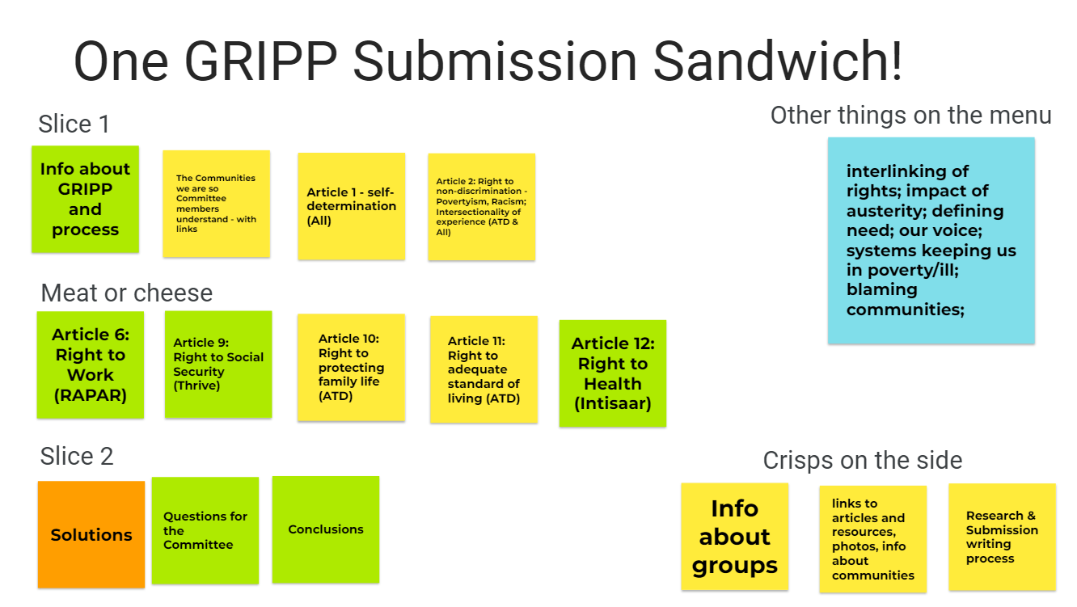

Step 5: Draft review
The draft submission was shared with academically located allies and policy professionals within the GRIPP partnership, along with the other grassroots researchers. Comments and suggestions were shared back and a facilitated session allowed the lead writers to work through comments and decide what to incorporate. Authorship and responsibility for this submission lies entirely with the four organisations: ATD Fourth World, Intisaar, RAPAR and Thrive Teesside.

Appendix 3: Links to articles, resources, photos
Some other potential links re context of the lived realities and government responses
Levelling up: where and how? | Institute for Fiscal Studies (ifs.org.uk)

The first one below was designed by the Poverty2Solutions coalition (ATD, Thrive and Dole Animators and reflects the need to include our insight and knowledge)
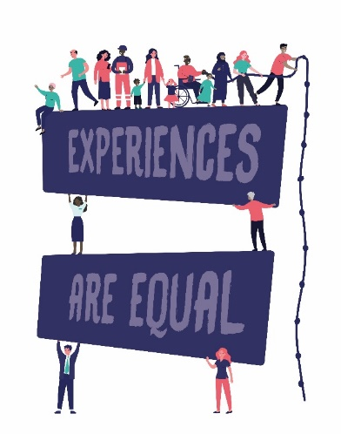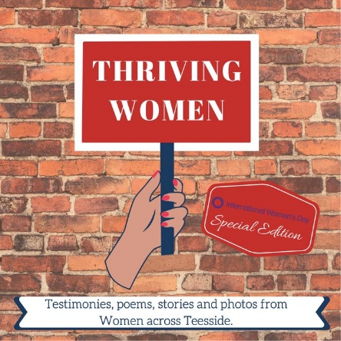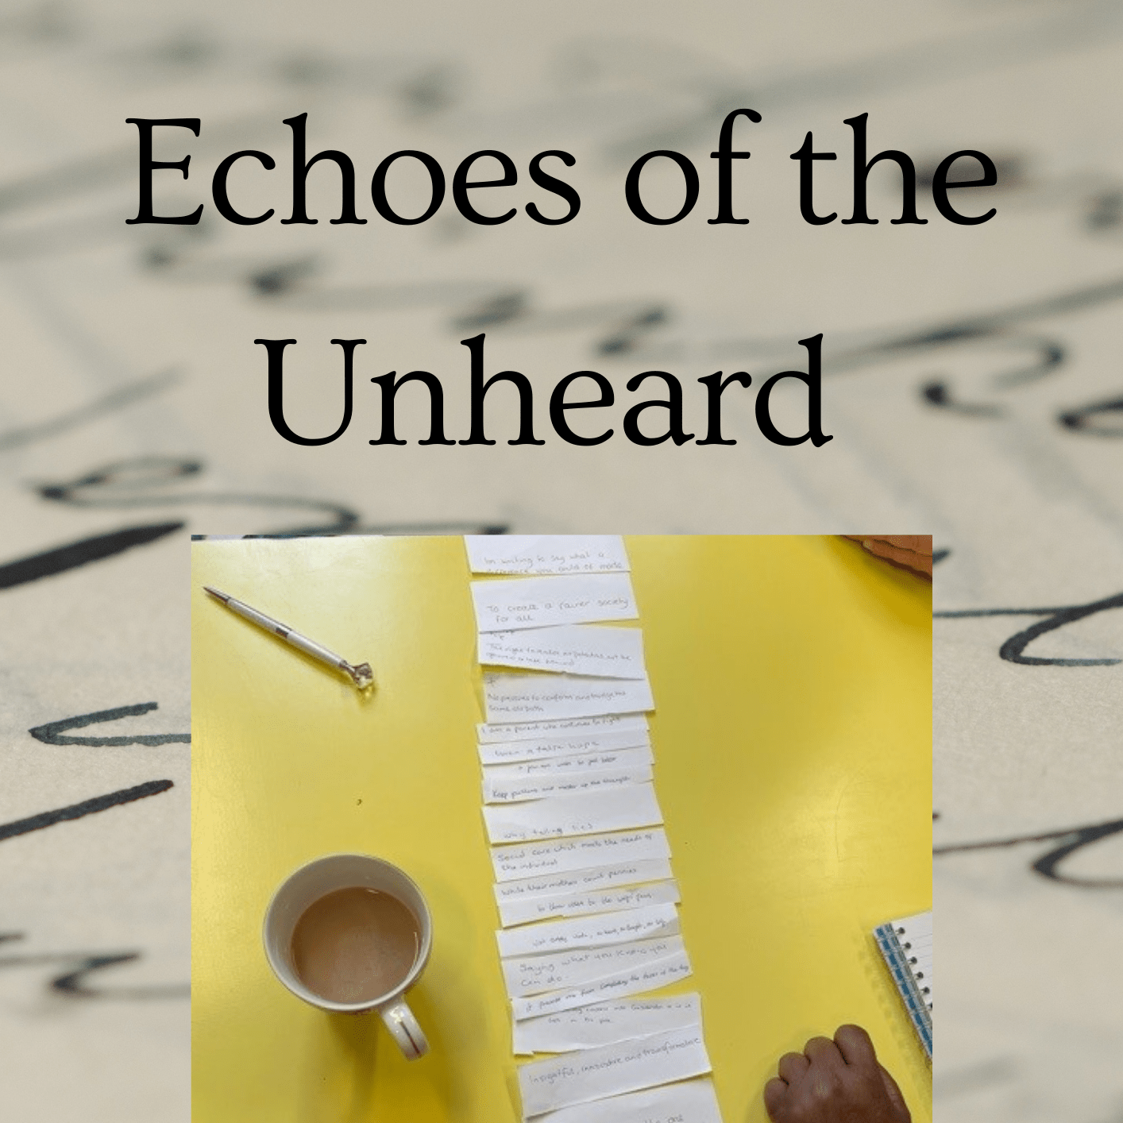

Appendix 5: Endnotes

We recognise the “undocumented” both in terms of people who are without status and therefore undocumented, and people with status whose experiences have so far remained undocumented
CESCR, ‘Substantive Issues Arising in the Implementation of the International Covenant on Economic, Social and Cultural Rights: Poverty and the International Covenant on Economic, Social and Cultural Rights’ (2002) UN Doc E/C.12/2001/10 para 1
CESCR, ‘Concluding Observations on the Sixth Periodic Report of the United Kingdom of Great Britain and Northern Ireland’ (2016) UN Doc E/C.12/GBR/CO/6 paras 18, 19, 40, 41, 42; OHCHR, UN Special Rapporteur on Extreme Poverty and Human Rights, ‘Visit to the UK’ (2018) UN doc. A/HRC/41/39/Add.1, 2019
David Walsh, Ruth Dundas, Gerry McCartney, Marica Gibson, et al. J, ‘Bearing the Burden of Austerity: How Do Changing Mortality Rates in the UK Compare between Men and Women?’ (2022) Journal of Epidemiology and Community Health <http://dx.doi.org/10.1136/jech-2022-219645>
National Audit Officer, “Financial Sustainability of Local Authorities 2018 - National Audit Office (NAO) Report” (National Audit Office (NAO), March 2018) <https://www.nao.org.uk/reports/financial-sustainability-of-local-authorities-2018/
Katie Schmuecker and Rachelle Earwaker, ‘Not heating, eating or meeting bills: managing a cost of living crisis on a low income’ (Joseph Rowntree Foundation 2022) 2-3 <https://www.jrf.org.uk/report/not-heating-eating-or-meeting-bills-managing-cost-living-crisis-low-income>
Resolution Foundation, 'Lack of Support for Low-Income Families Will See 1.3 Million People Pushed into Absolute Poverty Next Year • Resolution Foundation' (Resolutionfoundation.org, 2022) <https://www.resolutionfoundation.org/press- releases/33284/>
CERD ‘Committee on the Elimination of Racial Discrimination, General Recommendation 21, The right to self-determination (1996) UN Doc A/5/18 Annex VIII para 4
UN Special Rapporteur on Extreme Poverty and Human Rights ‘Banning discrimination on grounds of socioeconomic disadvantage: an essential tool in the fight against poverty’ (2022) UN Doc A/77/157 paras 4, 46
BACH, S. 2016. Deprivileging the public sector workforce: Austerity, fragmentation and service withdrawal in Britain. The economic and labour relations review: ELRR, 27, 11-28
BEATTY, C. & FOTHERGILL, S. 2018. Welfare reform in the United Kingdom 2010–16: Expectations, outcomes, and local impacts. Social Policy & Administration, 52, 950-968
Kate Morris, Calum Webb, Paul Bywaters, Martin Elliott and Jonathan Scourfield, ‘Social work, poverty, and child welfare interventions’ (2018) 23(3) Child & Family Social Work 370 <https://doi.org/10.1111/cfs.12423>
Emily Dugan, ‘Too Many Children Wrongly Taken into Care, Admits Chief Social Worker Isabelle Trowler’ (News | The Sunday Times, 2021) <https://www.thetimes.co.uk/article/too-many-children-wrongly-taken-into-care-admits-chief-social-worker-isabelle-trowler-95g5ft0ss>
Andy Nicoll, “Children in Poorest Areas '10 Times More Likely to Enter Care'” (communitycare.co.uk, 2017) <https://www.communitycare.co.uk/2017/02/28/children-poorest-areas-likely-enter-care-finds-study/>; Paul Bywaters et al., ‘The Child Welfare Inequalities Project; Final Report’ (Child Welfare Inequalities Project 2022) 6 <https://pure.hud.ac.uk/ws/files/21398145/CWIP_Final_Report.pdf>
Patrick Butler, "Children in UK's Poorest Areas Ten Times More Likely to Go Into Care" (The Guardian, 28 Feb 2017) https://www.theguardian.com/society/2017/feb/28/children-in-uks-poorest-areas-10-times-more-likely-to-go-into-care
Anastasia Koutsounia, ‘I wanted to go back and stand up for the little girl that I was’ (communitycare.co.uk, 2022) <https://www.communitycare.co.uk/2022/10/25/rebekah-pierre-case-files-open-letter-to-social-worker/>

