Interregional social movement «For democracy and human rights»
Iformation group on crimes against the person
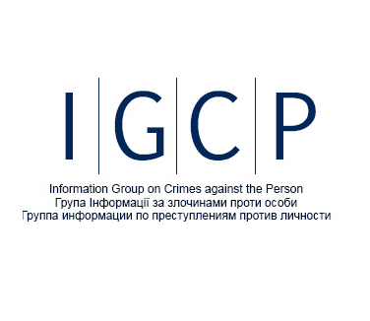
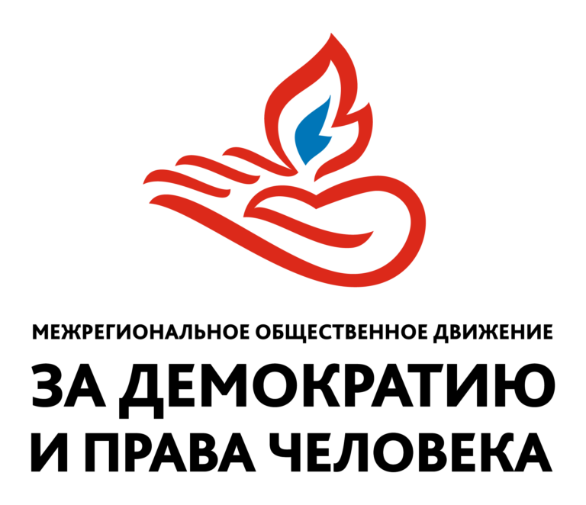

Parallel report on the combined second, third, fourth, fifth, sixth periodic report of the Republic of Latvia on the implementation of the 1966 International Covenant on Economic, Social and Cultural Rights in 2008-2017

Right to education (arts. 13–14)
Latvian education laws do not guarantee the right of citizens to receive education in their mother tongue.
Amendments to the Law on Education, initiated by the Ministry of Education and Science in 2017 and adopted by the Latvian Sejm on March 22, 2018, provide for education in secondary schools only in Latvian, in 7th-9th grades by at least 80% in Latvian. Exceptions are provided for programs with the study of the official languages ​ ​ of the EU or for education under special international treaties. According to the report of the Latvian Foreign Ministry of March 2018 [1], the only exception to the general education system on the basis of a bilateral international agreement is the Latvian International School, with education under American programs. Changes in the laws also apply to private schools.
Thus, Latvia has eliminated the successful biligval education system.
The reform was contrary to international principles guaranteeing the rights of minorities to receive education in their mother tongue.
Including:
The EU Charter of Fundamental Rights proclaims respect for the diversity of cultures and languages.
The Framework Convention for the Protection of National Minorities, to which Latvia acceded after the decision of the COP of 2005, requires that in the application of international norms, they strive to harmonize with national legislation, and not contradiction. Article. 14, paragraph 2 of the Convention stipulates the obligation of the state, if there is sufficient demand, to provide representatives of national minorities with education in their native language in places where they live historically or in large numbers. The demand for education in Russian in Latvia is confirmed by the existing system, in which there are both educational institutions with programs for national minorities and people who want to receive such an education. In interpreting this situation, the preamble to the Convention, which obliges the State not only to support the preservation of the national identity of minorities but also to promote its development, must be taken into account. Thus, the state has positive obligations in this area: if previously there was no opportunity to study in its native language, its appearance will be a positive decision, but if it was and is narrowed or eliminated, it will not. This is explicitly stated in Art. 22 of the Convention, which at the time of filing the second lawsuit on school reform with the Constitutional Court was already ratified by Latvia and became mandatory for it.
Despite the fact that the first protocol of the European Convention on Human Rights (st.2) stipulates that the right to education is not equal to the right to education in a certain language, when assessing the closure of Greek schools in the Turkish part of Cyprus (Cyprus v. Turkey, 10 May 2001 [57]) The European Court of Human Rights concluded that this constituted a violation of the family's rights to continue teaching children in their mother tongue, which existed earlier (paragraphs 277-280 of the court decision).
The inadmissibility of narrowing the rights of national minorities was explicitly indicated by Latvia in 2008 by the executive institution for monitoring the application of the Framework Convention - the Advisory Committee to the Council of Europe [58], its conclusion was supported by the Committee of Ministers of the Council of Europe in 2011.
School reform also contradicts the UN Convention on the Prevention of Racial Discrimination, as reported by the corresponding supervisory committee on August 30, 2018 [59]. It acknowledged that current language policies discriminated against ethnic minorities in the areas of education and employment, public and political life and access to services, recommending that amendments to the Education Act be reviewed to reduce minority language teaching in public and private secondary schools and to reduce the proportion of instruction in that language in mainstream school.

Recommendations:
1. Repeal the provisions of the Education Act that discriminate against Latvian minorities.
2. Take advantage of dialogue opportunities with Latvian civil society organizations representing the interests of national minorities.
3. Use the possibilities of international organizations, including the UN Human Rights Council, to convince the Latvian government of the need to bring national educational legislation in line with international obligations

