
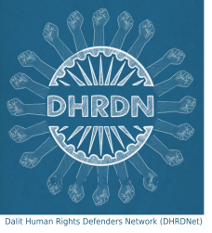

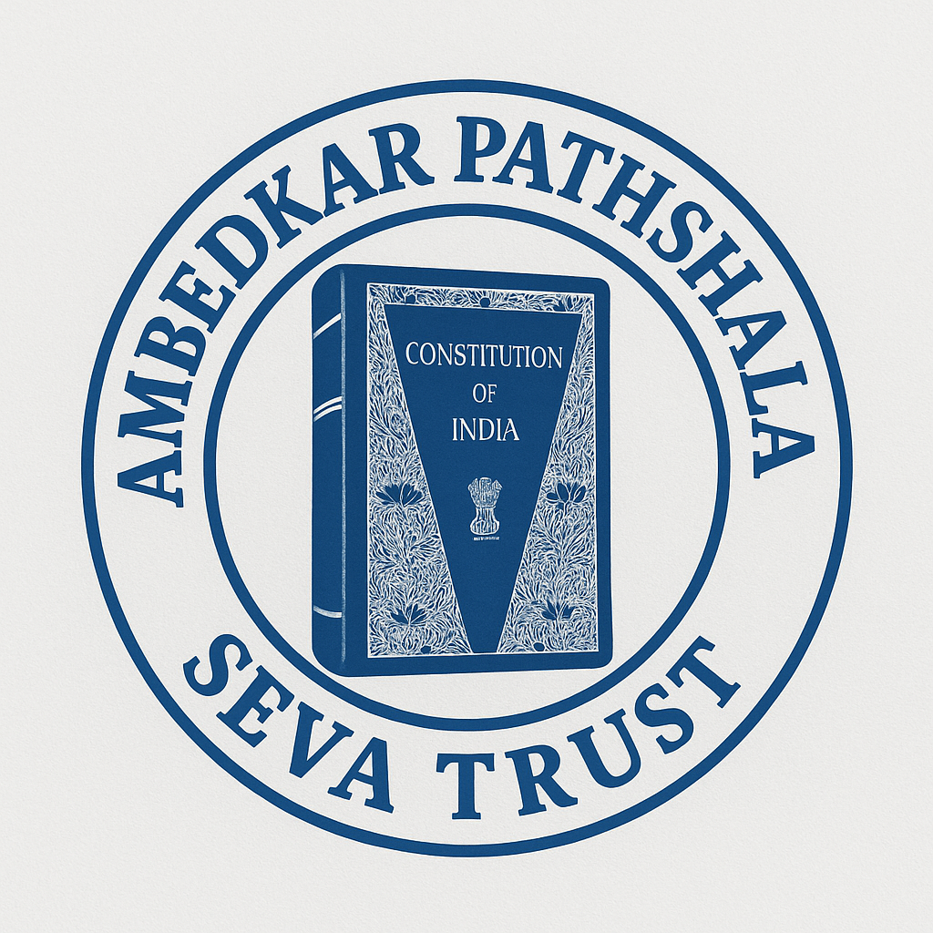
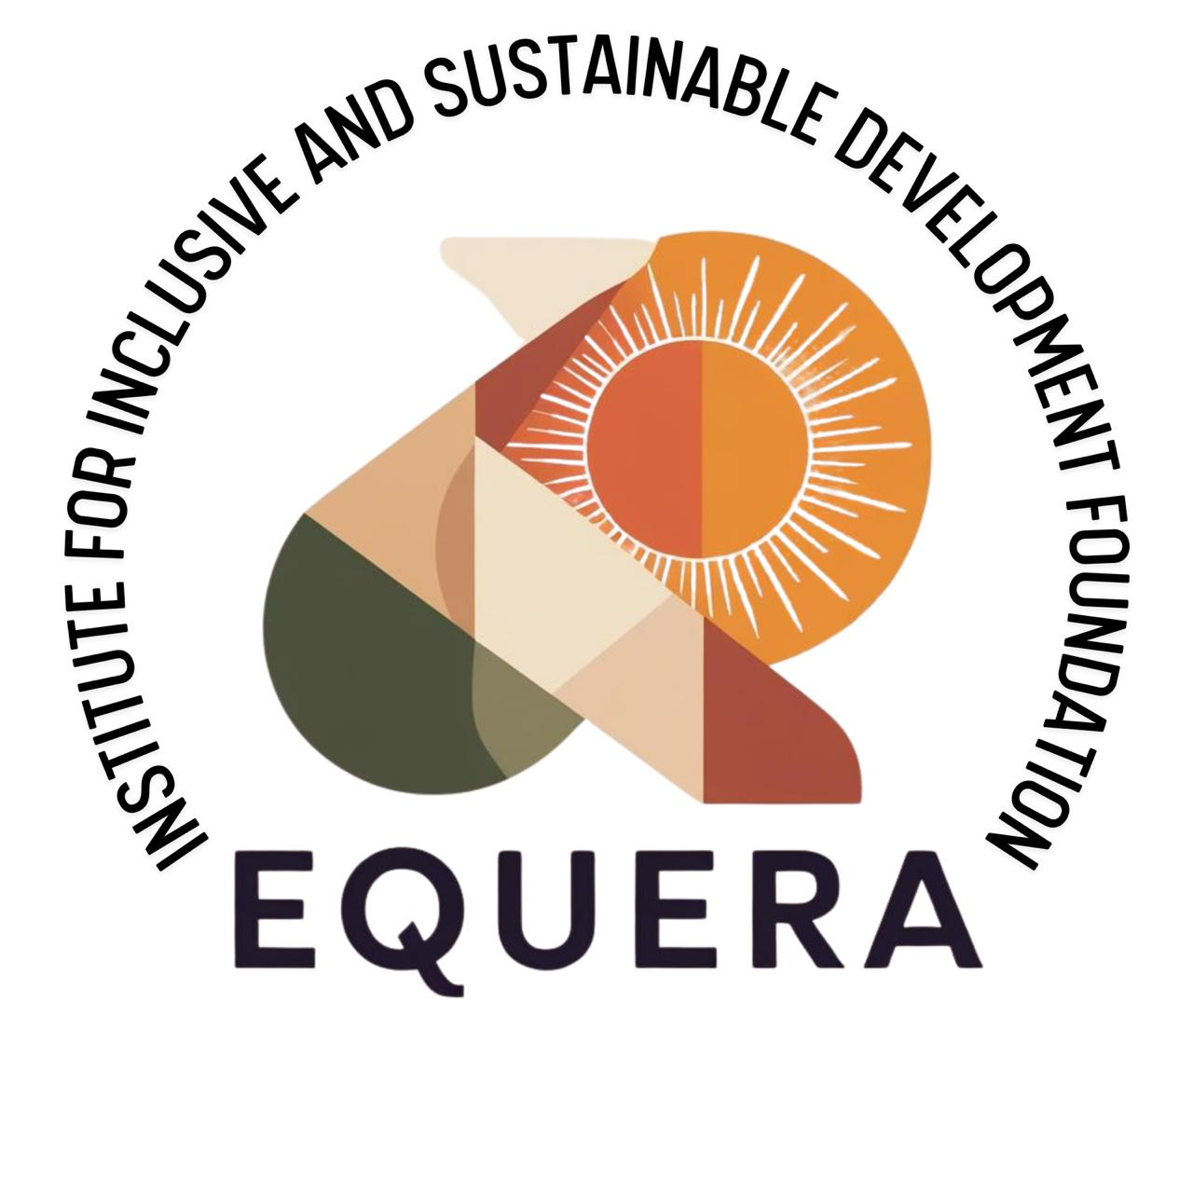
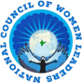

Committee for the Elimination of Discrimination against Women
Human Rights Treaties Division (HRTD)
Office of the United Nations High Commissioner for Human Rights (OHCHR)
Palais Wilson - 52, rue des Paquis
CH-1201 Geneva, Switzerland
Submitted through: https://events.ohchr.org/

29 September 2025
Information on India for consideration by the Committee for the Elimination of Discrimination against Women at the Pre-Sessional Working Group of its 94th Session (27 - 31 October 2025)
Introduction:
- We respectfully present this report regarding the adoption of a list of issues prior to reporting on India by the Committee on the Elimination of Discrimination against Women ("the Committee") during its 94th session (27 - 31 October 2025). This report is submitted jointly by Equality Now, the National Council of Women Leaders (NCWL), WeSpeakOut, and Dalit Human Rights Defenders Network and highlights the issues of sexual violence and female genital mutilation (FGM) in India.
- The National Council of Women Leaders (NCWL) is a coalition of women leaders from marginalized communities across India, working at the grassroots to support and empower marginalized women and girls in their communities, addressing issues relating to gender-based violence, including sexual violence, through research, advocacy, and access to justice.
- Equality Now is a worldwide human rights organisation dedicated to securing the legal and systemic change needed to end discrimination against all women and girls, everywhere in the world. Since its inception in 1992, it has played a role in reforming 130 discriminatory laws globally, positively impacting the lives of hundreds of millions of women and girls, their communities and nations, both now and for generations to come. Working with partners at national, regional and global levels, Equality Now draws on deep legal expertise and a diverse range of social, political and cultural perspectives to continue to lead the way in steering, shaping and driving the change needed to achieve enduring gender equality, to the benefit of all.
- WeSpeakOut is a survivor-led organization composed of women from the Bohra community. Established in 2015, we are committed to ending Female Genital Mutilation/Cutting/ Khafz in India and worldwide. We aim to use a combination of methods, including legal advocacy, research, community outreach in order to effectively remove forced FGM against the girl child from within the Bohra community and the Indian society.
- Dalit Human Rights Defenders Network (DHRDNet) is a coalition of Dalit human rights defenders from various states in India, built on the needs and demands of civil society organisations and Dalit human rights defenders to ensure a comprehensive Rights-Based Approach in combating caste-based discrimination. We intend to promote and be guided by internationally recognised principles, in particular contributing to the implementation in India of the UN Draft Principles and Guidelines for the Effective Elimination of Discrimination based on Work and Descent.
- Ambedkar Pathshala Seva Trust is dedicated to empowering women and girls in the rural districts of Gorakhpur and Maharajganj in Uttar Pradesh, where they continue to face economic discrimination, gender bias, school dropouts, early marriage, and violence. The Trust works to prevent child marriage, ensure girls continue their education, and reconnect dropouts with schools through awareness campaigns and free coaching.
- Equera Institute for Inclusive and Sustainable Development Foundation (EQUERA) works to advance women’s rights by fostering leadership, expanding access to education, health, and livelihoods, and addressing systemic challenges through community engagement. EQUERA builds women’s capacities as community leaders while supporting them through research, counselling, legal aid, and connections with government authorities. It also documents cases of sexual violence and caste-based discrimination, with particular focus on the struggles of single women and widows of farm labourers in the state of Maharashtra.
- The issues and practices detailed in our report highlight the State's failure to fulfil its duty to protect women and girls from sexual violence and female gential mutilation (FGM) under the Convention on the Elimination of All Forms of Discrimination against Women (‘the Convention’) (Article 2(c) and (e)) and that the decisions and faults of the authorities and their agents constitute demonstrable direct and indirect discrimination against women (Article 2(d)). We argue that the root causes of the failures of the State are due to the failure to comply with the obligation to transform gender hierarchies and stereotyped attitudes towards women, which violate Articles 2(f) and 5(a) of the Convention since the State has an obligation to combat violence against women and girls, as outlined in the Committee’s General Recommendations 14, 19 and 31, 33 and 35.
Sexual Violence Against Women And Girls
- India has ratified numerous international human rights treaties and they require India to ensure that laws relating to sexual violence (including procedural laws) are not discriminatory, as well as to exercise due diligence to “prevent as well as to investigate, prosecute, punish and provide reparation” for acts or omissions by both State and non-State actors which result in gender-based violence against women.
- Being able to live a life free from sexual violence is also necessary to meeting Goal 5 on Gender Equality and Empowerment of all Women and Girls of the 2030 Agenda for Sustainable Development (the SDGs) that includes targets to “end all forms of discrimination against all women and girls everywhere” (Target 5.1) and “eliminate all forms of violence against all women and girls in the public and private spheres, including trafficking and sexual and other types of exploitation” (Target 5.2). Additionally, Target 16.3 of the SDGs requires States to “promote the rule of law at the national and international levels and ensure equal access to justice for all”.
- The Constitution of India established under Article 14 “Equality before law - The State shall not deny to any person equality before the law or the equal protection of the laws within the territory of India. Prohibition of discrimination on grounds of religion, race, caste, sex or place of birth”. To address violence against Dalit (officially referred to as Scheduled Castes) and Adivasi/Tribal (officially referred to as Scheduled Tribes) women, the Parliament of India enacted a law named Scheduled Castes & Scheduled Tribes (Prevention of Atrocities) (SC & ST PoA) Act in 1989, which was further amended in 2015 and 2018.
- Sexual offences against minors (including Dalit and Adivasi/Tribal children) are addressed by the Prevention of Child Sexual Offences Act (POCSO Act) which protects children from all forms of sexual violence, covering both male and female children and including different forms of sexual abuse, including penetrative and non-penetrative assault, as well as sexual harassment and pornography.
- In 2023, the Bharatiya Nyaya Sanhita, 2023 (BNS), Bharatiya Nagarik Suraksha Sanhita (BNSS) and Bharatiya Sakshya Adhiniyam (BSA) were passed which displaced the existing Indian Penal Code (IPC), the Criminal Procedure Code (CrPC), and the Indian Evidence Act, respectively, and introduced new criminal law provisions in their place.
Marital Rape
- Indian criminal law explicitly excludes marital rape from the scope of the rape provision. Previously, under Sections 375 and 376 of the Indian Penal Code, 1860 (‘IPC’) and now Section 63 of the BNS, the law criminalises non-consensual penetrative and non-penetrative sexual intercourse by a man with a woman. Exception 2 to Section 63 states that “Sexual intercourse or sexual acts by a man with his own wife, the wife not being under eighteen years of age, is not rape”. The new legislation retains the provision and therefore the marital status and age of a woman continue to be a defence to rape perpetrated by her husband.
- Although the provision has been challenged before the Supreme Court on constitutional grounds, the ruling remains pending. The Delhi High Court issued a split decision on this issue in 2022. The Karnataka High Court also issued a significant judgment in 2022, allowing charges of rape to be framed against a husband, while noting that the marital rape exception violates the right to equality under Article 14 of the Indian Constitution. Both decisions of the Karnataka and Delhi High Courts are now under appeal before the Supreme Court. Before the Supreme Court, the Indian government has filed an affidavit opposing the striking down of the marital rape exception. This is despite the fact that the Indian Supreme Court has already held that marital rape of girls under the age of 18 violated their right to bodily integrity. The same logic ought to apply to adult women as well.
- A presumption of ongoing consent in a marital relationship violates a woman’s right to her autonomy, security, and bodily integrity. ​​Findings from the National Family Health Survey - IV show that 7% of ever-married women between the ages of 15-49 have faced sexual violence committed by their husband, during their lifetime. Thus, criminalisation of marital rape is imperative to ensure that married women can access justice for rape to the same extent as unmarried women.

Barriers to Accessing Justice for Survivors of Sexual Violence
Lack of Police Accountability
- Even though it is a criminal offence for police officers to refuse to register a First Information Report (FIR) i.e., the complaint, rape survivors of sexual violence, particularly those from marginalised communities, routinely face difficulties in ensuring that the police register cases of rape. Police officers often pressure the survivor to drop the complaint or delay registration of the FIR. Such delays in registration of the FIR often have a direct impact on the success of the case, as they can affect the quality of medical evidence available and give perpetrators and community members more time to pressure survivors to drop the case, among other consequences.

Medical Examinations of Rape Survivors are not Survivor-friendly
- Indian law mandates that the medical examination be conducted within 24 hours of receiving the complaint. However, survivors have experienced many challenges to this. Survivors have spoken about delays by the police in referring the case to the hospital or the lack of availability of healthcare providers or equipment in the hospitals. In a subsequent study, survivors noted that they were coerced into signing consent forms or medical examination reports without being informed of the details of their consent. There are also reports of doctors untrained in the court processes conducting medical examinations and then being unable to provide accurate evidence in court.
- Survivors report that often, even where they were sent for medical examination in accordance with the provisions of the law after reporting the case to the police, they did not receive sufficient medical treatment for the injuries or, in some cases, pregnancy, caused by the sexual assault. The failure to provide medical treatment is a violation of section 397 of the BNSS, which provides that all hospitals, both public and private, are required to immediately provide first aid and medical treatment free of cost to rape survivors.
- Additionally, the unscientific and traumatising two-finger test is still being used as part of the medical examination for rape survivors in India, as confirmed by numerous reports and evidence provided by survivors. This test involves a medical practitioner inserting two fingers into the vagina of a rape survivor in an attempt to determine if the hymen is broken, as well as to test the laxity of the vagina. The test is often used to declare rape survivors as “habituated to sex” and therefore not harmed by it or deserving of justice.
- The two-finger test was banned by India’s Supreme Court in 2013. The 2014 guidelines released by the Ministry of Health also clarify that the two-finger test has no bearing on cases of sexual violence. The Supreme Court further reiterated the ban on using the “two-finger test” in rape cases and issued a warning that those who do so will be found guilty of misconduct. However, many states in India have not yet adopted the national guidelines for medico-legal care of survivors of sexual violence. From a human rights perspective, conducting a test on rape victims that has no probative value is a violation of the personal integrity of the women and girls, and could cause further trauma to these rape survivors.
- For instance, the NCWL & DHRDNet report from 2021 found that out of 7 rape cases included in the study from the state of Tamil Nadu, six survivors reported being subjected to the two-finger test. The continued use of the two-finger test in Tamil Nadu is also borne out of the allegations of an Indian Air Force officer in September 2021, whose case received widespread media coverage after she noted that she had been subjected to the two-finger test in a military hospital after she was raped. A study of fast-track court judgments in the state of Karnataka found that 25% of the judgments made explicit reference to the two-finger test and to the victim being habituated to sexual intercourse.
Compromises in Cases of Sexual Violence
- Every year, several rape cases are compromised or compounded (i.e. settled) by the courts, despite the fact that rape is a non-compoundable offence and the Supreme Court has held that compromises in rape cases are not permissible under law. Even when the compromise is not officially recorded by the criminal justice system, unofficial compromises or out-of-court settlements are undertaken by the accused and the general community putting pressure on the survivor or her family through various means - filing of spurious counter-cases with the police; threats of physical violence and assault, including threats to the life of the survivor, her children or her family; use of political influence with the police and health care providers to impact the results of the criminal investigation; societal pressure through social boycott, or banishing the family from the village (or threatening to do so); and economic retaliation by threatening loss of jobs of the survivor or her family, particularly when they are dependent on the dominant castes for their livelihood.
- The role of the community in impeding access to justice for cases of sexual violence is often particularly acute in cases of sexual violence against women and girls from marginalised communities, with perpetrators from dominant caste families. The accused and their families use their casteist influences and political, social, and economic clout and influence to threaten or pressure survivors and their families. This is often done with the support of officials within the criminal justice system.
Delays & Discriminatory Approaches in Investigation and Trial
- Long delays in the investigation and trial of rape cases have a profound impact on access to justice for survivors of sexual violence in India. The BNSS mandates a time limit of two months for the completion of the investigation of rape cases by the police. However, despite this time limit, it is seen that there are often delays in the completion of the investigation and the filing of the chargesheet by the police. The report by NCWL and DHRDNet found that the delay in filing the charge sheet in the cases studied (beyond the two-month limit provided by law) ranged from an additional 0.5 months to 6 years.
- Judges deciding sexual violence cases continue to have victim-blaming and gender discriminatory attitudes, which affect the possibility of successful convictions. For example, the Nagpur bench of the Bombay High Court had ruled that in cases of child sexual assault, there must be a “skin-to-skin contact” with sexual intent, and mere groping is not sufficient to constitute sexual assault (though this order was swiftly overturned by the Supreme Court). Similarly, a Supreme Court bench headed by the then Chief Justice of India asked a rape accused in open court whether he was ready to marry the complainant. In 2022, a Kerala court acquitted a former bishop accused of raping a nun 13 times over three years in a convent, citing a lack of evidence. This was despite 39 witnesses, most of them nuns, stepping forward to provide evidence supporting the survivor and being cross-examined in court. Discounting this crucial evidence, the Court focused instead on irrelevant evidence relating to the past sexual history of the survivor; relied on discriminatory gender stereotypes, and engaged in victim blaming, while acquitting the accused. In 2020, nine concerned citizens filed a special leave petition with the state of Madhya Pradesh, accusing the state of failing in its responsibility to oppose the high court’s order of granting bail to the accused in a case of sexual assault. Bail was granted based on patriarchal notions and discriminatory gender stereotypes that the accused should make the victim a “sister” on the day of Raksha Bandhan, an Indian festival that honours the role of sisters, and pledge to protect her in the future.
High Prevalence & Prevailing Impunity For Sexual Violence, Particularly When Committed Against Women And Girls From Marginalised Communities
- Dalit women and girls are at the bottom of caste and class hierarchies. Dalit women and girls are oppressed with sexual violence, and the forms of sexual violence specifically against Dalit women are not just confined to rape or sexual harassment. Rape and sexual violence against Dalit women are often accompanied by other forms of violence, such as gang rape, murder, assault, kidnapping, social boycott, mass attack, arson, false case accusation, witch hunting, abetment to suicide, etc.
- It is important to note that the Adivasi/Tribal people constitute 8.6 percent of India's population (Census 2011). Tribal peoples’ rights are enshrined in Schedule 5 and Schedule 6 of the Constitution of India. With deep connections with land, the forests and other natural resources, women (and men) from these communities often clash with the current developmental paradigms, making them vulnerable to sexual violence amongst other forms of abuse.
- In 2022, the government released a report on the overall cases of atrocities against Scheduled Castes and Scheduled Tribes under the SC & ST PoA Act, highlighting that almost 97% cases were from 13 states in India. Only 60.38% of these cases related to Scheduled Castes led to charge sheets being filed, while 14.78% were concluded with final reports due to reasons such as false claims or lack of evidence. For Scheduled Tribes, only 63.32% resulted in charge sheets being filed, while 14.7% were concluded with final reports. The conviction rate in the Act dropped to 32.4% in 2022 from 39.2% in 2020, an indication that access to justice is more challenging for these marginalised communities.

- A report in 2024 showed that the percentage of rape cases against Scheduled Castes and Scheduled Tribes women and girls more than doubled from 2014 from 6.08% to 13.46% in 2022.
- Dalit women and girls face degrading, insulting, and undignified behaviour in the Police Station when they go to file an FIR, and also face the stigma and stereotyped excuse of having registered the cases for the monetary assistance provided under the SC & ST (PoA) Act by the police. The police cause undue delay in case registration, and the investigation officers cause excessive delays in filing the charge sheet in the cases of Dalit women's sexual offences (the stipulated time of filing the charge sheet under SC & ST (PoA) Act is 60 days from the date of FIR). In the FIR, the police deliberately avoid invoking the appropriate sections of SC & ST (PoA) and POCSO Acts with a view to shielding the perpetrators and weakening the case of Dalit women and minor girls. The partial and biased investigation, motivated by caste and gender prejudice, leads to a miscarriage of justice for the Dalit and Adivasi/Tribal women. Along with it, a deliberate delay is also made in arresting the accused, which leads to subsequent incidents with the Dalit women and their family members.
- The disappointing ruling from the Indian Court on the Hathras murder and rape case acquitting three men out of the four men (accused of gang-raping a 19 year old Dalit teenager which caused global outrage after authorities allegedly forcibly cremated her body without her family's consent) does not lend confidence that cases of sexual violence against Dalit women will reach a conviction.
- The majority of the cases of violence against Dalit women and girls arise while they are out and about doing their daily activities - to fill water, grazing cattle on someone’s land or defecating in the open due to the lack of sanitation facilities, going to schools or colleges. This adds to their vulnerability and marginalisation, and, given that the issue of discrimination and sexual and gender-based violence against Dalit women and girls has remained unaddressed for decades, it is having a multi-dimensional effect on their socio-economic position, their health, including their sexual and reproductive health, and their overall well-being. The barrier they face to obtain justice and access legal recourse/remedies has broader implications on their lives and their future as they are prevented from asserting their right to work, their right to education, their right to obtain information and services, and their right to participate in public and private life.

Failure to Effectively Implement provisions of the Scheduled Castes and Scheduled Tribes (Prevention of Atrocities) Act, 1989
- Evidence from grassroots groups and lawyers indicates that in many cases of rape against Dalit women and girls, even where the rape case is registered by the police, the FIR does not normally include offences under the SC & ST (PoA) Act. Due to pressure from high-level politicians to clamp down on caste-based atrocities within the state, district-level authorities are responding to this by registering fewer cases under the SC & ST (PoA) Act rather than taking measures to prevent the atrocities.
- The 2015 amendment to the SC & ST (PoA) Act requires the state government to set up Exclusive Special Courts for the trial of offences under the SC & ST (PoA) Act. These special courts are meant to provide speedy trials, to be completed within two months. The state government is also required to appoint Special Public Prosecutors for the prosecution of offences before these courts. However, only 13 out of the 36 states and Union Territories across the country have set up Exclusive Special Courts to try offences under the SC & ST (PoA) Act as required by the 2015 amendment.
- Further, the SC & ST (PoA) Act requires Special and Exclusive Special Courts set up to try offences under the Act to provide travelling and maintenance expenses during the investigation and trial. However, in practice, these maintenance expenses are hardly ever provided to survivors/victims, who are not aware of their rights under the law.
- The SC & ST (PoA) Act also requires state governments to identify atrocity-prone districts so that measures can be taken within these areas to prevent atrocities and improve safety, including through the appointment of a special officer in these areas to monitor implementation of the SC & ST (PoA) Act. However, of the 36 states and Union Territories in the country, only 12 states have identified atrocity-prone areas. Only five states had special police stations for the registration of cases against Scheduled Castes and Scheduled Tribes. Given that provisions of the SC & ST (PoA) Act can be legally added in cases of sexual violence, measures to prevent the occurrence of any kind of atrocities have the potential to prevent sexual violence.
- Despite the SC & ST (PoA) Rules mandating the provision of the relief amount within 7 days, in most cases known to the authors, the payment of compensation is delayed significantly. The period of delay ranged from 2 months to 1 year. For the payment of interim compensation (due after filing the charge sheet), delays were more commonly reported, with the compensation in one case being received only 3 years after the charge sheet was filed. These long delays in the provision of immediate and interim relief defeat their purpose since the relief is meant to provide support for the essential needs of the survivor or her family after the rape and her ability to access justice through the courts.
Sexual Violence against Muslim Women & Girls
- There are no disaggregated data available on the number of reported cases of sexual violence against Muslim women and girls, and rape against Muslim women is often invisibilised and under-reported. However, survey data from the National Family Health Survey shows rates of sexual violence against Muslim women at 5.1% which is slightly higher than against non-marginalised communities. Religious riots in the country have sometimes resulted in sexual violence against Muslim women, as was the case after the Delhi riots in 2020. Even individual cases of rape against Muslim women and girls have indicated an element of hate, as can be seen in the rape of an eight-year-old from the Muslim nomad community in Kashmir in 2018. In recent years, threats of sexual violence against Muslim women, particularly in online spaces, have been associated with increasing intolerance of the community in the country.
- In 2021, Muslim women were “auctioned” online for sale as maids (in a mock auction) with their photographs doctored and sourced without their permission, in the “Sulli Deals” hosted by GitHub. However, the state failed to take action against the perpetrators of this online harassment, which then led to a similar app, “Bulli Bai” (an Islamophobic slur), being established in 2022, again hosted by GitHub. Many women found themselves “auctioned” in both incidents, which show that they clearly targeted vocal Muslim women for their religious identity.
Female genital mutilation (FGM)
- FGM is known to be practiced in India by the Dawoodi, Alvi, and Suleimani Bohra communities, as well as certain sections of Sunni Muslim communities. In the Bohra community, FGM is mainly performed on young girls around the age of seven. Within the community, the practice of FGM involves the cutting of the prepuce or clitoral hood, which is classified as Type I (partial and/or total removal of the clitoris and/or the prepuce), as classified by the World Health Organization. In the Sunni communities of south India, for example, Kerala, it is performed within the first year after birth, and the type of cutting could be either Type I or Type IV (all other harmful procedures to the female genitalia for non-medical purposes, for example, pricking, piercing, incising, scraping, and cauterization).
- There are no country-wide studies or large-scale population surveys that measure the prevalence of FGM in India. However, the existence of FGM in India has been documented through two independent research studies. The most recent study, titled The Clitoral Hood: A Contested Site, was commissioned by WeSpeakOut and Nari Samata Manch and released in 2018. The study largely included participants from the Bohra community and found that 75% of all daughters of participants of the study sample were subjected to FGM, which means it continues to be practiced on little girls. 97% of women who remembered their FGM experience from childhood recalled it as painful.
- Two participants from the Sunni Muslim community were also included in the WeSpeakOut study, who reported that girls from their community were usually cut as babies below the age of one. Despite some scant evidence, it has been challenging to access and learn more about the practice of FGM amongst other communities in India (including a Sunni Muslim community in Kerala and a few other unknown ones in the South). This is primarily due to the covert nature of the practice and the extreme reluctance of all members of the affected community to speak about the same.
- Another study titled Understanding Female Genital Cutting within the Dawoodi Bohra Community was conducted by Sahiyo in 2017. It included 385 respondents from numerous countries, all from the Bohra community. 34% of the study’s participants were from India. The survey findings indicated that 80% of the survey’s participants had undergone FGM.
- FGM, including the type practiced in India, has short-term and long-term ill effects on the health and psychological well-being of the victims. The research study, The Clitoral Hood: A Contested Site, has documented the case of a 7-year-old girl in India who nearly bled to death after being subjected to FGM.
- The practice of FGM has severe implications on women and girls’ bodily integrity and bodily autonomy and also violates their constitutional rights to equality, non-discrimination, and privacy. The Indian Constitution guarantees a fundamental right to equality and non-discrimination based on sex (Articles 14 & 15) and the rights to life and personal liberty (Article 21). Despite its international and national obligations, India does not have a law specifically banning FGM. In 2022, India also received a recommendation during its Universal Periodic Review (UPR) to criminalize FGM and adopt a national action plan to address FGM. Disappointingly, the Indian government merely ‘noted’ this recommendation in its response.
- As highlighted in a report published by WeSpeakOut, Female Genital Mutilation – A Guide to Eliminating the Practice of FGM in India, the lack of a specific mention and definition of FGM in India’s criminal laws means that the practice largely goes unnoticed since it is shrouded in secrecy and the community prefers to remain silent on the subject with members of the community even fearing ostracisation if they oppose FGM.
- Ensuring the complete elimination of the practice of FGM requires law reform and/ or the passage of a separate law against FGM that adopts a holistic approach toward ending the practice. Such an approach needs to address the various aspects of FGM, including abetting or aiding the practice, propagating the practice, prevention of FGM, regulations on medical/health professionals who carry out this practice, duty to report, support and rehabilitative provisions, and awareness building with appropriate budgetary support.
- ​​In recognition of this, a public interest litigation seeking a legal ban on the practice of FGM in India was filed before the Supreme Court. However, the case has now been tagged with other cases relating to the right to religious freedom under the Constitution and referred to a Nine-Judge Bench to decide on the larger issue of the scope and ambit of the right to religious freedom under Article 26 of the Constitution of India and balancing the right to religion with other fundamental rights. Before the referral, the judges made oral remarks stating that FGM prima facie appears to be a violation of the right to privacy guaranteed by the Constitution and the right to bodily integrity of the child. The Court also noted that there seems to be no scientific or medical basis for the practice of FGM, which is likely to cause a significant amount of trauma, pain, and bleeding.
- Despite the pending case before the Indian Supreme Court, the Indian government still retains the primary responsibility to take action and pass a law banning FGM in India, given that this practice is a harmful practice that undermines the dignity, human rights, and well-being of women and girls.
- With the Indian government turning a blind eye, societal efforts against FGM are limited to a few NGOs trying to create awareness and advocating for legal bans. Consequently, academic resources on FGM in India are scarce and come from non-governmental sources. The lack of national-level prevalence data on FGM in India means that the issue often goes unnoticed and unaddressed by government authorities, despite evidence provided to them by NGOs in the form of small-scale studies or anecdotal evidence. A key challenge that needs to be addressed on a priority basis is to, at the outset, map the national prevalence of FGM in India, including its prevalence in communities other than the Bohras that are yet to be studied.
- The lack of holistic action against FGM also means that there is an acute lack of awareness amongst the community members who practice FGM as to the medical, sexual, and psychological impact of this harmful practice. Studies reveal that most people hesitate to broach this matter, even when they are assured of complete anonymity. Information is not even shared with family and friends.
- In recent years, especially in metropolitan cities like Mumbai, there has been a growing trend in the “medicalization” of the practice and procedure of FGM. The WeSpeakOut study titled ‘Clitoral Hood: A Contested Site’ has brought out the involvement of nurses, general practitioners, and gynecologists. Recognizing this trend, in February 2020, the Federation of Obstetric and Gynaecological Societies of India (FOGSI) published a policy statement on FGM, which “directs all its member gynecologists and all other health care professionals to desist from performing or participating in any procedure of female genital mutilation.” The WHO Guideline on the prevention of female genital mutilation and clinical management of complications (2025) also includes specific recommendations on capacity-building for health workers, as well as the creation and enforcement of laws and policies against FGM/C, and professional codes of conduct for health workers, to ensure accountability.

Suggested Questions for the State Party
It is respectfully suggested that the following questions be raised with the Indian government as part of the List of Issues Prior to Reporting (LOIPR) issued to India:
- What steps, based on the recommendations from the UN treaty bodies, Indian courts, and law reform committees, will be taken to criminalise marital rape and provide access to justice to survivors of marital rape?
- What further mechanisms will the government set up to address gaps in the Scheduled Castes and Scheduled Tribes Prevention of Atrocities Act and the Prevention of Children against Sexual Offences (POCSO) Act, ensuring no delay in reporting, investigation, and prosecution in the cases of sexual violence on women and girls from the Scheduled Castes and Scheduled Tribes?
- What new steps will be taken to make the implementation of the Scheduled Castes and Scheduled Tribes (Prevention of Atrocities) Act, 1989 more effective and to ensure that cases of sexual violence are being filed and investigated in a timely manner?
- What safeguards have been taken to ensure that survivors of sexual violence, particularly from Dalit and Adivasi/Tribal communities, are not pressured and influenced to ‘settle’ the case with the accused or the accused’s family through unlawful methods?
- What steps will the government take to effectively implement the Supreme Court of India’s decision to ban the ‘two-finger’ test and ensure that all States adopt and implement the national guidelines immediately?
- What steps are being taken to collect reliable and accurate data on incidents of sexual violence against all women and girls, with an inclusive focus on Dalit, Tribal, and Muslim women and girls?
- How is the government handling issues relating to police negligence and accountability in the cases of sexual violence?
- What steps are being taken to end the long delays in the investigation and trial of rape cases?
- What kind of steps are being taken by the Government to sensitise and train police, judiciary, and health workers on survivor-centred investigations and prosecutions, and intersectional aspects based on caste, gender, ethnic, and religious bias while handling cases of sexual violence?
- What are the government’s plans and timeframe for enacting and enforcing a comprehensive law that prohibits female genital mutilation/cutting (FGM/C) and guarantees the protection of women and girls who are at risk of undergoing FGM/C?
- Please provide statistical and other relevant data on the extent of the practice and impact of FGM/C in India and the measures taken by the government to eliminate and address it. If such data is unavailable, what are the government’s plans to collect such data to estimate the prevalence and impact of FGM/C across the country?
- What are the government’s plans for ensuring that all women and girls who have been subjected to FGM/C receive justice and protection?

For more information, please see www.equalitynow.org
Committee on the Elimination of Discrimination against Women, CEDAW/C/GC/35, General Recommendation No. 35 on gender-based violence against women, updating general recommendation No. 19.
RIT Foundation v. Union of India, 2022 SCC OnLine Del 1404
Hrishikesh Sahoo v. State of Karnataka, Order dated 23 March 2022, https://www.livelaw.in/top-stories/marital-rape-exception-regressive,-violates-article-14-husband-not-ruler-of-wifes-body-mind-karnataka-high-court-194834
Supreme Court Observer, Challenge to the Marital Rape Exception: Hrishikesh Sahoo v. State of Karnataka, https://www.scobserver.in/cases/challenge-to-the-marital-rape-exception-hrishikesh-sahoo-v-state-of-karnataka/
AIR 2017 SC 4904
International Institute for Population Sciences (IIPS) and ICF. 2017. National Family Health Survey (NFHS-4), 2015-16: India. Mumbai: IIPS. http://rchiips.org/nfhs/pdf/NFHS4/India.pdf. Also see https://pmc.ncbi.nlm.nih.gov/articles/PMC8559397/
Section 198 and 199 (C) of BNS
Equality Now and Swabhiman Society, 2020, Justice Denied: Sexual Violence and Intersectional Discrimination, Barriers to Accessing Justice for Dalit women and girls in Haryana, India, https://www.equalitynow.org/resource/justicedenied/
Equality Now and Swabhiman Society, 2020, Justice Denied: Sexual Violence and Intersectional Discrimination, Barriers to Accessing Justice for Dalit women and girls in Haryana, India, https://www.equalitynow.org/resource/justicedenied/
National Council of Women Leaders, Dalit Human Rights Defenders Network, Tata Institute of Social Sciences, 2022, Caste Based Sexual Violence and State Impunity.. https://www.ncwl.org.in/ebook/caste-based-sexual-violence-and-state-impunity/
National Council of Women Leaders, Dalit Human Rights Defenders Network, Tata Institute of Social Sciences, 2022, Caste Based Sexual Violence and State Impunity.. https://www.ncwl.org.in/ebook/caste-based-sexual-violence-and-state-impunity/
Equality Now, 2021, Sexual Violence in South Asia: Legal and Other Barriers to Justice for Survivors, https://live-equality-now.pantheonsite.io/resource/sexualviolencesouthasia/; Equality Now and Swabhiman Society, 2020, Justice Denied: Sexual Violence and Intersectional Discrimination, Barriers to Accessing Justice for Dalit women and girls in Haryana, India, https://www.equalitynow.org/resource/justicedenied/; National Council of Women Leaders, Dalit Human Rights Defenders Network, Tata Institute of Social Sciences, 2022, Caste Based Sexual Violence and State Impunity. https://www.ncwl.org.in/ebook/caste-based-sexual-violence-and-state-impunity/
​​Lillu v State of Haryana (2013)14 SCC 643
https://jlrjs.com/supreme-court-of-india-bans-two-finger-test/
Centre for Enquiry into Health and Allied Themes, 2018, Understanding Dynamics of Sexual Violence : Study of case records.
National Council of Women Leaders, Dalit Human Rights Defenders Network, Tata Institute of Social Sciences, 2022, Caste Based Sexual Violence and State Impunity. https://www.ncwl.org.in/ebook/caste-based-sexual-violence-and-state-impunity/
The New Indian Express, 2021, Doctors performed two-finger test to prove I was raped: Woman IAF officer,, https://www.newindianexpress.com/states/tamil-nadu/2021/sep/30/doctors-performed-two-finger-test-to-prove-i-was-raped-woman-iaf-officer-2365584.html
National Council of Women Leaders, Dalit Human Rights Defenders Network, Tata Institute of Social Sciences, 2022, Caste Based Sexual Violence and State Impunity. https://www.ncwl.org.in/ebook/caste-based-sexual-violence-and-state-impunity/
Over a thousand rape cases were officially compromised by Indian Courts between 2015 and 2020 as per data from the National Crime Records Bureau. See National Crime Records Bureau, Crime in India, 2016- 2020, available at https://ncrb.gov.in/en/crime-in-india
Equality Now and Swabhiman Society, 2020, Justice Denied: Sexual Violence and Intersectional Discrimination, Barriers to Accessing Justice for Dalit women and girls in Haryana, India, https://www.equalitynow.org/resource/justicedenied/
Human Rights Watch, 2017, ‘Everyone Blames Me:” Barriers to Justice and Support Services for Sexual Assault Survivors in India, https://www.hrw.org/report/2017/11/08/everyone-blames-me/barriers-justice-and-support-services-sexual-assault-survivors
Equality Now and Swabhiman Society, 2020, Justice Denied: Sexual Violence and Intersectional Discrimination, Barriers to Accessing Justice for Dalit women and girls in Haryana, India, https://www.equalitynow.org/resource/justicedenied/
Section 193(2), BNSS
The Wire, 2021, Groping Without Skin-to-Skin Contact Is Not 'Sexual Assault' Under POCSO: Bombay HC, 24 January, https://thewire.in/law/groping-without-skin-to-skin-contact-is-not-sexual-assault-under-posco-bombay-hc
Hindustan Times, 2021, ‘Are you willing to marry her?’ Supreme Court to rape accused, 2 March , https://www.hindustantimes.com/india-news/are-you-willing-to-marry-her-supreme-court-to-rape-accused-101614646926673.html
Feminism in India, 2022, The Acquittal of Franco Mulakkal: How One Woman’s agony becomes every woman’s agony, 19 January, https://feminisminindia.com/2022/01/19/the-acquittal-of-franco-mulakkal-how-one-womans-agony-becomes-every-womans-agony/
National Council of Women Leaders, 2024, Beyond Rape: Examining the systemic oppression leading to sexual violence against Adivasi women, https://www.ncwl.org.in/ebook/beyond-rape/
CHRI, 2024, Rape and rape/gang-rape with murder in India: Incidences of Cases, Preliminary analysis of National Crime Records Bureau Data - Part 1, https://www.humanrightsinitiative.org/download/CHRI-NCRBData-RapeStats-Analysis-Part1-Sep24.pdf
BBC News, 2023, Hathras rape and murder case: Indian courts clear three of four accused, 2 March https://www.bbc.co.uk/news/world-asia-india-64820721
Equality Now, 2020, Justice: Sexual Violence and Intersectional Discrimination, Barriers to Accessing Justice for Dalit women and girls in Haryana, India
Section 14, Scheduled Castes and Scheduled Tribes (Prevention of Atrocities) Act, 1989, as amended in 2015
Ministry of Social Justice and Empowerment, Annual Report 2020-21, https://socialjustice.nic.in/writereaddata/UploadFile/ANNUAL_REPORT_2021_ENG.pdf
Section 15A, Scheduled Castes and Scheduled Tribes (Prevention of Atrocities) Act, 1989 as amended in 2015
Ministry of Social Justice and Empowerment, Annual Report 2020-21, https://socialjustice.nic.in/writereaddata/UploadFile/ANNUAL_REPORT_2021_ENG.pdf
The Indian Express, 2024, 97% cases of atrocities against SCs in 2022 reported from 13 states, says govt report, 22 September, https://indianexpress.com/article/india/cases-of-atrocities-against-scs-in-2022-government-report-9582076/
Rule 12(4), The Scheduled Caste and Scheduled Tribe (Prevention of Atrocities) Rules 1995 (as amended in 2016).
News18, Beaten, Molested and Homeless: How Women Became Worst Victims of Delhi Riots https://www.news18.com/news/india/beaten-molested-and-homeless-hindu-or-muslim-women-became-the-undocumented-victims-of-delhi-riots-2520457.html
Al Jazeera, Rape as a political tool in India, 19 April 2018, https://www.aljazeera.com/opinions/2018/4/19/rape-as-a-political-tool-in-india
Article 14, Unchecked Tsunami Of Online Sexual Violence By Hindu Right Against India's Muslim Women, 21 May 2021, https://article-14.com/post/unchecked-tsunami-of-online-sexual-violence-by-hindu-right-against-india-s-muslim-women
The Wire, ‘Bulli Bai’, 'Sulli Deals': On Being Put Up for ‘Auction’ as an Indian Muslim Woman, 16 January 2022, , https://thewire.in/communalism/indian-muslim-woman-auction-bulli-bai
Types of FGM, World Health Organisation, available at: https://www.who.int/teams/sexual-and-reproductive-health-and-research-(srh)/areas-of-work/female-genital-mutilation/types-of-female-genital-mutilation
Lakshmi Anantnarayan, Shabana Diler and Natasha Menon, The Clitoral Hood: A Contested Site, 2018, available online at https://www.wespeakout.org/images/files/pdf/fgmc_study_results_jan_2018.pdf
See survivor story on FGM/C within the Sunni Muslim community, https://www.youtube.com/watch?v=DQZ-C4VIBCA
Mariya Taher, Understanding Female Genital Mutilation within the Bohra Community – An Exploratory Survey, 2017, available online at https://www.28toomany.org/static/media/uploads/Continent%20Research%20and%20Resources/Asia/sahiyo_report_final-updatedbymt2.pdf
Lakshmi Anantnarayan, Shabana Diler and Natasha Menon, The Clitoral Hood: A Contested Site, 2018, p. 43, available online at http://wespeakout.org/site/assets/files/1439/fgmc_study_results_jan_2018.pdf
Articles 14, 15 and 21, Indian Constitution
Report of the Working Group on the Universal Periodic Review - India; and Addendum: Views on conclusions and/or recommendations, voluntary commitments and replies presented by the State under review, A/HRC/52/11/Add.1, 27th February 2023
WeSpeakOut & Lawyers Collective, Female Genital Mutilation – A Guide to Eliminating the Practice of FGM in India, available at: https://www.lawyerscollective.org/wp-content/uploads/2012/07/Female-Genital-Mutilation-A-guide-to-eliminating-the-FGM-practice-in-India.pdf
Sunita Tiwari v. Union of India, Writ Petition (Civil) No. 286/2017 (Public Interest Litigation).
The New Indian Express, Female genital mutilation violative of constitutional rights: Supreme Court, 30 July 2018, available online at http://www.newindianexpress.com/nation/2018/jul/30/female-genital-mutilation-violative-of-constitutional-rights-supreme-court-1850779.html
Press Trust of India, SC questions rationale behind female genital mutilation, says it can't direct doctors to perform procedure, 31 July 2018, available online at https://www.firstpost.com/india/sc-questions-rationale-behind-female-genital-mutilation-says-it-cant-direct-doctors-to-perform-procedure-4862561.html
Mariya Taher, 'Understanding Female Genital Cutting In The Dawoodi Bohra Community: An Exploratory Study' (Sahiyo 2017) <https://sahiyo.files.wordpress.com/2019/05/sahiyo_report_final-5.21.19.pdf> accessed 14 March 2021; Lakshmi Anantarayan, Shabana Diler and Natasha Menon, ‘The Clitoral Hood: A Contested Site’, (WeSpeakOut and Naari Samta Manch, 2018)<http://wespeakout.org/site/assets/files/1439/fgmc_study_results_jan_2018.pdf> accessed 14 March 2021.
Ibid.
FOGSI Position Statement on Female Genital Mutilation, available at https://www.fogsi.org/fogsis-policy-statements/
World Health Organization, WHO Guideline on the prevention of female genital mutilation and clinical management of complications (2025) https://iris.who.int/bitstream/handle/10665/381102/9789240107281-eng.pdf

