ALTERNATIVE REPORT
OF THE AKYIKATCHY (OMBUDSMAN)
OF THE KYRGYZ REPUBLIC

to the list of issues relating to the third periodic report of Kyrgyzstan
on VIOLENCE AGAINST WOMEN AND CHILDREN (Articles 2-3, 6-7, 26) and CORPORAL PUNISHMENT (Articles 7 and 24)

September 2022

CONTENT

Introduction | 2-3
1. Recommendations | 3
2. Violence against women and children - overview of the situation in Kyrgyzstan | 4-15
3. General information | 15-16

INTRODUCTION

On February 18, 2020, the Third Periodic Report of the Kyrgyz Republic on the implementation of the ICCPR for the period from 2014 to 2018 (Third Report of the Kyrgyz Republic) was approved by Order No. 46-p of the Government of the Kyrgyz Republic.

In the concluding observations to the Third Report of the KR (CCPR/C/C/KGZ/2) the United Nations Human Rights Committee (hereinafter - the HRC) formulated recommendations aimed at promoting the full implementation by the state party of its obligations, in particular the issue of violence against women and children, corporal punishment.

Data from the National Statistics Committee, the Ministry of Internal Affairs and the Prosecutor General's Office on the crimes against women and children differ, which does not allow decision-makers to see the real picture of violence and systemic shortcomings in the work of law enforcement agencies and to take adequate, reasonable and timely decisions in order to protect the rights and interests of women and children.

At the same time, the dynamics of dismissed criminal cases provided by the General Prosecutor's Office and data from court practice show that the principle of the inevitability of punishment for crimes against women and children is not fully implemented by them.

In this connection, the national human rights institution, the Ombudsman Institute
Recognizing that the strict application by the state of the principle of the inevitability of punishment is a key factor in the process of decriminalization of society
Encouraging the active actions of the state leadership aimed at enhancing the accountability for crimes committed against women and children;
Guided by the constitutional guarantee of equal rights and freedoms of men and women in the Kyrgyz Republic;
Calling for the due and effective protection of the best interests of the child;
prepared this alternative report to draw the attention of decision makers of the Kyrgyz Republic and international treaty bodies to the need to ensure the principle of inevitability of punishment for violence committed against women and children.

I. RECOMMENDATIONS

General recommendation:
In order to eliminate violence against women and children and prevent such offenses, the Kyrgyz Republic should ensure publicity and inevitability of legal liability for all types of violence against women and children proportional to the offense committed at all levels, regardless of gender, race, language, disability, ethnicity, religion, age, education, origin, property or other status, position held, as well as other circumstances.

1. To introduce a system for the protection and restoration of violated rights of women and children who have suffered from all forms of violence, taking into account digital technologies, including an algorithm for the interaction of state bodies, local self-governance bodies and non-governmental organizations in the protection and rehabilitation of victims.
2. To develop a state program to support labor migrants and their children, including measures for the return of migrants to their homeland.
3. Introduce unified standards for collecting and processing information on cases of violence against women and children and their classification.

II. VIOLENCE AGAINST WOMEN AND CHILDREN – OVERVIEW OF THE SITUATION IN KYRGYZSTAN

Despite the government's efforts to combat violence against women and children and to increase accountability, cases of violence (physical, sexual) against women and children are published daily in the media.

The lack of an evidence-based approach undermines the actions and decisions of decision-makers to eliminate all forms of violence against women and children

Example 1. The official data of the Prosecutor General's Office shows the number of registered reports/statements under Article 161 of the Criminal Code “Rape”:
- against minors 38 cases were registered for 2021, of which 17 were dismissed,
- against women (all types of sexual crimes) 262 cases were registered, of which 209 cases were dismissed.

According to the Ministry of Internal Affairs, in 2021, “internal affairs bodies registered 604 pre-trial proceedings on rape cases (without division by age). 325 or 53% of cases were dismissed for the absence of corpus delicti or event of the crime.”

The Ombudsman Institute received an official reply from the National Statistics Committee that the National Statistics Committee has no information on criminal cases and cases of administrative responsibility for crimes and offenses committed against women and minor children.

Example 2. Information from the Ministry of Health and Social Development and data from the National Statistics Committee for 2019 on persons seeking medical help for cases of violence differ. Thus, the Ministry of Health reports that the number of persons examined by the Bureau of Forensic Medical Examination (forensic medical expert) for violence was 2,982 women that year, while according to the National Statistics Committee’s data 1,764 women applied for it the same year.
Below are the data of the two above bodies for 2020 (Figure 1)
Figure 1
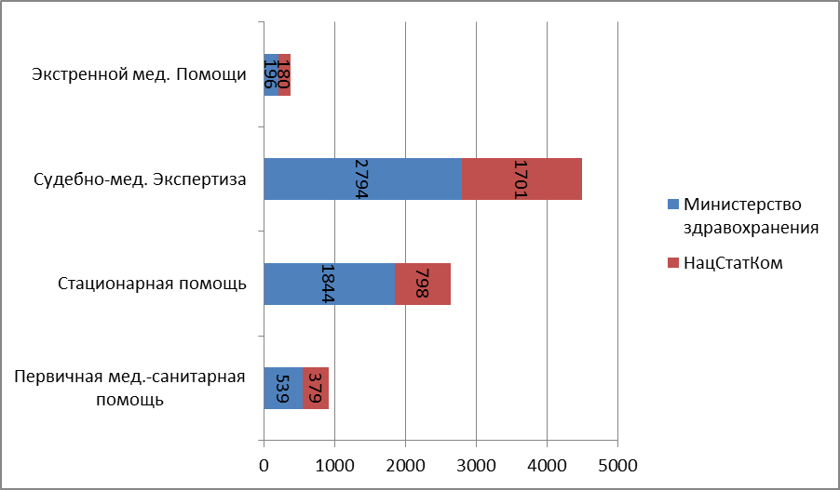
Ministry of Health

National Statistics Committee

Emergency medical assistance

Forensic medical examination

In-patient care

Primary health care
The absence of unified principles of data collection and unified classification on violence against women and children leads to the fact that different government agencies provide official information that does not correlate with each other.
As a result, it is nearly impossible to determine the actual number of crimes of violence against women and children, which in turn
- makes it difficult for all stakeholders to make an analysis of the causes and consequences of this type of offence;
- makes it difficult for all concerned parties to analyze the causes and consequences of this type of abuse
- prevents the stakeholders from developing precise, targeted and effective measures to eliminate all types of violence
- causes distrust and criticism on the part of civil society;
- causes distrust of citizens towards law enforcement agencies and courts.

Case 1

Taxi driver who raped a woman in front of her child
According to the information provided by the Issyk-Kul Regional Court, by the verdict of the Ton District Court of November 30, 2016, N.T.K. was found guilty under Article 129 of the Criminal Code of the Kyrgyz Republic and sentenced to 3 years of imprisonment at a colony with a reinforced regime.
By the decision of the Issyk-Kul Regional Court of February 27, 2017, the decision of the Ton District Court was canceled and sent to the Issyk-Kul District Court for a new consideration.
By the verdict of the Issyk-Kul District Court of August 15, 2017, N.T.K. was found guilty under Article 129 of the Criminal Code of the Kyrgyz Republic and sentenced to 8 (eight) years of imprisonment at a colony with a reinforced regime and compensation for material damage in the amount of 30,000 soms and moral damage of 100,000 soms.
By the decision of the Issyk-Kul Regional Court of December 26, 2017, the verdict of the Issyk-Kul District Court of August 15, 2017, was left unchanged.
The appeal of the lawyer who defended the interests of the defendant was not satisfied.
The decision of the Issyk-Kul regional court was not appealed by the parties to the Supreme Court of the Kyrgyz Republic.

The emerging practice of closing most cases of violence against women and children during pre-trial proceedings contributes to the increased latency of this type of offence.

According to the data of the General Prosecutor's Office, reports/statements on crimes and offenses were registered (see Table No. 1):

Table 1
In relation to minors:
Name | 2020 | 2021
Code about Offences (as amended in 2017)
Article 65. Beatings  of which discontinued | 13  12 | 58  57
Article 66. Causing minor injury to health  of which discontinued | 89  75 | 247  227
Article 75. Domestic violence  of which discontinued | 28  15 | 104  95
Criminal Code of the Kyrgyz Republic (as amended in 2017)
Article 130. Murder  of which discontinued | - | 2  2
Article 131. Murder in a state of passion  of which discontinued | - | 1  1
Article 136. Incitement to suicide  of which discontinued | 13  13 | 60  60
Article 137. Inducement to suicide  of which discontinued | 3  3 | 11  11
Article 138. Causing serious injury to health  of which discontinued | 11  3 | 3
Article 139. Causing less serious injury to health  of which discontinued | 11  4 | 26  22
Article 142. Causing serious injury to health by negligence  of which discontinued | 7  6 | 14  14
Article 145. Threat of violence dangerous to life or health  of which discontinued | - | 3  3
Article 161. Rape  of which discontinued | 33  10 | 38  17
Article 164. Sexual acts with a person under the age of sixteen  of which discontinued | 16  9 | 60  44
Article 165. Lewd act  of which discontinued | 17  9 | 36  26

Criminal Code of the Kyrgyz Republic (as amended in 2017)
Registered sexual offences committed against women  of which discontinued | 171  77 | 262  209
Cases of female suicide registered (a corpse was found without obvious signs of criminal death, incitement to suicide and inducement to suicide)  of which discontinued | 72  69 | 57  50

Analysis of data from women's non-governmental organizations and the Ombudsman Institute on complaints about inadequate responses and misconduct by individual law enforcement and investigative officials at the pre-trial stage revealed the following violations of the criminal procedure legislation of the Kyrgyz Republic:
- when accepting applications - cases of unjustified refusal and delay of the investigative process;
- failure to inform the victim of her rights and due process;
- failure to issue an order to conduct forensic examination;
- conducting investigations in the absence of a lawyer for the victim;
- failure to observe the constitutional rights and freedoms of a citizen;
- one-sided collection of evidence, biased attitude to the victim;
- unjustified change in the qualification of criminal offenses, including termination of criminal cases.

The emerging practice of terminating most cases of violence against women and children in law enforcement agencies:
- indicates discrimination against the most vulnerable group of the population: women and children, where persons with disabilities and representatives of vulnerable segments of society are at double risk;
- forms an opinion in the public about the high level of corruption in the law enforcement structures,
- shows the inconsistency and low level of professionalism in conducting investigations,
- shows negligent, perfunctory attitude to their duties by the supervisory bodies, reinforcing the irresponsibility of the employees of internal affairs bodies,
- reduces the level of public trust in state structures and increases the number of violent incidents that are not reflected in the official statistics;
- reduces the preventive educational value of prohibitions, forming in both the offender, and in persons who refrain from the offense under the fear of punishment, the understanding of the possible impunity, encouraging unlawful behavior;
- points to the low quality of work of lawyers, primarily in terms of guaranteed by the state legal aid.

The high degree of latency of crimes of violence against women and children is caused by both natural (reluctance of victims themselves) and systemic reasons (inefficiency of law enforcement and judicial authorities, corruption of these authorities, non-compliance with the principles of working with victims).

Case 2
In Talas, a junior traffic inspector of the Ministry of Internal Affairs beat his wife to death.
The incident happened on December 29, 2021.
The murder became known after the blogger Ertai Iskakov published a video of the woman's beating on his Instagram page.
The case was delayed. On May 18, 2022, the case was submitted to the Talas City Court, and before that it was under investigation.
As a result, J.A.K. was found guilty under Article 122 part 2, paragraph 7 of the Criminal Code and sentenced to 12 years and 6 months, without confiscation of property, to serve his sentence in a penal colony of general regime.

Case 3
In 2022, U.A. applied to the Ombudsman Institute about domestic violence committed by her husband. At the time of applying to the Ombudsman Institute, the woman had numerous bruises and abrasions on her body and face.
The police officers of Karakol city did not act on the fact of domestic violence. The Ombudsman Institute sent a letter to the Prosecutor of Issyk-Kul Province and to the Department of Internal Affairs of Issyk-Kul Province. After that, a criminal case was initiated based on Part 1 of Art. 138 of the CC of the KR. The victim's husband was detained as a suspect in the crime and placed in the temporary detention facility of the Department of Internal Affairs in Karakol.
By the decision of the commission on children's affairs, the victim U.A. and her minor children were temporarily placed in Cholpon-Ata city. By the decision of the Karakol City Court, where a lawyer was provided, U.A.'s husband was sentenced to six years of imprisonment.
Concerning the failure to act by the police officers of Karakol city, the Ombudsman Institute sent a demand to bring to justice the responsible persons. For dissemination of inaccurate information in the Internet sources about this case of violence and inaction, the major of the district police, the Department of Internal Affairs of Karakol city received a disciplinary sanction in the form of reprimand.

Case 4
The Ombudsman Institute has been working for more than a year to reinstate the violated rights of citizen R.N., on the fact of torture in 2017 by police officers and unjustified termination of pre-trial proceedings by the Investigation Department of the SCNS Department in Jalal-Abad Province.
At the time of the torture the woman was pregnant.
Only in 2018, the General Prosecutor's Office approved a resolution to initiate criminal proceedings on the above fact and the investigation was entrusted to the Investigative Division of the Jalal-Abad Province Department of the SCNS.
According to the conclusion of a comprehensive forensic medical and psychiatric examination, R.N. suffered less severe injury to health in the form of post-traumatic stress disorder.
The victim R.N.'s post-traumatic stress disorder was confirmed by an examination conducted in accordance with the standards of the Istanbul Protocol based on the form approved by the Ministry of Health.
However, despite the conclusion of the examination, pre-trial proceedings were repeatedly terminated for lack of corpus delicti.
Disagreeing with the decision of the investigative authorities, R.N. appealed to the judicial authorities to cancel the decision to terminate the pre-trial proceedings.
During the trial, the prosecutor overseeing the investigation believed that the investigator's decision was lawful and justified and requested that the appeal be dismissed. As a result, the court dismissed the complaint.
To date, no proper legal assessment of the case has been made.

The fewest crimes and offences for all types of violence against women and children reach the courts.

In Kyrgyzstan, the number of domestic violence is increasing, so according to the National Statistics Committee in 2014 as a result of domestic violence there were 2,521 cases of violence against women and for seven years this figure has increased to 8,587 cases (see Figure 2).
Figure 2
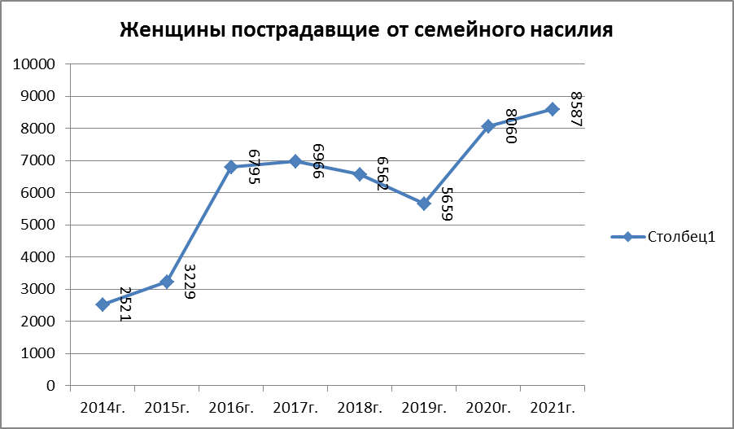
Column1
Women, the victims of domestic violence

For example, in 2019, according to the data of the Supreme Court of the Kyrgyz Republic, out of 5,659 registered cases of domestic violence, 140 criminal cases were brought to court, of which 53 cases were terminated. At the same time, out of 653 cases of domestic violence-related offenses brought to courts of the republic, 148 guilty verdicts and 1 acquittal verdict were issued based on results of consideration, with 110 of 148 verdicts being on domestic violence facts (Article 75 of the Criminal Code) (74.3 per cent of the total number of sentences) and 384 cases were dismissed, making up 58.8% of the total number of completed cases of offences related to domestic violence. (See Figure 3).
Figure 3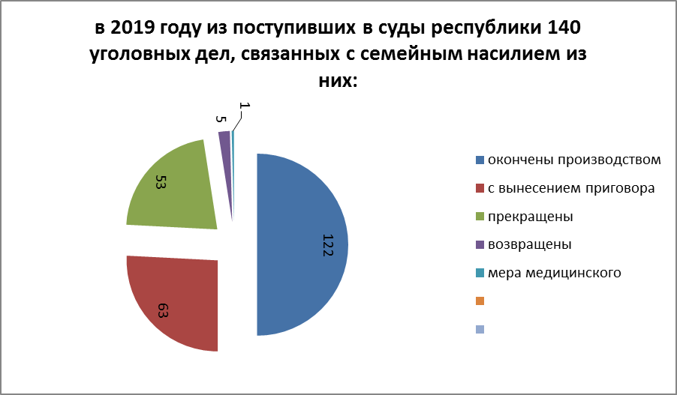
In 2019, 140 criminal cases related to domestic violence received by the courts, of which
ended in proceedings
with a verdict
terminated
returned
medical measure

In 2020, of 5,903 misdemeanor cases received, cases under Article 75 of the Administrative Code totaled 1,028, or 20.5%. Of the 1,028 cases received, 728 were dismissed (70.8%) and 287 were considered resulting in a guilty verdict (27.9%).

The high proportion of cases dismissed in the courts testifies to the fact that perpetrators of crimes can avoid responsibility under formal legal norms, which creates a feeling of impunity in society for guilty acts committed against women and children.
At the same time, one of the grounds for exemption from liability is reconciliation of the parties and absence of claims from the injured party.

Misdemeanor cases of domestic violence averaged 19% of all misdemeanor cases, and the percentage of persons convicted of domestic violence misdemeanors from 2019 to 2021 averaged 13% of all persons prosecuted for various misdemeanors in the same period.

It should be noted that a significant number of misdemeanor cases are dismissed during court proceedings and this rate is on an increasing trend. For example, while 384 domestic violence misdemeanor cases were dismissed in 2019, representing 21% of all misdemeanor cases dismissed, in 2020 there were 728 such cases (27%), and in 2021 the figure is 794 cases (25%). At the same time, some cases last for years in the courts.

Case 5
The husband poured boiling water over his wife's genitals and beat her to death. As a result, she died of the received injuries.
A dispute between the spouses escalated into a beating. An investigation under the Article "Murder" was initiated regarding this fact.
They left behind one daughter and two sons.
The verdict of Batken District Court of June 1, 2020 found S. Sh. guilty under Article 130 para. 2 p. 3, 9 of the Criminal Code of the Kyrgyz Republic and sentenced to 15 years of imprisonment.

Case 6
К. A. (31 years old). She applied to Sezim Crisis Center (hereinafter - CC) for legal assistance, in December 2013 she was raped by the employees of the judicial authorities in one of the provinces of the KR. On the basis of the victim's statement dated 31.12.2013, a criminal case was initiated on the fact of rape. Due to the fact that the rapists were representatives of the judiciary, the victim K.A. expressed her distrust in the composition of the court in the province, the proceedings on the challenge of the entire composition of the court lasted for 8 months, and only in October 2014 the Supreme Court of the Kyrgyz Republic issued a determination to transfer the criminal case to the Sokuluk district court of the Chui Province of the Kyrgyz Republic. K. applied to Sezim CC and was provided with shelter services. She was in an extremely anxious state, complaining of headaches and bleeding. The woman was hospitalized in maternity hospital No. 4 in Bishkek. K.A.'s two children were temporarily placed in an orphanage. As a result of the assistance rendered (psychological, legal, medical and social), K.A.'s condition has significantly improved. For eight months, Sezim's specialists provided her with legal assistance in preparing petitions, statements, and complaints to law-enforcement and judicial agencies. A press conference was initiated on the case by the Center, and articles were prepared and published in the national media. The lawyer of the center took part in 5 court sessions, also Sezim CC provided the victim K.A. with the public defender. As of today, the case is at the stage of proceedings in the Court of First Instance.

High risk of exposure to violence among migrant children, the scale of the problem is critical.

According to the Ministry of Labor, Social Welfare and Migration of the Kyrgyz Republic, in 2021 93,501 children whose parents work outside the country were identified. In the first half of 2022 the number of migrant children was 87,426 (see Table 2).
Table 2
 | 2019 | 2020 | 2021 | 2022, 6 months
Number of migrants’ children | 106,000 | 85,459 | 93,501 | 87,462
Number of sexually abused children | 62 | 71 | 118 | 55 (beginning of 2022)

In 2020, according to information from the Prosecutor General's Office, 788 crimes and misdemeanors were committed against minors; in 2021, 2,287 crimes and misdemeanors were committed against minors.

For 2020, data on children subjected to abuse and violence are presented by categories: physical violence-171, sexual violence-71, psychological violence-39. For 2021: physical violence-222, sexual violence-111, psychological violence-77. According to the Ministry of Internal Affairs, more than 400 cases of violence against children have been registered since the beginning of 2022. Out of these 400 cases, 55 cases were sexual violence. Of the 55 cases of sexual violence, there were: 19 cases of rape, 5 attempted sexual abuse, 23 attempted sexual abuse of minors, and 8 cases of debauchery.

The key reasons for the high risk of violence against migrant children are:
- impunity for violence;
- irresponsibility of parents;
- difficult life situation;
- inadequate prevention mechanisms and silencing of cases of violence by those around the child;
- low level of education, limited resources for access to education;
- child labor and psychological violence;
After the migration of parents, children are often left with relatives, and in many cases with grandparents, who may not be able to meet the needs of growing children.

Case 7
In Batken Province, three men raped and killed a 14-year-old girl.
On 04.09.2022 at about 3:25 p.m. the Department of Internal Affairs of Kadamjay District of Batken Province received a call that an unknown girl's body was found on the 146th km of the Osh - Razzakov road inside a mud diversion tunnel in the village of Noogardan.
The police arrived on the site and determined that the victim was a 14-year-old girl, whose hands were tied behind her and there were signs of strangulation on her neck with a rope. The girl had been raped.
A criminal case was opened under the article "Murder" of the Criminal Code of the Kyrgyz Republic and a forensic medical examination was ordered.
During the investigation four residents of Kadamjay District born in 1995, 1997 and 1998 were detained on suspicion of murdering the girl. Evidence was found in the car of one of the suspects and the car was seized as physical evidence.
The detainees were brought to the temporary detention facility. The investigation into the case continues.
The girl's parents were migrants and were in Russia, the girl lived with her grandmother.
The case was taken under the personal control of the President.

III. General information

This alternative report was prepared by the Ombudsman Institute.
The methodology of the report includes:
1. Gathering of information from the annual and special reports of the Ombudsman of the Kyrgyz Republic; data on the complaints of citizens received by the Ombudsman; official information of the State bodies; non-governmental organizations; materials of the complaints received by the internal affairs bodies on which the initiation of criminal proceedings was refused.
2. Analysis and systematization of the collected data.
3. Consultations with representatives of the civil society.
In preparing the alternative report, the team of the Ombudsman Institute adhered to the principles of objectivity, validity and balance of the recommendations developed.

List of abbreviations:

KR - Kyrgyz Republic
ICCPR - International Covenant on Civil and Political Rights
PGO - Prosecutor General's Office of the Kyrgyz Republic
MoH - Ministry of Health of the Kyrgyz Republic
National Statistics Committee - National Statistics Committee of the Kyrgyz Republic
MIA - Ministry of Internal Affairs of the Kyrgyz Republic
DIA - Department of Internal Affairs
OIA - Office of Internal Affairs
CC - Criminal Code

The Criminal Code of the Kyrgyz Republic (2017) excluded the possibility of exemption from criminal liability for crimes against sexual inviolability and sexual freedom of a person in relation to persons under 14 years of age due to the limitation of the crime and the limitation of execution of the conviction. Already on August 9, 2022, amendments to the Criminal Code were adopted which exclude the grounds for exemption from criminal liability and punishment for committing a crime against a child under the age of 18 years, and also increase the minimum limit of sanctions for articles and exclude the application of amnesty to persons convicted for committing crimes against the sexual inviolability of a child under the age of 18. The president instructed state agencies to strengthen work on preventing violence against children. https://kabar.kg/news/ubiistvo-devochki-v-kadamzhae-sadyr-zhaparov-vzial-delo-na-kontrol/
Letter of the Prosecutor General's Office to the Ombudsman Institute dated 07.03.2022, however, the same Prosecutor General's Office in its letter dated 26.07.2022 indicated that 233 cases were registered on the crime of “Rape” of which 157 cases were against women and 76 cases were against children.
https://mvd.gov.kg/news/1106
Letter of the National Statistical Committee dated 11.08.2022
Letter of the Ministry of Health and Social Development to the Ombudsman Institute dated 11.05.21
Letter of the Prosecutor General's Office to the Ombudsman Institute dated 07.03.2022,
Alternative report to the fifth periodic report of the Kyrgyz Republic to the CEDAW Committee, NGO Council 2019
According to the National Statistical Committee
Alternative report to the fifth periodic report of the Kyrgyz Republic to the CEDAW Committee, NGO Council 2019
http://admin-vshp.sot.kg/public/sites/3/2020/02/ug_analit_obzor_sudi-29052019.pdf
Data from the Prosecutor's Office, the Ministry Internal Affairs, the National Statistics Committee and other state bodies and non-governmental organizations were received at the time of preparing this report (June-September 2022) and were updated.
On August 12, the Ombudsman of the Kyrgyz Republic held a consultation with representatives of non-governmental organizations of Kyrgyzstan working on the protection of women and children.

