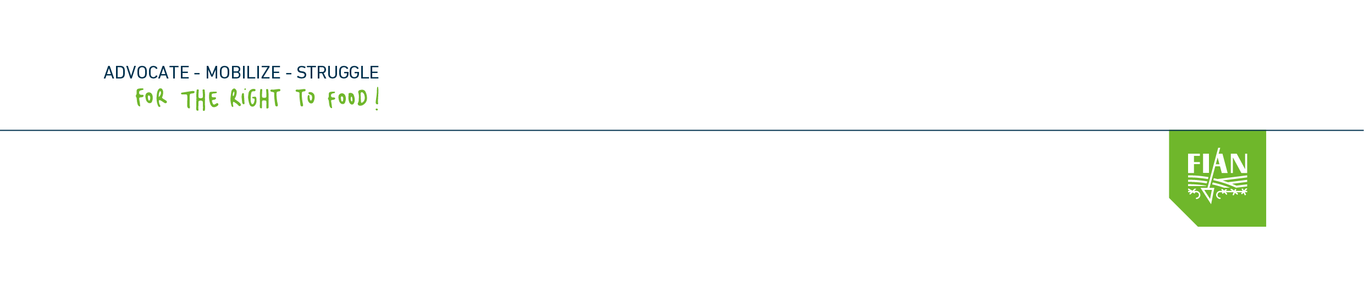

Submission to the UN Committee on Economic, Social and Cultural Rights

Belgium – 5th periodic report

Pre-sessional working group (15 – 19 October 2018)

List of Issues Prior to Reporting

August 2018

Contribution by FIAN Belgium (member of FIAN International)
Rue Van Elewyck, 35
1050 Bruxelles – Belgium
Tél : +32 2 640 84 17
www.fian.be

Contact person : Manuel Eggen – manu@fian.be
FIAN Belgium submits this written contribution to the United Nations Committee on Economic, Social and Cultural Rights (Committee ESCR) in advance of the adoption of the list of issues prior to reporting (LoIPR) for Belgium's 5th periodic report on the implementation of the obligations of the International Covenant on Economic, Social and Cultural Rights (the Covenant).

Part I: Domestic application of the Covenant
1. Despite Belgium being one of the wealthiest country in the world, the right to food and nutrition is still far from being a reality in Belgium. More than 577.000 people live in severe material deprivation (Eurostat) and food banks estimate that 450.000 people are dependent on food aid. On the other side nearly half of the population is overweight because of inadequate diets and rising consumption of junk food promoted by the non regulated industrial food companies. Small-scale farmers are disappearing and their rights are under threats. FIAN Belgium is concerned that the right to food is not enshrined in national legislation and that Belgium is not taking the necessary measures « to the maximum of its available resources » to ensure the progressive realization of the right to food for every citizen. In the second part FIAN Belgium highlihts some problems regarding the extraterritorial obligations of Belgium.

Issue 1: The right to food is not enshrined in Belgian law
2. Despite the ratification by Belgium of various international human rights instruments recognizing the right to food, it is not explicitly enshrined in the Constitution nor in any national legislation, unlike other economic, social and cultural rights (see article 23 of the Constitution). This prevents the implementation and invocation of the right to food and nutrition before the courts and tribunals affecting the access to justice of victims of right to food violations and abuses. To our knowledge, no judicial decision has been based on the right to food.
3. A proposal for a framework law on the right to food was tabled in the Federal Parliament in 2014. However, it has never been considered and discussed so far.
4. Belgium does not have a national strategy for the realization of the right to food and nutrition. On the contrary, food policies are characterized by a significant fragmentation in the intricated institutional system of Belgium with various level of power (federal, regional, community and local) as well as through a multitude of sectoral policies with no link between them. This excessive segregation prevents a strategic and coordinated approach to the realization of the right to food and nutrition in Belgium.

5. Relevant international recommendations to be considered:
- Recommendations from the Human Rights Council (HRC) in the last Universal Periodic Review of Belgium to “Consider debating and adopting the framework law on the right to food” (A/HRC/32/8, §140.32).
- Committee ESCR, General Comment n°12: the right to adequate food (art. 11) (E/C.12/1999/5, §21 and following) recommending States to adopt framework laws and national strategies on the right to food.
- Voluntary Guidelines to support the progressive realization of the right to adequate food in the context of national security (Right to Food Guidelines) (especially Guidelines 7 on the adoption of framework laws and national strategies);
- Recommendations from the Special Rapporteur on the Right to Food regarding national laws and strategies (A/HRC/25/57, §40-44).
Proposed question to the Committee:
6. How does Belgium ensure the implementation of the obligations of the right to food in its domestic legal order? Is the right to food directly invocable before the courts and tribunals? Can Belgium provide examples of court decisions relying on the right to food? Does Belgium consider adopting a framework law on the right to food and a national strategy in line with international recommendations?

Issue 2: Poverty level in Belgium
7. As part of the Europe 2020 targets, Belgium has committed to reducing the number of people at risk of poverty or social exclusion by 380,000 compared to 2010 figures. In this perspective, Belgium has adopted three Federal Plans to Combat Poverty.
8. With two years to go before the 2020 targets and ten years after the adoption of the first federal plan in July 2008, no significant reduction has been achieved. The risk of poverty and social exclusion navigates from 20.8% in 2010 to 20.3% in 2017 and the rate of severe material deprivation has also not been reduced.
Belgium | 2008 | 2009 | 2010 | 2011 | 2012 | 2013 | 2014 | 2015 | 2016 | 2017
People at risk of poverty or social exclusion (%) | 20,8 | 20,2 | 20,8 | 21 | 21,6 | 20,8 | 21,2 | 21,1 | 20,7 | 20,3
Severe material deprivation (%) | 5,6 | 5,2 | 5,9 | 5,7 | 6,3 | 5,1 | 5,9 | 5,8 | 5,5 | 5,1
Inability to afford a meal with meat, chicken, fish (or vegetarian equivalent) every second day (%) | 5 | 4,6 | 5 | 4,8 | 5,2 | 4,6 | 5,1 | 5,1 | 6,1 | 5,6
Source: Eurostat

9. These figures demonstrate the inadequacy of poverty reduction plans. And the plans contain no accountability measures for Parliament and civil society to hold the government accountable for its commitments.
10. On the other hand new austerity measures have been adopted that risk to impact the level of poverty for unemployed people. Namely the Royal Decree of 23 July 2012 (Arrêté royal portant la réglementation du chômage dans le cadre de la dégressivité renforcée des allocations de chômage) has included new exclusion criteria for unemployment benefits which resulted in massive exclusion, especially for young people. Approximately 37.000 have been excluded between 2015 and 2017. This is contrary to the obligation of non retrogression.
11. Relevant international recommendations to be considered:
- Recommendations of the Committee ESCR during Belgium's last periodic report asking Belgium to ensure that “poverty reduction plans and other policy measures have a concrete impact on poverty reduction”. (E/C.12/BEL/CO/4, §18).
- ICESCR art. 11 (the right to an adequate standard of living) and General Comment n°3 on the nature of States parties’ obligations (E/1991/23) (especially §9 and 10 on non retrogressive measures and on a minimum core obligation to ensure the satisfaction of, at the very least, minimum essential levels of each of the rights).
Proposed question to the Committee
12. How does Belgium intend to achieve its objective of lifting 380,000 people out of poverty by 2020? What accountability mechanisms have been put in place to hold the government accountable for its commitments? How many people have lost their unemployment benefits following the introduction of the Royal Decree of 23 July 2012 and what is the impact on their risk of poverty?

Issue 3: Rising level of overweight and obesity
13. Since 1997, health surveys conducted in Belgium have revealed a worrying increase in overweight and obesity. In the course of surveys, the prevalence of overweight rose from 41% in 1997 to 48% in 2013 (last survey), while obesity rose from 11% to 14% over the same period. It should also be noted that nutritional status is strongly linked to people's socio-economic conditions. Among less educated populations, two in three adults (64%) are overweight and 1 in 4 (25%) are obese.

14. Relevant international recommendations:
- Right to Food Guidelines (Guidelines No. 10), including Guideline 10.2 which recommends “to take steps, in particular through education, information and labelling regulations, to prevent overconsumption and unbalanced diets that may lead to malnutrition, obesity and degenerative diseases. »
- Committee ESCR, General Comment n°12 on the right to food which recommends to take measures “to maintain, adapt or strengthen dietary diversity and appropriate consumption and feeding patterns” (E/C.12/1999/5, §9).
Proposed question to the Committee
15. How does Belgium intend to combat the worrying increase in the prevalence of overweight and obesity? In addition to awareness measures, what regulatory measures are envisaged to address inadequate diets, including the regulation of non states actors commercializing ultra processed food and junk food in the market and their marketing practices?

Issue 4: Difficulties of small-scale farmers and rights of peasants
16. Despite the recommendations of the Committee ESCR during the last periodic report to protect small-scale agriculture in Belgium and to implement plans aimed at its preservation, small farms continue to be disappearing in Belgium. Since 1980, Belgium has lost 68% of its farms.
 | 1980 | 1990 | 2000 | 2010 | 2014 | 2015 | 2016
Number of farms | 113.883 | 87.180 | 61.926 | 42.854 | 37.194 | 36.921 | 36.910
Source : Ministère de l’Economie

17. This situation unveils the unease that weighs on the profession of farmer: downward trend in prices and price volatility of agricultural raw materials, increasing indebtedness, non-valuation of the social functions of the profession of farmer, administrative burdens for the management of subsidies, etc. The isolation and marginalization of farmers is accompanied by particularly worrying suicide rates, particularly among small farmers. Although there are no official figures in Belgium, the situation is comparable to other European countries, such as France, where studies reveal that farmers constitute the socio-professional category most at risk with an excess mortality by suicide among farmers 20 to 30% higher than the population average.
18. This situation is not only a violation of the rights of peasants in Belgium but poses a threat for the sustainability of the right to food of the overall population in Belgium.
19. Against this background it is also important that Belgium supports the protection and promotion of the rights of peasants at international level. To this end the HRC has created an Open-ended intergovernmental working group (IGWG) on the rights of peasants and other people working in rural areas. Unfortunately Belgium has voted against the creation of this IGWG in 2012 and has not participated constructively to the discussions so far.
20. Relevant international recommendations:
- The recommendations of the Committee ESCR during Belgium's last periodic report asking Belgium to "protect small-scale farming in Belgium and implement the plans designed to preserve it" (E/C.12/BEL/CO/4, §21).
- The recommendations of the Human Rights Council during the last universal periodic review which recommended that Belgium "Promote and protect the rights of indigenous peoples, peasants and other persons working in rural areas" (A/HRC/32/8, §138.129).
Proposed question to the Committee
21. What plans have been implemented by Belgium to protect small-scale agriculture in accordance with the recommendations of the last periodic report? Does Belgium have specific data on the living conditions of farmers, in particular suicide rates?
22. How is Belgium internationally cooperating to create an enabling environment for the realization of the ESCR of peasants. In particular will Belgium support the work of the IGWG to adopt a UN Declaration on the the rights of peasants and other people working in rural areas ?

Part II: Extraterritorial obligations of Belgium to the Covenant

Issue 5: Decrease of Official Development Assistance
23. Despite the commitment in the Development Cooperation Act of 19 March 2013 (article 9) to devote 0.7% of gross national income to official development assistance (ODA), there has been a downward trend in Belgian ODA since 2010, falling from 0.64% of GNI to 0.45% in 2017.
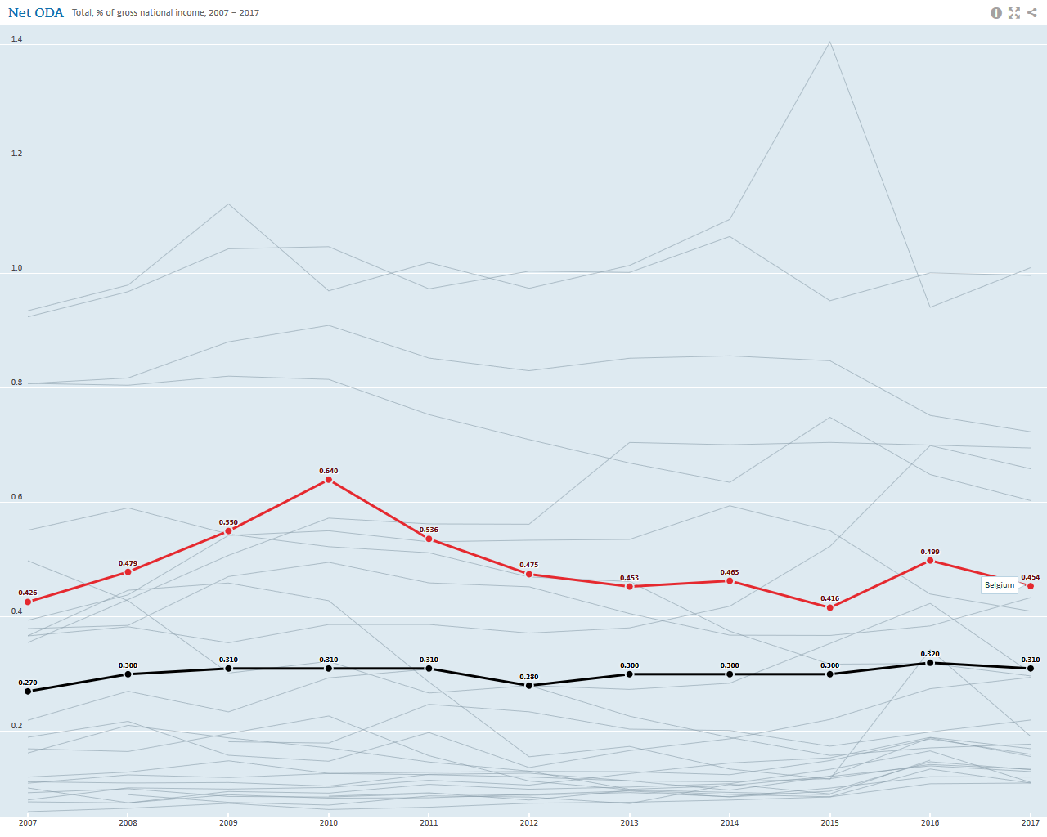
Source : OECD (Red : Belgium ODA – black : average for OECD countries)

24. Relevant international recommendations:
- The Committee ESCR "recommends that Belgium « step up its efforts to attain the objective of increasing its international official development assistance to 0.7 per cent of GDP."(E/C.12/BEL/CO/4, §9).
Proposed question to the Committee
25. Why does Belgium not respect its international commitments, enshrined in the Development Cooperation Act, to devote 0.7% of its Gross National Income to official development assistance? What are the forecasts for the future?

Issue 6: Policy support to agrofuels impacting food security
26. Numerous international reports have demonstrated the impacts of large-scale agrofuels plantations on food security, particularly in developing countries.
27. During the last periodic report the Committee ESCR had expressed concerns regarding the Belgian policy promoting agrofuels: “The Committee is concerned by reports that the State party’s policy for promoting agrofuels, in particular its new Agrofuels Act of 17 July 2013, is likely to encourage large-scale cultivation of these products in third countries where Belgian firms operate and could lead to negative consequences for local farmers” (E/C.12/BEL/CO/4, §22).
28. Despite this, Belgium has continued to promote agrofuels. In January 2017 the E10 fuel (composed of 10% max of ethanol) was introduced on the Belgian market in replacement of E5 fuel (composed of 5% max of ethanol). As a result consumption of ethanol has once again increased. And unlike in other countries consumers don’t have the possibility to choose for biofuel-free petrol.
29. Relevant international recommendations:
- Recommendations of the Committee ESCR on biofuels (E/C.12/BEL/CO/4, §22) “The Committee recommends that the State party systematically conduct human rights impact assessments in order to ensure that projects promoting agrofuels do not have a negative impact on the economic, social and cultural rights of local communities in third countries where Belgian firms working in this field operate”.
- The recommendations of the Human Rights Council during the last universal periodic review which recommended that Belgium "Conduct studies on the impact that agrofuel production projects promoted by Belgian companies may have on the human rights of local communities in third countries" (A/HRC/32/8, §141.35)
Proposed question to the Committee
30. Has Belgium conducted human rights impact assessments of its agrofuels promotion policy as recommended by the Committee and the Human Rights Council? Does Belgium plan to limit the use of agrofuels produced from agricultural commodities or linked to agricultural land? How does Belgium regulate the due diligence and duty of care of Belgian companies (and companies benefitting from public support) active on trade of agrofuels? Which regulations have been adopted to hold them accountable for violations and which remedy mechanisms are available for the communities affected by such activities ?

Issue 7: Corporporate Accountability for human rights abuses
31. In July 2017, the federal government approved the first "National Action Plan for Business and Human Rights" (NAP) as recommended by the Guiding Principles on Business and Human Rights. While welcoming this first NAP, civil society has identified critical gaps:
- The NAP is limited to a series of voluntary measures to strengthen corporate social responsibility, while the International Principles and the recommendations of the ESCR Committee call for a mix of voluntary and mandatory measures, including legislative initiatives.
- The NAP lists a series of actions without clearly setting out objectives and indicators, responsibilities for implementing the actions and the resources needed to implement them, or deadlines.
- While consultative sessions were organised by governement representatives during the elaboration of the NAP the official opinions of the representative bodies of civil society (namely the Federal Council for Sustainable Development and the Advisory Council on Policy Coherence for Development) were not taken into account.
32. FIAN Belgium is also concerned about Belgium's position in the negotiations for the preparation of a legally binding international instrument on transnational corporations and other business enterprises and human rights. Belgium has so far shown itself to be unconstructive in the discussions with a view to drawing up the Treaty.
33. Relevant international recommendations
- General comment No. 24 (2017) of the Committee on ESCR on States' obligations under the International Covenant on Economic, Social and Cultural Rights in the context of business activities (E/C.12/GC/24).
Proposed question to the Committee
34. Does Belgium plan to supplement its NAP with objectives, indicators, distribution of roles, financial resources and implementation deadlines? Does Belgium plan to supplement its NAP with binding measures, in particular on the duty of vigilance of companies? Does Belgium plan to participate actively in the negotiations on a UN binding treaty and if so which position will it support?

H-O Hubert et J. Vleminckx, (2016) « L’aide alimentaire aujourd’hui, le droit à l’alimentation demain », Recherche-Action, Fédération des services sociaux, Bruxelles.
DOC 54 0518/001. Voir : http://www.lachambre.be/FLWB/PDF/54/0518/54K0518001.pdf
For example: agricultural policy is shared between the federal level and the three Regions. There is a federal minister of agriculture and 3 regional ministers, whose exact powers are not clearly defined. Health competencies are also sausaged between the federal level and the regions. Since the 6th reform of the State, the "National Nutrition-Health Plans" will be replaced by regional plans.
https://www.mi-is.be/fr/plan-federal-de-lutte-contre-la-pauvrete
http://www.etaamb.be/fr/arrete-royal-du-23-juillet-2012_n2012204341.html
Le Soir « 37.000 personnes exclues des allocations d’insertion en deux ans », 16/03/2017. http://plus.lesoir.be/86193/article/2017-03-16/37000-personnes-exclues-des-allocations-dinsertion-en-deux-ans
Institut scientifique de santé publique (2013), « Enquête de santé 2013 », Bruxelles. Disponible : https://his.wiv-isp.be/fr/Documents%20partages/NS_FR_2013.pdf (consulté le 24 juillet 2018).
Voir : Le suicide des agriculteurs en chiffres https://www.francebleu.fr/infos/societe/le-suicide-des-agriculteurs-en-chiffres-1517491824 ; et I. Khireddine-Medouni et al. (2016), « Surveillance de la mortalité par suicide des agriculteurs exploitants. Situation 2010-2011 et évolution 2007-2011 ». Saint-Maurice : Santé publique France. http://invs.santepubliquefrance.fr/Publications-et-outils/Rapports-et-syntheses/Travail-et-sante/2016/Surveillance-de-la-mortalite-par-suicide-des-agriculteurs-exploitants
HLPE (2013), “Biofuels and food security”, A report by the High Level Panel of Experts on Food Security and Nutrition of the Committee on World Food Security, Rome.
https://www.fian.be/Le-Plan-d-Action-National-belge-Entreprises-et-Droits-de-l-Homme-1052?lang=fr

