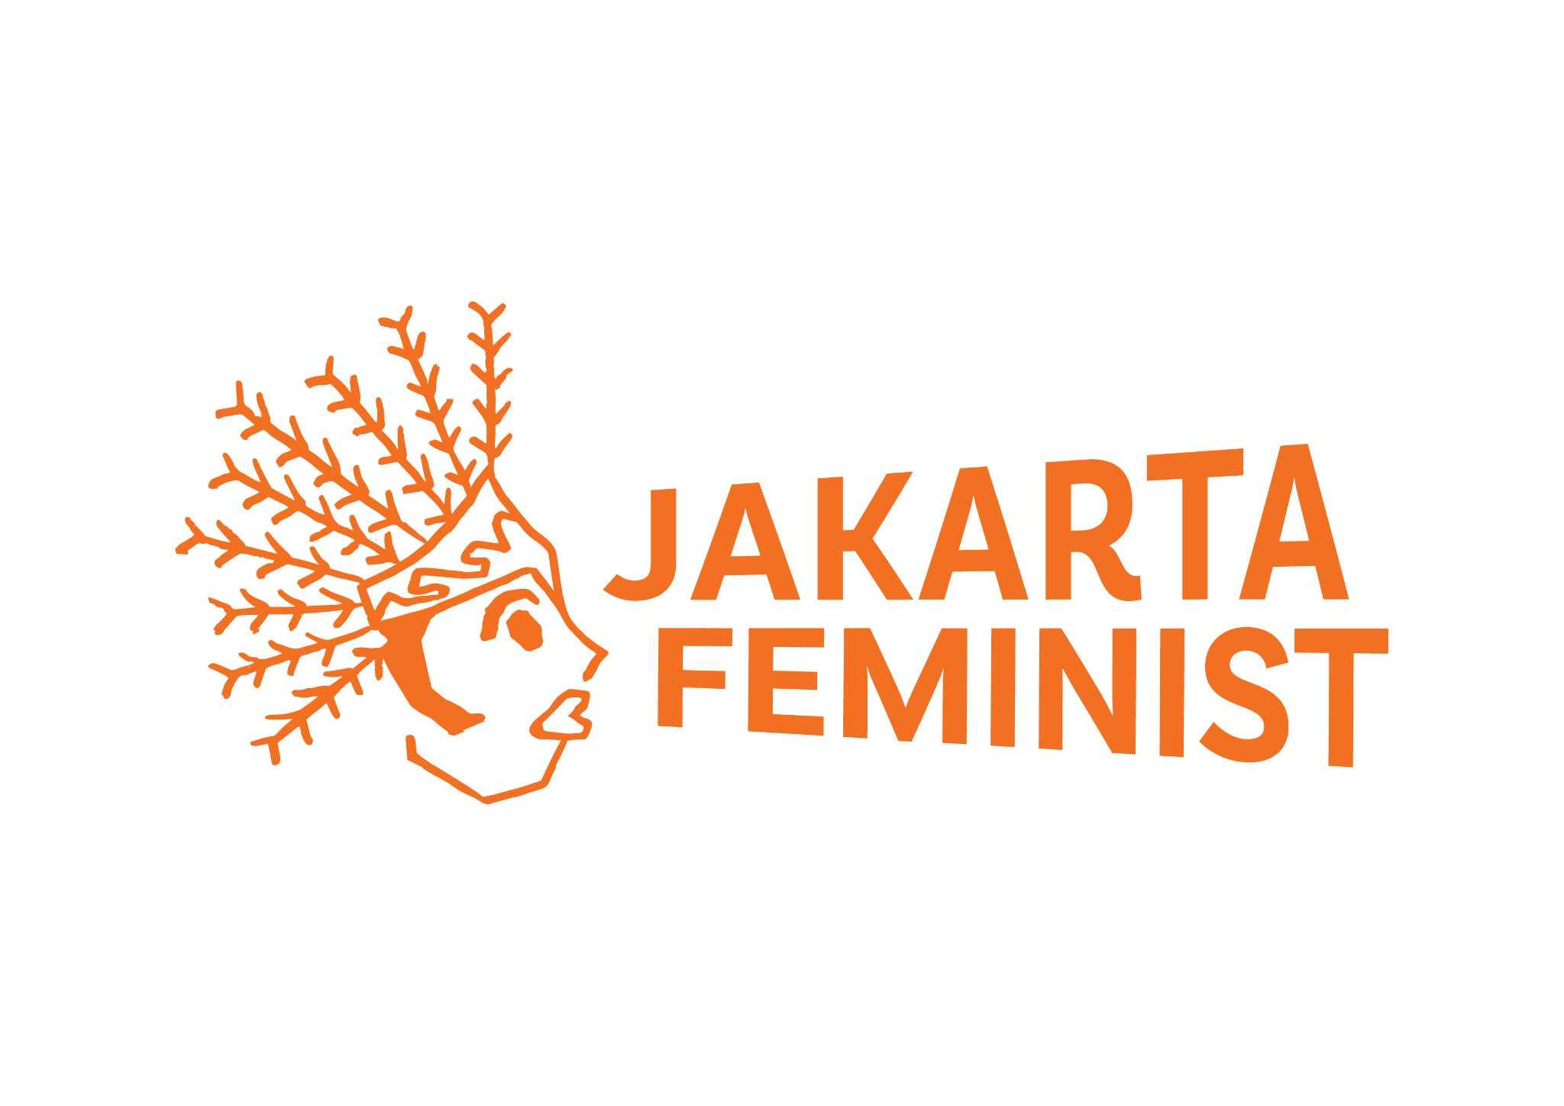

CEDAW Shadow Report 2021:

INDONESIA

FOR THE 80TH SESSION OF THE UNITED NATIONS COMMITTEE ON CEDAW (2021)

Prepared by:
Perkumpulan Lintas Feminis Jakarta
(Jakarta Feminist)

September 2021

Executive summary
Gender-based violence (GBV) remains a pressing issue in Indonesia, with reported cases increasing almost eight-fold between 2008 and 2019. Of particular concern is online GBV, particularly due to the lack of legal routes for victim-survivors and the tendency of existing laws to place victim-survivors as producers of pornography.

Community acceptance of GBV also remains worryingly high, and awareness of service providers is low. Consequently, only a small minority of victim-survivors report the violence they experience. Significant legislative challenges complicate the situation, especially with regard to the non-ratification of the Draft Law on the Elimination of Sexual Violence.

Summary of recommendations:
- Urgently revise existing and draft laws to ensure GBV victim-survivors’ rights are upheld;
- Urgently ratify the Draft Law on the Elimination of Sexual Violence;
- Repeal and amend existing and draft laws criminalising and persecuting homosexuality, consensual sex, abortion, and sexual education;
- Strengthen key GBV support providers (P2TP2A and SAPA 129);
- Provide annual funding to non-government GBV support providers.

This report may be posted on the CEDAW website for public information purposes.

Authors can be contacted at info@jakartafeminist.com.

Submitted by Perkumpulan Lintas Feminis Jakarta
20 September 2021

Section 1. GBV prior to the COVID-19 pandemic
Prevalence of GBV
The 2016 Women’s Health Survey found that 1 in 3 women in Indonesia aged 15-64 have experienced physical and/or sexual violence. Indonesia’s CEDAW report cites government data from Simfoni PPA, stating that 21,428 cases of domestic abuse were recorded in 2018.

However, other data indicate that GBV levels are significantly higher. Data from the National Commission on Violence Against Women (Komnas Perempuan) – collected from on cases reported to service providers, courts, Komnas Perempuan, and the National Commisison on Human Rights (Komnas HAM) – shows that between 2008 and 2019, the number of reported GBV cases increased 792%. The increase is dramatic: in 2008, just 54,425 cases of GBV were reported. In 2019 alone, a total of 431,471 cases were reported.

Table 1. GBV cases recorded by Komnas Perempuan, 2017-2020
Year | Number of GBV cases reported | Number of cases handled by GBV service providers | Number of cases handled by religious courts | Number of cases handled by Komnas HAM
2017 | 348,466 | 13,384 | 335,062 | 20
2018 | 406,178 | 13,568 | 392,610 | 768
2019 | 431,471 | 14,719 | 421,752 | 1,277
2020 | 299,911 | 8,234 | 285,819 | 2,389
(Source: compiled from Catatan Tahunan Komnas Perempuan 2018-2021)

Annually, domestic violence represents as much as 80% of reported cases. One high-profile domestic violence case was the 2017 murder of a medical doctor who was shot six times by her husband at her medical practice in Jakarta. The doctor had repeatedly asked for a divorce, reportedly due to frequent physical abuse. Her death was widely-discussed in Indonesia due to the brutality and public location of her murder.

Online GBV has particularly increased in recent years. According to LBH APIK Jakarta, a legal aid body that assists women and children victims of violence in Greater Jakarta, the frequency of online GBV has grown dramatically within the past five years. In 2019, LBH APIK Jakarta received 196 reports of online GBV.

One high-profile case of online GBV is that of B, a female high school staff member from Lombok, who was sexually harassed during a phone conversation with her former employer and school principal. The National Court in Mataram found B guilty under Article 27(1) of the Electronic Information and Transaction Law (UU ITE) for recording their conversation on her mobile phone. B filed an appeal to Indonesia’s Supreme Court. Despite having previously issued Supreme Court Regulation No. 7/2017 as guidance for examining women in court, the Supreme Court found Nuril guilty, sentencing her to six months in prison and a fine of IDR five hundred million. B gained national support and received amnesty from President Joko Widodo in 2018. B’s case shows the lack of protection for victims of GBV in Indonesia, including the existence of laws that actually increase their vulnerability. (See Section 3 of this report for further discussion of UU ITE.)

GBV against women human rights defenders
Women human rights defenders (WHRD) in Indonesia are facing increased stigmatization, intimidation, and violence. In 2019, Komnas Perempuan received 36 reports from WHRD who experienced violence from the state and/or mass organisations. In early 2020, LBH Apik Jakarta staff were physically intimidated by a group of people and several police officers. The intimidation occured when LBH Apik was handling a domestic violence case; the aggressors falsely claimed to be friends and relatives of the victim’s family members and demanded to see the victim.

Aggression and intimidation is also experienced by organisers of women’s protests. During the Women’s Marches in Yogyakarta and Jakarta in 2018, female and LGBTQ+ organisers were followed by members of both mass organisations and state intelligence, and their pictures and identities were circulated on social media by Islamist groups. Multiple organisers received threats of rape and murder through social media.

GBV affects everyone, not only cisgender women
There remains a tendency in Indonesia to believe that only cisgender women can be victim-survivors of GBV. In fact, men (both cisgender and transgender), transgender women, non-binary people, and third gender people are also affected by GBV in Indonesia.

Trans women are especially vulnerable with regard to violence and discrimination. In Jakarta in early 2020, a trans woman was accused of stealing from a truck driver. The woman was interrogated by a group of six preman (paid thugs), who forced her to admit to stealing. They beat her up, poured petrol on her, and set her on fire. A National Police Commission member described the woman’s murder as “barbaric”.

Violence against trans women does not only come from community members but also from law enforcement officers. In 2018, police and Syariah Wilayatul Hisbah (Islamic Religious Police Force) officers arrested 12 transgender women working in beauty salons. The women were forced to undergo a religious form of conversion therapy. The head of the police force later claimed that the LGBTIQ+ community is “more dangerous than terrorism”.

The misconception that only cisgender women experience GBV also results in discrimination in the provision of support services, including non-provision of services. This challenge is particularly acute in government support services. Discrimination can lead to fewer non-cisgender women reporting and seeking help for GBV. Of 12 men and three non-binary respondents of a 2020 nation-wide survey conducted by Perkumpulan Lintas Feminis Jakarta, only one male respondent reported his experience to a service provider.

High level of community acceptance of GBV
GBV is rampant in Indonesia due to high levels of community acceptance, especially with regards to domestic violence, which is generally seen as a private ‘family matter’. A 2020 World Bank survey found that many Indonesians perceive GBV as common and normal. 43% of respondents said that violence against intimate partners is common or very common, while 27% of respondents reported that harassment is normal or very normal in society.

Research conducted by the UN found high levels of male acceptance and perpetration of GBV across Indonesia. In Jakarta, 31% of ever-partnered men had ever perpetrated physical and/or sexual violence; in rural Purworejo, the same statistic was 26%; while in Jayapura, the statistic was shockingly high, at 60%. Most concerningly, 18% of ever-partnered men in Purworejo, 24% in Jakarta, and 44% in Jayapura reported they had committed rape. Over 50% said they had perpetrated rape on more than one occassion. The men’s most-common motivation for rape was ‘sexual entitlement’.

Low community awareness of support services
We recognise and appreciate that the Indonesian government is undertaking efforts to increase victim-survivors’ access to and utilisation of GBV support services. However, research indicates that community awareness of support services is low, including government service providers, specifically P2TP2A (Integrated Service Posts for the Protection of Women and Children). Indonesia’s report notes there were 470 such units in 2017.

Indonesia’s report also recognises that under-reporting of GBV is a challenge. The report notes that “this is due to the high sensitivity of the subject”. This is correct, but overlooks the reality of low community awareness of support services. Research conducted by Perkumpulan Lintas Feminis Jakarta in early 2021 found that of 1,238 nation-wide respondents, only 51% were aware of P2TP2A, as were just 20% of 401 Jakartan university students. Low levels of awareness of GBV service providers results in many victim-survivors not accessing the support they need. For example, Jayapura P2TP2A reported that less than 10% of cases of violence against women in Papua Province make it to court.

Section 2. GBV during the COVID-19 pandemic
GBV is widely-agreed to have increased dramatically during the COVID-19 pandemic since March 2020. This can be attributed to ongoing lockdowns, increased emotional and financial stress, and more time spent online. LBH APIK Jakarta received 1,178 reports of GBV in 2020, a 50% increase on 2019. The largest number of reports were domestic violence, followed by online GBV. Research by Perkumpulan Lintas Feminis Jakarta found the same trend: 56% of respondents experiencing GBV during the pandemic reported it occurred at their place of residence while 38% experienced GBV online. Most concerningly, 22% of victims experienced GBV for the first time in their lives during the pandemic.

The pandemic also made it more difficult for victims to report GBV. Just 9% of victims surveyed by Perkumpulan Lintas Feminis Jakarta reported the violence they experienced during the pandemic to a service provider, and only 7% made a police report. Common challenges include under-staffing of service providers; reduced opening hours; closure of safe houses; and lack of online reporting facilities, especially for the police. The difficulty experienced by victims in reporting their cases is further reflected in the number of cases recorded by Komnas Perempuan for the year 2020 – just 299,991 cases were reported. This is the first time since 2016 that the reported number of GBV cases decreased.

Altogether, data indicates that the Indonesian government was unprepared and did not sufficiently adapt to the needs of GBV victims during the pandemic. For example, just one out of 12 GBV service providers received additional financial support from the government in 2020. This service provider was a government agency.

Section 3. Legal and Policy Framework on GBV
Draft Law on the Elimination of Sexual Violence
The state's commitment to eliminate sexual violence has not yet been fulfilled. Indonesia does not have a law that specifically and comprehensively regulates sexual violence. A civil society coalition submitted the Draft Law on the Elimination of Sexual Violence (RUU PKS) to the parliament and government in 2016. This bill contains six important elements in the elimination of sexual violence: prevention; nine forms of sexual violence; criminal sanctions; criminal procedural law; the rights of the victim, the victim's family, and the witness; and monitoring. At the time of writing (September 2021), RUU PKS has not been ratified.

Existing regulations regarding sexual violence in Indonesia are limited. The provision on rape is limited to forced penis-in-vagina penetration. In addition, there is no adequate legal instrument that regulates victims’ rights to justice and recovery. These issues would be resolved with the ratification of RUU PKS.

In September 2021, parliament proposed a new draft that eliminates critical elements. This draft cuts the categories of sexual violence from nine to just four, and does not include provisions on victims’ rights to justice and recovery.

Draft Criminal Code
A significant threat to women’s rights has emerged with the Draft Criminal Code (RKUHP). The Criminal Code was revised to reform and decolonise criminal law but many provisions in the draft suppress the rights of women and vulnerable groups. The Draft Criminal Code criminalises same-sex sexual relations, and states that sexual and reproductive health education can only be provided by “authorised and licensed parties”, meaning that civil society advocates will not be permitted to conduct educational activities. RKUHP also criminalises abortion despite the Health Law already regulating abortion provisions. These articles will have a negative impact on women, LGBTIQ+ individuals, and other vulnerable communities

RKUHP also opens up opportunities for discriminatory regional regulations. Article 2 contains a “living law” provision which could be interpreted to include customary, indigenous, and sharia laws. This provision allows local governments to make bylaws containing criminal sanctions based on local values, which could limit women's rights, such as through enforcing curfews and Muslim clothing. Based on Komnas Perempuan's monitoring, there were already 421 discriminatory bylaws targeting women in 2018; this number will increase if RKUHP is ratified.

Draft Law on Family Resilience
In early 2020, a coalition of political parties proposed a Draft Law on Family Resilience (RUU Ketahanan Keluarga). This bill aims to intervene in citizens’ domestic affairs, including regulating household roles, prohibiting surrogacy and sperm/ovum donors, and mandatory reporting of LGBTIQ+ individuals. The bill also legalises conversion therapy. RUU Ketahanan Keluarga is formulated on the basis of religious morality, not human rights. The concept of family resilience imagined by the drafters is an obsolete, patriarchal, and misogynistic concept that marginalises and forces women to return to the domestic space.

The bill was dropped from the 2021 list of national priority legislation but can still be discussed until 2024.

Electronic Transaction and Information (ITE) Law and Pornography Law
Despite increases in online GBV, the protection of victims and prosecution of online GBV cases in Indonesia remains weak. Existing laws do not side with victim-survivors. Article 27 paragraph (1) of the ITE Law to handle online GBV cases. Unfortunately, this law actually harms victims, as it states that anyone who distributes or provides access to ‘immoral content’ is a perpetrator. This definition automatically includes victims, even if they did not consent to the content’s distribution. Victims of online GBV can also be considered to have violated Article 4 of the Pornography Law because they are considered to have produced pornographic content; again, even if they did not consent.

In addition, the ITE Law has frequently been used by perpetrators to silence victim-survivors. Article 27 paragraph (3) of the ITE Law regulates insults and defamation. This makes victims of gender-based violence afraid and reluctant to report their cases. There are many cases of GBV where the victim was reported to the police on charges of defamation.

Safe abortion
Abortion in Indonesia is legal but restricted and regulated under the 2009 Health Law. The law states that abortion is lawful for victim-survivors of sexual violence prior to six weeks since the first day of last menstruation cycle. On the surface, this law appears to acknowledges the right of victim-survivors to safe abortion; however in implementation, it is highly unlikely that victim-survivors will be aware of their pregnancy within the provided timeframe. Consequently, many victim-survivors of sexual violence are forced to continue their pregnancies or seek out unsafe illegal abortion and prone to be prosecuted.

P2TP2A/UPT PPA
We recognise and appreciate that the Indonesian government is undertaking efforts to increase the quality of victim-survivors’ services regulated by Ministry for Women’s Empowerment and Child Protection (MoWECP) Regulation No. 4/2018 on Guidelines for Establishing a Technical Implementation Unit for the Protection of Women and Children. The regulation aims to provide common guidelines for all P2TP2A/UPT PPA units, but significant challenges remain. First, funding is not the same for all units across the country, with local governments determining funding amounts based on local leaders’ own interests and budget availability. This especially affects units in rural and remote areas. Secondly, despite the above-mentioned regulation, services are not standardised and in fact vary significantly. Thirdly, the values of unit staff differ, with substantial evidence from victim-survivors indicating that staff often blame or shame them. Fourth, many units are difficult if not impossible to contact; the unit list on the MoWECP website is incomplete and out of date, with many phone numbers inactive. Finally, the related women’s and children’s protection units at police hospitals and police stations do not always work as intended: too few officers are properly trained to understand GBV and victim-survivors’ needs; reporting and handling procedures vary; and coordination is limited. Altogether, these challenges leave victim-survivors without the support they need and with little chance of justice and recovery.

SAPA 129
We recognise and appreciate the Sahabat Perempuan dan Anak (SAPA) 129 hotline initiative launched by MoWECP in March 2021. The long-awaited national hotline aims to provide centralised access for victim-survivors to seek assistance from P2TP2A units across Indonesia. However, despite widespread media publicity, at the time of writing (September 2021), the SAPA 129 service is under-staffed and information provided by hotline workers to victim-survivors is often not in line with their needs.

Section 4. Recommendations
Based on the above information, Perkumpulan Lintas Feminis Jakarta recommends that:

- Parliament immediately ratify the civil society-submitted version of the Draft Law on the Elimination of Sexual Violence (not the 2021 parliamentary version);
- The Laws on ITE and on Pornography be urgently revised to ensure that victim-survivors of GBV cannot be prosecuted in cases of distribution of intimate images;
- The 2009 Health Law be revised to increase the time period for which safe abortions are permitted for victim-survivors of rape;
- The Draft Criminal Code be revised to ensure that it full upholds, protects and fulfils the rights of women, LGBTIQ+ people, and other vulnerable communities;
- MoWECP urgently strengthen, increase funding, build the capacity of, and increase community awareness of key GBV support units, including P2TP2A and SAPA 129;
- Central, provincial and local governments provide annual funding to non-government GBV support service providers;
- Police in all provinces but especially in Aceh cease the prosecution of LGBTIQ+ individuals, especially transgender women;
- Ensure that there is no criminalisation and persecution of LGBTIQ+ individuals both at the local and national legislation.

https://blogs.worldbank.org/id/eastasiapacific/mengukur-dan-memahami-kekerasan-berbasis-gender-di-indonesia-selama-pandemi-covid
CEDAW. 2020. Eighth periodic report submitted by Indonesia under article 18 of the Convention, p.16.
Perkumpulan Lintas Feminis Jakarta. 2021. Internal baseline research.
https://news.detik.com/berita/d-3485593/cuma-10-kasus-kekerasan-perempuan-di-papua-yang-sampai-pengadilan
https://theconversation.com/baiq-nurils-case-shows-sexism-still-remains-in-indonesias-supreme-court-despite-its-equality-guidelines-120289
https://sejuk.org/2020/03/11/siaran-pers-jaringan-masyarakat-sipil-mendukung-penuntasan-kasus-intimidasi-terhadap-lbh-apik-jakarta-dalam-menangani-kasus-perempuan-korban/
https://restofworld.org/2021/feminist-internet-indonesia/
https://www.bbc.com/indonesia/indonesia-42850327
ibid.
Walton, Kate. 2018. Counting Dead Women: Indonesia. 2017 Report.
Perkumpulan Lintas Feminis Jakarta. 2021. Research Report: Gender-based Violence in Indonesia during the COVID-19 pandemic. Accessible here.
https://www.thejakartapost.com/news/2020/04/14/activists-demand-justice-for-trans-woman-burned-to-death-in-north-jakarta.html
Fulu, E., Warner, X., Miedema, S., Jewkes, R., Roselli, T. and Lang, J. 2013. Why Do Some Men Use Violence Against Women and How Can We Prevent It? Quantitative Findings from the United Nations Multi-country Study on Men and Violence in Asia and the Pacific. Bangkok: UNDP, UNFPA, UN Women and UNV.
Nilan, Pam, Argyo Demartoto, Alex Broom and John Germov. 2014. ‘Indonesian Men’s Perceptions of Violence Against Women’, Violence Against Women 20(7).
LBH APIK Jakarta. 2021. Laporan Tahunan LBH APIK Jakarta 2020.
Perkumpulan Lintas Feminis Jakarta. 2021. Op. cit.
ibid.
https://www.thejakartapost.com/news/2021/09/08/activists-slam-latest-draft-of-sexual-violence-bill-for-neglecting-victims-rights.html
https://nasional.tempo.co/read/1404887/10-pasal-ruu-ketahanan-keluarga-agama-anak-sampai-homoseks
Komnas Perempuan. 2020. Lembar Fakta dan Temuan Kunci Catatan Tahunan Komnas Perempuan Tahun 2019.
Komnas Perempuan. 2021. Catatan Tahunan 2020.
Perkumpulan Lintas Feminis Jakarta. 2021. Op. cit.
https://www.hrw.org/news/2019/09/18/indonesia-draft-criminal-code-disastrous-rights
Multiple allegations of sexual abuse have emerged from P2TP2A/UPT PPA units in recent years. For example: https://nasional.kompas.com/read/2020/07/06/12254541/kepala-p2tp2a-diduga-perkosa-anak-kpai-sebut-ada-kecolongan-saat-rekrutmen?page=all .
https://icjr.or.id/icjr-aturan-pengguguran-kandungan-bagi-korban-perkosaan-butuh-perhatian-lebih/
Komnas Perempuan. 2020. Catatan Tahunan Komnas Perempuan 2019.
https://komnasperempuan.go.id/siaran-pers-detail/siaran-pers-komnas-perempuan-kasus-pemaksaan-busana-dengan-identitas-agama-27-januari-2021
For example: https://www.bbc.com/indonesia/indonesia-45324342
The following are examples of cases where online victims of GBV have been criminalized because they are considered to have create and/or to provide access of intimate content: https://www.tribunnews.com/seleb/2020/12/29/naik-status-jadi-tersangka-ini-pasal-yang-menjerat-gisel-dan-pemeran-berinisial-myd and https://www.bbc.com/indonesia/indonesia-48757902
LBH APIK Jakarta. 2020. Laporan Tahunan LBH APIK Jakarta 2019.
Komnas Perempuan. 2020. Lembar Fakta dan Temuan Kunci Catatan Tahunan Komnas Perempuan Tahun 2019.

