Breach of Articles 2, 11 and 12 of the International Covenant on Economic, Social and Cultural Rights, occasioned by long-term exposure of the community in Arica, Chile, to hazardous industrial waste from Sweden

Contribution to the List of Issues submitted to the Working Group on Sweden’s Report

Committee on Economic, Social and Cultural Rights
67th Pre-Sessional Working Group
October 19 - 23, 2020

Report submitted by:
Rodrigo Pino Vargas - Community Leader and coordinator, Arica, Chile; and Chilean Impact Producer, ARICA IMPACT
Ellie Smith – International Impact Producer, ARICA IMPACT (initial point of contact ellie@radiofilm.co.uk)
This submission has been elaborated with the legal advice of Franciscans International

ARICA IMPACT is honoured to submit the following issues to the Committee on Economic, Social and Cultural Rights with the aim of helping the Committee in producing the List of Issues for the review of the implementation of the International Covenant on Economic, Social and Cultural Rights by Sweden.
Introduction
Between 1984 and 1985, the Swedish mining company Boliden shipped 19,139 tonnes of toxic waste, containing arsenic, mercury, cadmium and lead, from its smelter in Rönnskärsverken in Skellefteå, Sweden, to Arica, in northern Chile. The shipments were made with the knowledge of the Swedish Environmental Protection Agency, a governmental body.
Boliden exported the sludge for processing and arsenic extraction to a subcontractor, Promel S.A., a Chilean mining company. Promel processed just 120 of the 19,139 tonnes. The remainder of the waste was left outdoors and uncovered, at a site known as Sitio F, 250 metres from Sica Sica, a neighbourhood of low-income family housing. The location of the storage site is indicated on the attached map. It remained there for 14 years.
The surrounding community was not advised that the material was toxic, and families used some of the abandoned material to build or extend patio areas for their houses. The waste pile also became a playground for local children.
In 1997, toxicology samples taken from the site revealed high levels of arsenic (including weapons-grade arsenic), mercury, lead, cadmium, zinc and copper, amongst other heavy metals. In Spring 1998, the Chilean State relocated the waste pile from Sitio F to a location known as Quebrada Encantada, to the east of Arica and approximately 650 metres away from the neighbourhood of Cerro Chuño. The site is marked on the map and remains the location of the waste today.
In the following, the authors are arguing that the situation is a denial of justice and represents a violation of several of the substantive rights of the Covenant, in particular the rights to housing (article 11) and health (article 12) in conjunction with article 2 of the Covenant. Article 2 of the Covenant prescribes States to realize rights, including through international cooperation and assistance. Moreover, this Committee has recognized that the obligation to protect is not limited by territorial borders, following the “fact that the obligations of the Covenant are expressed without any restriction linked to territory or jurisdiction”. These extraterritorial obligations imply positive duties on the State to “take steps necessary to prevent human rights violations abroad” and, in cases in which prevention has failed, appropriate actions should be taken including access to effective justice and effective remedy (including reparations).
Obligation to Protect
Article 2

- As mentioned, between 1984 and 1985, the Swedish mining conglomerate Boliden shipped 19,139 tonnes of toxic waste, containing arsenic, mercury, cadmium and lead, from its smelter in Rönnskärsverken in Skellefteå, Sweden, to Arica. All such exports were regulated by the State’s Environmental Protection Agency (EPA). Hans Roland Lindgren, who worked for the EPA at the time, has confirmed that Rolf Svedberg, Boliden’s environmental manager, informed him of the shipments at the time. The shipments were therefore made with the knowledge of the Swedish government.
- The precise details of the contract between Boliden and Promel are unknown, although according to a recent report produced by the European Parliament “it is an undisputed fact that Boliden paid Promel, a Chilean company, 10 million SEK (approx. EUR 1 million) for taking care of the sludge”. As mentioned, Promel was able to process just 120 of the 19,139 tonnes, lacking both the technology and specialists necessary to do so. Despite this lack of processing, Boliden continued to send their smelter waste to Arica. A Swedish District Court noted in this respect that they found it “remarkable and negligent of Boliden to have continued the relationship with Promel after realizing any exported waste would end up in an uncovered pile in close proximity to already populated areas - despite knowing this would never be acceptable in Sweden.”
- The people in Arica were never advised that the material that was dumped in the area they had been living in was toxic, and families used some of the abandoned material to build or extend patio areas for their houses.As a consequence of leaving the waste outdoors and uncovered, the health and environmental consequences of the waste have been catastrophic. In 1998, the Chilean government estimated that approximately 5,000 people had been exposed to dangerous toxins. Moreover, in 2009 the Chilean government also acknowledged that the area was heavily contaminated by toxic heavy metals.
- Over the years, the community has made requests for help and remediation to Boliden, the Swedish company, and to the Swedish State. Boliden has offered to make its experts available to the communities on the basis that the community would pay for their services, including their Business class flights to Chile. As a result, the communities have not accepted this offer, nor been in a financial position to do so.
- In 2003, the mayor of Arica, Carlos Valcarce, travelled to Sweden and asked Boliden to take their waste back for safe disposal. Boliden have refused to do so. No other known action has been taken by Chile and/or Sweden to look for cooperation or assistance in this case.
- A number of letters have been sent to the Swedish ambassador in Santiago by the affected community in Arica, requesting support from the Swedish government for health matters and the repatriation of the waste to Sweden for secure underground storage.
- Letters were initially sent in February 2019. When no response was received, a second letter was sent in June of the same year, requesting that the ambassador visit the waste site and meet with the community.
- In September 2019 the Swedish ambassador eventually visited Arica and listened to the concerns of the community. He promised that a response would be received from the government in due course. The community sent a further letter to the ambassador later that month, reiterating the discussion points of the meeting and seeking a response in due course. In the absence of a response, in November 2019 Rodrigo Pino Vargas, community representative and one of the authors of the present submission, travelled to Santiago to meet with the Ambassador’s representative in order to seek such response. The community was assured that a response would be forthcoming by the end of the year. None was received.
- An additional letter from the community was sent in June 2020, requesting a response. At the time of writing, no response has been received to any of the letters since the visit of the Ambassador in September 2019.
- In addition to the correspondence and letters, a legal case was brought against Boliden in Sweden by 796 victims from Arica, who collectively formed a company, Arica Victims, in order to bring the claim in the Swedish courts.
- In March 2018, despite finding Boliden negligent in continuing to send waste to Arica, a District Court in Sweden concluded that the victims had failed to establish a causal link between the high levels of arsenic in their bodies and the exported smelter sludge. This decision was appealed by the victims.
- In spring 2019, the Court of Appeal for Northern Norrland, Sweden, determined that indeed Swedish law should apply to the case, but that under that law the claims of the victims were time barred and so would not be considered on the merits. According to Swedish law, a claim becomes time-barred 10 years after the negligent act that gave rise to the alleged harm. The relevant “act”, the Court said, was the decision of Boliden to export the waste. Chronic arsenic poisoning occurs as a result of long-term exposure, where health impacts may take up to 25 years to manifest themselves. As a result of the Court’s decision, any legal action in Sweden became time-barred before many of the victims of the toxic dumping were even born. The Supreme Court of Sweden refused leave to appeal.
- Boliden sought to recover their financial costs from the community, in the sum of 3,585,415 euros. The company that was formed by the victims to bring the action in Sweden is unable to pay the costs, and is now bankrupt.
- As a result, the affected community has been and is still unable to act in Sweden to claim the rights that have been violated.
- It is also important to mention there has been an attempt to also look for justice in Chile. In 1999, 960 residents sued Promel and the Health Authority of Arica for the damage they had suffered. In 2007, the Chilean Supreme Court ordered Promel to restore the site. However, Promel had become bankrupt during the course of the legal proceedings, and restoration of the site was not undertaken. The Court also ordered the award of compensation, paid by the Chilean Health Authority, of $8,000,000 (approx. 9,900 euros) to 357 people. The specific obligations of Chile have also been addressed in the List of Issues Report earlier this year.

The lack of compensation to all the victims, the rejection of the case by Swedish Courts due to the time barriers and statute of limitations shows a de facto denial of justice and the lack of access to effective remedies to the victims.

Questions for the State:

- What measures have been adopted by the State to effectively protect economic, social and cultural rights and prevent further infringements in the context of business activities including those activities with an extraterritorial dimension?
- What are the concrete actions taken by the State to look for cooperation and assistance with third States concerned by abuses within the context of business activities? And the actions taken by the State in the case of Boliden?
- What efforts or actions is the State carrying out to address possible legal and policy gaps, particularly statute of limitations, concerning similar cases of violations of ESCR involving national business enterprises engaging in transnational activities, including protection of rights violated in third States by national corporations?

Right to an adequate standard of living, including housing
Article 11

- In 2009 the Chilean government recognised that the area was heavily contaminated by toxic heavy metals and initiated a program that included the destruction of 1,880 homes in the vicinity of Sitio F and restoration of the contaminated sectors.
- Under that program, a number of residents have been rehoused, although not all properties within the contaminated areas have been demolished.
- Many residents are still living in properties that are either contaminated by the toxic waste or are threatened by exposure due to the current storage conditions of the waste materials. As a result, their right to adequate housing is being violated.
- Where empty properties have not been demolished, they have now been occupied by illegal migrants – principally from Colombia – who live in the houses with ongoing toxic exposure and without State protections. The individuals concerned are also suffering violations of their right to adequate housing.

Questions for the State
- What measures or policies (including repatriation of the waste to Sweden) are in place or will be put in place to ensure that the waste pile, currently stored at Quebrada Encantada, Arica, does not continue to pose a risk to the right to adequate housing of the neighbouring communities, including in light of heavy rains and the entry of toxic materials into the ground water?

The right to the highest attainable standard of physical and mental health
Article 12

- In 1998, the Chilean government estimated that approximately 5,000 people had been exposed to dangerous toxins, and in 2009 it identified an array of illnesses and health conditions within the community, which include cancers, pains in the joints and bones, chronic cough and respiratory difficulties, allergies and anemia.
- Many of the women who played on the waste pile as children have been unable to conceive. They experience high rates of miscarriage, and also suffer significant birth defects in their children, including neurological disorders, hydrocephalus and spina bifida. In permitting the export of the toxic waste, the State is therefore in breach of the rights of children to healthy development, guaranteed by Article 12(2)(a).
- The current site of the waste is accessible to the public and largely exposed to the elements, including the heavy rains that have recently begun to fall in Arica.
- The environment remains contaminated in many sectors, in breach of the obligation to improve all aspects of environmental and industrial hygiene (Article 12(2)(b)).

Questions for the State

- What policies are in place or will be enacted to ensure adequate access to medical treatment for individuals in Arica affected by exposure to the toxic waste, shipped by Boliden, including the provision of medical specialists?
- What actions are envisaged to ensure monitoring of diseases within the affected communities of Arica, including the conduct of biological sampling to determine levels of chromium, mercury and cadmium?
- What measures or policies are in place to ensure that the waste pile, currently stored at Quebrada Encantada, Arica, does not continue to pose a risk to the health of the neighbouring communities? (including repatriation of the waste to Sweden)

Map of Arica, Chile, indicating original and current
storage sites for the waste

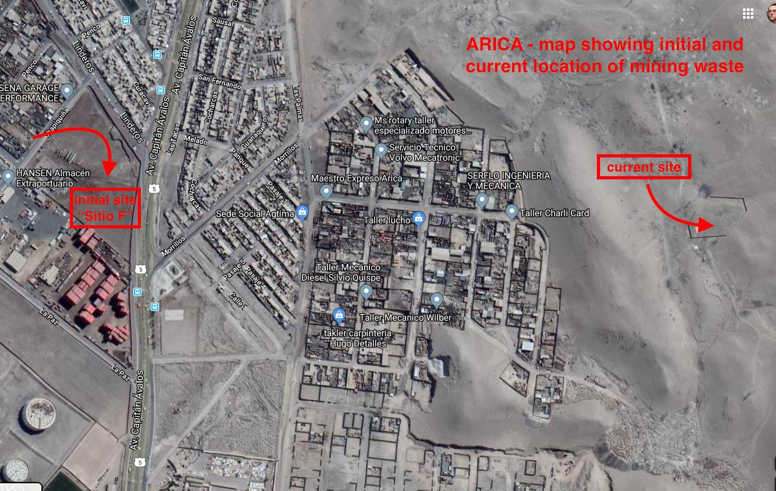

Correspondence with Swedish Ambassador in Chile:
Excelentísimo señor Embajador del Reino de Suecia en Chile
Don Oscar Stenstrôm
Presente
Con todo el respeto que usted se merece, como representante del Reino de Suecia en Chile, nos dirigimos a usted en nombre de una parte de comunidad de la ciudad de Arica, que se ve enfrentada a un conflicto socio ambiental por varias décadas, el cual tiene relación con el Estado sueco y con la compañía minera más importante de Suecia, como es Boliden AB. Lo siguiente es una exposición acompañada de una solicitud que esperamos que tenga su debida atención, atendiendo los méritos de los hechos y de las consecuencias que de éstos han derivado, por lo que exponemos lo siguiente:
Primero
Que, en el texto de la “Declaración de la Conferencia de las Naciones sobre el Medio Ambiente Humano”, conferencia realizada en la ciudad de Estocolmo en el año 1972, se solicita a los pueblos del mundo la elaboración de un marco de Principios que permita preservar y mejorar el medio ambiente humano.
Que, en sus acápites 1, 2, 3 y 7, afirma que el medio ambiente es el soporte físico que permite el desarrollo del ser humano de manera integral y que es fundamental la protección y mejoramiento del medio ambiente humano; Que existen demasiadas evidencias del daño causado por la contaminación del medio ambiente con efectos sobre el ser humano en su salud física, mental y social; .Que para alcanzar el objetivo de proteger y mejorar el medio ambiente humano es indispensable que tanto comunidades, compañías e instituciones, acepten las responsabilidades que les cabe en cada una de sus acciones.
Que, a partir de todo lo anterior, la Conferencia proclamó alguno de los siguientes Principios:
1.- El hombre tiene el derecho fundamental a la libertad, la igualdad y el disfrute de condiciones de vida adecuadas en un medio de calidad tal que le permita llevar una vida digna y gozar de bienestar, y tiene la solemne obligación de proteger y mejorar el medio para las generaciones presentes y futuras.
2.- Debe aplicarse la planificación a los asentamientos humanos y a la urbanización con miras a evitar repercusiones perjudiciales sobre el medio y a obtener los máximos beneficios sociales, económicos y ambientales. A este respecto deben abandonarse los proyectos destinados a la dominación colonialista y racista.
22.- Los Estados deben cooperar para continuar desarrollando el derecho internacional en lo que se refiere a la responsabilidad y a la indemnización a las víctimas de la contaminación y otros daños ambientales que las actividades realizadas dentro de la jurisdicción o bajo el control de tales Estados causen en zonas situadas fuera de su jurisdicción.
23.- Toda persona, de conformidad con la legislación nacional, tendrá, la oportunidad de participar, individual o colectivamente, en el proceso de preparación de las decisiones que conciernen directamente a su medio ambiente y, cuando éste haya sido objeto de daño o deterioro, podrá ejercer los recursos necesarios para obtener una indemnización.
24.- Incumbe a toda persona actuar de conformidad con lo dispuesto en la presente Carta. Toda persona, actuando individual o colectivamente, o en el marco de su participación en la vida política, procurará que se alcancen y se observen los objetivos y las disposiciones de la presente Carta.
Segundo:
Que, a pesar de los principios planteados en la Conferencia de Estocolmo, el Estado sueco, entre los años 1984 y 1985, autorizó para que la compañía minera sueca Boliden Metal, exportara desde su fundición en Ronnskar, ubicada en el norte del país, la cantidad de 19.134 toneladas de desechos mineros, principalmente compuesto por arsénico, plomo, cadmio y mercurio, hasta la ciudad de Arica, como destino final la empresa procesadora de metales, Promel Limitada, con la justificación que la empresa chilena reciclaría del material, los metales que contenía y recuperar, sobre todo el oro y plata y el arsénico. Finalmente, el material no se recicló y quedó abandonado sin ningún tipo de protección hasta el año 1998, dentro de un sector donde vivían miles de familias de escasos recursos, las que estuvieron expuestos por años al material tóxico, el que por sus componentes generó un daño incuantificable para la salud de los pobladores, como también para el medio ambiente.
Que, como una manera de acreditar el daño en la salud de las personas, es el hecho que en el año 1998, el Servicio de Salud de Arica, SSA, realizó un muestreo de arsénico y plomo en 650 personas (mayormente niños), en orina y sangre respectivamente, para detectar y determinar la exposición y posible contaminación de la población. Los resultados arrojaron niveles de hasta 1.620 ug/lt de arsénico en niños (hoy en Chile el nivel de riesgo del arsénico se considera 35ug/lt). En tanto respecto del metal plomo, el nivel más alto fue de 28ug/dl( hoy la Organización Mundial de la Salud, OMS, considera que con 10ug/dl se genera un daño al sistema nervioso central). Hoy en el año 2019, después de 21 años que la comunidad tuviera conocimiento de la gravedad de la situación a la que se enfrentaba, es posible asegurar que la salud de la población ha sido dañada de manera severa e irreversible debido a la exposición crónica a metales pesados.

Que, en el año 2008, el ex gerente del medioambiente de la compañía Boliden en el año 1984, Rolf Svedberg, el mismo que visitó la planta Promel en Arica, para evaluar y entregar el visto bueno para la operación, señaló que el material era riesgoso, que Boliden Metal había pagado la suma de U$80 por tonelada a Promel para que ésta recibiera el material, además de pagar por el flete marítimo. Svedberg sostuvo que él se había convencido que la compañía Promel podía reciclar el material de desecho, por cuanto se disponía de la tecnología y experiencia suficiente para realizar el proceso pirometalúrgico necesario, a pesar que todos los antecedentes actuales permiten contradecirlo. En síntesis, es posible asegurar, a partir de la propia declaración del señor Svedberg, sumados a otros antecedentes, que la operación fue un tráfico de desechos encubierto y en donde las dos partes involucradas obraron de mala fe, violando con ellos los derechos humanos más elementales de las personas, lo que derivó en un daño irreparable para una comunidad y su medioambiente.

Tercero:
Que, a partir del daño causado, miles de pobladores afectados en su salud han demandado en tribunales al Estado chileno y a los representantes legales de la empresa Promel, acciones que han resultado en fallos judiciales que han sentenciado la responsabilidad de ambos entes, obligando al Estado chileno a indemnizar a 350 pobladores por daño moral, en tanto que la compañía Promel fue condenada a reparar el daño medioambiental. Además, como antecedente se debe mencionar que desde el año 1999 hasta el 2013 se han presentado más de 16 demandas en tribunales contra el Estado chileno y la ex compañía Promel, en donde todas, excepto en dos casos, se ha declarado por parte de los órganos encargados de repartir justicia en Chile, que estos casos estaban prescritos, desatendiendo que las violaciones a los derechos humanos son de carácter imprescriptible.

Que, desde que nuestra comunidad fue informada de la grave situación, el Estado chileno ha reaccionado de manera tardía y deficiente, primero negando la gravedad de la situación y después interviniendo a través de un Plan Maestro en el año 2009 y con la promulgación de la ley de polimetales en el año 2012, las que como herramientas de intervención no ha reparado todo el daño causado, no sólo debido a sus incumplimientos, sino que la ley ha excluido en la reparación del daño a todos los niños nacido después del mes de enero del año 2012.

Que, persiguiendo las responsabilidades por el daño causado, 796 pobladores demandaron, en el año 2013, a la compañía sueca Boliden AB en los tribunales de la ciudad de Skelleftea, Suecia, persiguiendo su responsabilidad en los hechos arriba descritos los que han derivado a una afectación seria a su salud. Hoy esa demanda se encuentra en etapa de apelación, por parte de los pobladores, tras perder el juicio en primera instancia.

Cuarto:
Que, Considerando los antecedentes mencionados, más otros que forman parte de éste histórico proceso, y que se adjuntan como anexos a éste documento, nos asiste firmemente la convicción del daño causado; de la violación sistemática de los derechos humanos de cada uno de los pobladores expuestos a la contaminación, tal y como lo ha planteado la Comisión de Derechos Humanos del Parlamento Europeo en su sesión en el mes de enero del año 2019 donde se aborda el caso Boliden en Arica; que el daño causado ha tenido efectos transgeneracionales en las familias; que no se ha hecho justicia, tanto desde una perspectiva jurídica como política, y que no todos los responsables que generaron esta problemática socio ambiental, han reconocido y/o aceptado su responsabilidad en los hechos.

Que, está acreditado que existieron cuatro entes responsables en la generación de la problemática: El Estado sueco que permitió que el material saliera de su territorio sin evaluar los potenciales riesgos de la exportación, y contradiciendo con ello la Conferencia de Estocolmo del año 1972; el Estado chileno que permitió que el material ingresara a su territorio sin exigir ni disponer de las medidas de prevención y fiscalización mínimas necesarias; la compañía minera sueca Boliden Metal, que fue la que se deshizo del material tóxico sabiendo de los riesgos que eso representaba y, finalmente la compañía Promel que tuvo un actuar negligente, buscando sólo sus intereses y réditos económicos en desmedro de la salud de la comunidad.

Que, hoy, sólo tres responsables de la contaminación han sido interpelados en diferentes espacios, tanto jurídico como político, los que han sido sancionados de diferentes formas. El Estado chileno, ha sido obligado a indemnizar a cientos de pobladores; la compañía Promel ha sido condenada a reparar el daño medioambiental y la compañía sueca Boliden AB, la que se encuentra demandada en los tribunales suecos, pero falta que el Estado sueco asuma su responsabilidad en los hechos, porque se debe recordar que las 19.130 toneladas de desechos tóxicos salieron desde territorio sueco, bajo las leyes y normativas vigentes de la época. Sobre todo con el agravante para el Estado sueco que era de conocimiento global que el Estado chileno, en el año 1984, estaba gobernada por una dictadura cívico-militar, en donde no funcionaban las instituciones en términos democráticos ni se respetaban los derechos humanos, menos los derechos medioambientales, sin embargo eso no fue un obstáculo para que el Estado sueco autorizara la exportación del material de desecho, y hasta el día de hoy nunca se ha manifestado respecto de su responsabilidad en los hechos y de hacerse parte de la reparación del daño causado.

Que, no se puede aceptar, desde ninguna perspectiva humana, social, económica, política ética y moral, que la prosperidad de un pueblo sea a base de la desgracia de otros.

Que, por todo lo anteriormente expuesto solicitamos de forma muy respetuosa que usted evalúe los antecedentes entregados, y permita que su gobierno asuma un rol en ésta irresuelta problemática, a través de las siguientes acciones:

Primero
Que, usted como representante del gobierno del Reino de Suecia en Chile, pueda visitar la ciudad de Arica y conozca in situ la realidad que experimenta la comunidad afectada por la exposición a los metales pesados, y que el gobierno de Suecia se pueda pronunciar formalmente sobre esta grave situación actual.

Segundo
Que, el gobierno de Suecia pueda desarrollar un trabajo en conjunto con la comunidad afectada, que permita generar un programa de reparación integral de salud para las miles de personas involucradas en la problemática socio ambiental.

Tercero
Que, como hoy en día las 19.134 toneladas del material de desecho se encuentra depositado en un sitio cercano al sector poblacional afectado, urge erradicar esta amenaza, por lo que se solicita formalmente que su gobierno, en coordinación con el gobierno chileno, regrese el material hacia la fundición de Ronnskar, que es el lugar a donde pertenece y de donde nunca debió haber salido, siguiendo el espíritu de la Conferencia de Estocolmo del año 1972.

Finalmente distinguido señor Embajador, junto a esta misiva, la hacemos acompañar de un dossier con una serie de documentos que demuestran todo el proceso de la problemática y de cómo hoy, lamentablemente, sigue vigente, y además de un listado de 2.374 pobladores afectados, a los cuales representamos en esta causa justa.

.- Marisol Maibe, pobladora del sector de “Cerro Chuño”
Email Fono Firma

.- Silvia Encina, pobladora del sector “Los Industriales”
Email Fono Firma

.- Lombardo Molina, poblador del sector de “Cerro Chuño”
Email Fono Firma

.- Rodrigo Pino, antropólogo y coordinador comunitario
Email Fono Firma

Arica, 03 de febrero 2019

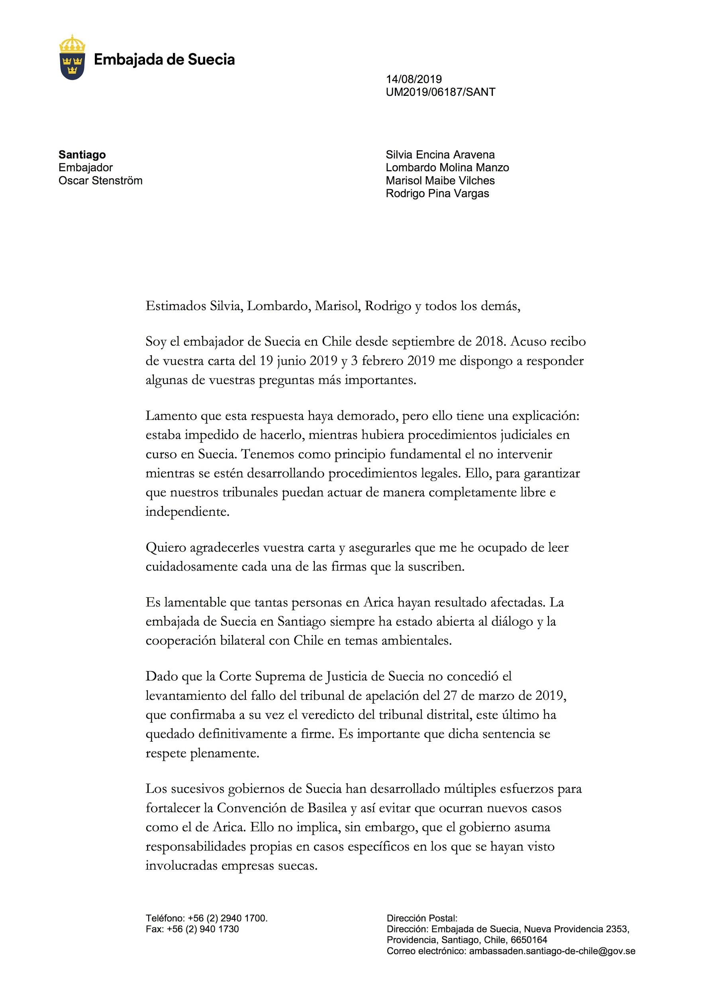

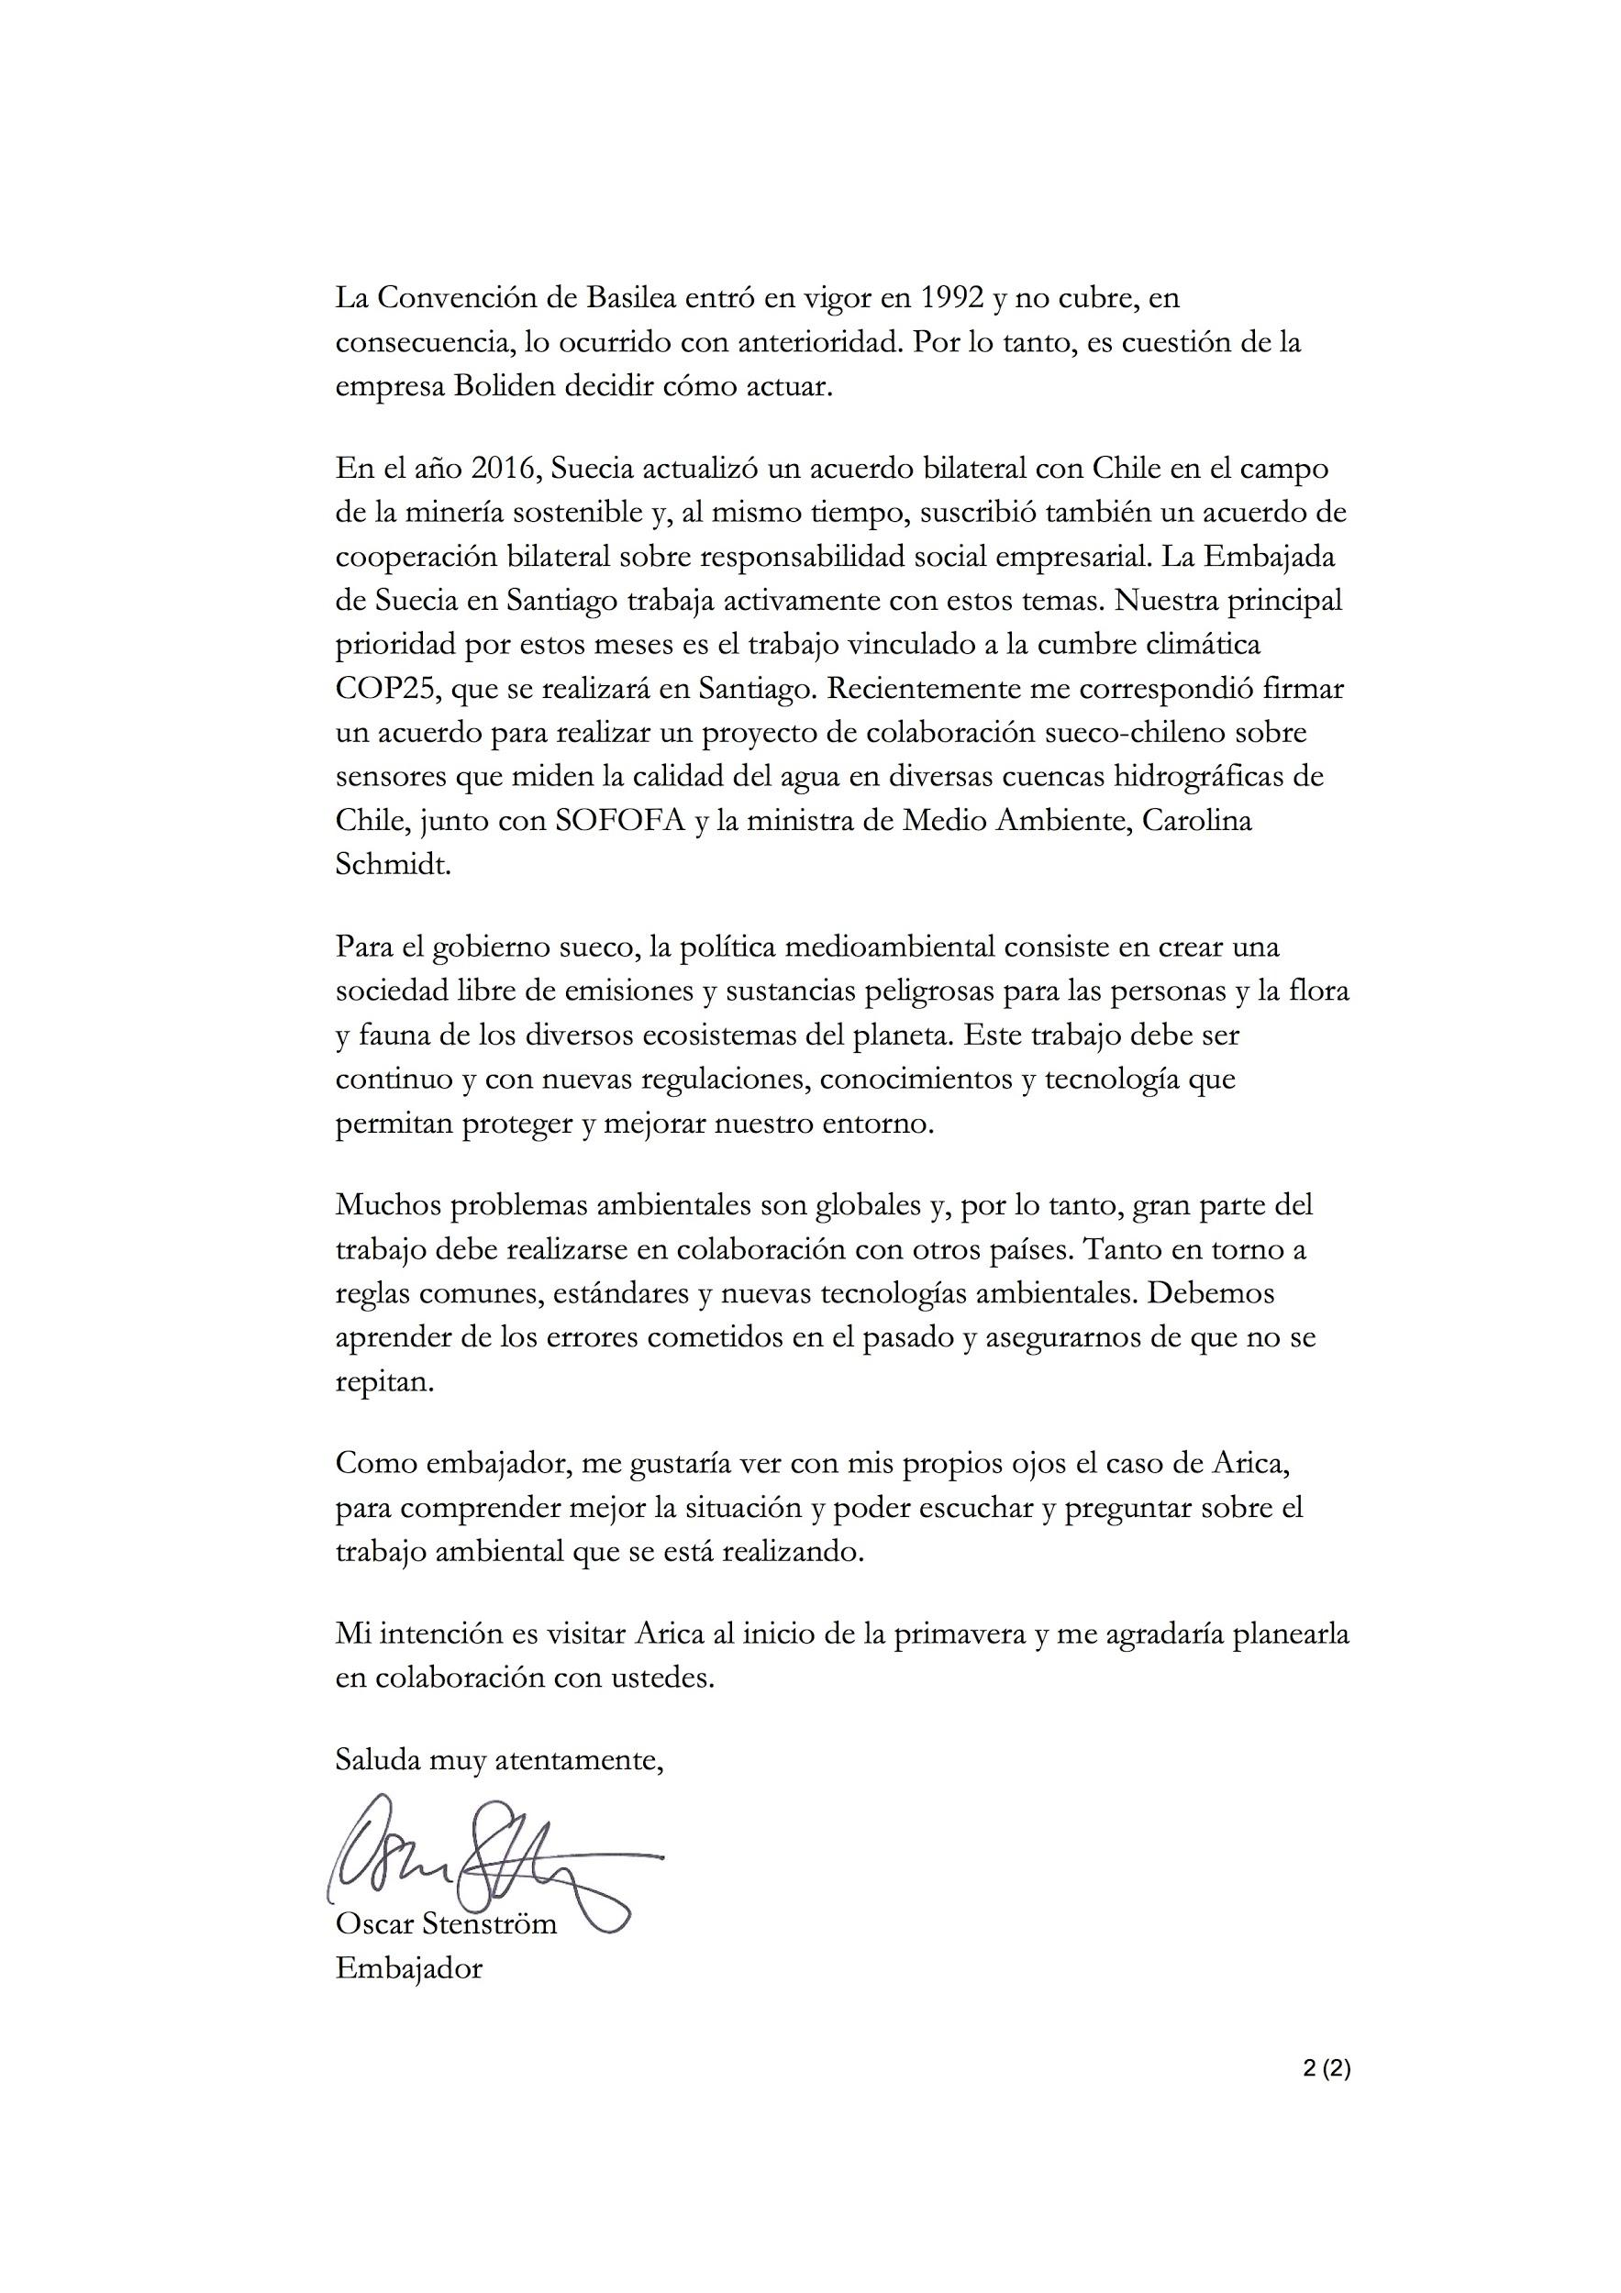

Estimado señor Óscar Stenström
Embajador del Reino de Suecia en Chile
Presente
En nombre de las familias que forman la comunidad de Arica que ha sido afectada en sus vidas cotidianas por la exposición a los residuos mineros tóxicos suecos, deseamos agradecerle infinitamente su visita del día 11 de septiembre del presente años, porque sentimos que su gesto de conocer en terreno la realidad que experimenta la comunidad ha sido muy valioso y pertinente porque permitió al gobierno de Suecia , a través suyo, poder discutir los impactos negativos generales y particulares sufridos por las personas de nuestra comunidad, también de conocer las necesidades de salud y de medio ambiente.
Finalmente, como usted nos ha manifestado en esa oportunidad que por la complejidad y naturaleza misma de la problemática, la respuesta de su gobierno tomaría un debido y necesario tiempo, sólo nos queda reafirmar, de manera muy respetuosa, nuestras peticiones como comunidad respecto de que el gobierno de Suecia nos apoye en la prestación de asistencia sanitaria a los afectados por los tóxico y de que los residuos tóxicos sean devueltos a Suecia porque hoy representan un evidente riesgo para la comunidad y porque el Estado chileno se ha mostrado indolente frente a dar una solución definitiva para los acopios de Boliden, depositados hoy en el sector de Quebrada Encantada.
Sin más, y reiterando nuestros agradecimientos por su venida a la ciudad de Arica, se despiden atentamente S.S.S

Marisol Maibe Vilches
Lombardo Molina Manso
Rodrigo Pino Vargas
September 2019

Estimado Sr. Stenstrom,
ARICA: Residuos tóxicos suecos
Les escribo en nombre de las comunidades de Arica que se han visto afectadas por los residuos tóxicos suecos, y me refiero a nuestra correspondencia y compromiso previo con usted sobre este asunto: nuestras cartas a usted de febrero de 2019 y mayo de 2019, su visita para reunirse con nosotros en septiembre de 2019, y mi reunión en noviembre de 2019 en Santiago con el Sr. Roberto Boschek.
A pesar de recibir varias promesas de su oficina de que recibiríamos una respuesta sustantiva con respecto a nuestra queja a su debido tiempo, todavía no hemos recibido ninguna respuesta de usted con respecto a nuestras demandas:
- Que el gobierno sueco, en colaboración con la comunidad afectada, establezca y aplique un plan de intervención sanitaria con el fin de abordar exhaustivamente los problemas de salud de todas las personas afectadas por la contaminación; Y
- que los residuos tóxicos suecos, depositados y contenidos desde 1998 hasta la actualidad en el sector de "Quebrada Encantada", sean devueltos a Suecia.
Como señalamos en nuestra carta de febrero de 2019, los residuos representan un riesgo actual y continuo para la comunidad de Arica. La empresa sueca responsable de los residuos, Boliden Mineral AB, tiene tanto el espacio como la capacidad técnica para almacenar los residuos de una manera que no amenace la vida y la salud de las personas.
Los afectados por los desechos son ahora muy vulnerables a los efectos de Covid-19: muchos de los expuestos a los desechos sufren de enfermedades catastróficas como resultado, incluyendo cánceres, enfermedad pulmonar obstructiva crónica y diabetes. Por lo tanto, las necesidades de atención médica de la comunidad son críticas, y la pila de residuos se erige como una afrenta diaria a nuestra comunidad.
Por lo tanto, el retraso en su respuesta es inaceptable e inconcebible.
Como comunidad, buscamos protegernos de la mejor manera posible: nos hemos acercado a los tribunales de Chile para pedir una orden especial de protección y una cuarentena de la zona a la luz de la vulnerabilidad particular de nuestra comunidad; hemos sido visitados por el Director del Instituto Nacional de Derechos Humanos, quien buscó evaluar los riesgos del sitio para la comunidad inmigrante colombiana actualmente presente en las cercanías de la pila de residuos; y también hemos estado en contacto directo con el embajador colombiano en Chile para expresar nuestras preocupaciones.
A nivel internacional, somos conscientes de que en febrero de 2019 la situación en Arica fue la base de un debate y un informe específico para el Subcomité de Derechos Humanos del Parlamento Europeo, relativo a la falta de acceso a recursos legales para las víctimas de abusos corporativos en países no pertenecientes a la UE. Este escándalo también aparece ahora en el Atlas Mundial de Conflictos Ambientales, y forma parte de un proceso formal de investigación llevado a cabo por el Comité de Derechos Económicos, Sociales y Culturales de las Naciones Unidas en Chile, así como dos películas suecas sobre la materia ("Toxic Playground" y "ARICA [próximamente]).
Debemos informarle de que actualmente estamos trabajando con una serie de grupos internacionales de derechos humanos expertos, que nos han ayudado a preparar una queja formal que se enviará a una serie de mecanismos especializados de derechos humanos en las Naciones Unidas. Tal como está redactado actualmente, la queja incluye detalles de la falta de respuesta de Suecia sobre esta cuestión. Si no tenemos noticias de usted dentro de los 14 días, no tendremos otra opción que enviar la queja tal como está. Esperamos que esto no sea necesario, y que ahora podamos avanzar en esta cuestión urgente con prontitud y mediante una colaboración respetuosa por su parte.
Por lo tanto, ahora solicitamos una respuesta sustantiva de usted en los próximos 14 días.
Espero tener noticias tuyas,
Rodrigo Pino Vargas, Arica
June 2020

International Covenant on Economic, Social and Cultural Rights. Adopted and opened for signature, ratification and accession by General Assembly resolution 2200A (XXI) of 16 December 1966. Entry into force 3 January 1976, in accordance with article 27
General Comment No. 24, para 27 and E/C.12/2011/1, para. 5 and 6
General Comment No. 24, para. 16 and 26
General Comment No. 24, para. 40
“Access to legal remedies for victims of corporate human rights abuses in third countries”, Policy Department for External Relations, Directorate General for External Policies of the Union (PE 603.475), February 2019, p.46, available online at: http://www.europarl.europa.eu/RegData/etudes/STUD/2019/603475/EXPO_STU(2019)603475_EN.pdf
Judgment, cited in the EU Parliamentary report, ibid, p.49.
http://www.serviu15.cl/opensite_20130822152329.aspx
Arica Victims KB v. Boliden, Judgment, (County Court, 8th March 2018), p.33.
http://www.serviu15.cl/opensite_20130822152329.aspx
https://ejatlas.org/conflict/contaminacion-plomo-arica

