Convention Against Torture and other Cruel, Inhuman or Degrading Treatment or Punishment

Seventh Periodic Report

Annex to the Response of the Kingdom of the Netherlands to the list of issues (CAT/C/NLD/QPR/7) transmitted to the State Party under the optional reporting procedure (A/62/44, paras. 23 and 24)

Please note that as some figures could not be translated, the translation for these figures is incorporated at the end of this document (p. 59).
The Netherlands
Annexe to answer 3a: right of access to a lawyer
On 28 November 2014, the Council of State’s Advisory Division issued an advisory opinion on two bills. On 13 February 2015 the government issued its response to this opinion. On 19 February 2015 the government sent the bills to Parliament (House of Representatives). The parliamentary legislative procedure concluded on 15 November 2016 when the Senate approved both bills. The legislation was subject to the Advisory Referendum Act. This means that after royal assent has been obtained, another two months must pass before legislation can enter into force. As a result, the two Acts entered into force on 1 March 2017.
On 22 December 2015 the Dutch Supreme Court decided that the right of access to a lawyer when a suspect is being interviewed should be implemented before 1 March 2016. This meant that the right of access had to be in place in legal practice well before 27 November 2016, the implementation deadline set by Directive 2013/48/EU. The Dutch authorities complied with the Supreme Court ruling. A binding policy letter, constituting the legal framework for police, lawyers and prosecutors, was issued by the Board of Prosecutors General. At the same time the Legal Aid Council amended the rules on the provision of legal aid. The Ministry of Security and Justice ordered a monitoring study to see how the system was functioning in practice. The results of this study were positive and were sent to the House of Representatives. Claiming that the rules set out in the policy letter were not in line with ECtHR case law, a group of lawyers brought interim injunction proceedings against the State and the Legal Aid Council. The Hague District Court referred the matter to Supreme Court for a preliminary ruling. On 13 September 2016 the Supreme Court ruled, inter alia, that in general it could not be said that application of the rules laid down by the Board of Prosecutors General, regardless of the circumstances of the case, would frustrate the practical and effective exercise of the right of a suspect to legal assistance during a police interview. The Supreme Court took into account the powers granted to lawyers under the rules in question.

Annexe to answer 4a-d: domestic violence
Over a period of two years, an average of 34 adults (men and women) and 13 children died as a result of domestic violence (CBS, 2012).
In March 2015 the Dutch Public Prosecution Service began adding a social qualifier (in this case, domestic violence) to the classification of incoming criminal cases alongside the statutory definition of the offence. Pending cases dating from before March 2015 are not so described. Consequently, the 2015 figures given below are not complete. With regard to the figures for 2016, it should be noted that they may be inaccurate, since this method of registration was new and a certain amount of time is necessary before input into all systems is correctly carried out.
Domestic violence cases registered with the Public Prosecution Service (OM) | 2015 (from March onwards) | 2016
Registered with OM | 7217 | 8803
Disposed of by OM | Unknown | 3476
Disposed of by courts | Unknown | 4803
Convicted | Unknown | 3911

Unfortunately, no recent figures can be supplied concerning the number of complaints registered by the police. This is a consequence of the reorganisation of the Dutch police force and associated changes to the registration system. However, a gender-sensitive study of the incidence of domestic violence and child abuse is under way. The study aims to increase understanding of the nature and extent of domestic violence. Results are expected in the first half of 2018.
Migrants (men and women) who are residing legally in the Netherlands with their spouse or partner on the basis of a dependent residence permit can apply for independent residence after five years of legal residence if the relationship, and subsequently the permit, ends as a result of domestic violence. The application for an independent residence permit must be supported by an affidavit from the police confirming that the victim has reported the offence, and by information from a doctor, a social worker or a (women’s) shelter. This is long-standing policy. No recent changes have been made regarding the burden of proof. The victim is not required to be staying in a shelter; nor is the prosecution or conviction of the perpetrator a condition for independent residence status.

Victims of domestic violence applying for independent residence status | 2013 | 2014 | 2015 | 2016 (up to October)
Applications | 160 | 260 | 200 | 180
Permit granted | 100 | 200 | 180 | 130
Permit refused | 20 | 50 | 30 | 20
Application withdrawn by applicant/applicant left the country | <10 | <10 | 10 | 10

Migrants who are not legally resident in the Netherlands can apply for a residence permit on the grounds of having suffered domestic violence. The application must be supported by an affidavit from the police and information from a doctor, social worker or (women’s) shelter. In addition it must be established that the victim has no real options for returning to the country of origin to find protection against the violence. If victims are residing in a shelter they can apply for benefit to meet their basic needs. However such an application is not a condition for obtaining a residence permit

Victims of domestic violence who are not legally resident | 2013 | 2014 | 2015 | 2016 up to October
Applications | 30 | 30 | 40 | 40
Permit granted | <10 | 10 | <10 | <10
Permit refused | <10 | 20 | 20 | 20
Application withdrawn by the applicant/applicant left the country | <10 | <10 | <10 | <10

The Netherlands has 16 Sexual Violence Advice Centres (CSG) offering multidisciplinary support to all victims of sexual violence. This embraces forensic expertise, medical care and psychosocial support. The CSGs work according to national quality criteria and in close cooperation with the police. The aim is to identify and preserve trace evidence at an early stage and to start an investigation as soon as possible. In the first six months of 2016, 1000 victims reported sexual violence to the CSGs. Alongside the CSGs there is a nationwide network of women’s shelters, which offer women and children tailored support. In 2015, 7,339 clients (of whom 2,569 were 17 years old or younger) were accommodated in 20 shelters. Male victims of domestic violence, honour-related violence or human trafficking are offered shelter at six locations (a total of 40 places). In addition, non-residential support is provided at local level. There is a free national helpline that victims can contact.

Annexe to answer 5a: human trafficking
The most recent data from the National Rapporteur on Trafficking in Human Beings and Sexual Violence against Children are as follows. Of the 7,252 possible victims of human trafficking (THB) registered with the Human Trafficking Coordination Centre (CoMensha) in the period from 2011 to 2015, 85% (n=6134) were women. In 2015, 1047 of 1321 victims were women (79%). There were slightly more male victims (21%; n=274) as a proportion of the total in 2015 than in the preceding four years. The highest number of male victims was recorded in 2014 (n=247) and 2015 (n=274).

Employment sectors in which possible human trafficking victims in the Netherlands were working from 2011 to 2015:
Figure 3.1
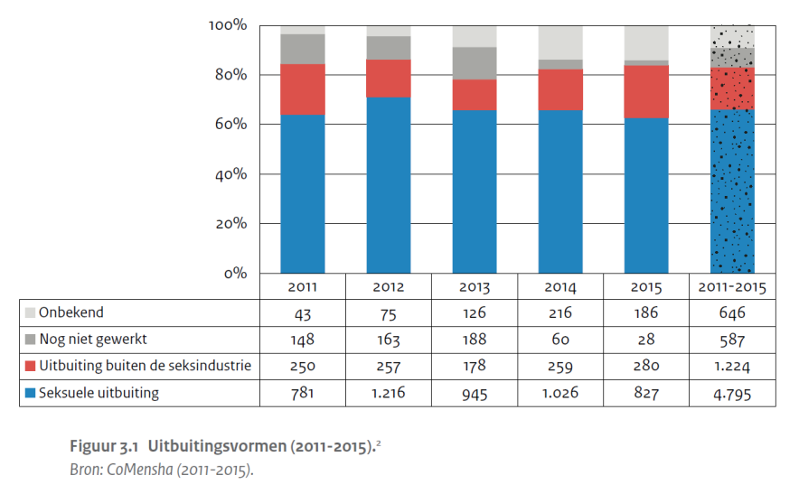

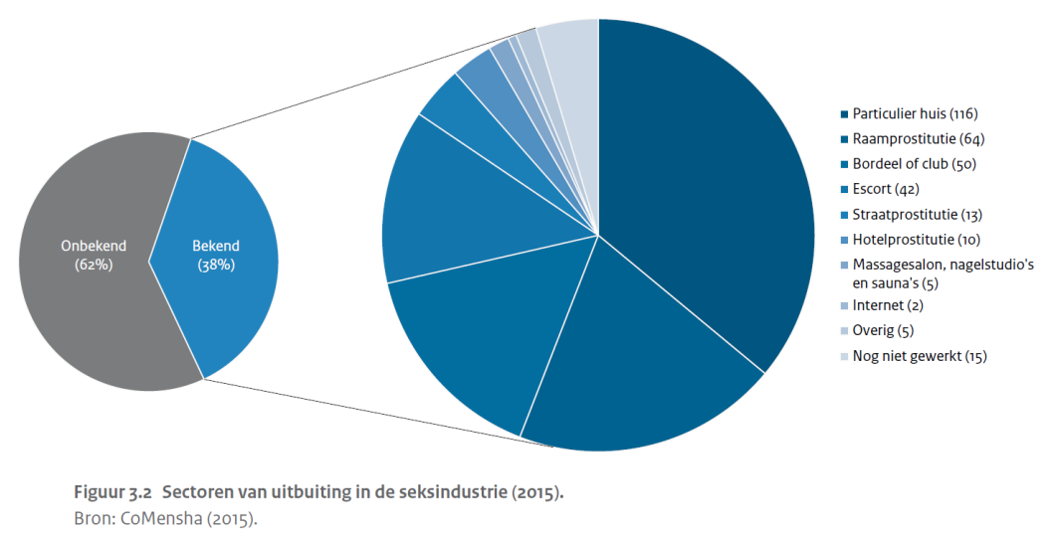
Figure 3.2

Figure 3.3
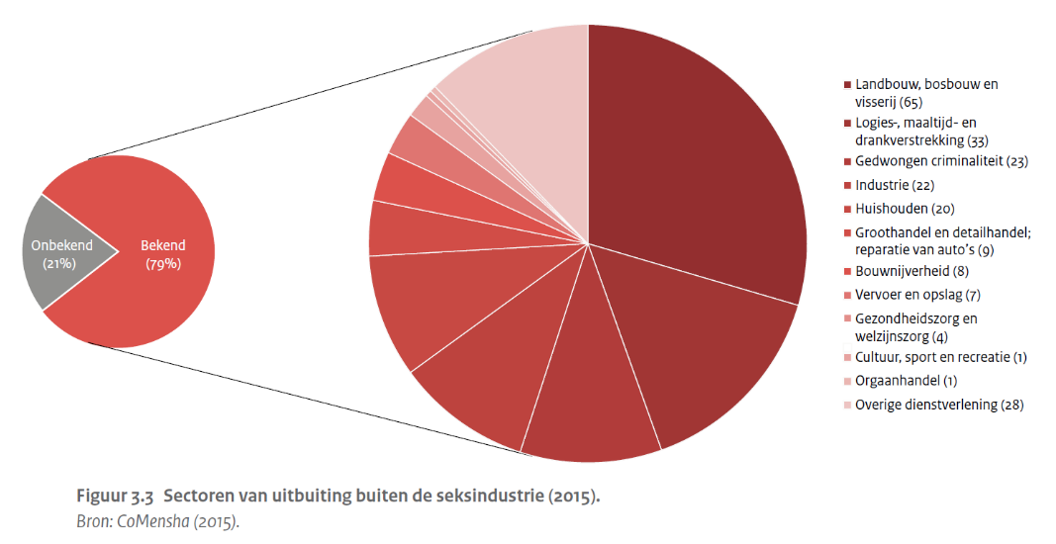
The following table shows the average age of possible victims of the different forms of human trafficking in the Netherlands between 2011 and 2015:

Figure 4.2
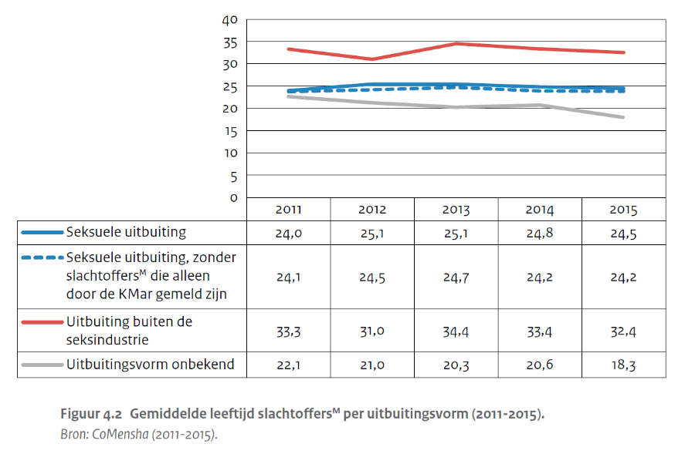

The most common countries of origin of possible human trafficking victims reported in the Netherlands in 2015 were:

The Netherlands | 434 (33%)
Bulgaria | 132 (10%)
Romania | 129 (10%)
Poland | 92 (7%)
Hungary | 50 (4%)

The most recent statistics on prosecutions, convictions and sentencing provided by the National Rapporteur on Trafficking in Human Beings and Sexual Violence against Children are as follows.

Key figures relating to prosecution and sentencing in human trafficking cases (2011-2015)
 |  | 2011 | 2012 | 2013 | 2014 | 2015 | 2011-2015
 | Number of human trafficking cases registered with Public Prosecution Service (OM) | 261 | 315 | 257 | 282 | 217 | 1332
 | Number of human trafficking cases disposed of by the OM on the merits | 232 | 281 | 271 | 253 | 285 | 1322
 | % summonses (partly) on human trafficking charges | 72% | 70% | 72% | 76% | 65% | 71%
 | Number of human trafficking cases disposed of at first instance | 126 | 147 | 200 | 162 | 184 | 819
 | % convictions for at least one human trafficking offence | 64% | 76% | 77% | 80% | 67% | 73%
 | Average duration in days of the non-suspended part of custodial sentences | 753 | 772 | 803 | 665 | 558 | 709

There are no statistics available on the number of complaints lodged and reports registered by the police in connection with human trafficking or the number of those that were investigated.

Annexe to answer 5b: human trafficking
Shelters
The Netherlands offers several types of shelter for different categories of victims (including children and victims without residence rights) and many different types of services (including legal, medical and psychological assistance and appropriate accommodation) with a view to providing tailored assistance. Many parties (governmental and non-governmental) are involved in the identification and support of victims. If there is even the slightest indication that a person is a victim of human trafficking he or she is offered support.
- Victims with Dutch nationality and victims residing legally in the Netherlands have access to all forms of support and assistance, regardless of whether they cooperate with the investigation and prosecution or not. Regular women’s shelters and youth care facilities are available to them. The indication that a person might be a victim of human trafficking need not be a formal statement to the police. Dutch citizens and other EU residents can be referred to a shelter or other forms of support by a law enforcement organisation, NGO, healthcare organisation and so on.
- Third-country nationals who are given a reflection period are offered special shelter for victims without residence rights, where they receive an income and legal, medical and psychological assistance if needed. There are special shelters for both male and female victims.
- CoMensha has a budget for temporary shelter for victims of labour exploitation who do not need urgent care. Should it later emerge that any of these victims do in fact need care, they can go to the special shelters.
- There are protected reception centres for unaccompanied minor asylum seekers who are at risk of falling victim to human trafficking.
- In Amsterdam, The Hague, Rotterdam and Utrecht, there are regular shelters for male victims of violence.
No figures are available on the occupancy rates of all these shelters. However, the National Rapporteur provides figures on the number of requests for shelter received by CoMensha, the NGO that refers human trafficking victims to shelters.
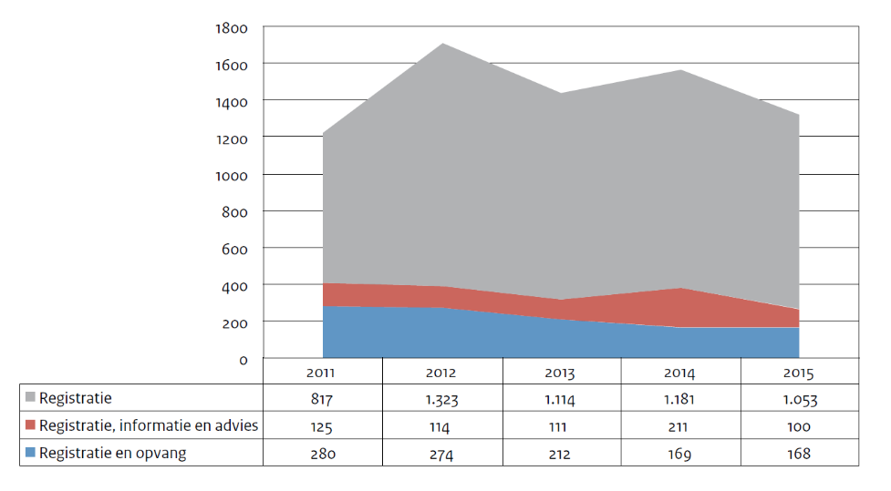
Redress
Victims of human trafficking can seek redress by joining criminal proceedings or instituting civil proceedings. The amounts awarded are primarily for pecuniary damage such as unpaid wages, but limited amounts for non-pecuniary damage have also been granted on some occasions. In addition, the Criminal Injuries Compensation Fund provides financial compensation to victims of violent crimes, including human trafficking, who have sustained serious physical or psychological injury.
The number of compensation orders made by the courts fell from 35 in 2012 to 26 in 2013, and rose again in 2014 to 45. The table below shows the amounts of compensation awarded by the courts per offender (not per victim) from 2010 to 2014 (Figure 2).
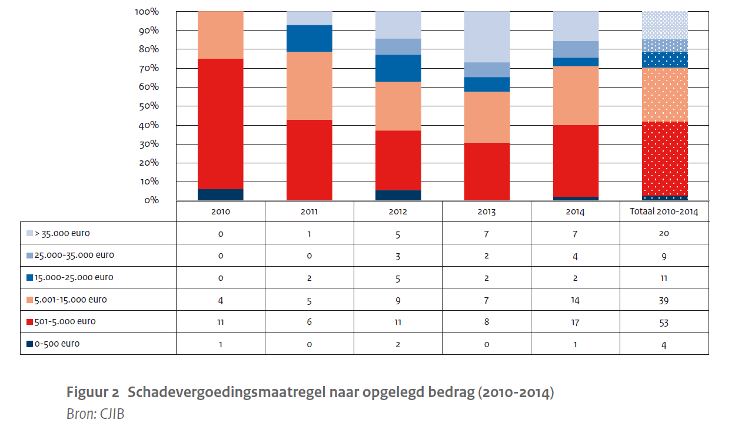

In 2013 and 2014 the Criminal Injuries Compensation Fund decided on 58 and 61 applications respectively for financial compensation in connection with human trafficking. In 2014 over 75% of applications were granted. This represents a considerable increase compared with preceding years. In 2014, the average amount granted by the Fund for violent crimes in general was €3161. Data on the average amount granted to victims of human trafficking is not available.
Rights of residence for victims of human trafficking
Under the current rules on residence for human trafficking victims, such persons can obtain a temporary residence permit on humanitarian grounds if there are clear indications that they are the victim of human trafficking but are unable to cooperate with the criminal investigation due to threats or a serious medical condition. The National Rapporteur noted in her Ninth Report that in practice this provision is invoked only a few times a year. In response to this observation, the provision was explicitly drawn to the attention of the police, health and social care workers and the Immigration and Naturalisation Service (IND). In addition, the Aliens Act Implementation Guidelines were amended so that the police are no longer required to draw up an affidavit confirming that the person is a victim of human trafficking; their affidavit merely has to confirm the existence of signs of human trafficking.
If there is the slightest indication of human trafficking victims have the right to a rest and reflection period of up to three months, in which they can come to a decision about cooperating in the investigation or prosecution. If after that period the victim decides to cooperate, this constitutes an application for a temporary residence permit on the grounds of human trafficking.
The number of times victims made use of the reflection period fell from 223 in 2013 to 174 in 2014. The number of applications for a temporary residence permit also fell slightly: from 268 in 2013 to 251 in 2014. Not all victims apply for a residence permit after the reflection period. This was particularly the case with victims originating from Central and Eastern Europe and under-age victims. Applications for a temporary residence permit on these grounds are usually granted. The figures for 2015 and 2016 had not yet been published by the National Rapporteur at the time of writing.
With regard to residence permits for victims of human trafficking, including those who are unable to cooperate, the following applies.
- A residence permit can be granted to third-country nationals on the condition that human trafficking is reported to the police and a criminal investigation of the perpetrator has begun. This is an important measure to ensure not only the support of victims of human trafficking, but also that the perpetrators are brought to justice. Only if these two elements are combined can human trafficking be successfully tackled.
- Victims do not have to report human trafficking to the police immediately. If there is even the slightest indication of human trafficking, the police or the Royal Military and Border Police (KMAR) at Schiphol Airport should offer a suspected victim of human trafficking a reflection period of up to three months to consider whether they want to press charges. During this period the victim has time to recover and consider whether to lodge a criminal complaint with the police or to cooperate in the investigation in another way.
- When the victim lodges a criminal complaint and the prosecution results in the conviction of the perpetrator, the victim can obtain a non-temporary residence permit. If the prosecution continues for at least three years the victim can apply for continued residence, even if the criminal case is still pending or the charges are eventually dropped.
- As stated above, a suspected victim can also obtain a temporary residence permit on humanitarian grounds if there is an indication that they are victim of human trafficking, but are unable to cooperate with the criminal investigation due to threats or a serious medical condition.

Annexe to answer 5c: human trafficking
Measures taken to strengthen prevention, investigation and punishment of trafficking
- The Task Force on Human Trafficking is responsible for formulating an integrated approach to human trafficking. The Task Force is headed by the chair of the Board of Procurators General
- The number of district courts was reduced to eleven in 2013 as a consequence of the Reorganisation of the Judiciary (Territorial Division) Act. The National Consultative Committee of Criminal Law Sector Chairpersons (LOVS) then decided to have a limited number of judges and legal staff deal with all human trafficking cases. This allows the courts to ensure that judges and staff possess enough substantive knowledge to handle such cases, which are often complex.
- All plans for larger scale trafficking investigations need to include a paragraph on how to investigate criminal profits. This should describe the tactics to be employed by the financial investigation, which serves three purposes: to establish the truth, to compensate the victims and to recover illicit gains.
- The Netherlands is ‘co-driver’ of the EU project on operational cooperation against human trafficking, known as EMPACT THB. The UK is the driver of this project. As part of EMPACT THB, from 28 May to 5 June 2016 a joint action week on human trafficking for labour exploitation was held for the first time in 21 EU member states, during which a significant number of inspections took place. For the first time, labour inspectors worked alongside police officers. The action week resulted in the identification of 275 possible victims of human trafficking for labour exploitation, the arrest of 41 suspects and the launch of 23 criminal investigations. The Gangmasters Licensing Authority (UK) and Inspectorate SZW organised this joint action week, which was supported by Europol.
Identification of victims of loverboys
A number of studies and projects are being or have been conducted to address the issue of loverboys.
- The committee chaired by Naïma Azough worked on improving the integrated approach to loverboy issues and the support offered to child victims of human trafficking. The committee drew up a number of practical guides and roadmaps to help youth-care professionals identify and support child victims. These should lead to better cooperation between youth-care professionals and the police. The committee also established arrangements for the registration of child victims by youth-care professionals with the NGO CoMensha to improve understanding of the nature and extent of human trafficking of minors.
- A bill has been introduced in Parliament to allow police officers to pose as adolescents on the internet. This should help identify and prosecute people who groom children in order to sexually abuse them or exploit them through forced prostitution.
- An overview of all the available prevention material relating to under-age victims of loverboys will be distributed to schools, municipalities and youth workers.
National referral mechanism
In 2013, an interministerial project was launched to develop a national referral mechanism for victims of human trafficking and to offer victims support tailored to their needs. Several initiatives have been undertaken as part of this project.
- The Wegwijzer Mensenhandel website (www.wegwijzermensenhandel.nl) offers an accessible overview of the support available to victims of human trafficking. Here professionals, victims and members of the public can find organisations that provide help and support to human trafficking victims and an overview of arrangements that may be relevant to them.
- A model based on a multidisciplinary approach to establish that people are in fact victims of human trafficking was tested in an exploratory pre-pilot project in 2016. This exploratory project looked at how the new procedure might tie in with existing procedures for human trafficking victims. An operational pilot is expected to start in which possible victims will be assessed by a multidisciplinary committee.
- An updated list of indicators which can be used by all professionals who come into contact with possible victims has also been published on the website.

Annexe to answer 8a+8b: asylum applications
Asylum applications registered in the Netherlands in 2014 according to age.
 | Under 14 | Between 14 and 17 | Between 18 and 34 | Between 35 and 64 | 65 or over | Total 2014
Females | 1,640 | 415 | 2,970 | 1,505 | 145 | 6,670
Males | 1,830 | 1,260 | 9,960 | 4,680 | 130 | 17,865
Total | 3,470 | 1,675 | 12,930 | 6,185 | 270 | 24,535
Source: Eurostat
Asylum applications registered in the Netherlands in 2015 according to age.
 | Under 14 | Between 14 and 17 | Between 18 and 34 | Between 35 and 64 | 65 or over | Total 2015 | Unknown
Females | 2,525 | 990 | 5970 | 2,520 | 180 | 12,190 | 0
Males | 3,245 | 3,810 | 18,050 | 7,425 | 175 | 32,705 | 5
Total | 5,775 | 4,805 | 24,065 | 9,970 | 355 | 44,970 | 5
Unknown | 5 | 5 | 45 | 20 | 0 | 75 | 0
Source: Eurostat
Asylum applications registered in the Netherlands in 2016 according to age.
 | Under 14 | Between 14 and 17 | Between 18 and 34 | Between 35 and 64 | 65 or over | Total 2016
Females | 1,935 | 555 | 2530 | 1,395 | 105 | 6,520
Males | 2,135 | 1,595 | 8,075 | 2,520 | 90 | 14,415
Total asylum applications | 4,070 | 2,150 | 10605 | 3,920 | 195 | 20,940
Source: Eurostat

Top ten countries of origin of asylum applicants in the Netherlands.

CITIZEN OF | 2014 |  | CITIZEN OF | 2015 |  | CITIZEN OF | 2016
Syria | 8,790 |  | Syria | 18,690 |  | Syria | 2,910
Eritrea | 3,910 |  | Eritrea | 7,455 |  | Eritrea | 1,925
Stateless | 2,720 |  | Iraq | 3,240 |  | Albania | 1,700
Iraq | 1,320 |  | Afghanistan | 2,875 |  | Afghanistan | 1,385
Afghanistan | 880 |  | Stateless | 2,500 |  | Morocco | 1,280
Iran | 665 |  | Iran | 2,030 |  | Iraq | 1,115
Somalia | 595 |  | Albania | 1,010 |  | Iran | 995
Unknown | 555 |  | Ukraine | 760 |  | Algeria | 985
Mongolia | 445 |  | Kosovo | 690 |  | Serbia | 945
Georgia | 335 |  | Somalia | 450 |  | Georgia | 595
Other countries | 4,320 |  | Other countries | 5,270 |  | Other countries | 7,110
Total | 24,535 |  | Total | 44,970 |  | Total | 20,945
Source: Eurostat
Applications processed in the Netherlands, first instance decisions for the top ten countries of origin and total.
2014 | Geneva Convention status | Humanitarian status | Subsidiary protection status | Total positive decisions | Rejected | Total 2014
Syria | 350 | 125 | 4,965 | 5,440 | 515 | 5,950
Eritrea | 35 | 90 | 3,365 | 3,490 | 355 | 3,845
Stateless | 1,285 | 15 | 65 | 1,365 | 240 | 1,605
Afghanistan | 180 | 85 | 145 | 415 | 415 | 830
Iraq | 85 | 40 | 200 | 325 | 450 | 775
Iran | 205 | 40 | 20 | 260 | 320 | 580
Somalia | 10 | 225 | 100 | 335 | 235 | 570
Unknown | 40 | 45 | 105 | 185 | 225 | 410
Mongolia | 0 | 5 | 5 | 10 | 295 | 305
Georgia | 0 | 0 | 5 | 5 | 280 | 285
Total first instance decisions | 2,485 | 775 | 9,290 | 12,550 | 6,260 | 18,810
Source: Eurostat
2015 | Geneva Convention status | Humanitarian status | Subsidiary protection status | Total positive decisions | Rejected | Total 2015
Syria | 4,015 | 40 | 3,800 | 7,850 | 160 | 8,010
Eritrea | 60 | 20 | 4,790 | 4,875 | 105 | 4,980
Stateless | 1,695 | 75 | 50 | 1,820 | 120 | 1,940
Afghanistan | 125 | 50 | 185 | 360 | 320 | 685
Ukraine | 0 | 0 | 0 | 5 | 440 | 445
Iran | 240 | 30 | 10 | 285 | 125 | 410
Iraq | 70 | 15 | 165 | 255 | 140 | 395
Albania | 0 | 0 | 0 | 0 | 315 | 315
Somalia | 10 | 20 | 90 | 120 | 145 | 265
Mongolia | 0 | 0 | 0 | 5 | 260 | 265
Total first instance decisions | 6,660 | 390 | 9,400 | 16,450 | 4,015 | 20,465
Source: Eurostat
2016 | Geneva Convention status | Humanitarian status | Subsidiary protection status | Total positive decisions | Rejected | Total
Syria | 6,735 | 30 | 6,130 | 12,895 | 395 | 13,295
Eritrea | 40 | 20 | 3,060 | 3,120 | 125 | 3,240
Iraq | 135 | 45 | 800 | 980 | 1,050 | 2,035
Afghanistan | 140 | 100 | 340 | 575 | 1,090 | 1,670
Iran | 355 | 50 | 25 | 435 | 395 | 830
Albania | 0 | 0 | 0 | 5 | 795 | 800
Serbia | 0 | 0 | 0 | 0 | 560 | 560
Morocco | 10 | 0 | 0 | 15 | 240 | 250
Algeria | 0 | 0 | 0 | 0 | 160 | 165
Georgia | 5 | 0 | 0 | 5 | 135 | 140
Total first instance decisions | 9,740 | 365 | 10,705 | 20,810 | 8,065 | 28,875
Source: Eurostat

Annexe to answer 8c: persons expelled or returned
The tables below provide an overview of registered departures (across the system). The total number of departures is divided into:
- demonstrable departures: actual removals and third-country nationals surrendered at the border;
- non-demonstrable departures: when an address check reveals that the third-country national in question is no longer living at the address given.

System-wide demonstrable departures
(Source: KMI system, as of 1 January 2017)
Nationality | 2016-1 | in %
Syrian | 570 | 4%
Serbian | 610 | 5%
Ukrainian | 650 | 5%
Iraqi | 790 | 6%
Albanian | 1,840 | 14%
Other | 8,420 | 66%
Total | 12,890 | 100%

System-wide non-demonstrable departures
(Source: KMI system, as of 1 January 2017)
Nationality | 2016-1 | in %
Moroccan | 910 | 8%
Serbian | 640 | 5%
Kosovan | 570 | 5%
Iraqi | 680 | 6%
Albanian | 1,290 | 11%
Other | 7,840 | 66%
Total | 11,930 | 100%

Annexe to answer 8d: extradition requests
Extradition requests are examined extremely thoroughly by the courts and the Minister of Security and Justice. The Netherlands believes that torture is unacceptable in any circumstances whatsoever and so a request for extradition will be refused if there are substantial grounds for assuming there is a real risk of a violation of article 3 of the ECHR (torture), the equivalent of article 3 of the Convention. If the district court which initially examines the extradition request determines that torture has taken place, and that it was perpetrated by the authorities requesting extradition, the request will be denied.
With regard to the risk (the threat of a threatened violation) the requested person faces of being tortured in the requesting state, the decision falls to the Minister of Security and Justice. The Minister will examine whether there are indeed substantial grounds for believing that there is a real risk of torture. He may ask the requesting state for guarantees that torture will not take place. If the Minister approves the request, the requested person can begin interim injunction proceedings claiming that extradition would be in breach of article 3 of the ECHR. The highest court of the Netherlands, the Supreme Court, has stated that the prohibition of torture falls under peremptory law, is of an absolute nature and is intended to prevent torture all over the world. If the requested person puts forward specific arguments and they are sufficiently compelling and plausible, this may place an obligation on the State to examine the validity of those arguments further.
Some extradition requests are not processed because there is an automatic assumption that the person in question faces a serious risk of being tortured in the requesting state. There are also cases in which extradition is refused because of the poor conditions of detention in the requesting state. A recent example concerned a request for the extradition of a suspect who claimed that his extradition would be incompatible with article 3 of the ECHR, since he feared that he would be subjected to inhuman treatment in detention there on account of his sexual orientation. After the district court ruled that there was indeed a risk of inhuman treatment in prison in the requesting state the extradition request was refused.
In the period between 2013 and 2016, a total of over 400 extradition requests were received. The number of cases in which extradition was challenged on the grounds that the requested person faced the risk of torture in the country of destination is unknown.
Annexe to answer 14: involuntary care
Although the Health Care Inspectorate (IGZ) has no figures on the number of persons admitted involuntarily to institutions for the care of the disabled or psychogeriatric care, the Ministry of Health, Welfare and Sport does register the number of places in locations designated under the Psychiatric Hospitals (Committals) Act (BOPZ). There are at present 1,766 nursing homes with a BOPZ designation and 1,750 BOPZ-designated locations offering care for people with an intellectual disability. This means that in the opinion of the IGZ, these institutions are appropriately equipped to provide care to patients admitted under the BOPZ. They can house both persons admitted under a court order and those who can express neither consent nor objection to admission.
Every year over 750,000 people receive treatment under secondary mental health care. There are 10,000 involuntary admissions and 8,000 people are committed by order of the mayor (IBS). Involuntary admissions last on average 41 days, committals by order of the mayor 14 days. Approximately 1,125 beds are occupied by the 10,000 involuntary admissions.
The number of BOPZ orders rose slightly in the period 2011 to 2014. Approximately 75% of the increase consisted of ‘suspended orders’, which do not result in admission. Around 5,000 of a total of 15,000 orders are suspended and therefore have no effect on the numbers of places or beds. The duration of such orders is reasonably stable.
The IGZ has no figures on the numbers of complaints relating to involuntary admission and stay, since they are lodged with the institution concerned. In addition, the role of the confidential advisors in the institutions is significant. They advise patients on their rights and duties and can assist them in lodging a complaint. As a result, patients always have someone who represents their interests.
In 2016, involuntary care under the BOPZ was reported on 13,572 occasions to the IGZ.

Sector | Form of compulsion | No. of unique reports* | Placements in seclusion (in special room) | Placements in seclusion (in normal room) | Use of restraints | Administration of medication | Instances of (forced) feeding or administration of fluids | Other procedures | Total number of procedures
Care for the disabled | Beginning or continuation of compulsion | 717 | 57 | 208 | 404 | 30 | 4 | 135 | 838
 | Beginning of treatment or order | 2,888 | 125 | 931 | 2,132 | 64 | 3 | n.a. | 3,255
Care and nursing | Beginning or continuation of compulsion | 441 | 1 | 16 | 45 | 344 | 1 | 70 | 477
 | Beginning of treatment or order | 100 | 9 | 7 | 23 | 58 | 2 | n.a. | 99
Mental health care | Beginning or continuation of compulsion | 2,406 | 703 | 378 | 225 | 1,559 | 63 | 180 | 3,108
 | Beginning of treatment or order | 7,020 | 4,267 | 1,048 | 682 | 2,785 | 44 | n.a. | 8,826
Total | Beginning or continuation of compulsion | 3,564 | 761 | 602 | 674 | 1,933 | 68 | 385 | 4,423
 | Beginning of treatment or order | 10,008 | 4,401 | 1,986 | 2,837 | 2,907 | 49 | n.a. | 12,180

*NB: these are the numbers of unique reports. A single report may involve several procedures, including placement in seclusion, medication, administration of fluids, feeding etc., which is why the total number of procedures differs from the number of unique reports.

Mental health care | No. of designated BOPZ locations | No. of involuntary admissions | Average duration involuntary admission | No. of IBS orders | Average duration of IBS orders | No. of patients treated
 | 899 | 10,000 | 41 days | 8,000 | 14 days | 750,000

Annexe to answer 15: excessive use of restraint and force during forced returns
In 2013 the KMAR received five complaints of excessive use of restraint and force during forced returns. Two of these were not accepted for processing by the complaints committee because a criminal investigation was under way (a criminal complaint had been lodged). The committee was unable to assess the third complaint and the remaining two were declared unfounded. In 2014 and 2015 no complaints were lodged. In 2016 the committee again refused to process one complaint because a criminal investigation was under way. Another complaint was assessed and the committee found that the authorities had acted lawfully.
Since 2014 the Inspectorate of Security and Justice has monitored the forced return process in the Netherlands. The authorities are not aware of any alleged incidents of excessive use of force. In 2013 the Repatriation Supervisory Committee (CITT) was responsible for monitoring returns; its 2013 annual report shows that it investigated a single case in which ‘the authorities were systematically accused of inhuman, violent, unlawful and even fraudulent conduct in the removal of a highly vulnerable person: a third-country national who as a consequence of a hunger and thirst strike was extremely weak’. The Committee noted that ‘the officers involved carried out the removal procedure in a professional and humane manner and with great commitment, despite continuous physical and verbal violence from B [the person being removed]’. It further found no evidence of excessive use of restraint and force.

Annexe to answer 16: deaths and violence in detention
 | Custodial institutions |  |  |  |  |  | 2013 | 2014 |  |  | 2015 | 2016
 | Suicide |  |  |  |  |  | 4 | 14 |  |  | 11 | 6
 | Death from natural causes and from unnatural causes other than suicide |  |  |  |  |  | 10 | 11 |  |  | 21 | 15
 | Total |  |  |  |  |  | 14 | 25 |  |  | 32 | 21
 | Immigration detention |  |  |  |  |  | 2013 | 2014 |  |  | 2015 | 2016
 | Suicide |  |  |  |  |  | 1 | 0 |  |  | 1 | 0
 | Death from natural causes and from unnatural causes other than suicide |  |  |  |  |  | 0 | 0 |  |  | 0 | 0
 | Total |  |  |  |  |  | 1 | 0 |  |  | 1 | 0
 | Custodial institutions + immigration detention |  |  |  |  |  | 2013 | 2014 |  |  | 2015 | 2016
 | Suicide |  |  |  |  |  | 5 | 14 |  |  | 12 | 6
 | Death from natural causes and from unnatural causes other than suicide |  |  |  |  |  | 10 | 11 |  |  | 21 | 15
 | Total |  |  |  |  |  | 15 | 25 |  |  | 33 | 21
 | Violence between detainees leading to serious injury
 |  |  |  |  | 2013 |  |  |  |  | 2014 |  |  | 2015 |  | 2016
 | Custodial institutions |  |  |  | 14 |  |  |  |  | 5 |  |  | 6 |  | 4
 | Immigration detention |  |  |  | 0 |  |  |  |  | 1 |  |  | 1 |  | 0
 | Total |  |  |  | 14 |  |  |  |  | 6 |  |  | 7 |  | 4

Overview of reports of incidents registered as crimes of violence committed by personnel against detainees
2013 = 5 reports registered
Case number | Type | Description | Disposal
2608 | Disciplinary investigation | Officer placed disorderly adolescent in isolation; use of neck hold by officer resulted in injury | Written reprimand
2528 | Disciplinary investigation | A prison officer used crude language towards a detainee and then seized him ‘by the collar’ in order to place him ‘behind the door’. | Written reprimand
2453 | Investigation of the facts | Possible use of force by a staff member against a detainee. | Investigation by Integrity Bureau revealed that no physical violence had been used; issue to be addressed in job performance interview.
2598 | Report of breach of professional ethics | Staff member concerned was alleged to have kicked a detainee twice in the back in his cell or stood watching while another person did this. The detainee lodged a complaint with the duty member of the supervisory committee. The incident was allegedly witnessed by another detainee. | An internal investigation found no grounds for further investigation by Integrity Bureau. Facts not proven (case involved two members of staff, see below).
2599 | Report of breach of professional ethics | Staff member concerned was alleged to have kicked a detainee twice in the back in his cell or stood watching while another person did this. The detainee lodged a complaint with the duty member of the supervisory committee. The incident was allegedly witnessed by another detainee. | An internal investigation found no grounds for further investigation by Integrity Bureau. Facts not proven (case involved two members of staff, see above).

2014 = 3 reports registered
Case number | Type | Description | Disposal
3054 | Request for advice | An escort from the Transport and Support Services Department (DV&O) was alleged to have used force. A criminal complaint was lodged against him. | An internal investigation found that excessive force had not been used; Public Prosecution Service (OM) decided not to prosecute.
2831 | Request for advice | Possible ill-treatment of a detainee. A criminal complaint alleging ill-treatment was lodged and an investigation launched by Zeist police. | Involved an external employee. Contract with the individual was terminated. Not known if criminal complaint led to conviction.
3103 | Questions from third party | Young detainee lodged complaint of ill-treatment against staff member | OM decided not to investigate complaint (the conclusion was that appropriate force had been used).

2015 = 2 registered reports
Case number | Type | Description | Disposal
3138 | Report of breach of professional ethics | Criminal complaint lodged by detainee against DV&O staff member. | OM decided not to prosecute; no intentional ill-treatment.
3305 | Report of breach of professional ethics | Staff member seized hold of young detainee and bit him. | Conditional termination of employment.

2016 = 2 reports registered
Case number | Type | Description | Disposal
3138 | Report of breach of professional ethics | Criminal complaint lodged by detainee against DV&O staff member (officer closed sliding door on detainee who sustained a minor injury). | OM decided not to prosecute; no intentional ill-treatment.
3286 | Disciplinary investigation | Dept. head used unnecessary force against detainee/disproportionate use of force against a detainee. | Dismissal.

2017 = 1 report registered
Case number | Type | Description | Disposal
3450 | Report of breach of professional ethics | Use of neck hold allegedly led to detainee sustaining an injury. | Criminal complaint lodged with KMAR; investigation revealed no use of disproportionate force, injury not established.

Caribbean Netherlands
In 2016 two incidents involving detainees in the Correctional Institution Caribbean Netherlands (JICN) were reported. An official report of the first incident was drawn up but no criminal complaint was lodged. The second incident concerned a detainee who was tackled by prison officers during a search for firearms because he refused to obey orders issued by the police. He was sent to hospital for medical treatment. The detainee lodged a criminal complaint which was handled and disposed of by the Public Prosecution Service in Aruba.
With regard to police cells in Bonaire, in the period under review no violent incidents leading to a report or visit by a nurse or doctor took place.

Annexe to answer 17a: statistical data on pre-trial detention
The overview below shows numbers of persons in pre-trial detention and convicted persons according to nationality and country of birth, plus the occupancy rate of custodial institutions. The figures show the situation as of September 2016.
Pre-trial detention: September 2016
Nationality of detainees in custodial institutions | Pre-trial detention | Appeal or appeal in cassation pending after conviction at first instance | Convicted by final judgment | Total
Unknown | 60 | 11 | 157 | 228
Dutch | 2,149 | 792 | 3,990 | 6,931
National of northern, western and southern European country, excluding the Netherlands | 68 | 25 | 110 | 203
Eastern European and Russian | 251 | 66 | 291 | 608
Moroccan | 95 | 34 | 127 | 256
National of another African country | 75 | 19 | 88 | 182
North American | 5 | 1 | 3 | 9
Central American and Caribbean nationals | 10 | 2 | 8 | 20
Surinamese | 30 | 12 | 31 | 73
South American nationals excluding Surinamese | 22 | 9 | 31 | 62
Turkish | 35 | 11 | 72 | 118
Middle Eastern | 23 | 9 | 28 | 60
National of another country in Asia | 22 | 3 | 28 | 53
Stateless | 1 | 0 | 2 | 3
Total | 2,846 | 994 | 4,966 | 8,806
Country of birth of detainees in custodial institutions | Pre-trial detention | Appeal or appeal in cassation pending after conviction at first instance | Convicted by final judgment | Total
Unknown | 43 | 6 | 58 | 107
Netherlands | 1,626 | 549 | 2,952 | 5,127
Northern, western and southern Europe, excluding the Netherlands | 90 | 35 | 117 | 242
Eastern Europe and Russia | 266 | 78 | 334 | 678
Morocco | 114 | 50 | 232 | 396
Other African countries | 145 | 46 | 222 | 413
North America | 6 | 3 | 8 | 17
Netherlands Antilles + Aruba | 185 | 88 | 362 | 635
Other Central American and Caribbean countries | 30 | 7 | 56 | 93
Suriname | 123 | 64 | 269 | 456
Other South American countries | 43 | 16 | 63 | 122
Turkey | 63 | 23 | 127 | 213
Middle East | 64 | 18 | 85 | 167
Indonesia, Dutch East Indies | 4 | 1 | 16 | 21
Other countries in Asia | 43 | 9 | 65 | 117
Australia, New Zealand | 1 | 1 | 0 | 2
Total | 2,846 | 994 | 4,966 | 8,806
Occupancy rate as a proportion of funded capacity | 76.7%
Occupancy rate as a proportion of usable capacity | 86.0%
Difference in occupancy rate is due to concentration of empty cells (‘redundant’ capacity)
Duration of pre-trial detention
(including remand in police custody, excluding appeal or appeal in cassation phase)
 | 2012 |  | 2013 |  | 2014 |  | 2015 |  | 2016
 | no. | cum. % | no. | cum. % | no. | cum. % | no. | cum. % | no. | cum.%
< 2 weeks | 2,965 | 16% | 2,915 | 18% | 2,560 | 17% | 2,144 | 16% | 2,086 | 16%
2 wks - < 1 month | 3,531 | 36% | 3,466 | 40% | 3,230 | 39% | 3,350 | 41% | 3,304 | 41%
1 month - < 2 months | 2,145 | 48% | 1,739 | 51% | 2,016 | 53% | 1,875 | 56% | 1,694 | 54%
2 months - < 3 months | 1,897 | 58% | 1,595 | 62% | 1,396 | 62% | 1,098 | 64% | 1,048 | 62%
3 months - < 4 months | 2,314 | 71% | 1,702 | 72% | 1,585 | 73% | 1,425 | 75% | 1,378 | 73%
4 months - < 5 months | 1,438 | 79% | 1,202 | 80% | 1,135 | 80% | 1,162 | 83% | 991 | 80%
5 months - < 6 months | 1,089 | 85% | 903 | 86% | 836 | 86% | 680 | 89% | 721 | 86%
6 months - <9 months | 1,601 | 94% | 1,266 | 94% | 1,153 | 94% | 964 | 96% | 1,081 | 94%
9 months - < 1 year | 650 | 97% | 553 | 97% | 500 | 97% | 384 | 99% | 429 | 98%
1 year or over | 488 | 100% | 453 | 100% | 405 | 100% | 175 | 100% | 320 | 100%
Unknown | 404 | * | 367 | * | 362 | * | 307 | * | 233 | *
Total | 18,552 | 100% | 16,161 | 100% | 15,178 | 100% | 13,564 | 100% | 13,285 | 100%

Annexe to answer 17b: Information on alternative measures to pre-trial detention

The Public Prosecution Service and the judiciary are at present exploring the options for encouraging the further use of alternatives to pre-trial detention on the basis of joint policy. The basic principle will be that the courts will always examine whether alternative measures can be as effective as deprivation of liberty in achieving the aims of pre-trial detention.
In addition, in 2016 the judiciary took a number of measures to ensure that court decisions (including the imposition of pre-trial detention) are better substantiated. The duty to substantiate decisions has been incorporated in the professional standards for criminal law judges drawn up by the judiciary. The standards are intended to complement legislation and other instruments which aim to improve the quality of the work of the criminal courts. They target both the organisation and individual judges.
Moreover, as part of the modernisation of the Code of Criminal Procedure, proposals are being developed to further promote the use of alternatives to pre-trial detention. The core of these proposals is to enable the courts to order temporary restrictions on a suspect’s liberty and to abolish the suspension of pre-trial detention. This will prevent the situation arising in which the court must first order pre-trial detention before the application of alternatives to such detention (in the context of suspension) becomes possible. Making the order for temporary restrictions on liberty an independent measure will compel the courts (more so than under the present pre-trial detention arrangements) to examine whether duties and prohibitions restricting a suspect’s liberty can be imposed, so that pre-trial detention is only ordered when necessary and unavoidable.
A number of advisory bodies have been asked to give their opinion on a bill to this effect.

Annexe to answer 18c: families with children and unaccompanied minors detained
To express the number of unaccompanied minors (UAM) and families with children (FwC) as a percentage of the total number of immigrants or asylum seekers would not be informative, as the percentages would be so small that any distinction between the years would be lost. However, the government can show the number in each group detained for longer than 14 days as a percentage of the total number detained per group.
 | 2013 | 2014 | 2015 | 2016
Absolute number detained | 30 UAM  90 FwC | 10 UAM  40 FwC | 10 UAM  70 FwC | 30 UAM  80 FwC
FwC detained >14 days | 3% | 7% | 3% | 3%
Average duration | 38 days UAM | 14 days UAM | 16 days UAM | 17 days UAM
Average duration | 5 days FwC | 6 days FwC | 7 days FwC | 7 days FwC

Annexe to answer 19: occupancy rate reception and immigration detention centres
No. of third-country nationals per location on 31-12-2016 (DTC= detention centre)
 |  | Frequency | Percentage | Verified percentage | Cumulative percentage
 | DTC Zeist | 83 | 23.0 | 23.0 | 23
 | DTC Rotterdam | 228 | 63.2 | 63.2 | 86.1
 | DTC Schiphol | 43 | 11.4 | 11.4 | 97.5
 | Veldzicht | 9 | 2.5 | 2.5 | 100
 | Total | 361 | 100 | 100

Annexe to answer 21: use of force by police officers
In 2016 the National Police Internal Investigations Department investigated 35 shooting incidents in which police officers had used firearms in the conduct of their duties. In these incidents, 33 people were injured and 4 were killed. In 2015 there were 30 shooting incidents with 29 people injured and none killed. In 2014, 33 shooting incidents were investigated, in which 30 people had been injured and none killed. No recent figures are available in the category ‘bodily injury as a result of a confrontation with police, other than by the use of firearms’. It is known, however, that the National Police Internal Investigations Department investigated an average of twelve cases a year in this category between 2014 and 2017.
In 2016 the court of appeal ordered the prosecution of three police officers. Two cases involved the use of force by police officers during the search of a suspect prior to remanding him in police custody. The third involved a police officer who fired at a suspect.
In three cases in 2016 a police officer was convicted of shooting at a suspect fleeing in a vehicle. Another officer was convicted of shooting a suspect in the foot while he was running away.
No new acquittal cases are known apart from those referred to in footnote 10 of the information on follow-up.
In 2017 the district court held that a police officer charged with manslaughter after shooting at an approaching vehicle – without hitting the driver – had acted in self-defence.
Annexe to answer 24a: redress
In the Netherlands victims – or their surviving relatives – who have suffered physical or psychological injury through a criminal offence can join the criminal proceedings with a claim for compensation. This claim can only be examined by the court if it does not impose an undue burden on proceedings.
If the court examines the claim, grants it partially or in its entirety and imposes a compensation order, the Central Fine Collection Agency (CJIB) collects the amount awarded by the court and pays it to the victim immediately. If a convicted person does not pay the full amount within eight months of the judgment becoming final, the CJIB pays the victim an advance on the amount outstanding at that time. This arrangement came into force for crimes of violence and sexual offences in January 2011; there is no limit set on the amount of the advance for these types of offences.
As of 1 January 2016 victims of all other offences may be eligible for an advance on compensation, up to a maximum of €5,000. Victims may also take their compensation claim to the civil courts, which have more scope and expertise to assess complex claims.
Victims of violent crime who cannot obtain compensation from the offender can approach the Criminal Injuries Compensation Fund, an independent government body that provides financial compensation for suffering and any financial losses. The amount awarded is determined on the basis of the nature and severity of the injury and can vary from €1,000 to €35,000.
Table 1: no. of joinders compared with total no. of criminal cases
Year | No. of criminal cases | No. of joinders | Percentage
2010 | 110,027 | 18,180 | 16.5%
2011 | 105,465 | 17,264 | 16.4%
2012 | 99,723 | 18,045 | 18.1%
2013 | 100,207 | 18,321 | 18.2%
2014 | 97,732 | 17,738 | 18.1%

Table 2: admissibility

Year | No. of joinders | Admissible | Partially admissible | Inadmissible
2010 | 18,180 | 30.3% | 37.5% | 32.2%
2011 | 17,264 | 28.4% | 48.1% | 23.5%
2012 | 18,045 | 25.9% | 53.0% | 21.1%
2013 | 18,321 | 22.8% | 58.3% | 18.9%
2014 | 17,738 | 19.2% | 64.2% | 16.6%

Table 3: compensation orders enforced by CJIB
 | 2010 | 2011 | 2012 | 2013 | 2014 | 2015
Sent to CJIB for enforcement | 11,126 | 10,858 | 13,357 | 12,391 | 13,391 | 13,539
Average initial claim amount | €1,853 | €1,818 | €2,581 | €1,585 | €2,014 | €2,712

Table 4: compensation paid by Criminal Injuries Compensation Fund
Year | No. of awards | Average amount
2010 | 5,006 | €2,137
2011 | 4,334 | €2,400
2012 | 4,656 | €2,921
2013 | 4,147 | €2,720
2014 | 4,145 | €3,161
2015 | 4,874 | €3,272

Annexe to answer 26a: racist or racially discriminatory acts by police officers

Disposal of complaints of discrimination by the police
 | 2013 | 2014 | 2015
Disposed of at intake | 8 | 21 | 0
Disposed of at initial stage (complaints mediator) | 31 | 33 | 39
Disposed of at second stage (independent complaints committee) | 13 | 19  (of which 1 upheld ) | 22  (of which 1 upheld )
Total | 65 | 73 | 61

The figures for 2016 are not yet known.
In the period under review no discrimination cases involving an investigating officer were notified to the Public Prosecution Service.

Annexe to answer 32: antiterrorism measures
The comprehensive action programme to combat jihadism describes a combination of preventive and reactive measures to be taken by government and social partners in working together to create a resilient society capable of responding to the increased threat we face, both now and in the future, and to counter the processes that lead to radicalisation and tensions. The programme also states which supplementary measures are needed to strengthen the rule of law and forge an alliance against extremism and hate in society.
The action programme gave rise to a number of legislative proposals, some of which have already entered into force and are relevant in this context.
Counterterrorism (Interim Administrative Measures) Act
The Act entered into force on 1 March 2017 and contains interim rules on measures to restrict a person’s liberty if he/she constitutes a danger to national security or is intending to join a jihadist group. The Act protects national security and helps prevent participation in or financial or other support for terrorism. It allows for the imposition of reporting requirements, banning orders or restraining orders on the basis of behaviour associated with terrorist activity or support for such activity. These measures can be imposed on individuals who are in contact with other radicalised individuals and have shown a noticeable interest in certain items or events. Persons may also be prohibited from leaving the Schengen Area if there are serious suspicions that they are intending to travel outside the territory with the intention of joining an organisation that the Minister of Security and Justice, with the agreement of Cabinet, has placed on the list of organisations which are participating in a national or international armed conflict and pose a threat to national security. The measures may only be imposed if this is necessary to protect national security.
Amendment of the Passport Act in connection with the automatic cancellation of travel documents issued to persons on whom a travel ban has been imposed
The changes to the Passport Act include the automatic cancellation of the passport or Dutch identity card of persons on whom a travel ban has been imposed under the Counterterrorism (Interim Administrative Measures) Act. In addition, it creates an additional ground for refusing to issue a new passport or identity card to such persons and the option of issuing a replacement identity card on application.

Amendment of the Netherlands Nationality Act in connection with the revocation of Dutch nationality in the interests of national security
This amendment entered into force on 1 March 2017 and enables the Minister of Security and Justice to revoke the Dutch nationality of jihadists who have joined a terrorist organisation abroad, without the need for a prior criminal conviction. On their return to the Netherlands these jihadists can pose an immediate danger to national security. Revocation of Dutch nationality is only possible if the persons concerned will not become stateless as a result. The new provisions make it possible to revoke a person’s Dutch nationality as soon as they join a group that has been placed on a public list of terrorist organisations (such as ISIS and al Qa’ida). Once such a person’s Dutch nationality has been revoked, he/she is also subjected to an exclusion order, making it impossible to return legally to the Netherlands and the rest of the Schengen Area.
When a person’s Dutch nationality is revoked because he/she has joined a terrorist organisation abroad, the district court is automatically notified of the revocation decision if the person concerned does not lodge an application for review within four weeks. This guarantees that the courts review the revocation decision in every case. There is no objections stage, so that a court decision on the measures taken can be obtained as quickly as possible. Appeal from the decision of the district court lies to the Council of State.
Curacao
Article 1 & 4:

Table 1: Total number of persons remanded in custody on suspicion of domestic or gender-based violence

Source: Public Prosecutor’s Office
GENDER | 2013 | 2014 | 2015 | 2016
MEN | 88 | 93 | 103 | 33
WOMEN | 11 | 5 | 8 | 5
TOTAL | 99 | 98 | 111 | 38

Table 2: Disposal of cases
Source: Public Prosecutor’s Office
Type of disposal | 2013 | 2014 | 2015 | 2016
Report issued | 45 | 79 | 55 | 5
Letter issued | 54 | 19 | 46 | 32
Cases still open | 0 | 0 | 10 | 1

Table 3: Mandatory supervision to prevent re-offending
Modalities | 2013 | 2014 | 2015 | 2016
Sentenced | 31 | 11 | 15 | 2
Suspended | 18 | 25 | 16 | 6
Release on parole | 4 | 2 | 0 | 0
HuRa sitting | 3 | 4 | 12 | 5
Unknown | 43 | 56 | 68 | 25

Table 4: Training and individual guidance
Type of training/guidance | 2013 | 2014 | 2015 | 2016
Group training | 30 | 11 | 11 | 3
Equip training | 0 | 2 | 5 | 2
Individual guidance | 5 | 29 | 22 | 2

Article 2:
Table 5: Reasons for registering with the Curaçao Victim Support Foundation in 2015
Source: Victim Support Foundation
Issue/offence | Classified as | Sub-total | Total
Threatening behaviour |  |  | 54
 | unspecified | 48
 | threat of violence | 1
 | threat with a firearm | 5
Arson |  |  | 14
 | unspecified | 8
 | attempted arson | 1
 | arson | 5
Theft |  |  | 14
 | unspecified | 11
 | violent | 3
Manslaughter |  |  | 3
 | attempted manslaughter | 2
 | manslaughter | 1
Family problems |  |  | 63
 | unspecified | 63
Violence |  |  | 2
 | psychological | 1
 | physical | 1
Hostage-taking |  |  | 1
 | attempted hostage-taking | 1
Burglary |  |  | 1
 | unspecified | 1
Child abuse |  |  | 3
 | unspecified | 3
Assault |  |  | 77
 | unspecified | 65
 | ill-treatment by authorities | 2
 | verbal abuse | 3
 | emotional abuse | 3
 | Serious assault | 4
Murder |  |  | 5
 | attempted murder | 1
 | murder | 4
Emergency landing |  |  | 150
 | emergency landing causing injury | 150
Kidnapping |  |  | 1
 | unspecified | 1
Domestic violence |  |  | 279
 | stalking | 15
 | assault, threatening behaviour, destruction of property | 261
 | domestic violence resulting in death | 3
Armed robbery |  |  | 221
 | attempted armed robbery | 5
 | unspecified | 200
 | armed robbery causing injury | 3
 | violent armed robbery | 11
 | armed robbery resulting in death | 2
Shooting incident |  |  | 16
 | unspecified | 11
 | shooting incident resulting in death | 5
Sexual abuse |  |  | 11
 | unspecified | 1
 | attempted rape | 1
 | rape | 6
 | indecent or sexually abusive behaviour (ontuchtige handelingen) | 2
 | sexting | 1
Trauma following accident |  |  | 84
 | unspecified | 17
 | following police raid on incorrectly identified house | 5
 | following assault | 1
 | following murder | 5
 | following accident at sea | 1
 | following domestic violence | 1
 | following domestic violence resulting in death | 11
 | following armed robbery | 1
 | following armed robbery resulting in death | 8
 | following a shooting incident | 11
 | following a shooting incident resulting in death | 2
 | following a drowning | 4
 | following a road accident | 1
 | following a road accident resulting in death | 11
 | following disappearance of person resulting in death | 1
 | following attempted suicide | 1
 | following suicide | 3
Exclusion order |  |  | 5
 | unspecified | 5
Drowning |  |  | 3
 | unspecified | 3
Road accident |  |  | 40
 | unspecified | 23
 | road accident resulting in death | 13
 | road accident resulting in permanent injury | 4
Destruction of property |  |  | 12
 | unspecified | 12
Addiction |  |  | 5
 | alcohol and drugs | 4
 | gambling | 1
Neglect |  |  | 12
 | neglect of a child | 8
 | neglect of an elderly person | 4
Joinder report |  |  | 62
 | unspecified | 3
 | arson | 4
 | theft | 11
 | theft/destruction of property | 2
 | handling stolen property | 1
 | dog bite | 2
 | assault | 3
 | assault with a firearm | 1
 | fraud | 6
 | attempted murder | 2
 | murder | 1
 | domestic violence | 1
 | domestic violence resulting in death | 1
 | armed robbery | 5
 | shooting incident | 11
 | shooting incident resulting in death | 1
 | road accident | 1
 | road accident resulting in death | 2
 | destruction of property/threatening behaviour/stalking | 1
 | attempted rape | 1
 | rape | 2
Suicide |  |  | 6
 | attempted suicide | 4
 | suicide | 2
Other |  |  | 67
 | advice and information | 16
 | advice concerning divorce and maintenance in connection with domestic violence | 2
 | mediation in connection with refusal to issue a passport | 1
 | dispute between neighbours | 1
 | funeral costs | 1
 | search for accommodation in connection with domestic violence | 10
 | death from natural causes | 7
 | fraud and embezzlement | 8
 | bullying | 2
 | placement in a residential facility | 11
 | psychiatric patient in connection with domestic violence | 1
 | grieving process | 1
 | wage freeze | 1
 | delivery of bad news at work | 3
 | forgery | 1
 | failure by employer to pay wages | 1

Table 6: Annual data on human trafficking cases
YEAR | NAME OF INVESTIGATION | SUSPECTS | VICTIMS | COUNTRY OF ORIGIN OF VICTIM(S)
2013 |  | 0 | 0 | N.A.
2014 | VICTORIA | 3 | 9 | Colombia/ Dominican Republic
2015 |  | 0 | 0
2016 | FLAGGS | 3 | 1 | Venezuela

Table 7: List of awareness-raising campaigns organised in the period under review
1. | - In January 2014 a working lunch was held with CoMensha (Human Trafficking Coordination Centre, the Netherlands), the Justice Department and the Department of Social Development, Labour and Welfare to discuss human trafficking issues in Curaçao and how to deal with issues around exploitation.  - At this meeting the issue of ‘sugar daddies’ and ‘sugar mamas’ was raised as one of the topics to be put on the agenda of the anti-trafficking task force. The outcome of the meeting was a plan for close cooperation between the Ministry of Justice and the Ministry of Social Development, Labour and Welfare in dealing with human trafficking problems and launching awareness campaigns. Both Ministers attended the working lunch.
2. | - On 21 May 2014, a forum was organised by the Ministry of Justice to inform the general public about human trafficking issues. Participants included the Ministry of Social Development, Labour and Welfare and the Human Trafficking Coordinator in Aruba. The forum was attended by a significant number of interested citizens. On 22 May 2014, a series of plenary sessions and workshops were held to raise awareness among staff at the Ministry of Justice and the Ministry of Social Development, Labour and Welfare. Other government bodies and a number of NGOs attended the events.
3. | - In November 2014 the Minister of Social Development, Labour and Welfare and the Minister of Justice signed a protocol between the government of Curaçao and the business community aimed at preventing human trafficking. The specific objectives of the protocol are to raise awareness and set up barriers in order to prevent situations which might lead to labour exploitation and/or human trafficking, in collaboration with representatives of businesses and/or sectors eligible for the accelerated administrative procedure when applying for work permits for persons whose skills are absolutely necessary for a particular job.
4. | Following the signing of the protocol, a road show was organised to inform and raise awareness within the business community and among other partners about human trafficking and labour exploitation throughout the year 2015.
5. | - On 19 October 2016 the human trafficking coordinator held a workshop on the problem of ‘trago girls’ (girls working in bars who induce men to buy them drinks (tragos) to boost the bar’s income). This is a new and serious phenomenon in Curaçao.

Article 10

Table 8: participants in training courses for prison staff
Source: Prison staff training coordinator P.R. Maria (26-7-2016)

BBB = basic training for security guards
PIW = prison officer training course
FOBA = forensic observation unit

Security guards | Total | BBB completed | BBB not yet completed | Stage 1 of BBB completed | Engaged in stage 1 of BBB | Engaged in stage 2 of BBB | BBB not yet started
 | 155 | 102 | 61 | 2 | 16 (2 suspended);  must have completed BBB by mid-December | 21 (3 removed from examination hall for cheating). Results of resits: early September | 14 (1 suspended).  Planning: from February to mid-July  2017
Prison officers | Total | PIW course completed | PIW not yet started | Work placement
 | 157 | 122 have completed the course; Some trainees still have to complete certain subjects. | 35 (three groups).  Planning:  29 Aug. to 28 Oct.,  31 Oct. to 30 Dec. and 9 Jan. to 17 March. | 19 trainees have completed work placement in the FOBA unit.

Table 9: Source: Curriculum for PIW & BBB

2016 curriculum for SDKK (prison officers)

General
- Computer skills (Windows)
- Computer skills (Word)
- Fitness/sport
- Social communication skills
- Aggression management

Legislation
- Introduction to law
- Penitentiary law

Practical skills
- Use of firearms
2. Prison officers Code of Conduct and Prison officers Instructions on the Use of Force

Institution-specific training
- Mandate and organisation
- Infectious diseases
- Addiction care
- Integrity

Profession-specific training
- Security training
- Arrest techniques
- Unarmed self-defence techniques
- Reporting

Practical training
- Professional practice
- Social skills
- Learning skills

Curriculum for SDKK security guards

General
- Computer skills (Windows)
- Computer skills (Word)
- Fitness/sport
- Social communication skills
- Professional ethics
- Dutch
- English

Legislation
- Introduction to law
- Criminal law
- Law of criminal procedure
- Specific ordinances
- Penitentiary law

Practical skills
- Knowledge of firearms
- Use of firearms
- Prisoners’s Code of Conduct and Prisoners Instructions on the Use of Force

Institution-specific training
- Mandate and organisation
- Access control and other posts
- Infectious diseases
- First aid training

Profession-specific training
- Security training
- Arrest techniques/Unarmed self-defence techniques
- In-house emergency response
- Managing risk and responding to specific situations
- Reporting on incidents/specific situations/changes

Practical training
- Professional practice

Table 10: Number of deaths in custody, indicating the cause of death.
Source: SDKK/Public Prosecutor’s Office

YEAR | TOTAL | CAUSE OF DEATH
2013 | 1 | Heart attack
2014 | 0
2015 | 1 | Heart attack
2016 | 0

Table 11: Source: SDKK
Injuries sustained in 2016:
MONTH injuries MONTH injuries
January: 3 July: 0
February: 4 August: 2
March: 6 September: 5
April: 6 October: 3
May: 9 November: 5
June: 4 December: 0

Table 12: Incidents between prison staff and inmates, and complaints
Year | Internal Relations (IR) SDKK | Public Prosecutor | Reported to SDKK management by IR | Dismissed (IR) | Not completed (IR) | Department of Justice
2014 | 2 |  | 2
2015 | 2 | 1 (between inmates) |  | 1 | 1
2016 | 1 | 1 (between inmates) |  |  |  | 1

Table 13: approximate no. detainees
Source: SDKK

No. of detainees as of 06-01-2017 (total) : 377
No. born outside Curaçao : 85
No. sentenced : 208
No. awaiting judgment : 169

Table 14:
ANNUAL DATA ON PERSONS DEPRIVED OF THEIR LIBERTY
Source: Public Prosecutor’s Office
YEAR | TOTAL NO. PERSONS DEPRIVED OF THEIR LIBERTY
2013 | 554
2014 | 465
2015 | 570
2016 | 695

Table 15:
Alternatives to pre-trial detention
1. | THE HUSTISIA RAPIDO OR ‘HURA’ SITTING  HuRa sittings were introduced on 17 April 2012 by the Public Prosecutor’s Office. HuRa stands for ‘Hustisia Rapido’ or ‘speedy justice’. The Public Prosecutor is in charge of the sitting. HuRa represents the speed-oriented disposal of relatively simple criminal matters in accordance with both the legal and the social context, in which the victim’s interests are taken into consideration and where collaboration is sought with the partners in the justice system. The most common outcomes are (a) the dismissal of the case subject to conditions (charges dropped) and (b) imposition of a settlement penalty.  The suspect is arrested but is not held in pre-trial detention or may be released from pre-trial detention very shortly after arrest. One morning a week is reserved for a HuRa sitting. The defendant and counsel are called by telephone to appear at the sitting. Contact is also made with the victim, who is given the opportunity to state whether he/she suffered any damage or injury and thus requires compensation. The victim can also give his/her views on the nature of the penalty to be imposed (mainly community service sentences). During the HuRa sitting, arrangements are made with the probation or guardianship council official present.
 | In the year 2012, from 17 April onwards, a total of 23 HuRa sittings were held to which 146 suspects were summoned. During the sittings, 18 ‘last chance’ conversations were held in the presence of the probation officer with convicted persons who had failed to do the community service they had been sentenced to by the court.
2. | QUICK JUSTICE  An alternative to pre-trial detention which started in April 2013 is quick justice. One advantage of this new approach is that imposition of a penalty quickly follows the commission of the offence.  In the pilot phase, when the public prosecutor applies for an extension to detention of 60 days, the examining magistrate acts as trial judge and hears the case.  Given the short time frame between arrest and a court hearing, only straightforward cases in which no psychiatric or psychological report is necessary are suitable for quick justice. Possession of controlled substances (cocaine, heroin), possession of marijuana, possession of firearms, aggravated assault, armed robbery, sexual abuse of a child, sexual assault and the gravest offences (e.g. genocide, treason, terrorist offences, murder) cannot be tried in this way. The maximum sentence that can be demanded is a term of one year in prison.
3. | ELECTRONIC SURVEILLANCE  Another alternative to pre-trial detention used in Curaçao is electronic monitoring through the placing of an ankle bracelet. The examining magistrate or the court can directly place someone under electronic surveillance by ordering them to wear such a bracelet. Special conditions may also be imposed, for example a ban on visiting certain places, such as the area where the victim lives.

Key to figures

Figure 3.1 (page 6)
Forms of exploitation 2011-2015
Source: CoMensha (2011-2015)
Unknown
Has not yet worked
Exploitation outside the sex industry
Sexual exploitation

Figure 3.2 (page 7)
Sectors of exploitation in the sex industry
Source: CoMensha (2015)
Unknown (62%)
Known (38%)
Private home (116)
Window prostitution (64)
Brothel or club (50)
Escort (42)
Street prostitution (13)
Hotel prostitution (10)
Massage parlours, nail studios and saunas (5)
Internet (2)
Other (5)
Has not yet worked (15)

Figure 3.3 (page 7)
Sectors of exploitation outside the sex industry (2015)
Source: CoMensha (2015)
Unknown: 21%
Known: 79%
Agriculture, forestry and fisheries (65)
Hospitality industry (33)
Forced criminality (23)
Industry (22)
Household work (20)
Wholesale and retail; car repair (9)
Construction industry (8)
Transport and storage (7)
Health care and social welfare (4)
Culture, sport and recreation (1)
Organ trade (1)
Other services (28)

Figure 4.2 (page 8)
Average age of victims according to form of exploitation (2011-2015)
Source: CoMensha (2011-2015)
Sexual exploitation
Sexual exploitation excluding victims only reported by the KMAR (Royal Military Border Police)
Exploitation outside the sex industry
Form of exploitation unknown

Figure on page 11
Registration
Registration, information and advice
Registration and shelter

Figure 2 (page 11)
Compensation orders according to amount awarded
Source: Central Fine Collection Agency (CJIB)

National Rapporteur on Trafficking in Human Beings and Sexual Violence against Children, Human Trafficking Monitor, figures relating to possible victims 2011-2015, The Hague, 2016. See also https://www.dutchrapporteur.nl/Publications.
When a complaint is investigated the person/organisation that is the subject of the complaint must make a statement. In a criminal investigation the suspect has the right to remain silent.
Arnhem-Leeuwarden Court of Appeal, 1 March 2016, ECLI:GHARL:2016:1696; Amsterdam Court of Appeal, 14 November 2016, ECLI:NL:GHAMS:2016:4437.
Noord-Holland District Court, 10 November 2016, ECLI:NL:RBNHO:2016:10016; The Hague Court of Appeal, 15 July 2016, ECLI:NL:GHDHA:2016:2133 and The Hague Appeal Court, 3 October 2016, ECLI:NL:GHDHA:2016:2872.
Gelderland District Court, 5 July 2016, ECLI:NL:RBGEL:2016:3629.
Noord-Nederland District Court, 14 February 2017, ECLI:NL:RBNNE:2017:438.

