
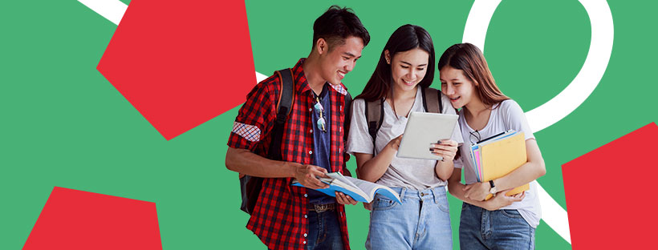


Young Wales Report to the United Nations Committee on the Rights of the Child

Young Volunteer Researchers: Arthur Templeman-Lilley, Ayse Gulcimen, Brandon Gale, Charlie Farr, Farrah Earl, Safiyah Hicks

Supported by Young Wales Staff: Bethany Turner, Elaine Speyer, Gareth Hicks, Juhela Rahman-Daultrey, Rebecca Bennett-Wilding, Tegan Waites

Edited by: Tegan Waites

December 2022

childreninwales.org.uk / www.plantyngnghymru.org.uk
@YoungWalesCIW






Executive Summary

Young Wales is based in Children in Wales, the national umbrella body for organisations working with children and young people, funded by Welsh Government. Young Wales aims to give children and young people in Wales a voice on issues that affect them, so that their views can be heard.

Welsh Government has a duty to have due regard to the United Nations Convention on the Rights of the Child as part of the ‘Rights of Children and Young Persons (Wales) Measure 2011.’

‘We want Wales to be a wonderful place to grow up, live and work, now and in the future.’

In 2022 Welsh Government launched the ‘Children and Young People’s Plan’ with a commitment to the principles of the UNCRC and to seven cross governmental priorities developed with Young Wales in consultation with over 200 children and young people.

This report has been co-produced by the Young Volunteer Researchers and Young Wales staff and is about the experiences of young people and their human rights in Wales. It will be sent to the UN Committee on the Rights of the Child.

We worked with Young Wales to better understand what children’s rights are, and what they mean for children and young people. We looked at the previous report, conducted a literature review, decided some questions to ask, and got in touch with other groups to see what children and young people saw as priorities in Wales. We contacted all 22 local authorities in Wales and a range of other organisations including the Welsh Youth Parliament, Children’s Commissioner for Wales Office, Young Carers Network, National Participation Workers Network, Supporting Service children in education in Wales, TGP Cymru Refugee and Asylum Programme and many others, to better understand the priority areas on a local and national level.

We worked with Young Wales to collate the data from 41 young people consultations delivered by Young Wales between 2020 to 2022 with over 1000 young people contributing. We drew upon data received from events attended by Young Wales between 2020 to 2022 including the newly formed 2022 annual young carers Wales Festival and annual Young Wales Festival with over 200 young people in total attending across both events. We also consulted with the Young Wales young people advisory groups with 56 young members that include: Education and Social Justice Special Interest Group, Health and Social Services Special Interest Group, Climate Change and Rural Affairs Special Interest Group, Young Wales Project Board and the National Youth Stakeholders Group; to further inform this report. We also created an online survey with questions on children’s rights and on the priority areas which had been decided by children and young people across Wales.

We asked organisations and young people to identify their current priority areas, we then asked young people to rank the priority areas in order of importance as follows:

- Cost of Living
- Mental Health and Wellbeing
- Addiction and Substance Misuse
- Equality, Diversity and Inclusion
- Children’s Rights and Participation
- Education
- Crime
- Life Experiences
- Play
- Transport
- Online Safety
- COVID-19
- Climate Change

We listened to what children and young people have told us and have come up with some recommendations for each of the priority areas as follows:

Recommendations
Cost of Living

- Full roll out of free school meals
- Re-Nationalisation of organisations like energy and transport providers
- Better standards of living
- Free Activities for children and young people
- More financial support for people living in poverty

Mental Health and Wellbeing

- Increased levels of support and earlier intervention
- Ensure better access to services.
- Offer a wider range of services
- Increase visibility and normalise mental health
- Create Safe Spaces

Addiction and Substance Misuse

- Stronger enforcement of age restricted products.
- More support for those who are already addicted to substances.
- Make drugs and substances un-cool through awareness raising strategies.
- Include drug and substance awareness in the new curriculum and in training for teachers.

Equality, Diversity and Inclusion

- Ensure young people feel safe by introducing more laws to protect us all.
- Include Equality, Diversity and Inclusion in the New Curriculum for young people and training for teachers.

Children’s Rights and Participation

- Increase awareness activities and resources so that all children and young people know they have rights and how to access their rights.
- Create more opportunities for young people to have a say.
- Ensure that all children and young people have the opportunity to be heard representing the diversity and culture within Wales.
- Ensure that opportunities for participation are accessible and inclusive to all children and young people.
- Increase awareness resources and training for adults.

Education

- Improve awareness of the new curriculum
- Make education more relevant to the real world. Provide work experience that interests and motivates young people.
- Provide more funding in education for resources and meaningful experiences and opportunities for all young people.
- Make education accessible and inclusive to all children and young people in Wales.
- Provide quality mental health training and support for teachers and young people to change the stigma around mental health.
- Change the rules around school uniforms so they are affordable for all families.

Crime

- Increase police numbers and visibility and consider introducing harsher punishments as a preventative approach to reduce crime rates.
- There needs to be a change in the system to prevent crime, support those who commit crimes and support victims of crime.
- Raise awareness and education on crime and where to get help.
- Create safer spaces for children and young people.
- Wales should have more devolved powers for the justice system, as it would have a specific focus on Welsh issues such as the ongoing addiction and substance misuse and knife crime problems prevalent here.

Life Experiences

- More tailored and specific services and support is required for children and young people who experience negative life experiences. Including earlier mental health interventions and preventative approaches for mental health support.
- More funding is required to ensure support and services can be offered at the right time and appropriately to the needs of the child or young person.

Play

- We need more options, opportunities and time to play.
- There should be open access and free opportunities to play for all children and young people in Wales.
- Play spaces should be accessible, inclusive and safe.

Transport

- Make public transport free for all children and young people.
- Improve reliability, frequency and accessibility of public transport so that children and young people feel safe.
- Extend catchment areas so that more young people can access free school transport.
- Improve the public transport infrastructure so that it is accessible in all areas including rural areas of Wales.

Online Safety

- Introduce more rules and accountability on providers to check ages of users accessing the web to make it safer for all.
- Raise more awareness of online safety amongst children and young people using real life experiences as examples.
- Provide more training and resources on online safety for adults.

COVID-19

- Provide additional 1 to 1 support and resources for children and young people who need it post pandemic.
- Continue to acknowledge the long-term effects of the pandemic on children and young people. Specifically with regard to mental health and wellbeing and provide support to mitigate the long-term impacts.
- Provide safe and meaningful opportunities for children and young people to socialise and regain their social skills and face-to-face interactions with their friends and peers.

Climate Change

- Embed lessons, resources and more campaigns on climate change in to the curriculum to raise awareness on the reality now, what is being done, and what can be done with practical advice on how children and young people can make a difference.
- Provide clearer recycling bins, more safe walkways to school and support more outdoor activities such as gardening and litter picking.
- Reduce industrial impact on the climate and offer more incentives for eco-friendly industries.
- Listen to children and young people on climate change.

Young people are using their voices, claiming their right to be heard, and telling us what issues are important to them. It is crucial that we listen, understand, and act upon the concerns and suggestions outlined within this report.

Co-producing this report with Young Wales has been a fantastic opportunity for us volunteers. We have not only been able to share our own views but also amplify the voices and advocate for fellow young people.

In Wales, Children’s rights are generally upheld. However, there are some improvements to be made. The UNCRC works hand in hand with ideas of equality, diversity, and inclusion. Throughout the report accessibility and inclusivity has a strong presence. When actions are taken following this review, this ethos must remain as a central factor. Children’s rights should be the forefront of decision-making, with young people’s voices acting as the driving force for change and progress.

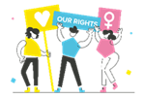

Contents

Executive Summary 1

Introduction 7

About Us 8

What We Did 10

Priority Areas 11
Cost of living 12
Mental health and wellbeing 15
Addiction and substance misuse 19
Equality, Diversity and Inclusion 22
Children’s Rights and Participation 26
Education 30
Crime 34
Life experiences 37
Play 40
Transport 46
Online safety 49
COVID-19 53
Climate change 56

If you were First Minister for the day 60

Recommendations 62

Conclusion 66

Appendices 67

Introduction

Young Wales is based in Children in Wales, the national umbrella body for organisations working with children and young people, funded by Welsh Government. Young Wales aims to give children and young people in Wales a voice on issues that affect them, so that their views can be heard, particularly by Ministers in Welsh Government and other policy makers. The project website can be found at https://www.childreninwales.org.uk/children-young-people/young-wales.

Welsh Government has a duty to have due regard to the United Nations Convention on the Rights of the Child as part of the ‘Rights of Children and Young Persons (Wales) Measure 2011.’

‘We want Wales to be a wonderful place to grow up, live and work, now and in the future.’

In 2022 Welsh Government launched the ‘Children and Young People’s Plan’ with a commitment to the principles of the UNCRC and to seven cross governmental priorities developed with Young Wales in consultation with over 200 children and young people.

This report has been co-produced by the Young Volunteer Researchers and Young Wales staff and is about the experiences of young people and their human rights in Wales. It will be sent to the UN Committee on the Rights of the Child. We would like to thank all the young people, organisations and groups who contributed to this report.

The United Nation Convention on the Rights of the Child (UNCRC) is an International Agreement on how countries should treat children. There are 54 Articles in total and each one contains a children’s right: Rights are something everyone has as a result of being born. No one has power to give them or take them away from people. Examples of rights: the right to life, the right to a name, the right to be listened to and the right to get information. (Children Rights Wales, UNCRC)
http://www.childrensrights.wales/images/PDF/ActivityToolkits/RaisingAwareness/UNCRCTheUNCRCDecodedEnglish.pdf)

Every five to seven years each country (called a State party) has to submit a report on how well it is promoting the Articles in the UNCRC. Lots of reports are sent in, from people like the UK Government and the Children’s Commissioners.

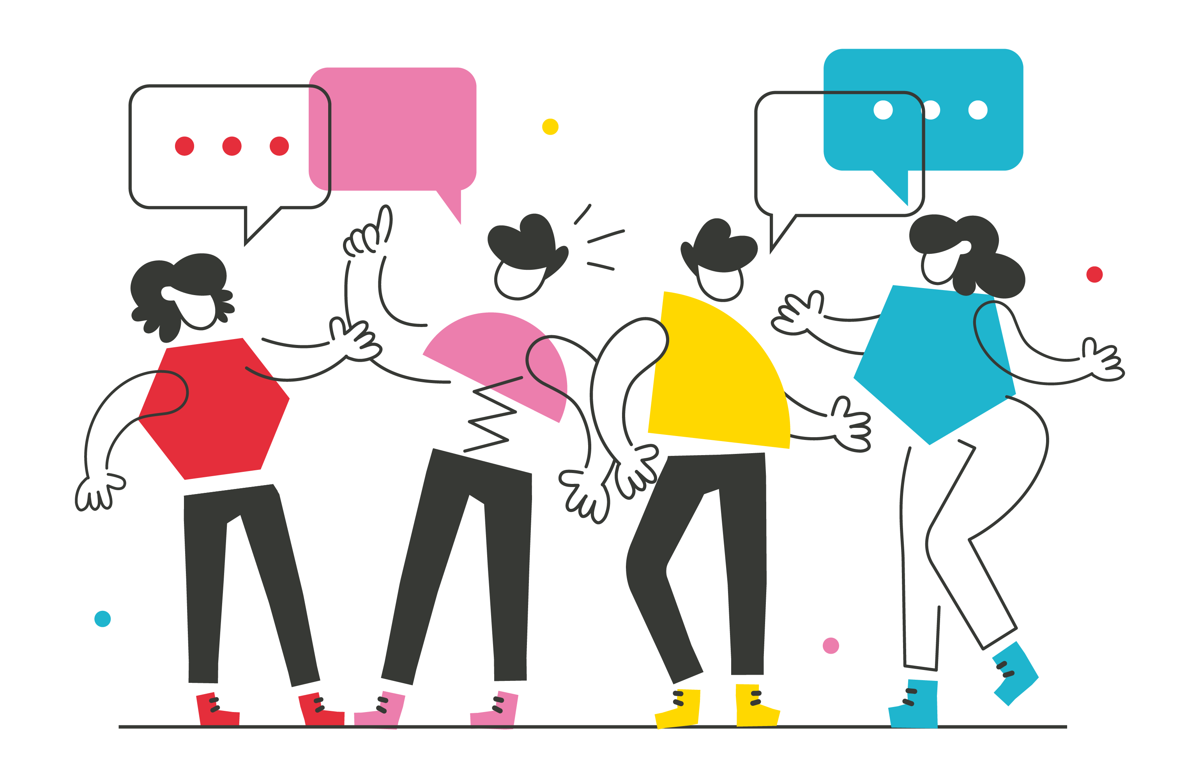The previous Young Wales report to the United Nations Committee on the Rights of the Child was produced in 2017 and had six recommendations. The report is on this link https://www.childreninwales.org.uk/application/files/4616/1972/4935/YW-Report-for-UN-Final1_1.pdf

About us

Our names are Arthur, Ayse, Brandon, Charlie, Farrah and Safiyah, we have volunteered our time over the past year and worked with staff members of Young Wales to do this research and we hope you enjoy reading our report.

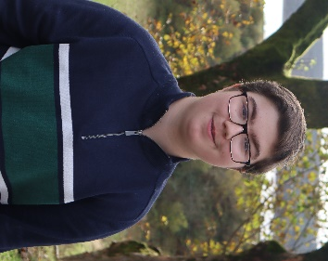
My name is Arthur, I am 15, and am a Young Wales volunteer. Over the last year, I have worked on many projects with Young Wales including the UNCRC report. It has been a fantastic experience, with plenty of opportunities to collaborate with the Young Wales team and my fellow volunteers on a range of different areas from consultations to presentations, allowing me to develop a variety of skills. Recently, Young Wales has also supported me in starting my own youth voice group Future Youth Impact (fyi_change). I have made some good friends through this work; the meetings are always relaxed but productive, where everyone feels comfortable and is open to share their opinions. I joined Young Wales so I could share my own views and amplify the voices of other young people within my community, all through the lens of the UNCRC. I believe that children’s rights are fundamental to a child’s mental, physical, and social development, and feel that young people must be empowered to claim these rights. In my spare time, I enjoy learning about medieval history, particularly comparing political systems between the centuries. I also listen to a lot of 80s music (I’m a huge Genesis fan) and bake whenever possible.

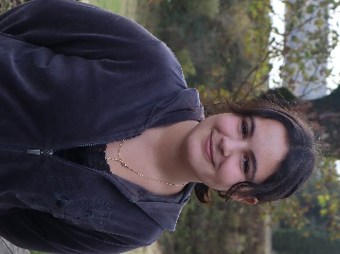
Hello, my name is Ayse. I am a volunteer at Young Wales and a member of the UNCRC Volunteer Group. I am 13 years old and my goal is to get my voice heard as a young person in Wales. I enjoy going to all the Young Wales meetings and residentials. I like making new friends and learning new stuff. I love reading and listening to music. I enjoy being a volunteer at Young Wales because I like meeting other young people like me (and for the free food).

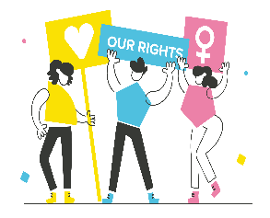
Hi, my name is Safiyah, I’m 14 years old and I’m a Young Wales volunteer. I like art, swimming and the summer. My goal is to make sure my voice gets heard and other young people in Wales have opportunities to be represented. Ever since I joined Young Wales, I have had a big boost to my confidence and have met a lot of new people and made loads of friends.

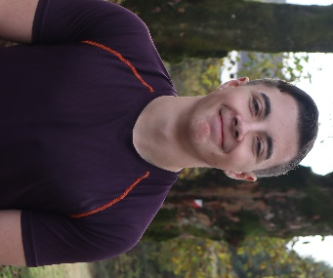
Hi, my name is Brandon. I am a volunteer with Young Wales. I am heavily involved as a National Participation Standards Young Inspector and sit on the Young Wales Project Board, Education and Social Justice Special Interest Group (SiG), Health and Social Services SiG, the National Youth Stakeholders Group, and the UNCRC Volunteer Group. I also help with the museum project and the various other projects and consultations with Young Wales for Welsh Government. I’m 17, and a student at Cardiff and Vale College. I enjoy many things, such as politics and football. I joined Young Wales to make a positive difference for all young people in Wales. I would recommend anyone and everyone to join and take part as every young person has equal opportunities and a right to be heard (article 12 UNCRC). It is for everyone, from
people who want to benefit their CV to benefiting their communities and the country. I assure you, you will learn all 54 articles from the UNCRC to the 7 National Participation Standards and lots, lots more!

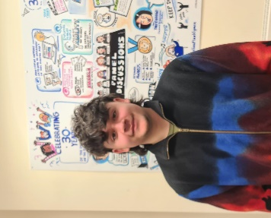
Hello, I’m Charlie, I’m 17 and a member of the Young Wales UNCRC Volunteer Group. I also participate in other roles within Young Wales such as being a National Participation Standards Inspector and a member of the Education and Social Justice SiG. Young Wales has allowed me the opportunity to make a difference as a young person. My experiences with Young Wales have helped improve my confidence, team building and education on children’s rights. I have met so many unique and incredible people and I could not be more ecstatic that I chose to join up last year.

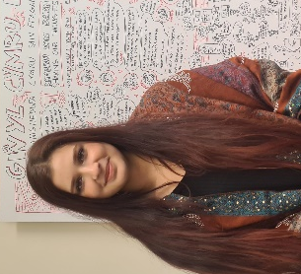
Hi! My name is Farrah, I am 17 years old and a Young Wales volunteer. I have been involved with Young Wales projects for 3 years and have thoroughly enjoyed every minute of it. I strongly believe young people can change the world when we are informed and empowered to speak. Equality, inclusion and diversity are especially important to me – everyone must feel that they have a platform to be heard.
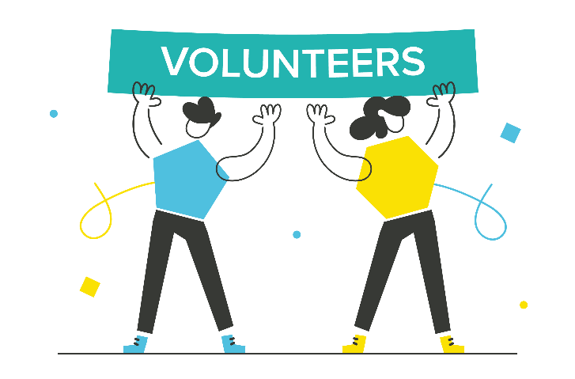

What we did

We worked with Young Wales to better understand what children’s rights are, and what they mean for children and young people. We looked at the previous report, conducted a literature review, decided some questions to ask, and got in touch with other groups to see what children and young people saw as priorities in Wales. We contacted all 22 local authorities in Wales and a range of other organisations including the Welsh Youth Parliament, Children’s Commissioner for Wales Office, Young Carers Network, National Participation Workers Network, Supporting Service children in education in Wales, TGP Cymru Refugee and Asylum Programme and many others, to better understand the priority areas on a local and national level.

We worked with Young Wales to collate the data from 41 young people consultations delivered by Young Wales between 2020 to 2022 with over 1000 young people contributing. We drew upon data received from events attended by Young Wales between 2020 to 2022 including the newly formed 2022 annual young carers Wales Festival and annual Young Wales Festival with over 200 young people in total attending across both events. We also consulted with the Young Wales young people advisory groups with 56 young members that include: Education and Social Justice Special Interest Group, Health and Social Services Special Interest Group, Climate Change and Rural Affairs Special Interest Group, Young Wales Project Board and the National Youth Stakeholders Group; to further inform this report.

We also created an online survey with questions on children’s rights and on the priority areas which had been decided by children and young people across Wales. We wanted to know whether things had changed since the last report, so some questions asked if things are better or worse than they were since the last report. We decided on an online survey, because we saw that as the best way to get information from children and young people across Wales that we might not have heard from already, and we wanted to hear from as many young people as possible to support our findings and our direct work with groups of young people.

The survey ran from the 19th November to the 5th December. We had 26 responses overall. The survey was anonymous, which means that we don’t know the names or contact details of people who answered, but we do know their age and what area of Wales they live in. We wanted to find out people’s ages, to see if there are particular issues affecting certain age groups, and whether different support is required according to age. We asked where in Wales they lived because we wanted to better understand local and national issues.

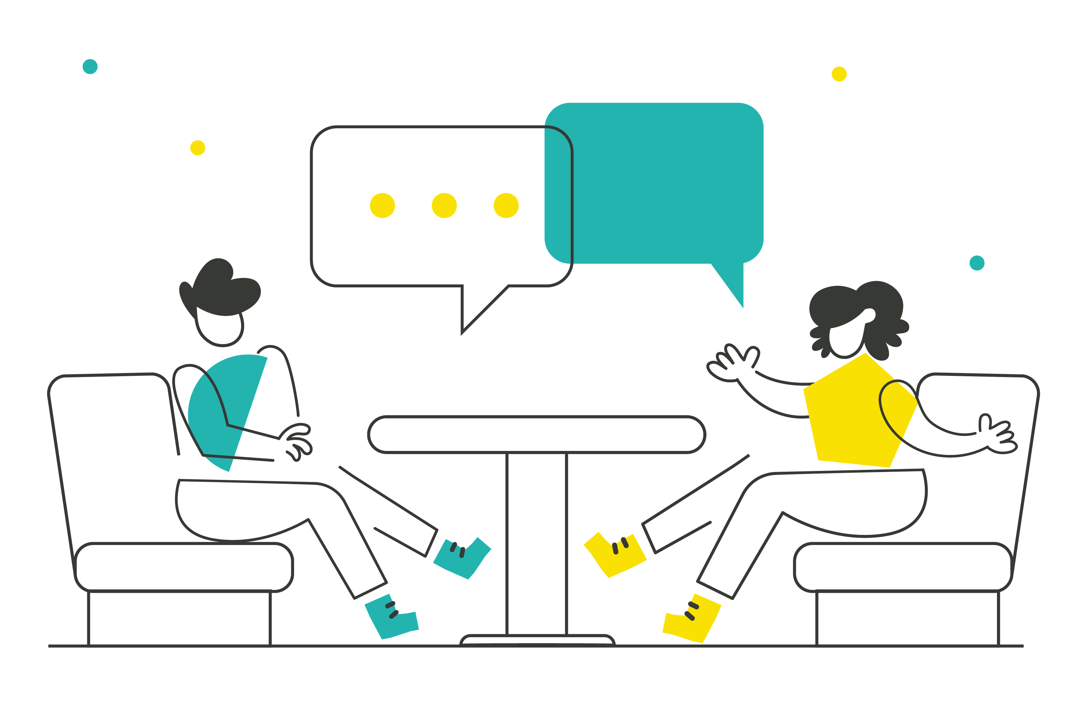We co-produced, wrote and edited this report with the support of Young Wales staff.

Priority Areas

The priority areas in this report have been identified by young people and organisations working directly with children and young people from across Wales. We asked organisations and young people to identify their current priority areas, we then asked young people to rank the priority areas in order of importance, the top results were:

Cost of living Mental health and wellbeing Addiction and
substance misuse

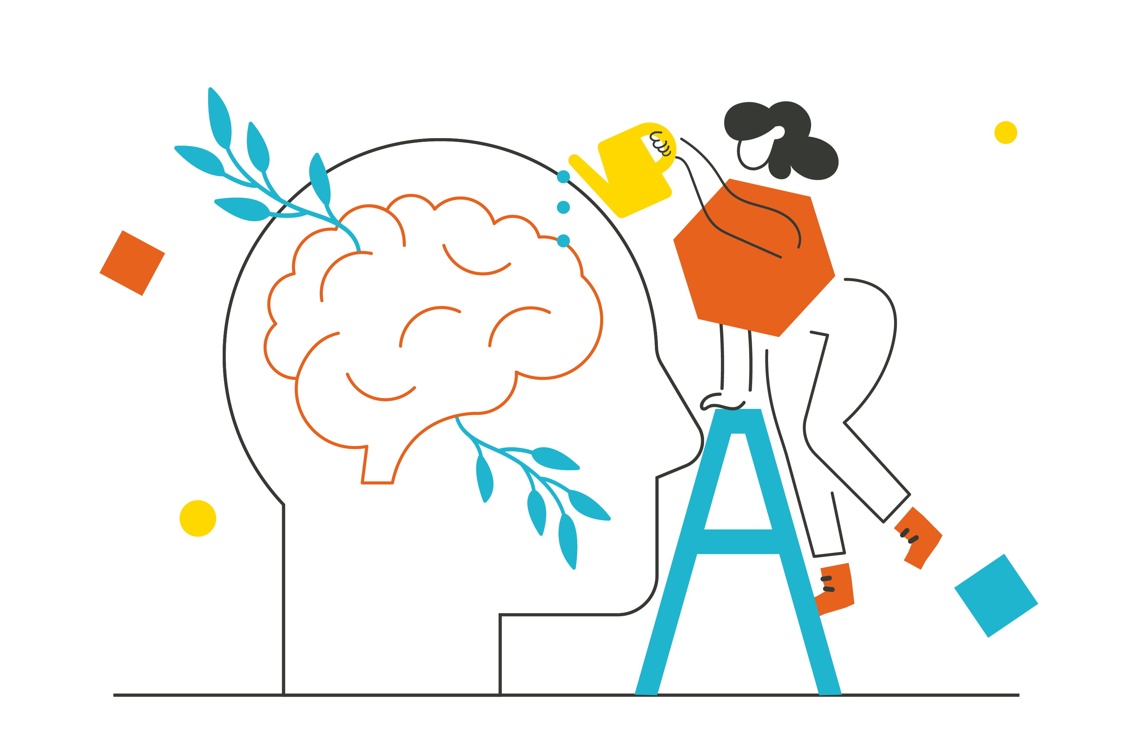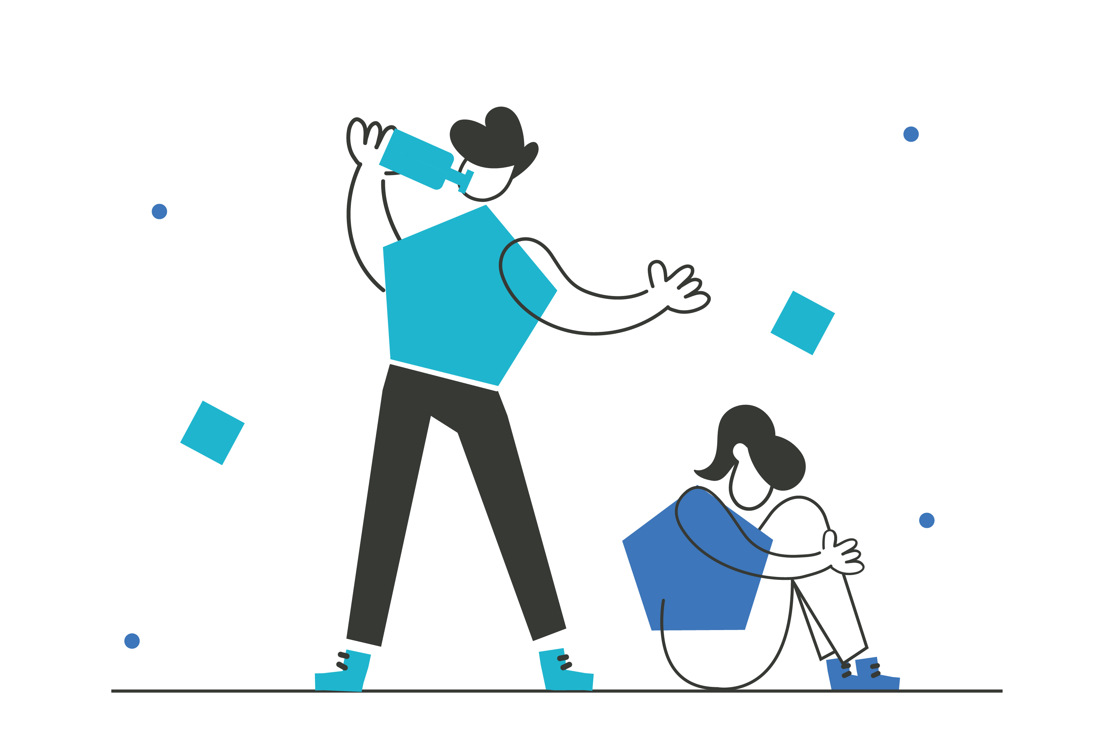

Equality, Diversity and Inclusion
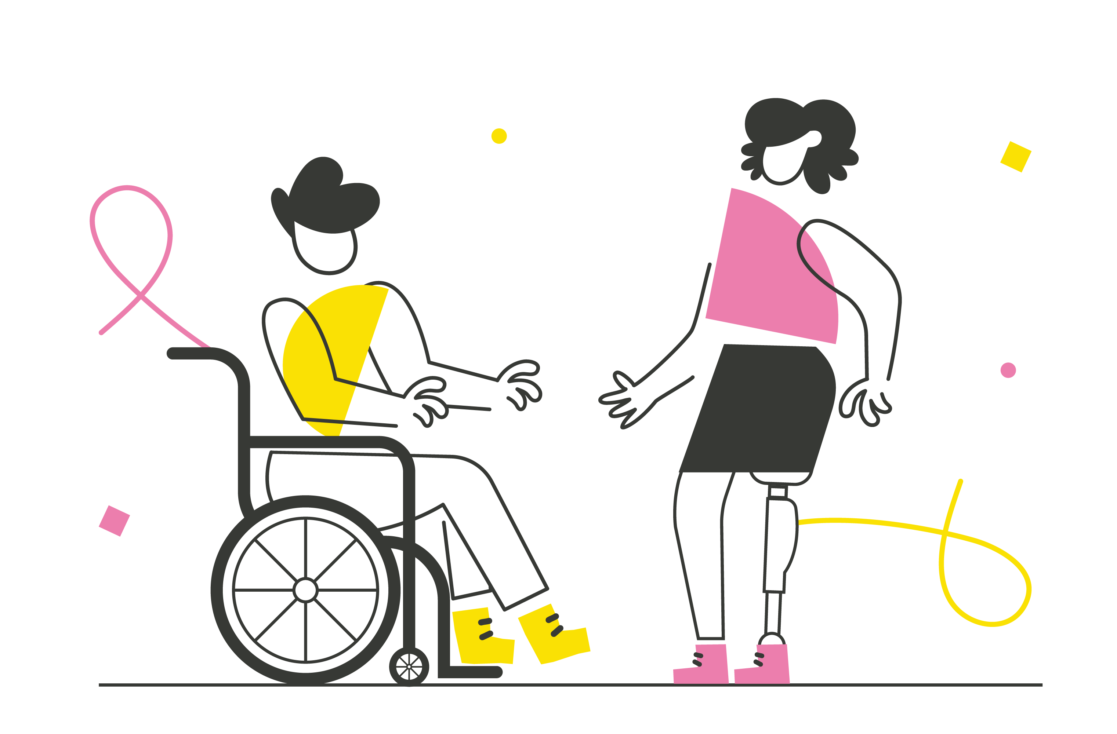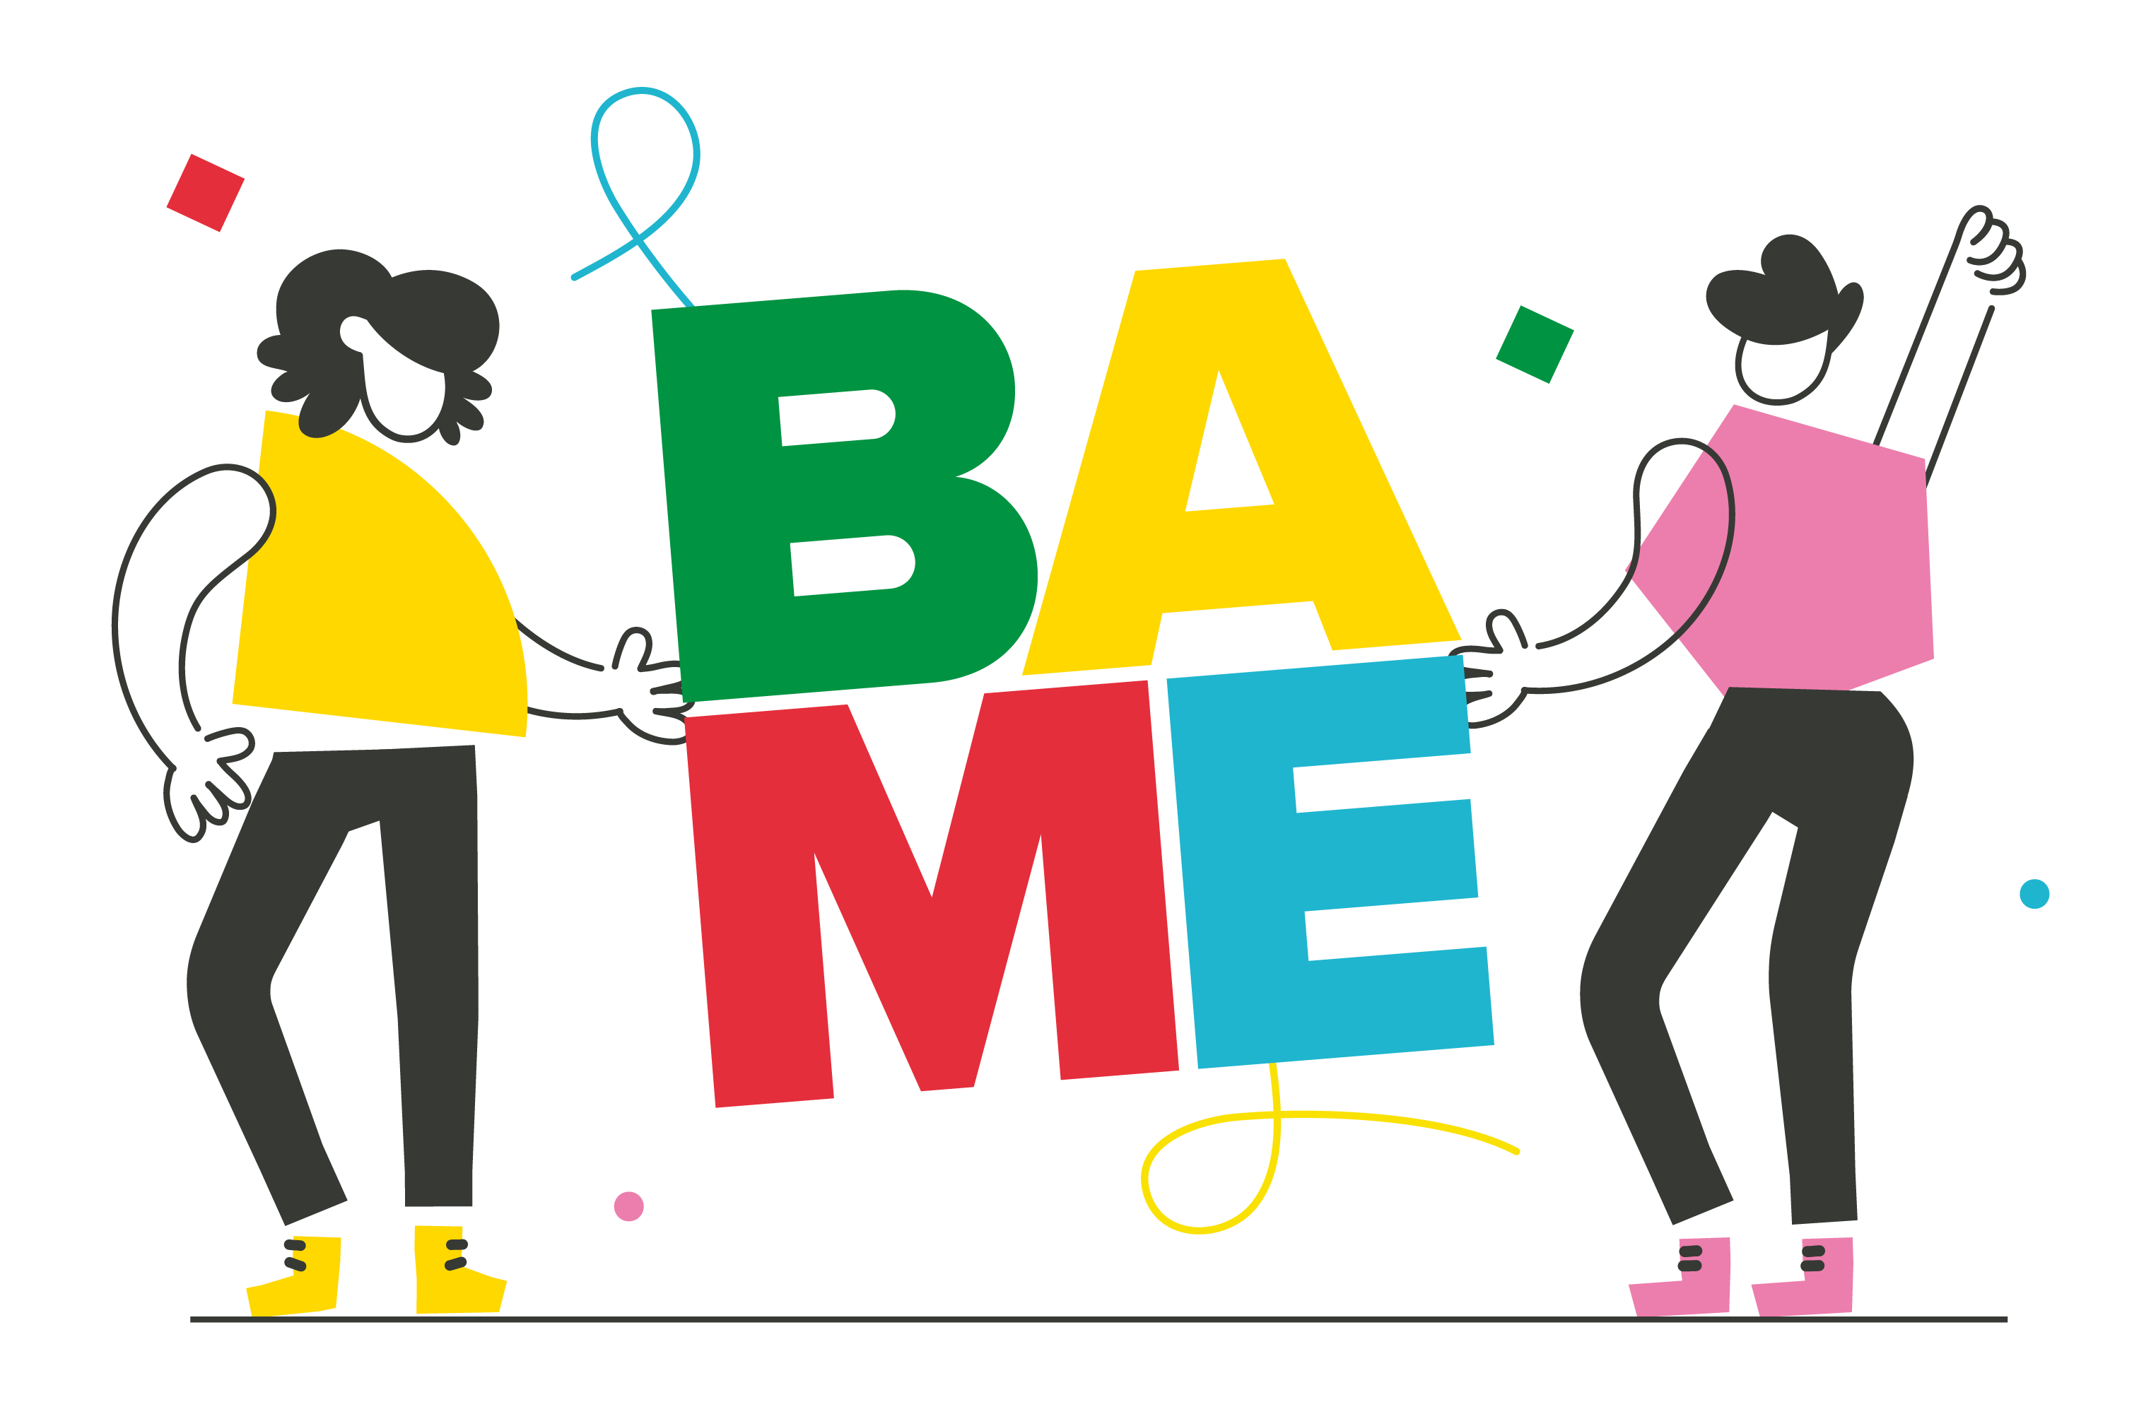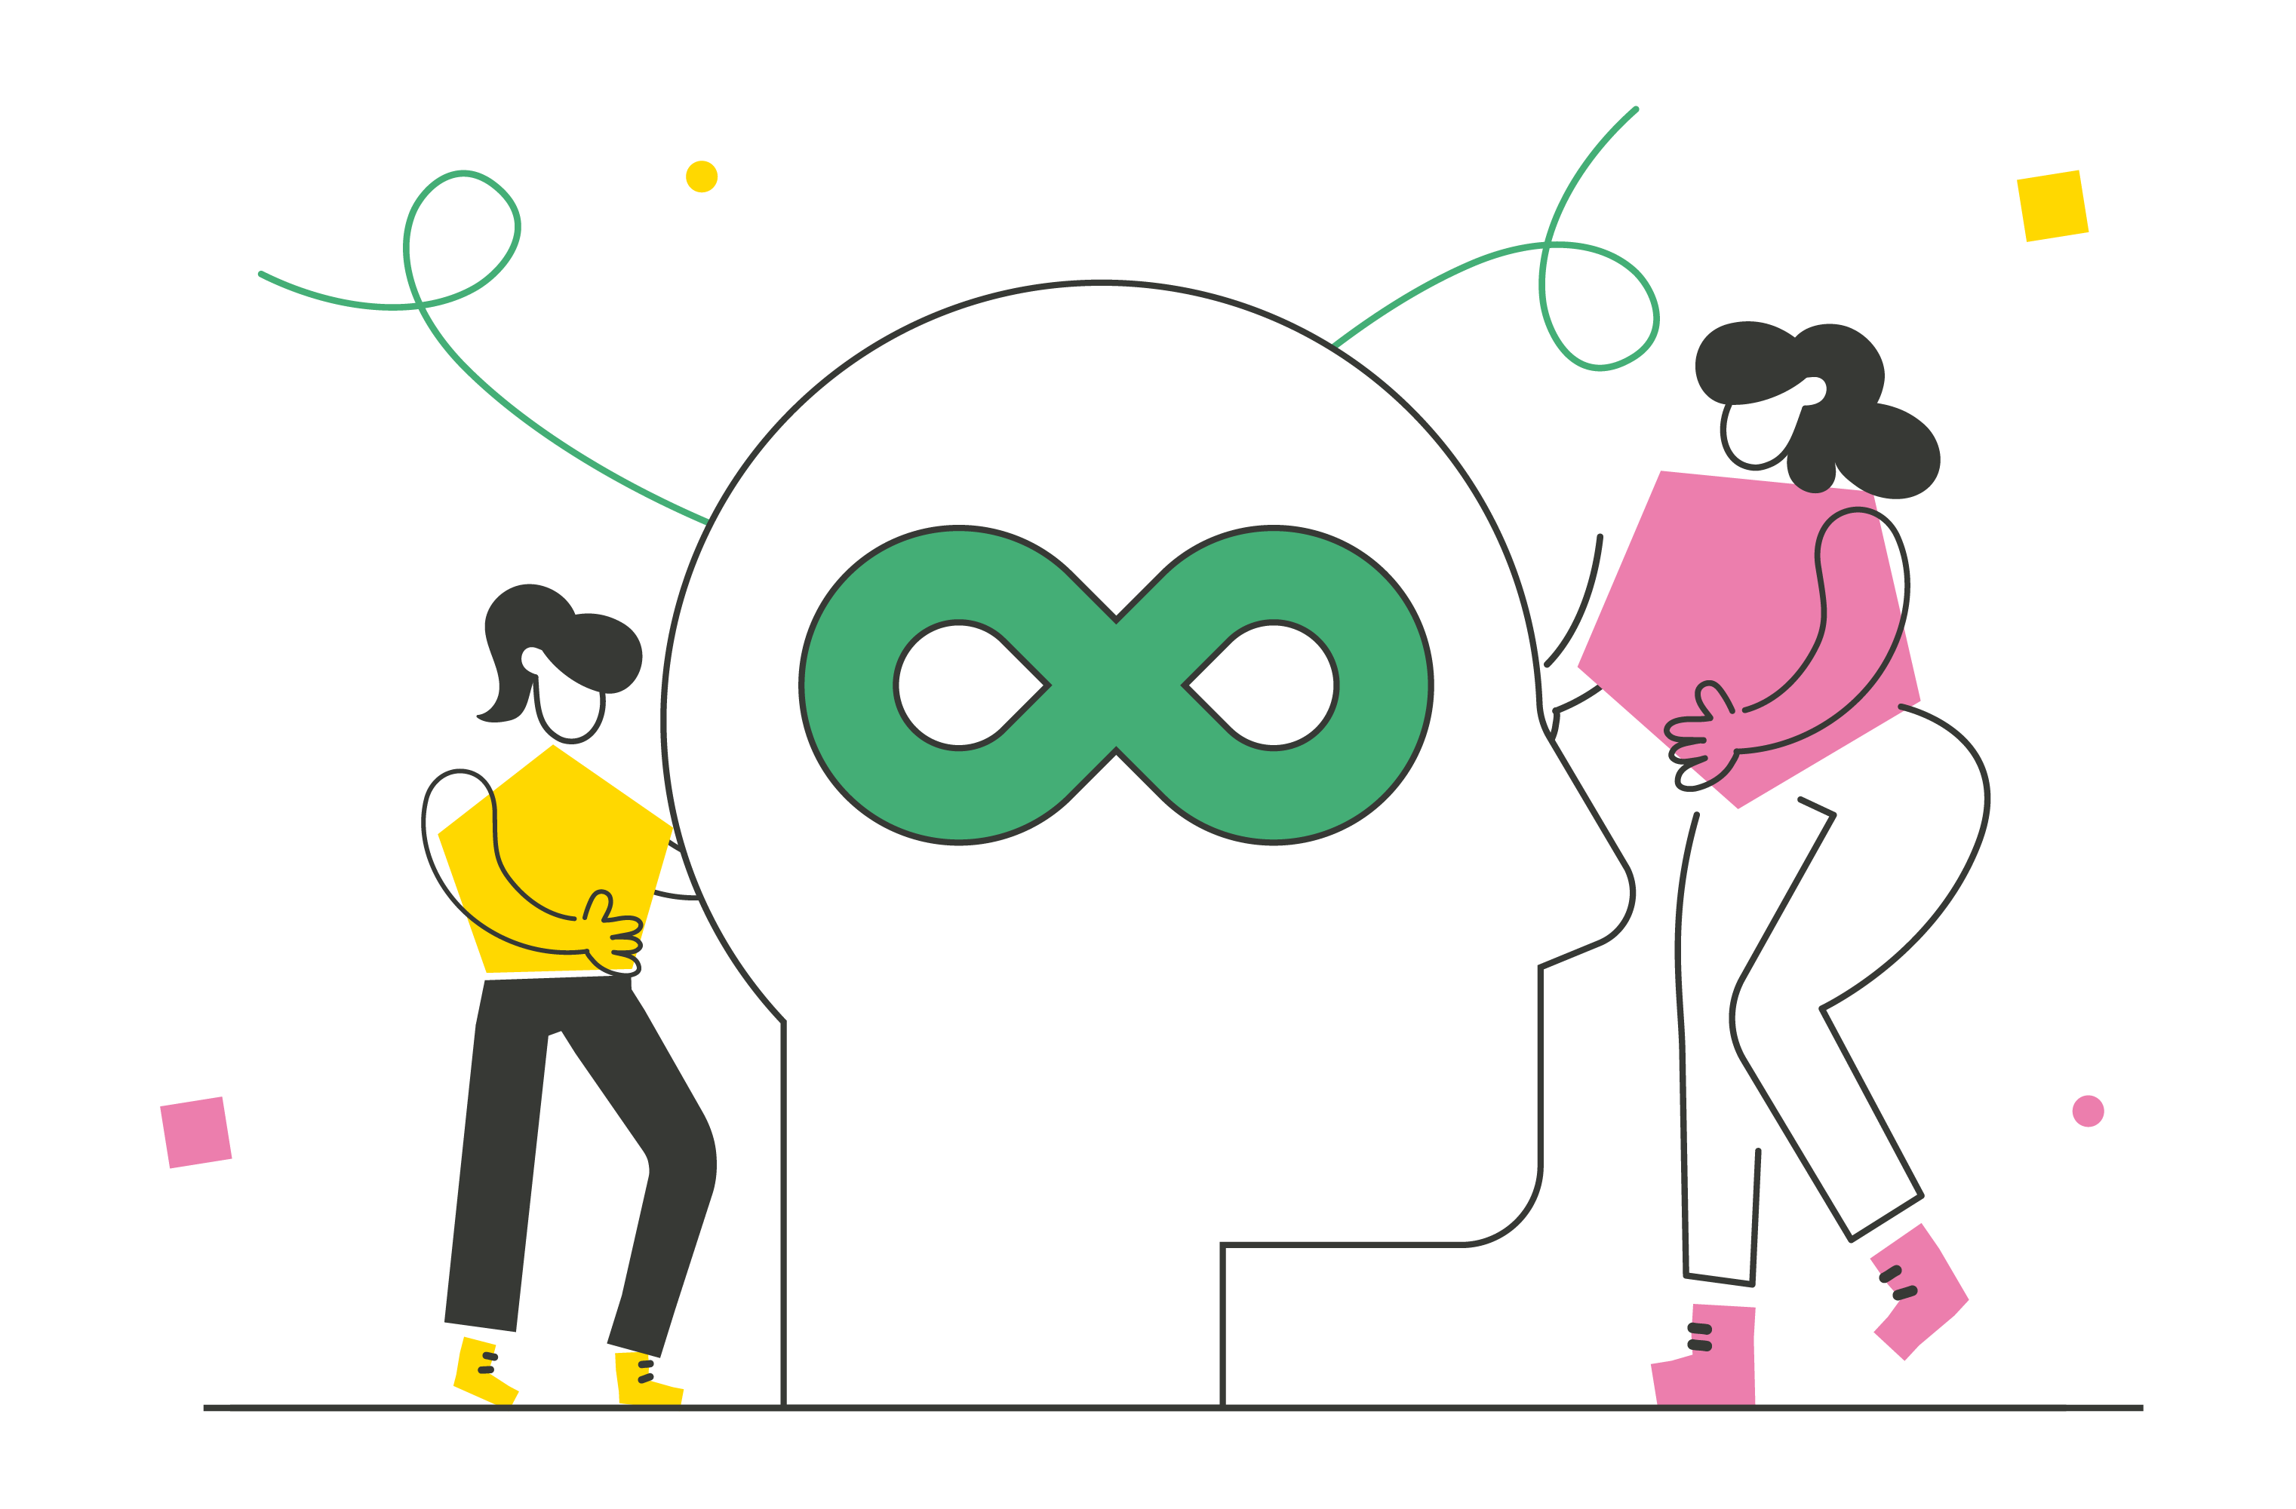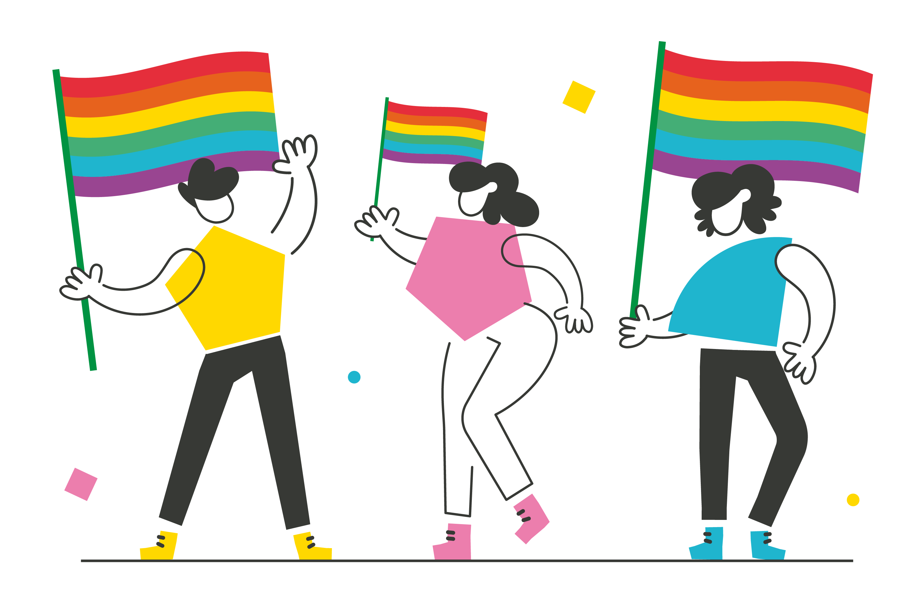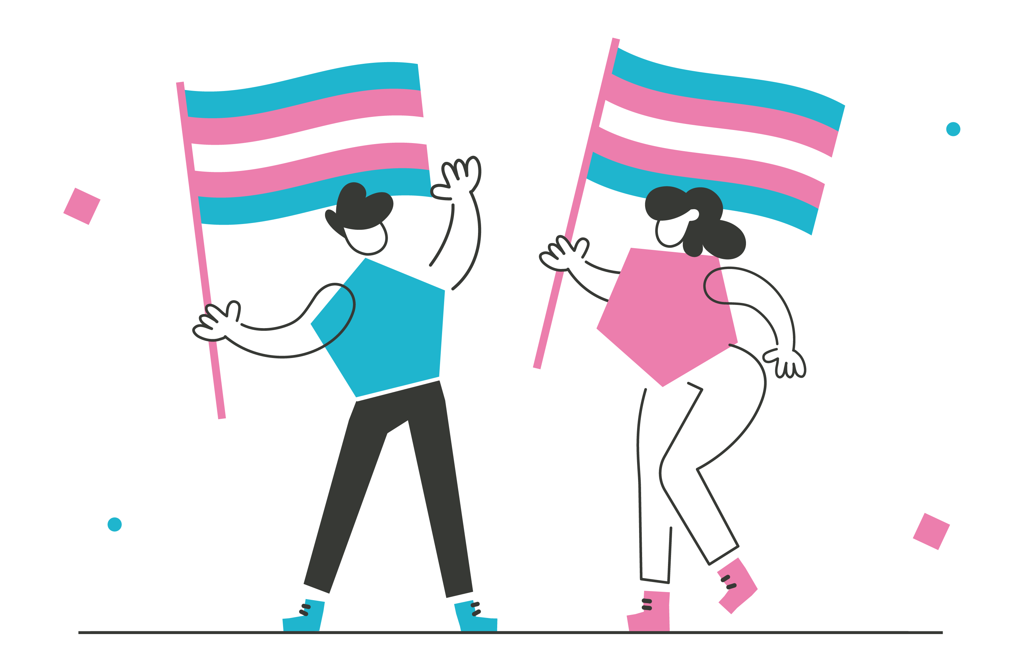

Other priority areas identified included:

Children’s Rights Education Crime
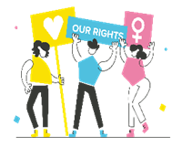
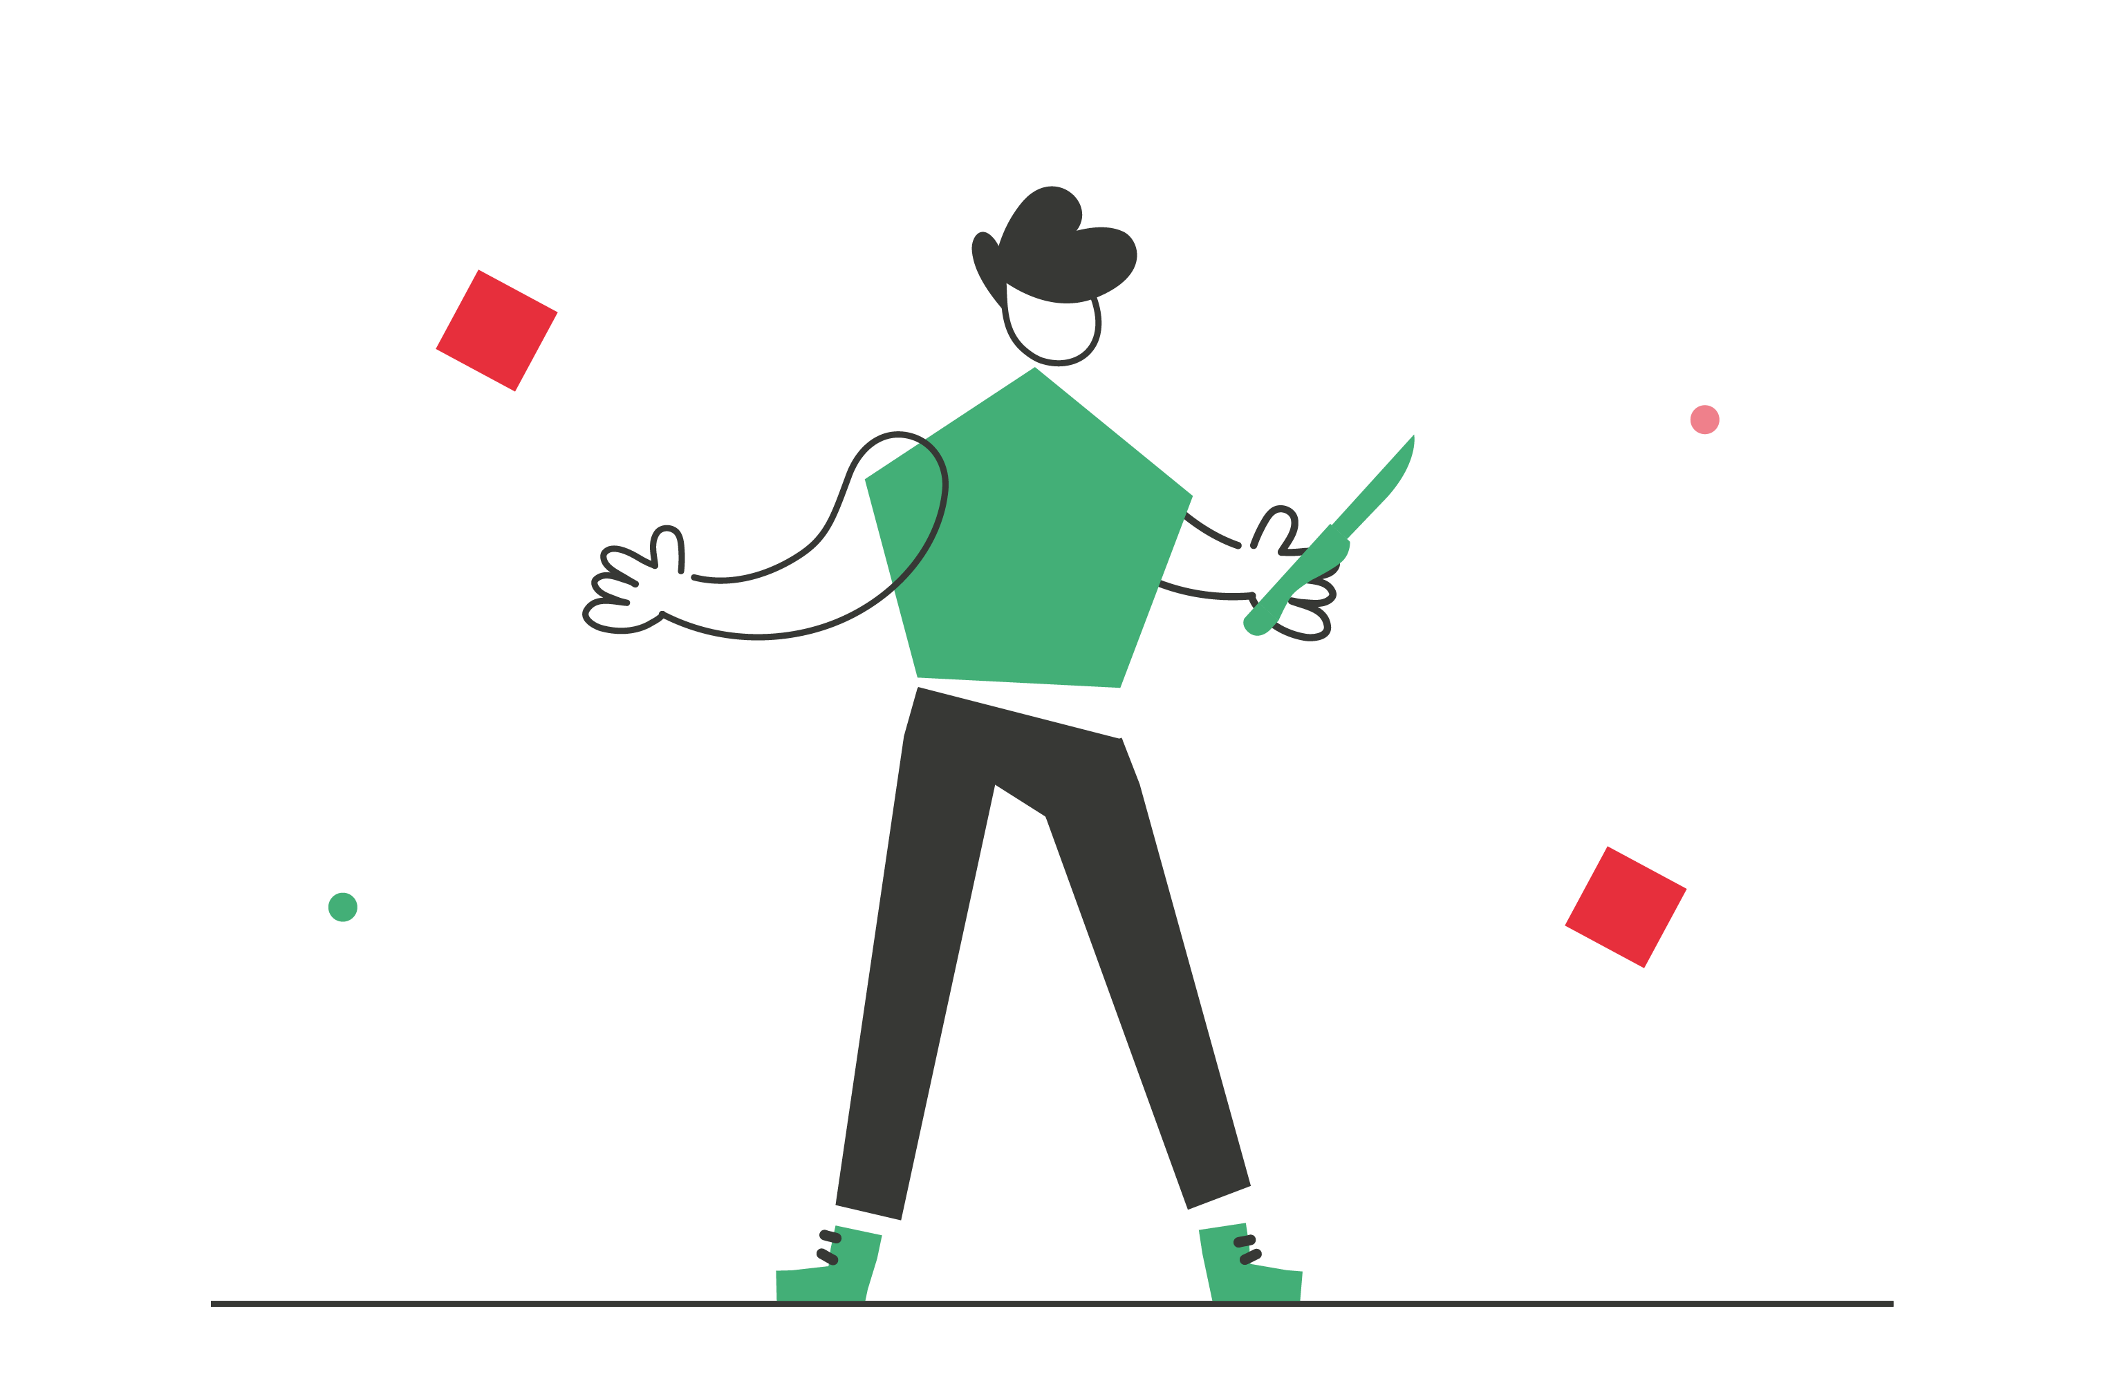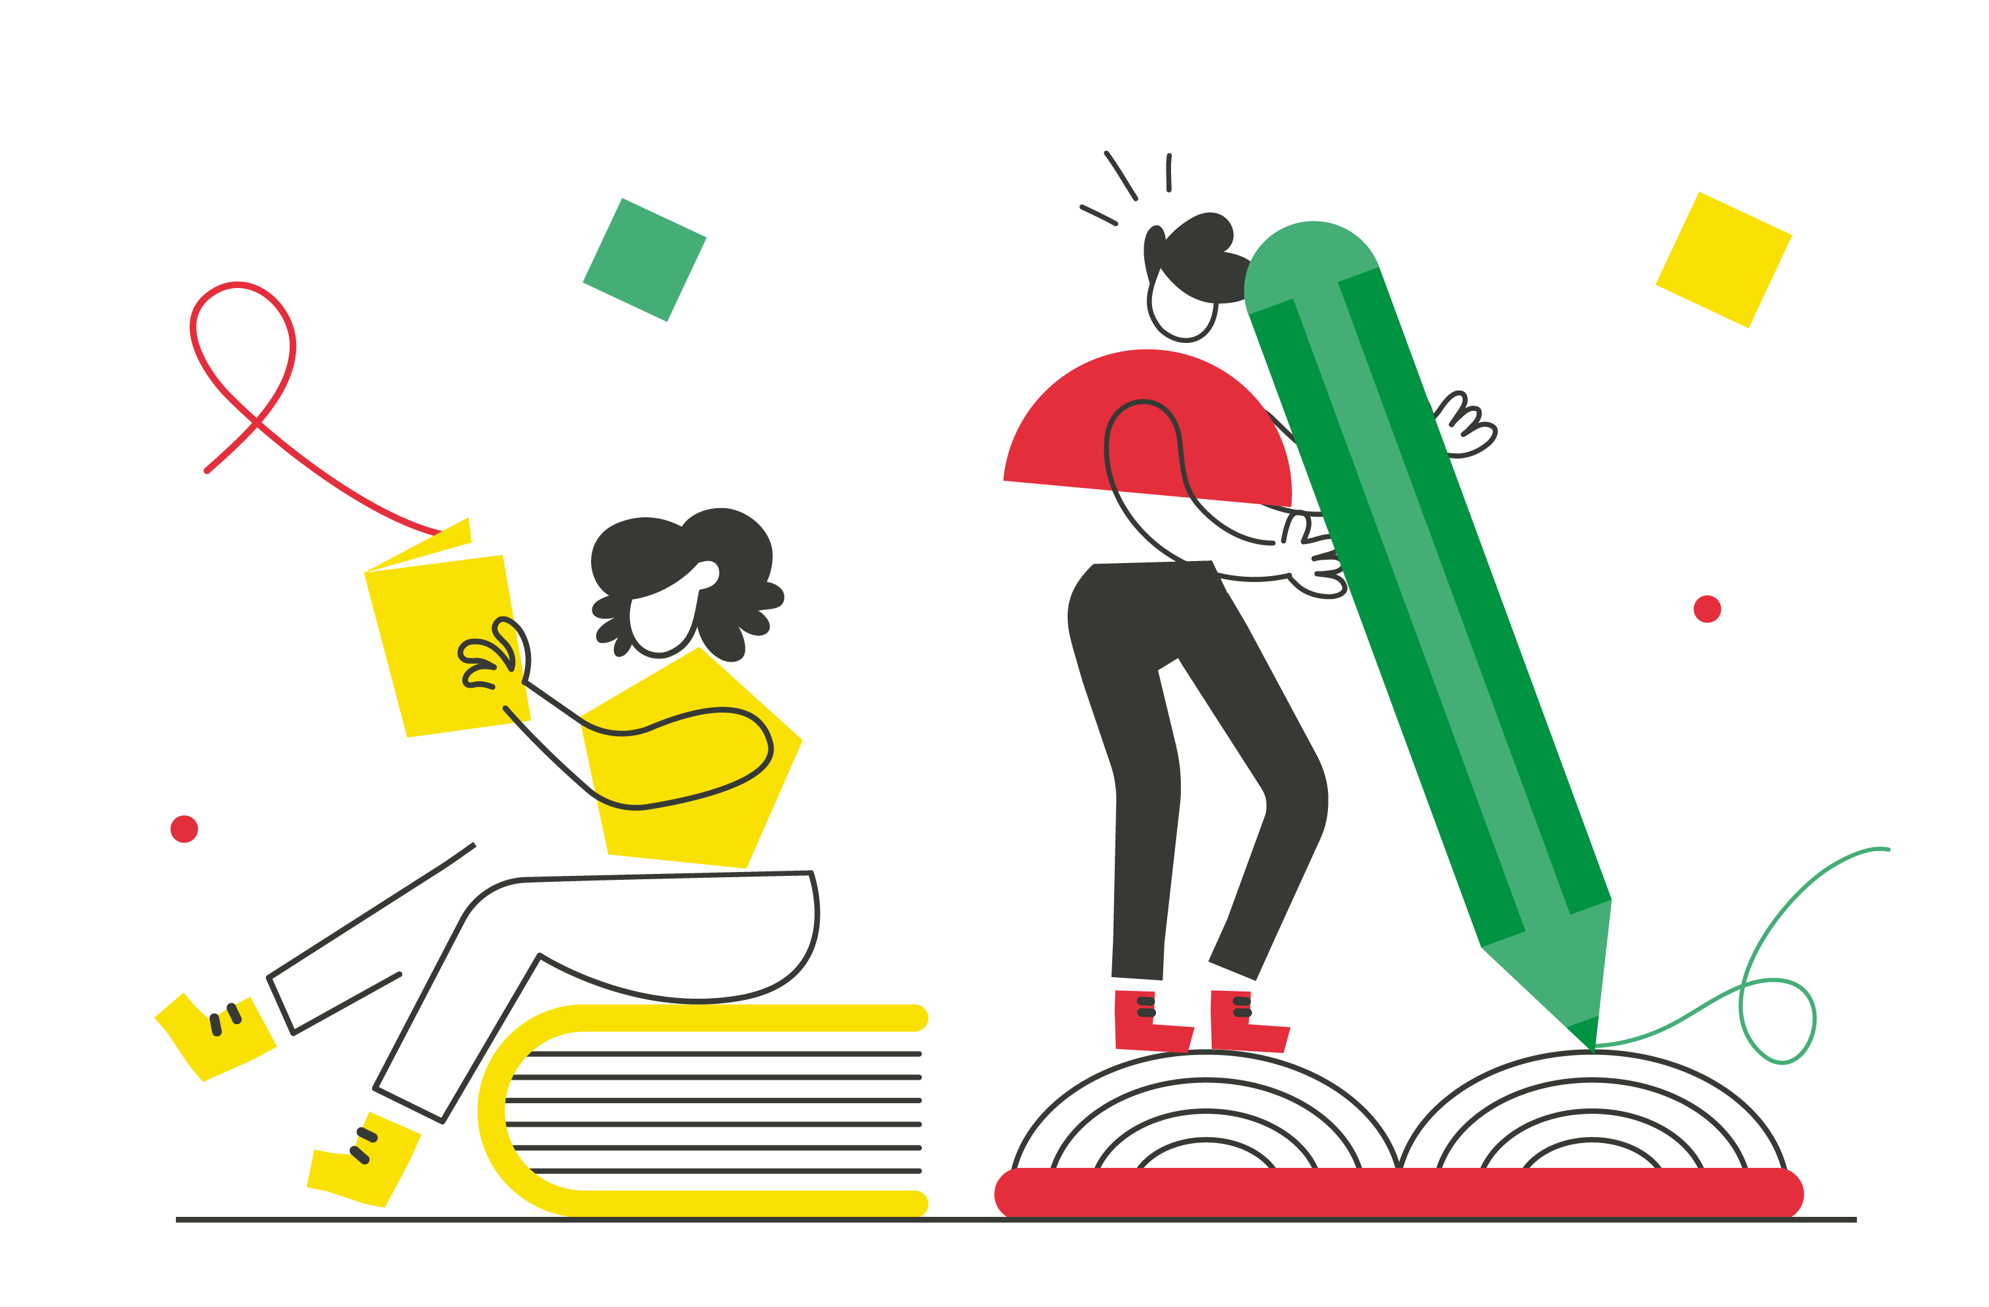and Participation

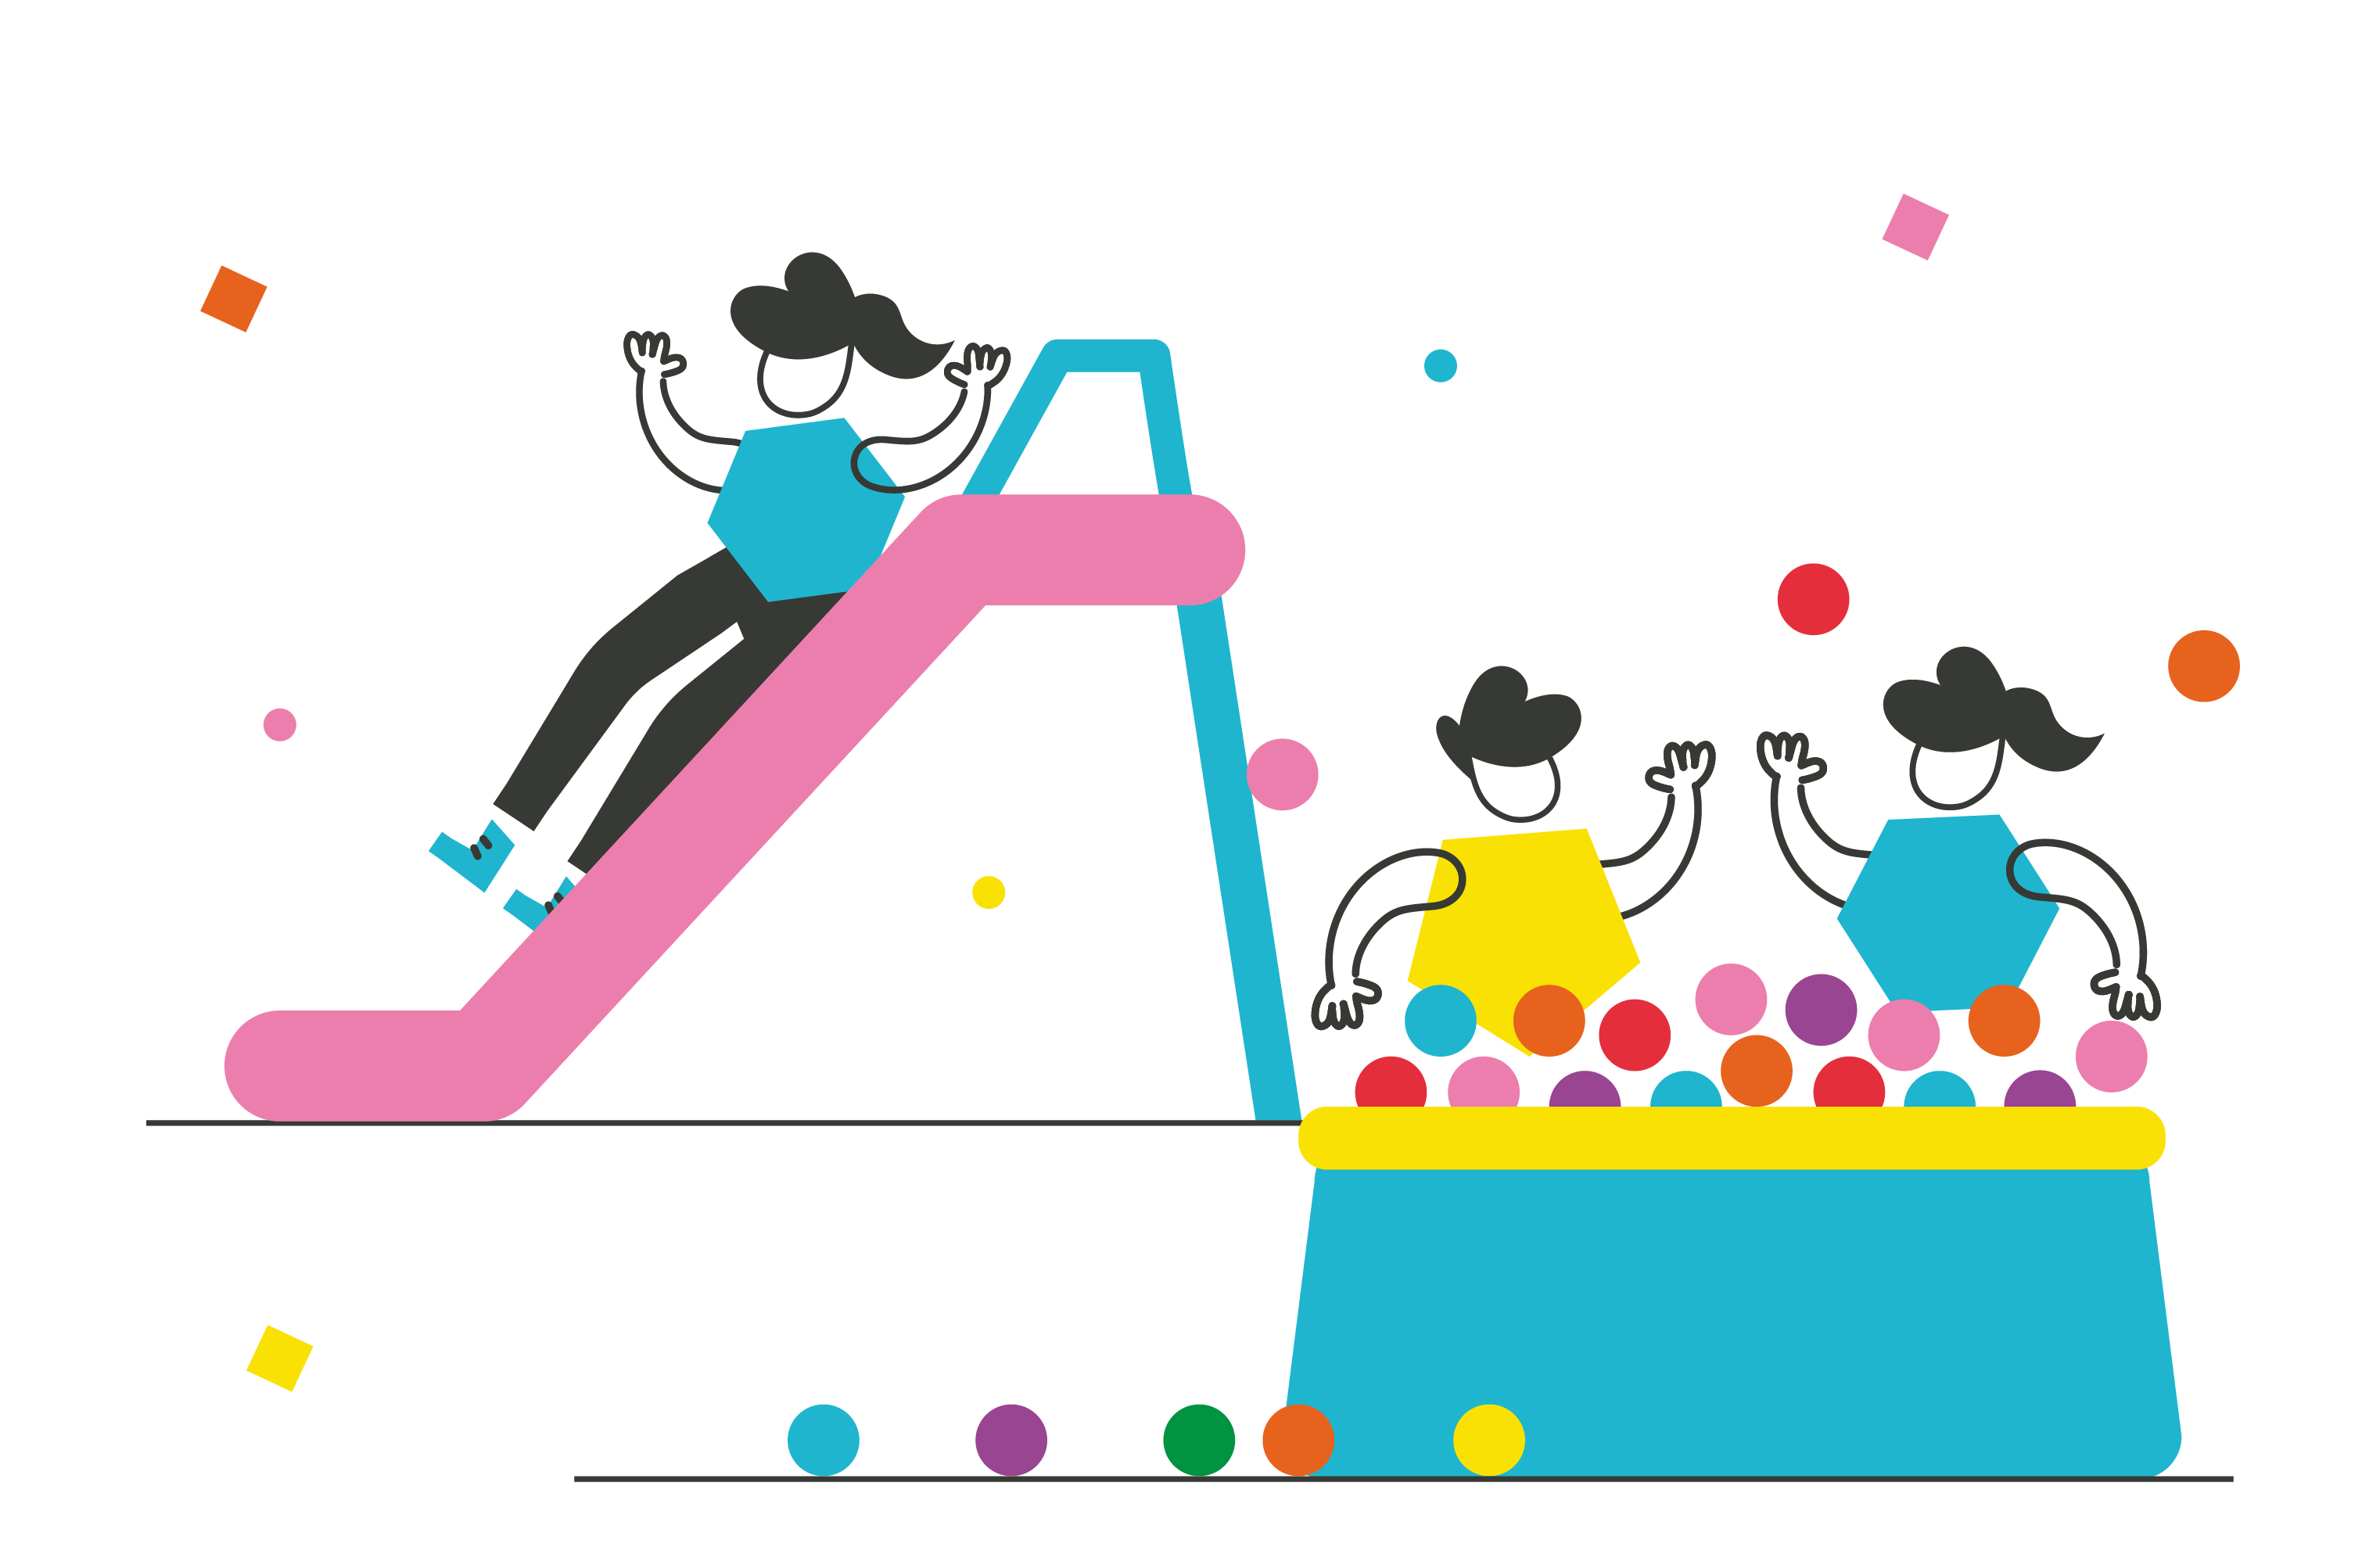Life experiences Play Transport
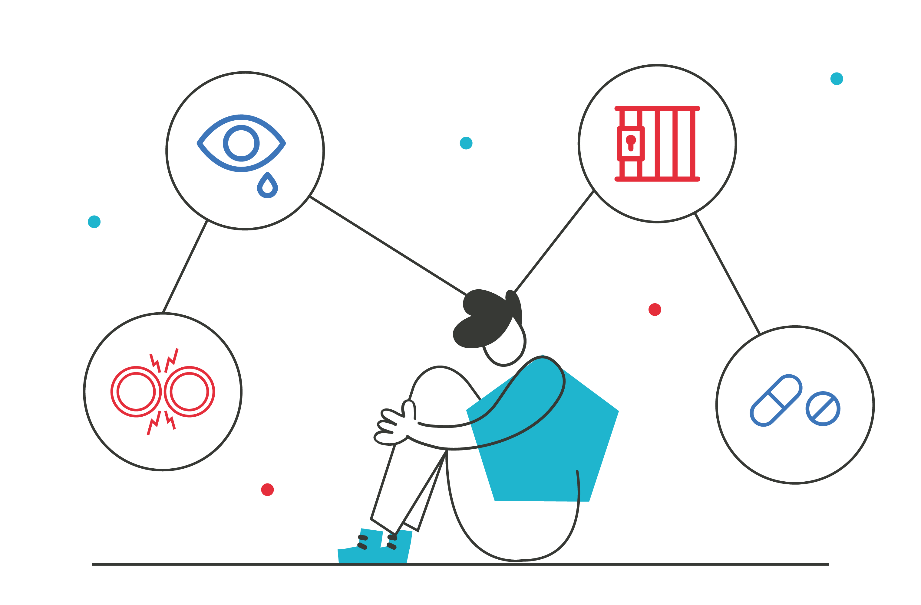

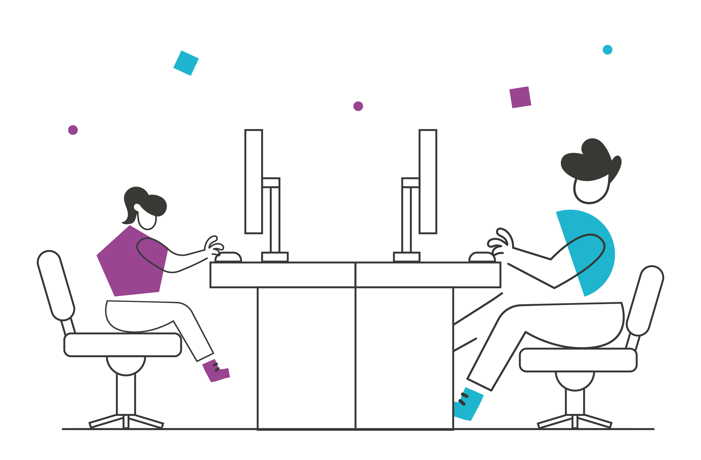 Online safety COVID-19 Climate change
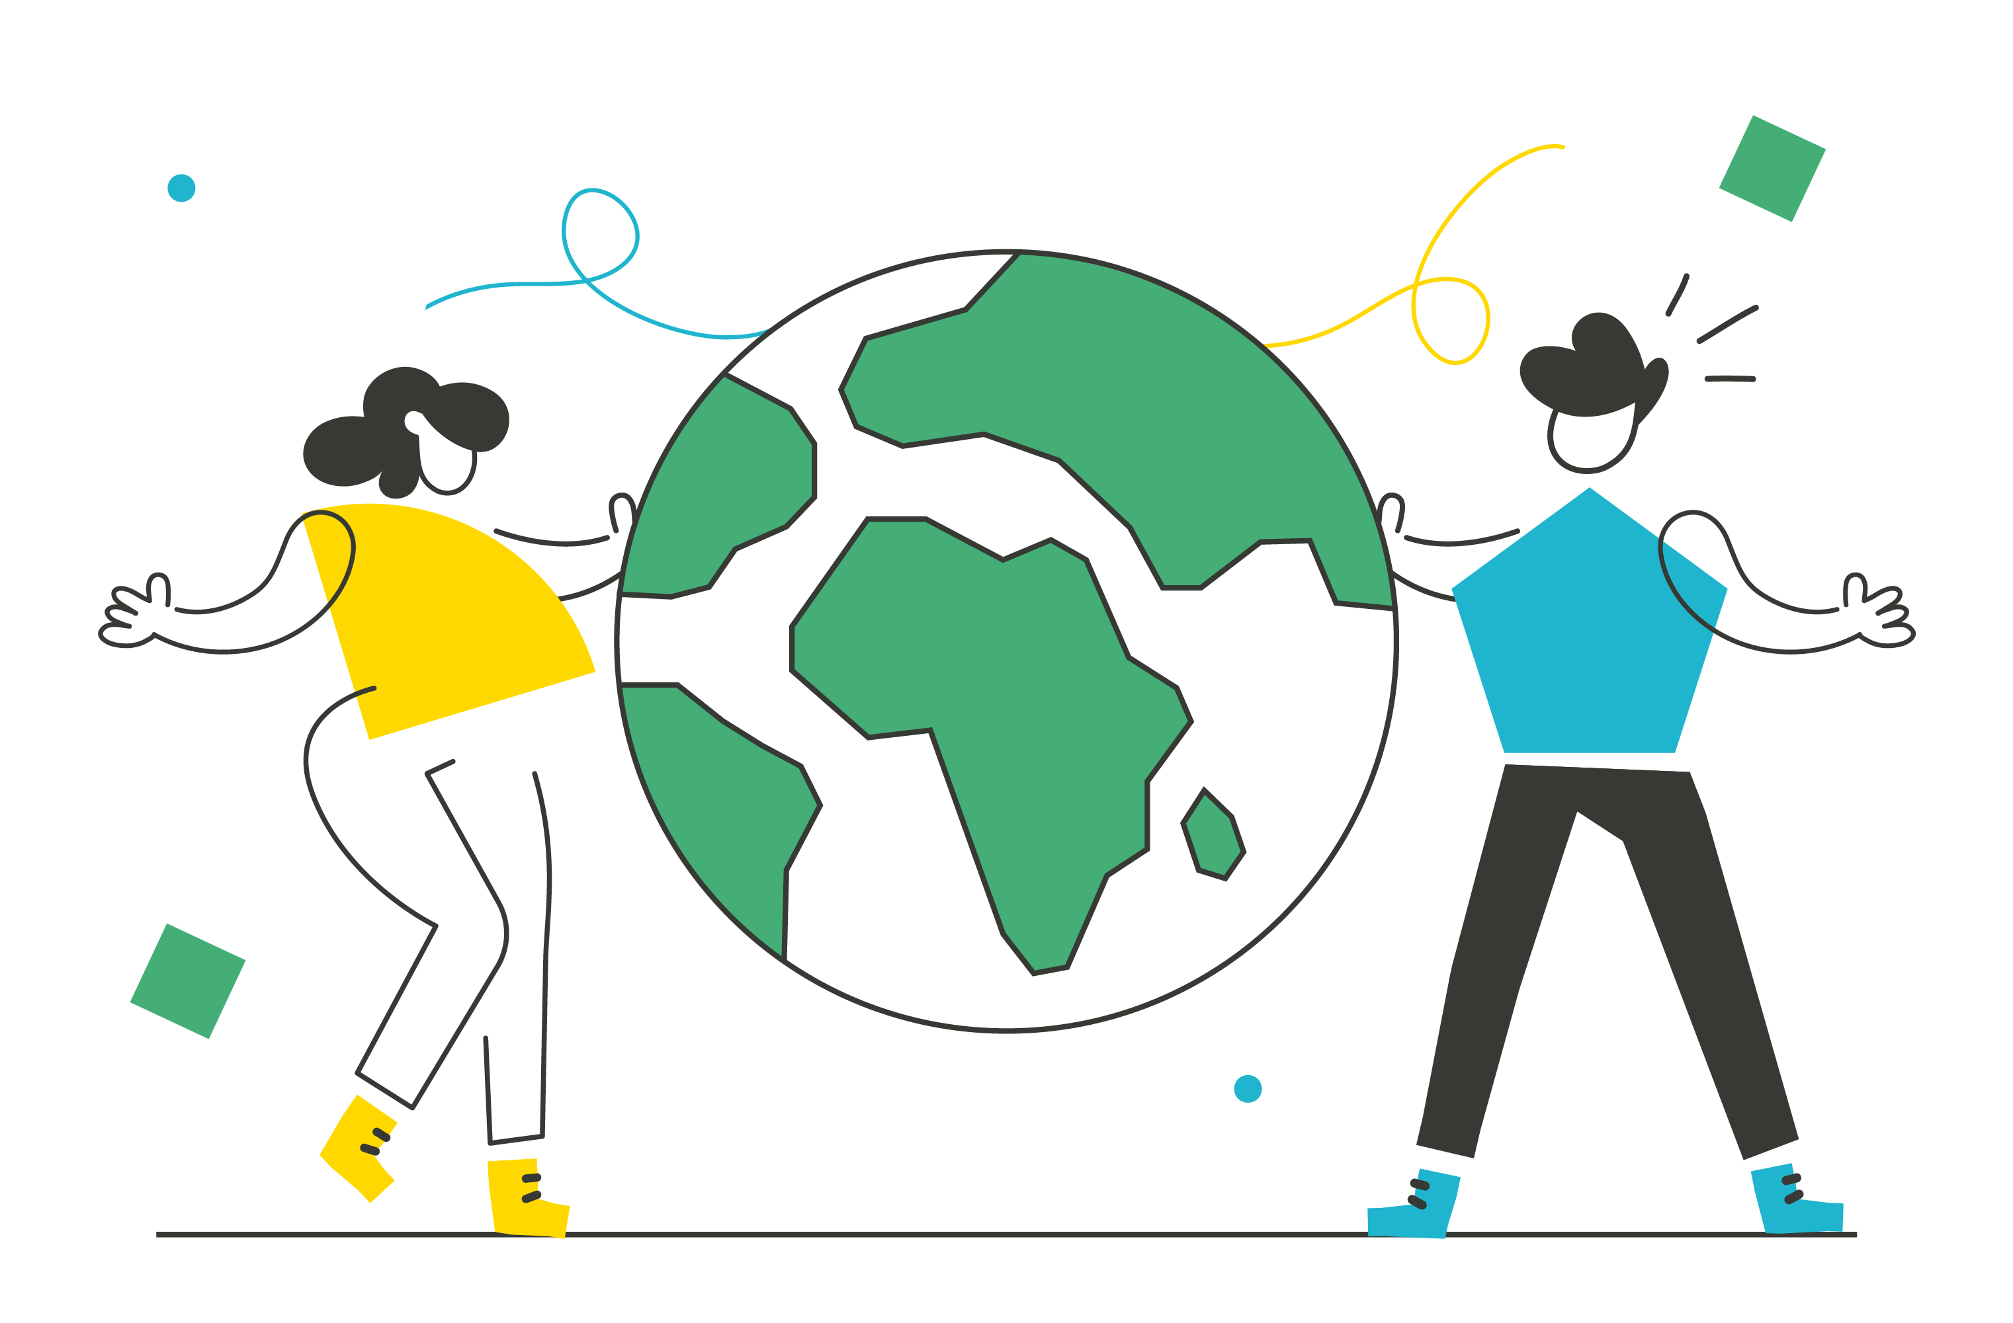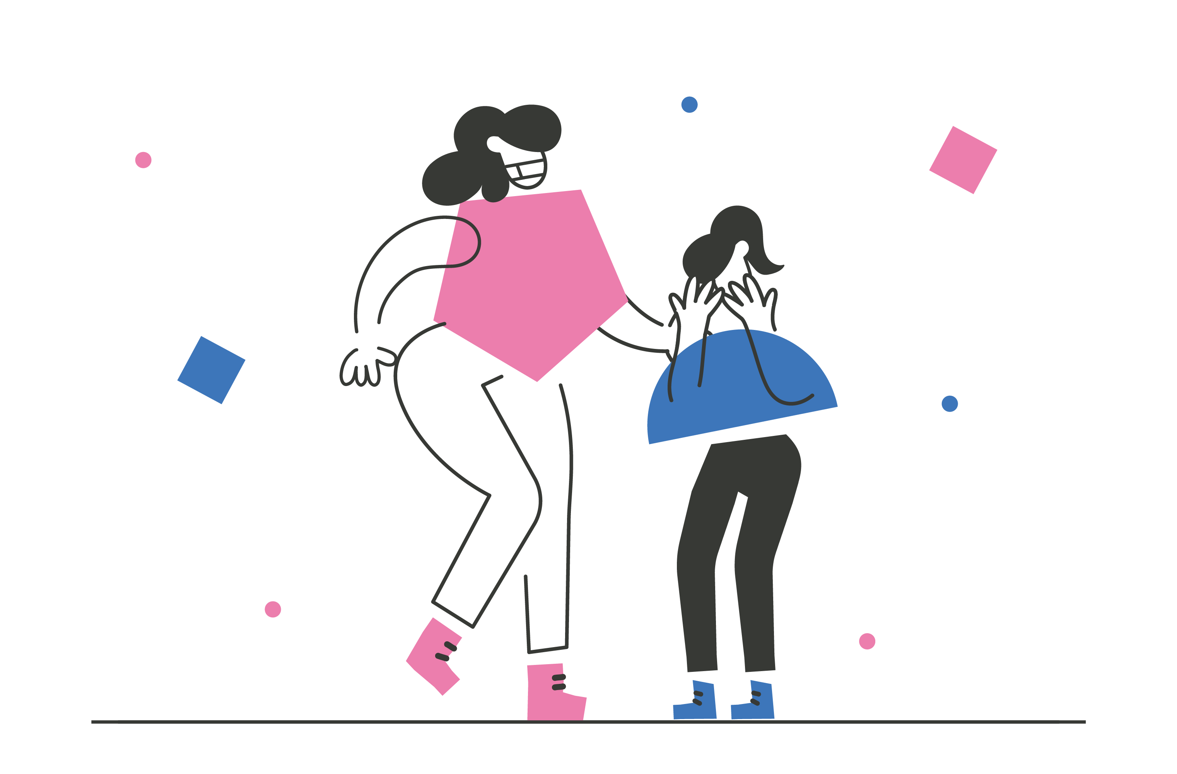

Cost of Living

Throughout the past year the cost of living crisis has had a significant impact on children and young people in Wales and a cross cutting theme with the priority areas included in this report. The cost of living was identified in our survey as a top priority for young people in Wales and has also been highlighted in our consultation work on behalf of Welsh Government on a proposed Social Water Tariff consultation and Access to the Child Trust Fund consultation.

‘Bills are really high and very expensive’

‘More families are struggling because of the cost of living crisis’

‘It’s a major concern as bills have dramatically increased’

‘Many young people are feeling anxious and mental health
issues will be increased for young people and their families’

‘There’s a widening gap with more young people and families living in poverty’

Survey Data

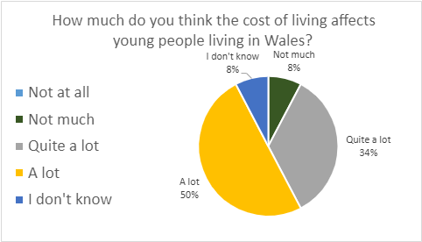

When asked how much the cost of living affects young people living in Wales, 84% answered either ‘a lot’ or ‘quite a lot.’ Only 8% answered ‘not much.’

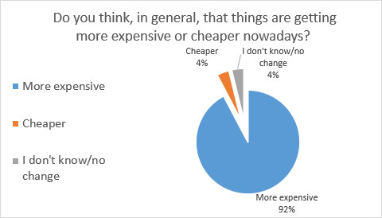

When we asked young people to consider whether things were getting more expensive or cheaper, 92% of them answered that things were getting more expensive.

What young people told us about how the cost of living affects them

Less opportunities to have fun – One of the most popular answers was that there were less opportunities to go out with friends or have fun.

‘As it is affecting our parents/ guardians it is affecting us. We are getting less money to go out with our friends.’

Impacting parents/home life - Many of the young people talked about their parents having less money, or giving their children the same amount of money, but things were costing more.

‘I see my parents making big changes and we get less treats.’

Young people often mentioned how the cost of living affects home environments or makes it harder to have basic needs met.

‘They may not have a nice home environment and may not have what they need for everyday life.’

Impact on broader issues - Other answers to this question included that parents were becoming more stressed, the impact on young people’s physical and mental health and concerns about the future.

‘Might not directly affect us now but affects our future a lot.’

General inequality, concerns about Government decision making, the cost of green initiatives and that disabled children were more likely to experience poverty and the cost of specialist equipment for children with disabilities was also mentioned.

Other Voices

Karen McFarlane, Policy Officer for Poverty and author of the Children in Wales’s 6th annual poverty survey and report 2022 said that:

‘Around 34% of children and young people in Wales now live in poverty. The impacts of poverty can be far reaching and touch every aspect of children’s lives. Right now, as you are reading this, many families in Wales are having to make the decision to either feed their children or use electricity. It is therefore not surprising that the findings show increasing debt, food and fuel poverty and a dramatic increase in poor emotional health, not only of parents, but children and young people themselves.’

A summary report of the children and young peoples survey findings can be accessed here: CIW_Poverty_Report_2022_CYP_English.pdf (childreninwales.org.uk)

We think (volunteers' thoughts)

The fact that this area has been selected as a top priority proves the severity of the situation. The majority of young people are very concerned, and directly affected by the cost of living crisis.

Our Recommendations

Free School Meals: We recognise that Welsh Government has begun a rollout of free school meals. In order to improve the cost of living crisis, free school meals should be rolled out more quickly and offered to all children and young people in Wales. This will relieve some pressures off parents/carers and guarantee a healthy meal daily for all children.

Re-Nationalisation: We recommend that there should be consideration around re-nationalising key organisations such as energy suppliers, and transport providers to reduce costs to everyday people.

Standards of living: There should be a minimum standard of living for all people in Wales.

Free Activities: More open access and free activities for children and young people.


Financial Support: Provide additional support to those most in need including financial help and support with mental and physical health.

Mental Health and Wellbeing

Mental health and wellbeing is becoming more and more challenging for children and young people and a cross cutting theme amongst the priority areas included in this report. There is a lack of early support services and many are getting to crisis point before getting the support they need. The Young People’s National Youth Stakeholder Group (NYSG) and the Health and Social Services Special Interest Group have identified key recommendations to improve services and access:

- Continue to consult with the NYSG and Health and Social Services SiG
- Consider the continued impacts of COVID-19 on young people and access to services
- Improve waiting times for services
- Introduce more wellbeing services in school and outside of school for children and young people
- Improve transitions between children and adult services

Mental health and wellbeing has consistently been highlighted across a range of Young Wales consultations with children and young people.

The Access to Health Services by Children and Young People during the COVID-19 Pandemic consultation reported on children and young people’s experiences and challenges in accessing healthcare including longer waiting lists, waiting times and delayed check-ups or appointments.

Survey Data

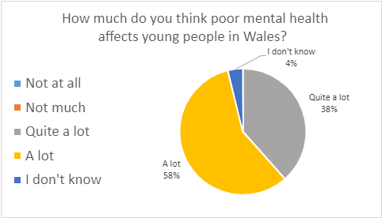

The responses to this question show that poor mental health affects young people a significant amount, with all respondents except one answering ‘A lot’ or ‘Quite a lot’ to this question.

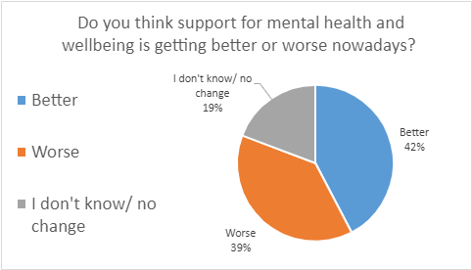

Outside of those who said ‘I don’t know/no change,’ there was almost a 50/50 split amongst young people of whether they thought support for mental health and wellbeing is getting better or worse.

What young people told us about how mental health and wellbeing affects them

There were 3 main themes on how mental health and wellbeing affects young people.

Education: Young people mentioned that they feel increasing exam stress, with GCSEs particularly mentioned.

‘When picking GCSEs people are under pressure from their [sic] parents and basically had them pick the subjects and are now nervous because of this for exams.’

It was also mentioned that

‘Schools need education on young mental health.’

Lack of support: Young people said that they felt they had a lack of support for their mental health and wellbeing and that some techniques do not work.

‘Kids are usually judged [sic] for not feeling ok mentally.’

They mentioned that there needs to be more support so that:

‘...young people understand it’s ok to have ill mental health.’

Combination/escalation of issues: A range of issues were said to affect young people’s mental health and their ability to reach help and support including COVID and disability issues. One young person focused on the escalation of poor mental health:

‘Poor mental health leads to skipping school and a bad life later on (potentially causing self-harm or suicide) and to addiction or misusing substances.’

Other Voices

Young Wales worked in partnership with Public Health Wales on a Mental Wellbeing Impact Assessment; you can access the full repot here: https://phw.nhs.wales/news/learnings-from-pandemic-can-help-young-people-in-wales-mental-health-and-wellbeing-in-the-future/.

Recommendations included:

- Listening to young people and ensure their views and needs inform policy and recovery measures.
- Addressing long term impacts and inequalities in mental health and wellbeing
- Mitigate negative impacts identified on the protective factors for mental wellbeing
- Increase emphasis on mental health and wellbeing in education
- Support parents and family relationships
- Communications and information provision
- Use and access to digital tools and internet connectivity
- Improve access to mental health and wellbeing support
- Communities, housing, and the built and natural environment
- Build the evidence base on the impact of health protection measures on mental wellbeing

We think (volunteers’ thoughts)

The fifty-fifty split on the question about whether support for mental health has got better or worse could be due to the lack of understanding about mental health, and whether reaching for support is seen as weak.

For tests and exams, if you are a young person who struggles with exams, that can cause stress, particularly if there is a lack of understanding and this can cause more anxiety for young people.

Children can be judged or bullied for not feeling ok mentally. We think that if lots of people are getting bullied for it, or see it as being weak or If they see other people being bullied, maybe they will hide it and it could get worse for them.

Our Recommendations

Increase levels of support: Young people need more support and early intervention including free counselling.

‘While services are getting better in theory, in practice... they are not keeping up with the surge in demand.’

Ensure better access: young people need more services and less waiting time to access services in consultation with young people.

‘Make it easier to access and ask young people how.’

Offer a range of services: A wider range of services will meet their needs and support more young people.

‘..Maybe they should try newer techniques... some current techniques can be unhelpful to some individuals... they don't take into account people with neurological difficulties and therefore the techniques might work for one and not for the other.’

Increase visibility: Mental health should be more normalised, so people are more willing to seek the help they ned in the first instance before it escalates to a crisis point.

‘Let young people know that it's not just them feeling like they do.’

Safe Spaces: Provide mental health safe spaces. These could be created in public places for anyone who needs to take some time out.

.

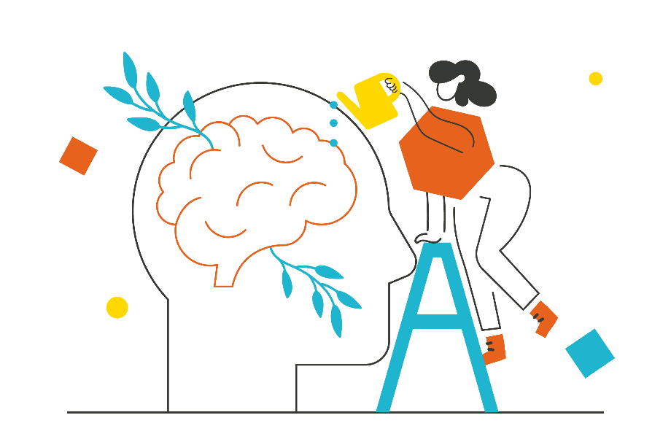

Addiction and Substance Misuse

Data suggests that alcohol and substance misuse has been consistently declining amongst young people in Wales over the past few years. However, from a young person’s perspective, the majority have said that they feel addiction and substance misuse is increasing amongst children and young people post pandemic. They said that there is also an increase in vaping amongst children and young people and this has been reported as a particular concern for the young people prioritising this issue.

Survey Data

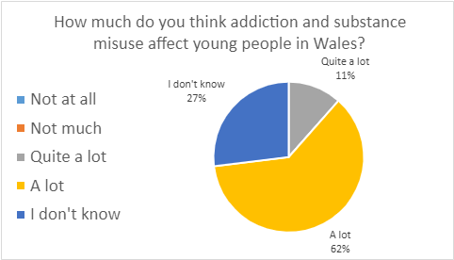
Just over a quarter (27%) answered ‘I don’t know.’ Of the rest, 62% said ‘A lot’ and 11% said ‘Quite a lot.’
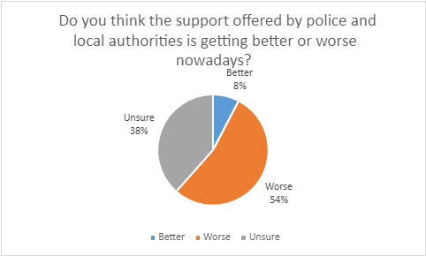
Almost 40% of young people answered that they were unsure. Of the rest, only 8% said that support had gotten better.

What young people told us about how addiction and substance misuse affects them

Being seen as ‘cool’: Several young people mentioned that drugs were seen as ‘cool’ and/or normalised among young people.

‘Lots of people think it’s cool but it is not.’

High levels around Wales: Young people mentioned that more and more young people are taking drugs and need support.

‘Drugs are everywhere’

Lack of support: It was mentioned that schools need more investment to support and nurture young people. One young person mentioned how taking drugs can impact young people’s whole lives:

‘Not only do parents have addictions and misuse substances... young people do as well, which can impede their education... but also impede their social life as they would be with people who misuse substances.’

Other Voices

‘The Mix’ report 2022 on ‘A post-pandemic spike in substance use amongst young people and barriers to accessing support’ states:

1 in 5 substance users now take drugs or alcohol to escape problems in their life, and growing numbers experience challenges due to substance use and are in need of support. However, societal attitudes connected to substance use and addiction, lack of awareness of services available or belief that there are no suitable services available prevent many from seeking help. As a result, hundreds of thousands of young people are suffering in silence rather than reaching out for support.’

The report also highlights the increase in vaping amongst young people which aligns to the data provided by the young people in our research for this report.

‘The proportion of young people vaping in the past 12 months has almost trebled to 44%, from 15% in 2021.’

The Mix report can be accessed here: DRUGS ALCOHOL REPORT_2022_DRAFT (themix.org.uk)

We think (volunteers' thoughts)

This highlights that drug misuse is too normalised. More support should be offered to those already addicted, and prevention and stronger laws in place to stop young people getting access.

Our Recommendations

Enforcement: Stronger enforcement of age restricted products.

Support Services: More support for those who are already addicted to substances.

Change the ‘norm’: Make drugs and substances un-cool through awareness raising strategies.

Education: Include drug and substance awareness in the new curriculum and in training for teachers.

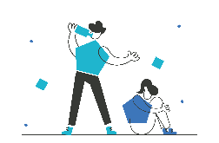

Equality, Diversity and Inclusion

Equality, Diversity and Inclusion is a cross cutting theme spanning all of the priority areas included in this report. The Equality Act 2010 says that everyone should be protected from discrimination and it includes nine protected characteristics.

Throughout the past few years, young people have consistently shared that they have experienced inequality and discrimination often in Wales. The Education and Social Justice Special Interest Group has identified some areas to focus on as follows:

- Mental Health and Wellbeing
- Poverty
- Gender and Identity
- Discrimination and the protected characteristics

Young Wales has also been working closely with TGP Cymru Refugee and Asylum Seekers Programme and with their Travelling Ahead Programme and have identified further inequalities and discrimination in these groups in terms of how they can access their rights in Wales.

Survey Data

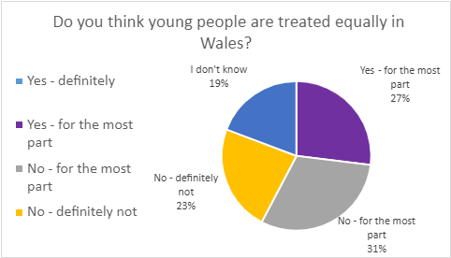

Answers were fairly divided on this question however, the majority (54%) chose ‘no definitely not’ or ‘No - for the most part,’ with no young people choosing ‘yes - definitely.’ 19% of the young people chose ‘I don’t know.’

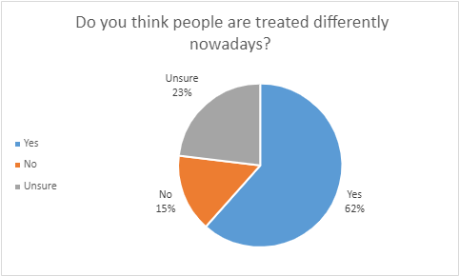
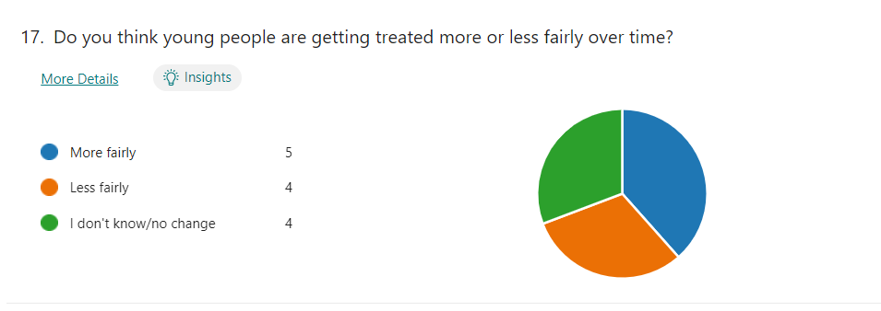

The majority of young people (62%) said that they felt young people are treated differently however young people were divided on whether they felt young people were getting treated more or less fairly over time. There was an almost even split between ‘more fairly.’ ‘less fairly’ and ‘I don’t know/no change.’

What young people told us about being treated fairly and how it affects them

Treated differently based on age: Young people mentioned a range of ways that they are treated differently, including not having the right to vote, being viewed as inferior, feeling as if they don’t have a voice:

‘Seen as 'kids' who have no real opinions or experience on the world.’

One young person mentioned that those who have strong opinions are called aggressive.

Racism and antisemitism: Several young people mentioned racism and antisemitism in their responses:

‘People are being bullied based on height and race.’

‘Jewish people are seeing more abuse.’

Differences between minority groups: One young person said:

‘While racism in certain areas has decreased significantly, there are high rates of homophobia, transphobia etc.’

Another said:

‘Some groups get more support than others.’

EDI measures as unnecessary: A minority of young people suggested that people are treated fairly and that this issue is overstated. One young person said

‘People have gone soft.’

One young person said that he felt as a white boy he was treated as the enemy and that this should stop.

A parent on behalf of their disabled son said that he is:

‘Othered systematically and not afforded equity since he is being filtered into special courses or schools rather than going to college with his friends like he hopes to.’

Other Voices

Young Wales produced a report in 2020 on behalf of Swansea University and Welsh Government titled ‘Advancing and Strengthening Equality and Human Rights in Wales: a Consultation with Children and Young People.’ The report said that:

Young people were very clear that they felt a duty to challenge discrimination specifically in terms of young people who are marginalised, have protected characteristic or are vulnerable. Furthermore it was felt very strongly that marginalised young people required much more support and guidance in terms of raising awareness of their rights and empowering them to exercise those rights. The group questioned the processes on reporting, monitoring and regulation of acts of discrimination and how the role of the media can influence discrimination particularly in relation to racism and the Black Lives Matter Campaign, LGBTQ rights, disability and equalities, age discrimination and the unfair portrayal of young people by the media throughout the pandemic.’

We think (volunteers' thoughts)

Some young people think that by creating more opportunities for some groups above others, we are causing equality. We think a lack of education can lead to inequality or racism. There should be more education on equalities, diversity, and inclusion. There are lots of opportunities to cover this issue, it could come under life skills in the curriculum, or in history, for example. If a disabled young person wants to go to college with his friends, he should be able to go. He is being filtered, which is not really fair. The recurring theme with threats to equality diversity and inclusion, is the public being uneducated on the matter. We believe stronger education regarding culture, history, and equality would create a more tolerant society as a whole.

Our Recommendations

Safety: Ensure young people feel safe by introducing more laws to protect us all.

‘Make it illegal to make fun of people within schools and have it enforced correctly.’

Education: Include Equality, Diversity and Inclusion in the New Curriculum for young people and training for teachers.
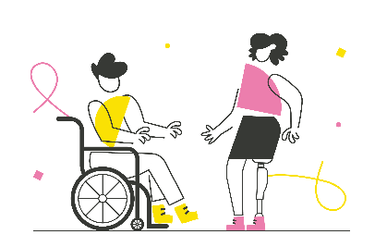
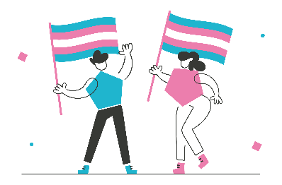

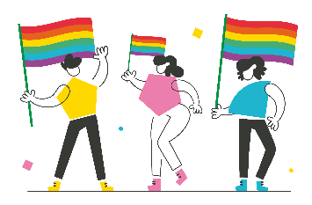
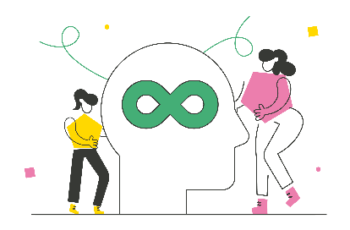
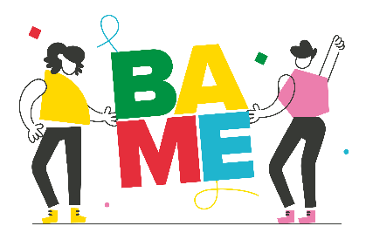

Children’s Rights and Participation

Young Wales has been committed to increasing the awareness on children’s rights and providing opportunities for participation over the past few years and has established a number of young people advisory groups and special interest groups. We have also conducted a large number of consultations on behalf of Welsh Government and external partners in order to ensure that young people’s voices are listened to on issues that affect their lives as well as provide opportunities for young people to meet directly with decision makers and influence policy and decisions.

Young Wales led a consultation on behalf of Welsh Government in 2022 with over 200 children and young people that informed their Children and Young People’s Plan. It sets out Welsh Governments commitment to the principles of the UNCRC and to seven cross governmental priorities. Welsh Government aims to measure their progress annually and include children and young people at all stages to inform their action plan and aims to achieve their milestones by 2050.

Survey Data

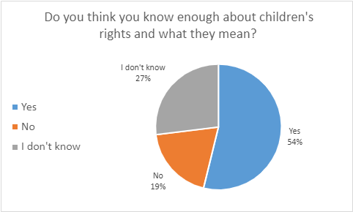

We asked young people whether they feel they know enough about children’s rights and what they mean. More than half answered yes to this question, just over a quarter were not sure, and 19% said no.

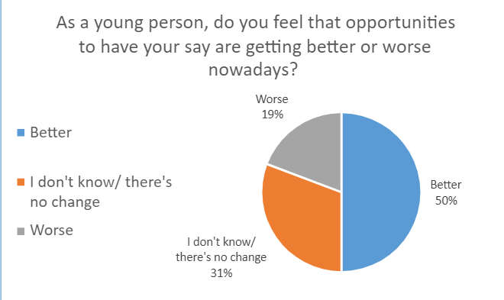

We then asked young people more about Article 12, which is their right to have a say and be listened to. We asked whether young people feel that opportunities to have a say are better or worse than they were before. Half of all young people said that the opportunities are better, 31% said that they did not know, or that there was no change, and 19% said they had got worse.

What young people told us about opportunities to have a say and how it affects them

We asked young people an open question about why they think opportunities to have a say are getting better or worse. There was a mix of answers, which were positive, negative, or a mix of both. There were more positive than negative answers.

Positive responses: Some young people said were that there was more awareness of children’s rights and more opportunities to have a say.

‘Far more people are aware of the UNCRC and that we have a Children’s Commissioner.’

It was also mentioned that Welsh Government, and other agencies, including schools, had changed the way they worked with young people for the better.

‘My voice is heard and is making a difference to things that affect young people.’

Mixed responses: Others said there are more opportunities, but that sometimes it was difficult to take those opportunities and get your point across. Other mixed answers were that there was more awareness, but that rights were ignored, or that rights were met, but not to everyone.

Negative responses: One young person said:

‘Adults don't see us as mature or smart enough to make decisions or contribute ideas to society.’

Another said there is not as much freedom for children and young people, and that there is a lack of inclusion for disabled children and young people, particularly in education.

Other Voices

Young Wales worked in partnership with the Centre for Youth Impact to support organisations working with children and young people in Wales to share their participation models and practices. This data has been included in the Centre for Youth Impacts report: Young People’s Participation in Decision Making: UK 2022 Survey Report. The report found overall that:

‘Young people are supported to participate in decision-making at a variety of levels, including at higher levels around ‘setting the agenda’ rather than just contributing to or commenting on the agenda once ‘set’, and this has improved since 2010. The primary methods organisations use with young people to enable them to participate in decision-making are through ongoing informal discussions, consultation sessions, surveys, and youth councils or forums.’

The Centre for Youth Impact report can be accessed here: youth power survey_FINAL PUBLISHED_24.11.22.pdf (youthimpact.uk)

We think (volunteers' thoughts)

It is really good that over half of the people we asked knew about their rights and what they actually mean. It is important to us for a diverse range of young people, especially those who feel they are a minority, or have a protected characteristic, to feel included in the conversation and be heard. It is important for disabled children and young people to be included in mainstream services including education, so that they can participate the same as their peers.

Our Recommendations

Awareness: Increase awareness activities and resources so that all children and young people know they have rights and how to access their rights.

‘Encourage through social media to show awareness.’

‘Put up posters around areas with info to what our rights are.’

‘Rights should be taught in lessons and shared across the whole school, and to have a larger portion of students representing the student body.’

Opportunities: Create more opportunities for young people to have a say.

‘More online surveys that are easy to access by young people asking for our opinions (share them with all schools possibly).’

‘I think that becoming a rights ambassador definitely helps to inform others and yourself about rights so maybe encourage becoming a rights ambassador a bit more.’

‘Level 2 or 3 qualification made… available on the UNCRC.’

Representation: Ensure that all children and young people have the opportunity to be heard representing the diversity and culture within Wales.

‘Having other people speak on their behalf. Talking to people in similar situations and making sure people are properly educated about what their rights actually are.’

Accessibility and communication: Ensure that opportunities for participation are accessible and inclusive to all children and young people.

‘We need the UNCRDP to be used together with the UNCRC. The right to communication needs a lot of attention... more interactive - play - use of tech - games
etc. Again this needs to be done alongside non-disabled children and young people.’ (Parent on behalf of their disabled son)

Raise awareness for adults: Increase awareness resources and training for adults.

‘More education for adults on children’s rights.’

‘Make sure schools, youth workers and parents know about it.’

Education

The roll out of the New Curriculum for Wales is well under way, due to be completed by 2026. It has 4 purposes to support children and young people to be:

- Ambitious, capable learners, ready to learn throughout their lives
- Enterprising, creative contributors, ready to play a full part in life and work
- Ethical, informed citizens of Wales and the world
- Healthy, confident individuals, ready to lead fulfilling lives as valued members of society

The data from our research suggests a mixed response from young people to developments in education. This might be due to the New Curriculum being at its infancy at this stage. Young people have told us that they would like more information on the New Curriculum in accessible formats so that they can better understand the changes taking place and reflect or share their informed views on the changes.

Education is a cross cutting theme across the priority areas in this report and children and young people have consistently told us that education is key for them to access all of their rights. The pandemic has had a significant impact on children and young people’s education and many young people have told us that they would like to see a more rounded and holistic approach to support them throughout their educational journey. Over the past two years Young Wales has conducted a number of consultations with children and young people on behalf of Welsh Government and external partners to inform Education policy in Wales and supported the young people’s Education and Social Justice Special Interest Group.

The Education and Social Justice Special Interest Group has made some recommendations to support children and young people’s experiences in education under their 4 focus areas as follows:

- Mental Health and Wellbeing
  - Change the stigma around mental health in the education system
  - Provide quality and accessible school counsellors in all schools
- Poverty
  - Provide extra support for children and young people living in poverty to access their education
  - Change the rules around school uniforms so they are affordable for all
- Gender and Identity
  - Provide gender neutral facilities
  - Provide safe places for students with no judgement
- Discrimination and the protected characteristics
  - Teach about tolerance and acceptance of different identities
  - Embrace communities and share our cultures

Survey Data
.
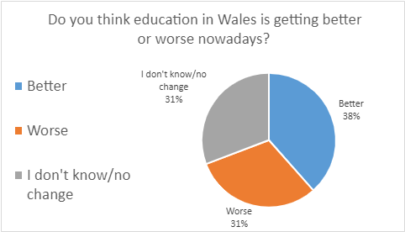

This question had a fairly even split between ‘better,’ ‘worse’ and ‘I don’t know/no change.’

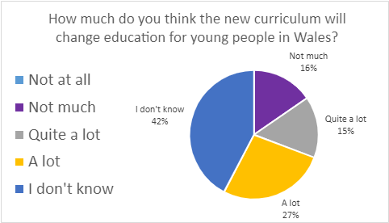

For this question, almost half (42%) of the young people chose ‘I don’t know.’ Of those who answered with a statement other than ‘I don’t know,’ 32% said ‘A lot’ or ‘Quite a lot.’

What young people told us about education and how it affects them

Funding: Young people feel there is not enough funding in education and would like to see more opportunities available to them to have meaningful experiences.

‘More funding to allow more physical experiences e.g. visits to business to learn about entrepreneurs.’

Inclusivity: Young people feel strongly that education should become more inclusive and diverse.

‘If there was a way to teach everyone by their own ability.’

‘Make a better environment for young people who are marginalised so they do not have to deal with hate every day.’

Another young person said that he felt that he was treated poorly as a young boy in the education system.

Conditions for learning: A few young people mentioned that learning should be made more enjoyable, saying that currently:

‘...teachers can’t be bothered.’

One young person said we should:

‘Make learning more enjoyable but still learnable.’

Other Voices

Young Wales worked in partnership with TGP Cymru Refugee and Asylum Seekers Programme to conduct a consultation on the Young Person Guarantee in 2022. 20 Refugee and asylum seekers attended the consultation and shared feedback on the challenges they faced in accessing education and employment in Wales. Refugee and asylum status is controlled by the UK Government, however Welsh Government is committed to be a ‘Nation of Sanctuary’ and has a duty to have due regard to the United Nations Convention on the Rights of the Child as part of the ‘Rights of Children and Young Persons (Wales) Measure 2011.’ The report concluded as follows:

‘The young people’s lack of status was consistently reinforced throughout the session as something that was a source of anxiety and stress for them. Many said that it prevented them from being able to access education and that they worried about how this would impact their job prospects in the future.’

We think (volunteers’ thoughts)

Forty two percent of people said they did not know how the curriculum would change education for young people in Wales. This shows that there is not enough awareness or discussion about the new curriculum. Young people do not really know what it is or how it affects them. We think that young people want to be taught more about real world experiences, such as entrepreneurship, this can be linked to skills and future work opportunities. Education should be specific to all young people, acknowledging that all young people are different and learn in different ways.

Our Recommendations

Awareness: Improve awareness of the new curriculum, ensure that the changes and reasons for them are understood by all.

Reform: Make education more relevant to the real world. Provide work experience that interests and motivates young people.

Funding: Provide more funding in education for resources and meaningful experiences and opportunities for all young people.

Inclusivity: Make education accessible and inclusive to all children and young people in Wales.

Services: Provide quality mental health training and support for teachers and young people to change the stigma around mental health.

Uniforms: Change the rules around school uniforms so they are affordable for all families.

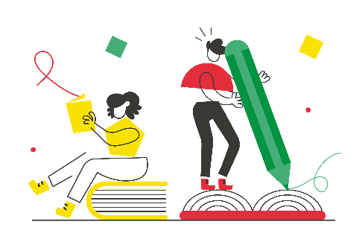

Crime

During our research into the priority areas, several local authorities told us that there had been an increase in knife crime in their areas and that they had been working on specific programmes to address this challenge locally. This also aligns to the data we have had from young people about an increase in addiction and substance misuse amongst young people.

Survey Data
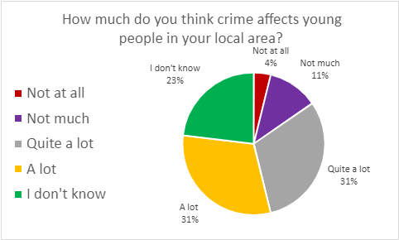
We asked young people how much they think crime affects young people. 62% said that they felt crime affects them ‘a lot’ or ‘quite a lot.’ 23% said they didn’t know.
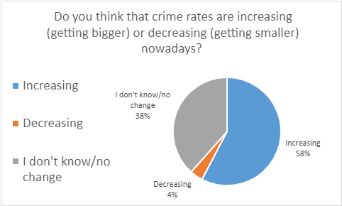
There was almost a 60/40 split between those who said ‘increasing’ and those who said ‘I don’t know/no change,’ with only one respondent saying they thought crime rates were decreasing.

What young people told us about crime and how it affects them
.
Young people committing crimes: Some young people focused on young people committing crimes themselves. Many mentioned specific types of crimes like antisocial behaviour, knife crime, violence and drugs. Some said there was a sense of peer pressure to commit crimes:

‘People get persuaded to do crime.’

Young people being victims: Some young people told us about being victims of crimes. One young person said:

‘Crime affects many young people in a negative way and can be the cause of many mental illnesses shown in young people.’

Another young person said that it has a particular negative affect on boys:

‘Violence happens every day for lads.’

Other Voices

The Youth Justice Board for England and Wales published a report in 2022, Brighter Futures: an analysis of the youth justice system; detailing their plans to deliver a child first approach. Recommendations included:

- Recognise the youth justice system as part of a wider system and make changes beyond – like improving understanding of why children offend.
- Collect the right data and to share it with agencies effectively.
- Enable greater child and workforce participation and collaboration.
- Challenge current reforms to go further, including police and courts, and to reflect this in changes to inspection.
- Review training for youth justice staff, including supporting staff to deal with trauma, and in Wales to build on in-depth trauma informed training already delivered.

The full report can be found here: Child First: Identifying Progress and Priorities Using a System Map – Youth Justice Board for England and Wales (October 2022) - Youth Justice Resource Hub (yjresourcehub.uk)

We think (volunteers' thoughts)

We think there is a close link between crime and mental health, young people are more likely to be victims of crime and it is important to address this and support young victims with their mental health too. We also think that police not acting on smaller crimes, can lead more people to commit crimes, if they see that it is not being tackled. We believe that to combat crime rates amongst young people there should be more focus addressing the peer pressure felt by young people to perform criminal acts.

Our Recommendations

More police and higher levels of punishment: Increase police numbers and visibility and consider introducing harsher punishments as a preventative approach to reduce crime rates.

‘More community officers and we need the police to take more and more action on the smaller crimes.’

Reform: There needs to be a change in the system to prevent crime, support those who commit crimes and support victims of crime.

‘Offer more help to the people that are committing crimes... with stronger but fair punishments.’

‘Reform in terms of drugs such as by going for harm reduction...allowing people to have better opportunities if they did poorly in education or have left prison.’

Education: Raise awareness and education on crime and where to get help.

‘Stop excluding kids from school, work with young people find out there [sic] story.’

Safe spaces: Create safer spaces for children and young people.

‘Safe spaces and better lighting” and “Neighbourhood CCTV.’

Powers: Wales should have more devolved powers for the justice system, as it would have a specific focus on Welsh issues such as the ongoing addiction and substance misuse and knife crime problems prevalent here.


Life Experiences

Negative life experiences can impact children and young people throughout their lives. They are traumatic events that can significantly affect the health and wellbeing of children and young people. They could range from suffering verbal, mental, sexual and physical abuse, to being raised in a household where domestic violence, alcohol abuse, parental separation or drug abuse is present. Children and young people should be protected against experiencing negative life experiences under the UNCRC and supported appropriately if they have any negative life experiences.

We believe that Welsh Governments introduction of the Abolition of Defence of Reasonable Punishment (Wales) Act 2020 offers an additional layer of protection for children and young people against negative life experiences.
Survey Data
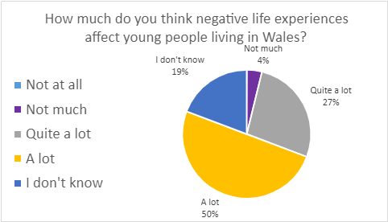
Over three quarters, 77% of the young people who answered said ‘A lot’ or ‘Quite a lot.’ Nearly 20% of young people who answered said ‘I don’t know.’

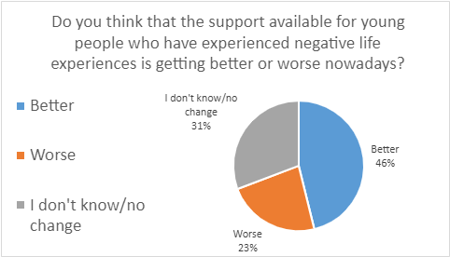

This was an almost 50/50 split between those who said ‘Better’ and those who said ‘Worse’ or ‘I don’t know/no change.’

What young people told us about negative life experiences and how it affects them

Impact: Young people mentioned that negative life experiences affect:

‘So many young people.’

Mental health was specifically mentioned by young people; with depression, anxiety and suicidal thoughts mentioned:

‘Less action can result in depression or worse.’

Support: Young people mentioned that more support was needed and schools

‘Need to consider... that we do need time to process different things.’

One mentioned that:

‘There are many more helplines and other stuff like that to help and support.’

One young person mentioned that he felt like he was treated badly because of being white and male. He was also concerned about immigration, drugs, violence and crime.

Other Voices

Public Health Wales describes the impacts of children experiencing adverse childhood experiences as:

‘Children who experience stressful and poor quality childhoods are more likely to experience poor mental health due to poor self-image and self-worth. They are more likely to adopt health-harming behaviours during adolescence which can lead to diseases such as cancer, heart disease and diabetes later in life.

Adverse childhood experiences are not just a concern for health; experiencing them can mean individuals are more likely to perform poorly in school and more likely to be involved in crime both as victims and perpetrators.

People who experience multiple adverse childhood experiences as children often raise their own children in households where adverse childhood experiences are more common. This cycle of childhood adversity can lock generations of families into poor health and anti-social behaviour.’

The ACE Support Hub has been set up in Wales to change the cycles mentioned above. It aims to:

- Spread information and knowledge enabling the voices of communities, children and families to co-design solutions that will work for them.
- Share evidence about what organisations can do differently to help prevent and mitigate Adverse Childhood Experiences
- Develop knowledge and skills amongst professionals, providing training for them to enable themselves and their organisations to grow their internal and external networks to change practice.
- Pull learning from individuals, communities, organisations and the wider system and sharing it through a range of action learning sets and communities of practice.
- Drive change and system transformation at local and national levels.

We think (volunteers' thoughts)

There is a correlation between negative life experiences, mental health, and a lack of support. More services should be available to support people with this in their communities. These life experiences can also be linked to education and feelings of connection to communities.

Our Recommendations

Support: More tailored and specific services and support is required for children and young people who experience negative life experiences. Including earlier mental health interventions and preventative approaches for mental health support.

‘More free therapy and opportunities to recover from trauma.’

Funding: More funding is required to ensure support and services can be offered at the right time and appropriately to the needs of the child or young person.

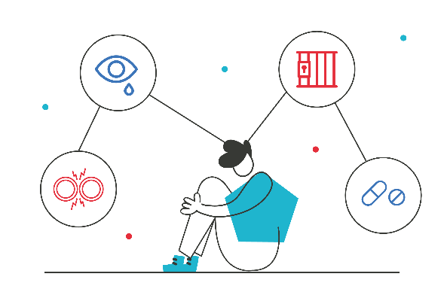

Play

In 2020 Welsh Government announced there would be a Ministerial Play Review to assess current Welsh Government play policy, and inform how these policies are developed and progressed. It considered Welsh Government’s progress in achieving its vision for play as set out in Welsh Government’s Play Policy 2002 and Play Policy Implementation Plan 2006 to create a play friendly Wales. In addition the Children and Families (Wales) Measure 2010 includes a section on Play Opportunities aimed at Local Authorities, partners and stakeholders and the Wales – a Play Friendly Country 2014 sets out statutory guidance for Local Authorities’ duty to assess and secure sufficient play opportunities.

Survey Data
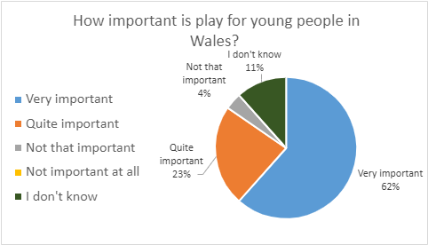
Most of the young people felt that play was important to young people, with 85% saying that play was ‘very important’ or ‘quite important.’
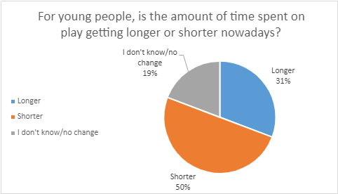
The responses were split 50/50 between those who said ‘shorter’ and those who said ‘longer’ or ‘I don’t know/no change.’

What young people told us about how important play is and how it affects them

High importance of play: Young people mentioned that play was really important to them, to give them a break and to express themselves.

‘People need a break to play.’

Reasons for less time spent on play: Young people mentioned a range of reasons why they felt that less time was being spent on play. COVID-19 and the cost-of-living crisis were mentioned as well as technology.

‘Young people spent less time on play since they are always on phones/tablets/etc.’

Places young people can play: Young people mentioned that they can play in parks, youth clubs and other youth services. On behalf of her disabled son, a parent said:

‘Disabled children and young people need activities that are intended for children and young people to be accessible.’

One young person simply said:

’I just worry about getting home safe.’

Other Voices

Young Wales led a consultation on behalf of Welsh Government in 2021 on the Ministerial Play Review with over 200 children and young people participating. Young Wales included a section regarding COVID-19 and its impact on play, alongside a focus on five policy and development key areas:

- Settings registration, regulation and exceptions
- Play Sufficiency Duty and funding
- The workforce and qualifications
- Working across policy areas
- Spatial justice and societal involvement

COVID-19 and Play
Recommendations included:
- Open schools as soon as it is safe to do so.
- Open play provisions as soon as it is safe to do so.
- Consider the levels of homework given during lockdown periods.
- Additional support is required for children, young people and families at times of crisis. Additional support is required for children, young people’s wellbeing, and mental health services.

- Consider children and young people when easing restrictions in terms of their play and socialising needs.
- Additional support is required for children and young people returning to a notion of ‘new normal.’
- Restrictions need to be more informed with a clear plan for easing them that is communicated appropriately and informed by children and young people’s needs.
- Enforcement of restrictions should consider and understand the wider impacts of COVID -19 and the impacts of restrictions directly on children and young people.

Settings registration, regulation and exceptions
Recommendations included:
- Play places should aim to be happy and safe spaces.
- Play provision in rural areas needs to be improved.
- Youth services should be increased.
- Promotion and communication of existing provision needs to be improved.
- Rules should be developed for play spaces and activities for safeguarding but there should be no rules around play itself.
- A code of conduct should be developed for all staff working with children and young people within the play sector.
- Decisions around what play provisions are provided should be informed by parents or carers and children and young people, taking into consideration the type of activity on offer, affordability and price, the location, the reputation of the provider and the trust in the provider.
- Safeguarding policies should be followed and providers made accountable if regulations are not followed correctly.
- All clubs and provisions, including those that offer coaching and mentoring, should be required to undertake registration.
- All clubs and provisions working with children and young people that offer under two hour sessions should be required to undertake registration.

Play Sufficiency Duty and funding
Recommendations included:
- Consider the challenges for children and young people around transport infrastructure and access to play spaces and make improvements where possible.
- Create more opportunities and spaces for play.
- Create more open spaces for children and young people that are safe.
- Promotion and communication of existing play spaces needs to be improved.
- Play should be promoted and supported throughout all ages of children and young people.
- Children and young people should be supported and encouraged to contribute to the planning of play opportunities and services within Local Authorities.

- Welsh Government, Local Authorities and their staff, Schools and the education sector are responsible in ensuring that there is sufficient play opportunities for children and young people in Wales.
- Children and young people, as well as parents or carers, should have an opportunity to contribute and be listened to in all developments of play opportunities within their Local Authority areas.
- Local and National Governments should allocate and ring fence long term funding for play opportunities.
- Welsh Government should provide Local Authorities with funding for play.
- Places for children and young people to hang out safely should be prioritised for investment alongside further investments on the following: more play areas, more play activities, more indoor play settings, more detached youth workers, more play staff and more training opportunities, new play equipment, more open access youth and play clubs.
- Any decisions in terms of play opportunities or investments should be consulted with children and young people.

The workforce and qualifications
Recommendations included:
- Play workers should be registered with a body that checks their qualifications and development.
- Opportunities should be given to older children and young people to support and encourage them to take an active role in planning and leading on play services and activities for younger children.
- All play workers should have an enhanced DBS check and have no criminal record. All play workers should have an awareness of issues that affect children and young people and have a level of relevant experience.
- All play workers should undertake the following training:
  - Safeguarding
  - First Aid,
  - Health and Safety,
  - Fire Safety,
  - Conflict resolution,
  - Mental Health and Wellbeing in children and young people,
  - Bias,
  - Participation, and
  - Play Work.
  - All play workers should have the following qualifications:
  - At least 4 GCSE’s at grade C or above, and
  - At least a level 2 qualification in play work or youth work.

Working across policy areas
Recommendations included:
- Consider the challenges for children and young people around transport infrastructure and access to play spaces and make improvements where possible.
- Play should be promoted and supported throughout all ages of children and young people and across all sectors.
- Children and young people should be supported and encouraged to contribute to the planning of play opportunities and services within Local Authorities and across sectors. Welsh Government, Local Authorities and their staff, Schools and the education sector are responsible for ensuring that there is sufficient play opportunities for children and young people in Wales.
- Children and young people, as well as parents or carers, should have an opportunity to contribute and be listened to in all developments of play opportunities within their Local Authority areas and across sectors.
- Review playtime or hang out time for young people age 11 to 18 in school and colleges.

Spatial justice and societal involvement
Recommendations included:
- Lift restrictions on play places when it is safe to do so.
- Continue the vaccination offer and program.
- Lift restrictions on children and young people to play out as soon as it is safe to do so.
- Consider family and school bubbles and how these can better meet the needs of children and young people.
- Develop a greater understanding within the police force of children and young people and their play needs.
- Support is required to change the perception of young people, which should include working with services and offering training on how to improve engagement with young people.
- Ensure there are sufficient safe, well-organised and accessible play opportunities.
- Allocate more time for play and more opportunities for children and young people to hang out during the school day.

We think (volunteers' thoughts)
To promote opportunities for play, it is really important that there is time for play made available for it, particularly with all the stresses that young people experience. Young people may define play differently to younger children, which may affect how they responded. There is an interesting link between opportunities to play and feelings of safety. It is important that environments are child and play friendly. This includes clearing up litter and making spaces safe.

It is really important that play is accessible for all children and young people, this includes opportunities to join groups. As well as the right to play, we think this also links to the right to freedom of association.

Our Recommendations

Opportunities and Time: We need more options, opportunities and time to play.

‘More places to go like parks or centres which can be used as places to hang out.’
.
Funding: There should be open access and free opportunities to play for all children and young people in Wales.

‘Funded by the Government, Council or Charities.’

Spaces: Play spaces should be accessible, inclusive and safe. On behalf of her disabled son, a parent said:

‘Activities that encourage disabled and non-disabled youngsters to play together.’

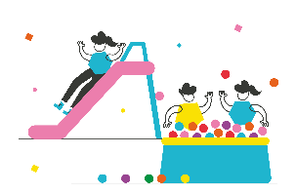

Transport

Young people have told us consistently that there needs to be a focus on geographical issues, costs and the current infrastructures to support accessibility to transport for young people in Wales. This includes not just physical accessibility, but also feeling safe and protected while using public transport.

At the Young Carers Wales Festival 2022 young people told us that transport could be a barrier to young carers in terms of accessibility and cost for supporting their family member but also to access recreational activities.
.
Survey Data

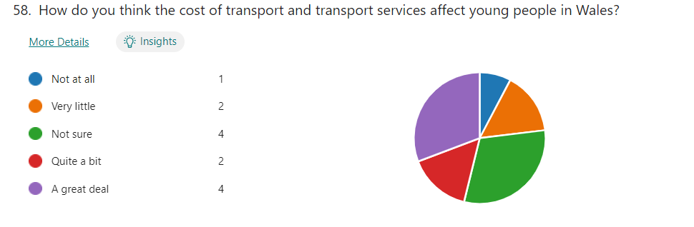
Young people were fairly divided on the extent to which they felt the cost of transport and transport services affects young people in Wales. Around 30% said they were not sure about this. Of the rest, a third said ‘not at all’ or ‘very little’ and two thirds said ‘quite a bit’ or ‘a great deal.’

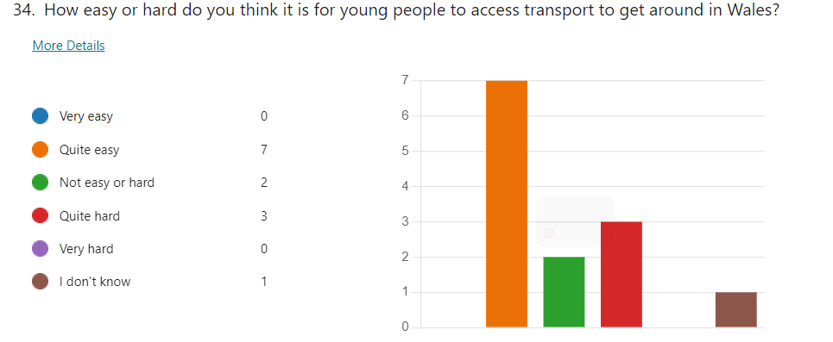

Over half of young people (53%) said that it was ‘quite easy.’ 15% said that it was ‘not easy or hard’ and 23% said that it was ‘quite hard.’

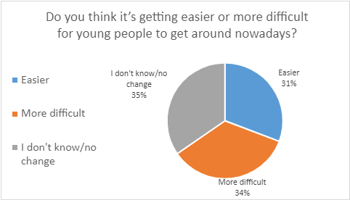

The young people were again quite divided on this issue. 35% of the young people didn’t know or felt there was no change in their ability to get around. Of the rest, very slightly more (34%) of respondents felt it was more difficult, and slightly less felt it was easier.

What young people told us about how important transport is and how it affects them

Cost: Young people mentioned that transport was at times expensive and that they think:

‘Public transport should be free for children and young people.’

Another said that:

‘Children’s transport rates should apply until you are 18.’

Frequency: The reliability and frequency of public transport was also highlighted with one young person saying:

‘Transport needs to be more frequent.’

Accessibility: A parent on behalf of their disabled son said that buses and trains have become more accessible:

‘But there is still work to do in terms of accessibility.’

Other Voices

In 2022 Sophie Howe, The Future Generations Commissioner for Wales called for free public transport for all under 25 year olds in response to her five point plan for the cost of living crisis. Young people currently have access to discounted public transport, however 40% of young people think that poor public transport is a barrier to getting a job according to data from Sustrans.

We think (volunteers' thoughts)

We think public transport should be free for children and young people, because if you are living in poverty, and the cost of living is going up, it is really difficult to be able to afford to get around. We know people who struggle with this.

Some young people do not have proper transport for school, so have to catch taxi’s, which is really expensive. In addition, some young people are unable to access school transport due to living outside of catchment areas, we think this is unfair and can affect our education.

In relation to rural areas in Wales, we know that there are issues with transport there. Some of our volunteers live in rural areas in Wales, which makes it more challenging for them to access opportunities and participate.

There are real safety concerns for young people on public transport, especially when their buses or trains get cancelled, particularly for young women, but this can affect young men too.

Our Recommendations

Cost: Make public transport free for all children and young people.
Safety: Improve reliability, frequency and accessibility of public transport so that children and young people feel safe.

School Transport: Extend catchment areas so that more young people can access free school transport.

Infrastructure: Improve the public transport infrastructure so that it is accessible in all areas including rural areas of Wales.


Online Safety

Children and young people in Wales are facing growing risks while accessing the internet as usage and accessibility post pandemic has increased significantly. The internet can be a useful tool for young people to access information, entertainment and connect with friends but it is not always a safe space.

Welsh Government published the Online Safety Action Plan for children and young people in Wales 2019 with the following actions:

- Advice and support – providing children and young people, education practitioners, education professionals, parents and carers with information and knowledge to promote online safety for young people.

- Collaboration – working together with UK-wide partners and other organisations to take coordinated actions to meet our common aims.

- Communication and promotion – raising the profile of online safety to reach a wide audience and reinforce the importance of using the internet safely and responsibly.

- Guidance and policy – maintaining statutory and non-statutory guidance to reflect technological developments and changes in how the internet is used.

- Research – supporting research into the use of the internet by children and young people so that we stay up to date with the evolving threats and continue to inform policy development and actions needed to promote online safety.

- Resources – providing a range of resources for children and young people, education practitioners, education professionals, parents and carers to support the delivery of online safety education and promotion.

- Training and development – providing relevant training to education practitioners, education professionals, schools and other partners to support the delivery of online safety education to children and young people.

Young Wales has recently established a Keeping Safe Online young person advisory group on behalf of Welsh Government. The advisory group with 20 representative from across Wales; will have the opportunity to shape the guidance and support regarding online safety offered to children and young people via Welsh Governments Online Safety Hwb.

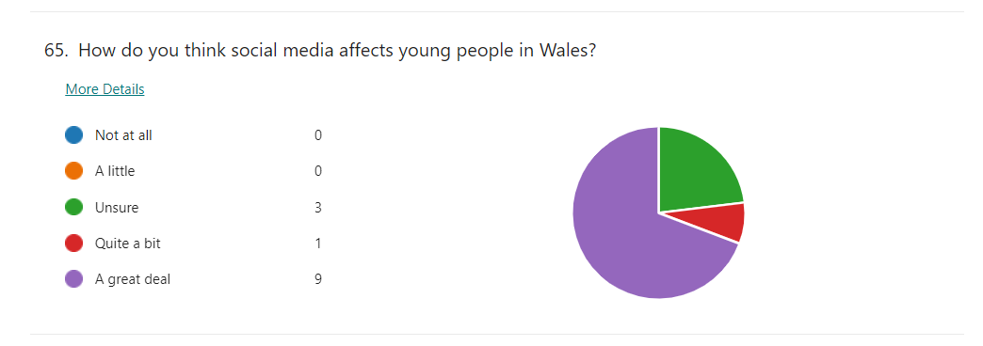
Survey Data
15% said that they were unsure about how much social media affected young people. Of the rest, 80% said that social media affected them ‘A great deal’ and 5% said it affected them ‘Quite a bit.’
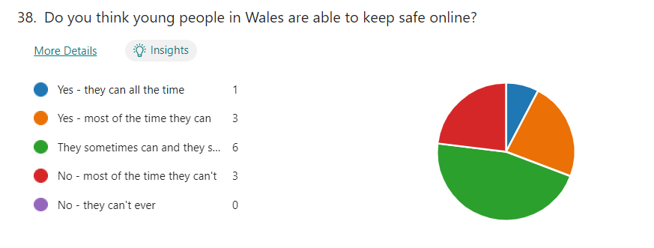
Almost 25% said that there were times that young people weren’t able to keep safe online. 50% said that ‘they sometimes can and they sometimes can’t.’ with the other almost 25% split between ‘No - most of the time they can’t’ and ‘Yes - most of the time they can.’ Only one young person said ‘Yes - they can all the time.’
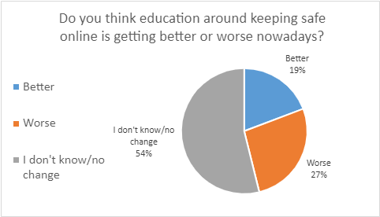

Around half said that they didn’t know or there was no change in education around keeping safe online. Of the rest, around 27% said that education was worse and 19% said that it was better.

What young people told us about how important online safety is and how it affects them

Education: Young people mentioned that they felt they needed more education on the topic, both on safety and knowing how to use a computer. They need more support and training in this area:

‘It is taken as a joke when we are taught online safety... it should provide real life examples from victims of online crime.’

Examples of negative effects of being online: Severe negative effects of being online were mentioned by young people, including online bullying and low self-esteem.

‘Negative body image and increased communication leads to online bullying.’

Another young person mentioned that there is pressure to seem ‘cool’ by having social media.

Support for all: it was mentioned that both parents and those of younger ages needed help, support and guidance to keep safe online.

‘Everybody needs to be safe.’

Other Voices

The Office for National Statistics report on Children‘s online behaviour in England and Wales: year ending March 2020 states:

- Almost 9 in 10 children (89%) aged 10 to 15 years said they went online every day.
- While the majority of children told us they only spoke to or exchanged messages with people online who they knew in person, around one in six children (17%) aged 10 to 15 years spoke with someone they had never met before (equivalent to 682,000 children) in the previous 12 months.
- An estimated 1 in 50 children (2%) said that they spoke to or messaged someone online in the previous 12 months who they thought was their age but later found out were much older.
- An estimated 5% of children aged 10 to 15 years met up in person with someone they had only spoken to online (equivalent to 212,000 children) in the previous 12 months.

- Around 1 in 10 children (11%) aged 13 to 15 years reported receiving a sexual message, while 1 in 100 reported sending a sexual message, in the previous 12 months.
- Girls aged 13 to 15 years were significantly more likely to report receiving sexual messages than boys (16% compared with 6%) in the previous 12 months.
- The majority of parents or guardians of children aged 10 to 15 years (64%) had some sort of rules about the length of time and when their children can go online.

We think (volunteers' thoughts)

We think social media and internet use can affect and influence us in so many ways. Like how we look, behave and connect with others. It is our experience that education on online safety needs improvement in Wales. We think that using more real life experiences and examples on online risks and harms would help more children and young people to understand the risks and keep safe online. Parents and schools could do a lot more to support us in keeping safe online too with the right training and support for adults to enable them to advise us.

Our Recommendations
.
Safety: Introduce more rules and accountability on providers to check ages of users accessing the web to make it safer for all.

‘Stricter and better checks for age limits.’

Education: Raise more awareness of online safety amongst children and young people using real life experiences as examples.

Training: Provide more training and resources on online safety for adults.

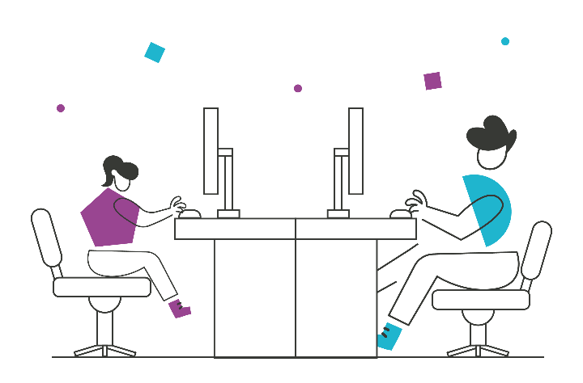

COVID-19

Throughout the COVID-19 pandemic Young Wales supported children and young people to be listened to in an ever changing landscape on the impacts of restrictions, vaccination roll out, testing, self-isolation, face masks and educational impacts. We delivered 7 consultations on behalf of Welsh Government during the pandemic to inform regulations.

During the pandemic and as a direct result of the consultation process delivered by Young Wales with children and young people; Welsh Government changed their guidance on restrictions to enable young people to meet as a group of 6 in hospitality venues. This demonstrates how young people in Wales were able to influence policy and be listened to in an ever-changing environment to best meet their needs and uphold their rights during a time when so many rights could not be fully fulfilled.

Young people have told us that the long term affects of COVID-19 on children and young people will need substantial support over the coming years. They have said that mental health and wellbeing, health, education and social interaction have been most impacted.

Survey Data

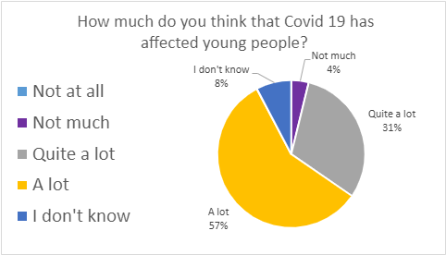

According to these results, COVID-19 has had a significant impact on young people. 88% of young people said that it has affected young people ‘A lot’ or ‘Quite a lot.’

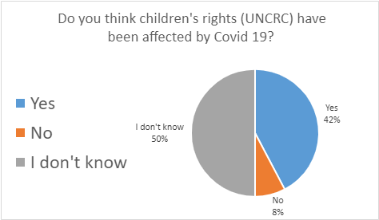

Exactly half said that they didn’t know, with 42% saying ‘Yes’ children’s rights have been affected.

What young people told us about how COVID-19 affects them

‘COVID-19 has affected every part of our lives.’

Mental Health: Many young people mentioned the impact that COVID-19 has had on young people’s mental health, mentioning self-esteem, social anxiety, with one young person saying:

‘Not enough social time, stuck on devices, very bad mental impact from [sic] lack of socialisation.’

Education: Others mentioned the impact that COVID-19 had on young people’s schooling, with one mentioning they had been isolated and home-schooled. A parent on behalf of their disabled son said:

‘He wasn't supported to do schoolwork during COVID-19 nor to access lessons... no help with maintaining physical health... no support maintaining friendships.’

Other Voices

Young Wales worked in partnership with the Children’s Commissioner for Wales and other partners on the Corona Virus and Me consultation during the pandemic. Over 23,0000 children and young people in Wales aged 3-18 responded to the survey highlighting the impacts and concerns they had about COVID-19. The report from the findings says:

Whilst the restrictions affected everyone, this consultation shows children have had widely different experiences. Some have experienced bereavement, distress and worry. Many have missed their friends, their families and feel they are missing out on their education. At the same time, many children describe how they have valued a chance to spend more time with their family, to play and relax more, or to learn in a different way.

During this time, children and young people have experienced a restriction to their human rights, as guaranteed by the United Nations Convention on the Rights of the Child (UNCRC). But these human rights have not gone away and once it is safe to do, children will be able to experience their rights again.

The full report can be found here: Coronavirus and Me Results - Children’s Commissioner for Wales (childcomwales.org.uk)

We think (volunteers’ thoughts)

The fact that 50% of people who responded said that they didn’t know if children’s rights had been affected by Covid-19, may show that although children and young people know what rights are, they may not realise how they relate to their day to day lives and how COVID-19 impacted our rights. The media are not really reporting on COVID-19 anymore, so it may not be so prominent in young people’s minds. Within education and mental health specifically, the effects of COVID-19 and lockdowns are still being felt by young people.

Our Recommendations

Education: Provide additional 1 to 1 support and resources for children and young people who need it post pandemic.

Support: Continue to acknowledge the long-term effects of the pandemic on children and young people. Specifically with regard to mental health and wellbeing and provide support to mitigate the long-term impacts.

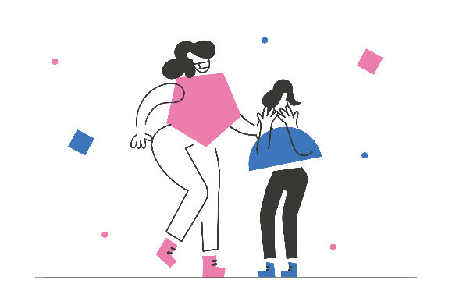
Opportunities: Provide safe and meaningful opportunities for children and young people to socialise and regain their social skills and face-to-face interactions with their friends and peers.

Climate Change

Many children and young people have told us that they suffer with climate anxiety and are uncertain about the future and are worried about the impact of climate change on their future and future generations. The Young Wales Climate Change and Rural Affairs Special Interest Group have been working on three Welsh Government consultations over the past year:

- The National Forest for Wales aims to:
  - create areas of new woodland
  - help to restore and maintain some of our irreplaceable ancient woodlands
  - In time form a connected network of woodlands throughout Wales. This will bring social, economic and environmental benefits.
  - provide spaces for leisure and nature
  - help to capture and store carbon
  - provide timber - a sustainable resource for construction

- Single Use Plastics. The Environmental Protection (Single-use Plastic Products) (Wales) Bill was passed in 2022 and makes the following items an offence to supply or offer to supply:
- cutlery
- plates
- stirrers
- drinking straws – this product has an exemption for health needs
- plastic stemmed cotton buds
- balloon sticks
- expanded and foamed extruded polystyrene fast-food containers
- expanded and foamed extruded polystyrene cups
- polystyrene lids for all cups and fast-food containers
- thin plastic single-use carrier bags – this product has an exemption for health or safety needs
- all products made of oxo-degradable plastic

- Coal Tip Safety. There are nearly 2,500 disused coal tips in Wales, a legacy
from the mining industry. Many of these tips are located close to communities, roads, railways as well as historic sites and designated habitats. Recent events such as the landslide in Tylorstown in 2020, shows the impact storms and heavy rainfall can have on these tips. Current estimates indicate climate change could have an impact on mining legacy infrastructure due to predicted increases in rainfall.

85% of the tips are in the South Wales Valley region, which includes some of the most deprived communities in Wales. The Welsh Government (WG) would like to introduce new legislation regarding this matter to ensure that the tips are managed correctly and more importantly safely.

Young people participating in this consultation stated that all tips should be removed, but were aware that this could take some time. Before the complete removal, they said it is important to ensure they are well monitored and managed, and prioritise the removal of high-risk tips first as this could significantly reduce the risk of an incident. Young people also recognised the legacy and history of mining in Wales and felt that this should also be acknowledged more widely in some way for example in museums or leisure activity spaces.
Survey Data
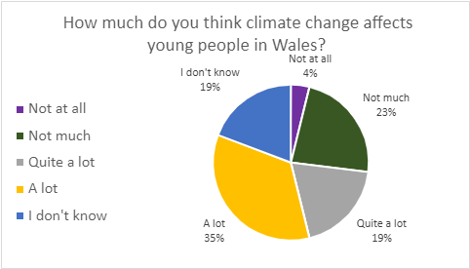

They were quite divided in their responses, however the most popular response was ‘A lot,’ with 35% of respondents choosing this answer.

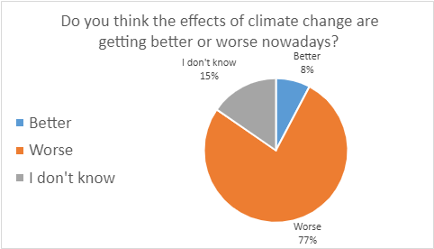

Most young people seemed to agree on this issue, with 77% saying that the effects of climate change are getting worse.

What young people told us about how climate change affects them

Lack of future due to lack of action: Young people mentioned that due to climate change they:

‘Don't see a future for themselves.’

Another mentioned

‘Government bodies and other groups are doing very little on the subject so it is being left to our generation.’

Another simply said

‘Scary.’

Awareness: Young people mentioned that they notice people talking and taking action on climate change more often:

‘People are protesting.’

‘People are complaining more.’

Lack of concern: In contrast, two young people displayed a lack of concern or thought for climate change, with one saying:

‘I don’t really think about climate change.’

Another stating that they do not believe in climate change or what is taught in school.This issue was also mentioned by a parent on behalf of her disabled son:

‘Most children who have the label Additional Learning Needs are taxied across the city - often further afield. [sic] This costs money and impacts the environment.’

Other Voices

At the Young Wales annual Festival 2022 the Size of Wales presented to over 80 children and young people about the impacts of de-forestation, how the food chain affects the planet and how engaging with nature and the outside can positively affect our health and wellbeing.
‘Protecting our environment and ourselves can have mutual benefits.’
Find out more about Size of Wales here: Home - Size of Wales

The Size of Wales is currently campaigning for Wales to become a deforestation free nation:
In 2020, Size of Wales joined WWF Cymru and RSPB Cymru to call for Wales to become a Deforestation Free Nation. We want the Welsh Government and Senedd to take action to eliminate imported deforestation from our economy.
They also have an established Youth Climate Ambassadors group who have identified the following priority areas for 2022 to 2023:
- Raising awareness of climate refugees.
- Supporting Indigenous Peoples and nations.
- Raising awareness about biodiversity among young people in Wales.

We think (volunteers' thoughts)

There seems to be a lack of education around climate change. It is interesting that many young people say that climate change affects them a lot, however, lots of young people have also told us that they are unsure about the issue. We think this aligns with other research in this area, which suggests that Cardiff is particularly affected by climate change due to its city status, population and industry. We think that people may have different levels of education and experience of climate change depending on where they live in Wales, which may explain some of the variation in data. We would like to see more consistent raising awareness of climate change across Wales.

Our Recommendations
Education: Embed lessons, resources and more campaigns on climate change in to the curriculum to raise awareness on the reality now, what is being done, and what can be done with practical advice on how children and young people can make a difference.

‘Young people should be taught from a young age the dangers of climate change.’

‘Teach about the impacts that climate change has and will have in the future.’

Resources and activities: Provide clearer recycling bins, more safe walkways to school and support more outdoor activities such as gardening and litter picking.

Longer term: Reduce industrial impact on the climate and offer more incentives for eco-friendly industries.

‘Remove high polluting industries and make them eco-friendly.’

‘Reduce the amount of palm tree oil that is imported.’

Children’s voice: Listen to children and young people on climate change.
‘Children are more creative and come up with new ideas.’

.

If you were First Minister for a day…

Young people were asked what they would do if they were Frist Minister of Wales for the Day. They had a range of ideas of what would be best for young people covering many of the priority areas:

Cost of Living

‘Increase funding for programs which help deal with poverty, mental health, addiction and substance misuse, and education.’

‘Help with better police and cost of living by giving more benefits.’

Mental Health and Wellbeing:

‘More mental health support put in place, holidays to relax from mental health and let people express themselves instead of all having to dress and act the same.’

‘Ensure that mental health comes first.’

‘Provide easy mental health support in school.’

‘Help mental health and help with the cost of living.’

Addiction and Substance Misuse

‘I would ban children under 18 from vaping or taking drugs.’

Equality, Diversity and Inclusion

‘Make all the racism go.’

Children’s Rights and Participation:

‘Ensure we are heard just as much as adults; our opinions are just as important.’

‘Explain to young people it’s ok to have different ideas and make safe spaces to talk about things where they don’t get in to trouble.’

‘Make a survey to figure out the problems.’

‘Create a questionnaire to see what they want to learn.’

‘Try to talk to children and get their opinions and use as much of their ideas as I can.’

‘Push for a vote for 16-17 year olds in a general election, improve education.’

‘Make any sort of help known by putting posters, ads etc around, getting people's attention for the children’s rights.’

Education:

‘Get more male teachers.’

‘Start an Inclusive Education System - this would change everything.’ (Parent of disabled child)

‘Improve education by increasing teachers pay and school funding.’

‘Make school at a later time, make sure support staff are doing their job.’

Life Experiences

‘Offer free help and support inside and outside of school, children's rehab centre, have a children anonymous building (children can write how they feel or what's going on in their life that's affected them badly and try our best to help.’

‘I would make sure that all young people are taken into consideration and are all being given the right support and help they need.’

‘Offer more support.’
Climate Change

‘Increase the amount of eco-friendly business and ways to generate electricity via eco-friendly methods.’



Recommendations

Cost of Living

Free School Meals: We recognise that Welsh Government has begun a rollout of free school meals. In order to improve the cost of living crisis, free school meals should be rolled out more quickly and offered to all children and young people in Wales. This will relieve some pressures off parents/carers and guarantee a healthy meal daily for all children.

Re-Nationalisation: We recommend that there should be consideration around re-nationalising key organisations such as energy suppliers, and transport providers to reduce costs to everyday people.

Standards of living: There should be a minimum standard of living for all people in Wales.

Free Activities: More open access and free activities for children and young people.

Financial Support: Provide additional support to those most in need including financial help and support with mental and physical health.

Mental Health and Wellbeing

Increase levels of support: Young people need more support and early intervention including free counselling.

Ensure better access: young people need more services and less waiting time to access services in consultation with young people.

Offer a range of services: A wider range of services will meet their needs and support more young people.

Increase visibility: Mental health should be more normalised, so people are more willing to seek the help they ned in the first instance before it escalates to a crisis point.

Safe Spaces: Provide mental health safe spaces. These could be created in public places for anyone who needs to take some time out.

Addiction and Substance Misuse

Enforcement: Stronger enforcement of age restricted products.

Support Services: More support for those who are already addicted to substances.

Change the ‘norm’: Make drugs and substances un-cool through awareness raising strategies.

Education: Include drug and substance awareness in the new curriculum and in training for teachers.

Equality, Diversity and Inclusion

Safety: Ensure young people feel safe by introducing more laws to protect us all.

Education: Include Equality, Diversity and Inclusion in the New Curriculum for young people and training for teachers.

Children’s Rights and Participation

Awareness: Increase awareness activities and resources so that all children and young people know they have rights and how to access their rights.

Opportunities: Create more opportunities for young people to have a say.

Representation: Ensure that all children and young people have the opportunity to be heard representing the diversity and culture within Wales.

Accessibility and communication: Ensure that opportunities for participation are accessible and inclusive to all children and young people.

Raise awareness for adults: Increase awareness resources and training for adults.

Education

Awareness: Improve awareness of the new curriculum, ensure that the changes and reasons for them are understood by all.

Reform: Make education more relevant to the real world. Provide work experience that interests and motivates young people.

Funding: Provide more funding in education for resources and meaningful experiences and opportunities for all young people.

Inclusivity: Make education accessible and inclusive to all children and young people in Wales.

Services: Provide quality mental health training and support for teachers and young people to change the stigma around mental health.

Uniforms: Change the rules around school uniforms so they are affordable for all families.

Crime

More police and higher levels of punishment: Increase police numbers and visibility and consider introducing harsher punishments as a preventative approach to reduce crime rates.

Reform: There needs to be a change in the system to prevent crime, support those who commit crimes and support victims of crime.

Education: Raise awareness and education on crime and where to get help.

Safe spaces: Create safer spaces for children and young people.

Powers: Wales should have more devolved powers for the justice system, as it would have a specific focus on Welsh issues such as the ongoing addiction and substance misuse and knife crime problems prevalent here.

Life Experiences

Support: More tailored and specific services and support is required for children and young people who experience negative life experiences. Including earlier mental health interventions and preventative approaches for mental health support.

Funding: More funding is required to ensure support and services can be offered at the right time and appropriately to the needs of the child or young person.

Play

Opportunities and Time: We need more options, opportunities and time to play.
.
Funding: There should be open access and free opportunities to play for all children and young people in Wales.

Spaces: Play spaces should be accessible, inclusive and safe. On behalf of her disabled son, a parent said:

Transport

Cost: Make public transport free for all children and young people.
Safety: Improve reliability, frequency and accessibility of public transport so that children and young people feel safe.

School Transport: Extend catchment areas so that more young people can access free school transport.

Infrastructure: Improve the public transport infrastructure so that it is accessible in all areas including rural areas of Wales.

Online Safety

Safety: Introduce more rules and accountability on providers to check ages of users accessing the web to make it safer for all.

Education: Raise more awareness of online safety amongst children and young people using real life experiences as examples.

Training: Provide more training and resources on online safety for adults.

COVID-19

Education: Provide additional 1 to 1 support and resources for children and young people who need it post pandemic.

Support: Continue to acknowledge the long-term effects of the pandemic on children and young people. Specifically with regard to mental health and wellbeing and provide support to mitigate the long-term impacts.

Opportunities: Provide safe and meaningful opportunities for children and young people to socialise and regain their social skills and face-to-face interactions with their friends and peers.

Climate Change

Education: Embed lessons, resources and more campaigns on climate change in to the curriculum to raise awareness on the reality now, what is being done, and what can be done with practical advice on how children and young people can make a difference.

Resources and activities: Provide clearer recycling bins, more safe walkways to school and support more outdoor activities such as gardening and litter picking.

Longer term: Reduce industrial impact on the climate and offer more incentives for eco-friendly industries.

Children’s voice: Listen to children and young people on climate change.

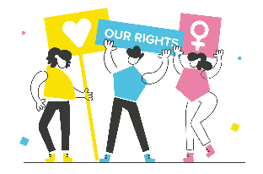

Conclusion

This project has highlighted the current issues within wales by gauging Wales’ young people’s opinions through the survey, Young Wales boards and groups, Young Wales events and Young Wales consultations and has prioritised the topics through the findings and in consultation with local authorities and organisations in Wales. This has provided some unexpected results such as the lack of outcry for climate change by young people, however, the cost of living crisis was voted as the top priority for young people in Wales. Young people are using their voices, claiming their right to be heard, and telling us what issues are important to them. It is crucial that we listen, understand, and act upon the concerns and suggestions outlined within this report.

When analysing the findings, we identified various links between the priority areas. For example, exam stress and the associated time commitments was discussed within the play section of this report, as well as mental health which was intertwined within areas such as life experiences and COVID-19. This shows us that holistic approach is necessary when working to solve the issues outlined.

Co-producing this report with Young Wales has been a fantastic opportunity for us volunteers. We have not only been able to share our own views but also amplify the voices and advocate for fellow young people. During this process, we have developed a variety of skills and have had some amazing opportunities such as presenting at the Young Wales Festival. We would like to thank the team who have supported us throughout this process.

In Wales, Children’s rights are generally upheld. However, there are some improvements to be made. The UNCRC works hand in hand with ideas of equality, diversity, and inclusion. Throughout the report accessibility and inclusivity has a strong presence. When actions are taken following this review, this ethos must remain as a central factor. Children’s rights should be the forefront of decision-making, with young people’s voices acting as the driving force for change and progress.

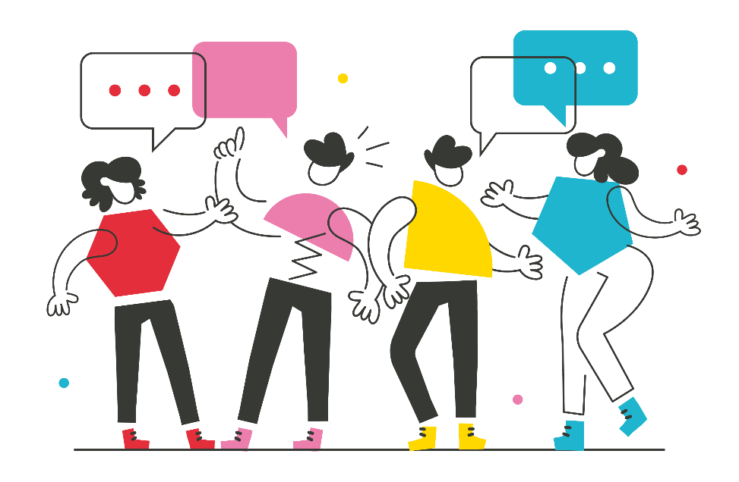

Appendices

Survey Participant Data

How old were people who answered our survey?

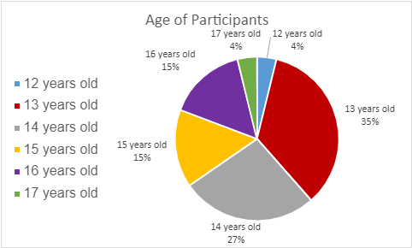

We had quite a range of young people who filled out the survey. The most common age for young people filling out the survey was 13 years old, with 35% of respondents being this age. We had no 11-year-olds or 18-year-olds fill out the survey and over half (62%) were 13 or 14 years old.

Where in Wales did the people who answered our survey come from?

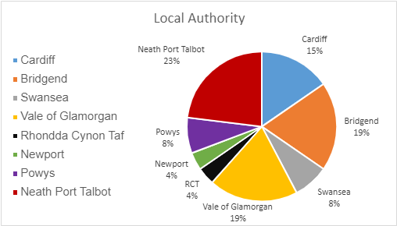

We had eight of the 22 local authorities in Wales represented in our survey, with the most popular choice being Neath Port Talbot with 23% of respondents. Only 8% of our respondents came from Mid or North Wales and these were all from Powys.

Concerning survey response
One young person responding to the survey, at times shared quite concerning views, some of which were racist and sexist. This appeared to be in response to feelings of anger about unfair treatment as a young, white, working-class male, as well as concerns about crime, poverty, and mental health. The contributions this person made have been interpreted with this lens. Their concerns, such as those about being treated unfairly, rising levels of crime, and mental health have been included in the findings of the survey, however, we have not used any offensive quotes. Unfortunately, as our survey was anonymous, we are not able to trace who this person was to follow up on any concerns and provide support.

Half of the young volunteer researchers are females with ethnic minority backgrounds. Despite some of the comments from one individual being concerning, and at times, potentially offensive, we have decided to include their responses as it highlights issues where young people may be feeling overwhelmed and looking for someone to blame.
As a whole team we do not agree with all of the comments. This has been a learning experience as a researcher. We came to an agreement that they should still be represented, which links to the UNCRC around having a say and being listened too.

Parental response
One response was from a parent of a disabled young person. They used the survey to represent their son in their answers. Where quotes are relating to this response, we have identified them within brackets afterwards.



