Assessment of Economic and Social Rights Fulfilment in the Philippines
Submission from the Human Rights Measurement Initiative to the United Nations Committee on Economic, Social and Cultural Rights for the 77th Pre-Sessional Working Group Geneva, February 2025.
I. Reporting Organisation
1. The Human Rights Measurement Initiative (HRMI) measures the human rights performance of countries, including the Philippines. HRMI is an independent, not-for-profit NGO with a primary base of operations in New Zealand, and a second base in the United States at the University of Georgia’s Center for the Study of Global Issues (GLOBIS).
II. Assessment Methodology
2. HRMI uses the award-winning and peer-reviewed SERF Index methodology to measure the fulfilment of economic and social rights (ESR).
3. This methodology uses bellwether indicator data from international organisations—such as the World Health Organization and UNICEF—and compares each country’s achievement to what other countries at the same level of income have achieved. In this way, HRMI measures progressive realisation of economic and social rights (ESRs) as defined in the International Covenant on Economic, Social, and Cultural Rights (ICESCR). A country’s income-adjusted HRMI score is a measure of how well its government is converting its resources into good human rights outcomes for its people.
4. HRMI supplements these scores with qualitative information sourced by a confidential survey of on-the-ground human rights experts, such as NGO researchers, journalists, and human rights lawyers and advocates. For more details on HRMI’s methodology, please refer to the resources on our website. All HRMI’s data are published annually on the Rights Tracker and are freely available for non-commercial use under a Creative Commons License. HRMI’s Rights Tracker is a certified Digital Public Good with the Digital Public Good Alliance.
III. Overview of Economic and Social Rights Fulfilment in the Philippines
5. HRMI’s most recent ESR scores for Philippines measure its achievement as of 2021 and show significant room for improvement. They are shown in the graph below.

6. The Philippines’ scores for 2021, the most recent available year, are as follows:
▪ Overall Quality of Life score = 72.4%
▪ Right to education = 63.3% (very bad)
▪ Right to food = 58.6% (very bad)
▪ Right to health = 77.6% (bad)
▪ Right to housing = 80.5% (bad)
▪ Right to work = 82.1% (bad)
7. These scores fall in the ‘very bad’ and ‘bad’ ranges, with none reaching the ‘fair’ and ‘good’ range.
8. The Philippines scores 72.4% on Quality of Life when scored against the 'Income adjusted' benchmark. This score takes into account the Philippine’s resources and how well it is using them to make sure its people's Quality of Life rights are fulfilled.
9. This score tells us that the Philippines is only doing 72.4% of what should be possible right now with the resources it has. Since anything less than 100% indicates that a country is not meeting its current duty under international human rights law, our assessment is that the Philippines has a very long way to go to meet its immediate economic and social rights duty.
10. Compared with other countries in East Asia, the Philippines is performing lower than average on Quality of Life rights.
IV. Right to Education
11. HRMI defines the right to education in accordance with ICESCR Article 13 and CESCR General Comments 11 and 13. In the case of low- and middle-income countries, such as the Philippines, HRMI further breaks down the right to education into three areas of measurement: primary school enrolment, secondary school enrolment, and quality of education. Our scores show significant challenges within all three areas.

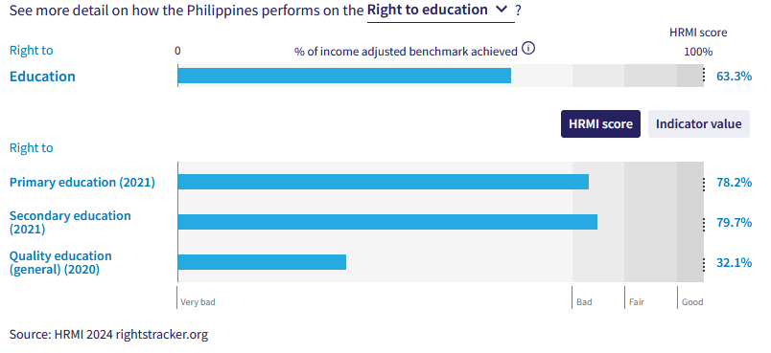

12. In primary education the Philippines is performing lower than average when compared to 16 other countries in East Asia. The Philippines holds a HRMI score 78.2% in 2021 which has fallen substantially from the previous score of 87.5% in 2020. This score indicates that they are only achieving 78.2% of what is possible with their available resources and shows that they are not meeting their immediate obligations under international law.
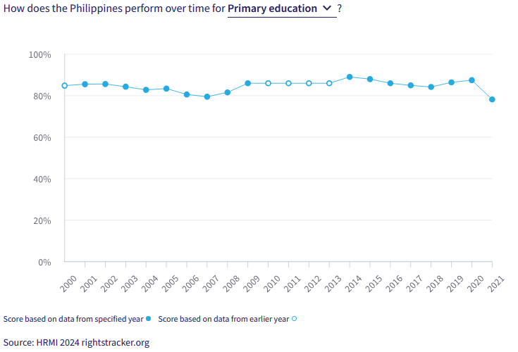
13. Secondary education is faring at a similar rate with a HRMI score of 79.7%. This score draws on a 76.7% enrolment rate in upper secondary school for 2021. The current HRMI score of 79.7% falls into the ‘bad’ range.
14. The current quality education score falls into the ‘very bad’ range. The Philippines is achieving only 32.1% of what we calculate ought to be possible in terms of quality of education. This HRMI score presents a significant drop when compared to previous years, though it has never scored higher than the ‘very bad’ range. The current score indicates that the Philippines is not efficiently turning its available resources into positive outcomes for its people, and is very far from meeting its immediate obligations under international law. The current score places the Philippines within the bottom 25 out of 172 nations for quality education, and places them lowest among the 17 nations in East Asia.
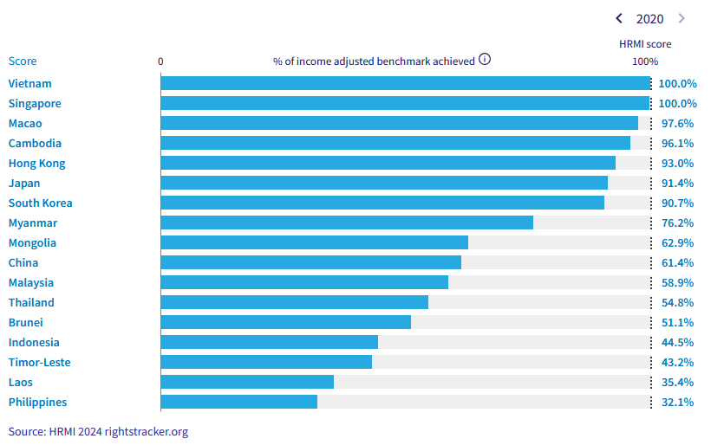
Caption: HRMI income adjusted quality education scores for East Asia (2020)
V. Right to Food
15. HRMI defines the right to food in accordance with ICESCR Article 11 and CESCR General Comment 12. For low- and middle-income countries, such as the Philippines, HRMI first uses a bellwether indicator of how many children are growing well (are not stunted). The Philippine’s score for the right to food is 58.6% and falls in the ‘very bad’ range. This means that the Philippines is doing 58.6% of what ought to be possible to ensure the right to food for its people. This score draws on indicator data on child stunting rates published by the UNICEF-WHO-World Bank: Joint child malnutrition (JME) database.
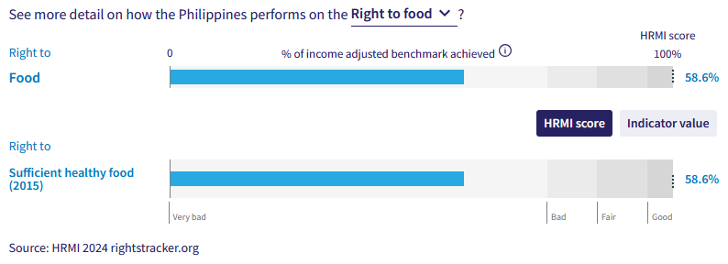
17. The score of 58.6% is given in 2015, but due to lack of data, a more recent score cannot be provided. However, the scores from previous years show little change over the past two decades and indicate that the Philippines is very far from achieving its immediate obligations under international law. This score places the Philippines in the bottom 11 of 136 countries and far lower than average for East Asia for the right to sufficient healthy food.
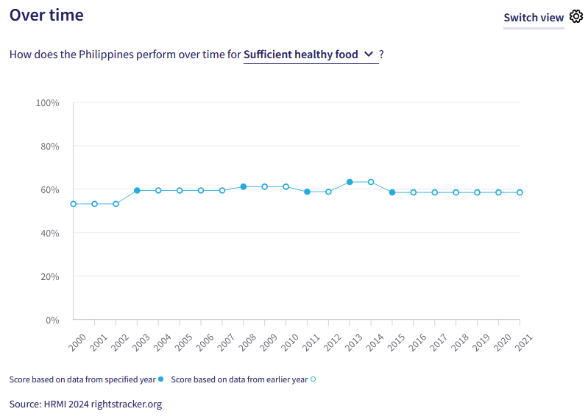
VI. Right to Health

19. HRMI defines the right to health in accordance with ICESCR Article 12.1 and CESCR General Comment 14. In the case of low- and middle-income countries, such as the Philippines, HRMI uses three indicators to measure the country’s achievement in child health, adult health, and reproductive health. The Philippines is allocating 94.8% of its available resources to child, health yet the HRMI score for reproductive health lies in the ‘very bad’ range.

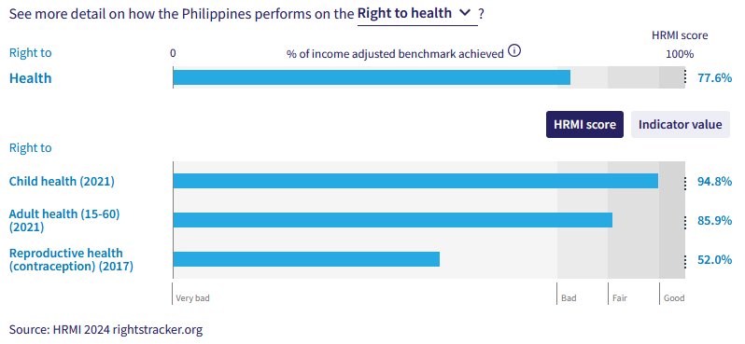
20. The overall right to health has a HRMI score of 77.6% and sits within the ‘bad’ range. Over the past two decades, the right to health has remained stagnant and only moved a few percentage points.

21.The Philippines hold a HRMI score of 94.8% for the right to child health, which is at the upper end of the ‘fair’ range. This score has been gradually increasing for the past two decades from 93.2% in 2000, this indicates that the Philippines is gradually progressing and is on the way towards meeting their obligations under international law.

23. The current HRMI score for right to reproductive health sits within the ‘very bad’ range at 52.0%. This score has been very slowly rising over the past two decades, but the current score which has been held since 2017 indicates that resources are not being effectively used to secure this right.

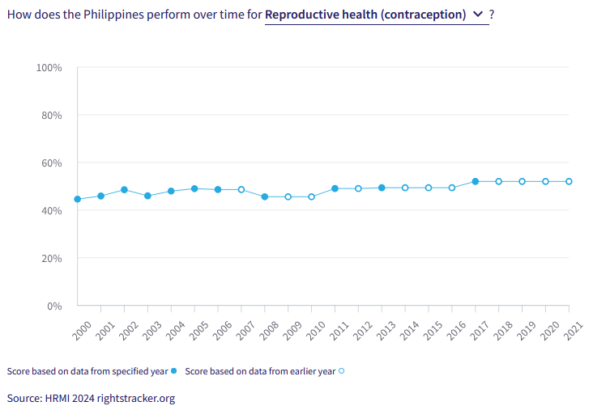
VII. Right to Housing

24. HRMI defines the right to housing in accordance with ICESCR Article 11.1 and CESCR General Comment 4. In the case of low- and middle-income countries, such as the Philippines, HRMI uses an assessment standard that measures the right to water on premises and ‘basic’ sanitation (each household having its own improved toilet facilities). For basic sanitation and for water, the Philippines has both scores within the ‘bad’. The overall HRMI score for the right to housing is 80.5%, falling within the ‘bad’ range.

25. In the Philippines, 80.4% of households have water on premises as of 2021. Given what other countries with the same level of income have shown to be possible, these statistics lead to a HRMI score of 82.0% for the right to water. However, the HRMI score has progressively improved from a score of 45.4% in 2000, to the current score of 82.0% in 2021. Many more people in Philippines now have access to these necessities and the Philippines is on the right track towards fulfilling progressive realisation of these rights in coming years if the rate of progress continues.

26. There have been significant improvements regarding basic sanitation over the decade. While the Philippines was only achieving 65.1% of what was possible in 2000, that score has now risen to 79.1% in 2021. The Philippines is still not achieving 100% of what is possible, but the recent progress in the realm of right to basic sanitation is very encouraging.

VIII. Right to Work and Social Security
27. HRMI measures the right to work in accordance with ICESCR Articles 6 and 7. For low and middle-income countries, such as the Philippines, HRMI measures the right to work and social security using a subsistence income indicator. According to the World Bank PovcalNet in 2019, in the Philippines, the percentage of people who are not absolutely poor was 82.2%, leading to a HRMI score of 82.1%, which falls within the ‘bad’ range, indicating that Philippines has a way to go to meet its immediate obligations.

28. Over the course of the last decade the Philippines has had a slow but appreciable increase regarding this right. The current score of 82.1% presents a new peak score and is up from the lowes HRMI score of 66.5% in 2007. The scores from 2018 to 2021 show a marginal increase from 81.3% to 82.1%, which suggests a stagnation in human rights progress.
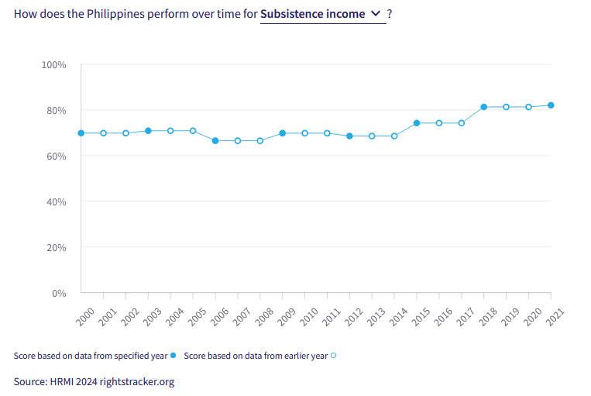
X. Concluding Remarks

29. The Philippines’ best HRMI score is for child health (survival to age five) - the only score which reaches as high as the ‘fair’ band.

30. The Philippines’ most concerning scores are for education, with quality education being particularly low; sufficient healthy food; and reproductive health.

31. There have been encouraging improvements in the rights to water and sanitation over the last two decades. Improvements in the right to subsistence income are slower.

32. HRMI respectfully submits its data and findings on the fulfilment of economic and social rights in the Philippines. We hope that this Submission will serve as a useful resource to the Committee on Economic, Social and Cultural Rights for drafting specific and meaningful questions to the Philippines during the CESCR’s 77th Pre-Sessional Working Group.

Visit HRMI’s website to learn more about our mission and work, https://humanrightsmeasurement.org/.
This content represents the opinions of the Human Rights Measurements Initiative. It carries no endorsement of the University of Georgia.
See HRMI’s methodology for measuring economic and social rights: https://humanrightsmeasurement.org/methodology and https://rightstracker.org/page/methodology.
Ibid
Ibid
HRMI 2024 Rights Tracker, https://rightstracker.org/
See Human Rights Measurement Initiative (HRMI) Digital Public Good Certificate, https://app.digitalpublicgoods.net/a/11781 The Digital Public Goods Alliance is endorsed by the UN Secretary General’s “Roadmap for Digital Cooperation,” https://www.un.org/en/content/digital-cooperationroadmap/assets/pdf/Roadmap_for_Digital_Cooperation_EN.pdf. It defines digital public goods as: “open source software, open data, open AI models, open standards and open content that adhere to privacy and other applicable laws and best practices, do no harm, and help attain the SDGs,” https://digitalpublicgoods.net/standard/.
HRMI 2024 Rights Tracker, https://rightstracker.org/country/MWI?qolFdScore=hrmi&as=core&tab=report-esr
The labels on the country charts of good, fair, bad, and very bad are used to give a general indication of how to understand the scores. HRMI’s income adjusted Quality of Life scores can be broadly interpreted as showing the percentage of the country’s obligation it has met, compared to what the best performing countries have achieved at each income level. A country scoring below 75% with a label of “Very bad” is failing to put in place the kinds of structures and policies that help people claim the right concerned, but the structures and policies in place most likely prevent many people from claiming their rights. See HRMI’s methodology for measuring human rights, https://rightstracker.org/page/methodology.
HRMI 2024 Rights Tracker, https://rightstracker.org/country/MWI?qolFdScore=hrmi&as=core&tab=report-esr
HRMI 2024 Rights Tracker, https://rightstracker.org/metric/esr?tab=report-esr&region=sub-saharan-africa
HRMI 2024 Rights Tracker, https://rightstracker.org/metric/education.
HRMI 2024 Rights Tracker, https://rightstracker.org/country/MWI?qolFdScore=hrmi&as=core&tab=report-esr
Ibid
---
HRMI 2024 Rights Tracker, https://rightstracker.org/country/MWI?qolFdScore=hrmi&as=core&tab=report-esr
----
HRMI 2024 Rights Tracker, https://rightstracker.org/country/MWI?qolFdScore=hrmi&as=core&tab=report-esr
HRMI 2024 Rights Tracker, https://rightstracker.org/metric/not-stunted.
HRMI 2024 Rights Tracker, https://rightstracker.org/country/MWI?qolFdScore=hrmi&as=core&tab=report-esr
HRMI 2024 Rights Tracker, https://rightstracker.org/country/MWI?qolFdScore=hrmi&as=core&tab=report-esr
Ibid
HRMI 2024 Rights Tracker, https://rightstracker.org/country/MWI?qolFdScore=hrmi&as=core&tab=report-esr
Ibid
Ibid
HRMI 2024 Rights Tracker, https://rightstracker.org/country/MWI?qolFdScore=hrmi&as=core&tab=report-esr

