alternate report to the un CRC committee on the rights of the child in accordance with the fifth periodic report of state parties of the government of fiji

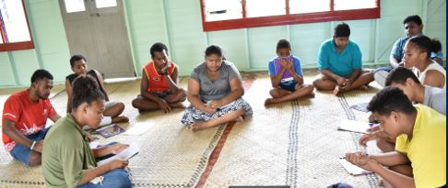

4th May 2021

APRIL 2021


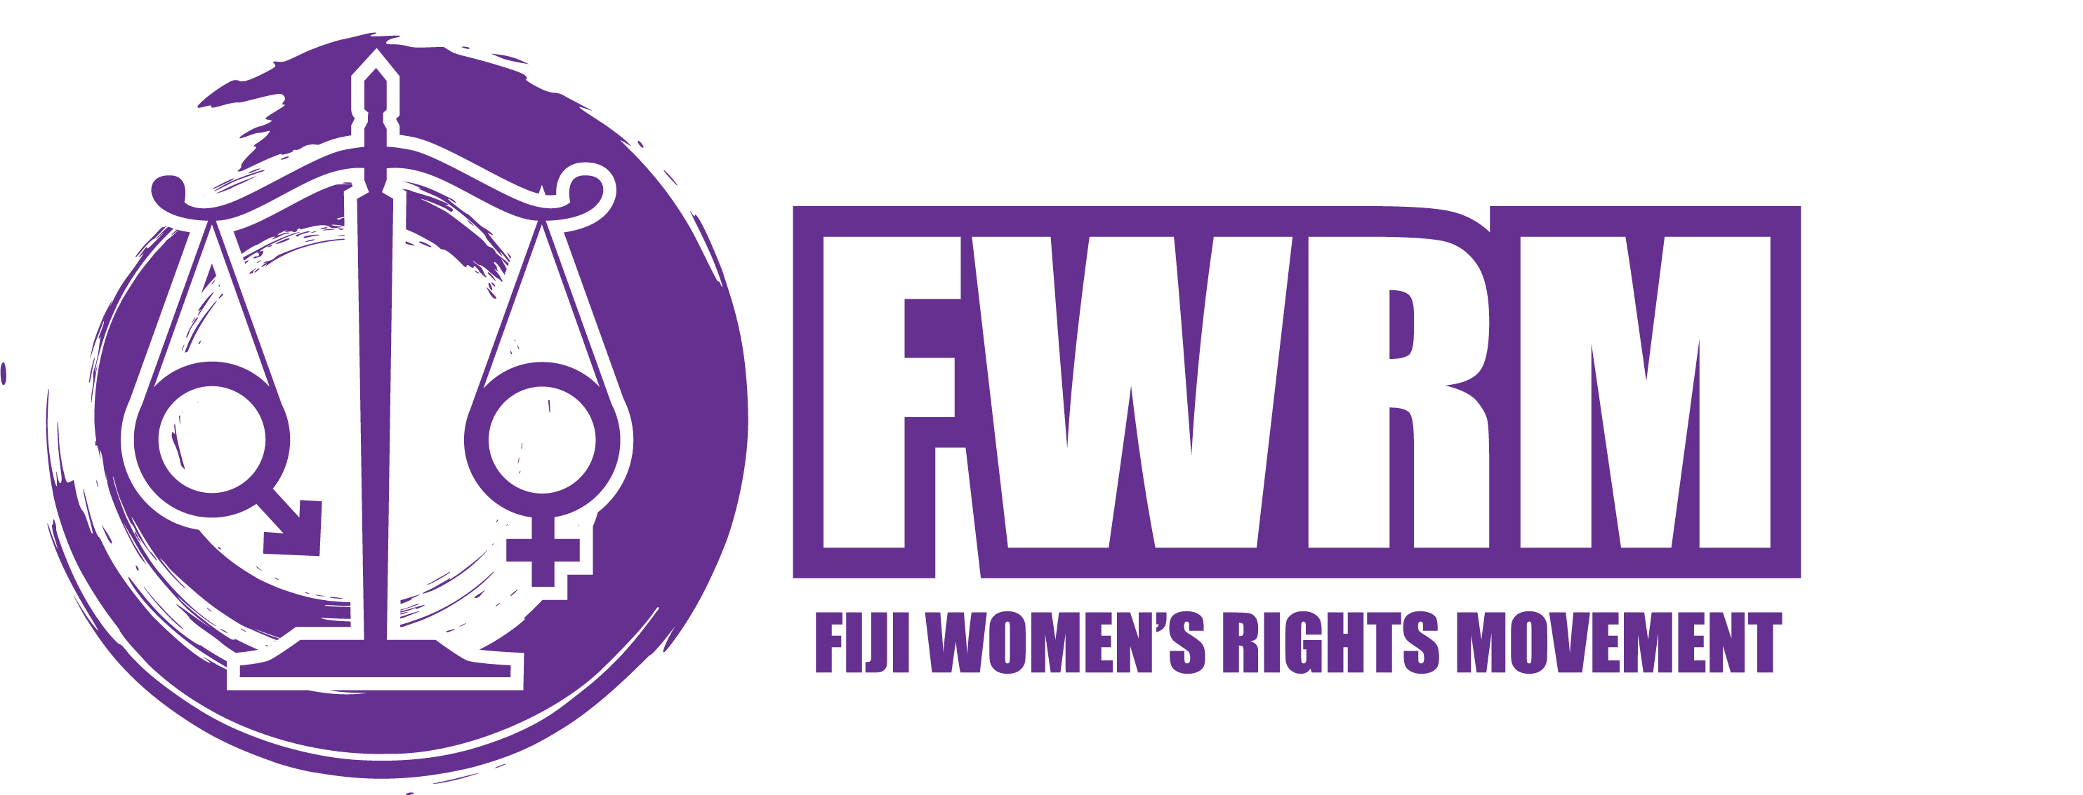
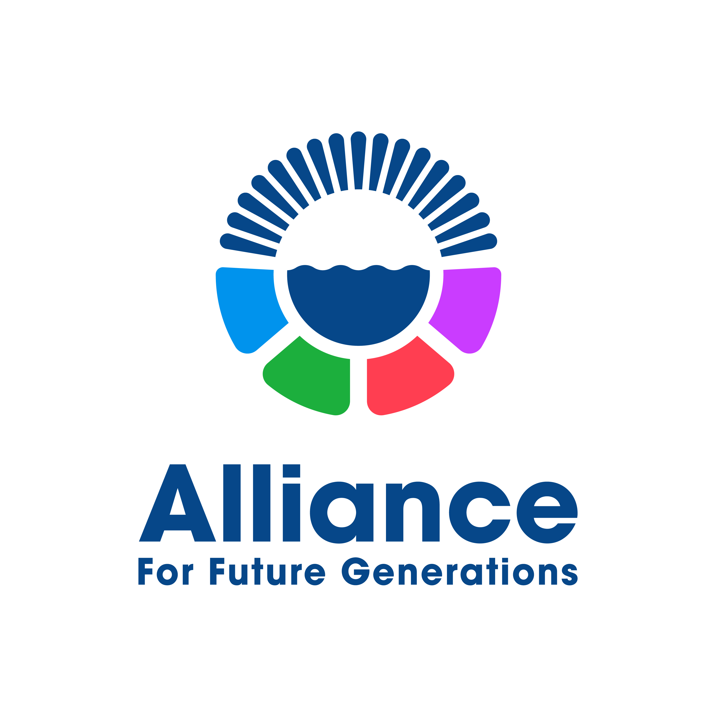
  - 

  - 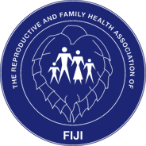
  - 

TABLE OF CONTENTS
ACRONYMS & ABBREVIATIONS | 2
PREFACE | 3
EXECUTIVE SUMMARY | 4
INTRODUCTION | 6
METHODOLOGY | 8
CSOs PERSPECTIVE ON THE CRC THEMATIC CLUSTERS | 9
ONE: GENERAL IMPLEMENTATION MEASURE (ARTICLES 4, 42, 44.6) | 9
Legislation and Policies | 9
Coordination and Evaluation | 13
Independent monitoring | 14
Allocation of Resources | 14
Data Collection | 16
Dissemination, awareness raising and training | 17
TWO: DEFINITION OF THE CHILD (ARTICLE 1) | 17
THREE: GENERAL PRINCIPLES (ARTICLES 2,3,6 AND 12 | 18
Best interests of the Child | 18
Rights to life, survival and development | 19
Respect for the views of a child | 20
FOUR: DISABILITY, BASIC HEALTH AND WELFARE (ARTICLES 6,18 (Para.3), 23,24,26,27 (paras. 1-3) and 33) | 22
FIVE: EDUCATION.LEISURE AND CULTURAL ACTIVITIES (ARTICLES 28-31) | 23
SIX: SPECIAL PROTECTION MEASURES (ARTICLES 22,30,32-33, 35-36, 37 (b)-(d) and 38-40) | 24
Sexual exploitation and sexual abuse | 24
Sexual violence against women and girls rape case analysis | 24
Sale, trafficking and abduction | 25
State v J Werenalagi | 26
Violence in schools | 26
SEVEN: CHILD PARTICIPATION AND REPRESENTATION | 27
ARTICLE 12: RIGHT OF THE CHILD TO PARTICIPATE | 27
Impact of Climate Change on the Rights of the Child | 27
Child Rights Situational Analysis | 28
Child Rights Governance | 28
CONCLUSION | 29
BIBLIOGRAPHY | 30
ANNEXES | 33

ACRONYMS
CDRR | Child-Centered Disaster Risk Reduction
CPiE | Child Protection in Emergencies
CRC | Convention on the Rights of the Child
CRIA | Child Rights Impact Assessment
CRPD | Convention on the Rights of Persons with Disabilities
CRSA | Child Rights Situational Analysis
CSO | Civil Society Organization
CSU | Child Services Unit
CTO | Care and Treatment Order
EiE | Education in Emergencies
FBO | Faith Based Organization
FPF | Fiji Police Force
FWCC | Fiji Women’s Crisis Centre
FWRM | Fiji Women’s Rights Movement
MEHA | Ministry of Education, Heritage and the Arts
MHMS | Ministry of Health and Medical Services
MSF | Medical Services Pacific
MWCPA | Ministry of Women, Children and Poverty Alleviation
NCCC | National Coordinating Committee on Children
NCD | Non communicable Diseases
NGO | Non-Governmental Organization
NHRI | National Human Rights Institution
OP | Optional Protocol
RFMF | Royal Fiji Military Forces
SCF | Save the Children Fiji
SEC | Sexual Exploitation of Children
UNICEF | United Nations Children’s Fund
UPR | Universal Periodic Review
YG | Young Girls
WHO | World Health Organization

PREFACE
The report is intended to supplement the Government of Fiji’s Fifth Periodic Report of State Parties 2021, by providing additional inputs and recommendations for the effective responses to the situation of children from the CSO perspective and experience.
The compilation of the report was funded and led by Save the Children Fiji, a civil society organisation mandated to lead on child rights in Fiji. The process to formulate the report was also funded by the Fiji Women’s Rights Movement. It has been developed jointly by the National CSO Working Group which includes: Fiji Association for the Deaf, Fiji Women’s Rights Movement, Plan International Pacific, Alliance for Future Generations, The Reproductive and Family Health Association for Fiji, Adventist Development and Relief Agency Fiji and Save the Children Fiji with the technical support from The Pacific Community (SPC).
To develop the report, members of the CSO working group held meetings and discussed the progress made against the concluding observations of Fiji’s combined second to the fourth periodic report to the UN CRC Committee in September 2014. Areas of concern were discussed with recommendations made under relevant clusters of the CRC agreed upon by the Working Group. Information had been gathered from individual interviews, surveys and reports written by organizations between the period 2015 to 2021. Focus group discussions were held with 12 children from ages ranging from 13 to 20 years of age who were mostly from the informal settlement area. This consisted of semi-structured interviews. Key findings from this FGD reflected that, in general, children felt well protected and valued by their families. However, religion and culture remain an impediment to the realization of their rights in terms of the limited freedom to express themselves, corporal punishment as a dominant disciplinary measure, and generally to be heard in matters that concern their lives.
An online survey was conducted with 76 children were received from a cross section of rural, urban, villages and informal settlements with 58% attending primary schools, 40% secondary schools and 2% at the university level. 63% were male, 36% were female and one respondent did not wish to state his-her gender. Key findings from the children’s responses based on the CRC were as follows: The rights most violated were the right to be safe and protected: Verbal and emotional abuse 38%, Physical abuse 29%, Neglect 20%, Sexual abuse 11%. 15% stated they were never listened to by their parents whilst 85% were listened to at times. 45% stated they were not respected for who they are as children, 36% stated they were given some respect whilst 19% stated maybe. Their knowledge of services or whom to go to when their rights are violated had the Police with 28%, SCF 18%, Department of Social Welfare 17%, FWCC 8%, Parents 8%, Child Helpline 1325 7% Village Headman 5% and MSP 1%. These findings reflect the level of CRC awareness across all communities and resonate with the CRSA findings discussed later in section 10.4.
A draft report was circulated between the network for final comments and feedback before finalization and submission.

EXECUTIVE SUMMARY
While the State has the legal obligation to report on and implement the CRC, achieving the desired change we seek for all children demands the engagement of society as a whole, including Non-Governmental Organizations (NGOs), National Human Rights Institutions (NHRIs), and children themselves.
As Fijis's fifth periodical report is due to be reviewed, this alternate report provides the CSO’s perspectives on six of the nine clusters of the CRC articles. Whilst acknowledging the progress in the CRC implementation to date, the report has identified certain areas of concern, presenting the following related questions to the State to assist in the fulfillment of its obligations to uphold children’s rights in Fiji.
- General Measures of Implementation
Legislations and Policies
- Can a child labor survey be carried out on the worst forms of child labor, using primary sources and interviews, rather than collating data from previous surveys? The research should include reasons why children engage in the worst forms of child labor to assist stakeholders in targeting their responses and programs.
- When will the Adoption Act enter into force?
- What are administrative changes planned or underway to affect the new Adoption law?
- What training and support will designated professionals receive to ensure they have the appropriate training and tools to fulfill their duty of care under the Child Welfare law?
- How does the State intend to address the lack of reporting from maritime and rural communities to ensure that any type of abuse involving children is reported immediately?
- What is the status of the proposed amendments to the Hazardous Work Order in terms of progress and timing?
- How will the Government ensure new measures in the Cybercrime Act that do not adversely affect the right to privacy?
- Have the rights of children who might be registered sex offenders been considered?
Coordination and Evaluation
- Why is a Child Rights Impact Assessment (CRIA) not conducted to date despite the previous CRC recommendations?

- Definition of the Child
- Are there any plans to harmonize all legislations in line with the CRC definition of a Child?
- General Principles
Best interests of the Child
- Can the State clarify the law regarding the need for children’s evidence to be corroborated or will it continue to rely on the common law ruling against corroboration?
Right to life, survival and development
- Has the National Mental Health and Suicide Prevention Policy (2015) been reviewed, published and socialized with schools and communities? If not, will the Government review and reform the Policy and will the amended Policy be socialized throughout Fiji especially in schools?
- Can the Fiji Government have mental health professionals and children be part of the design and implementation of strategies and action plans to address mental health issues of children in Fiji?
- As an interim measure, can the Fiji Government consider having mental health professionals in the professional cadre of Government funded schools or in all schools?
Respect for the views of the child
- Can the gaps in data be addressed, and are there any evaluations planned or undertaken for the Child Helpline?

- Special Protection Measures
Sale, trafficking and abduction
- Can the State increase the resources of the FPF so it can investigate and the ODPP to prosecute the perpetrators of child abuse and neglect, sexual assault cases and domestic trafficking and sexual commercial exploitation of children?
- Can the Online Safety Commission of Fiji disclose its work plan and proposed activities in addressing cybercrime in Fiji. Will those activities involve working in coordination with other State agencies and the NGO community? By the same token, why has the Online Safety Commission not disclosed its work plan or published its Annual Report?
- Can a national summit be convened by the MEHA, heads of Government funded schools or partially Government funded schools and key State agencies to address the growing incidences of violence in schools? This summit will be an opportune time for all Fijians to devise and formulate strategic plans to address this serious societal issue.
- Child Participation
How is the Government addressing the challenge of child rights and how are negative reactions from parents and communities countered?

1.0 INTRODUCTION
1.1 Fiji has made steady progress towards the realization of child rights since becoming a signatory of the Convention of the Rights of the Child in 1993. Since the review of the 3rd and 4th reports of Fiji on the implementation of the CRC, there were a number of significant changes that directly and indirectly affected the lives of children in Fiji.
1.2 The Government of Fiji is commended for its progress in implementing the provisions of the CRC, namely, the establishment of laws and policies which impact the wellbeing of Fijian children and their ability to thrive.
1.2.1 The constitution of Fiji (2013) states in its article 41.1:
Every child has the right:
a. To be registered at or soon after birth, and to have a name and nationality
b. To basic nutrition, clothing, shelter, sanitation and health care
c. To family care, protection and guidance, which includes the equal responsibility of the child’s parents to provide for the child i) whether or not the parents are, or have ever been, married to each other; and ii) whether or not the parents are living together, have lived together, or are separated;
d. To be protected from abuse, neglect, harmful cultural practices, any forms of violence, inhumane treatment and punishment and hazardous or exploitative labor.
e. Not to be detained except for a measure of last resort only for a period of time as is necessary and separate from adults and in conditions that take into account the child’s sex and age.
Article 41.2: The best interests of the child are the primary consideration in every matter concerning the child.
1.2.2 The Optional Protocol to the CRC on the Sale of Children, Child Prostitution and Child Pornography (OP-CRC SC) was signed in 2005; the Optional Protocol to the CRC on the involvement of Children in Armed Conflict (OP-CRC AC) signed in 2005 and the Optional Protocol to the CRC on the Rights of Persons with Disabilities was signed in 2010.
There’s a unanimous call from all agencies who work with children, urging the State to ratify the signed OP to the CRC on the sale of children, child prostitution and child pornography and the signed OP to the CRC on the Involvement of Children in Armed Conflict. Additionally, the State is strongly urged to sign and ratify the OP to the Convention on the Rights of the Child on a communications procedure.
1.2.3 The Child Welfare (Amendment) Decree 2013)
The Act promotes the health and protection of children through mandatory reporting, emphasizing the duty of care for persons handling child cases and confidentiality and integrity of cases being handled by professionals. The CWD has been one of the most progressive laws for children in Fiji with the Child Help Line hosting a centralized database on CWD.
1.3 The improvement in maternal and child health services across Fiji is the result of better antenatal services coverage, high immunization rates, the promotion of breastfeeding, the application of Integrated Management of Childhood illness techniques as well as improved access to clean water and sanitation.
1.4 Fiji achieves high primary and secondary school enrolment rates, as well as gender parity in schools. Free basic education has been extended to twelve (12) years, and funding and grants for school tuition fees have been increased, besides various assistance schemes which have been established since 2014 to ensure that every school-aged child has access to primary and secondary education. Enrolment in Early Childhood Education (ECE) has also benefited from a boost in recent years increasing from 14.1% to 85% in 2017.
1.5 Significant issues remain however, with the clear implications for the realization of child rights. Despite Fiji’s status as an upper middle-income country, an estimated 61% of children live in or are vulnerable to poverty, and UNICEF (2015) estimates that up to 80% of children live in families that do not have the means to provide for their adequate development. Inequalities between national and sub-national levels persist, and particularly disadvantaged are children living in rural areas, squatter settlements, low quality urban dwellings and the Northern division. Urbanization is on the rise and, with limited land available and housing largely unaffordable, the growing urban population is increasingly pushed into living in informal settlements, many without basic amenities, adequate housing and tenure security seek support from the Government or CSOs.
1.6 COVID-19 has had a huge impact on Fiji’s working population. It is estimated that thousands of children of parents economically affected by COVID-19 response measures are seeking assistance from Government and CSOs. Concerns were raised by stakeholders in relation to the significant number of children begging and selling on the streets (more pronounced during COVID-19).
1.7 In the current COVID-19 climate, there has been an increased demand for social protection from the Department of Social Welfare. The Department provides social protection assistance to over 77,000 people in Fiji. In 2020, there were increased payments in three benefit schemes which include the Disability Allowance, Poverty Benefit Scheme and Care and Protection allowance for children. In 2020, verification and re-certifications were carried out so beneficiaries could continue to receive allowances with the Australian Government providing US $4.7M to enable top-ups for the welfare protection programs.
1.8 2021 has been declared the international year for the elimination of child labor.Fiji had ratified the Worst Forms of Child Labor Convention, 1999 in 2002 and had submitted a number of reports on the application of Convention No.182 to the ILO Committee for Experts on the Application of Conventions and Recommendations. (CEACR) . The next report is due on the 1st of September, 2021. In its 2017 observation, the CEACR took due note of the Government's efforts to combat the commercial sexual exploitation of children CSEC and expressed its concern regarding the continuation of CSEC, including sex tourism in Fiji. The CEACR urged the Government to take effective and time bound measures to remove children from the worst forms of child labor, taking into account the special situation of girls, requested that the Government provide concrete information on the intervention strategies and rehabilitation programs aimed at victims of CSEC and to provide concrete information on the number of victims of CSEC that have been rehabilitated and socially integrated.
Question to the State
Can a child labor survey be carried out on the worst forms of child labor, using primary sources and interviews, rather than collating data from previous surveys? The research should include reasons why children engage in the worst forms of child labor to assist stakeholders in targeting their responses and programs.
2.0 METHODOLOGY
2.1 The Report was guided by a desk review and meeting with stakeholders to ensure rigor in the analysis of the data, a combination of quantitative and qualitative data collection methods was applied. The mixed method approach informed the shape and content of the Report.
2.2 Quantitative
2.2.1 The development of this Report involved a desk review (including online research) of laws relating to children, supporting policies including those developed by the SCF and other Fiji NGOs who work in the area of children’s rights. UNICEF reports on Fiji’s situation regarding children were also considered.
2.2.2 Qualitative
2.2.3 Face-to-face meetings were conducted with relevant government officials, NGO members and children to ensure that their views were captured in this report. See Annexure III for a list of persons interviewed, the NGO workshop participants and the children who took part in a group activity that assisted in the writing of this Report.
2.2.4 Engagement with the Fiji NGOs occurred on two fronts: an initial meeting on the 27th March 2021 to discuss a roadmap, proposed report structure and request for data to populate and analyze. This was followed by a validation workshop was held on Friday 9 April with the Fiji CSOs to endorse the content of the Report. A list of Fijis CSOs who contributed to this report and attended the consultation meetings are listed in Annexure III. Regional partners SPC and UNICEF were also consulted with the Child Services Unit in the Department of Social Welfare.
3.0 Limitations
3.1 The Report has limitations but does not weaken the content of the Report and are important to acknowledge-
- Coverage and analysis of issues are not comprehensive due to gaps identified and impact assessments that have yet to be undertaken.
- Due to the short timeframe to prepare the Report, it covers the period 2015 to 2021 and collecting information posed a challenge.
- The report does not cover all the articles.
- The impact of the Covid-19 lockdown resulted in some partners unable to provide further feedback of the final draft of the report.
3.2 Despite the challenges of collecting meaningful information in a short period of time, all care has been taken to ensure the accuracy of the information.

4.0 CSOs PERSPECTIVE ON THE CRC THEMATIC CLUSTERS.
4.1 ONE: GENERAL IMPLEMENTATION MEASURES
4.1.1 Legislation and policies
In Fiji, protection of children’s rights and subsequent legal remedies are captured in various legislative frameworks. These laws cover a range of issues such as domestic violence, custody, juveniles act, disability issues, child protection and welfare, adoption, child trafficking and smuggling.
4.1.2 Adoption Act No.37 of 2020
4.1.2.1This Act repeals and replaces the outdated Adoption of Infants Act 1944. It provides for processes that facilitate local and intercountry adoptions. This enacted law provides, inter alia, for intercountry adoptions, on which the former Act was silent4.1.2.2 The Adoption Act was enacted in September 2020 but it has yet to become law. At the time of this report, there was no legal notice to confirm the date on which the relevant Minister had nominated that the Act would come into force.

Questions to the State
- When will the Adoption Act enter into force?
- What administrative changes are planned or underway to affect the new law?
4.1.3 Child Welfare Act 2010
4.1.3.1The Child Welfare Act is one legal response to the growing incidences of child abuse and neglect in Fiji. The Act mandates healthcare workers along with other professionals, that is, a teacher and a lawyer, to report any possible, likely or actual harm to a child. It also empowers a designated medical officer to action a Community Treatment Order to retain a child in a health facility where there is concern that the child may be at immediate risk of harm.
4.1.3.2 The rationale for mandatory reporting is that early detection of abuse can help prevent the occurrence of serious injuries and assist coordination between health, social welfare, legal and other responses.
4.1.3.3 There have been calls to widen the definition of “professionals” under the Act to include “a labour officer” as defined in section 4 of the Employment Relations Act and a counsellor in respect of “child-counselling” as set out in section 2 of the Family Law Act.

Questions to the State
What training and support will designated professionals receive to ensure they have the appropriate training and tools to fulfill their duty of care under the law?
How does the State intend to address the lack of reporting from maritime and rural communities to ensure that any type of abuse involving children is reported immediately?

4.1.4 Crimes Act No.44 of 2009
4.1.4.1 The Crimes Act provides for criminal offences in Fiji and it must be read in conjunction with other laws of Fiji.
4.1.4.2 Part 12B and Part 13 of that Act prescribes sexual offences and prostitution as separate classes of offences. It covers both adult and child victims. Offences include, but are not limited to, rape, sexual assault, indecent assault, trafficking in minors, facilitating the sexual exploitation of minors. Divisions 5 and 6, Part 12, of the Crimes Act are also relevant as they cover offences such as domestic trafficking of children, and victims may be anyone present in Fiji, regardless of whether they are citizens or not, including minors. The age of the majority is 18 years old.
4.1.4.3 According to the Crimes Act, the age of consent for sexual activity is 16 years. The age of the majority is 18 years old. For ages 13 and 16 there is a statutory defence if the accused reasonably believed or was made to believe that the victim was above 16 years. The law is silent on the age gap between 16 and 18. However, for trafficking in persons type of charge there is no age for consent, as one of the elements of the offense is that the victim was forced into sexual activity, therefore there is no minimum age for consent because the act is legally prohibited. For sexual offences which have a component of consent being a primary issue, there the age of consent is relevant.
4.1.4.4 Additionally, the law prescribes the offence of defilement of persons under 18 years of age with intent to have carnal knowledge, however the maximum sentence is only 5 years and it is usually used in circumstances where a victim wilfully leaves their home to reside elsewhere.

4.1.5 Employment Relations Act 2007
4.1.5.1 This Act guarantees fundamental principles and rights of any worker in Fiji, including but not limited to sections 90 to 99 which prohibits the worst forms of child labour, sets minimum age and conditions and allows certain rights and freedoms for children who are legally allowed to be employed. In Fiji, child labour undermines the realization of children’s rights and this has been triggered by increasing cost of living, family breakdown, children dropping out of schools and peer pressure. For example, the Fiji Government received notification of 188 cases of child labour in 2016.
Proposed amendments to the Hazardous Work order that were validated by stakeholders including tripartite constituents , included the collection of marine life and fish, the transportation of passengers, automobile repairs and working as vehicle mechanics including welding, panel beating and painting.

Question to the State
What is the status of the proposed amendments to the Hazardous Work Order in terms of progress and timing?

4.1.6 Juveniles Act
4.1.6.1 The Juveniles Act provides juvenile justice in Fiji.
4.1.6.2 The Act was enacted in 1974 and it has had piecemeal amendments made to it. Combined with the case precedents interpreting the principle “Best interests of the Child” as discussed in paragraph 5.2.16.1 makes the need to review and reform the Act an urgent priority for the Government. Reforming this Act is imperative so that it reflects the lived realities of juvenile offenders and ensures that the provisions are consistent with CRC.
4.1.7 Cybercrime Act
4..1.7.1In February 2021 the Cybercrime Bill 2020 was passed and it contains provisions relating to child pornography.
Question to the State
How will the Government ensure new measures in the Cybercrime Act that do not adversely affect the right to privacy?

4.1.8 Proposed Registration of Sexual Offenders Bill
4.1.8.1 The objective of the draft Bill is to reduce the risk of recidivism by sexual offenders and to treat sexual assault with the seriousness that it deserves. The Bill facilitates this by establishing a process whereby specific State agencies will have access to and use the information to monitor sex offenders even after they have served their sentence. FPF will have updated information in order to rapidly investigate and, where appropriate, gather evidence to assist in the prosecution of a sexual offence case.
4.1.8.2 Clause 5(2) provides that a sex offender refers to a person above the age of 12 and, if convicted of a sexual offence, would be registered under the Bill. This suggests that a juvenile that is a person under the age of 18 years as prescribed under the Juveniles Act, if found guilty of committing a sexual offence such as defilement (section 215 of the Crimes Act) would have his or her name registered in the Sex Offenders Registry for life.
4.1.8.3 Such a provision undermines the concept of a holistic intervention and treatment of the alleged perpetrator. Identifying children who sexually offend will pose a serious threat to such children and it may play a part in making it difficult for such children to assimilate into the community and become productive citizens.
4.1.8.4 Under Clause 5(3) of the Bill, a person only ceases to be a sex offender where the conviction is quashed or set aside in a court of law. Where this does not occur, that sex offender is required to comply with the reporting obligations set by the court for life.
Question to the State
Have the rights of children who might be registered offenders been considered?

4.2 Coordination and evaluation
4.2.1. The National Coordinating Committee on the Rights of Children (NCCC) is the national level coordination mechanism that sits within the structure of the Ministry of Women, Children, and Poverty Alleviation. A multi-sectoral committee chaired by the Permanent Secretary/Chief Executive Officer of the line Ministry, it is charged with the task of developing and ensuring that State agencies and the NGOs who work in child’s rights are coordinated in their approach and execution of policies and laws relating to children.
4.2.2 The Inter-Agency Committee on all Forms of Child Abuse, Neglect and Abandonment is a sub-committee of the NCCC. The Inter-Agency is composed of both NGOs including the FWCC, Medical Services Pacific and State agencies: The Departments of Health, Social Welfare, Education, the Fiji Police Force, the Director of Public Prosecutions, Ministry of iTaukei Affairs and Ministry of Employment, Productivity and Industrial Relations. The Inter-Agency Committee Guidelines on Child Abuse and Neglect outlines the procedures for responding to child protection cases and the roles and responsibilities of the implementing partners.
4.2.3 The CRC Committee has recommended that the State Parties consider how their laws and policies will impact children through the systematic use of Child Rights Impact Assessments (CRIAs). CRIAs can fulfill the procedural requirement needed to implement the best interests of the child principle by scrutinizing whether policy and legislative decisions are in the best interests of children and groups of children. The CRC Committee has called for CRIAs to be part of government decision making at all levels as early as possible, and has specified that CRIAs should incorporate inputs from a range of stakeholders including children, produce recommendations and amendments and be made available to the public.
4.2.4 Per the unfulfilled CRC Committee’s Concluding Observations to Fiji (September,2014): Fiji should take all necessary measures to reinforce the coordination responsibilities of the NCCC and to accelerate the approval of its new structure consisting of Permanent Secretaries of the relevant ministries pending approval by Cabinet.
Question to the State
Why is a Child Rights Impact Assessment not conducted to date despite the previous CRC recommendations?

4.3 Independent monitoring
4.3.1 Depending on their statutory mandate, each institution has independent monitoring powers on matters such as child protection, juvenile justice systems and complaints.
4.3.2 The NCCC does not have the legal mandate to monitor or deal with complaints about individual children. However, under section 4 (2) of the Child Welfare Act, the Permanent Secretary of the Ministry of Social Welfare, Women and Poverty Alleviation has the authority to receive complaints regarding the sexual exploitation of children. Further, the Act mandates healthcare and other professionals to report cases when they “become aware reasonably suspects… that a child has been or is being or likely to be harmed”. A National Child Register has been established as a key tool to support mandatory reporting as well as identify trends and gaps in child protection and develop strategies to address them.
4.3.3 The Fiji Human Rights and Anti-Discrimination Commission is mandated under section 27(1) and section 28(1) of the Human Rights and Anti-Discrimination Act No.11 of 2009 to receive or investigate complaints on its own motion contraventions of human rights and discriminatory practices on a range of prohibited grounds of discrimination, including age.

4.4 Allocation of resources
4.4.1 The Fiji Attorney-General Hon Aiyaz Khaiyum, in delivering the 2020/2021 COVID-19 budget noted, inter alia, - “Barring drastic intervention, our economy may never fully recover; not this year, not next year, not decades on from now. That’s what is at stake; not only our economy, but our children’s economy.”
4.4.2 Budgetary allocation to support or strengthen the implementation of laws, policies and initiatives is clear evidence of the Fiji Government’s commitment to the children of Fiji. COVID-19 highlights the critical need for proper planning, prudent expenditure, and monitoring and evaluation of laws and policies to ensure that they are fulfilling their purpose and they are leading to the desired impact on vulnerable communities including children.
4.4.3 For the period 2015-2020, most of the budgetary allocation for children has been channeled to three key Government Ministries: Ministry of Women, Children and Poverty Alleviation; Ministry of Education and the Ministry of Health and Medical Services. Apart from these three State agencies, this report acknowledges that there are other State agencies and quasi-government institutions who work on an aspect of children’s rights and they are fully or partially funded by Government.
Priority sectors 2016-2020 as it relates to children
4.4.5 For the period 2016/2017, MEHA received the largest budgetary allocation of $448.5 million, an increase of $26.6 million from the revised estimate for 2015/2016. This was followed by the Ministry of Health (MOH), which received $244.0 million and the Ministry of Women, Children and Poverty Alleviation (MWCPA) which received the lowest allocation ($56 million) in comparison to the two State agencies. For the period 2017/2018, MEHA was allocated $90.1m, MOH $321.2m and MWCPA $113.4m. For the period 2018/2019 MEHA was allocated $535.4m, MOH $334.9m and MWCPA $133m. For the period 2019/2020 MEHA was allocated $467.7m, MOH $349.8m and MWCPA $127.7m. For the period 2020/2021 MEHA was allocated $450.6m, MOH $394.3m and MWCPA $159m.

4.4.6 Despite steady increases in budgetary allocation for 2015 to 2020, the MWCPA still lagged behind MOH and MEHA. The Government budget for this period 2016/2017 was the last occasion in which budgetary lines were specifically focused on children, as a useful budget tracking tool.
4.4.7 This Government budget for 2017/2018 was described by the Minister of Economy as the “People’s Budget”. Key policy initiatives included, inter alia, increasing the minimum wage from $2.32 to $2.68, and significant increases to the budgetary allocation for MWCPA and MEHA.
4.5 Data collection
4.5.1 UNICEF in its situational analysis for children for 2015 to 2019 continues to reiterate the lack of data as being a significant challenge for the Fiji Government in designing, implementing laws and policies and monitoring their effectiveness.
4.6 Dissemination, awareness-raising and training
4.6.1 FWRM has provided training to state entities such as Access to Justice Information session to Women’s Interest Officers from MWCPA (2018); Human Rights and Law Enforcement Training: Treatment of Women Training of the Trainers with the Fiji Police Force – 5th November 2019
4.6.2 SCF has provided training with Social Welfare Officers on the UNCRC, Child Protection, and Child Safeguarding in 2018-2019 and supporting the faith-based organisations such as CANDO in developing their Child Protection Policies with organisations. Under the CDRR Program, the following had taken place :
- 58% (Female 32%, Male 25%) of front-line responders from the target government ministries, NGOs, and community focal points have been trained on Child Protection in Emergency’s (CPiE), which has exceeded its target of 50% within a four-year project period. This illustrates the national commitment to ensuring that all divisions and district-level teams are trained on CPiE.
- 470 (58% out of 50% target) people were trained on CPiE at the national, divisional, and district levels. The front-line responders have been active in the disasters (TC Keni and TC Josie in 2018, TC Harold, TC Sarai, and COVID-19 in 2020). Front liners applied this learning to assess the safety measures at evacuation centers and ensure that children's needs and issues were met during and after an emergency. Child Safeguarding and Child-Friendly Spaces (CFS) were embedded in this training in 2020.
- MoWCPA will fund CPiE training in the future as the Child Services Unit (CSU) has been allocated national funding by the Government due to the demonstrated benefits of CDRR CPIE training over the past four years. CSU will engage the Child Protection Unit of SC Fiji for future CPiE training.
- Key messages from children were quoted in the National Disaster Management Act policy; CDRR has also provided inputs into the National Disaster Management Act, Humanitarian Policy, and the Education in Emergency (EiE) policy

Education in Emergencies
As co-lead of the Education Cluster, the team provided technical support to the MoEHA’s
Asset Monitoring Unit (AMU) in developing the school-based DRR training manual to be
implemented across all schools in Fiji.

5.0 TWO: DEFINITION OF THE CHILD
5.1 Article 2.1 of the CRC defines a child as every human being below the age of 18 years. However, there are discrepancies in the definition of child in various laws in Fiji, outlined below.
5.2 Section 2 of the Juveniles Act defines these key terms as follows:
“child” is defined as “a person who has not attained the age of 14 years”;
“juvenile” is defined as a person who has not attained the age of 18 years and includes a young person and a child” while
“young person” means a person who has attained the age of 14 years but who has not attained the age of 18 years.
Question to the State
Are there any plans to harmonize all legislations in line with the CRC definition of a Child?
6.0 THREE: GENERAL PRINCIPLES
6.1 Best interests of the child
6.1.1 In Fiji, the “best interests of the child” are embedded in legislation relating to children.
6.1.2 For example, section 41 (2) in the supreme law (the Constitution) provides that “the best interests of a child are the primary consideration in every matter concerning the child.”. Section 15 of the Child Welfare Act provides that the Act is to be administered subject to the principle that at all times the welfare and best interests of the child are paramount.
6.1.3 While the laws recognize the importance of the best interests principle, and have policies to guide its implementation, its application varies significantly.
6.1.4 For example, section 10 of the Juveniles Act is in its current form is problematic as it reinforces the common law position and reinforces the stereotype that children are predisposed to lie or embellish the truth. Therefore, their evidence must be corroborated by an adult in court.
6.1.5 The interpretation of section 10 was considered in Kumar v State. The facts of the case were the appellant (A) was convicted of rape based on uncorroborated evidence provided by an eight-year-old victim child. A sought to rely on a statutory provision in relation to the need for corroboration before a child's evidence could be relied on for a conviction. A alleged that allowing the conviction under the circumstances violated his constitutional right to a fair trial guaranteed under s. 15(1) of the constitution. The court at first instance relied on a 2008 High Court (HC) decision, which held that statutory provisions requiring a child's evidence to be corroborated unconstitutional.
The court added that a law that restricted a child victim's right to testify would be inconsistent with the best interests of a child enshrined in the Constitution.

Question to the State
Can the State clarify the law regarding the need for children’s evidence to be corroborated or will it continue to rely on the common law ruling against corroboration?

6.2 Right to life, survival and development
6.2.1 Causes of death
6.2.2 There is no regular national report on all causes of death for Fijian children under the age of 18 years.
6.2.3 Existing data in some institutions is shared in a sporadic manner especially when a child’s rights issue receives media attention. However, ODPP and the FPF appear to be the only institutions that share data, such as Sexual Offences against Children on a regular basis.
6.2.4 Current data from various institutions appear to merge developmental age groups without differentiating between childhood, adolescence and early adulthood.
6.2.5 Such data gaps make it difficult for the State to then guide policy interventions, policy-making and planning for children in Fiji.
6.2.2 Suicide
6.2.2.1 Incidences of suicide or attempted suicide is one indicator of the mental health and life satisfaction of the population including children.
6.2.2.2 The Ministry of Health developed a National Mental Health and Suicide Prevention Policy in 2015 which is subject to review by December 2018. It is important to note that aspects of Mental Health have been linked to the Fiji Ministry of Health’s Non-Communicable
Diseases Strategic Plan: 2015-2019.
Question to the State
Has this Policy been reviewed, published and socialized with schools and communities, accordingly?
6.2.2.3 In the Crimes Statistics Annual Report 2019, the Fiji Police Force reported that between the years of 2014 and 2019 within the age group of 0-16 years there were 131 attempted and completed suicides in Fiji.
6.2.2.4 At the time of this report, there has been no documented independent evaluation study on whether the Policy is fulfilling its intended purpose, although there has been academic commentary about it.
6.2.2.5 The high rates of suicide and attempted suicide amongst school students is of great concern. There have been media reports about suicide or attempted suicide by children with the youngest person to commit suicide being seven years old in Ba, Fiji. The Fiji Police Force has made repeated calls to the public asking that children discuss their problems with a person they trust.
6.2.2.6 A significant challenge is that data on suicides in Fiji, represents data collected by the FPF only. That is, a family member or a friend has reported the suicide or attempted suicide incident directly to the FPF. The FPF’s suicide or attempted suicide data excludes people who fall outside the FPF reporting mechanism.
Questions to the State
- Can the Government have mental health professionals and children being part of the design and implementation of strategies and action plans to address mental health issues of children in Fiji?
- Can the Government have mental health professionals in the professional cadre of Government funded schools or in all schools?

6.3 Respect for the views of the child
6.3.1 In 2015, the Ministry of Women, Children and Poverty Alleviation established the National Child Helpline. It is part of the Child Protection Multi Year Work Plan agreed with UNICEF to provide improved services for the prevention of and response to the abuse and neglect of children. The Helpline 1325 is hosted by MSP professional counsellors. It provides a 24 hour (7 days a week) telephone information and counselling service for children and youth, and those reporting child abuse and neglect. It operates within formal protocols developed collaboratively with the Ministry of Women, Children and Poverty Alleviation, the FPF, the Ministry of Education and UNICEF.
6.3.2 According to MSP statistics, a total of 45,774 Child Helpline calls were received for the period 2015 to 2018 which are broken down as follows-

6.3.3 Following the establishment of the Child Helpline, calls received steadily increased for the period 2015 to 2017, while there was a decline in 2018. The breakdown on the Child Helpline calls for 2019 and 2020 respectively are notably absent as there were no MSP annual reports for 2019 and 2020 on its website. MSP data also revealed the following-
 | 2015 | 2016 | 2017 | 2018
Prank calls | 2083 | 2600 | 2440 | 2073
Silent calls | 2639 | 3489 | 2720 | 2584
Total male callers (Genuine only) | 550 | 638 | 493 | 248
Total female callers (Genuine only) | 954 | 1105 | 1009 | 431
Total LGBQTI callers) | 9 | - | - | -

6.3.4 The Helpline team had undertaken to modify data collection to categorize and capture calls regarding suicide as they are currently reported based on the priority of the call or the treatment such as depression. It is unknown whether the data collection in relation to the Helpline has been disaggregated accordingly.
6.3.5 Data for 2020 would have been insightful as there is strong evidence that children are the most vulnerable group during a public health emergency like a global pandemic. Family and financial stress, disrupted routines and lack of community access and support caused by lockdowns and quarantine periods can be attributed to this vulnerability.
6.3.6 Additionally, during the COVID-19 response period, with the imposition of nightly curfews from 11pm till 4am, juveniles have also been arrested in the process, with no regard to the effect this would have on their education, health and wellbeing, and participation in society. Approximately 108 juveniles have been arrested for breach of curfew. Notably a female child was also arrested and charged for her social media post which expressed frustration at the State with regards to the imposition of curfew.
6.3.7 The above data would be useful if it were broadly disaggregated by sex, nature of calls received, that is, child abuse, child neglect or counselling and in those cited calls how many did MSP follow through in terms of referral to the Police and or Department of Social Welfare.
Question to the State
Can the gaps in data be addressed, and are there any evaluations planned or undertaken?

7.0 FOUR: DISABILITY, BASIC HEALTH AND WELFARE
7.1 Fifteen out of the forty-two social protection schemes administered by the Fiji Government focus on Fijian children. These social protection schemes are in five categories: Education, Health, Economic & Livelihoods, Legal Provisions and Other Essential Services. In addition, the nature of the coverage is placed in two categories: universal or specific. Most social protection schemes for children are specific in nature depicted in the graphs in Annex II.
7.2 The Poverty Benefit Scheme replaces the Family Assistance Program allowing anyone below a certain income threshold to apply for the scheme. However, eligibility is determined by the evidence gathered during the assessment process. The Scheme ensures that a maximum of four members in a household are assisted. Assessment is done by looking at the properties, land ownership and household items owned by the applicants. Evidence gathering through home visits is a compulsory component in processing all the applications under Poverty Benefit Scheme.
7.3 The Department of Women under the Ministry of Women, Children and Poverty Alleviation approved a total of 4505 according to the 2016-2017 the Ministry of Women’s Annual Report. A total of 3358 cases under the Scheme were then subsequently reviewed.
7.4 Child Protection Allowance targets single mothers, deserted spouses, widows, prisoners’ dependents and children under the care of the State to ensure that underprivileged children are provided proper care and protection. The Allowance provides $30 to $60 per month to children, depending on age and dependency, while families are permitted to receive a maximum of $100 plus a food voucher of $30. The CPA also gives cash grants to residential homes that provide foster care, adoption and residential facilities to orphans. The Department approved 970 new cases and reviewed 844 cases under the scheme as of 2017/18. For 2016, the Department approved a total of 321 new cases and reviewed a total of 31,819. During the pandemic, a number of schemes were either eliminated or significantly reduced.
8.0 FIVE: EDUCATION, LEISURE AND CULTURAL ACTIVITIES
8.1 Teenage pregnancies are a concern, with high levels of pregnancies being recorded each year. This calls for a review of the current education curriculum, to include comprehensive sex education and provide material to students which are in line with international standards.
8.2 Bullying in schools has become a concern in recent times. Accident Compensation Commission of Fiji (ACCF) CEO Parvez Akbar said since January 1, 2019, the Commission had received a total of 384 notifications and 168 applications for compensation resulting from school accidents resulting in injuries. Mr. Akbar said all forms of bullying, including physical, verbal and cyberbullying, must be addressed, irrespective of where the bullying took place – in schools or workplaces. We commend the compensation of victims of school accidents; however, we note that such compensation may be contrary to the purpose of the Act and it is a short-term fix to a serious and pervasive violence problem in Fijian schools. Public awareness raising and use of the courts should be considered options available to victims.
8.3 Poverty, especially in the COVID-19 era, has seen an urgent need for basic amenities such as the provision of school lunches for children who have been severely impacted by the pandemic. Whilst some NGOs and FBOs are working to address this issue, the State needs to amplify its efforts to provide basic human needs to every child in Fiji, so that their access to and attainment of a quality education is ensured.
8.4 Core child-related education indicators have improved in the reporting period. There have been improvements in school enrolment rates, the performance of girls and boys in primary and secondary schools, in some instances girls outperform boys at both primary and secondary school levels, despite hurdles posed by gender as well as social and cultural considerations. Science, Technology, Electronics and Mathematics (STEM) is one such area in which girls can be encouraged to participate. The Minister of Women, Children and Poverty Alleviation, Hon Minister Vuniwaqa, emphasized the rationale for young girls to participate in STEM activities:
“Women have made significant contributions to science, technology and innovation from the earliest times but despite this, we lag far behind men as a share of the workforce in most STEM professions, even as demand for those skills increase in order to help Fiji remain globally competitive”.

9.0 SIX: SPECIAL PROTECTION MEASURES
9.1 Sexual exploitation and sexual abuse
9.1.2 FWRM analyzed rape cases decided by the Fijian High Courts. These case precedents are published on Paclii (online database of published cases), where the victim is female and the perpetrator is male, and where the Accused pleads not guilty and the matter proceeds to trial.
9.1.3 According to services sought by child rape victims/survivors, there were a total of 185 child rape survivors aged 2-17 years old who sought assistance from 2016-2020.
9.2 Sexual Violence Against Women and Girls Rape Case Analysis 2020.
9.2.1 In 2020, out of all the rape cases decided in the High Court, 81 rape cases which were analyzed according to the criteria mentioned above found as follows:
• The youngest accused was 14 years old (male).
• The oldest accused was 78 years old (male).
• The youngest victim survivor was 3 years (female).
• The oldest victim survivor was 83 years old (female).
• The highest sentence meted out was life imprisonment.
• In 63% of cases the victim/ survivor knew the accused (violence in the home/family).
• In 65% of cases the victim/ survivor was 17 years or younger.
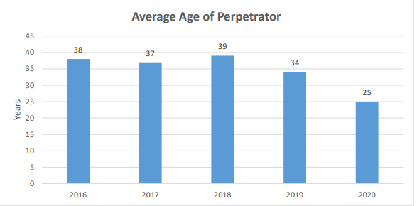

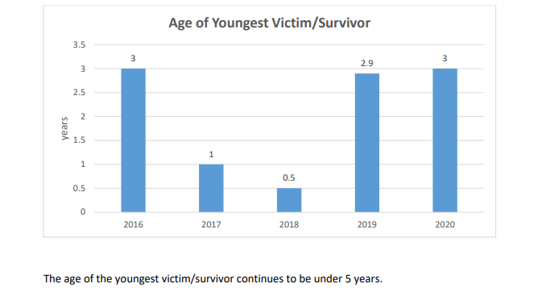
The average age of the perpetrator in 2020 was 25 years compared to 2016 to 2017, where the perpetrators were in their thirties, 34 years at the lower end and 39 years at the higher end in 2018. A more compelling fact is that in the majority of rape cases, the perpetrator was known to the victim survivor.
9.3 Sale, trafficking and abduction (Article 34)
9.3.1 Cases of sexual servitude and domestic trafficking of children especially of the girl child are of grave concern.
9.3.2 In the reporting period, there was a successful prosecution of a person who had committed these offences under the Crimes Act.
9.3.3 State v J Werenalagi
9.3.4 He had groomed and sold a 15-year-old female to adult male clients from the Gospel bus stop on Rewa Street in Suva. The perpetrator demanded a share of payment for the sexual services she provided to the adult male clients.
In 2019 the perpetrator was convicted of aggravated sexual servitude and three counts of domestic trafficking involving a child and was sentenced to 14 years imprisonment.
9.4 Violence in Schools
9.4.1 There is a rise in instances of physical bullying/assaults in schools between peers, inflicted by adults (teachers) towards students and by third parties occasionally as well. This has often been perceived to have resulted from an overreach by human rights promoters in society. Because of the conservative nature of Fijian society, which is still heavily dependent on deeply rooted religious views, child rights are blamed for allegedly encouraging unruly behavior in children. Some have even called for corporal punishment to be reintroduced in schools to curb the issue of bullying.
9.4.2 Cyberbullying is also on the rise with more children having access to the internet on a regular basis. One extreme example of this is when a female school student was trolled online for her tik-tok videos, which led her to unfortunately attempt suicide.
9.4.3 The Online Safety Commission of Fiji is a statutory body established in 2018 to deal with complaints of cyberbullying, especially relating to children. However to date there is no publicly available information on the Commission, its current work, governance structures and policies. There is no data published on the number of children who have been assisted by the Commission, the nature of the assistance sought by complaints, the success and challenges in handling such complaints, number of complaints that have resulted in litigation.
With these significant data gaps, it is impossible to determine whether the Commission is fulfilling its statutory mandate to assist children who are the victims of cyberbullying.
Questions for the State
11.Can the State increase the resources of the FPF so it can investigate and the ODPP to prosecute the perpetrators of child abuse and neglect, sexual assault cases and domestic trafficking and sexual commercial exploitation of children?
12. Can the Online Safety Commission of Fiji disclose its work plan and proposed activities in addressing cybercrime in Fiji. Will those activities involve working in coordination with other State agencies and the NGO community? By the same token, why has the Online Safety Commission not disclosed its work plan or published its Annual Report?
13. Can a national summit be convened by the MEHA, heads of Government funded schools or partially Government funded schools and key State agencies to address the growing incidences of violence in schools?

10.0 CHILD PARTICIPATION AND REPRESENTATION
10.1 ARTICLE 12: RIGHT OF THE CHILD TO PARTICIPATE
The right of children to be heard in matters affecting them, pursuant to UNCRC, Article 12, is inextricably linked to the best interest of the child principle, and it is essential to help decision makers determine what a child’s or a group of children’s best interests are.
10.2 Impact of Climate Change on the Rights of the Child
For children growing up in Fiji, learning to recover from disasters is a part of life. Disasters bring along new hardship, increased poverty, loss of education and adaptation to periods of need with precarious housing. Recovery conditions are always very stressful with increased risks for children in terms of exposure to violence, abuse and exploitation.
Per the unfulfilled CRC Committee’s Concluding Observations to Fiji (2014) 56 (a), the Committee recommended to the State Party:
“In developing policies or programmes to address the issues of climate change and disaster risk management, ensure that the social, physical and psychological vulnerabilities and needs of children, as well as their views, are taken into account and that children are fully involved in the dialogue on climate change.”
Save the Children Fiji, in its national advocacy work on the rights of the child, has continually promoted and encouraged the participation of children in appropriate events. Stemming off from TC Winston's emergency response in 2016, to TC Yasa in 2020, children in the affected communities have been trained to become advocates of Disaster Risk Reduction, WASH and Child Protection advocates in their respective communities. Child participants’ ages range from 4 years to 18years. Since 2016, through SCF’s education program that includes child protection and CDRR, 9,381 children have been reached. The efforts continue with SCF’s work to create long lasting and sustainable change in the lives of children in Fiji by driving the change from community level to Government policy level.
10.3 Child inclusion and representation
From 2016-2018, SC Fiji provided a three-year secondment of Child Inclusion Officer to the MWCPA: The secondment provided opportunities to build links to government policy formulation and ensure that child rights are embedded in disaster risk management and risk reduction and climate change adaptation policy in support of the Fiji Safety and Protection Cluster arrangement. In 2016/2017, SC Fiji held three Forums involving 90 children and as a follow-up, the Department of Social Welfare (DSW) held three Children’s Symposiums as a result of these forums. The SC Fiji forums assisted the Government to meet recommendations from the CRC Committee and provided an enabling environment for strengthened partnerships between children and decision-making mechanisms at the local and national level.
10.4 Child Rights Situational Analysis
The Child Rights Situational Analysis (2018) captured the violation of children’s rights from the perspective of children. The CRSA questions were designed by children and were enumerated by SC Fiji’s child-led initiative, Kids Link Fiji (KLF) members. Children were interviewed in the Northern, Western and Central Division in Fiji.
Some key findings from thematic areas are as follows:
- Knowledge of child rights
According to the survey, approximately a third of children in Fiji have never heard of child rights. Children from the Northern division were the most knowledgeable with 95% of children having heard of child rights and 73% of children aware of laws and policies that protect a child. The Western and Central only had 16% and 19% respectively being aware of child rights legislation.
- Reasons children believe these rights are broken
Religion is presented as a justification for the mistreatment of children. Culture and tradition are blamed for a girl’s rights not being upheld. Alcohol, kava and drug abuse were repeatedly mentioned throughout the survey as lifestyle obstacles to the realization of children’s rights.
“Rights are hard for parents to cope with due to tradition” (12-year-old boy)
“Our rights are not respected because we are just children, we should just listen to what we are told” (14 -year-old girl)
10.5 Child Rights Governance
As reflected in some of the children’s responses in the CRSA and the online survey where children contributed their views toward this report, Child Rights is often a misunderstood concept that is seen as conflicting with traditional, social, cultural and religious norms. Parents' responses in this CRSA echoed the perspective that child rights are a hindrance to disciplining their children putting them at risk of arrest.
Question to the State
How is the Government addressing the challenge of child rights and how are such reactions from parents countered?
There is a fair number of laws and frameworks in place to protect children’s rights. However, adequate financial and human resources are needed to ensure adequate implementation.

11. CONCLUSION
Since Fiji ratified the UN Convention on the Rights of the Child, both government and non-government organizations have exerted efforts, time and resources to fulfill the CRC provisions.
It is important to foster and sustain productive and effective partnerships between agencies and organizations involved with children’s issues and concerns. Strengthening coordination between Government, non-government, the private sector among other duty bearers with an active participation and representation of children will help in the realization of children’s rights.
__________________________________

Bibliography
Laws
Constitution Decree
Juveniles Act
Cybercrime Act
Adoption Act
Adoption of Infants Act
Proposed Registration of Sexual Offenders Bill
Employment Relations Act
Human Rights and Anti-Discrimination Act
Reports
1. Review Report on the Optional Protocol to the Convention on the Rights of the Child on the Involvement of Children in Armed Conflict prepared by the Standing Committee on Foreign Affairs and Defense – Parliamentary Paper No.67 of 2020
2. FWRM & ARROW (October 2018); Breaking the Barriers: Understanding Cancer Services, Screening, and Treatment available for Women in Fiji: State of the Region Report on the SRHR ICPD +25
http://www.fwrm.org.fj/images/fwrm2017/PDFs/research/ICPD-Research-Report.pdf
3. Save the Children Fiji (2019): Child Rights Situational Analysis http://www.savethechildren.org.fj/wp-content/uploads/2020/09/CRSA.pdf
Budget estimates: Parliament of Fiji
- http://www.parliament.gov.fj/wp-content/uploads/2017/03/2016-2017-Budget-Estimates.pdf
- http://www.parliament.gov.fj/wp-content/uploads/2019/02/2018-2019-Budget-Estimates.pdf
- http://www.parliament.gov.fj/wp-content/uploads/2020/07/Budget-Estimates-2020-2021_1.pdf
Online newspaper articles
- https://www.fbcnews.com.fj/news/more-than-100-thousand-fijians-have-a-disability-census-2017/
- https://www.fijivillage.com/news/About-3000-operations-done-at-the-CWM-Hospital-from-January-to-April-2020---Doctor-Waqainabete-x584fr/
- https://fijisun.com.fj/2021/02/04/health-ministry-probes-asthma-patients-death-at-savusavu-hospital/
- https://www.fijivillage.com/news-feature/Police-investigate-death-of-8-year-old-boy-r2ks95
- https://www.fijitimes.com/accf-36k-paid-to-students-for-injuries-sustained-at-the-handspeers/?fbclid=IwAR1RU__MbfJYcksvtFqf2l42xSzTOTcEo4BX9HNWw7c3uHX534Wmf9yZUeQ
- https://www.fijitimes.com/accf-36k-paid-to-students-for-injuries-sustained-at-the-hands-of-peers/?fbclid=IwAR1RU__MbfJYcksvtFqf2l42xSzTOTcEo4BX9HNWw7c3uHX534Wmf9yZUeQ
- https://www.fijivillage.com/news/A-7-year-old-girl-is-the-youngest-person-to-commit-suicide-in-Fiji-52ks9r/
- https://www.fbcnews.com.fj/news/covid-19/student-charged-for-alleged-traffic-in-obscene-publications/
- https://www.stuff.co.nz/world/south-pacific/104333879/three-amputations-a-day-fiji-diabetes-death-rate-worst-in-the-world
Government speeches and press releases
- https://www.fiji.gov.fj/Media-Centre/Speeches/MINISTER-FOR-WOMEN,-CHILDREN-AND-POVERTY-ALLEVIATI
- https://www.google.com/search?q=Fiji+Census+207+population&rlz=1C1ZKTG_enFJ840FJ840&oq=Fiji+Census+207+population&aqs=chrome..69i57j33i10i160j33i160l2.10695j0j7&sourceid=chrome&ie=UTF-8
- https://www.fiji.gov.fj/Media-Centre/News/NATIONAL-CHILD-REGISTER-TO-ADRESS-SHORTFALLS
Annual reports
- http://msp.org.fj/reports/
- http://www.education.gov.fj/wp-content/uploads/Teachers&staff/IDADAIT/Activity-IDADAIT-2019.pdf
Organizational weblinks
- https://www.lifelinefiji.com/about/
- https://onlinesafetycommission.com/about-online-safety-commission/
Research articles
- http://www3.weforum.org/docs/WEF_GGGR_2020.pdf
- http://www.fwrm.org.fj/images/fwrm2017/PDFs/research/ICPD-Research-Report.pdf
- http://www.forumsec.org/wp-content/uploads/2017/09/010.Regional-Initiative-Cervical-Cancer-Screening-Preventation-Policy-Prog-Pacific.pdf
- https://www.business-humanrights.org/en/latest-news/fiji-trade-unions-will-continue-to-fight-for-permit-to-hold-protest-on-labour-rights/
- https://education.stateuniversity.com/pages/466/Fiji.html

- https://www.unicef.org/pacificislands/media/1116/file/Situation-Analysis-of-Children-Fiji.pdf

- https://www.ilo.org/dyn/natlex/docs/ELECTRONIC/111060/138330/F1719547450/FJI111060.pdf

- https://www.asiapacificforum.net/news/apf-advises-fijis-nhri-accreditation-process/

- https://tbinternet.ohchr.org/Treaties/CEDAW/Shared%20Documents/FJI/INT_CEDAW_IFN_FJI_30059_E.pdf

- http://www.fwrm.org.fj/images/FWRM_National_Budget_Submission_2020_-_COVID19_Response.pdf

- http://www.paclii.org/other/PHRLD/pacific-human-rights-law-digest-5.html#CHILDREN

- https://spccfpstore1.blob.core.windows.net/digitallibrary-docs/files/dd/dd136c531460453ec964b7b673654975.pdf?sv=2015-12-11&sr=b&sig=cGJ1IXGIN6VDNOwyrGiz6fnueKcdFnWXRqW4IRiXo%2BU%3D&se=2021-10-09T23%3A12%3A18Z&sp=r&rscc=public%2C%20max-age%3D864000%2C%20max-stale%3D86400&rsct=application%2Fpdf&rscd=inline%3B%20filename%3D%22Pacific_Human_Rights_Law_Digest_Volume_6.pdf%22

- https://www.researchgate.net/publication/330651414_Suicide_prevention_in_Fiji_-_Social_and_clinical_issues’

- http://www.paclii.org/fj/cases/FJHC/2019/1159.html

Annexures
ANNEX 1
FIJI
(An overview on specific contextual factors in which child rights have been implemented.)
Geography and demography
Geography | Fiji is located in the Pacific region. Fiji is made up of over 330 islands, of which 106 islands are inhabited.
Population | Eight hundred eighty-four thousand eight hundred eighty-seven reside on two main islands: Viti Levu and Vanuatu Levu.
Demographics | Over 75% of the population live in Viti Levu  The i-Taukei community accounts for 56.8%, while Fijians of Indian Descents account for 37.5%.  Other communities in Fiji are Chinese, people of European descent, and people from other Pacific islands.
Language | English, Fijian, and Hindi are the official languages of Fiji.  Fourteen provinces of the i-Taukei community have their own dialects plus Rabi and Rotuma.

Fiji’s population is young, with 10.4% of the population under five years of age. By 2030, 34% of the population is expected to be less than 17 years old. A higher proportion of the young, aged from 0 to 14 years of age, live in the rural areas.
Significant economic opportunities exist in urban centers. People in rural areas and the outer islands have limited economic opportunities given the heavy reliance on subsistence agriculture as a source of livelihood and food security. Subsistence agriculture is heavily impacted by the shocks of natural disasters, as demonstrated by Tropical Cyclones such as Winston, Harold, Yasa, and Ana.
As a result, the proportion of Fiji’s urban population continues to increase, from 37.2% in 1976 to 55.9% in 2017. Fiji is the most urbanized state in the Melanesian region.
Political landscape
Fiji became an independent and sovereign country from its British colonizers in 1970. Fiji has experienced a turbulent political history due to military coups and an attempted civilian coup since 1987. These events led to the promulgation of four constitutions following its independence. Currently, Fiji has a unicameral parliamentary system. Under the Constitution Decree 2013, Fiji has a President [a ceremonial figure] and an elected Prime Minister. Elections are held every four years and operate on “the principle of one man, one vote” and one constituency. The age for voting is 18 years old. Voting is not compulsory. Women make up 19.6 percent (10 out of 51) of elected officials to the Fijian Parliament at present. Fiji Government works with 14 provincial Councils and 17 districts, creatures of statute who are, inter alia, facilitate the delivery of resources and services to the iTaukei community and other communities, respectively. For example, in the iTaukei administration, a Roko Tui is in charge of the administration of these provincial councils. These administration systems are a product of colonial rule. Faith Based organizations (FBOs), Non-Governmental Organizations (NGOs), and civil society organizations (CSOs) also deliver services and programmes.

Economy
World Bank classifies Fiji as an Upper Middle-Income country. Prior to the global pandemic in 2020, Fiji’s GDP per capita stood at $7685 in 2017 compared to $4058 in 2008. And Fiji’s main GDP contributing actors are Services (67%), Industry (18%), and Agriculture (14%). And the tourism sector contributed significantly to the international trade sector – FJ$2.94 billion to the Fiji economy. The unemployment rate in Fiji increased to 4.20 percent in 2018 from 4.10 percent in 2017. The unemployment rate in Fiji is expected to reach 7.00 percent by the end of 2021, according to Trading Economics global macro models and analysts' expectations. In the long-term, the Fiji Unemployment Rate is projected to trend around 6.00 percent in 2022 and 4.50 percent in 2023. According to the Asian Development Bank, 28.1% of the proportion of the population lived below the poverty line in 2013. However, Fiji’s geographical isolation, scattered population and porous borders, narrow resource base, strong reliance on subsistence farming and vulnerability to disasters (including droughts, floods, cyclones), resource limitations and management of resources further represent serious obstacles to its economic development, and ability to attract foreign investments.
Fiji, like many countries in the world, experienced unprecedented economic shocks because of the global pandemic COVID-19. In Fiji’s case, the impacts were further exacerbated by tropical cyclones Harold, Ana, and Yasa.
The global pandemic has reversed years of development progress, and it will take a significant time before Fiji returns to its economic status pre-COVID. An estimated 115,000 Fijians lost their jobs or are on reduced hours, which represents 13 percent of the population, or almost a third of the labor force. There is anecdotal evidence to suggest that the number of Fijians who have lost their jobs has risen to about 200,000. The majority of the affected people are concentrated in the tourism sector.
Social, cultural, and religious
Fiji ‘s way of life and modern Fijian national is shaped by the richness and evolution of these cultures: iTaukei, Indian, Chinese, part European, and other Pacific Island communities.
The iTaukei community is communal in nature, with high importance placed on family, the village, and the Vanua. The Vanua is understood to mean “the people, their traditions and customs, beliefs and values, and the various other institutions established for the sake of achieving harmony, solidarity, and prosperity within a particular social context. It provides a sense of identity and belonging. The Vanua is an extension of the self.”.
Fiji is a predominantly Christian country with the majority of Christians belonging to the Methodist branch of Christianity. Besides Christianity, Hinduism, and to a lesser extent, Islam is also practiced. Fiji’s constitution confirms that Fiji is a secular state; that is, people are free to practice their religion, so long as they do not impose it on others. FBOs yield a significant influence over people’s lives.
Within the Fijian society, there are also present children and adults of all diversities, including the LGBTQI community. The LGBTQI community is generally accepted. However, the treatment of, discrimination of, and access to and opportunities for the grown of the LGBQTI community remains a significant challenge for all diversities. Despite constitutional guarantees in the 2013 Fijian Constitution
Perception of the place that children hold in society and understanding of child rights is rooted in traditional norms, customs, and models of decision making, which give more power to adults than to children. Whilst children occupy a primary place in both Fijian and Fijians of Indian Descent families, they are also rarely given a voice and are socially dependent. One child informant shared that “a child’s opinion and interests must be heard.” Another child informant shared that this meant having “the right to choose peers and friends.”
Such parental views are shaped to some extent by cultural and religious attitudes and practices which offers an explanation as to why there is a general misunderstanding that child rights are a foreign concept. Moreover, it is largely misunderstood as a hindrance to parental authority and to children's discipline.
Indigenous Fijian and Fijians of Indian Descent communities are patriarchal with distinctly established traditional gender roles. The Global Gender Gap Report (2014) ranks Fiji 122 out of 142 countries, with a score of 0.629 (0.00 = inequality; 1.00 = equality). In 2020, the report ranked Fiji at 103 out of 153 countries assessed, scoring 0.678 from a total of 1. In relation to the key indicators, Fiji scored 0.584, ranking 123 for Economic participation and opportunity, 0.997 scores and ranked 51 for Educational Attainment, 0.979 scores and ranked 41 for Health and Survival, and 0.150 scores and ranked 97 for Political Empowerment. A key marker of gender inequality in Fiji is violence against women.Health
On average, Fijians have a life expectancy rate of 70 years. The vast majority of premature deaths are linked to NCD. Most notably, Fiji is ranked number 1 in the world for diabetes-related deaths. Obesity and malnutrition trends due to the consumption of cheap, accessible, and processed are growing in the context of what the MHMS has labeled the NCD epidemic.

Mental health issues are affecting younger populations disproportionately in Fiji. Lifeline Fiji, an organization that works towards preventing suicide, states that on average, 110 Fijian lives are lost to suicide annually. It is estimated that for every completed suicide, there are 20 attempts made. The youngest person to complete suicide in Fiji was seven years old. The data shows that more men are completing suicide, and the age of victims is getting younger, with those in the 16 years to 25 years of age being most vulnerable. It is estimated that every 36 hours, a Fijian attempts suicide.
A UNICEF Situational Analysis found that child mortality rates in Fiji have been gradually declining since the early 1990s, with the country largely performing in line with international development goals. Fiji has achieved near-universal coverage for almost all recommended vaccines; however, measles immunization coverage has recently been declining. The maternal mortality ratio stands at 30 deaths per 100,000 live births –already below the SDG target for 2030. Contraceptive prevalence is at a low 44 percent, which contributes to high rates of adolescent fertility and sexually transmitted infections. There has been a recent upward trend in reported HIV incidence in Fiji, especially among young people and women.
Reproductive health concerns for women are also of grave concern. Despite wide access to family planning services, social constraints such as taboos surrounding reproductive health, but also gender dynamics illustrated by the fact that 39% of women surveyed needed to ask permission from their partner if they want to access medical care, render access to family planning difficult. Adolescent pregnancy rates per 1,000 are determined from the adolescent age group of 10 – 19 years. In 2016 & 2017, the rate in Fiji had stabilized at 19 per 1,000 populations In 2018; there were a total of 104 teenage pregnancies recorded (13%). . As FWRM’s research titled “Breaking the Barriers: Understanding Cancer Services, Screening & Treatment Available for Women in Fiji” the prevalence rate of reproductive cancers is equally alarming in the Pacific with breast and cervical cancers being the top two cancers affecting Pacific women to date. Cancer screening programs are not matched by capacity and resource commitment towards implementing nationwide screening programs for high-risk groups except for a few Pacific countries. Additional data sources reveal that the mortality rate for breast cancer was reported to be the highest in Fiji (26.6).
An estimated 13.7% of Fijians aged three and over live with at least one functional disability, a percentage expected to risedue to the ongoing NCD crisis. The Fiji National Council for Disabled Persons (FNCDP) highlights that people living with disabilities are “largely invisible” and disadvantaged in terms of access to education, health services, employment, livelihood opportunities, and support services. Many factors influence the experiences of people living with disabilities in Fiji, namely where they live, and how easily accessible services such as health and education are for them, household income, and religious beliefs.
The health infrastructure in Fiji is also at the brink of collapse as more frequent incidences of healthcare facilities not being able to adequately meet the needs of Fijians come to the fore. An example is a lack of functioning operating theatres in the national hospital, the Colonial War Memorial Hospital, located in the capital, Suva. Another recent example occurred in Savusavu, where a patient passed away due to asthma because there was no electricity supply at the hospital. The patient’s family even resorted to providing a generator to the health facility. These are just a few recent examples of the failing health infrastructure in Fiji, which have become a usual occurrence.
Human rights
Fiji has made -international commitments to uphold human rights at the country level as articulated in Chapter 2 – the Bill of Rights in the 2013 Constitution. Contrary to international human rights law and international norms, the Bill of Rights provisions is problematic as section 7(3) requires a narrow interpretation of human rights contradicting subsections 7(1)(a), 7(1)(b), and 7(2) of the 2013 Constitution.
For example, section 19 provides for the “Right of Assembly”; however that right can be limited, inter alia, by (a) in the interests of national security, public safety, public order, public morality, public health, or the orderly conduct of elections. However, authorized State agencies have used this constitutional provision as a justification to sometimes deny the granting of permits to the NGO and trade unions to publicly protest and or march;
Fiji’s commitment has been met with global approval, with the international community backing Fiji’s candidacy in 2018 as the first Pacific Island nation to have a seat on the United Nations Human Rights Council. In 2021 the UN Human Rights Council elected Ambassador Nazhat Shameem Khan, Permanent Representative of Fiji, to the United Nations Office in Geneva to serve as its President for 2021
Rights specific to children include CRC, the OP to the CRC on the involvement of children in Armed Conflict and the OP to the CRC on the Sale of Children, Child Prostitution and Child Pornography, the OP to the CRC on the Rights of Persons with Disabilities as well as the minimum age ILO Convention ratified in 1973 and the Worst Forms of Labour Convention ratified in 1999.
The courts have played a critical role as well as some sectors of the Fijian community in calling for compliance with the provisions of CRC. With more community members sharing their stories to denounce child abuse and child neglect.

Education and Sports
According to the most recent census from 2007, the total population of Fiji is around 837,000, with children and youth aged 0–19 comprising 38.5 percent of the total population Fiji has a high literacy rate (91.6 percent) and, although there is no compulsory education, more than 85 percent of the children between the ages of 6 to 13 attend primary school. Youth participation in Sports has steadily been on the rise, with an increasing number registered in sporting clubs around the country. It is common for children to start participating in sports as early as primary schools and also competitively in some sports.
___________________

Annex II Graphs Social Protection Schemes in Fiji
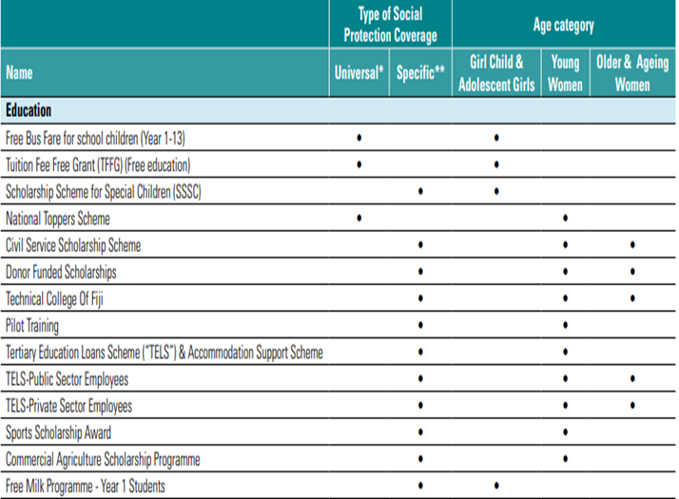
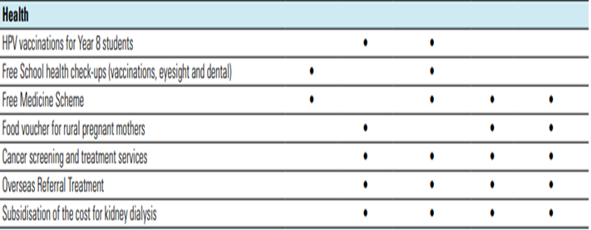
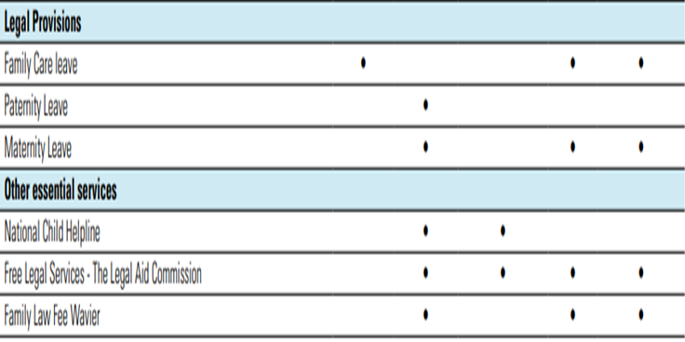
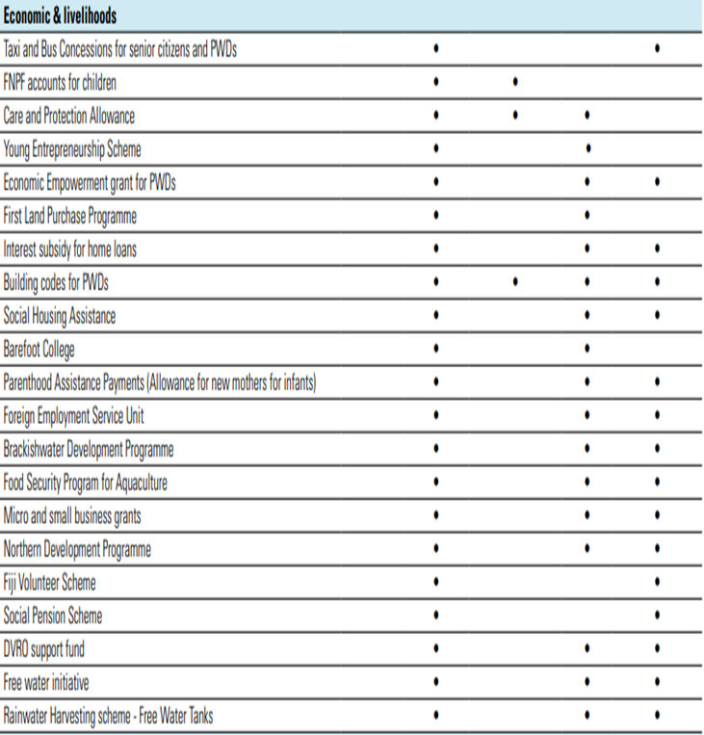
Source: http://www.fwrm.org.fj/images/FWRM_Factsheet_1_Social_Protection_Schemes_in_Fiji.pdf
ANNEX III
CIVIL SOCIETY ORGANIZATIONS
- Adventist Development and Relief Agency (ADRA)
- Fiji Association of the Deaf
- Fiji National Council of Disabled Persons
- Fiji Women’s Rights Movement
- Medical Services Pacific (MSP)
- Plan International
- Save the Children Fiji
REGIONAL ORGANIZATIONS
- Secretariat of the Pacific Community (SPC)
- UNICEF
GOVERNMENT PARTNERS
- Department of Social Welfare Child Services Unit.

SPC (2016),Human Rights in the Pacific Situational Analysis
Review Report on the Optional Protocol to the Convention on the Rights of the Child on the Involvement of Children in Armed Conflict prepared by the Standing Committee on Foreign Affairs and Defense – Parliamentary Paper No.67 of 2020 was tabled in Fiji Parliament. That Parliamentary Standing Committee recommended, inter alia, that Fiji ratify the Optional Protocol without reservation and make appropriate amendments to section 7(3) of the RFMF Act.
Portugal in Fiji’s second UPR review cycle in 2019 recommended that Fiji ratify this specific Optional Protocol.
PIFS (2015), Pacific Regional MDGs Tracking Report
World Bank (2015),Development Indicators
MEHA (2015), Fiji Education for All National Review
UNICEF (2017), Status Report on Early Childhood Education and Development in the Pacific Island Countries.
UNESCO, cited in UNICEF.
IWDA (2017), Exploring Multidimensional Poverty in Fiji
Save the Children Fiji (2018) Child Rights Situational Analysis
Recent research has been carried out to confirm the number of children affected by COVID-19. FTUC’s Rapid Assessment on the Impact of COVID-19 on Employment & Businesses estimates that: “…almost 50% of affected workers on reduced income are now earning 30% less compared to pre-COVID-19”.
Recommendations on the application of the Worst Forms of Child Labour Convention, 1999 (N0.182) ILO, 2021
https://www.fbcnews.com.fj/news/increased-payments-for three-social-welfare-schemes.
Recommendations on the application of the Worst Forms of Child Labor Convention, 1999. ( No.182) ILO, 2021
ILO also noted ..the concern expressed by the UN Committee on the Elimination of Discrimination Against Women about the exploitation of underage girls in commercial sex work.
See http://www.parliament.gov.fj/wp-content/uploads/2020/09/Act-37-Adoption.pdf (accessed on 1 April 2021)
Act No.36 of 2007
Act No.17 of 2005
Crimes Act commenced on 1 February 2010
Section 117 of the Crimes Act.
Section 211 of the Crimes Act.
Section 212(2) of the Crimes Act.
Section 212(2) of the Crimes Act.
Section 215 of the Crimes Act.
Section 117 of the Crimes Act.
Section 215(2) of the Crimes Act.
Section 215 of the Crimes Act.
See https://www.fijitimes.com.fj/188-cases-of-child-labour/
See footnote 70.
Recommendations on the application of the Worst Forms of Child Labor Convention, 1999 (No.82) (2021) ILO
See https://www.ilo.org/dyn/natlex/docs/ELECTRONIC/111060/138330/F1719547450/FJI111060.pdf (accessed on 28 March 2021)
UN Committee on the Rights of the Child. 62nd session, “General Comment No.14 (2013) on the rights of the child to have his or her best interests taken as primary consideration (Article 3, para.1).
See https://www.fiji.gov.fj/Media-Centre/News/NATIONAL-CHILD-REGISTER-TO-ADRESS-SHORTFALLS (accessed on 2 April 2021)
See https://www.fiji.gov.fj/Media-Centre/Speeches/HON-AIYAZ-SAYED-KHAIYUM-S-2020-2021-NATIONAL-BUDGET (accessed on 1 April 2021.
See http://www.parliament.gov.fj/wp-content/uploads/2017/03/2016-2017-Budget-Estimates.pdf accessed on 8 April 2021.
See file:///C:/Users/Artika%20Singh/Downloads/fiji-budget-estimates-2017-2018-parliament-of-fiji.pdf accessed on 8 April 2021.
See http://www.parliament.gov.fj/wp-content/uploads/2019/02/2018-2019-Budget-Estimates.pdf accessed on 8 April 2021.
See http://www.parliament.gov.fj/wp-content/uploads/2019/06/2019-2020-budget-estimates.pdf accessed on 8 April 2021.
See http://www.parliament.gov.fj/wp-content/uploads/2020/07/Budget-Estimates-2020-2021_1.pdf accessed on 8 April 2021.
Cite UNICEF situational analysis for 2015; 2016; 2017 and 201; 2019; 20205.1.
Low,I & Robinson, L (2020) End of CDRR Project Review Report.
[4 March 2015] FJCA 32: Calanchini P, Basnayake and Goundar JJA.
See footnote 30.
See file:///C:/Users/Buresova/Downloads/fiji_national_mental_health_and_suicide_prevention_policy_2015.pdf (accessed on 1 April 2021).
See pages 29 to 31 at http://www.health.gov.fj/wp-content/uploads/2014/05/Final-NCD-Strategic-Plan-2015-2019.pdf (accessed on 1 April 2021).
See https://www.researchgate.net/publication/330651414_Suicide_prevention_in_Fiji_-_Social_and_clinical_issues (accessed on 1 April 2021).
See https://www.fijivillage.com/news/A-7-year-old-girl-is-the-youngest-person-to-commit-suicide-in-Fiji-52ks9r/ (Accessed on 2 April 2021); see https://www.fijivillage.com/news-feature/Police-investigate-death-of-8-year-old-boy-r2ks95 (accessed on 2 April 2021).
MSP Annual Report 2018 ,page 20.
See footnote 19 at page 6.
See http://msp.org.fj/reports/ under the heading: Reports and statistics for its published annual reports.
See MSP Annual Report 2018 at page 21.
See MSP Annual Report 2018 at page 22.
See https://bcmj.org/articles/child-abuse-and-neglect-covid-19-era-primer-front-line-physicians-british-columbia
See footnote 34.
See https://fijisun.com.fj/2020/05/06/police-concerned-with-number-of-juveniles-arrested-for-covid-19-restriction-breaches/ accessed on 8 April 2021.
See https://www.fbcnews.com.fj/news/covid-19/student-charged-for-alleged-traffic-in-obscene-publications/ accessed on 8 April 2021.
https://www.fijitimes.com/accf-36k-paid-to-students-for-injuries-sustained-at-the-hands-of-peers/?fbclid=IwAR1RU__MbfJYcksvtFqf2l42xSzTOTcEo4BX9HNWw7c3uHX534Wmf9yZUeQ accessed on 8 April 2021.
See https://www.fiji.gov.fj/Media-Centre/Speeches/MINISTER-FOR-WOMEN,-CHILDREN-AND-POVERTY-ALLEVIATI (accessed on 31 March 2021).
See https://fijisun.com.fj/2019/05/04/vuniwaqa-lauds-stem-summer-camp-for-girls/ (accessed on 1 April 2021)
https://www.facebook.com/FijiWomen/photos/a.1839578142955007/2893612070884937/ accessed on 8 April 2021.
High Court Criminal Case No. HAC 425 of 2018.
See http://www.paclii.org/fj/cases/FJHC/2019/1159.html accessed on 8 April 2021.
See https://www.fijitimes.com/accf-36k-paid-to-students-for-injuries-sustained-at-the-hands-of-peers/?fbclid=IwAR1RU__MbfJYcksvtFqf2l42xSzTOTcEo4BX9HNWw7c3uHX534Wmf9yZUeQ accessed on 8 April 2021.
See https://onlinesafetycommission.com/about-online-safety-commission/ accessed on 8 April 2021.
UN CRC Committee General Comment no.14 supra note 47, paras. 43-45.
Bartlett, 2010.
See https://www.google.com/search?q=Fiji+Census+207+population&rlz=1C1ZKTG_enFJ840FJ840&oq=Fiji+Census+207+population&aqs=chrome..69i57j33i10i160j33i160l2.10695j0j7&sourceid=chrome&ie=UTF-8 (Accessed on 28 March 2021)
See iTaukei Affairs Act which establishes the 14 administrative units: Ba Province, Bua Province, Cakaudrove Province, Kadavu Province, Lau Province, Lomaiviti Province, Macuata Province, Nadroga-Navosa Province, Naitasiri Province, Namosi Province, Ra Province, Rewa Province, Serua Province, Tailevu Province plus Rotuma under the Rotuma Act and the Rotuma Lands Act.
See footnote 6
http://www.savethechildren.org.fj/wp-content/uploads/2020/09/CRSA.pdf accessed on 7th April 2021
See footnote 9
See Phillips T & Keen M; Sharing the City: Urban Grown and Governance in Suva, Fiji: SSGM Discussion Paper 2016/6 http://ssgm.bellschool.anu.edu.au/sites/default/files/publications/attachments/2016-09/dp_2016_6_phillips_and_keen.pdf (accessed on 30 March 2021)
1970 Constitution; 1990 Constitution; 1997 Constitution; and 2013 Constitution Decree
Section 54 of the Constitution Decree 2013
Section 53(1) of the Constitution Decree 2013
Section 55 of the Fiji Constitution Decree 2013
Section X of the Electoral Act
https://www.pacwip.org/women-mps/national-women-mps/ accessed on 7th April 2021
See https://data.worldbank.org/country/FJ (accessed on 1 April 2021)
Fiji Bureau of Statistics 2017
https://www.pacific.undp.org/content/pacific/en/home/countryinfo/fiji.html#:~:text=Economic%20Performance,-Kadavu%2C%20Fiji.&text=Fiji%20is%20a%20small%20island,in%202008%20of%20around%20%244050 (accessed on 1 April 2021
See https://tradingeconomics.com/fiji/unemployment-rate (accessed on 7 April 2021)
See https://tradingeconomics.com/fiji/unemployment- rate?embed?embed/forecast#:~:text=Unemployment%20Rate%20in%20Fiji%20is,according%20to%20our%20econometric%20models. (Accessed on 7 April 2021)
See https://tradingeconomics.com/fiji/unemployment-rate (accessed on 7th April 2021
See https://www.adb.org/countries/fiji/poverty#accordion-0-0 (accessed on 7th April 2021)
https://www.ifc.org/wps/wcm/connect/news_ext_content/ifc_external_corporate_site/news+and+events/news/fiji-cpf
See footnote 11
See https://www.fiji.gov.fj/Media-Centre/Speeches/HON-AIYAZ-SAYED-KHAIYUM-S-2020-2021-NATIONAL-BUDGE(accessed on 1 April 2021
See footnote 9
See footnote 9 where Ravuvu, 1983 is referenced.
See footnote 9
See https://en.wikipedia.org/wiki/Religion_in_Fiji (accessed on 7 April 2021)
See section 4 of the 2013 Fiji Constitution.
https://www.fiji.gov.fj/getattachment/a3cddc01-dc73-4823-83b8-f290672ddae0/2013-Constitution-of-The-Republic-of-Fiji.aspx accessed on 8 April 2021; See section 26.
See footnote 9
See footnote 9 at page 22
See footnote 9 at page 22
See http://www3.weforum.org/docs/WEF_GGGR_2020.pdf accessed on 8th April 2021
FWCC’s report titled :Somebody’s Life; Everybody’s business: National Research on Women’s Health and Life Experiences in Fiji. (2010/2011) - 61% of women were subject to physical violence (more than 3 in 5); 34% were subjected to sexual violence (1 in 3) and 58% experienced emotional violence (about 3 in 5).
See https://www.stuff.co.nz/world/south-pacific/104333879/three-amputations-a-day-fiji-diabetes-death-rate-worst-in-the-world (accessed on 10 April 2021)
See http://www.health.gov.fj/childhood-obesity/ (accessed on 1 April 2021)
See https://www.lifelinefiji.com/about/ accessed on 8th April 2021
United Nations Children’s Fund, Situation Analysis of Children in Fiji, UNICEF, Suva, 2017 (accessed on 7th April 2021 from https://www.unicef.org/pacificislands/media/1116/file/Situation-Analysis-of-Children-Fiji.pdf)
See http://www.health.gov.fj/wp-content/uploads/2020/03/HSR-2017-.pdf accessed on 8th April 2021
See http://www.education.gov.fj/wp-content/uploads/Teachers&staff/IDADAIT/Activity-IDADAIT-2019.pdf accessed on 8 April 2021
See http://www.fwrm.org.fj/images/fwrm2017/PDFs/research/ICPD-Research-Report.pdf accessed on 8 April 2021
See http://www.forumsec.org/wp-content/uploads/2017/09/010.Regional-Initiative-Cervical-Cancer-Screening-Preventation-Policy-Prog-Pacific.pdf (accessed on 1 April 2021)
Asian – Pacific Resource and Research Centre for Women (ARROW 2018) cited within http://www.fwrm.org.fj/images/fwrm2017/PDFs/research/ICPD-Research-Report.pdf accessed on 8th April 2021
See https://www.fbcnews.com.fj/news/more-than-100-thousand-fijians-have-a-disability-census-2017/ (accessed on 1 April 2021)
See https://www.fijivillage.com/news/About-3000-operations-done-at-the-CWM-Hospital-from-January-to-April-2020---Doctor-Waqainabete-x584fr/ accessed on April 2021.
See https://fijisun.com.fj/2021/02/04/health-ministry-probes-asthma-patients-death-at-savusavu-hospital/ accessed on 8 April 2021.
See https://www.business-humanrights.org/en/latest-news/fiji-trade-unions-will-continue-to-fight-for-permit-to-hold-protest-on-labour-rights/ (accessed on 1 April 2021)
See https://www.ohchr.org/EN/HRBodies/HRC/Pages/NewsDetail.aspx?NewsID=26663&LangID=E accessed on 8 April 2021
See https://www.unicef.org/pacificislands/media/1116/file/Situation-Analysis-of-Children-Fiji.pdf accessed on 8 April 2021
See https://education.stateuniversity.com/pages/466/Fiji.html accessed on 8 April 2021
See file:///C:/Users/Bernice%20Lata/Downloads/Situational-Analysis-Report.pdf accessed on 8 April 2021

