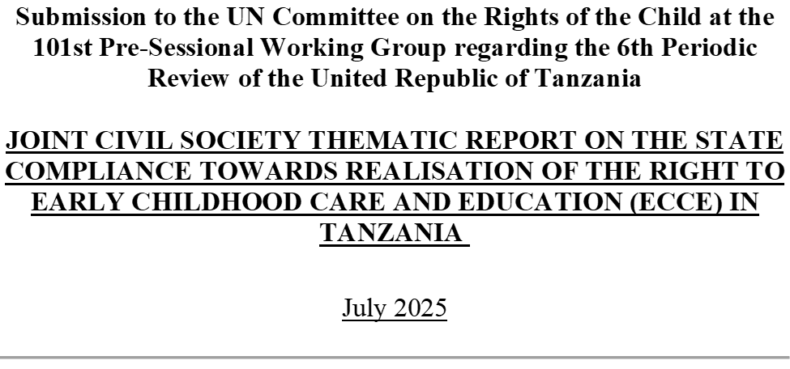
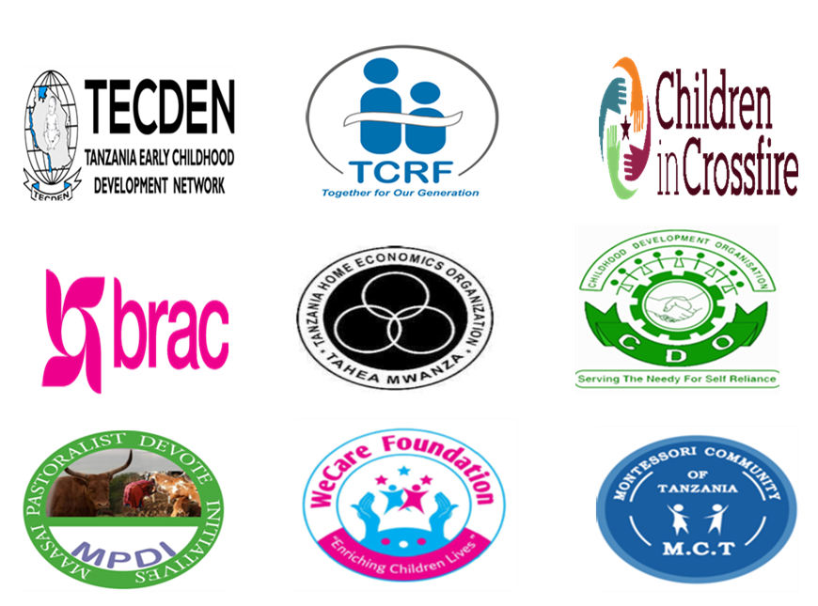

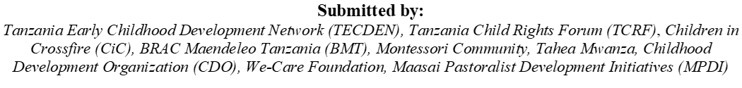

Introduction

This thematic report is jointly prepared by civil society organizations affiliated with the Tanzania Early Childhood Development Network (TECDEN) and the Tanzania Child Rights Forum. It is submitted to the United Nations Committee on the Rights of the Child (UNCRC) to complement the 6th periodic report presented by the United Republic of Tanzania (hereafter referred to as the State Party).

While the State Party's report outlines the measures undertaken and progress made in implementing the Committee’s recommendations following the 2015 Concluding Observations, it provides limited information about young children particularly regarding the development, accessibility, and expansion of Early Childhood Care and Education (ECCE). This is despite the Committee’s explicit recommendation on ECCE in paragraph 61(f) of the 2015 Concluding Observations.

In this context, the purpose of this thematic report is to:
- Highlight the challenges that young children in Tanzania face, especially in accessing inclusive, equitable, and quality ECCE services; and
- Offer concrete recommendations to advance the right of every child to quality early childhood care and education.

General measures of implementation

2.1 Legal and Policy Frameworks on ECCE
In the previous review, the Committee encouraged (para. 8) the State party to reform existing legislation to create an appropriate legal framework in compliance with the provisions of the Convention as a measure to strengthen the protection of children’s rights.
The State Party in its report (paras. 22, 24 and 26) highlighted the several measures taken to strengthen the legal protection of children’s rights including the adoption of the LCA (Day Care Centers and Crèches) Regulations in mainland Tanzania and the enactment of the Children’s Act of 2011 and the Children’s Act (Care and Protection of Children) Regulations of 2017 in Zanzibar.
We also commend the State for adopting the National Multisectoral Early Childhood Development Program (NM-ECDP) 2021/22–2025/26 and the National Plan of Action to End Violence Against Women and Children (NPA-VAWC) II 2024/25-2028/29.
Despite notable progress in enacting ECCE related laws and policies, significant gaps remain in their dissemination and implementation. Local Government Authorities (LGAs), ECCE providers, and frontline workers often lack adequate knowledge of the legal and policy frameworks due to inadequate training and communication. This has led to misinterpretation, inconsistent enforcement, and inappropriate service delivery, particularly at the community level.
Furthermore, the continued use of the outdated 2008 National Child Development Policy poses a serious challenge as it does not reflect current priorities such as inclusive education, climate resilience, or integrated multi sectoral approaches to ECCE. The absence of updated guidelines to LGAs, strategic coordination, adequate resource allocation, and accountability mechanism, affects implementation of the new laws and policies.
The Committee may raise the below questions to the State:
- What efforts have been made for effective implementation and awareness raising among the local government authorities, and frontline workers on the new legal and policy frameworks?

2.2 Coordination

The Committee recommended (para. 12), that the State party establish an appropriate body at a high inter-ministerial level with a clear mandate and sufficient authority to coordinate all sectors relevant to the implementation of the Convention at the national and sub-national local levels. Furthermore, to ensure the coordinating body is provided with the necessary human and financial resources to operate effectively.
In connection to this, the State reported (para. 31) that it has developed functional institutional coordination mechanisms, both sectoral and cross-sectoral, involving all relevant line ministries and Ministries, Departments and Agencies (MDAs) and other key stakeholders in the implementation of the CRC in both mainland Tanzania and Zanzibar.
However, ECCE services are affected due to poor intersectoral coordination. ECCE does not have any standalone legislation and is not compulsory, therefore lacking clarity on institutional responsibilities, service standards, and accountability mechanisms. Responsible line ministries lack clear operational mandates and harmonized monitoring mechanisms. Pre-primary schools and Day Care Centers (DCCs) are administered under separate structures without formal transition mechanisms, resulting in service discontinuities and dropouts.

The Committee may inquire from the State on the below:
- Does the legal and/or policy framework on ECCE establish a central authority mandated to oversee ECCE, ensuring a comprehensive and holistic approach to early childhood care and development?
- Are there any established mechanisms that exist to oversee the coordination of ECCE services between different ministries? Does this mechanism clearly define the roles and responsibilities of various ministries including the coordinating ministry?

2.3 Data Collection
The Committee's recommended (para. 16) that the State party, expeditiously improve its data-collection system to cover all areas of the Convention and be disaggregated by age, sex, disability, geographic location, ethnic origin and socioeconomic background in order to facilitate analysis of the situation of all children, particularly those in situations of vulnerability.
The State reported in (paras. 38 and 39) about the adoption of a centralized data collection and management system, managed by the National Bureau of Statistics (NBS) that collects data across sectors and ministries.
We recognize government efforts in collecting data including on ECCE, as demonstrated in the Basic Education Statistics System (BEST) and through other initiatives including the Most Vulnerable Children Management Information System (MV-MIS) and the Integrated Monitoring and Evaluation System (IMES).
However, the data collected is spread across ministries without a centralized, interoperable system, hindering cohesive analysis and decision-making—especially for children aged 0–4 in Day care centres. There’s insufficient data disaggregation as current datasets often lack detailed breakdowns by age (especially under-3), disability, socioeconomic status, and geography, limiting the ability to identify and address inequalities. This system also excludes informal DCCs and therefore official data doesn't capture information about unregistered or community-run centers.
Further, there’s inadequate capacity building, human resources and poor internet and power connectivity and shortage of devices affecting the data collection process, especially in the rural areas. Moreover, the indicators focus mainly on enrollment and infrastructure, and don't effectively measure quality, child outcomes, or inclusivity.
The Committee may consider raising the following questions to the State:
- What specific measures does the State take to collect the disaggregated data of children in early childhood?
- Are appropriate indicators included for assessing the dimensions of ECCE including quality, child outcomes and inclusivity?

2.4 Monitoring of Private Providers
Private providers of ECCE, including pre-primary schools, daycare centers, and home-based services—increasingly dominate Tanzania’s early learning landscape, particularly in urban and underserved areas (UNESCO, 2022). While the Education Regulations of 2016 require all ECCE institutions to register and meet national standards (URT, 2016), many providers operate informally, with limited or no government oversight, especially in low-income and rural communities (World Bank & UNICEF, 2022).
The monitoring and regulation mechanisms are weak due to inadequate resources, and logistical support at the local government level. Ward Education and Quality Assurance Officers—tasked with supervision—are often overstretched and lack the tools to enforce compliance. Informal and home-based centers, which are emerging in large numbers, are unregulated and undocumented, making it difficult to ensure quality, safety, and developmental outcomes for children (UNICEF, 2023). Although an estimated 4,000 daycare centers are officially registered, the majority operate informally without oversight—posing serious risks to child safety and development. Home-based childcare, while widely used by working parents, remains unrecognized and unsupported. Moreover, while national standards and curricula exist, compliance among private providers is inconsistent, leading to wide disparities in quality (URT & UNICEF, 2021). While the law regulates service fees, private day care centers and pre-primary schools are unaffordable for families from marginalized backgrounds due to high direct and indirect costs, with minimal government subsidies or financial support.
The Committee may raise the below questions to the State:
- Are there laws and policies regulating the privatisation of ECCE and private day care centres/pre-primary schools? And is there an effective monitoring mechanism in place?
- Are fees and indirect costs to access private day care centres/pre-primary schools regulated to ensure they are free or affordable to families from marginalised backgrounds?

Violence against children

3.1 Corporal punishment
The Committee recommended (para. 37), that the State party repeal or amend, as needed, all legislation in order to explicitly prohibit corporal/physical punishment in all settings as “justifiable” correction or discipline; sensitize and educate parents, guardians, teachers and professionals working with children and promote positive, non-violent and participatory forms of child-rearing and discipline in all settings.
The State reported in (paras. 77, 78 and 79 the several efforts taken against abuse of corporal punishment especially for promoting positive, non-violent and participatory forms of child rearing and discipline in all settings.
The laws have constantly been amended but despite such measures, corporal punishment remains a legally permitted disciplinary measure in schools, homes, religious settings and penal institutions. While the Law of the Child Act 2009 (R.E 2024) prohibits torture and cruel, inhuman, or degrading treatment, it also allows for "justifiable" correction, which is interpreted to include some forms of corporal punishment. Excessive corporal punishment is still being practiced in schools, causing severe injuries to children and deaths in some instances; a vivid indication of failure to adhere to established guidelines.
The Committee may inquire from the State:
- Does the State have an efficient enforcement mechanism in place for the implementation of the laws that ban corporal punishment in all settings?

Disability, basic health and welfare

4.1 Health Budget Allocation and Human Resource Investment
The Committee recommended (para. 55(a)) allocation of sufficient financial and human resources to health services; in particular, access to trained care at delivery, improved antenatal care, improved care for newborns and during the neonatal period, and services for infants and preschool children at primary health centres.
The State reported (para. 126) about its efforts to increase the health budget which accounts for 7% of the national budget and 1.8% of the GDP.
Despite these advances, the health sector budget remains below the 15% Abuja Declaration target, with only 5.3% allocated in the 2024/25 fiscal year. The Tanzania Demographic and Health Survey 2022 (TDHS) shows that access to care for children under five remains constrained in many rural areas, with only 60% of children with fever receiving medical treatment, and regional disparities are stark. The integration of ECD into operational budgets and human resource planning is still weak, and staffing gaps disproportionately affect rural and hard-to-reach areas.
The Committee may inquire from the State:
- What measures has the State taken to integrate ECD into existing health and nutrition budgets? Especially in operational budgets and human resource planning.

Education, leisure and cultural activities

5.1 Early Childhood Care and Education (ECCE)
The Committee recommended (para. 61(f)) allocation of sufficient financial resources for the development and expansion of early childhood education, based on a comprehensive and holistic policy of ECCE.
The State report (para. 153), highlights a 33% increase in pre-primary enrolment. That the Educational and Training Policy of 2014 in mainland Tanzania promotes free basic education and in Zanzibar, the Education Policy of 2006 (reviewed in 2018) formalized free and compulsory basic education for 12 years including 2 years of pre-primary education.
The Reviewed Education Policy of 2014 acknowledges the importance of ECCE; further, the government introduced the National Multi-sectoral Early Childhood Development Programme, which focuses on meeting the holistic developmental needs of children aged 0–8 years and promotes multisectoral collaboration and coordination.
Yet, the fact that ECCE is not compulsory in mainland Tanzania, inadequate budget allocation, and shortage of trained qualified ECCE teachers and caregivers, affects the overall quality and implementation of ECCE.
While the government reports spending TZS 20.8 billion monthly on free education every month and prioritizing education budget in the total national budget, it doesn’t specify the resource allocated for pre-primary education. Although the education budget increased to TZS 6.7 billion for fiscal year 2025/26), there is no specific line item for ECCE. It is difficult to assess the percentage of the education budget allocated for ECCE.
Furthermore, Councils are expected to allocate at least 3% of their budgets to social welfare interventions, including ECCE, but implementation is inconsistent. There is no dedicated budget line for ECCE or DCCs in the national education or social welfare budgets. As a result, ECCE expansion and quality are hindered through reliance on external funding and household contributions.
The Committee recommended (para. 61(e)) that the State Party continue its efforts to improve the quality of teacher training particularly in rural areas. The State reported (para. 159) about the development of the National School-Based Continuous Professional Development Framework and a National Framework for Continuous Professional Development for Practicing Teachers (NFCPDPT) in 2017, and data about the number of teachers trained at the primary and secondary level. But it doesn’t provide any information about pre-primary level.
The Education and Training Policy (2014) and the National Curriculum Framework for Pre-primary Education (2016) outline required teacher qualifications and competencies. Pre-primary teachers are expected to have at least a certificate in early childhood education, and there are provisions for in-service training. However, implementation remains uneven, especially in rural and private settings, where many caregivers lack formal training and access to continuous professional development opportunities is limited.
While some legal provisions exist under national labour laws and policies to promote fair labour standards, most ECCE personnel particularly in private and informal settings do not enjoy guaranteed fair wages, equal pay, or comprehensive social protections. Many work in low-paid, unregulated environments without no access to any social security benefits. There is no standardized employment framework for ECCE personnel, leading to disparities in pay and working conditions, particularly between public and private sector workers. There is also a shortage of ECCE personnel including trained qualified teachers, caregivers and Social Welfare Officers (SWOs) at the rural areas.
Other concerns include the lack of formal linkage between DCCs and pre-primary schools, resulting in gaps during the transition period, including loss of information and increased dropout rates. Compounding these challenges, many ECCE settings lack adequate Water, Sanitation, and Hygiene (WASH) facilities, affecting children’s health, attendance, and overall well-being.

The Committee may raise the below questions to the State:
- What percentage of the total education budget has been allocated to pre-primary education?
- Has the ECCE budget been adequate to provide quality and free pre-primary education to all children? Especially to the children in rural areas?
- Are there adequate resources allocated for recruitment and training of ECCE personnel?
- Does the legal and/or policy framework establish minimum qualification standards for recruitment, and continuous professional development and training requirements for ECCE personnel?
- Are ECCE personnel guaranteed fair wages and equal remuneration of work for equal value without discrimination?

Climate Change

In 2022, Tanzania was ranked the 47th most vulnerable country to Climate Change (CC), and 150th out of 191 countries on readiness to cope with climate change. Most climate models predict an average increase in temperature by 1.23°C from baseline across the country by 2050, with wide ranging impacts.
We commend efforts by the State Party to develop and execute climate change actions, through legislation, policies, strategies and programmes including signing the Paris Agreement 2015 and regional frameworks for combating climate change. The State has integrated issues of climate change and environment in education curricula and in various sector-specific MDAs, to mitigate the impacts of CC and strengthen the resilience of communities.
Despite multiple efforts, there are concerns about the vulnerability of young children to climate effects which pose significant and multifaceted threats to children's well-being, impacting their health, safety, and access to essential resources like food, water, and education.
Tanzania has developed broader national disaster management frameworks, such as the National Disaster Management Policy (2015) and the Disaster Management Act (2015), which include general provisions for protecting vulnerable groups, including children. However, there is no specific, widely implemented contingency plan exclusively focused on childcare facilities and preschools to ensure their protection during natural disasters.
Existing frameworks emphasize emergency response but lack tailored guidance on alternative education modalities or maintaining minimum educational standards during such events in ECCE settings. Efforts to integrate ECCE into disaster preparedness remain limited and inconsistent.
Currently, there is no dedicated policy mandating the training of ECCE personnel specifically to handle climate disasters or health crises such as pandemics. Strengthening capacity-building initiatives to equip ECCE personnel with disaster risk reduction and health crisis management skills is an identified gap needing urgent attention.
The Committee may raise the below questions to the State:

  - Do national contingency plans exist to protect children and staff in child care facilities and preschools in natural disasters? Does this plan include any alternative education modalities and plans to comply with minimum educational standards during natural disasters?
  - Is there a policy in place to ensure ECCE personnel are trained to handle climate disasters and health crises?
Recommendations
The Committee may encourage the State party to consider:
- Enacting comprehensive legislation for ECCE that ensures at least one year of free and compulsory pre-primary education, adopting holistic approach with clear institutional mandates, and covers all ECCE settings including home and community based centres.
- Strengthening ECCE data systems to provide disaggregated data and developing a centralized and interoperable ECCE information system for effective utilization of data in addressing inequalities.
- Effectively regulating the private educational sector, ensuring that all pre-primary schools and day care centres are licensed, registered, have reasonable charges and are regularly monitored to ensure compliance with education law and standards.
- Improving access and quality of ECCE by strengthening the monitoring and accountability mechanisms.
- Enhancing the ECCE workforce by safeguarding their rights with fair wages and social security benefits and establishing national standards for continuous professional development, especially in remote areas.
- Securing adequate ECCE financing by establishing a dedicated ECCE budget line at all government levels. Ensuring that at least 3% of each council's budget is allocated to ECCE-related social welfare programs and integrating ECCE funding into the mainstream education and social protection budget frameworks.

Committee on the Rights of the Child. 2015. CRC/C/TZA/CO/3-5, para. 61.f: ‘Allocate sufficient financial resources for the development and expansion of early childhood education, based on a comprehensive and holistic policy of early childhood care and development.’
https://www.worldbank.org/en/country/tanzania/publication/ccdr

