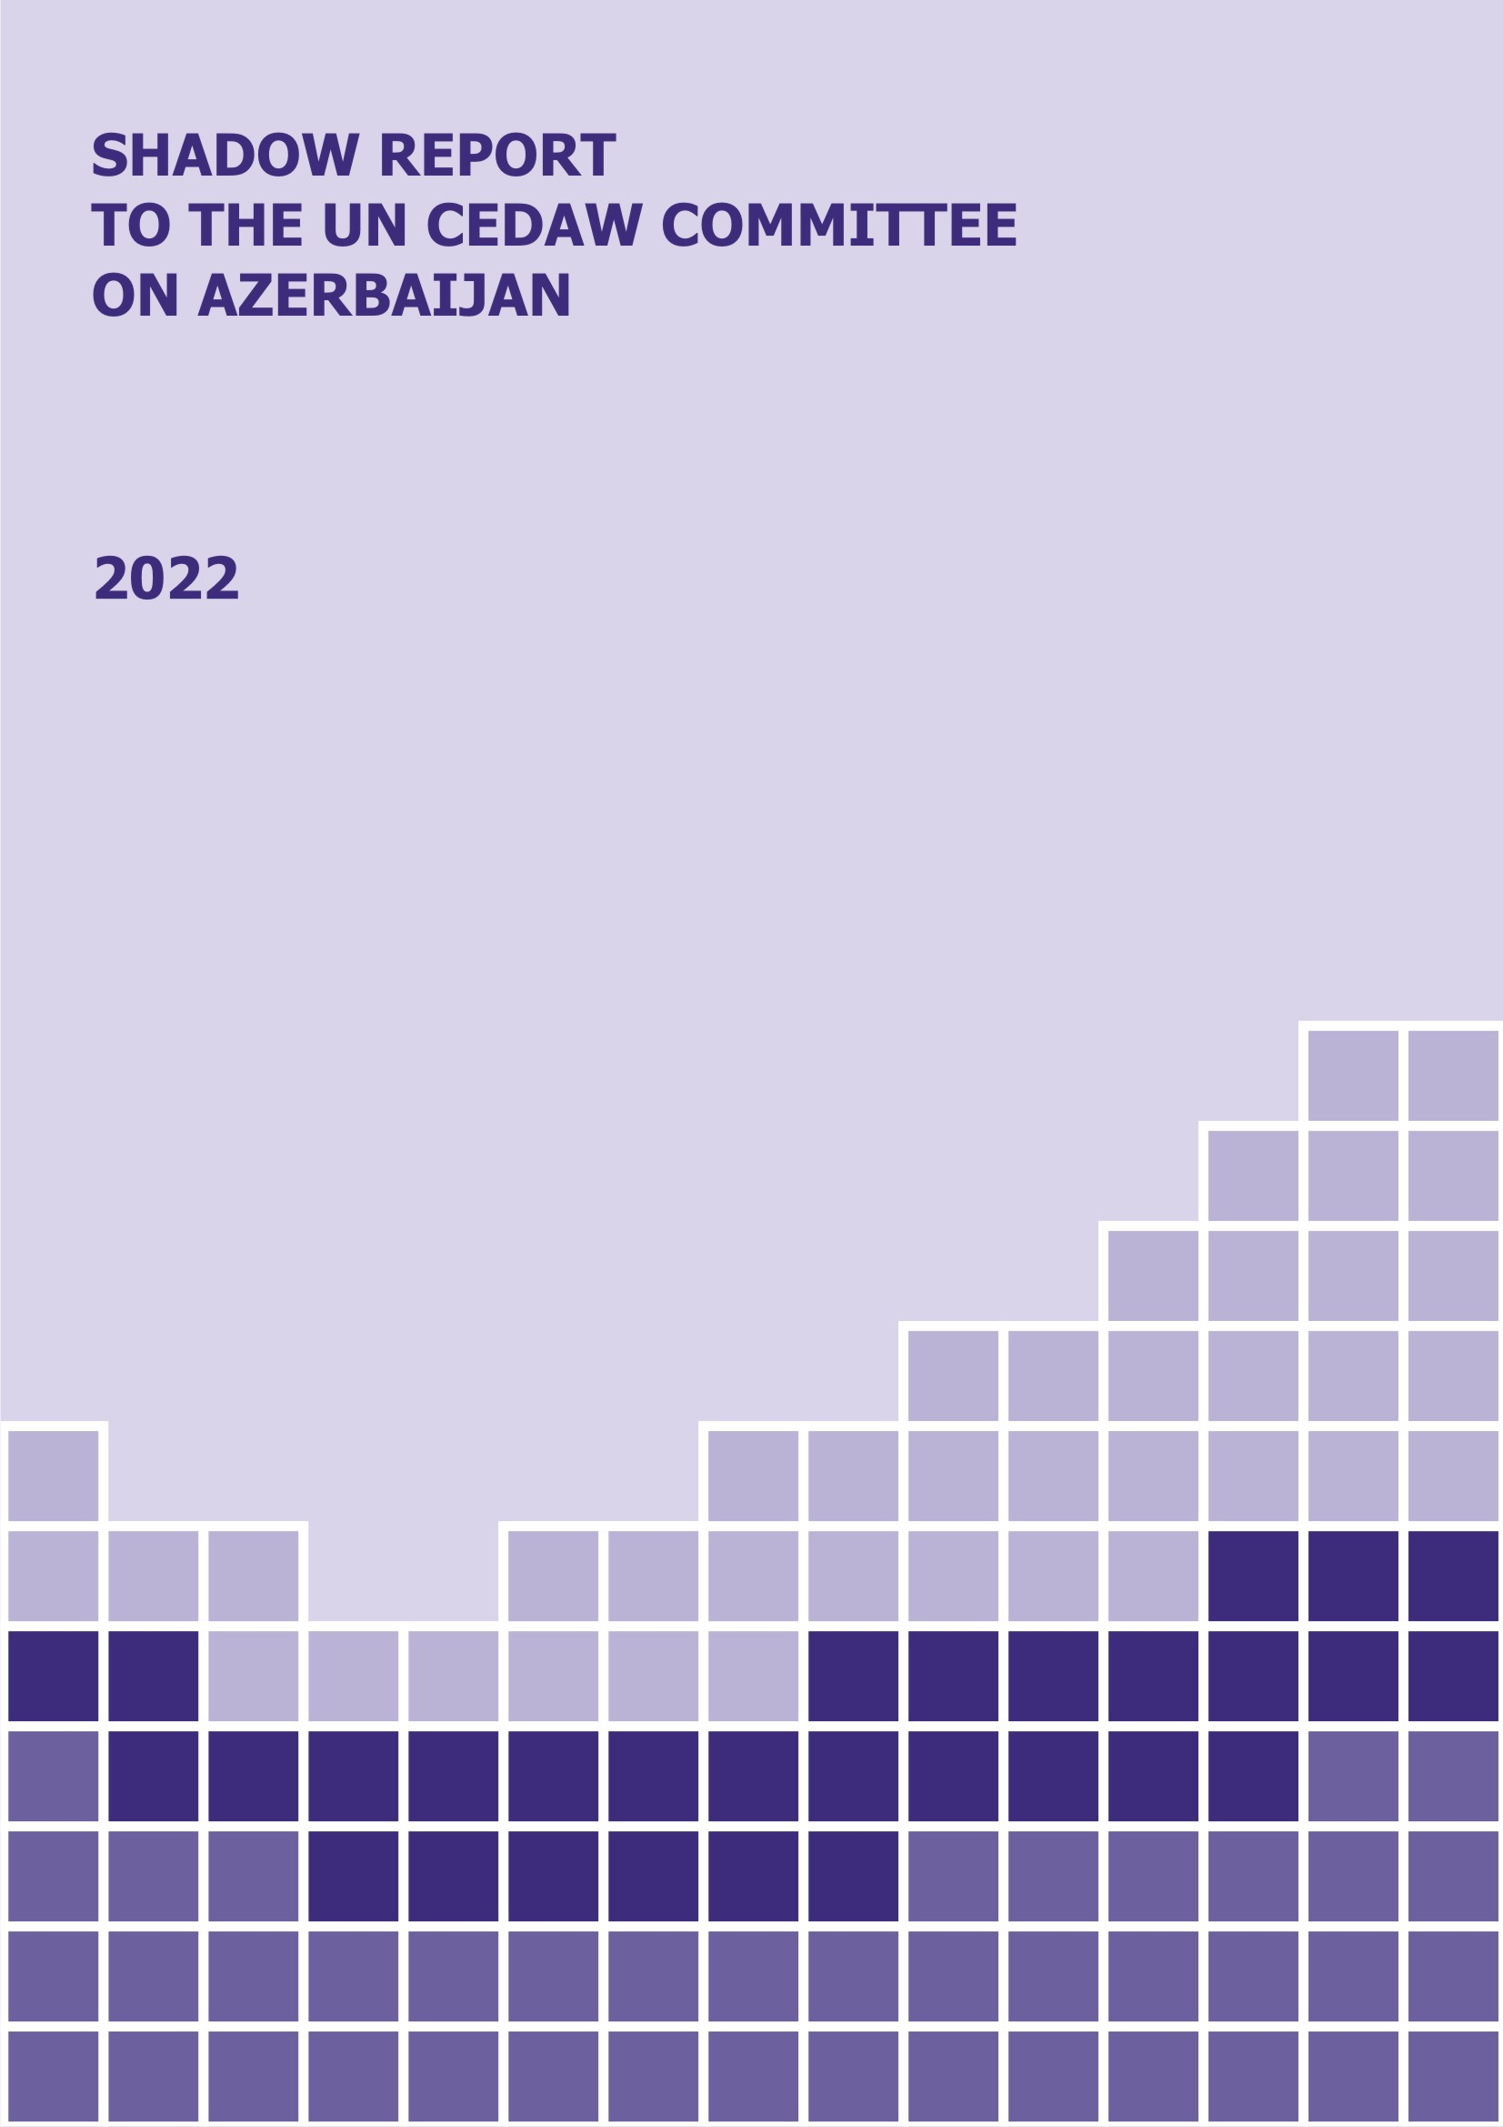
SHADOW REPORT TO THE UN CEDAW COMMITTEE ON AZERBAIJAN, 2022
This report was prepared by the Azerbaijan-based Women's Association for Rational Development (WARD) in cooperation with the Women’s Parliament in Azerbaijan.

Established in 2002, WARD is aimed at contributing to the development of Azerbaijan through women’s empowerment and equal participation via 5 priority programs – gender equality, healthcare, economic development, peacebuilding and legal literacy.

WARD is a founding and coordinating organization of the Women’s Parliament, first established in 2010. The Women’s Parliament is a coalition of 25 active and well-known women from Azerbaijan, united for improving women’s rights and the gender equality situation in Azerbaijan through awareness-raising, monitoring, reporting and advocacy on UN CEDAW implementation.

@ WARD, 2022. All rights reserved.
Reproduction, distribution, electronic or mechanical copying of any part of this report without the written permission of the author organization (s) is prohibited.
When using the report, reference to the author's organization is mandatory.

ARTICLE 1
DEFINITION OF “DISCRIMINATION AGAINST WOMEN”

- Discrimination against women remains one of the key challenges in the women’s rights agenda in Azerbaijan. Women experience gender-based discrimination in all spheres of their personal and professional lives despite existing legislative norms.

- The Constitution of the Azerbaijan Republic contains Article 25, requiring full equality between men and women. Additionally, Article 2.4. of the 2006 Law “On Gender Equality” contains a definition of “gender-based discrimination”, however, there is no clear definition regarding indirect discrimination in any legislative text, which hampers the ability to identify indirect discrimination cases and make complaints about their occurrences.

Recommendations:

- To develop a definition of indirect discrimination and include it in the Law “On Gender Equality” and the Criminal Code of Azerbaijan to enforce criminal liability on such cases.

ARTICLE 2
OBLIGATIONS OF STATE PARTIES TO ELIMINATE DISCRIMINATION

- Azerbaijan’s Constitution guarantees gender equality before the law and the country has relevant legislation and court procedures in place that address domestic violence; however, domestic violence offenses are not criminalized. Azerbaijan has not signed, nor ratified the 2011 Istanbul Convention of the Council of Europe (CoE) to fully address gender-based violence.

- The scope of domestic violence in Azerbaijan has been difficult to estimate, there is still no database on the cases domestic violence in Azerbaijan or if there is it is not accessible to the public. Yet, in 2020 the number of deaths due to domestic violence in Azerbaijan increased by 34.1%, as a gendered impact of COVID-19 pandemics.

- Due to the high level of impunity for male perpetrators, femicide rates have been rising in Azerbaijan. In one week alone in October 2019, 12 women were killed according to national media reports, and it can be assumed that the real number is much higher.

- Exceptional cruelty is not considered an additional aggravating factor in court decisions regarding women who have been brutally murdered. For example, in the trial of a trans woman killed in 2021, the killer was convicted of premeditated murder, while he stabbed the woman 15 times, tied her arms and burned her body.

- Rape is a criminal offense under Azerbaijan’s Criminal Code. The law specifically mentions rape and sexual assault as being criminal offenses, but the Criminal Code makes no specific reference to spousal rape.

- Suicides are also on the rise – 121 women committed suicide and 69 women made suicide attempts in 2018 alone. There is evidence that instances of suicide correlate to having been subjected to violence, and during the COVID-19 pandemics the number of suicides increased because of growing socioeconomic and psychological pressure.

- In the reporting period 2015-2022 some positive steps were taken to amend the legislation, enacting new laws and ratifying international conventions to address discrimination against women. However, the implementation of these laws remains problematic.

- Life imprisonment cannot be imposed on women, which is regarded as a case of positive discrimination in Azerbaijan.

- In 2017, Article 12.4 of the Law “On Combating Domestic Violence” was amended to ease the process for obtaining long-term protection orders, the procedure remains long and complicated.

- An amendment to the Family Code passed on June 1, 2015 requires a medical examination testing for sexually transmitted diseases, infections, and thalassemia in order to register a marriage.

- The Order on “National Action Plan (NAP) 2020-2023 to combat domestic violence in the Republic of Azerbaijan” was approved in November 2020. Although the NAP represents the harmonization of the legal framework with international practice, there is no specific clause on the Istanbul Convention. Main women’s rights organizations were not involved in the process of NAP development or review.

- In 2015, Domestic Violence Monitoring Groups (MGs) were established under each local Executive Authority office to enforce implementation of the 2010 Law on Combatting Domestic Violence; however, their operation and efficiency must be further enhanced, as there is no legal act regulating the work of MGs, nor are there any guidelines to strengthen their competences.

- IDP women lose their privileges regarding allowances when they marry non-IDP men. However, this regulation does not apply to IDP men and the children born of their marriages. IDP women get their status back if they get divorced, causing negative cases like unregistered marriages and fake divorces among IDP women.

Recommendations:

- To criminalize domestic violence offenses;
- To identify “spousal rape” as a crime and include it in the Criminal Code;
- To include “Femicide” as a separate article in the Criminal Code and examine these cases separately from intentional homicide;
- To differentiate murders committed “with exceptional cruelty” in the Law;
- To ensure the effective implementation of the Law on Combatting Domestic Violence by training justice personnel, law enforcement agencies, health workers and other stakeholders to deal with these offenses, and ensuring that survivors’ rights are respected;
- To issue legal acts to regulate the work of MGs and to grant them the authority to implement their roles; furthermore, to strengthen the competences of MGs;
- To develop an accurate database of cases of domestic violence to estimate its scope;
- To undertake the necessary steps for signing and ratifying the Istanbul Convention;
- To remove discriminatory legislation towards IDP women and allow them to keep the status of IDP regardless of the status of their spouse;
- To broadly involve women’s rights organizations in NAP development and implementation.

ARTICLE 3
DEVELOPMENT AND ADVANCEMENT OF WOMEN

- The positions of Gender Focal Points (GFPs), created within every national state institution, is an important gender-mainstreaming tool. However, the GFPs change frequently and in most cases are not instructed on the subject. GFPs cannot perform good quality work until they are granted formal authority and get access to compulsory training before appointed.

- In 2014, the legislation related to the registration, operation and funding of civil society organizations (CSOs) and donor institutions was amended, creating an absolutely unfavorable operational environment for them in Azerbaijan. More than 50 international organizations closed down their offices in Azerbaijan in 2014-2015 and at least 70% of CSOs became non-operational for the legislative restrictions, damaging the organizational capacities, infrastructure, financial viability, public image, advocacy work and service potential of the organizations. The blow was especially strong to women’s human rights organizations, which were fewer in number (only 5 percent of the CSO sector) and more underfinanced.

- There is no NAP on Gender Equality to ensure a comprehensive and holistic gender-sensitive approach although this measure was repeatedly recommended by stakeholders.

- There is no NAP on UNSCR 1325 to ensure the implementation of the Women, Peace and Security (WPS) agenda, although the primary draft NAP was developed in 2019.

Recommendations:

- To issue legal acts to regularize the work of GFPs and to grant them the authority to implement their roles; furthermore, to strengthen the competences of GFPs;
- To amend restrictive legislation for civil society organizations and donor institutions to create a favorable operational environment;
- To develop and adopt 4-year NAP on Gender Equality to be implemented between CEDAW reviews;
- To adopt the NAP on UNSCR 1325 to ensure the implementation of the WPS agenda on participation, protection, prevention, relief and recovery levels.

ARTICLE 4
TEMPORARY SPECIAL MEASURES

- Some measures were approved to address domestic violence, but they lacked an implementation plan. For example, in 2011, the Cabinet of Ministers issued the order “On Establishment and Maintainance of the Database on Domestic Violence” as it was stipulated by the Law “On Combating Domestic Violence” (Article 18). However, the database, which was also supposed to be available electronically, is not open to the public, nor is its data accessible to journalists and human right defenders.

- General gender-disaggregated statistics on Azerbaijan do not contain a sufficient breakdown (subcategories) that make it difficult to estimate the scope of any women’s issues. For example, there is no gender-disaggregated data on the number of GBV cases or demographic data on survivors/victims, the dropout rate of girls, IDP and refugee women, the number of people infected with or who died from the coronavirus, the number of voters in elections, etc.

- The number of shelters for women is not sufficient for the Azerbaijan’s population of 10 million. There are only 3 small shelters, operated by NGOs, with a total of 100 beds for survivors. There are no state-run shelters, although the 17 Children’s and Family Support Centers of the SCFWCA located across the country, including the conflict-affected area, can provide the primary support to women in need of social, psychological and information support.

- There is no 24/7 hotline for survivors of gender-based violence; and no easily accessible information or understanding of the referral system for GBV survivors and women in general, on the available services for women in relation to GBV and general counseling.

- The procedure of issuing protection orders to survivors of domestic violence remains complicated and long. Although Article 12.4 of the Law “On Combating Domestic Violence” was amended to ease the process for obtaining long-term protection orders, yet the implementation is not sufficient. It was reported that about 60 percent of women in Azerbaijan face some sort of violence, the number of applications for this order is less than 10 persons each year because of the ineffective enforcement process.

- There is no substantial effort to work with perpetrators of violence and sex offenders, potentially leading to a return to violent behavior after release. Without court-ordered rehabilitation and psychological treatment for perpetrators, their chances to reintegrate into society remain low.

Recommendations:

- To further develop the database on GBV cases and make it accessible to the general public;
- To simplify the procedure for obtaining protection orders for survivors of domestic violence;
- To transfer the duty to provide protection orders from local executive authorities to courts;
- To place on courts the obligation to process cases on violence against women without any delay and immediately take protective actions to get survivors out of risky situations;
- To establish and promote state-run shelters across Azerbaijan;
- To make psychological treatment and rehabilitation compulsory/court-ordered for perpetrators of violence.

ARTICLE 5
SEX ROLES AND STEREOTYPES

- Women remain dominant in certain professions such as education, healthcare, and social work, which is often presented positively, although these are low-paid sectors. Hence, gender-based stereotypes are strengthened by assigning to women only those positions which require skills in caretaking and nurturing. As a result, stereotypes are formed of traditional female professions, which are, as a rule, low paid sectors of the labor market.

- School textbooks contain discriminatory content and illustrations, assigning unequal gender roles to women and men, deepening gender-based stereotypes. The curricula do not contain gender-sensitization classes for pupils and students.

- As a result of these stereotypes, there is a growing number of female disadvantages, such as early (child) marriages, sex-selective abortions, bride kidnapping, sexual harassment, etc.

- There is no education on gender equality or non-violent conflict resolution in the school curriculum. The only higher education institution with gender equality in the curriculum is Baku State University (BSU), which has a Gender and Applied Psychology Department and a course on gender equality in the curricula of all faculties of BSU. In addition, there is a Gender Department at the National Academy of Sciences of Azerbaijan. As a result, the number of gender experts in the country is very limited and most of them have no academic background, but rather can be regarded as gender practitioners.

- There is no TV program, aimed at reducing gender-based stereotypes on Azerbaijani television. Several TV programs featuring supposedly “women’s” content on baking and cooking as well as beauty and fashion are counterproductive by deepening gender-based stereotypes regarding women’s “typical” interests.

Recommendations:

- To analyze and revise textbooks for gender biases and stereotypes at the level of content, language, and illustrations;
- To encourage female applications to non-traditional professions for women;
- To establish Gender Studies Departments in high schools to increase the academic gender expertise potential of the country;
- To integrate gender classes into the curricula and make gender education compulsory in primary schools and universities;
- To introduce multiple gender-sensitization projects to national and local television channels and promote gender values through all formats of (social) media.

ARTICLE 6
TRAFFICKING OF WOMEN AND EXPLOITATION OF PROSTITUTION

- Azerbaijan is a culturally conservative country, where sex workers consistently face discrimination and exploitation. Prostitution is not legalized in the country. Victims often face degradation and humiliation by police forces after applying for protection. Sex workers often conceal rape cases and don’t take them to court because of deeply rooted stigmas against sex workers.

- Although state reports contain the measures undertaken by the government to address human trafficking, there is no data about women in prostitution.

- The USAID’s 2021 Trafficking in Persons Report on Azerbaijan acknowledged the significant, yet not increasing efforts of Azerbaijani government in elimination of trafficking, even considering the impact of the COVID-19 pandemic on its anti-trafficking capacity. The government continued to lack interagency cooperation on anti-trafficking efforts and continued its moratorium on scheduled and unannounced labor inspections through 2021.

- In December 2019, Azerbaijan ratified the CoE Convention on the Protection of Children against Sexual Exploitation and Sexual Abuse (the Lanzarote Convention), which obliges states to criminalize all kinds of sexual offenses against children, to protect victims and to prosecute perpetrators.

- Azerbaijan adopted the 2014-2018 NAP on combatting trafficking in human beings to detect and prevent all forms of human trafficking, identify and eliminate the roots of human trafficking, as well as protect victims of human trafficking, restore the rights, socially rehabilitate, and ensure the safe repatriation of survivors.

Recommendations:

- To take all appropriate measures to prevent human trafficking and the exploitation of women in prostitution;
- To consider the legalization of prostitution as a means to ensure better protection of sex workers;
- To investigate cases of forced prostitution and penalize the perpetrators accordingly;
- To provide training courses for the police forces who work with sex workers and the survivors of the human trafficking;
- To encourage sex workers to bring rape cases to the courts;
- To penalize the perpetrators of sex workers’ rape and make information on such cases publicly available;
- To train police officers and investigation bodies to conduct impartial investigations;
- To introduce a state policy on the rehabilitation and reintegration of prostitutes to society.

ARTICLE 7
PARTICIPATION IN PUBLIC AND POLITICAL LIFE

- There are no legal restrictions on the participation of women in politics. As of 2020, there were 22 women in the 125-seat parliament, including the Speaker of the National Assembly. The percentage of female members of parliament increased from 11 to 17.6 percent between 2005 and 2020. Women are much better represented in municipalities (up to 35%), however, municipalities suffer from limited powers and a weak financial position, particularly after the COVID-19 pandemic.

- Progress in women’s political representation is modest compared to other countries. In the World Economic Forum Global Gender Gap Index 2018, Azerbaijan was ranked 137th for women’s political representation out of 149 countries. In the Women in Politics map 2021, Azerbaijan is ranked 125th, noting that there is not a single woman in a ministerial position.

- Lack of women in the judiciary and the police is a constraint that hinders women’s access to justice. Women are mostly unaware of the relevant administrative bodies or courts where they can go in cases of violation of their rights.”

- Women are not able to exercise their human rights on an equal basis in patriarchal societies. Women face gender-based attacks on their reputations, hindering their active involvement in public and political life. Such attacks are among the most widespread methods used against women human rights defenders and journalists in Azerbaijan.

Recommendations:

- To activate women to increase their participation in political and public life;
- To conduct role model initiatives to stimulate women’s interest to political participation;
- To take the necessary steps to provide gender balance in governance structures;
- To initiate special projects for promoting women’s participation in politics;
- To protect women human rights defenders and raise their status in society.

ARTICLE 8
REPRESENTATION AT THE INTERNATIONAL LEVEL

- Women continue to be underrepresented in senior diplomatic and international positions, although the number of women in diplomatic positions within the Ministry of Foreign Affairs of Azerbaijan, is slowly rising. According to the latest statistics, Azerbaijan has 3 women ambassadors, or 10% of the overall appointed ambassadors of Azerbaijan.

Recommendations:

- To encourage women’s participation and representation in diplomacy and international affairs;
- To introduce quotas in the Ministry of Foreign Affairs of Azerbaijan, as a temporary special measure, to stimulate women’s representation at the international level.

ARTICLE 9
NATIONALITY

- In law, there is no legal discrimination against foreigners. Everyone has equal rights before the law.

Recommendations:

- No recommendations or comments.

ARTICLE 10
EDUCATION

- The Law on Education, adopted in October 1992, guarantees equal access to primary, undergraduate, graduate and post-graduate education for both girls/women and boys/men. According to the Gender Gap Report 2021, Azerbaijan is ranked in 62nd in educational attainments.

- Although women constitute the majority in the education sector, still the number of men as directors/principals is much higher.

- School textbooks largely contain gender-based discriminatory content and illustrations. Women are mostly presented as care-takers, while men are portrayed as decision-makers. Besides, women are represented 3 times less in Azerbaijani textbooks. Such textbooks deepen existing gender-based stereotypes and promote unequal gender roles in society.

- Early (child) marriages remain widespread; in some rural communities, girls drop out of education to marry at the age of 15-16, i.e. after the 9th grade or even earlier. There are no official statistics about the number of girls who drop out of school in Azerbaijan.

- During the COVID-19 pandemic, women’s access to education deteriorated. The lockdowns significantly increased the household and family commitments of women and girls, reducing their participation and resulting in a higher number of (temporary) dropouts. The lack of IT skills among girls, especially in rural communities, in combination with poor internet quality, caused a serious decline in girls’ attendance of online education platforms. The situation is no different for women educators and academics. The burden of household chores affected their academic performance negatively.

- The number of women in preschool, primary, general secondary and upper secondary education is significantly higher (65.7% of them are women). As for the teaching staff of higher education institutions, although men predominate in senior positions, the vast majority of senior teachers (64 percent), teachers and assistants (71.6 percent), who have the most contact with students, are women.
Recommendations:

- To conduct gender-lens screening of textbooks for content, language and illustrations and replace all discriminatory parts with gender-sensitive substitutes;
- To eliminate gender stereotypes in the school environment and classroom practices;
- To develop gender-sensitive policies and programs in education;
- To invite gender experts to verify the textbooks as well as documents for gender-sensitiveness;
- To involve gender experts to conduct gender-orientation sessions for school teachers to make them aware of gender-sensitive teaching methods and tools;
- To publish guidelines for teachers and parents on gender-sensitive education tools and benefits.

ARTICLE 11
EMPLOYMENT

- As of 2021, the unemployment rate was about 40 percent higher among women (8.4 percent) than men (6 percent).

- The shadow economy has averaged about 54 percent over the past 20 years. This means that although a high number of women may be engaged in paid work, they are also subjected to lower job security and less access to maternity leave, pensions, protection from rights violations or other social benefits.

- Azerbaijan also has the weakest position in Commonwealth of Independent States (CIS) in terms of women's managerial positions. The World Bank stated that women constitute only 3.8 percent of managerial positions in medium-sized companies in Azerbaijan, compared to 36 percent in Georgia and 20 percent in Armenia.

- Because of sex discrimination in employment, women occupy less than 20 percent of positions in high-paid sectors such as mining and construction. For example, SOCAR has 50,424 employees and only 8,441 (16.8%) are women.

- Unpaid domestic labor remains the invisible restriction for working women, who have to combine their professional and family commitments. Women averagely spend 3 times more time on unpaid work than men do, even in cases when women are employed and men are not. Azerbaijan echoes a globally prevalent pattern: the workload of unpaid domestic work is unequally distributed between women and men, although women and men can both be the head of the household under Azerbaijani law. Hence women, especially in rural communities, have to choose part-time and flexible-scheduled jobs to allow them to continue taking care of their households.

- Article 241 of the Labor Code prohibits the employment of female labor in workplaces with difficult working conditions. Female labor is prohibited in 678 professions across 38 industries, according to the list approved by Cabinet of Ministers on October 20, 1999.
Recommendations:

- To amend the legislation, removing the articles that prevent women's right to freely choose their profession and employment;
- To eliminate/reduce the list of banned jobs for women and encourage women to choose non-traditional female occupations;
- To take steps for preventing gender-based discrimination and sexual harassment at the workplace;
- To conduct more research on the informal economy of Azerbaijan;
- To take measures to reduce the unbalanced domestic workload between women and men;
- To strengthen women’s economic participation through supporting infrastructure to take care of children and the elderly, such as kindergartens, daycare centers, etc.

ARTICLE 12
HEALTH

- Azerbaijan has the highest rate of induced abortions in the region due to low demand for family planning. The use of modern contraceptives has remained unchanged (14 percent) among currently married women for the past ten years. The vast majority of women with a reported need for contraceptives experienced major difficulties in access due to overstretched health services where resources have been diverted to address the impact of COVID-19.

- According to 2019 data of the State Statistics Committee, 45.2% of married women do not use contraceptive methods. This research shows that awareness about modern contraceptive methods is not widespread. The State Statistics Committee focused only on married women due to the prejudice against sex outside of marriage, depriving us of relevant healthcare data on unmarried women.

- Population trends show that the country has a highly skewed sex-at-birth ratio with 114 male births to every 100 female births, putting Azerbaijan at second place worldwide for sex selective abortions. The dramatic decline in fertility rates over the past 50 years from 5.60 in 1961 to 2.2 in 2020 deteriorates the situation.

- From the legal perspective, there is still no effective healthcare system in Azerbaijan. The draft Law “On Protection of Reproductive Health and Family Planning,” stipulating the legal basis for the protection of reproductive health, access to family planning services and implementation of reproductive rights, has been in legislative limbo since 2008.

Recommendations:

- To adopt the Law “On Protection of Reproductive Health and Family Planning” to stimulate a comprehensive approach to reproductive health issues and improve women’s access to healthcare;
- To take appropriate steps for changing attitudes towards unmarried and married women in terms of access to healthcare, especially abortions and gynecological exams;
- To introduce Compulsory Medical Insurance nationwide, and to add medical examinations and treatment of women during pregnancy, including the birth process, to the insurance system;
- To launch a broad awareness raising campaign on sexual and reproductive health and rights.

ARTICLE 13
EQUALITY IN ECONOMIC LIFE

- Women work across all sectors of the economy; however, women have limited access to economic resources compared to men. In addition, women lack opportunities and skills, required to fully participate in decision-making in personal, public, and political life. A complex interplay of different factors including interlinkages between gender and societal norms and institutions continues to confine women to the household where they are valued only for their reproductive capacity.

- Azerbaijan is ranked 45th for economic participation in the Gender Gap Report. Women’s share in the labor force is 48.1% compared to 51.9% for men. Of all employed women, 82% work in five sectors; yet women’s contribution to GDP is just 27%, evidence that women are mostly concentrated in low-paid sectors. Government statistics also noted that women face a higher unemployment rate at 2.9%, compared to 2.1% for men. Occupational patterns are highly gender segregated, with 73.8% of education jobs held by women, as well as 76.5% of positions in health and social services.

- Women’s economic dependence on male family members is still very high. Women, especially in rural areas, face multiple disadvantages due to limited access to education, income, land, and capital.

- Women do not enjoy equal access to labor and remuneration. Deeply rooted stereotypes regarding “male and female professions,” actual pay gaps (despite formal equal remuneration for men and women for work of equal value) and the so-called “glass ceiling” remain dominant in both state and private labor sectors.

Recommendations:

- To take appropriate steps for eliminating gender-related segregation in the labor market;
- To improve parental leave provisions, which force women to choose part-time work;
- To conduct a gender analysis of economic development and entrepreneurship in Azerbaijan and identify areas of concern for women’s economic participation;
- To encourage female entrepreneurship through a number of temporary measures, such as simplified terms for access to microloans, preferential loans for women, etc.;
- To offer women equal business opportunities and special programs for poverty reduction;
- To ensure equal working conditions and equal pay in the employment sector;
- To encourage international business forums and study tours for women entrepreneurs to foster partnership projects and promote networking;
- To strengthen women’s capacities in the areas of business management, leadership and communication;
- To attract non-governmental organizations to conduct capacity-building training courses and awareness-raising initiatives.

ARTICLE 14
RURAL WOMEN

- In rural areas, women’s participation in political, economic, social and cultural life is limited by unequally distributed household and family responsibilities and deeply rooted gender stereotypes. The lack of access to social services affects women’s economic independence, depriving women of additional income-generating opportunities.

- In Azerbaijan, where 77 percent of the total female population lives in rural areas, engrained cultural stereotypes reinforce the image of women solely as homemakers. The lack of basic literacy skills or access to jobs compounds their challenge, preventing them from exploring opportunities outside of what is traditionally expected.

- Smallholder agriculture remains the major occupation of rural women, accounting for over 50% of the labor force in the agricultural sector. However, at the rural household level, women’s labor in agriculture is perceived as contribution to the family’s well-being, rather than “active employment” which also limits women’s access to information and exchange opportunities.

- Among the factors preventing rural women from achieving an equal position with men are restrictions imposed by the family, the burden of unpaid domestic labor, pervasive gender stereotypes, and fear of harassment in the workplace. The lack of available advanced technology, the lack of equal access to existing business opportunities, and patriarchal attitudes in the male-dominated business world versus women’s lack of self-confidence and business leadership and management skills significantly reduce the space for potential female entrepreneurs.

- In 2019, the Ministry of Agriculture together with the World Bank established the Association of Rural Women of Azerbaijan to support the social and economic development of rural women. It is planned to cover 14 regions of Azerbaijan, but there is a need for further research into the impediments for women’s economic participation.

- In 2018, the Small and Medium Business Development Agency (KOBIA) was established to support the development of small and medium-sized enterprises (SMEs), provide services to SMEs, and exercise control over this segment of economy. However, the programs and policies of KOBIA do not envision special support to female entrepreneurs.

Recommendations:

- To study the regions of Azerbaijan to identify the specific needs of rural women;
- To eliminate barriers blocking access to the capital market for women entrepreneurs and agripreneurs engaged in smallholder farms and SMEs;
- To stimulate women’s economic participation through special state programs and projects;
- To encourage female entrepreneurship in rural areas by providing special subsidies to women entrepreneurs, including women farmers, to expand the use of leasing services;
- To develop policies to expand the participation of rural women in public life;
- To improve the availability of social services for rural women.

ARTICLE 15
EQUALITY BEFORE THE LAW

- Women are legally guaranteed equality with men. The Constitution of the Azerbaijan Republic contains Article 25, requiring full equality between men and women.

Recommendations:
- No recommendations or comments.

ARTICLE 16
MARRIAGE AND FAMILY RELATIONS

- Article 10 of the Family Code of Azerbaijan establishes the minimum marriage age for men and women at 18. The minimum marriage age can be reduced by one year if permission is granted by the local executive power in exceptional cases.

- Marriages are legally registered by the state; both spouses must provide written consent, and evidence that they have attained the minimum legal age for marriage.

- Religious marriages based on the kabin marriage contract, performed by the local mullah, are quite popular among the population, even non-practicing Muslims. Yet, religious marriages are not legally recognized or officially registered. Despite the fact that an agreement between the state and the religious authorities obliges the mullah to require potential spouses to show a civil marriage certificate and birth certificates for the bride and groom before the kabin, usually religious marriage ceremonies are conducted without checking either the age of the two spouses or the existence of the official marriage document.

- There is no statistical data on marriages involving people under 18 (or 17 in exceptional circumstances). Since Azerbaijan has always traditionally had high levels of early marriages, the phenomenon is quite widespread, especially in southern rural communities.

- Early marriages, registered as kabin, are rarely followed by state marriage registration once the spouses reach the marriage age of 18. Women whose marriage is unregistered have no rights to property, among other deprivations.

- Bride kidnapping is another tradition practiced in some regions of Azerbaijan. The new Criminal Code, which came into force on September 01, 2000, qualifies bride abductions as kidnapping and designates sentences from 5 to 12 years in prison, and 10 to 15 years in prison for the same act committed against a minor.

- Forced marriages are legally prohibited in Azerbaijan. Articles 150.1 and 150.3 of the Criminal Code of Azerbaijan state that forcing a person to engage in sexual activity is punishable by three to five years’ imprisonment; if these actions involve a person under 14, the punishment is eight to 15 years’ imprisonment.

- The institution of virginity is traditionally strong in Azerbaijan, hence virginity tests and examinations are a growing trend. Women preparing for marriage are unlikely to refuse such tests as they are often unaware of their rights.

- The divorce rate has grown rapidly in Azerbaijan in the past decade, with on average ¼ of all marriages ending in divorce. During the COVID-19 pandemic, the divorce rate rose to 1 divorce for every 2.5 marriages, as the number of newly registered marriages dropped by half. To counteract this trend, the Family Code introduced an obligatory mediation process for spouses, blocking immediate divorce proceedings even in cases of domestic violence.

Recommendations:

- To introduce more efficient legal prevention measures for early marriages, such as high penalties for religious clerks not requiring potential spouses to show a civil/state marriage certificate prior to concluding a kabin religious marriage;
- To review and amend the Family Code and national marriage/family policies that foster discrimination against women and girls, in order to enhance women’s rights to property, and their economic independence;
- To increase efforts in conducting wide public awareness-raising initiatives on the consequences of early marriages, forced marriages, unregistered or religious marriages;
- To draft and include new provisions in the Criminal Code establishing criminal liability for doctors who perform “virginity tests”;
- To introduce special temporary measures, such as financial incentives and scholarships for low-income families with female children, to delay marriage and encourage education;
- To organize country-wide advocacy and awareness-raising campaigns to promote awareness of the rights of girls and women;
- To develop multi-sectoral partnerships among state and non-governmental agencies to address the issue of early marriages.

ARTICLE 17-30
CEDAW and State Obligations

- Although in recent years Azerbaijan has made significant steps to comply with CEDAW obligations and standards, much effort is still needed to achieve visible progress towards a situation where women will be equal citizens enjoying all the fundamental rights and freedoms provided by the law. Serious measures should be undertaken for the implementation of laws and the strategic planning of actions within a certain timeline. Such measures can be comprehensive and efficient only if related stakeholders such as CSOs, academic institutions, mass media outlets and international organizations are involved in the state initiatives.

- Since 2014, a tremendous tendency has been observed to suppress alternative voices in Azerbaijan by continuous strategic and systematic measures taken by the government. The legal environment governing CSOs deteriorated severely marking 2014 as the worst year for CSOs in this region in the last 11 years. Women CSOs, which have always been fewer in number (5% of the entire NGO sector), have been disproportionately affected by this shrinking of the space for civil society, leaving their female constituencies underserved.

- The COVID-19 pandemic proved to be an ordeal for Azerbaijani women facing numerous gender-based limitations deeply rooted in patriarchal relations, traditional social norms, biased gender roles, and stereotypes. The lack of gender sensitivity in the decrees passed with a view to preventing COVID-19 made women ever more vulnerable to domestic violence (e.g., no special steps were taken to facilitate women’s access to hotlines, shelters, and social and psychological advice in cases of violence during the stay-at-home period).

Recommendations:

- To ensure full implementation of the laws in Azerbaijan;
- To endorse participation of the CSOs, academic institutions, mass media outlets and international organizations in the planning and implementation of state initiatives;
- To amend legislation, making the registration, operation and funding of CSOs and donor organizations easy and accessible;
- To arrange a number of women-friendly initiatives to mitigate the negative impact of the COVID-19 pandemic on Azerbaijani women.

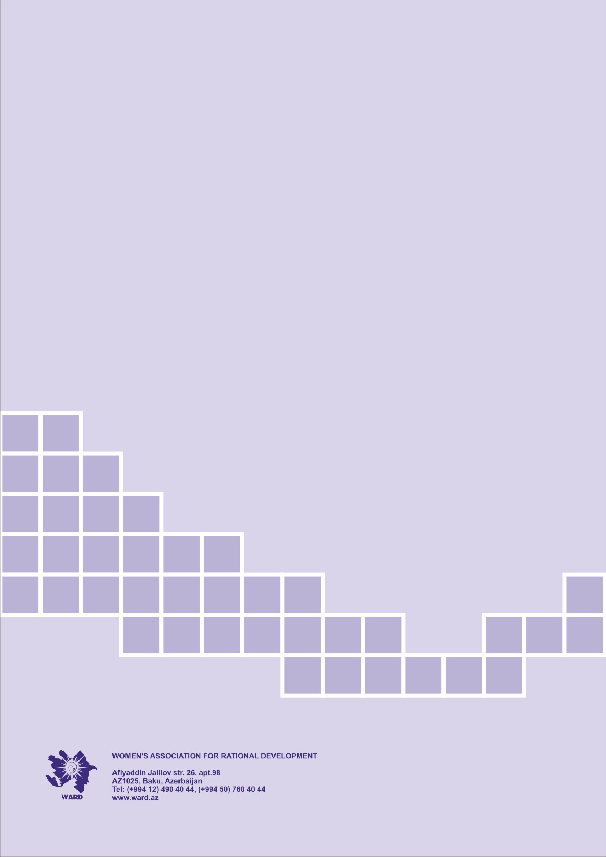

This is the reduced version of the Report, submitted to UN CEDAW Committee, for word limitation. A more detailed version is publicly accessible at WARD’s website (www.ward.az).
APA Information Agency, “The number of deaths as a result of domestic violence in Azerbaijan increased by 34.1 percent,” 2019, https://apa.az/az/hadise/Azrbaycanda-mist-zorakiligi-nticsind-olnlrin-sayi-341-faiz-artib-629933
Median.az, “Son bir həftədə Azərbaycanda 12 qadın qətlə yetirilib,” 2019, https://median.az/index.php?newsid=103278
UK news, “Trans woman brutally stabbed and burned alive in Azerbaijan,” 2021, https://uk.news.yahoo.com/trans-woman-brutally-stabbed-burned-161227662.html
Criminal Code of Azerbaijan, Article 149
BBC Azərbaycan, “Azərbaycan qadınlara qarşı zorakılığa dair sənədi niyə imzalamır?” 2018, https://www.bbc.com/azeri/azerbaijan-49729051
Criminal Code of Azerbaijan, Article 57
Law of the Republic of Azerbaijan on Amendments to the Law of the Republic of Azerbaijan “On Prevention of Domestic Violence,” http://www.e-qanun.az/framework/36302
Family Code of Azerbaijan, Article 13
Order of the President of the Republic of Azerbaijan on Approval of the “National Action Plan to Combat Domestic Violence in the Republic of Azerbaijan for 2020-2023,” http://www.e-qanun.az/framework/46358
Decision of the Cabinet of Ministers of the Republic of Azerbaijan on approval of the “Rules for payment of food allowances for IDPs and persons equal to them, as well as a single monthly allowance instead of payments from the state budget for utilities and other services,” Article 2.4, http://e-qanun.az/framework/34675
State Committee for Family, Women and Children’s Affairs, “Gender məsələləri üzrə məsul şəxslər üçün təlimlər keçirilir,” 2019, http://scfwca.gov.az/post/1724/gender-meseleleri-uzre-mesul-sexsler-ucun-telimler-kecirilir
State Committee for Family, Women and Children’s Affairs, reports, 2021
Amendments to the Law of Azerbaijan “On Prevention of Domestic Violence,” http://www.e-qanun.az/framework/36302
Report Information Agency, “Azərbaycanda qadın zorakılığı ilə bağlı statistik məlumatlar açıqlanıb,” 2016, https://report.az/sehiyye/azerbaycanda-qadin-zorakiligi-ile-bagli-statistik-melumatlar-aciqlanib/
State report to CEDAW, 2019, clause 64
“Speaker of Azerbaijan's Parliament elected,” 2020, https://en.trend.az/azerbaijan/politics/3204551.html
Council of Europe, Report “Monitoring of the Application of the European Charter of Local Self-Government in Azerbaijan,” 2021
UN Women, “Women in Politics,” 2021, https://www.unwomen.org/en/digital-library/publications/2021/03/women-in-politics-map-2021
Asian Development Bank, “Country Gender Assessment report,” 2019
Qafqaz.info, “Azərbaycan diplomatiyasını xaricdə təmsil edən - Qadın səfirlər,” https://qafqazinfo.az/news/detail/azerbaycan-diplomatiyasini-xaricde-temsil-eden-qadin-sefirler-231302
World Economic Forum (2021), “Global Gender Gap Report,” http://www3.weforum.org/docs/WEF_GGGR_2021.pdf
A. Dadasova, “Gender roles in Azerbaijan secondary school literature textbooks,” page 32
Musavi, N., “Azerbaijan: a wedding instead of a graduation,” 2019, https://jam-news.net/azerbaijan-a-wedding-instead-of-a-graduation/
FaktYoxla.info, 2021, “Online təhsil platformasında qeydiyyatdan keçənlərin üçdə biri aktiv iştirakçı deyil,” https://www.faktyoxla.info/articles/Online-tehsil-platformasinda-qeydiyyatdan-kechenlerin-uchde-biri-aktiv-ishtirakchi-deyil
Women’s Association for Rational Development (WARD), Report “Women’s Rights and COVID-19 Pandemic in Azerbaijan,” 2021
State Statistics Committee of Azerbaijan, “Women and men in Azerbaijan,” 2020
Azadlıq Radio, “Azərbaycanda qadınlar arasında işsizlik 40 faiz daha yüksəkdir,” 2021, https://azadliq1.azureedge.net/a/qadin-issizlik/31449455.html
International Monetary Fund, “Shadow Economies Around the World: What Did We Learn Over the Last 20 Years?” 2018
F. Guliyev, “The informal economy in Azerbaijan,” 2018
Azadlıq Radio, “Rəsmi rəqəmlərə görə, Azərbaycanda 154 min gənc işsizdir,” 2021, https://www.azadliq.org/a/azerbaycan-issizlik-gencler-bak%C4%B1/31451552.html
State Oil Company of the Azerbaijan Republic, “Sustainable Development Report,” 2017
Asian Development Bank, “Azerbaijan Gender Assessment Report,” 2019
The OECD Development Centre, “Azerbaijan, Gender Index,” https://www.genderindex.org/wp-content/uploads/files/datasheets/AZ.pdf
The Labor Code of Azerbaijan, Article 241, https://www.e-qanun.az/framework/46943
United Nations Population Fund, “Country program document for Azerbaijan,” 2020
United Nations Population Fund, “Rapid Gender Assessment,” 2020
The State Statistical Committee of the Republic of Azerbaijan (2019), “2019-cu ildə yaş qrupları üzrə abortların sayı,” "Azərbaycanda Demoqrafiya və Sağlamlıq-2011" sorğusunun məlumatlarına əsasən ərdə olan qadınlar arasında kontrasepsiya üsullarından istifadə edilməsi,” https://www.stat.gov.az/source/gender/az/qk/002_11-12.xls
United Nations Population Fund (2015), Population Projections, 2014–2050: Different Sex Ratio at Birth Scenarios in Azerbaijan
Women`s Association for Rational Development (2021), “Women`s Rights and the COVID-19 Pandemic in Azerbaijan,” page 41
United Nations Population Fund (UNFPA), Azerbaijan State Committee of the Republic of Azerbaijan for Family, Women and Children’s Affairs, International organization “Promundo,” International Center for Social Research (ICSR), “Gender Equality and Gender Relations in Azerbaijan: Current Trends and Opportunities,” 2018
World Economic Forum, “Global Gender Gap Report,” 2021, http://www3.weforum.org/docs/WEF_GGGR_2021.pdf
Asian Development Bank, Azerbaijan Gender Assessment Report, 2019.
UNDP Azerbaijan, “Towards Sustainable Development: Promoting Rural Women’s Leadership and Economic Empowerment”, 2018, https://www.az.undp.org/content/azerbaijan/en/home/presscenter/pressreleases/2018/07/05/towards-sustainable-development-promoting-rural-women-s-leadership-and-economic-empowerment.html
UNDP Azerbaijan/WARD, “Gender Assessment Report “Women in the Private Sector in Azerbaijan”, 2018
Azernews, “Association of Rural Women established in Azerbaijan,” 2019, https://www.azernews.az/nation/146832.html
UNFPA, Report “Child Marriage in Azerbaijan,” 2014
Family Code of Azerbaijan, Article 10, http://e-qanun.az/framework/46946
Criminal Code of Azerbaijan, Article 144, http://e-qanun.az/framework/46947
State Statistical Committee of Azerbaijan, https://www.stat.gov.az/source/gender/az/qk/001_38.xls
Family Code of Azerbaijan, Article 7-1, http://e-qanun.az/framework/46946

