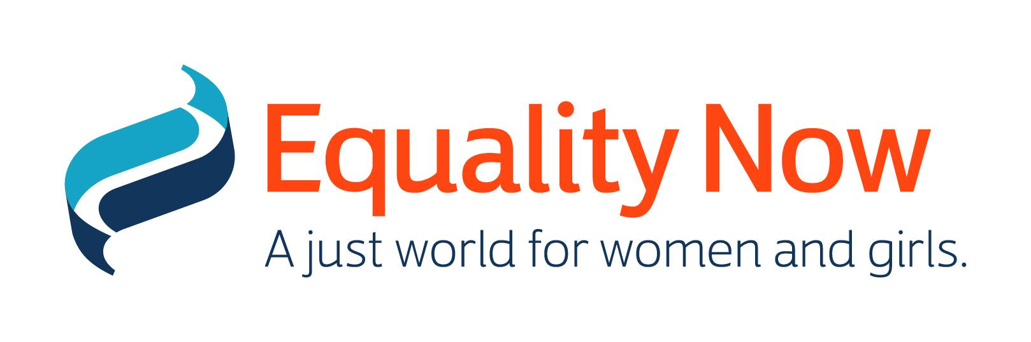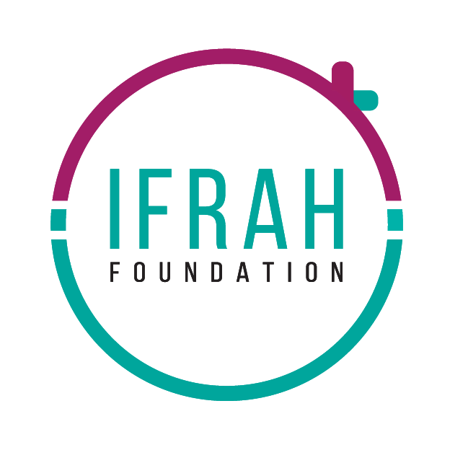

Ms. Tania María Abdo Rocholl
Chair, Human Rights Committee
Office of the United Nations High Commissioner for Human Rights (OHCHR)
Palais Wilson - 52, rue des Pâquis
CH-1201 Geneva (Switzerland)
Via E-mail: ccpr@ohchr.org; ohchr-ccpr@un.org

5 February 2024
Re: Information on Somalia for its Review by the Human Rights Committee at the 140th Session (4 - 28 March 2024)
Introduction
- Equality Now and the Ifrah Foundation present the following submission in advance of the 140th session of the Human Rights Committee (the Committee) taking place between 4th and 28th March 2024. In this submission, we express deep concern about the condition of women and girls in Somalia with regard to sexual and gender based violence and the practice and prevalence of female genital mutilation (FGM), both of which constitute violations of Somalia’s obligations under the International Covenant of Civil and Political Rights (ICCPR).
- In this submission, we note the State Party’s failure to comply with its obligations under the ICCPR which explicitly prohibits violence against persons and discrimination on the basis of sex, and mandates States Parties to “ensure that any person whose rights or freedoms as herein recognized are violated shall have an effective remedy” and to “undertake to ensure the equal right of men and women to the enjoyment of all civil and political rights” (Articles 2 and 3 ICCPR). The State Party is also in violation of the ICCPR provision that "all persons are equal before the law and are entitled without any discrimination to the equal protection of the law” (Article 26). In addition, the ICCPR protects individuals from “torture or cruel, inhuman or degrading treatment” and “arbitrary or unlawful interference with his or her privacy.” (Articles 7 and 17). The ICCPR states that everyone has the “right to liberty and security of person” and that “[e]very child shall have … the right to such measures of protection as are required by his status as a minor, on the part of his family, society and the State.” (Articles 9 and 24).
Information about the authors of the submission
- Equality Now is an international organization founded in 1992 with ECOSOC status and has been using a unique combination of legal advocacy, regional partnership-building and community mobilization to encourage governments to adopt, improve and enforce laws that protect and promote the human rights of women and girls around the world. With an international team, our campaigns are centered on four program areas: Achieve Legal Equality, End Sexual Violence, End Harmful Practices, and End Sexual Exploitation, with a cross-cutting focus on the unique needs of adolescent girls.
- Ifrah Foundation is a survivor-led NGO working in Somalia since 2016 to end FGM through 3 pillars of action: Advocacy, Awareness Raising and Community Empowerment. The work is led by Ifrah Ahmed, Somali survivor of FGM and internationally recognised activist with over 15 years’ experience engaging on FGM. Ifrah Foundation is supported by a small team with expertise in addressing gender equality in Somalia.
FGM in Somalia
- FGM prevalence in Somalia remains one of the highest in the world. The United Nations Children's Fund (UNICEF) and the Somali Demographic and Health Survey (DHS) data show that the prevalence rate of FGM among women and girls in Somalia is a staggering 99%. This means that the practice of FGM in Somalia is nearly universal. 64% of women in Somalia aged 15-49 have undergone one of the most severe forms of FGM - Type III (infibulation), which involves the narrowing of the vaginal opening with the creation of a covering seal; cutting and repositioning the labia minora or labia majora and sometimes removal of the clitoris as well.
- There is no known medical benefit to this harmful practice and the survivors of FGM are at risk of infection, birth complications, haemorrhage and even death. Survivors of FGM are as a result also made vulnerable to early marriage, dropping out of school, mental health concerns, and reduced opportunities for growth and development. A failure to prevent FGM is a serious violation of women and girls’ fundamental human rights and is a form of discrimination based on sex, prohibited under multiple international and regional human rights legal instruments.
- The practice of FGM is rooted in social norms, traditions, community, and culture. 76% of women between 15 and 49 years of age in Somalia believe that FGM should continue. Similar to many countries globally where FGM is practiced, the social drivers and root causes of FGM in Somalia stem from gender inequality, including a desire to control female sexuality, support for religious narratives, limited access to education and economic opportunities for girls and women and assurance of girls’ or women’s social status, chastity or marriageability.
- There are reports of “medicalized FGM” in Somalia, where women and girls have been cut by a medical and health professional. The medicalization of FGM has been increasing as a recourse for people who have greater access to education and economic resources with the false belief that this approach is less damaging. There are also reports of cross-border cutting where Somali women and girls are traveling to Somalia from among the Western diaspora as well as from neighbouring countries, to escape prosecution in places where FGM is illegal. For instance, in 2019, a Somali woman was found guilty under the Swiss anti-FGM laws for taking her daughter to Somalia to undergo FGM.
- However, there is a lack of reliable and accurate data on the number of women and girls undergoing ‘medicalized’ FGM and the number of survivors or at-risk women and girls who are coming to Somalia from other countries for FGM.
- We reiterate and support the 2022 Concluding Observations on Somalia by the Committee on the Rights of the Child (CRC). The CRC noted the development of draft legislation but maintained serious concerns about the widespread practice of FGM in the country, especially for girls between the ages of 5 and 10. The CRC made recommendations to “put an end to female genital mutilation” including by accelerating the adoption of the bill against FGM, developing awareness-raising campaigns and programmes on the harmful effects of FGM, and establishing protection schemes for FGM. In addition, it also recommended that the State encourages children to report instances of FGM to the authorities, and ensure their access to social, medical, psychological and rehabilitative services free of charge and to legal redress, including through international cooperation and assistance. (CRC/C/SOM/CO/1).
- We reiterate and support the 2022 Concluding Observations on Somalia by the Committee against Torture (CAT) which also expressed grave concerns on the extremely high rate of FGM in Somalia and the lack of legislation explicitly criminalizing it. The CAT recommended that Somalia “strengthened its efforts to eliminate female genital mutilation” and that the State considers adopting legislation criminalizing FGM, along with launching an awareness-raising campaign on the dangers and prohibition of FGM. (CAT/C/SOM/CO/1)
Legal and Policy Interventions of the Somalian Government relating to FGM
- Under the international human rights framework, FGM is recognised as a serious human rights violation and an extreme form of gender-based violence. More specifically, it is a violation of the right to life, equality, freedom and security, the right to be free from discrimination, the right to the best possible state of physical and mental health, and the right not to be subjected to torture or cruel and degrading punishment or treatment and other relevant rights under the various international conventions, treaties, and declarations. Somalia has signed on to the International Covenant on Civil and Political Rights (ICCPR), the International Covenant on Economic, Social and Cultural Rights (ICESCR), the Convention against Torture and Other Cruel Inhuman or Degrading Treatment or Punishment (CAT), and the Convention on the Rights of the Child (CRC). Somalia is yet to sign on and ratify the Convention on the Elimination of all Forms of Discrimination Against Women (CEDAW).
- Somalia has also signed the African Charter on Human & Peoples’ Rights (ACHPR) (the Banjul Charter), African Charter on the Rights and Welfare of the Child (the ACRWC) and the Protocol to the African Charter on Human and Peoples’ Rights on the Rights of the Women in Africa (the Maputo Protocol). The Maputo Protocol explicitly prohibits harmful practices including all forms of FGM and advocates for the protection of women at risk of being subjected to harmful practices or other forms of violence. At the time of this submission, Somalia has not yet acceded to the ACRWC or the Maputo Protocol.
- Article 15 of the Constitution of Somalia prohibits “circumcision of girls” and states that circumcision of girls is “a cruel and degrading customary practice, and is tantamount to torture.” Article 29 (2) of the Constitution further provides, ‘Every child has the right to be protected from mistreatment, neglect, abuse or degradation.’ However, despite this, there is no specific provision within Somali law which criminalizes FGM and creates penalties for those who practice FGM.
- The Somali Penal Code makes it a criminal offense to cause hurt to another and sets out the associated punishments. Under Article 440 (3), hurt is deemed ‘very grievous’ if it results in (b) ‘loss of a sense’ or (c) ‘loss of a limb, or a mutilation which renders the limb useless, or the loss of the use of an organ or of the capacity to procreate. However, there is no known case of this provision being used to prosecute cases of FGM in the country.
- The State Party submits to the Committee that,
“The Government has also developed legislative measures aimed at preventing gender-based violence, including harmful practices such as female genital mutilation, which are a result of gender inequality.” [para 87]
The above-mentioned submission is a reference to a bill developed by the Ministry of Women and Human Rights Development to ban and criminalize FGM in Somalia. The bill prohibits all types of FGM and creates criminal liability for individuals and accomplices who perform FGM, incite or instruct others to perform FGM, and those who fail to report the risk or occurrence of FGM. Further, as submitted by the State Party, there is a draft Child Rights Bill which would create domestic mechanisms with regards to its obligations under the CRC [Paras 110, 111, and 112].
However, none of these bills and ‘developed legislatures’ have been enacted into law and continue to face opposition on religious and cultural grounds.
- Despite the proposed pieces of legislation, there is still no national legislation that explicitly criminalizes, prohibits, and punishes the practice of FGM. This demonstrates a seriously lack of political will to urgently prevent and address FGM, thereby enabling this human rights violation to continue taking place in the country. The Constitutional provision does not offer adequate protection for women and girls as it does not define FGM and what constitutes as ‘circumcision’. There is no provision relating to whether the prohibition covers those who perform FGM, or if it could also include those who plan, procure, aid, facilitate, or assist acts of FGM, or who fail to report FGM that has already, or is due to, take place. All this would be better addressed by the adoption of national legislation prohibiting FGM, which would be considered necessary for the Constitutional provision to take effect.
- Somalia’s first attempt at prosecuting an FGM case was in July 2018, after the death of a 10-year old girl after having undergone FGM. The case received widespread media and global attention; the persistent efforts of activists and civil society organizations (CSOs) led the Attorney-General to make a public statement to the effect that the perpetrators in this case would be prosecuted. However, the police did not file any charges in this case and it was eventually dropped due to difficulties in obtaining evidence and locating the cutter who performed the act. A short while later, in September 2018, two sisters (10 and 11 years old) were reported to have died in the remote village of Arawda, in Puntland State, from complications arising from FGM. In 2021, a 13-year old girl was reported to have died due to execessive bleeding after undergoing FGM.These widely reported deaths have not led to prosecutions or convictions under existing law and policies.
- We recognise that addressing FGM requires multi-sectoral and structural solutions which are not limited to legal measures and needs to take into account the cultural and social norms of the country. However, international human rights law provides the framework for a substantive approach to ending the harmful practice. Criminalizing and explicitly prohibiting FGM under the law is the first of many other systemic solutions to meaningfully address the problem.
- The Ifrah Foundation model of effecting systemic change by addressing FGM from the 3 pillars of Advocacy, Awareness Raising and Community Empowerment, has evidence to prove its effectiveness. Ifrah Foundation’s ‘Dear Daughter Campaign’, with the support of UNFPA, is an effective model to tackle FGM. There is a need to increase resources to support this approach to accelerate the reducing of FGM prevalance in Somalia.
- According to the Committee’s General Comment No. 28, State Parties in countries where FGM is practised should provide the Committee with “information on its extent and on measures to eliminate it.” However in the State Party report submitted to the Committee on 22 October 2020, no comprehensive information on the delays and lack of actions to criminalize and punish acts of FGM has been provided.
Sexual and Gender Based violence and violence against women in Somalia
- According to a report by UNFPA in 2021, Sexual and Gender-Based Violence (SGBV) continues to be an issue of major concern in Somalia. A spike in Intimate Partner Violence, rape, sexual exploitation, sexual harassment and abuse have multiplied GBV risks for women and girls with worsening impact on women and girls living with disabilities.
- With regard to SGBV and violence against women, the Constitution of Somalia (2012) states that every person has the right to personal security including the prohibition of illegal detention, all forms of violence, including any form of violence against women, torture, or inhumane treatment under Article 15.2.
- However, the above constitutional provisions are hard to realize because of a duplicity of and lack of their harmonization relevant to sexual violence.
- In Somalia, crimes of sexual violence are addressed through three separate legal frameworks, the 1962 Penal Code and 1963 Criminal Procedure Code, customary law (Xeer), and Sharia law. This multiplicity of laws on sexual violence makes it difficult to address crimes of SGBV because they contain contradictory provisions.

- Customary law is entrenched and impedes access to justice in SGBV cases because under customary law, sexual violence is not conceptualised as a violation of individual bodily integrity but rather as an issue of morality and honour and a crime perpetrated first and foremost against the family, clan or wider community. Such cases often result in double victimisation as victims and survivors are excluded from the process and may be forced to marry the perpetrator whilst a nominal fine may be imposed, payable to their male relatives, with no further sanction envisaged.

- An attempt to have a stand-alone Sexual Offences Bill and harmonization of the above systems of laws failed in 2020 and an alternative bill pertaining to sexual offenses, the 2020 Sexual Intercourse Related Crimes Bill, was introduced. This Bill is said to contravene a number of Somalia’s obligations under international human rights law, particularly in relation to children’s rights. For instance, the proposed law legalizes child marriages, omits the age of consent, omits the offence of sexual exploitation and significantly reduces the types of admissible evidence in rape cases. Other wanting provisions of the proposed law include reductions in the rights of the survivors by allowing the (irrelevant) introduction of their sexual history to evidence during the trial, and reduction of situations where a person’s consent can be violated or invalidated even in the context of coercion.
Suggested Recommendations to the State Party
- We respectfully urge the Committee to make recommendations and urge the following with the Government of Somalia:

- To expedite and ensure the urgent adoption of a comprehensive national legislation that (i) defines and criminalizes FGM, (ii) provides penalties for those who perform the act or plan, procure or assist it; (iii) provides penalties for those who fail to report FGM that has already, or is due to take place and (iv) addresses medicalization of FGM and cross-border FGM.
- To provide for legislation and programmes for extensive public and community education, awareness-building, training and engagement to change the deep-rooted social and community norms with regards to harmful practices such as FGM.
- To implement a robust campaign to educate and raise awareness amongst citizens about FGM as a gendered and harmful practice, from a human rights lens; as well as to educate stakeholders, particularly religious, cultural and elected leaders, in order to address challenges to enacting legislation criminalizing FGM.
- To take concrete steps to coordinate the collection and maintenance of a centralised, accurate and accessible database of qualitative and quantitative data of FGM prevalence and trends in the country, including data on cross-border FGM.
- To develop a comprehensive and detailed National Action Plan with clear timelines, accountability measures, and designated public institutions to end all forms of FGM with effective and meaningful consultation and collaboration with CSOs, survivors, and experts working on the elimination of FGM.
- To support and allocate adequate funding to ensure the implementation of the Anti-FGM law and National Action Plan as well as advocacy programmes aimed at social and gender norms change such as community awareness-raising campaigns.
- Adopt a strong law on sexual violence conforming to international human rights standards based on consent and recognising fully all coercive circumstances which negate free, voluntary and genuine consent and harmonise all laws on sexual violence by recognizing sexual violence as an attack on personal dignity and security of the person..
- Take tangible steps to prevent sexual violence against women and children, including by adopting a new national action plan that will raise public awareness about sexual and gender-based violence and its causes based on gender-based discrimination with a view to promoting zero societal, institutional and law enforcement tolerance of such gender-based and sexual violence.
- To ratify and implement the CEDAW and the Optional Protocol to the CEDAW which creates complaints and inquiry mechanisms for these conventions.
- To ratify and implement the Maputo Protocol.

Equality Now, https://www.equalitynow.org/, last accessed 2023-04-12
Ifrah Foundation, https://www.ifrahfoundation.org/, last accessed 2023-04-12
International Covenant on Civil and Political Rights, United Nations Treaty Collection, online at: https://treaties.un.org/Pages/ViewDetails.aspx?chapter=4&clang=_en&mtdsg_no=IV-4&src=IND
UNICEF, Case Study on Ending Female Genital Mutilation in the Federal Republic of Somalia, April 2021, online at: https://www.unicef.org/esa/media/8936/file/Somalia-Case-Study-FGM-2021.pdf. (UNICEF Somalia Case Study)
Directorate of National Statistics, Federal Government of Somalia, The Somali Health and Demographic Survey 2020, online at: https://somalia.unfpa.org/sites/default/files/pub-pdf/FINAL%20SHDS%20Report%202020_V7_0.pdf
Ibid at 242
UNFPA Somalia, Female Genital Mutilation, online at: https://somalia.unfpa.org/en/topics/female-genital-mutilation-5#:~:text=Those%20subjected%20to%20FGM%20are,complications%2C%20haemorrhage%20and%20even%20death.
Ibid at 247
Supra note 3
The Medicalization of FGM In Kenya, Somalia, Ethiopia And Eritrea, UNICEF, https://www.unicef.org/esa/media/8866/file/The-Medicalization-of-FGM-2021.pdf (Medicalization report)
John Miller, Swiss court upholds sentence in genital mutilation case, February 22, 2019, https://www.reuters.com/article/us-swiss-fgm-africa-idUSKCN1QB1IU
Somalia: The law and the FGM, 28andTooMany, July 2018, online at: https://www.28toomany.org/media/uploads/Law%20Reports/somalia_law_report_v2_(july_2021).pdf (Somalia and Law) at 4; Also see: Medicalization report
Concluding observations on the initial report of Somalia, Committee on the Rights of the Child, CRC/C/SOM/CO/1) online at: https://tbinternet.ohchr.org/_layouts/15/treatybodyexternal/Download.aspx?symbolno=CRC%2FC%2FSOM%2FCO%2F1&Lang=en
Concluding observations on the initial report of Somalia, Committee against Torture, CAT/C/SOM/CO/1, at para 30, online at:https://tbinternet.ohchr.org/_layouts/15/treatybodyexternal/Download.aspx?symbolno=CAT%2FC%2FSOM%2FCO%2F1&Lang=en
Ratification Status for Somalia, UN Treaty Body Database, online at: https://tbinternet.ohchr.org/_layouts/15/TreatyBodyExternal/Treaty.aspx?CountryID=161&Lang=EN
Supra note 4
Somalia: The law and the FGM, 28andTooMany, July 2018, online at: https://www.28toomany.org/media/uploads/Law%20Reports/somalia_law_report_v2_(july_2021).pdf
Constitution of the Federal Republic of Somalia, online at: https://evaw-global-database.unwomen.org/fr/countries/africa/somalia/2012/constitution-2012#:~:text=Article%2015%3A,%2C%20torture%2C%20or%20inhumane%20treatment
Penal Code Legislative Decree No. 5 OF 16 December 1962, online at: http://www.somalilandlaw.com/Penal_Code_English.pdf
Supra note 6 at 4, UNICEF Somalia Case Study
Supra note 14, Somalia and the Law
Emma Batha, Thomson Reuters Foundation, Somalia's first FGM prosecution 'hampered' by victim's parents, August 23, 2018, online at: https://www.reuters.com/article/us-somalia-fgm-prosecution-idUSKCN1L824R
CNN, Bukola Adebayo, Two sisters die after undergoing FGM in Somalia, campaigner says, September 14, 2018, online at: https://www.cnn.com/2018/09/13/africa/somali-fgm-victims-intl/index.html
The Guardian, Death of 13-year-old girl sparks calls for action on FGM in Somalia, July 21, 2021, online at: https://www.theguardian.com/global-development/2021/jul/21/death-of-13-year-old-girl-sparks-calls-for-action-on-fgm-in-somalia
Ifrah Foundation, Dear Daughter Campaign, online at: https://www.ifrahfoundation.org/copy-of-model-of-systemic-change; Also see: UNFPA and Ifrah Foundation, Dear Daughter Campaign, online at: https://deardaughter.unfpa.org/
General Comment No. 28 Article 3, The equality of rights between men and women, HRI/GEN/1/Rev.9, online at: https://tbinternet.ohchr.org/_layouts/15/treatybodyexternal/Download.aspx?symbolno=CCPR%2FC%2F21%2FRev.1%2FAdd.10&Lang=en
International Alert, ‘The complexity of sexual and gender-based violence- Insights from Mogadishu and South Central Somalia,’ p. 22.
Ibid; Sonalia (2021) Universal Periodic Review, [Second Cycle], https://uprdoc.ohchr.org/uprweb/downloadfile.aspx?filename=8623&file=EnglishTranslation.
See https://plan-international.org/news/2020-08-13-concern-bill-normalises-violence-against-girls-women-somalia; Sonalia (2021) Universal Periodic Review, [Second Cycle], https://uprdoc.ohchr.org/uprweb/downloadfile.aspx?filename=8623&file=EnglishTranslation.

