Malaysia’s Compliance with the Convention on the Elimination of All Forms of Discrimination Against Women in Relation to the Death Penalty

Submitted by
The Anti-Death Penalty Asia Network

in collaboration with
Capital Punishment Justice Project ECPM - Together Against the Death Penalty REPRIEVE
Harm Reduction International The World Coalition Against the Death Penalty
The Cornell Center on the Death Penalty Worldwide The Advocates for Human Rights

With contributions from
Eversheds Sutherland

for the

84th Session of the Committee on the Elimination of Discrimination Against Women
6–24 February 2023

Submitted 30 January 2023


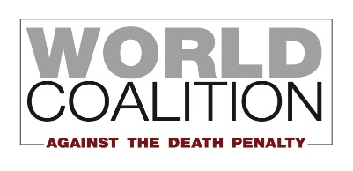

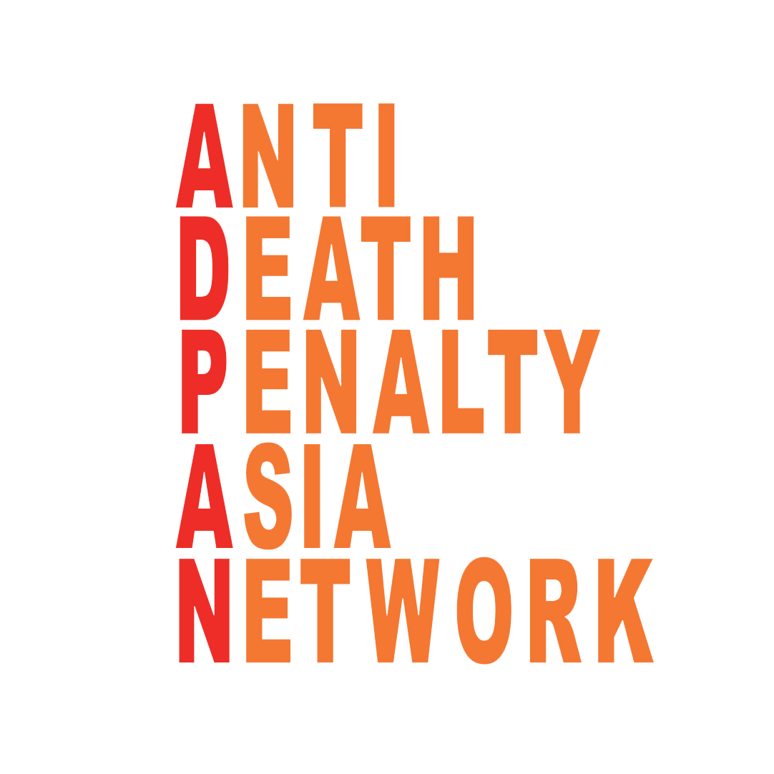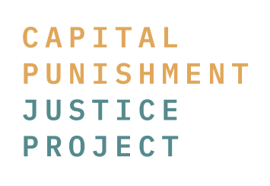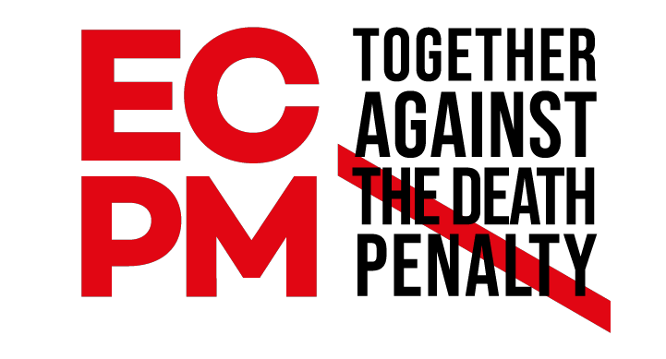

Executive Summary
- This report addresses Malaysia’s compliance with its obligations under the Convention on the Elimination of All Forms of Discrimination Against Women (CEDAW) with respect to the death penalty.
- Malaysia ratified CEDAW in 1995 and is obliged to report to the CEDAW Committee every four years. As of May 2022, however, Malaysia maintains reservations on Articles 9(2), 16(1)(a), 16(1)(c), 16(1)(f), and 16(1)(g) of the Convention – articles that grant women equal rights with men in respect to the nationality of their children and address matters related to marriage and family relations respectively.
- Malaysia fails to uphold its obligations under the Convention, as the country’s legal system often holds female defendants facing the death penalty to higher levels of culpability than their male counterparts. Courts have failed to consider gender-specific mitigation factors, including but not limited to a lack of consideration for women in economically precarious situations.
- This report examines Malaysia’s laws contributing to its death row population as well as its treatment of women in the criminal justice system and recommends questions to the Malaysian Government to better align its death penalty practices with its Convention obligations.

General Context

- Malaysia has had an unofficial moratorium on executions for drug offences since 2013, and an official moratorium for all executions since May 2018. In October 2018, the Malaysian Government had announced its intention to abolish the death penalty in its entirety. This was followed by Malaysia’s vote in favour of the UN General Assembly Resolution in December 2020 calling for a moratorium on the use of the death penalty with a view to abolishing it.

- After several delays, the government announced in December 2022 that it will table bills in Parliament in February 2023 to abolish the mandatory death penalty. However, contrary to its initial 2018 announcement, the bills do not aim at abolishing the death penalty entirely. Instead, they replace the mandatory nature of the death penalty by giving discretion to the courts to decide on an appropriate alternative punishment based on the facts of the case. Consequently, the courts can still impose the death penalty if they deem appropriate.

- Hence, while there have been no executions since March 2018, the use of the death penalty remains prevalent in Malaysia with 33 offences carrying the death penalty. Of the 33, at least 11 carry the mandatory death penalty with a majority of offenders convicted for the crimes of murder and drug trafficking.

- As of August 2022, Malaysia has 1,343 persons on death row, with women making up about 9% of the population (126 persons). Of the total, 903 were convicted of drug trafficking, 410 were convicted of murder, while 30 were convicted of other offences. 821 men and 28 women on death row are Malaysian; the remaining 396 men and 98 women are foreign nationals, including from Nigeria (90), followed by Indonesia (84), Iran (82), Philippines (54), India (44) and others. Gender-based data disaggregated by nationality, however, remain unavailable.

- Lack of data continues to obstruct local human rights groups’ efforts to monitor changes in Malaysia’s death row population as well as executions. With limited data, human rights groups are often unable to verify individuals who were executed unless i) the family of the person on death row reaches out for assistance, or ii) there is an announcement post-execution. There is only partial disaggregated data provided upon request by Members of Parliament through Parliament Questions and data requested are often not provided in full. With data limitations, it is often difficult if not impossible to ascertain the gender, ethnicity, nationality, or other identifying information of those executed.

- While data are scarce, information regarding the length of incarceration on death row does come to light, but this information is not disaggregated by variables such as gender. According to official data as of 2018, 5 people on death row have been incarcerated for more than 15 years – with 2 having been incarcerated for over two decades. For example, C.Y.F., a person on death row in Simpang Renggam, was sentenced to death in 1987 for drug trafficking. He is 61 years old and has been in prison for almost 36 years.

- Meanwhile, public opinion towards punishing death-eligible offences in Malaysia seems to be more nuanced than the laws suggest. In 2012, the Death Penalty Project, together with the Malaysian Bar Council, commissioned a public opinion survey on the attitudes of the Malaysian public towards the death penalty. A large majority of respondents supported either a mandatory or a discretionary death penalty for murder (91%). However, public opinion changed dramatically when presented with scenarios of the cases, some with aggravating features and some with mitigating features. Only 14% of respondents continued to favour the mandatory death penalty for murder for all the cases they were asked to judge. Therefore, when faced with reality, most respondents found that they favor discretion in deciding whether to sentence a person to death, rather than a law requiring the death penalty in all cases. The evidence shows that the level and strength of support among the Malaysian public for the death penalty for murder is lower than is perhaps commonly supposed, suggesting that public opinion in Malaysia should not be a barrier to the abolition of the death penalty.

General Compliance with the CEDAW Committee’s 2018 Concluding Observations

- This report demonstrates that, in the context of women charged with capital crimes and women sentenced to death, Malaysia has not successfully implemented the Committee’s relevant recommendations from its 2018 Concluding Observations.

- The Committee in its 2018 Concluding Observations expressed concern “about the existence of multiple barriers impeding women’s and girls’ access to justice . . . including discriminatory stereotypes and gender biases among personnel throughout the justice system.” The Committee recommended that Malaysian authorities “[s]implify the procedure for gaining access to legal aid,” and “[s]trengthen the gender responsiveness and gender sensitivity of the justice system, including by increasing the number of women in the justice system and providing systematic capacity-building for judges, prosecutors, lawyers, police officers and other law enforcement officials.”

- The Sixth Periodic Report describes the three types of legal aid bodies that provide legal aid services, but does not address the various barriers hindering women from accessing that legal aid. The report also states that “the Government has introduced training programmes. . . under the Judicial and Legal Training Institute,” but it provides no evidence that such programmes are systematic or are focused on the Convention.

- In its 2018 Concluding Observations, the Committee also recommended that Malaysia “[a]dopt a comprehensive strategy with proactive and sustained measures that target women and men at all levels of society . . . to eliminate discriminatory stereotypes and patriarchal attitudes.”

- The Sixth Periodic Report asserts that “Malaysia continues to adopt comprehensive strategies and measures to eliminate discriminatory stereotypes.” None of the strategies Malaysia describes, however, are connected to the criminal justice system.

- In 2018 the Committee also recommended that Malaysia “[a]dopt concrete measures to combat gender-based violence against women and girls, including the provision of mandatory, recurrent and effective capacity-building, education and training for members of the judiciary, lawyers and law enforcement officials.” The Sixth Periodic Report’s only reference to such training is the “Sexual, Women and Child Investigations Division (D11) under [the Royal Malaysian Police].” The Sixth Periodic Report says nothing about any efforts to build the capacity of the justice sector to uphold the rights of women-survivors of gender-based violence who are in conflict with the law.

Drug Trafficking & the Death Penalty in Malaysia

- Malaysia’s criminal code, through the Dangerous Drug Act of 1952 (“the Drug Act”), imposes the death penalty on those found guilty of drug trafficking. In contravention to international human rights standards, death remains the go-to sentence in cases of drug trafficking, with limited exceptions (see paragraph 7). The definition of “trafficking” depends on the weight of drugs found in the accused’s possession — a measure which varies by the type of drugs involved. Meanwhile, for amounts smaller than what constitutes “trafficking”, the Drug Act provides for both prison terms and corporal punishment. Some examples of the Drug Act’s rigid framework, as applied to certain drugs is provided below:

Heroin | Opium | Cocaine | Cannabis | Punishment
2-5 g | 100-250 g | 5-15 g | 20-50 g | 2-5 years in prison and 3-9 whip strokes
5-15 g | 250-1000 g | 15-40 g | 50-200 g | 5 years to life in prison and 10+ whip strokes
15 g + | 1 kg + | 40 g + | 200 g + | death or life imprisonment and 15+ whip strokes

- Under the Drug Act, simply finding prohibited drugs on someone’s person raises a presumption that they knowingly possessed the same. This contravenes the general legal principle, applied in most countries, of “semper necessitas probandi incumbit ei qui agit,” roughly meaning “he who asserts must prove.” It also contravenes Article 11 of the Universal Declaration of Human Rights, which enshrines the principle that anyone charged with a criminal offence must be presumed innocent until and unless proved guilty under the law. Section 37(d) of the Drug Act states:

any person who is found to have had in his custody or under his control anything whatsoever containing any dangerous drug shall, until the contrary is proved, be deemed to have been in possession of such drug and shall, until the contrary is proved, be deemed to have known the nature of such drug.

- Moreover, under Section 37(DA) of the Drug Act, if a given drug is found in a prohibitively large amount, that possession “shall be presumed, until the contrary is proved, to be trafficking in the said drug”. This means that convictions have been consequent of a “double presumption”: a presumption of possession followed by a presumption of trafficking under the Act. This “double presumption” was enshrined in a 2014 amendment to the Act which stated that “a presumption may be applied under this Part in addition to or in conjunction with any other presumption provided under this Part or any other written law.” While Malaysian courts found these double presumptions for drug trafficking unconstitutional, the Parliament has yet to repeal or amend this section of the statute. Hence, since the 2014 amendment is still in the criminal code, those accused still face arraignment and conviction under “double presumption”, and individuals wrongfully convicted by a “double presumption” may still be on death row.

- Once the quantity of drugs in possession is sufficient to presume trafficking, Section 39(B)(2) of the Drug Act provides that the offender shall receive “death or imprisonment for life and shall, if he is not sentenced to death, be punished with whipping of not less than fifteen strokes.” Prior to its 2017 amendment, Section 39(B)(2) stated that an offender “shall be punished on conviction with death.” Notably, this punishment applies regardless of the nationality of the accused.

- Judicial discretion provided following the 2017 amendment remains constrained. Under the current Section 39B(2A) of the Drug Act, in order for a defendant guilty of trafficking to not receive the death penalty, the court must be satisfied that: (a) the accused was not buying or selling the dangerous drugs at the time of arrest; (b) “there was no involvement of an agent provocateur in the case”; or (c) the role of the accused was limited to “transporting, carrying, sending or delivering dangerous drugs”; and (d) the accused “assisted an enforcement agency in disrupting drug trafficking activities within or outside Malaysia”. Its use, however, has been highly limited. From March 2018 to October 2020, only four of the 38 cases where a defendant was found guilty of drug trafficking did the defendant receive a prison sentence, rather than a sentence of death.

- The limited use of the 2017 amendment to Section 39(B) is largely due to narrow interpretations by the courts. Some courts require a defendant to meet all four criteria to avoid the death penalty. Further, courts apply a strict interpretation of “assistance” to require a defendant to disclose information that helps law enforcement identify drug trafficking networks and leaders. This is especially problematic since defendants, particularly women, are often low-level participants in the drug trade who are unlikely to possess information on the criminal organisation. Moreover, the assistance provision also creates incentives for an accused person to incriminate a co-accused, increasing the risk of wrongful convictions. Finally, judges cannot consider other mitigating and extenuating factors, such as the defendant’s background or socioeconomic circumstances. Thus, the death penalty is still effectively mandatory for most of those accused of drug trafficking.

- Additionally, the 2017 amendment to Section 39(B) of the Drug Act is not retroactive and, thus, does not apply to those already sentenced to death for the offence of drug trafficking.

Application of Drug Trafficking Laws Against Women in Malaysia

- The proportion of women on Malaysia’s death row is alarming. As of 2020, the figure (about 9%) is almost twice that of the global average (less than 5%). Further, data from 2019 indicated that the death penalty for drug offences in Malaysia disproportionately impacts women, with as many as 95% of all women on death row that year convicted of such offences compared to 70% of men.

- Recent case studies on women sentenced to death for drug trafficking highlight how economic insecurity drives vulnerable women to participate in the drug trade to gain quick money – a fact rarely recognised by judges at trial. Researchers have found many cases of “vulnerable” defendants that are “misinformed” about the nature of what they are carrying while travelling into and out of Malaysia.

- Meanwhile, other studies have revealed that women who intentionally traffic drugs — especially those who were single, divorced, or pregnant — decided to do so due to familial needs. A prominent case to illustrate this in Malaysia is the case of H.J., a single mother of nine children who was sentenced to death in October 2021 for possessing 114 grams of meth.

- In Southeast Asia, most women are sentenced to death for crimes that arise out of “their relationships, be it with their dependents, intimate romantic partners, friends, or relatives.” The Cornell Center on the Death Penalty Worldwide observes that “manipulative or coercive intimate relationships” can have an effect on the lives of women charged with drug-related offenses.

- Despite documented circumstances of women charged for drug trafficking, Malaysian courts have been found to be enforcing gender stereotypes on them. Research from the Cornell Center illustrates “the alarming extent to which women sentenced to death for drug offences experienced gender bias in criminal proceedings and violations of their right to a fair trial.” In jurisdictions such as Malaysia, the “presumption” shortcuts described in paragraphs 7-7 “dramatically increase the number of women who are sentenced to death while ignoring women’s position in the drug trade’s gender-stratified and predominantly masculine system. Women are disproportionately likely to be low-level drug couriers—and therefore ignorant of the type, quantity, and value of the drugs they are carrying.” Yet Malaysian courts rarely accept, or even fully consider, the “innocent courier” defence. The Cornell Center has uncovered many cases (not specific to Malaysia) in which judges “relied on gender stereotypes to interpret women’s circumstances and motivations” and were “reluctant to accept that a female defendant was tricked or pressured into transporting drugs unless she matches the profile of a helpless female victim.” In Malaysia, defendants – particularly vulnerable women who are foreign nationals – often assert that they did not know that they were transporting drugs. But courts treat this defence as a “mere afterthought” and accuse the defendant of “wilful blindness.”

- In another case involving a female defendant, a Malaysian court concluded that it was “very unlikely that the respondent, who is a diploma holder… could have placed herself in a situation where she could be exploited to commit a crime.” In a case involving a female foreign national, the Court of Appeal reversed her initial sentence of life imprisonment and imposed the death penalty on her as:

“She acted and portrayed herself like a damsel in her maiden love but, with respect, her background would indicate this most probably is a concoction of her real self. We noted she herself gave evidence that she was in the process of divorcing her husband and, on top of that, they have a child. Thus, it would not be too remote in finding that she fully knew the effect, danger, and pitfall of anyone madly and blindly in love.”

- Women charged for the offence of drug trafficking in Malaysia also face the likelihood of gender bias in court decisions. A 2018 study on incidence of judicial errors in capital punishment cases between 2013 and 2018 revealed that women are less likely to be acquitted in cases of drug trafficking compared to men on Malaysia’s death row, particularly if they are foreign nationals.

- The Cornell Center’s research “suggests that past trauma from abusive relationships affects the trajectories of many women who traffic drugs,” and that “women in prison for drug offenses are more likely than men to have endured adverse childhood experiences” but courts ignore such mitigating evidence.

- The Cornell Center’s research shows that “[w]omen—including those charged with drug offenses—often struggle more than men to retain skilled counsel due to gender disparities in socioeconomic status and educational attainment.” In many cases male codefendants have pressured women to sign papers attesting to their culpability and the innocence of the men—in many cases when the women are not literate.

The Death Penalty for Murder and Other Crimes

- Beyond drug trafficking, Malaysia’s various criminal statutes provide for either mandatory or discretionary death sentences, depending on the type of offence. Currently, the death penalty is retained under nine laws for 33 types of offences. The types of crimes where the death penalty is a mandatory punishment include: murder; certain types of possession(s) and/or discharging(s) of firearms in a “scheduled offence” (i.e., assisted suicide); and certain kinds of treason. The death penalty is discretionary for other types of treason; “consorting with a person carrying or having possession of arms or explosives”; and kidnapping.

a. Murder
- The Malaysian Penal Code provides a list of the criminal offences that still carry the death penalty. The offences relating to murder includes murder (Section 302) in which the death penalty is a mandatory punishment, attempt to murder while under a life sentence (Section 307(2)), kidnapping or abducting in order to murder (Section 364), and gang-robbery with murder (Section 396).

- Protection for persons with intellectual or psychosocial disabilities that may affect their culpability in law are often lacking. There are no explicit laws recognizing persons with intellectual or psychosocial disability and no protection or accommodation afforded within the criminal justice system. This often leads to circumstances where a person with medical history of intellectual or psychosocial disability is subjected to prosecution for murder without any safeguards. Furthermore, within the mandatory framework, any failure to make an insanity plea would result in a death sentence for murder irrespective of the established medical history and its impact on the accused’s actions.

Gender Based Violence & the Death Penalty
- Gender inequality and discrimination are key factors behind women on death row, particularly in the conviction of murder. In a 2018 study, the Cornell Center found that, in the global context, women are more vulnerable and most likely to be sentenced to death for criminal offenses committed within the context of gender-based violence and manipulative or coercive relationships with male co-defendants. Women sentenced to death for murder have overwhelmingly experienced prolonged domestic violence at the hands of a partner, spouse, or another family member. In many cases, the abuse has occurred repeatedly. Many women under sentence of death also come from disadvantaged socio-economic backgrounds.

- Women have been denied justice for the prolonged physical and sexual violence and abuse they have suffered, which preceded and triggered the offences for which they were convicted. This thus leads to unfair trials which often fail to consider mitigating factors such as long-term abuse, violence, and sexual assault. At a global level, sentencing courts typically fail to take into account a defendant’s experience as a survivor of gender-based violence or a victim of a manipulative or coercive relationship as mitigating factors during sentencing. Research also indicates that courts also fail to account for power dynamics and tactics of coercive control that may affect a woman’s involvement in and culpability for a crime.

- By retaining the death penalty for murder and sentencing these women to death, Malaysian authorities compel these women pay for the price of the authorities’ failures to i) address discrimination and ii) acknowledge their trauma and the realities and dynamics of domestic violence.

- Mental health issues such as post-traumatic stress disorder resulting from a history of domestic violence, depression, anxiety, and other mental health challenges need to be taken into consideration when sentencing women in capital cases. These issues require special consideration and even if the sentences are mitigated, women need to be able to access mental health support and rehabilitative care in prisons because their unique vulnerabilities remain.

- However, Malaysia has not formalised any legislative provisions providing explicit defence or mitigation for victims of domestic violence and persons with possible Post-Traumatic Stress Disorder (PTSD) arising out of a history of domestic violence can still be prosecuted for murder, which carries the mandatory death penalty. A 2021 follow-up study by the Cornell Center demonstrated that “fair trial principles dictate that courts should consider all relevant mitigating circumstances before imposing a sentence. In practice, however, many courts neglect gender-specific mitigation, and in states that impose a mandatory death penalty,” such as Malaysia, “courts may not consider any mitigating circumstances at all.”

- It is notable that certain cases of murder by victims of domestic violence do get prosecuted more leniently. In August 2020, a woman — who suffered from domestic violence — was sentenced to 42 months’ imprisonment and a fine of RM10,000 after the murder charges against her was amended. She served a prison term of 20-months before her charges were amended. But there is no evidence to suggest that this case represents a systematic approach to consideration of a defendant’s history as a victim of domestic violence at the time of sentencing.

b. Treason
- In Malaysia, treason is punishable by a discretionary death sentence. Specifically, either the death sentence or life in prison may be imposed upon “[w]hoever wages war against the Yang di-Pertuan Agong or against any of the Rulers or Yang di-Pertua Negeri.” “[A]ttempts to wage such war or abet[ting] the waging of such war” are punishable in the same manner. In addition, the Penal Code provides for a mandatory death sentence as per the following:
Whoever compasses, imagines, invents, devises or intends the death of or hurt to or imprisonment or restraint of the Yang di-Pertuan Agong or any of the Rulers or Yang di-Pertua Negeri, their heirs or successors, shall be punished with death and shall also be liable to fine.
- The Yang di-Pertuan Agong and Yang di-Pertua Negeri are the ceremonial governors of the Malaysian states without monarchs, and these statutory provisions outline crimes that are tantamount to treason. Though not enforced nearly as often as anti-drug laws, this provision did result in four executions (for “armed treason”) as recently as 2007, according to Amnesty International.

c. Assisted Suicide
- Malaysia’s criminal code provides for a discretionary death sentence for assisted suicide. Specifically, Section 305 of the Penal Code states the following:

If any person under eighteen years of age, any insane person, any delirious person, any idiot, or any person in a state of intoxication, commits suicide, whoever abets the commission of such suicide shall be punished with death or imprisonment for a term which may extend to twenty years, and shall also be liable to fine.

d. Kidnapping
- Any kidnapping that may possibly result in the kidnapped person being murdered is punishable with a discretionary death sentence. Section 364 of the Penal Code states as follows:
Whoever kidnaps or abducts any person in order that such person may be murdered or may be so disposed of as to be put in danger of being murdered, shall be punished with death or imprisonment for a term which may extend to twenty years and shall, if he is not sentenced to death, also be liable to whipping.

Malaysia’s Death Row and Detention Conditions

- Persons on death row are often subjected to long trial periods that could take up to 7 years with appeal further extending the trial periods. It is not uncommon for people under sentence of death to be imprisoned for more than 20 years on death row awaiting their fates. Data from 2018 indicates that the majority of those on death row are still in the trial process and have been in detention for less than 5 years (77%), with a substantial number serving more than 5 years and less than 10 (20%), with the rest having been in detention for more than 10 years.

- At least two persons were identified to have served a prison sentence of more than 20 years. One of the cases has been identified in 2022 with the person having served more than 34 years in prison, with at least 29 years on death row for the offence of drug trafficking.

- People on death row are usually kept in solitary confinement for 23 hours a day with an hour of ‘yard time’ per day, which is contrary to international human rights standards. General situations affecting the general prison population also affect those on death row, including limitations in amenities such as toothpaste, additional food, and access to phone calls without financial support by family members outside. It should be noted that there have been anecdotal reports from people on death row that some prisons occasionally allow for some personal items to be kept in their cells.

- The situation is usually much worse when compared to the general population as those on death row are not granted any opportunities for work in prison, denying them all opportunities for side income to supplement their expenses in detention. In addition, they do not have access to any education or rehabilitation programs. This renders them extremely vulnerable if they might be released after a successful appeal or a successful clemency application.

- Access to other prisoners in some circumstances can be based on the age and period in which the prison was constructed. Testimony from people on death row in newer prisons has described that their prison cells are structured in a way where the death row prisoners are able to hear and converse with one another. In contrast, people on death row in older prisons have described their cells as completely isolated and have stated that their only interactions with others are during the 1-hour yard time.

Detention of Women in Malaysia
- The situation and experience for women on death row may be notably different as the majority are likely to be detained at Kajang Women Prison.

- There is no access to gender-specific health care services, such as access to a gynaecologist or sufficient sanitary pads. This is contrary to the UN Rules for the Treatment of Women Prisoners and Non-custodial Measures for Women Offenders, also known as the Bangkok Rules.

- It should also be noted that gender segregation of prisons in Malaysia is problematic, especially when it involves transgender or intersex persons. Generally, the Prison Department designates the detention place of such persons based on the person’s sexual organs or the gender they were assigned at birth, resulting in a situation where trans women who have not had gender confirmation surgery are being detained in men’s prisons.

Clemency
- Article 42 of the Federal Constitution provides for two forms of clemency. Under Article 42(1), the heads of states have the power to grant pardons through a Pardon Board (comprising of the Attorney General, the Chief Minister or the Minister in charge of Federal Territories and three individuals appointed by the ruler) whereas Article 42(2) provides for power to remit, suspend, or commute sentences for any offence. While Section 42 of the Constitution and Sections 300 and 301 of the Malaysian Criminal Procedure Code provide some information on the composition of the Pardons Board and the power to suspend or commute sentences, the clemency process is very opaque. There are no laws or regulations describing clemency application procedures or the criteria used in such procedures.

- The clemency rate is relatively high (above 55%). However, people sentenced to death reported that they were not given information on the progress of their request. People sometimes spend ten years in detention before knowing the outcome of their request for clemency. In addition, some family members and lawyers state that people under death sentence hesitate to apply for clemency for fear that this will expedite their execution, worsen their mental health, and might also be taken as an admission of guilt.

Suggested Questions for the Government of Malaysia

- How many women, including trans women, have been charged with capital offenses or sentenced to death since 2018? For each woman, please provide demographic data including gender identity, age, ethnicity, nationality, age of any dependent children, as well as details regarding their conviction (crime, sentence issued at trial and/or on appeal, sentencing authority, year of sentencing/time spent on death row, and whether conviction is final), current sentence, status of any clemency proceedings, and current location.

- What are the policies in place to protect the rights and interests of pregnant persons and their physical and mental health when facing prosecution for death-eligible offences?

- What steps has Malaysia taken to abolish the death penalty and replace it with a penalty that is fair, proportionate, and consistent with international human rights standards? What steps has Malaysia taken to eliminate the mandatory death penalty for all crimes?

- What policies and procedures are in place to ensure that any person charged with a capital offence, including foreign nationals, has access to qualified legal counsel with prior experience in capital cases?

- What policies and procedures are in place to ensure that a person who is a foreign national charged with a capital offence has access to a qualified and independent interpreter at every stage of the criminal justice process – including every interaction and interrogation with police and prosecutors?

- What training is available to capital defence counsel representing women regarding gender-specific defences and mitigation in capital trials, encompassing trauma, gender-based violence, economic pressures, and family caretaking responsibilities? To what extent is the Legal Aid Centre equipped for these issues impacting women charged with capital offenses?

- What training is available to judges and other judicial officers presiding over criminal proceedings, particularly in capital cases, to educate them about the importance of considering gender-specific defences and gender-specific mitigation in capital trials, including trauma, gender-based violence, economic pressures, and caretaking responsibilities?

  - Considering the developments surrounding post-traumatic stress disorder (PTSD) and known cases of prosecution of a victim of domestic abuse for murder, are there any prosecution guidelines, sentencing guidelines or policies adopted by the Malaysian government to recognize the vulnerability and culpability of a victim of domestic abuse in similar circumstances?

  - Considering the possibility of women found in possession of drugs to be potential victims of human trafficking, are there any prosecution guidelines, sentencing guidelines, or policies adopted by the Malaysian government to recognize the vulnerability and culpability of a victim of human trafficking in similar circumstances?

- What steps, if any, has the State Party taken to codify gender-specific defences and mitigation in capital cases, encompassing women’s experiences of trauma, poverty, and gender-based violence?

- What policies are in place to ensure that women under sentence of death have timely and adequate access to general and female-specific healthcare and counselling, including access to sanitary and menstrual products?

- In what circumstances may women under sentence of death be kept in solitary confinement? To what extent do their detention conditions differ from the general conditions of detention for women in prison? How do prison authorities ensure that people under sentence of death are not held in solitary confinement in violation of Rule 45(1) of the Nelson Mandela Rules?

A regional network of organisations and individuals committed to working towards abolition of the death penalty in the Asia Pacific. Our role is to create wider societal support for abolition of the death penalty in the Asia Pacific region through advocacy, education, and network building. Contact: iecoordinator@adpan.org / www.adpan.org
Ministry of Women, Family and Community Development. (2022, May 9). Sixth periodic report submitted by Malaysia under article 18 of the Convention, due in 2022. Penerbitan Instrumen Antarabangsa KPWKM. Retrieved January 11, 2023, from https://www.kpwkm.gov.my/kpwkm/uploads/files/Penerbitan/instrument_antarabangsa/Discrimation%20against%20women%20CEDAW/CEDAW_C_MYS_6_8667_E.pdf [hereinafter Sixth Periodic Report].
Malay Mail, “Minister: Putrajaya to abolish death penalty”, 10 October 2018, <www.malaymail.com/news/malaysia/2018/10/10/ministerputrajaya-to-abolish-death-penalty/1681448>
UN General Assembly Resolution 73/175 of 17 December 2018
FMT Reporters, “Death penalty laws to be amended in February, says minister”, 21 December 2022 <https://www.freemalaysiatoday.com/category/nation/2022/12/21/death-penalty-laws-to-be-amended-in-february-says-minister/>, accessed 9 January 2023
The Star, “Azalina: Cabinet agrees to continue reviewing laws related to mandatory death penalty”, 22 December 2022, <https://www.thestar.com.my/news/nation/2022/12/22/azalina-cabinet-agrees-to-continue-reviewing-laws-related-to-mandatory-death-penalty>
SUARAM Human Rights Report 2018 <https://www.suaram.net/human-rights-reports?pgid=kvex92wb-16a603da-9bd2-4c3d-9be5-3afea14ea5b0>
FMT Reporters, ‘Mandatory Death Penalty to be Abolished’ (Free Malaysia Today, 10 June 2022) <https://www.freemalaysiatoday.com/category/nation/2022/06/10/death-penalty-to-be-abolished/> accessed 21 December 2022
Section 302 of the Penal Code
Section 39B of the Dangerous Drugs Act 1952
2nd August 2022, Question 71, Parliament reply, 2nd Meeting, 5th Term, 14th Parliament <https://parlimen.gov.my/files/jindex/pdf/JDR02082022.pdf> accessed 27 September 2022
https://www.malaymail.com/news/malaysia/2016/09/24/canny-ong-rapist-killer-finally-hanged/1212597
ibid.
ibid.
ibid.
Committee on the Elimination of Discrimination Against Women, Concluding observations on the combined third to fifth periodic reports of Malaysia, UN Doc. CEDAW/C/MYS/CO/3-5 (14 Mar. 2018), ¶ 13 [hereinafter Concluding Observations].
Id. ¶ 14(a), (c).
Sixth Periodic Report ¶¶ 11-12 .
Id. ¶ 13.
Concluding Observations ¶¶ 19, 20(a).
Sixth Periodic Report ¶ 19.
Id. ¶¶ 19-22.
Concluding Observations ¶ 24(f).
Sixth Periodic Report ¶ 32.
For more details see Antolak-Saper, N., Kowal, S., Lindsey S., Ngeow, C.Y. & Kananatu, T. (2020) Drug Offences and the Death Penalty in Malaysia: Fair Trial Rights and Ramifications. Clayton, Victoria: Monash University https://www.hri.global/files/2020/05/29/Malaysia_Death_Penalty_-_Fair_Trial_-_Monash_ADPAN.pdf
Drug Act at Section 39A(1)(a)
Id. 39A(1)(i)-(k)
Id. 39A(1)(e)
Id. 39A(1)(f)-(h)
Id. 39A(1)
Id. 39A(2)(a)
Id. 39A(2)(i)-(k)
Id. 39A(2)(e)
Id. 39A(2)(f)-(h)
Id. 39A(2)
Id. 37(da)(i)
Id. 37(da)(iv)-(v)
Id. 37(da)(ix)
Id. 37(da)(vi)-(viii)
Id. 37A.
See Benjamin Kho Jia Yuan, Double Trouble No More: The Striking Down of Double Presumptions for Drug Trafficking by The Federal Court, University of Malaya Law Review (July 14, 2019) available at https://www.umlawreview.com/lex-in-breve/double-trouble-no-more-the-striking-down-of-double-presumptions-for-drug-trafficking-by-the-federal-court (discussing PP v Alma Nudo Atenza [2019] 3 MLRA 1; [2019] MLJU 280).
Antolak-Saper et al., supra note 26.
NST Team, ‘No more mandatory death sentence soon as amendments to Dangerous Drugs Act passed in Parliament’ (30 November 2017, New Straits Times) <https://www.nst.com.my/news/government-public-policy/2017/11/309354/no-more-mandatory-death-sentence-soon-amendments> accessed 21 December 2022
Kowal, S., Chew, D. & Sato, M., ‘Discretion in law but not in practice: Malaysia’s Dangerous Drugs Act’ <https://www.monash.edu/law/research/eleos/blog/eleos-justice-blog-posts/discretion-in-law-but-not-in-practice-malaysias-dangerous-drugs-act> accessed 21 December 2022.
Ibid.
Cornell Center on the Death Penalty Worldwide, “No One Believed Me”: A Global Overview of Women Facing the Death Penalty for Drug Offenses, at 86 n.512 (Sept. 2021), http://fileserver.idpc.net/library/No-One-Believed-Me.pdf [hereinafter No One Believed].
Transformative Justice Collective, Explainer: What is the Certificate of Substantive Assistance?, May 29, 2021, https://transformativejusticecollective.org/2021/05/29/explainer-what-is-the-certificate-of-substantive-assistance/ (last visited Sept. 27, 2022).
Question 20, Parliament Reply, 3rd meeting, 3rd Term, 14th Parliament https://pardocs.sinarproject.org/documents/2020-november-december-parliamentary-session/oral-questions-soalan-lisan/2020-11-26-parliamentary-replies/20201126-p14m3p2-soalan-lisan-20.pdf/view accessed 5 Janaury 2023
Berrih C. & Ngeow, C. Y., ‘Isolation and desolation, conditions of detention of people sentenced to death in Malaysia’, (ECPM, 2020) https://www.ecpm.org/app/uploads/2022/08/OK-mission-enquete-Malaisie-GB-2019-280420-WEB.pdf accessed 16 January 2023.
Harry, L. (2022). Gender, globalisation, and the gallows: women sentenced to death for drug trafficking in Malaysia [PhD thesis]. University of Oxford. https://ora.ox.ac.uk/objects/uuid:d709b2c1-8ce4-4fc6-8e8d-8c4d1dee19ac
Antolak-Saper, N. & Kowal, S. (2020) ‘Drug trafficking, the death penalty and the vulnerable defendant’, Monash University Lens, 21 July. Available at: https://lens.monash.edu/@politics-society/2020/07/21/1380816/drugtrafficking-the-death-penalty-and-the-vulnerable-defendant
No One Believed, supra note 47.
Koh Ewe, A Single Mother With 9 Children Sentenced to Death for 114 Grams of Meth, VICE (Oct. 18, 2021) https://www.vice.com/en/article/epnjek/a-single-mother-with-nine-children-was-sentenced-to-death-for-114-grams-of-meth
Carolyn Hoyle & Lucy Harry, Compounded Vulnerability: Foreign National Women and the Death Penalty in Southeast Asia, Amicus J., Mar. 6, 2020, at 2.
No One Believed, supra note 47, at 22.
Id. at 5.
Id. at 7.
Ibid.
Antolak-Saper et al., supra note 26.
Id.
No One Believed, supra note 47.
Larasati, A., & Girelli, G. (2021). The Death Penalty for Drug Offences: Global Overview 2020. Retrieved January 10, 2023, from https://www.hri.global/files/2021/04/07/HRI_Death_Penalty_Report_2020_FINAL.pdf
Lim, C. H., Ngeow, C. Y., & Arivananthan, H. (2018). High Incidence of Judicial Errors in Capital Punishment Cases in Malaysia. Penang Institute. Retrieved January 10, 2023, from https://penanginstitute.org/wp-content/uploads/2018/10/oct_30_2018_CHTEAM_download.pdf
Ibid.
Id. at 32.
FATALLY FLAWED WHY MALAYSIA MUST ABOLISH THE DEATH PENALTY, Amnesty International (2019) https://www.amnesty.org/en/wp-content/uploads/2021/05/ACT5010782019ENGLISH.pdf
Id.
Anjumin, E., ‘Mentally ill man freed from charge of killing mother’ (New Straits Times, 22 September 2021) <https://www.nst.com.my/news/crime-courts/2021/09/729757/mentally-ill-man-freed-charge-killing-mothe> accessed 21 December 0222
Yahya, N., ‘Lelaki bunuh kekasih dihukum mati’ (Utusan Malaysia, 31 December 2021) <https://www.utusan.com.my/nasional/2021/12/lelaki-bunuh-kekasih-enggan-kahwin-digantung-sampai-mati/> accessed 21 December 2022
Cornell Center on the Death Penalty Worldwide, Judged for More Than Her Crime: A Global Overview of Women Facing the Death Penalty (Sept. 4, 2018). Available online at https://www.deathpenaltyworldwide.org/wp-content/uploads/2019/12/Judged-More-Than-Her-Crime.pdf [hereinafter Judged for More].
No One Believed, supra note 47, at 6.
Judged for More, supra note 74, at 4.
Ibid.
Women on death row face despicable discrimination (2022) Amnesty International. Available at: https://www.amnesty.org/en/latest/news/2021/10/world-day-against-the-death-penalty-women-on-death-row-face-despicable-discrimination/ (Accessed: January 17, 2023).
No One Believed, supra note 47.
What was formerly called “battered woman’s syndrome” “is now generally classed as a form of post-traumatic stress disorder (PTSD), a psychiatric condition first outlined in the third edition of the Diagnostic and Statistical Manual of Mental Disorders, and occasioned by exposure to events ‘outside the range of usual human experience.’” Evan Stark, Re-Presenting Woman Battering: From battered Woman Syndrome to Coercive Control, 58 Alb. L. Rev. 973, 974-75 (1995).
World Day against the death penalty - women and the death penalty (2021) The Death Penalty Project. Available at: https://deathpenaltyproject.org/world-day-against-the-death-penalty-women-and-the-death-penalty/ (Accessed: January 17, 2023).
No One Believed, supra note 47.
Gilllespie, T., ‘Samantha Jones: British woman who stabbed husband to death in Malaysia avoids death penalty’ (Sky News, 3 August 2020) <https://news.sky.com/story/samantha-jones-british-woman-who-stabbed-husband-to-death-in-malaysia-avoids-death-penalty-12041366> accessed 21 December 2022
Penal Code at Section 121.
Ibid.
Id. 121A.
Malaysia: Amnesty International Report 2007, Amnesty International, 2007, http://www.amnesty.org/en/region/malaysia/report-2007.
Penal Code at Section 305.
Id. 364.
Annmira Joseph, ‘Rights group seeks pardon for man on death row for 29 years’ (Free Malaysia Today, 24 November 2021) <https://www.freemalaysiatoday.com/category/nation/2021/11/24/rights-group-seeks-pardon-for-man-on-death-row-for-29-years/> accessed 21 December 2022.
Berrih & Ngeow, supra note 49, at 78.
Nelson Mandela Rules, Rule 43.1(a)/(b).
Prisons Regulations 2000, Regulation 181.
Berrih & Ngeow, supra note 49, at 78.
Ibid.
Id. at 61-62.
Prison-Insider, “Malaysia: detention conditions of people sentenced to death”, 18 January 2022, https://www.prison-insider.com/en/articles/malaisie-conditions-de-detention-des-condamnes-a-mort accessed 16 January 2023; Berrih & Ngeow, supra note 49, at 62.
Berrih & Ngeow, supra note 49, at 58.
Prison-Insider, supra note 98.

