BRIEFING ON QATAR FOR THE COMMITTEE ON THE RIGHTS OF THE CHILD, SESSION 95 PRE-SESSIONAL WORKING GROUP- May 2023
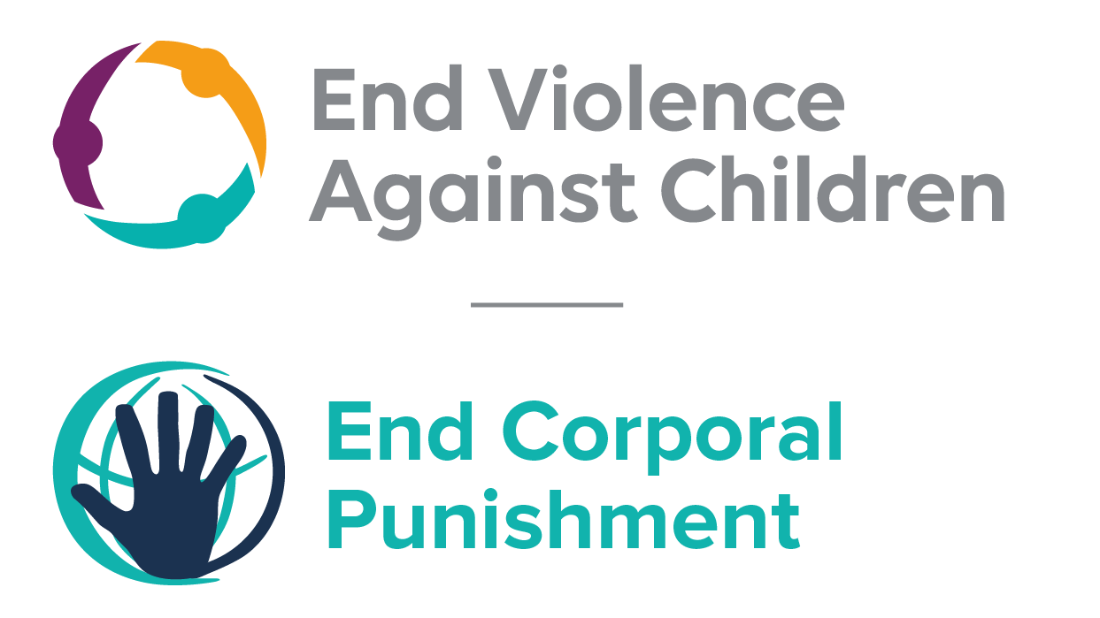
The Global Partnership to End Violence Against Children, February 2023

This briefing describes the legality of corporal punishment of children in Qatar. In light of the Committee’s General Comment No. 8 on “The rights of the child to protection from corporal punishment of children and other cruel or degrading forms of punishment”, its repeated recommendations on the issue and the importance of eradicating this form of violence given by the UN Secretary General’s Study on Violence against Children. Considering the recommendations to prohibit all corporal punishment made during the Universal Periodic Review in 2010 and 2019, as well as the global commitment to ending all violence against children in the context of the 2030 Agenda for Sustainable Development, we hope the Committee will:
• in its List of Issues Prior to Reporting for Qatar, raise the issue of corporal punishment of children, in particular asking what progress is being made towards the adoption of the Children’s Bill which should explicitly prohibit corporal punishment of children in all settings; and,
• in its concluding observations on the fifth-sixth report of Qatar, recommend that a legislation is enacted as a matter of priority to explicitly prohibit corporal punishment of children, in all settings including the home and repeal all provisions allowing the use corporal punishment by adults.

Summary of necessary legal reform to achieve full prohibition
Prohibition is still to be achieved in the home, alternative care settings, day care, schools and as a sentence for crime.
There appears to be no confirmation in the Penal or Family Codes of a “right” of parents and others to use corporal punishment in childrearing, but legal provisions against violence and assault are not interpreted as prohibiting all corporal punishment. Until 1971, Qatar was a British protectorate and it is likely that this relationship with the UK entailed an acceptance of the common law defence of “reasonable chastisement”. The near universal acceptance of corporal punishment in “disciplining” children necessitates clarity in law that no degree or kind of such punishment is acceptable or lawful. Legal defences of “reasonable chastisement” or similar – in legislation or common law – should be explicitly repealed, and prohibition enacted of all corporal punishment, however light and whoever the perpetrator.
Alternative care settings – Corporal punishment should be prohibited in all alternative care settings (foster care, institutions, places of safety, emergency care, etc).
Day care – Corporal punishment should be prohibited in all early childhood care (nurseries, crèches, kindergartens, preschools, family centres, etc) and all day care for older children (day centres, after-school childcare, childminding, etc).
Schools – The policy against the use of corporal punishment in schools should be confirmed through the enactment of legislation which clearly prohibits all corporal punishment in all education settings – public and private, religious and secular, and at all levels of education.
Sentence for crime – All judicial corporal punishment of persons under 18 at the time of the offence should be prohibited, including under Islamic Shari’a.

- Current legality of corporal punishment in Qatar
  - Home: Corporal punishment is lawful in the home. Until 1971, Qatar was a British protectorate and it is likely that this relationship with the UK entailed an acceptance of the common law defence of “reasonable chastisement”. Provisions against violence and abuse in the Criminal Code 2004, the Code of Criminal Procedure 2004, the Civil Code 2004, the Juveniles Act 1994, the Family Code 2006 and the Constitution 2003 are not interpreted as prohibiting all corporal punishment in childrearing.
  - In responding to recommendations on corporal punishment of children made during the Universal Periodic Review of Qatar in 2010, the Government stated that the recommendation to prohibit all forms of corporal punishment “has been put into effect”. We have been unable to verify this statement. In reporting to the UPR in 2014, the Government addressed only corporal punishment in schools (see under “Schools”). Qatar ratified the International Covenant on Civil and Political Rights in May 2018 but made a statement upon accession that it would “interpret the term “punishment” in Article 7 of the Covenant in accordance with the applicable legislation of Qatar and the Islamic Sharia”, thus attempting to avoid a ban on corporal punishment.
  - Reporting to the Committee on the Rights of the Child in June 2016, and again in May 2017, the Government stated that a Children’s Bill had been reviewed and would shortly be promulgated – we do not know whether prohibition of all corporal punishment is envisaged in this context. The National Human Rights Committee’s 2019 shadow report to the Universal Periodic Review reported that the Children’s Bill had been under discussions since 2012 and recommend enacting it as a matter of priority.

  - Alternative care settings: There is no explicit prohibition of corporal punishment in alternative care settings.

  - Day care: There is no explicit prohibition of corporal punishment in early childhood care and in day care for older children. The 2014 Act regulating Nurseries does not prohibit the use of corporal punishment.

  - Schools: The Code of Conduct for schools states that corporal punishment should not be used and there is a Ministerial Decree 2001 against its use, but there is no explicit prohibition in law. In reporting to the Universal Periodic Review of Qatar in 2014, the Government stated that in 2013 a Ministerial Decree against all violence in schools was adopted. The Government declared in 2019 that sanctions in schools did not “include practices that are inconsistent with human rights such as violence or corporal punishment”. Act No. 25 on compulsory education is silent on the issue.

  - Penal institutions: Corporal punishment is unlawful as a disciplinary measure in penal institutions. The Act regulating penal and correctional institutions, Act No. 3 2009, does not include corporal punishment among permitted disciplinary measures. It repeals the Prisons Act, Act No. 3 1995, which authorised flogging. It was reported that a Prison Act No. 3 of 2016 had been adopted and prohibited the use of flogging, but we have been unable to confirm this information.

  - Sentence for crime: Corporal punishment is lawful as a sentence for crime under Islamic law. Article 19 of the Juveniles Act 1994 explicitly prohibits flogging of juveniles under 16: “A juvenile over 14 and under 16 years of age who commits a serious or major offence shall not be sentenced to death, imprisonment with hard labour or flogging but rather to one of the following penalties….” Persons aged 16 and 17 are subject to the penalties in the Criminal Code, which do not include corporal punishment. Article 36 of the Constitution states that “no person may be subjected to torture, or any degrading treatment”.

  - However, according to article 1 of the Criminal Code, the Code and other criminal laws do not apply to Hudud or Qisas offences when the victim or the alleged offender is a Muslim: “Islamic Sharia provisions concerning the following crimes are applicable if the suspect or the victim is a Muslim: 1- The crimes such as theft, adultery, defamation, drinking alcohol and apostasy. 2- The crimes of retaliation and the blood money. Otherwise, the crimes and the punishments are determined due to this law and any other law.” Punishments for these offences under Shari’a law include flogging and amputation. The Government has confirmed that the prohibition of flogging of juveniles under 16 contained in article 19 of the Juveniles Act 1994 is not absolute in that article 1 of the Criminal Code takes precedence over the provisions of any other law.

  - The Government reported to the Committee Against Torture in 2018 that “the penalties of flogging, amputation and stoning had not been imposed in Qatar for some time”.

Recommendations by human rights treaty bodies and during the UPR

  - CRC: On three occasions, the Committee on the Rights of the Child has recommended to Qatar that legislation be enacted to explicitly prohibit corporal punishment in all settings: in its concluding observations on the state party’s initial report in 2001, on the second report in 2009, and on the third-fourth report in 2017.

  - CAT: The Committee Against Torture recommended that legislation be enacted to explicitly prohibit judicial corporal punishment, in its 2013 concluding observations on the state party’s second report, and in its 2006 concluding observations on the state party’s initial report.

  - CRPD: The Committee on the Rights of Persons with Disabilities recommended that the Government adopt a legislation to prohibit all corporal punishment, in its concluding observation on the state party’s initial report in 2015.
2.4 UPR: At the first cycle of the Universal Periodic Review of Qatar in 2010, recommendations to adopt legislation explicitly prohibiting corporal punishment were issued and partly accepted by the Government. A recommendation to prohibit all corporal punishment made in third cycle UPR in 2019 was accepted.

1 June 2010, A/HRC/14/2/Add.1, Report of the working group: Addendum, pages 3 and 4
24 June 2016, CRC/C/QAT/3-4, Third/fourth report, para. 60; see also 31 May 2017, CRC/C/SR.2205, Summary records of 2205th meeting, para. 42
[2019], Shadow report of the National Human Rights Committee in Qatar, pp 9-10
27 June 2014, A/HRC/27/15, Report of the working group, para. 114
1 March 2019, A/HRC/WG.6/33/QAT/1, National report to the UPR, para. 82
7 May 2018, CAT/C/SR.1630, Summary records of 1630th meeting, para. 16
22 March 2017, CRC/C/QAT/Q/3-4/Add.1, Reply to list of issues, para. 72
7 May 2018, CAT/C/SR.1630, Summary records of 1630th meeting, para. 43
6 November 2001, CRC/C/15/Add.163, Concluding observations on initial report, paras. 43, 44, 45, 46, 53 and 54
14 October 2009, CRC/C/QAT/CO/2, Concluding observations on second report, paras. 39 and 40
22 June 2017, CRC/C/QAT/CO/3-4, Concluding observations on third/fourth report, paras. 4, 21 and 22
25 January 2013, CAT/C/QAT/CO/2, Concluding observations on second report, para. 12
25 July 2006, CAT/C/QAT/CO/1, Concluding observations on initial report, para. 12
3 September 2015, CRPD/C/QAT/CO/1 Advance Unedited Version, Concluding observations on initial report, paras. 29 and 30
15 March 2010, A/HRC/14/2, Report of the working group, paras. 85(7), 85(14) and 86(10)
15 March 2010, A/HRC/14/2, Report of the working group, para. 86(10)
1 June 2010, A/HRC/14/2/Add.1, Report of the working group: Addendum, page 4; 18 June 2010, A/HRC/14/L.10, Report of the Human Rights Council on its fourteenth session, para. 214
11 July 2019, A/HRC/42/15, Report of the Working Group, para. 134(225)
27 August 2020/A/HRC/44/4/Add.1, Report of the working group, para. 65
30 August 2019, A/HRC/42/15/Add.1, Report of the Working Group: Addendum

