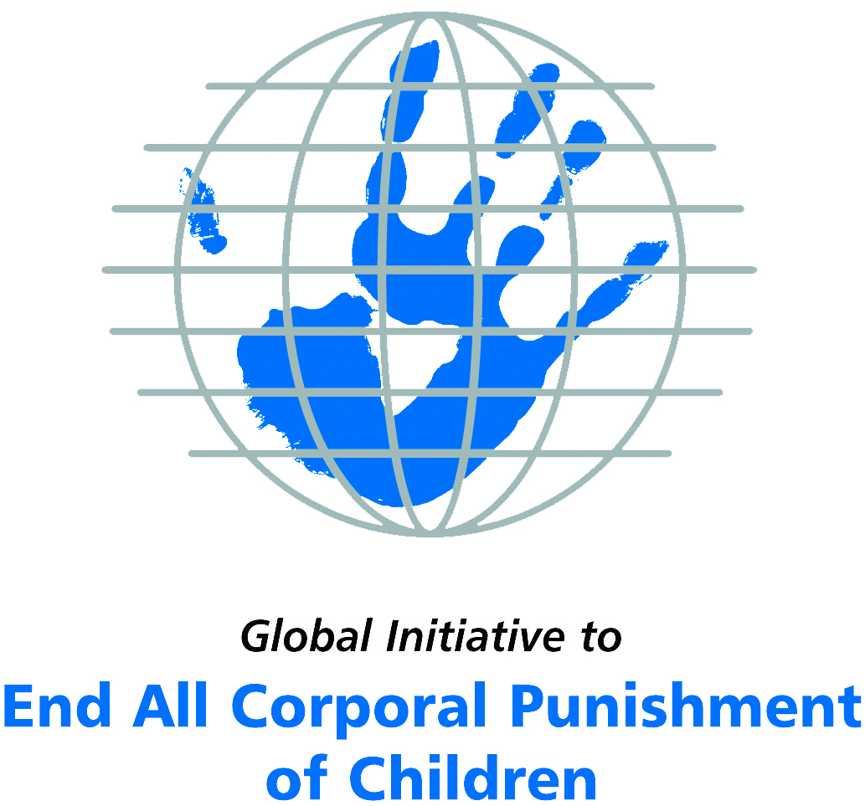
Briefing on the United Kingdom for the Committee on the Rights of Persons with Disabilities, 18th session, August 2017
From the Global Initiative to End All Corporal Punishment
of Children, July 2017

(a) About the Global Initiative to End All Corporal Punishment of Children
1. The Global Initiative (www.endcorporalpunishment.org) promotes universal prohibition and elimination of corporal punishment in fulfilment of states’ obligations under the UN Convention on the Rights of the Child and other international treaties. Our aims are supported by UNICEF, UNESCO, human rights institutions and international and national NGOs. Since 2002, the Global Initiative has regularly briefed the Committee on the Rights of the Child on this issue, and since 2004 has similarly briefed the Committee Against Torture, the Committee on the Elimination of Discrimination Against Women, the Committee on Economic, Social and Cultural Rights, the Human Rights Committee and the Human Rights Council; we have briefed the Committee on the Rights of Persons with Disabilities since the beginning of its work.

(b) Summary
2. Corporal punishment of children in the UK is unlawful in schools and as a sentence for a crime, but it is not yet prohibited in the home, in all alternative care and day care settings, and in penal institutions, in violation of the fundamental right of all children to protection from corporal punishment and other cruel or degrading forms of punishment.
3. With reference to articles 7, 15, 16 and 17 of the Convention on the Rights of Persons with Disabilities, and in light of the particular vulnerability of children with disabilities to corporal punishment by adults, the jurisprudence of the UN treaty bodies, the emphasis on eradicating this form of violence given by the UN Secretary General’s Study on Violence against Children and the importance of the issue to achieving target 16.2 on ending violence against children in the 2030 Sustainable Development Goals, we hope the Committee on the Rights of Persons with Disabilities will:
- recommend to the Government of the UK, in the Committee’s concluding observations on the initial report, that “legislation is drafted and enacted to explicitly prohibit corporal punishment of all children in all settings – including the home, all alternative care and day care settings and penal institutions – and that measures are put in place to ensure the law is properly implemented”.

(c) Detailed briefing
The right of children with disabilities not to be subjected to corporal punishment
4. The Convention on the Rights of Persons with Disabilities confirms that children with disabilities should enjoy all human rights and fundamental freedoms on an equal basis with other children (art. 7). The Convention also states that all persons have the rights to freedom from torture or cruel, inhuman or degrading treatment or punishment (art. 15), to freedom from exploitation, violence and abuse within and outside the home (art. 16) and to respect for their physical and mental integrity (art. 17). The jurisprudence of treaty monitoring bodies, led by the Committee on the Rights of the Child monitoring the Convention on the Rights of the Child, is clear that these rights put an obligation on states parties to prohibit and eliminate all corporal punishment of children, including within the family. However, the issue is not addressed in the UK’s initial state party report.
5. As confirmed in the UN Secretary General’s Study on Violence against Children, children with disabilities are particularly vulnerable to violence, including corporal punishment, and corporal punishment is a significant cause of impairment among children. Yet the obligation to prohibit corporal punishment is frequently ignored or evaded by governments. The near universal acceptance of violence in childrearing together with deeply held views that parents and other adults have a “right” to physically punish children can challenge efforts to achieve prohibition. It also means that corporal punishment – at least to some degree – is not readily perceived as violence in the same way as, for example, sexual and other socially unacceptable forms of violence.
6. The newly adopted Sustainable Development Goals under the 2030 Agenda include target 16.2 on ending all forms of violence against children. Violent punishment is the most common form of violence against children: ending it through the adoption and implementation of legislation prohibiting it in all settings including the home is critical.

The legality of corporal punishment of children with disabilities in the UK
7. Corporal punishment of children in the UK is unlawful in schools and as a sentence for a crime, but children with disabilities may lawfully be subjected to physical punishment in the home, in alternative care and day care settings, and in penal institutions.
8. Corporal punishment is lawful in the home. In England and Wales, section 58 of the Children Act 2004 provides for “reasonable punishment” of children. In Northern Ireland, article 2 of the Law Reform (Miscellaneous Provisions) (Northern Ireland) Order 2006 provides for “reasonable punishment”. In Scotland, “justifiable assault” of children is lawful under section 51 of the Criminal Justice (Scotland) Act 2003, defining blows to the head, shaking and use of implements as unjustifiable. Reporting to the Committee on the Rights of the Child in 2014, the UK Government stated that it “does not condone any violence towards children” but also that “our view is that a mild smack does not constitute violence”. However, changes in the charging standards introduced by the Crown Prosecution Service (CPS) have meant that in England and Wales the law now allows parents to raise the defence of “reasonable punishment” for bruises, cuts or weals (under section 58 of the Children Act 2004), and not only for a “mild smack”.
9. Corporal punishment is lawful in some alternative care settings. Corporal punishment is prohibited by regulation in residential care institutions throughout the UK (Children’s Homes Regulation Act 2001; Residential Establishments Child Care (Scotland) Regulations 1996). Residential care workers have been prohibited from smacking since 1991 (Children’s Homes Regulations 1991, SI 1991/1506, reg. 8). It is prohibited in foster care arranged by local authorities or voluntary organisations but is lawful in private foster care.
10. Corporal punishment is lawful in Northern Irish early childhood care and in day care for older children, including for children with disabilities. Corporal punishment is prohibited in day care institutions and childminding by regulations issued in 2002 for Wales and Scotland and in 2003 for England (Day Care and Child Minding (National Standards) (England) Regulations 2003, SI 2003/1996). Guidance states that physical punishment should not be used in day care institutions and childminding in Northern Ireland, but there is no explicit prohibition in law.
11. Corporal punishment is unlawful in schools. Corporal punishment was prohibited in all state-supported education in 1986. The prohibition was extended to cover private schools in England and Wales in 1998, in Scotland in 2000, and in Northern Ireland in 2003. But in 2014 the Government confirmed that legislation does not prohibit corporal punishment in “unregistered independent settings providing part-time education”.
12. Corporal punishment is lawful as a disciplinary measure in penal institutions. Corporal punishment is regarded as unlawful as a disciplinary measure in penal institutions, but there is no explicit prohibition. In secure training centres (privately-run centres for young offenders), the Secure Training Centre Rules 1998 (as amended in 2007) allow for the use of force (in the name of physical restraint) in maintaining order and discipline, including the infliction of physical pain (nose, rib and thumb “distractions”). The Rules were declared unlawful by the Court of Appeal in July 2008 but they have yet to be repealed.
13. Corporal punishment is unlawful as a sentence for crime. There is no provision for judicial corporal punishment in criminal law.
14. Opportunities for law reform. Successive Governments in Wales have since 2002 committed to removing the “reasonable punishment” defence and prohibiting all corporal punishment but initially lacked the power to do so. However, following an extension of devolution, the National Assembly of Wales has the power to remove the defence and in October 2011 voted to encourage the Government to introduce the necessary legislation. An amendment to the Violence Against Women, Domestic Abuse and Sexual Violence Bill that would have achieved prohibition was defeated in the National Assembly in 2015. The Assembly had voted to establish a Committee to consider how the repeal of the defence of “reasonable chastisement” could be implemented but it was never operational. During his speech to the new Welsh Assembly on 18 May 2016, First Minister Carwyn Jones announced that legislation which would “remove the defence of reasonable punishment” would be taken forward on a cross-party basis. On 27 June 2017, it was announced that a consultation on the removal of the defence would be launched in the coming 12 months with the aim to introduce legislation in 2018.
15. The Scottish Human Rights Commission recommended in September 2016 that the Scottish Government abolish corporal punishment. In May 2017, a consultation was opened in Scotland on the Children (Equal Protection from Assault) Bill. The Bill aims to repeal the legal defence of “justifiable assault” and ensure that children are equally protected from assault in law.

Recommendations by human rights treaty monitoring bodies and during the UPR
16. UN treaty bodies have made numerous recommendations to the UK to prohibit corporal punishment of children throughout the state party. Recommendations have been made by the Human Rights Committee (2015, 2008, 1995), the Committee on the Rights of the Child (2008, 2002, 1995), the Committee on Economic, Social and Cultural Rights (2009, 2002, 1997), the Committee Against Torture (2013, 1996) and the Committee on the Elimination of Discrimination Against Women (2013, 2008).
17. Recommendations to prohibit corporal punishment were also made during the Universal Periodic Review of the UK in 2008 and again in 2012. The Government rejected them on both occasions. The Government is yet to respond to further recommendations to prohibit which were extended in May 2017.
18. The European Committee of Social Rights has twice concluded that the situation in the UK is not in conformity with the European Social Charter because corporal punishment of children in the home is not prohibited.

Briefing prepared by the Global Initiative to End All Corporal Punishment of Children
www.endcorporalpunishment.org; info@endcorporalpunishment.org

Pinheiro, P. S. (2006), World Report on Violence against Children, Geneva: United Nations. See also Krug E. G. et al (eds) (2002), World Report on Violence and Health, Geneva: World Health Organisation
[2014], CRC/C/GBR/5, Fifth state party report, para. 12
[2014], CRC/C/GBR/5, Fifth state party report, para. 12
22 September 2016, Scottish Human Rights Commission submission to the UN Human Rights Council, rec. 10
See http://www.parliament.scot/S5MembersBills/John_Finnie_Final_Consultation_Document_pdf.pdf, accessed 16 May 2017
[July 2015], CCPR/C/GBR/CO/7 Advance Unedited Version, Concluding observations on seventh report, para. 20; 30 July 2008, CCPR/C/GBR/CO/6, Concluding observations on sixth report, para. 27; 27 July 1995, CCPR/C/79/Add.55, Concluding observations on fourth report, para. 8
20 October 2008, CRC/C/GBR/CO/4, Concluding observations on third/fourth report, paras. 6, 7, 38, 39, 40, 41 and 42; 9 October 2002, CRC/C/15/Add.188, Concluding observations on second report, paras. 8, 9, 35, 36, 37 and 38 ; 15 February 1995, CRC/C/15/Add.34, Concluding observations on initial report, paras. 16, 31 and 32
12 June 2009, E/C.12/GBR/CO/5, Concluding observations on fourth/fifth report, para. 24; 5 June 2002, E/C.12/1/Add.79, Concluding observations on fourth report, para. 36 ; 4 December 1997, CESCR/E/C.12/1/Add.19, Concluding observations on third report, paras. 16 and 28
[31 May 2013], CAT/C/GBR/CO/5 Advance Unedited Version, Concluding observations on fifth report, para. 29 ; 9 July 1996, A/51/44, Concluding observations on second report, para. 65
30 July 2013, CEDAW/C/GBR/CO/7, Concluding observations on seventh report of UK, paras. 34 and 35 ; 18 July 2008, Part of A/63/38, Concluding observations on fifth/sixth report, paras. 280 and 281
25 August 2008, A/HRC/8/25/Add.1, Report of the Working Group: Addendum, paras. 28, 29 and 30
29 May 2012, A/HRC/WG.6/13/L.7, Draft report of the Working Group, paras. 110(78), 10(79) and 110(80)
8 May 2017, A/HRC/WG.6/27/L.7, Draft report of the working group, unedited version, paras. 6(193), 6(194), 6(195), 6(196), 6(197), 6(198) and 6(199)
January 2012, Conclusions XIX-4 (2011); July 2005, Conclusions XVII-2

