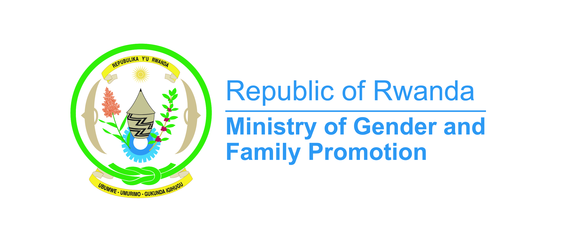
Rwanda Opening Statement Presented to the Committee on the Elimination of Discrimination against Women (CEDAW)-2024
- Excellency Chair of the CEDAW Committee,
- Excellencies,
- Distinguished delegates, and esteemed colleagues,

On behalf of the Government of Rwanda, it is my pleasure to address this distinguished assembly, reaffirming our unwavering commitment to the principles enshrined in the Convention on the Elimination of All Forms of Discrimination Against Women (CEDAW).
Rwanda's journey towards gender equality and women's empowerment has been shaped, in one way, by its tragic history and subsequent commitments in rebuilding a more inclusive society.
After the 1994 Genocide against Tutsi, the country had lost more than 1 million people, a bigger number had fled the country in addition to the destruction of infrastructure, economy and social fabric. Rwanda couldn’t afford another exclusion of particular group of its people to rebuild all of that… also women had contributed in the liberation of the country!
In our decision to unite, be accountable and think big, Rwandan women and men were expected to contribute equally to the development of the country despite the cultural norms and negative stereotypes pushing back women and girls in number of areas considered as for men only. The policy shift towards greater inclusion of women in Rwanda was rooted in the recognition of the vital role that women play in the social, economic, and political development of any country. At that time, the new government understood that promoting gender equality was not only a matter of justice but also a strategic imperative for sustainable development.
In response to these motivations, Rwanda implemented, among other various policies and initiatives to promote gender equality and empower women in leadership roles. One of the most notable initiatives was the adoption of a new constitution in 2003, which mandated a minimum of 30% representation of women in decision-making positions. This quota system has been instrumental in increasing the participation of women in politics and governance.
In the same line, Rwanda established the gender machinery institutions composed of the Ministry of Gender and Family Promotion, Gender Monitoring Office, National Women’s council and Forum of the Parliamentarian’s women to steer the advancement needed and ensure its sustainability
Currently, Rwanda leads globally in female representation in decision-making roles, with 61.3% of women in the parliament, 42.5% of women in the cabinet members and 30% of female mayors in the local government (Rwanda Governance Scorecard 2023). Economically, women are contributing to their own empowerment with 92% of women financially included versus 93% of men (Fin Scope Rwanda 2020).

Excellencies,
Today, I am pleased to share Rwanda's significant strides in promoting gender equality and women's empowerment, reflecting our dedication to building an inclusive and equitable society for all women and girls.
Rwanda prioritizes gender equality across various areas covered by the Convention, including education, employment, and financial services. This commitment is evident in substantial constitutional and legal framework improvements. Notable steps include extending parental leave and amending the Penal Code to reinforce protections against spousal sexual assault. Policies ensuring equal rights to land ownership, access to financial products for women in SMEs, and gender consideration in public servant recruitment further demonstrate our dedication to women's rights.
Economic transformation is crucial to national policy and development, with gender equality essential for inclusive socioeconomic transformation. In agriculture, where 77.7% of women rely on it as their primary income source, gender equality is promoted through sustainable practices and land ownership policies. Women only own 19% of land, men( only) 11%, and 49% is co-owned by both male and women. It is important to highlight that the Ministry of Agriculture has its specific gender mainstreaming strategy to further reinforce the role of women and girls in the sector.
Honorable Assembly,
Women's labor force participation increased from 46.2% in 2019 to 48.8% in 2023, while men's participation slightly declined from 65.3% to 64.1%. Despite this progress, women still face higher underemployment rates (34.4% vs. 29.6%) and an increase in unemployment (6% vs. 4.4%). Men still dominate managerial positions (73.9% vs. 26.1%) and executive roles (80.7% vs. 19.3%). One of the way we are remedying to this situation, we introduced a unique program in 2017, with the collaboration of the Private Sector Federation and our partners at the ONE UN, called the Gender Equality Seal Program. It is a program which consist in awarding public and private companies which have made significant progress in promoting gender equality at workplace. This month, we awarded the third cohort composed of 19 companies of different categories and we intend to keep the momentum as we look forward to implement our next strategy for transformation.
From 2019 to 2023, financial inclusion saw a marked improvement, with women's access to financial products increasing by 11% (from 63% to 74%), while men's access increased by 7% (from 74% to 81%). Despite this progress, there remains a significant gender gap in loans, with men taking 614,257 loans compared to 222,869 for women, borrowing 3.5 times more than women. To address this, the Government of Rwanda is leading efforts through the Private Sector Federation which has a special chamber for Women; putting in place strategies such as the Affirmative Finance Action for Women in Africa Strategy and the Women and Girls' Access to Finance Strategy to support women and girls in finance and create a conducive environment for financial institutions to work closely with women.
Rwanda is committed to universal digital literacy, with 82.4% of male-headed and 67.4% of female-headed households having at least one member owning a mobile phone. Women own 21.6% of smartphones compared to 26.7% of men, while owning 77.1% of ordinary phones with radios compared to 72.6% of men. We are aware of the positive outcome of owning a smartphone in this generation.
Gender-responsive budgeting ensures that gender equality and social inclusiveness are integral to public finance management. Supporting NGOs and regular meetings of the National Gender Machinery keep Rwanda aligned with international standards and national goals.
Excellencies,
The National Action Plan on Women, Peace, and Security (WPS) of 2023 highlights Rwanda’s commitment to integrating gender perspectives into peace and security initiatives. This plan enhances women's participation in peacebuilding processes and ensures their protection in conflict situations.Extensive community outreach programs, including gender dialogues in higher learning institutions, radio and TV shows, and training for religious leaders, aim to disseminate gender-transformative messages and combat violence against women and girls. Rwanda's gender-transformative programs, such as the Bandebereho and Indashyikirwa models, actively engage men and boys in gender equality efforts and are yielding tangible outcome hence the recent dissemination of the National Transformative Strategy engaging men and boys for gender equality promotion.
In regard to justice, decentralized legal aid services in collaboration with Civil Society Organizations (Haguruka, Legal Aid Forum,..) have significantly enhanced access to justice, achieving a high rate of amicable resolutions. Rwanda provides substantial financial and technical support to address gender-based violence (GBV). 44 Isange One Stop Centers countrywide offer comprehensive services to GBV victims free of charge, including medical care, psychosocial support, legal assistance, and forensic services.
Rwanda's comprehensive Counter-Trafficking in Persons Policy, led by the Ministry of Justice (MINIJUST), serves as a national reference for countering human trafficking. Enforcement of existing legislation and policies on trafficking in persons and labor recruitment companies is robust, with sustainable solutions addressing the root causes of trafficking.
In terms of education, the government has implemented various mechanisms to ensure equal access to education for boys and girls, including school feeding programs, access to 9- and 12-year basic education, and gender-friendly school environments. Female participation in TVET exceeds 40%, and there has been a commendable increase in girls' enrollment in STEM-related subjects.
In health, Rwanda has seen remarkable interventions that have improved health standards, particularly for women. Life expectancy has increased to 67.7 years for males and 71.2 years for females. Access to antenatal care services is very high, with 97.7% of women receiving care, and 64.1% of married women aged 15-49 use some form of birth control.
Rwanda aims to increase access to clean water from 87.4% to 100% and electricity from 34% to 100% in urban and rural areas by 2024. Currently, 82.3% of the population has access to clean drinking water, with no significant gender disparity in access.
In conclusion, Rwanda's achievements in promoting gender equality and women's empowerment demonstrate our commitment to building a more inclusive and equitable society. Through targeted policies, partnerships, and initiatives across various sectors, Rwanda continues to make progress towards realizing the full potential of its women and girls. These efforts drive sustainable development and social transformation, embodying the principles and objectives of CEDAW.

Thank you.

