List of issues in relation to the initial report of the United Kingdom of Great Britain and Northern Ireland*
  - Final UK-wide Civil Society Response

Introduction
- Deaf and Disabled People’s Organisations (DDPOs) in England, Wales, Scotland and Northern Ireland have compiled the following UK wide response to the UK List of Issues (LOI), which were agreed by the UNCRPD 7th pre-sessional working group 13th – 20th March 2017, and to the response to the LOI published by the Government of the United Kingdom of Great Britain and Northern Ireland (UKG) on 5 July 2017.

Devolution
- Northern Ireland (NI), Scotland and Wales are devolved nations of the UK.
- Schedule 7 to the Government of Wales Act 2006 defines the scope of the National Assembly for Wales’ legislative competence to make Assembly Acts, within areas where the Welsh Ministers exercise executive functions. Schedule 7 categorises the existing areas of policy responsibility devolved to the Welsh Government into 20 broad areas. These areas, known as “subjects” include education, health and social care, housing and transport.
- The Scottish Parliament is autonomous in several areas relevant to implementing the Convention. These include: health and social services (articles 19 and 25), housing (article 28), local authorities in Scotland, elections and the parts of social security which apply to disability benefits (articles 28 and 29). In relation to social security, new powers are being transferred between now and 2021. The Social Security (Scotland) Bill was passed in June 2017. This enables the Scottish Parliament to deliver devolved welfare benefits, including disability-related benefits, and to increase the value of benefits.
- The NI Assembly has power over devolved or transferred matters which include agriculture, education, housing, employment, health & social care, social security and policing and justice matters. Equal opportunities and discrimination are “transferred matters” under the NI Act 1998 unlike the Scottish Parliament or the National Assembly for Wales.

Social Model of Disability
- The UK Disabled people’s movement follows the social model of disability which is congruent with a human rights approach to disability and fully in accordance with the UNCRPD.

Terminology in this submission
- We use the term “Disabled people” rather than the term “persons with disabilities” as employed by the UNCRPD. This respects the theory, principles and terminology agreed by the UK Disabled people’s movement. It does not conflict with the definition of disability used by the UNCRPD. Similarly, we use “learning difficulties” and “people with “mental health conditions/support needs” rather than “people with intellectual/psychosocial disabilities” to respect the self-identification of these groups in the UK.

Executive Summary
- Disabled people are concerned about continuing retrogression of our rights under the UNCRPD as a direct consequence of UKG policy. The UKG response to the LOI does not present an accurate picture of life for Disabled people in the UK over the period since ratification of the Convention.
- We are concerned about a lack of commitment towards the UNCRPD and a human rights approach to disability by the UKG. The UKG response is notably poor in quality. In numerous places policy intent is described without evidence about how those policies are working in practice. There is also a general failure to adequately respond to substantive issues raised in the LOI questions. Self-advocates with learning difficulties have voiced a concern that the easy read version of the UKG response covers only a small amount of the information in the original.
- We have highlighted throughout this response where there are overlapping issues between the LOI and outstanding recommendations from the concluding observations of other UN committees, including those for the Convention on the Rights of the Child (CRC), the Convention on Economic, Social and Cultural Rights (CESCR), and the Convention for the Elimination of Discrimination against Women (CEDAW).
- There are significant differences in approach and implementation of Disabled people’s rights across the devolved nations of the UK. The Equality Act 2010 does not cover Northern Ireland (NI) and Disabled people in NI have less protection under the law than their counterparts in the rest of the UK. There has been no funding to support NI civil society involvement in the UNCRPD shadow reporting process.
- In Wales, the Framework for Action on Independent Living (2013), outlines how the Welsh Government fulfils its obligations under the Convention. Currently under review, engagement with disabled people, highlights that much more needs to be done to tackle barriers to independent living.
- Although Disabled people’s rights in Scotland are not being adequately met in many areas, the Scottish Government has committed to taking an overall more progressive approach than the UKG. This includes adoption on 2nd December 2016 of a national action plan to implement the UNCRPD. Financial mitigations of austerity impacts which disproportionately disadvantage Disabled people, such as the “bedroom tax”, are in place and Disabled people will be involved in the design of some elements of a new Scottish Social Security system.
- Across the UK, Disabled people are concerned about the potential consequences of leaving the EU. There is concern about the loss of access to redress under EU anti-discrimination legislation if this is not adequately enshrined in domestic law post-Brexit; and impacts on the social care workforce arising from restrictions on freedom of movement for EU nationals.
- The UKG continues to dismiss the findings and recommendations of the report of the inquiry procedure under article 6 of the Optional Protocol. This is effectively a dismissal of the lived experiences, views and interests of Disabled people in the UK which are accurately represented in the disability committee’s report.
  - Principle Areas of Concern and Recommendations

Articles 1 to 4 (Purpose and General obligations)

Article 4 – General obligations (issues 1a – 1f)
- (a) UKG promotes the social model of disability in name only. Legislation, policy and practice are underpinned by models that are inconsistent with a social model or human rights approach. Engagement is at best tokenistic and at worst carried out in bad faith.
- (b) While protection and promotion of human rights in overseas territories are primarily the responsibility of territorial governments, the UKG can and should take a more pro-active role in ensuring territorial governments do so, including with the UNCRPD.
- (c) The UKG has not “incorporated” its international human rights treaty commitments directly into UK law, but has undertaken, by way of ratifying them, to “translate” these commitments into UK law and policy. The UKG response does not address how UNCRPD implementation is coordinated across UK government governments, devolved administrations, local government and public bodies, nor how DDPOs are involved in this.
- (d) While the Equality Act 2010 is undoubtedly a centrally important vehicle for implementing the UNCRPD in Great Britain, its scope is insufficient to act as the sole legislative vehicle for guaranteeing that UNCRPD rights are enjoyed by Disabled people living in the UK. For example, it does not provide full protection of the right to live independently and be included in the community.
- (e) The UKG response does not answer the Committee’s question on the status of “Fulfilling Potential” as a national strategy for implementation of the Convention. The draft Programme for Government (PfG) in NI has no status as it has not been passed by the NI Executive.
- (f) The UKG response does not provide details as to whether reviews of the deaths of people with learning difficulties will be conducted by an independent body.

Proposed recommendations
We urge the State party to:
- Enshrine the UNCRPD in domestic legislation.
- Strengthen the role of the ODI to include a remit for scrutinising proposed legislation and policy from all UK government departments to check for consistency with a human rights based approach to disability. ODI must also ensure that it works constructively with the devolved administrations.
- Explain how the role of conditionality in welfare reform and the work of the BIT fits with a human rights model of disability.
- Require that NICE carry out a full review into their 2007 guideline on ME/CFS.,
- Move the ODI from its current departmental position within the DWP.
- Act on the 2012 recommendation of the Joint Parliamentary Committee on Human Rights.
- Conduct a systematic assessment of compliance with the UNCRPD, involving Disabled people, and set out areas for action in a clear and comprehensive strategy and plan.
- Institute new, fully independent and mandatory systems for investigating deaths of persons with mental health conditions or learning difficulties in the care of the State.

B. Specific rights

Article 5 – Equality and non-discrimination (issues 2a – 2d)
- (a) The UKG does not act to prevent discrimination in relation to pregnancy termination.
- (b) The UKG response makes no mention of concrete efforts to prevent and eliminate multiple and intersectional discrimination through the enforcement of the Equality Act or Section 75 in NI.
- (c) The UKG response makes no mention of concrete enforcement of the Equality Act, or on how often criminal penalties are used in cases of discrimination and racism against Disabled people belonging to ethnic minority groups.
- (d) The UKG response makes to commitment to close the legislative gap between NI and the rest of the UK in 7 years. Despite previous commitments no legislative timetable has been put in place.
- The UKG response does not state why it has not enforced Section 1 of the Equality Act 2010 requires all public bodies to take account of socio-economic disadvantage when making policy decisions.
- The UKG response does not state what mitigations are in place in relation to housing discrimination and how effective these measures are.

Proposed recommendations
We urge the State party to:
- Set a clear timetable for fully implementing the Equality Act 2010 across the whole of the UK, with emphasis on Section 1 concerning a socio-economic equality duty, and Section 14 concerning dual discrimination.
- Amend the Equality Act 2010 to include a duty to promote disability equality.
- Set a clear legislative timetable so close the legislative gap between disabled people in Northern Ireland and the rest of the UK.

Article 6 – Women with disabilities (issues 3a – 3b)
- (a) The UKG response does not address how gender-specific policies incorporate the social model of disability to break down barriers and meet the needs of Disabled women. Section 75 does not attempt to look at intersectionality.
- (b) The UKG response does not address how the data referred to in Annex A has influenced policy or been acted upon directly.
- (c) The UKG response does not address the “reasonable” and “best interests” defense to the offence of controlling or coercive behaviour in an intimate or family relationship (the Serious Crime Act 2015 s.76) and the impact on Disabled women.
- (d) The UKG response does not identify interventions that have been implemented to action the commitments made in the “England and Wales’ Violence against Women and Girls Strategy”, nor the NI strategy quoted in the response.
- (e) The UKG response makes no mention of obstacles faced by Disabled women including older women, asylum seeking women, Traveller women, and trans women in accessing medical care, including pre-natal and reproductive health services, as identified by CEDAW.

Proposed recommendations
We urge the State party to:
- Commit to an interim review of each of the strategies listed in the government’s response by reference to levels of domestic, emotional and sexual abuse of Disabled women.
- Amend the Serious Crime Act 2015 s.76 by removing the “reasonable and best interests” defense to abuse of women.
- Address how access to medical care for Disabled women will be improved including pre-natal and reproductive health services.

Article 7 – Children with disabilities (issues 4a – 4c)
- As a direct result of tax and social security decisions, child poverty is increasing yet the UKG has failed to act on recommendations from both the Committee on the Rights of the Child and the Committee on Economic, Social and Cultural Rights concerning measures to address child poverty.
- We welcome the commitments from Scotland and Wales to address poverty levels for Disabled children and their families, but NI does not have an overarching anti-poverty strategy and there are currently no programmes in place which specifically target poverty among families with Disabled children.
- (b) There is a vast amount of research that shows Disabled children are more likely to be bullied at school than their non-Disabled peers. There is no evidence that the measures cited in the UKG Response have done anything to address disability-related bullying at a national or school level.
- (c) We welcome commitments to improving the participation of Disabled children made in the legislation and policy cited by the UKG Response. However, there is no evidence of successful implementation.

Proposed Recommendations
We urge the State party to:
- Set interim targets and submit annual progress reports, documenting progress in eliminating child poverty – including that of Disabled children – to each of the devolved administrations for scrutiny.
- Adopt a human rights-based approach to disability including the setting up of a comprehensive strategy for the inclusion of Disabled children as recommended by the Committee on the Rights of the Child for the UK.

Article 8 – Awareness raising (issue 5)
- The UKG response makes no mention of the impact of the awareness raising measures listed, nor provides details as to how their impact will be measured. The response is also uncritical of any potential role UKG rhetoric and policy may have played in fostering negative attitudes towards Disabled people.

Proposed recommendations
We urge the State Party to:
- Assess and publish the results of the various initiatives aimed at increasing awareness of disability, and the mechanisms by which public organisations evidence or are not fostering relationships between Disabled and non-Disabled people.

Article 9 – Accessibility (issue 6)
- UKG outlines a range of initiatives aimed at achieving a more accessible built environment. Nevertheless, a 2016 House of Lords Select Committee Report stated that the needs of Disabled people still tend to be an afterthought despite twenty years of law requiring anticipatory reasonable adjustment in planning services and buildings. Only one in five rail stations in the UK have step free access and the Government recently deferred half of all station accessibility projects planned for the current period. Further to this, new laws around taxi discrimination will be unenforceable in many areas as the Government has failed to compel Councils to designate accessible vehicles.

Proposed recommendations
We urge the State Party to:
- Set a clear timetable for implementation of Part 4 s36 of the Equality Act 2010 relating to common parts of buildings without further delay and in NI strengthen planning policy so that it is enforceable.
- Actively consider removing the exemption of schools from the duty to make reasonable adjustment to physical features.
- Implement the House of Lords select committee on the Equality Act 2010 and Disability report recommendation that all local authorities follow the example of London and revise their planning policy to require a significant proportion of new dwellings to be wheelchair accessible or wheelchair adaptable.
- Redouble efforts to ensure the promotion and enforcement of accessibility law, regulations and standards, through use of levers including government procurement, resourcing of enforcement and embedding accessibility in inspection regimes in health, education etc.
- Remind local authorities of their obligations under the Equality Act 2010 to have due regard to equality between Disabled and non-Disabled people and the duty on public bodies in Wales and NI to consult with disabled people in the context of planning and street design.
- Ensure that all new public transport infrastructure meets the highest standards of accessibility and universal design, including the strict enforcement of deadlines to replace non-compliant vehicles.
- Consider rolling the accessible information standard out across public services.
- Increase investment in accessible infrastructure, establishing a road map to a fully accessible rail network.

Article 12 – Equal recognition before the law (issue 7)
- The UKG did not provide details on how Disabled people in immigration detention centres are identified as needing additional support, and how that support is accessed. The UKG made no mention of the pausing of resettlement schemes aimed at Disabled asylum seekers and refugees, or of reports the UKG has stopped accepting Disabled refugees because it lacks the capacity to provide them with support.

Proposed recommendations
We urge the State Party to:
- Develop options, with the full involvement of Disabled people, for reform or replacement of mental relevant mental health and incapacity legislation to ensure that new legislation fully complies with the UNCRPD.
- Ensure that Disabled people receive the necessary support to exercise legal capacity through supported decision making. Whilst new legislation in NI is in place there is still concern over compliance with Article 12, furthermore, there is no date for implementation or any resources to deliver on the Act.
- Detail the process used to identify detained asylum seekers who may need support to exercise legal capacity, to ensure they are provided with that support, and to not discriminate based on disability when processing asylum seeker applications.

Article 13 – Access to Justice (Issue 8a – 8d)
- (a) UKG has not detailed the ways in which it ensures that intermediaries, or “Appropriate Adults” in Scotland, ensure Disabled people can exercise full legal capacity. There is no comprehensive system of supported decision making at UK level, or in devolved administrations.
- (b) UKG have not noted the changes in eligibility criteria for Legal Aid, and the specific ways in which they impact disabled people’s access to justice. The Law Society however has confirmed that legal aid changes have “severely undermined access to justice, particularly for some of the most vulnerable in our society”. UKG proposes to increase the income threshold for “Help with Fees” (para. 55), but does not state when this will come into effect and in what way it will specifically remove barriers for disabled people.
- (c) While UKG outline reasonable adjustments for disabled jurors, no plans are indicated to ensure reasonable adjustments for Deaf people requiring a BSL/English interpreter to participate in the jury selection process on an equal basis with others. We do however commend Scottish Government for exploring how to support and enable those with communication difficulties to participate in jury service.
- (d) The HM Inspectorate of Probation concluded in 2014 that the needs of many people with learning difficulties are not considered when they are arrested by police, attend court and receive sentencing. The UKG response does not address the deficit in meeting the needs of people with learning difficulties through arrest and incarceration.

Proposed recommendations
We urge the State party to:
- Take concrete measures to ensure that Disabled people can access the legal system on the same terms as non-Disabled people, particularly addressing the discriminatory impact of Legal Aid restrictions under the Legal Aid, Sentencing, and Punishment of Offenders Act 2012.
- Make a firm commitment not to reintroduce fees for employment tribunal disability discrimination cases.
- We urge the State party and devolved administrations to replace the Appropriate Adult Scheme and the Registered Intermediaries scheme with more comprehensive systems of communication support which would fulfil Article 13 rights at each stage of the judicial process.

Article 14 – Liberty and security of the person (issues 9a – 9b)
- (a) It is welcome that the UKG is considering the recommendations of the Law Commission with respect to Mental Capacity and Deprivation of Liberty. However, it should be noted that the Law Commission has made clear that its proposals fall short of the requirements of UNCRPD Article 12.
- Whilst new legislation in NI is in place there is still concern over compliance with Article 12, furthermore, there is no date for implementation or any resources to deliver on the Act. The language used (lacking capacity) in relation to the legislation in NI demonstrates the lack of a right based approach, particularly for supported decision making.
- (b) The UKG response fails to address the question raised by the Committee and UK civil society shadow reports concerning the steep rise in detentions and compulsory treatment under the Mental Health Act 1983 and the disproportionate impact on people from BME communities. In addition, such detentions and compulsory treatment are a breach of Article 14.

Proposed recommendations
We urge the State Party to:
- Conduct an urgent review of current mental health legislation, designed to end the detention and compulsory treatment of people with mental health diagnoses.
- With the full involvement of Disabled people, develop options for reform or replacement the Mental Health Act, the Mental Capacity Act, the Mental Health (Care and Treatment) (Scotland) Act, and the Adults with Incapacity (Scotland) Act to ensure that new legislation complies with the UNCRPD. New legislation should ensure that safeguards enshrine the will and preferences of the person and promote independent living alternatives to institution-based services.

Article 15 – Freedom from torture or cruel, inhuman or degrading treatment or punishment (issues 10a – 10b)
- (a) The UKG response does not acknowledge that any use of restraints in care and particularly in educational settings must be considered a failure of effective practice.
- The UKG response does not acknowledge that any use of restraints in care and particularly in educational settings must be considered a failure of effective practice.
- (b) The UKG does not provide details of its response to the EHRC, or details as to where this response may be found. The NI Government has not responded at all.
- Serious cases of harm and neglect caused to Disabled prisoners due to failure to meet needs arising from their impairment continue to arise.

Proposed recommendations
We urge the State Party to:
- Make eliminating the use of restraints, both physical and chemical, in education, health and care settings the primary aim of restraint policies and its upcoming review into the use of restraints.
- Ensure the provision of reasonable accommodation and access to adequate treatment/support to Disabled persons serving custodian sentences in prisons.

Article 16 – Freedom from exploitation, violence and abuse (issues 11a – 11c)
- (a) Under-reporting of disability hate crime remains a problem across the UK, including within devolved administrations.
- Despite an Intermediaries scheme to support vulnerable witnesses throughout the UK, including Northern Ireland, and an Appropriate Adult Scheme in Scotland, prosecution for disability hate crime has not been increasing in Northern Ireland. There is no reference to disability hate crime in the draft Programme for Governance.
- (b) The UKG response to the use of ECT clearly demonstrates the lack of robust protections for Disabled people. The fact that the Mental Capacity Bill (NI) has not yet been implemented and that they are using the term “best interest” highlights that it is non-compliant with Article 16.
- Scottish Government’s new Equally Safe strategy makes little reference to disability, and contains no specific strategies to engage Disabled women.

Proposed recommendations
We urge:
- The Northern Ireland Executive to develop a specific strategy to deal with disability hate crime. It must also produce robust, human rights based policy on the use of ECT.
- The Scottish Government to establish a comprehensive and well-resourced strategy to ensure that Disabled women and girls are protected from the specific forms of hate crime which affect them.
- The UK Government to implement the recommendations related to disablist hate crime against Disabled children and young people, from the Equality & Human Rights Commission report of Disability Hate Crime (2012).

Article 17 – Protecting the integrity of the person (issue 12a)
- UKG has no stated plans to specifically criminalise/otherwise ban sterilisation that does not have the free and informed consent of the person undergoing sterilisation, and that given issues around the effectiveness of safeguards on compulsory treatment generally, specific regulations are required for sterilisation. The language used by the UKG in relation to best interest again highlight the lack of a rights based approach to supported decision making.

Proposed recommendations
We urge the State party to
- Criminalise or otherwise prohibit practices such as sterilization, abortion and contraception without the disabled person’s free and informed consent.
- Introduce training for medical professionals to ensure sterilization is not advised for disabled women and girls as an automatic form of menstrual management.
- Introduce training and practical information for disabled women and girls on the full range of options to effectively manage menstruation with dignity without necessarily resorting to sterilization.

Article 18 – Liberty of movement and nationality (issue 13a)

Proposed recommendations
We urge the State party to
- Explain the rationale for its reservation to Article 18, and how this is compatible with the object and purpose of the Convention.

Article 19 – Living independently and being included in the community (issues 14a – 14d, 15, 16)
- (a) There is no statutory right to independent living in the UK. There is no evidence to support the claim in the UKG Response that the Care Act 2014 is achieving its aims to place greater power in the hands of service users. There is overwhelming evidence, cited in the shadow reports, about the funding crisis in the social care system and how this is severely adversely impacting on Disabled people’s right to independent living. The UKG response suggests that it is not always possible to uphold Disabled people’s right to independent living (para.90).
- In Northern Ireland Disabled people have no legislative basis to ensure that they have control over the way social care is delivered and no statutory right to independent advocacy.
- (b) The UKG response does not address the question concerning the means by which Disabled persons can claim protection for their right to live independently. As noted in our shadow reports, we do not believe the current patchwork of UK law concerning human rights, anti-discrimination or care and support is sufficient to give effect to, and provide individuals with protection of their article 19 rights.
- Changes to legal aid have increased the barriers for Disabled people to claim protection of their right to independent living.
- (c) The UKG response does not address the question of how the State party calculates the costs of independent living vis-à-vis institutionalization of persons with disabilities.
- (d) The UKG response contains no information on how sufficient budget allocations for independent living are ensured.
- (e) The UKG response does not address the chronic shortage of accessible housing for Disabled people, highlighted in our shadow reports.
- (f) The UKG response lists measures put in place by the devolved governments following the closure of the Independent Living Fund (ILF). It is to be noted that these were implemented to mitigate the harmful impacts of UKG policy in closing the ILF.

Proposed recommendations
We urge the State party to:
- Enshrine UNCRPD Article 19 in domestic legislation as a freestanding right to independent living and being included in the community.
- Review the changes to legal aid that are now preventing Disabled people from claiming protection of their rights under the Care Act 2014.
- Where it has delegated responsibility for independent living funding to local authorities and devolved administrations, we urge the state party to provide:
  - sufficient independent living funding to enable each LA to meet the needs of Disabled people in their area,
  - guidance to LAs to clarify what they must do to meet the minimum requirements of Article 19, and provide examples of best practice, and
  - put in place a monitoring mechanism so that each LA reports on independent living funding and activities, enabling the UK Government to assure itself that it is complying with Article 19.
- We ask the state party to explain how it will ensure that support services are developed in response to the needs and wishes of Disabled people where those are contrary to the direction of development shaped by market forces.
- Involve Disabled people and our organisations in exploring how the lessons of the ILF can be built upon in developing a social care system able to support Disabled people’s right to independent living.
- Ensure that the consultation on funding for social care promised by Prime Minister Theresa May for later in 2017 addresses the independent living support needs of Disabled people in a way that complies with the UNCRPD.
We urge the Welsh Government to:
- Use the revised Independent Living Framework to commit to a human rights approach to tackling barriers to independent living and securing individual rights at national and local level through robust, enforceable and measurable actions.
We urge the Scottish Government to:
- establish an Independent Commission on Social Care. The Commission would explore new approaches to social care funding, which would help to ensure that Disabled people could live independently and be included in the community without a disproportionate financial burden.
We urge the NI government to:
- With Disabled people, establish an agreed definition of Independent Living and develop new policy and legislation that gives people real choice and control over their lives. This is vital given the current review of adult social care, the closure of ILF to new applicants and the reduction in funding for the Supporting People Programme

Article 21 – Freedom of expression and opinion, and access to information (issue 17)
- The UKG response refers to provisions under the BSL (Scotland) Act 2015. Deaf BSL users outside Scotland continue to lobby for equivalent legislation.

Proposed recommendations
We urge the State party:
- To introduce a BSL Act which will: improve access to adequate communication courses for family members, classmates and work colleagues of Deaf BSL users/people who are deafblind and reform education for Deaf BSL learners to guarantee access to bilingual teachers and appropriately qualified BSL/English interpreter support.
- Undertake a review of pressures on the BSL interpreting and communication support profession, including an assessment of the impact of framework agreements.
We urge the UK Government including the devolved administrations to:
- Ensure appropriate funding is available for the delivery of high quality BSL/English interpreters and communication support within all relevant settings, including education.

Article 24 – Education (issue 18a – 18f)
- (a) The UKG Response fails to recognise the wording of its Interpretative Declaration. The issue of “choice” is not consistent with the spirit and/or text of the UNCRPD. On the issue of qualified teacher status (para. 105), the Government claims that all teachers have this qualification, and yet we know that individual staff working in special schools are often not qualified and, in fact, can hold Teaching Assistance status only. In addition, Free Schools systematically endorse non-teaching qualification status.
- (b) The UKG response does not outline any initiative or evidence which shows progress towards providing real and lasting inclusive education. In practice the reverse is true. Year on year since ratification, there has been a decline in the numbers of Disabled children included in mainstream education in all devolved nations except Northern Ireland. Since the enactment of the Special Educational Needs and Disability (NI) Order 2005, and its emphasis on mainstream education, there has been a marked increase in the number of Disabled children in mainstream education. However there are concerns at the lack of resourcing, planning, participation and support available for these children.
- (c) The UKG response fails to mention the lack of data disaggregation which would show the real increase in the range of segregated education, both within and outside of mainstream education.
- (d) The UKG response sets out a series of initiatives that do not reflect reality for parents of Disabled children. Austerity measures and changes to education support criteria have meant that many families are receiving fewer community services. Without family focused support, there has been an increase in the numbers of disabled children being placed in full-time residential settings.
- (e) Disabled Students Allowance reforms have deterred potential Disabled students. There is a lack of clarity around disputes between HE providers and DSA when students are expected to follow complaints procedures through the Exceptional Case Process. Whilst UKG is attempting to encourage HE provision to readdress the balance of support using the EA2010, there is no legally enforceable guidance to monitor change.
- (f) Disability equality/awareness and inclusive education training and support for education and support staff is non-existent currently as all teaching training is focused on impairment/health condition, via SEN learning modules which are not mandatory.

Proposed recommendations
We urge the State party including devolved administrations to:
- Take steps to withdraw the Reservation and Interpretive Declaration to Article 24 of the Convention.
- Develop and implement a strategy with a transition plan setting out the steps from current segregated education arrangements to a fully inclusive education system, which ensures that parents of Disabled children have all necessary support to realise the right to and potential of inclusive education.
- Review what measures are being taken to ensure that Disabled pupils/students, are not discriminated against in education. This should include information on the qualifications processes, admissions criterion, exclusion policies and community SEND support arrangements.
- Disaggregate data for all separate provision for Disabled pupils/students, including special schools, special academies and free schools, Pupil Referral Units, Alternative Provision, and special Units within mainstream education.
- Set out plans to monitor the impact of reform to Disabled Students Allowance and the mitigating steps it will take if the reforms lead to a rise in disability discrimination by higher education institutions.
- Develop teacher training and workforce development programmes that enable inclusive learning and participation of Disabled pupils/students in mainstream education.

Article 25 – Health (issues 19a – 19g)
- (a) The UKG response does not provide information on the effectiveness of the national accessible information standards discussed, or on what supports are provided to ensure that informed consent is secured.
- (b) The UKG response does not detail how best practices in healthcare building design are followed.
- (c) The UKG response does not measure effectiveness of the provision for sexual and reproductive health. Our experience highlights a lack of accessible screening service, information and training for professionals so that disabled people can make informed choice.
- (d) The UKG response relates to a resource, it does not measure the impact, and the training is not mandatory.
- (e) The UKG response states the expectations it has for the NHS regarding health inequalities, but does not state what inequalities exist or how they can be addressed. There is very little data available on health inequalities, particularly for different impairment groups.
- (f) The UKG response does not demonstrate any measure of this policy or its practice. Our experience demonstrates the need for much more robust policy in supported decision making (not just anticipatory).
- (g) The UKG continues to deny a causal link between the removal of social security from Disabled people and suicides/avoidable deaths.

Proposed recommendations
We urge the State Party to:
- Monitor and report on the effectiveness of procedures to ensure Disabled people can have free and informed consent for medical treatment.
- Incorporate collection of health outcomes for Disabled people, including different impairment groups, into the NHS England performance assurance process.
- Introduce mandatory human rights and disability training health care professionals.
- To institute a reporting mechanism for health and social care professionals to flag to the DWP where benefit decisions have led to a substantial risk (SR) of harm.

Article 27 – Work and Employment (issues 20 – 21)
- (20) There has been an increase in the overall number of Disabled people in employment, but the gap in the employment rate between Disabled and non-Disabled people has been changing slowly and is currently 31.3 percentage points, a decrease of less than 2 points since 2013.
- The UKG refers to its “new Disability Confident scheme”, a voluntary scheme for employers which is a re-branding of the “Positive about disability” “Two Ticks” scheme of guaranteed interviews that has been in place since 1990. The “4000 employers signed up” to the scheme have been migrated from the Two Ticks scheme. The UKG response includes no evidence to demonstrate that the Disability Confident scheme has led to increased numbers of Disabled people in employment.
- (21) The UKG response provides no details on attempts to develop robust measurements of the disability pay gap.

Proposed recommendations
We urge the State Party to:
- Update on the development of proposals contained in the recent Green Paper including how it will mitigate the reduction in spending on specialist employment support.
- Clarify targets, including in devolved administrations, on closing the disability employment gap, and the strategies to achieve those targets.
- Review its Access to Work guidance and remove limitations on the support it will offer that disadvantage those with ongoing or higher support needs.
- Clarify the intended success measures of Disability Confident in reaching and influencing the behaviour and actions of employers, and to provide details of the impact of the programme to date on enhancing the employment prospects of Disabled people.
- Introduce levers to encourage the hiring of disabled people, including mandatory reporting by large firms and use of procurement as a lever.
- Conduct or commission research to develop robust methods of measuring the disability pay gap, to incorporate these results into the Annual Survey of Hours and Earnings, and act to address the significant pay gap between Disabled and non-Disabled people.

Article 28 – Adequate standard of living and social protection (issues 22, 23a – 23e)
- (22) (23b) The UKG response makes clear the state’s continued refusal to carry out a cumulative impact assessment on the impact of welfare reforms and tax policies on disabled people.
- This has also meant dismissing the Committee’s recommendation following its Inquiry into the UK under the Optional Protocol. We believe this is due to a lack of political will. We note that the UNCRPD’s recommendation following its Inquiry into the UK under the Optional Protocol has been dismissed by the state.
- (23 a) The UK welfare system is failing to deliver a comprehensive system of support for Disabled people.
- We note that devolved administrations, including in Scotland and NI, have made financial provisions to mitigate the impact of UKG welfare reform policies, particularly in housing. However, the full impact has not been mitigated and Disabled people remain financially disadvantaged locally. In NI the mitigations package in only in place until 2020 and in most cases only provides additional cash payment for up to one year.
- The claim that Universal Credit improves support for disabled people is completely false.
- (23d) The replacement of income related child poverty targets with statutory measurements of parental worklessness and educational attainment represents an effort to disguise the true extent of child poverty, including poverty of Disabled children. UKG has reduced benefits entitlement for disabled children under Universal Credit.
- (23e) The Work Capability Assessment is based on the academically discredited Waddell-Aylward bio-psycho-social model which is inconsistent with a human rights model of disability.
- We commend the Scottish Government for committing to ensure that assessments for disability benefits in Scotland are not carried out by private-sector companies. This should help to mitigate vested interests in assessment outcomes.

Proposed recommendations
We urge the State party to:
- Review the impact of welfare reform on rising levels of poverty amongst Disabled people, including Disabled children, Disabled women, and their families through a cumulative impact assessment of austerity measures; and reverse cuts which have a disproportionate and disadvantageous effect, as per CESCR recommendation 40.
- Overhaul the Work Capability Assessment and the assessment for Personal Independence Payment to remove the Mandatory Reconsideration stage and replace these with assessments based on a human rights model.
- Halt the roll out of Universal Credit.
We urge the UKG and all devolved administrations to:
- Promote greater national consistency with respect to the actions of local authorities to balance the rights of parents with learning difficulties and/or mental health conditions with the best interests of their children, including through the provision of timely and appropriate support.
- Develop and implement anti-poverty strategies, which contain a specific focus on Disabled people and their families.
We urge the NI Government to:
- Outline what it will do post 2020 when the mitigations package is to end.
- Measure the impact of UC on disabled children and their families.
- Explain how, in relation to sanctions, the NI Executive will ensure that an impact assessment is undertaken before any sanction is applied.

Article 29 – Participation in political and public life (issue 25)
- Current polling station access guidelines outline a range of access measures for voters with various impairments including wheelchair access. These are not consistently applied, with incidences of Disabled voters being turned away. Tactile voting devices are difficult to use and polling staff are often not aware of who can assist someone to vote.
- UKG put the Access to Elected Office (AEO) fund on hold after the May 2015 General Election. The fund was never introduced to Northern Ireland. The Scottish Government set up an AEO fund to assist Disabled candidates in the 2017 Local Authority elections.

Proposed recommendation
We urge the State party and devolved administrations to:
- Require that all polling stations are fully accessible and that Disabled people can vote in private and that the confidentiality of their vote is upheld.
- Reinstate the Access to Elected Office Fund, including Northern Ireland.

Article 30 – Participation in cultural life, recreation, leisure and sport (issue 24)
- The UKG response does not include examples of any concrete measures being taken to address the continuing failure of sports venues to fulfil their legal obligations on accessibility.
- The UKG response refers to the legacy of the Paralympic Games yet numbers of Disabled people engaged in sport and physical activity are decreasing.

Proposed recommendation
We urge the UKG to:
- To support the EHRC in their work to encourage Premier League football clubs to meet the accessibility standards set out in the Accessible Stadia Guide (ASG) published in 2003.
- To consult with Disabled people, our organisations and frontline community services about the reasons why fewer Disabled people are able to participate in sport and physical activity.

C. Specific Obligations

Article 31 – Statistics and Data Collection (Issue 26)
- (26) The EHRC detailed extensive gaps in available data on disability and Disabled people, which are not addressed in the UKG response. While disability equality is reported in various data releases, less data is available than for other equality groups.
- There is a complete dearth of data in relation to disability in Northern Ireland. This negatively impacts the formulation, implementation, monitoring and evaluation of policies and programmes to realise rights in the Convention.

Proposed recommendations
We urge the State to:
- Work with DDPOs to develop clear and consistent definitions of disability for use with official statistics and social surveys.
- Take concrete steps to address the data gaps outlined in the 2017 EHRC report “Being Disabled in Britain” and resume collecting data on Fulfilling Potential outcomes and indicators, ensuring data is provided from all the devolved governments.
- Encourage Research Council funded projects to collect data on disability issues wherever reasonably possible.
- Introduce an agreed, coherent set of published statistics which includes all information necessary to provide an overview of the number and features of the deaths of persons with mental health conditions or learning disabilities in the care of State or State-funded facilities.
We urge the Welsh Government to:
- Incorporate within the revised Independent Living Framework appropriate measurable disability equality indicators.

Article 32 – International cooperation (issues 27, 28)
- (27) The UKG response does not deal with the concerns that Disabled people throughout the UK have raised in relation to leaving the EU, for example the impact on Disabled people’s ability to recruit and retain Personal Assistants. The UKG does not state how EU funding such as ESF that support many disability employment programmes will be replaced after withdrawal. There is no commitment from the UKG on how it will involve Disabled people in the Brexit process to ensure the protection of rights or how it will progress rights so that Disabled people in the UK have the same protections as their European counterparts, for example, as under the European Accessibility Act.
- (28) The UKG response does not indicate how Disabled people are involved in any of the work highlighted in their response. The Department for International Development (DFID) has failed to engage, in any meaningful way, with UK DDPOs over the last six years.

Proposed recommendations
We urge the State party to:
- Explain how Disabled people will be involved in negotiations that affect our rights and in policies and programmes relating to the Sustainable and Development Goals (SDGs), ensure that funding available through the EU that supports the rights of Disabled people will be replaced.
- Carry out a full equality impact assessment of plans for freedom of movement ensuring no detrimental impact on disabled people’s independence through reducing the PA workforce.
- Ensure that the provisions of the EU Accessibility Act are mirrored in domestic legislation.
- Implement the recommendation of the Parliamentary International Development Committee report on Disability and Development to renew DFID’s links with UK DDPOs.

Article 33 – National Implementation and Monitoring (issue 29)
- Funding to monitor Disabled people’s human rights has been severely cut. A large part of the UK’s Independent Monitoring Mechanism, the Equality and Human Rights Commission (EHRC), received a 75% budget cut; and has recently been required to implement a further 25% cut.
- There is a lack of engagement with Disabled people in NI due to under-resourcing. Disabled people are not represented on either of the Commissions who make up the Independent Mechanisms in Northern Ireland. No resources have been made available to support the work of DPOs in NI to engage in the UNCRPD examination process.

Proposed recommendation
We urge the State party to:
- Strengthen the capacities of independent monitoring mechanisms and ensure the availability of resources for more comprehensive and effective monitoring of the Convention by Disabled people and our organisations.

Follow-up to proceedings under the Optional Protocol (issue 30)
- The UKG continues to dismiss the findings and recommendations of the report of the inquiry procedure under article 6 of the Optional Protocol. This is effectively a dismissal of the lived experiences, views and interests of Deaf and Disabled people in the UK as accurately represented in the report. The UKG cannot credibly demonstrate commitment to progressing the rights and lived experience of Disabled people while maintaining its position on the report. The UKG response underlines this apparent contempt for Deaf and Disabled people through its poor quality, lack of evidence base and failure to adequately respond to substantive issues highlighted in the LOI questions.

Proposed recommendations
We urge the State party to:
- Review its response to the report of the inquiry procedure under article 6 of the Optional Protocol.
- Widely disseminate the review and the original inquiry procedure report in a range of accessible formats.

Note of thanks
The content of this response, our earlier responses representing England and Wales, Scotland, and Northern Ireland specifically, and our original shadow reports have been shaped by a range of organisations working collaboratively across the United Kingdom. The authors are grateful to all for their contributions.


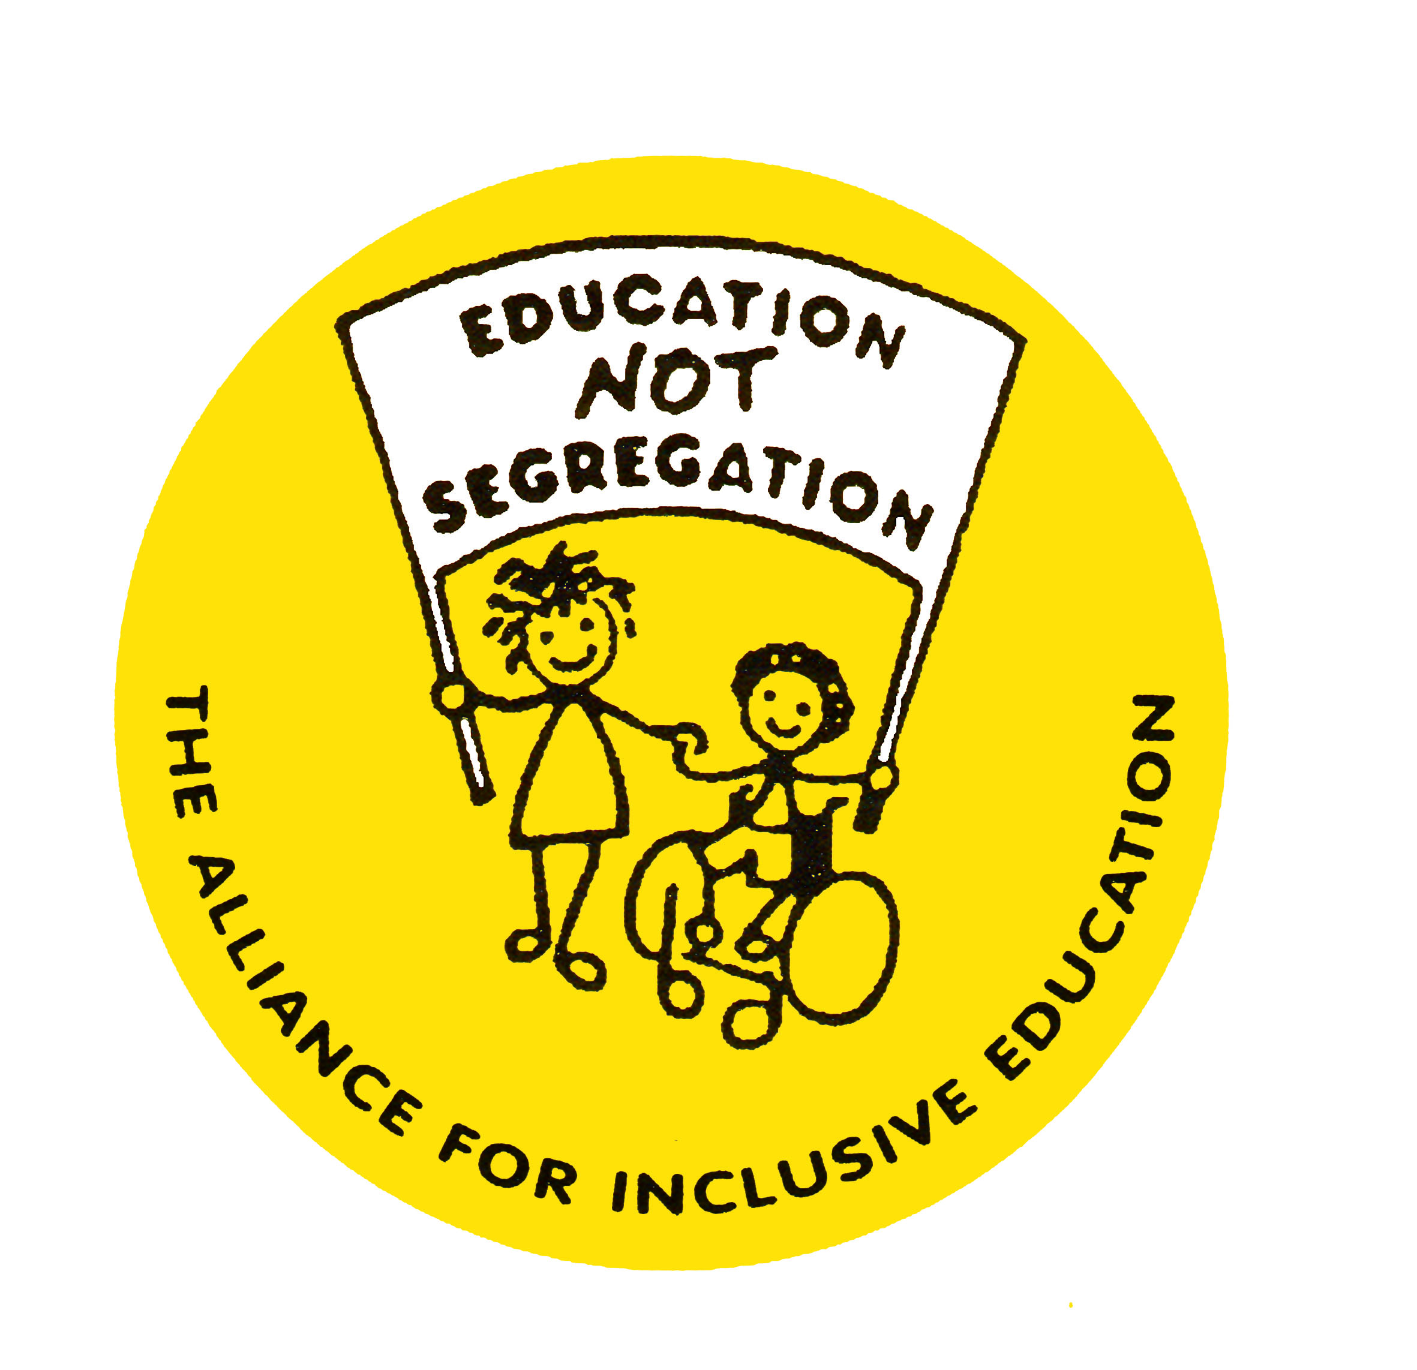
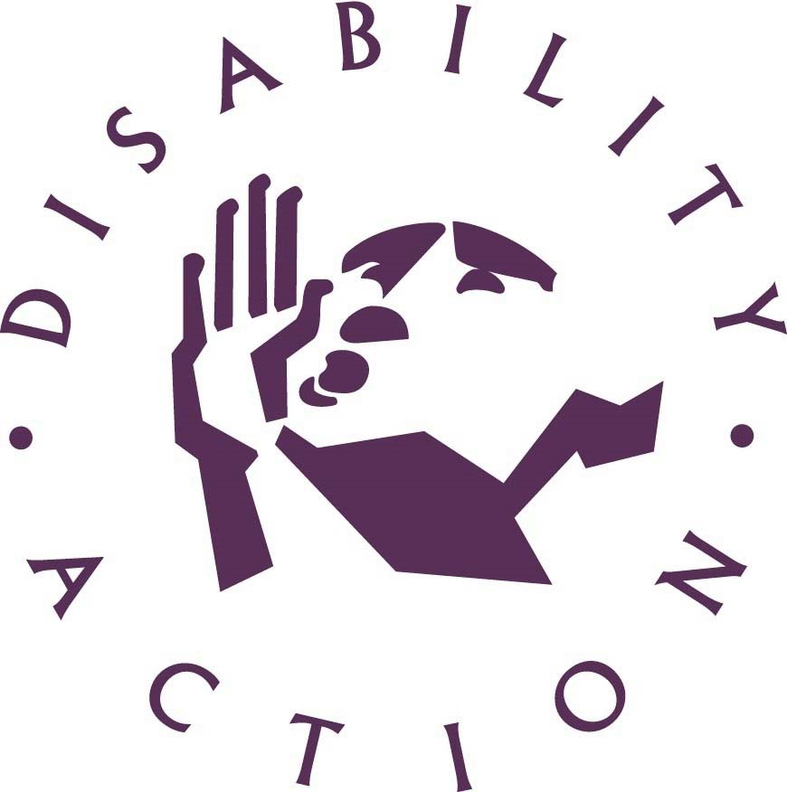
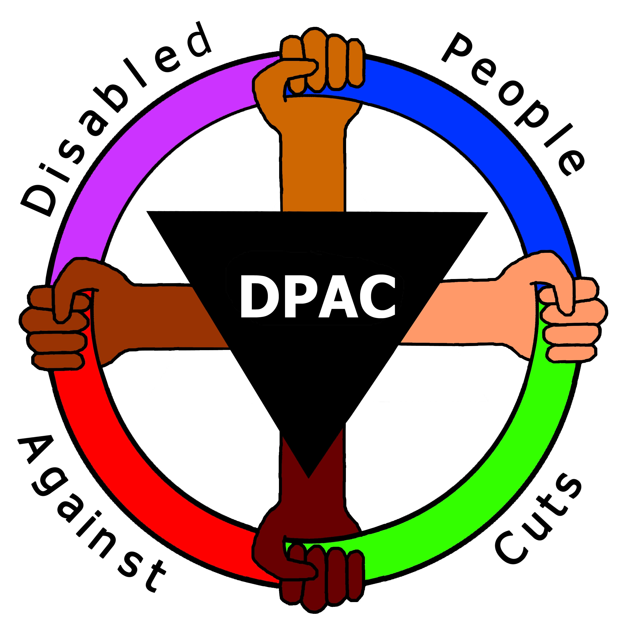
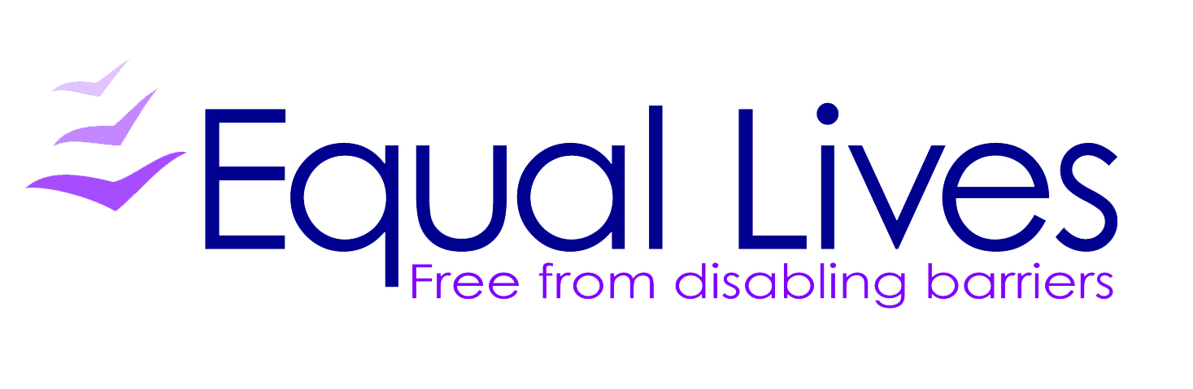
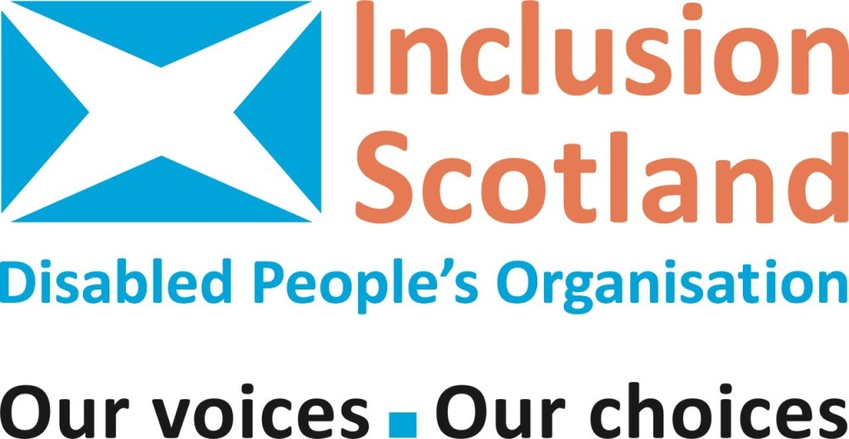


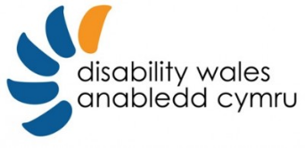
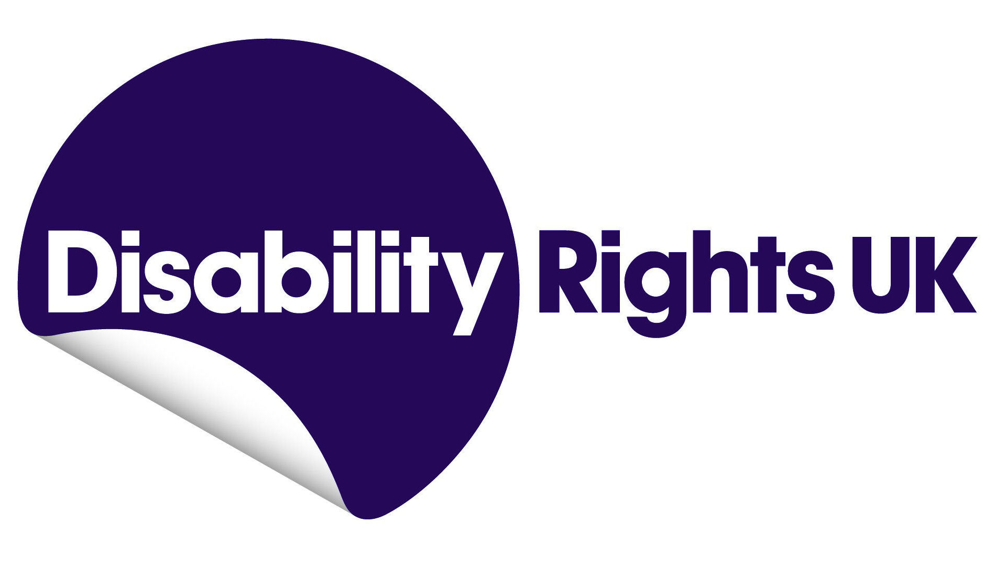

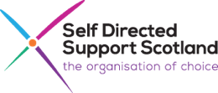

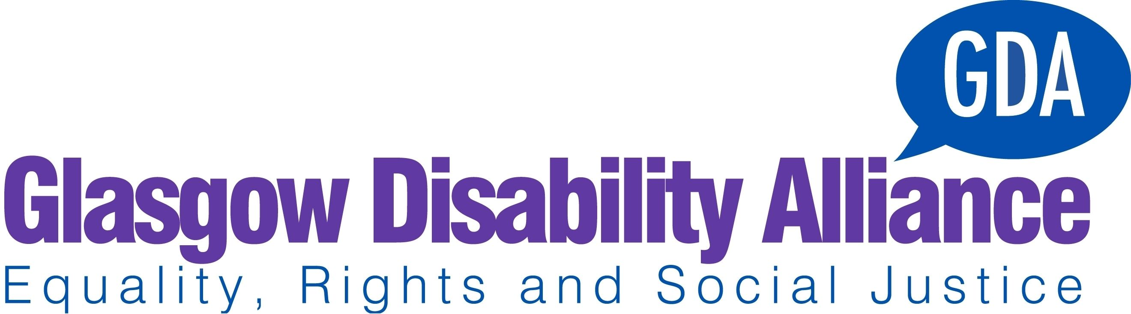
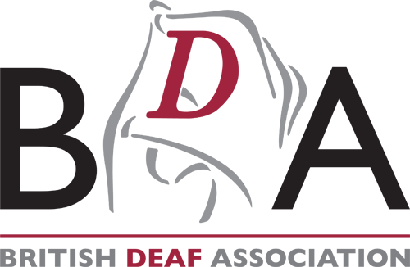




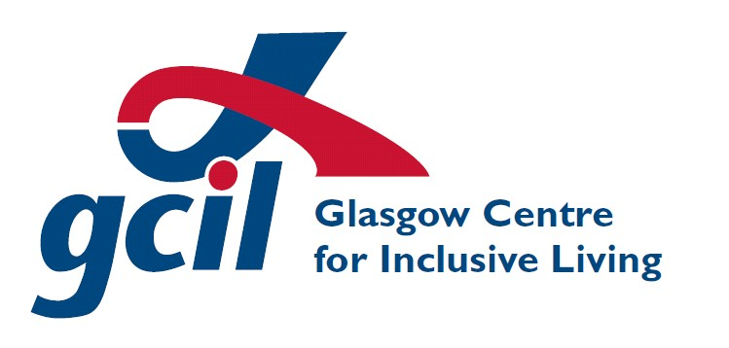

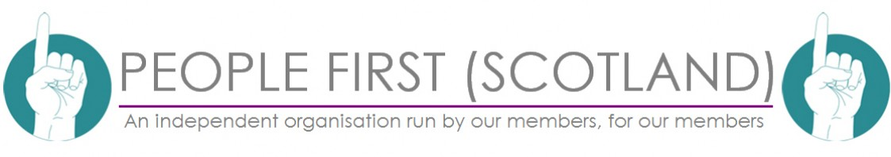

* Adopted by the pre-sessional working group at its seventh session (13-20 March 2017).
An organisation is a DDPO if: – Their Management Committee or Board has at least 75% of representation from Deaf and Disabled people and; At least 50% of their paid staff team are Deaf or Disabled people with representation at all levels of the organisation and; They provide services for or work on behalf of Deaf and Disabled people; They follow an equality and human rights approach in their work. We use the terminology “Deaf and Disabled people” to reflect the cultural model of Deafness whereby Deaf BSL users identify not as Disabled people but instead as a linguistic minority.
The following DDPOs have been involved in the development of this “Final UK-wide Civil Society Response’: Alliance for Inclusive Education, British Deaf Association, Disability Action Northern Ireland, Disability Wales, Disabled People Against Cuts, Equal Lives, Glasgow Disability Alliance, Glasgow Centre for Inclusive Living, Inclusion London, Inclusion Scotland, Lothian Centre for Inclusive Living, People First (Self Advocacy), People First Scotland, Scottish Council on Deafness, Self-Directed Support Scotland, Sisters of Frida, Transport for All and Voices of Experience. We would also like to thank the many Deaf and Disabled people and Deaf and Disabled People’s Organisations who attended the UNCRPD events facilitated by Disability Rights UK, Disability Wales, Inclusion Scotland and Disability Action Northern Ireland between August 2016 and January 2017; and the Equality and Human Rights Commission and Scottish Human Rights Commission for contributing funding towards those events.
Social Security (Scotland) Bill: http://www.parliament.scot/parliamentarybusiness/Bills/105267.aspx
For example, the bio-psycho-social model in welfare reform and the dominance of psychiatric and medical models in mental health legislation, policy and practice.
Disability organisations were dismayed when the UKG claimed to have consulted them over the introduction of mandatory Health and Work Conversations. The consultation had been carried out on the basis the HWC would be voluntary. Key recommendations put forward by charities and disability organisations to the Improving Lives consultation and supported by research such as the reversal of the cut to Employment Support Allowance (ESA) for those in the Work Related Activity Group (WRAG) have been ignored. https://www.disabilitynewsservice.com/boycott-call-after-dwp-wrongly-claims-dpos-helped-devise-punitive-work-scheme/
The Equality Act 2010 does not cover Northern Ireland.
Office for Disability Issues
Behavioural Insights Team, also known as the “Nudge Unit”. Training materials produced by the BIT for Work Coaches explain that the aim of the newly introduced Health and Work Conversation is to move claimants from a “Fixed Mindset” to a “Growth Mindset”, seeking to change the way Disable people feel, think and behave. Non-engagement will result in benefit sanctions. This approach effectively locates barriers to employment within the Disabled person, blaming the individual for unemployment and resultant poverty. It is wholly inconsistent with a social model/human rights model of disability. https://www.whatdotheyknow.com/request/403081/response/1002168/attach/8/HWC%20full%20e%20learning%20material%20BIT%20040117.pdf
National Institute for Health and Care Excellence, the regulatory body that sets out what treatments are approved and provided by the National Health Service.
Myalgic Encephalomyelitis / Chronic Fatigue Syndrome
This guideline currently includes Graded Exercise Therapy (GET) as the recommended treatment for all patients who have mild or moderate ME/CFS. Concerns have been raised that GET causes more harm than good. As covered in “DPAC / Inclusion London Follow Up Submission: response to the UNCRPD Inquiry and UK Government response (February 2017)”, the PACE trial findings which support the use of GET have been scientifically discredited. The results are, at best, unreliable, and, at worst, manipulated to produce a positive-looking result. The Department for Work and Pensions was one of the major funders of the trial, investing £5 million of public money, while the PACE Co-Principal Investigators had conflicts of interest by acting as consultants to large insurance companies and one (Professor White) had also worked as an advisor to the Department of Work and Pension with a special interest in reducing social security benefits to disabled ME/CFS claimants. This example highlights the influence of an approach to disability which prioritises the reduction of social security benefits and is inconsistent with a human rights model. “The PACE Trial: The Making of a Medical Scandal: Journal of Health Psychology Special Issue on The PACE Trial”, Vol. 22, No 9, Aug. 2017 http://journals.sagepub.com/toc/hpqa/22/9
Department for Work and Pensions. Disabled people’s rights in the UK have regressed due to welfare reform led by the DWP. We consider that a different government department (for example the Government Equalities Office) would be more appropriate for fostering a human rights approach to disability.
The Committee recommended that “the Government make a clear and unequivocal commitment to Parliament, equivalent to that which it has already given in relation to the UN Convention on the Rights of the Child, that they will give due consideration to the articles in the UN Disabilities Convention when making new policy and legislation, and in doing so will always consider relevant recommendations of the UN treaty monitoring bodies.” Implementation of the Right of Disabled People to Independent Living – Twenty-third Report of Session 2010–12 (March 2012) Joint Parliamentary Committee on Human Rights Para 110
As NI does not have single equality legislation, Section 75 legislation should provide the state with a vehicle to consider multiple discrimination and intersectionality. Section 75 and Schedule 9 to the Northern Ireland Act 1998 came into force on the 01 January 2000 and placed a statutory obligation on public authorities in carrying out their various functions relating to Northern Ireland, to have due regard to the need to promote equality of opportunity between people with and without a number of protected characteristics including disability. There is a clear legislative gap between NI and the rest of the UK in respect of disability.
The Disability Discrimination Act 1995 was amended by the Disability Discrimination Act (DDA) 2005 to place a duty to promote disability equality on all public authorities. This duty was not incorporated into the Equality Act 2010 which replaced the DDA.
Concluding observations on the seventh periodic report of the United Kingdom of Great Britain and Northern Ireland: Concluding Observation 52 http://docstore.ohchr.org/SelfServices/FilesHandler.ashx?enc=6QkG1d%2fPPRiCAqhKb7yhsldCrOlUTvLRFDjh6%2fx1pWB8bSlKfa34XmmIN3lG11hwWhjFqrEprJHQfoipZTwnVkhDALmzaR6gCklPapM2exTMh89SX7GUOJHbH%2bN8Qq9U
As a direct result of tax and benefit decisions made since 2010, the Institute for Fiscal Studies project that the number of children in relative poverty will have risen from 2.3 to 3.6 million by 2020. https://www.ifs.org.uk/publications/7448
The Committee on the Rights of the Child Concluding Observations on the fifth periodic report of the United Kingdom of Great Britain and Northern Ireland published in June 2016 made a specific recommendation concerning an adequate standard of living. Recommendation 71 c) urges the State party to “Conduct a comprehensive assessment of the cumulative impact of the full range of social security and tax credit reforms introduced between 2010 and 2016 on children, including children with disabilities;” This remains outstanding. http://docs.wixstatic.com/ugd/8a2436_a92ffde1bb174cfea8295ef365084988.pdf The UKG has stated that it will not respond to the Concluding Observations of the Committee on Economic, Social and Cultural Rights’ sixth periodic report of the United Kingdom of Great Britain and Northern Ireland until 2021. Recommendation 48 reads: “The Committee recommends that the State party take steps to introduce measures to guarantee targeted support to all those living in poverty or at risk of poverty, in particular persons with disabilities, persons belonging to an ethnic, religious or other minorities, single-parent families and families with children and adopt an anti-poverty strategy in Northern Ireland. The Committee also urges the State party to develop a comprehensive child poverty strategy and reinstate the targets and reporting duties on child poverty. In that regard, the Committee draws the attention of the State party to its statement on poverty and the International Covenant on Economic, Social and Cultural Rights, adopted on 4 May 2001 (E/C.12/2001/10). http://docs.wixstatic.com/ugd/8a2436_6c461f9046454918a815e7b51807c710.pdf
A selection of relevant research includes: Primary school pupils with special educational needs are twice as likely as other children to suffer from persistent bullying. (Institute of Education 2014) http://www.cls.ioe.ac.uk/news.aspx?itemid=2977&itemTitle=Children+with+special+educational+needs+twice+as+likely+to+be+bullied%2c+study+finds&sitesectionid=27&sitesectiontitle=News Young people with speech difficulties are three times more likely to be bullied than their peers (Savage 2005) http://www.tandfonline.com/doi/abs/10.1080/02667360500035140 83% of young people with learning difficulties reported experiencing bullying (Mencap 2007) https://www.mencap.org.uk/sites/default/files/2016-07/Bullying%20wrecks%20lives.pdf Disabled Children and young people in schools were more likely to report receiving an online interpersonal victimization in the past year, even after adjusting for other explanatory factors. (Wells, M. and Mitchell, K.J. 2013) http://journals.sagepub.com/doi/abs/10.1177/0022466913479141
Committee on the Rights of the Child Concluding observations on the fifth periodic report of the United Kingdom of Great Britain and Northern Ireland called upon the UK to: “adopt a human rights-based approach to disability, set up a comprehensive strategy for the inclusion of children with disabilities” (a) Ensure full respect of the rights of children with disabilities to express their views and to have their views given due weight in all decision-making that affects them, including on access to and choice of personal support and education; (b) Set up comprehensive measures to further develop inclusive education, ensure that inclusive education is given priority over the placement of children in specialized institutions and classes and make mainstream schools fully accessible to children with disabilities; (c) Provide children with disabilities with a comprehensive and integrated package of services for transition to adulthood, from a sufficiently early stage, by coordinating legislation, policy and programmes across relevant sectors, and ensure fully informed decisions by children with disabilities on their personal choice in the transition, by involving them in the design of services and by providing advice and information on available options.”
“We believe that other local authorities should follow the example of London and revise their planning policy to require a significant proportion of new dwellings to be wheelchair accessible or wheelchair adaptable (standard M4(3)), and all other new dwellings to comply with optional standard M4(2).” The House of Lords select committee on the Equality Act 2010 and Disability report (Recommendation 51; Paragraph 496)
Harriet Algerholm, “Disabled Child Refugees Entry to UK through Resettlement Scheme Suspended by Home Office,” The Independent, February 9, 2017, http://www.independent.co.uk/news/uk/home-news/Disabled-child-refugees-uk-suspend-entry-home-office-resettlement-unhcr-united-nations-lord-dubs-a7571451.html.
On 26 July 2017 the Supreme Court ruled that the introduction of employment tribunal fees was unlawful under UK and EU law. Paragraph 66 of the judgment states that: “The constitutional right of access to the courts is inherent in the rule of law.” The UK Governnment minister Dominic Raab said that immediate steps will be taken to stop charging fees in employment tribunals and put in place arrangements to refund those who have paid. This is welcome. However, he also said that “The Supreme Court recognised the important role fees can play, but rules that we have not struck the right balance in this case”, which indicates that the Government could take another decision to introduce fees. https://www.supremecourt.uk/cases/docs/uksc-2015-0233-judgment.pdf https://www.disabilitynewsservice.com/supreme-court-tribunal-fees-win-but-minister-hints-charges-could-be-reintroduced/
HM Inspectorate of Probation, “A Joint Inspection of the Treatment of Offenders with Learning Disabilities within the Criminal Justice System” (Manchester: HM Inspectorate of Probation, 2014), http://webarchive.nationalarchives.gov.uk/20130128112038/http://www.justice.gov.uk/downloads/publications/inspectorate-reports/hmiprobation/learning-disabilities-thematic-report.pdf.
Employment tribunal claims for disability discrimination fell by 54% from 7,492 in 2012-13 to 3,499 in 2016-16, since fees were introduced. Ministry of Justice [MoJ] (2016), Tribunals and gender recognition certificate statistics quarterly: January to March 2016.
“All appropriate efforts have been made to give effect to the will and preference of the person, and in places we have provisionally proposed amendments to the Mental Capacity Act in order to achieve this. However, aspirations such as the complete removal of substituted decision-making and of differentiation in law attributable to mental disability would require a greater process of change over a much longer timescale. They would also require policy decisions and resources from Government. These are matters beyond our powers. In the meantime, our new scheme aims to support the principles of the UN Disability Convention, whilst creating an appropriate balance with the existing regime of the Mental Capacity Act and ensuring compatibility with the European Convention on Human Rights.” Law Commission (2015) Mental Capacity and Deprivation of Liberty – a consultation paper.
From 44,093 in 2007-8 to 63,622 in 2015-16 in England alone. http://www.content.digital.nhs.uk/catalogue/PUB22571/inp-det-m-h-a – 1983-sup-com-eng-15-16-rep.pdf
The jury for the recently concluded inquest into the death of Sarah Reed in Holloway Prison found that inadequate management of her mental health medication and inadequate treatment in prison for her high levels of mental distress contributed to her death by suicide. https://www.theguardian.com/society/2017/jul/20/care-failings-contributed-to-death-of-woman-sarah-reed-in-prison-inquest-finds A petition has recently been started by the mother of Tom McMeekin, a Disabled prisoner whose condition has seriously deteriorated because of neglect, including life-threatening complications. He faces amputation of his legs for hip dislocation caused by bad positioning and moving by prison staff. https://www.change.org/p/sam-gyimah-justice-for-vulnerable-prisoners
http://wp.lancs.ac.uk/cedr/files/2017/06/A – Trade-in-People-CeDR-2017-1.pdf
Including Speech to Text Reporting (STTR – sometimes known as Palantypists), Manual note-takers, electronic note-takers, lip-speaking, and deafblind manual.
Provision of BSL/English interpreting is included in the following framework agreements: • Crown Commercial Services (these cover public service, such as social services etc) • Ministry of Justice (covering courts etc) • NHS Shared Business Services (covering hospitals and GP surgeries etc)
https://www.gov.uk/government/publications/lenehan-review-into-care-of-children-with-learning-disabilities
Latest UKG stats show 1129 under 16s in such settings. (Ibid.)
See the most recent ONS statistics from January to March 2017: https://www.ons.gov.uk/employmentandlabourmarket/peopleinwork/employmentandemployeetypes/datasets/labourmarketstatusofDisabledpeoplea08 For some groups of Disabled people the gap is significantly greater; only 5.8% of adults with a learning disability known to local authorities are employed (NHS Digital. Adult Social Care Statistics; 2016). It is unclear whether the UK government has an ambition to narrow the gap – as distinct from generally increasing the overall number of Disabled people in employment – and if so by what degree and over what timescale.
“Improving lives: work, health and disability” published on 31 October 2016,
While spending on disability benefits has increased overall, this increase does not reflect the £3,000 per year loss for individual disabled people who have been reassessed as no longer entitled to disability benefits, and the £1,872 per year for those who now receive less support. The total loss to Disabled people is around £320 million a year. Findings recently published from the single biggest nationwide study on foodbank use showed that over 50% of households using foodbanks included a Disabled person and 75% experienced ill health in their household. https://www.trusselltrust.org/wp-content/uploads/sites/2/2017/06/OU_Report_final_01_08_online.pdf
Scottish Government devolved £8 million to Local Authorities to mitigate increased housing costs. However, total mitigation would cost £12 million. Money devolved for housing is not protected, and so Local Authorities with smaller overall budgets continue to pass cuts onto Disabled people.
There are concerns from medical professionals that Universal credit rules forcing Disabled claimants to engage in work related activity is placing them at significant risk of harm. https://www.disabilitynewsservice.com/activists-horrified-by-universal-credit-rules-forcing-sick-claimants-into-work-activity/
Replacing the disability elements of child tax credit with “disability additions” under Universal Credit was estimated by UKG to affect around 100,000 disabled children. Sam Royston, “Cuts to Financial Support for 100,000 Disabled Children under the Universal Credit” (London: The Children’s Society, 2011), https://www.childrenssociety.org.uk/sites/default/files/tcs/microsoft_word_-_disabled_children_briefing.pdf. The freezing of the lower disabled child element of Universal Credit introduced on 7 April 2017 was not subject to any form of Government announcement, statement of policy intent, or impact assessment and subject to no prior consultation.
Both the WCA and the assessment for Personal Independence Payment do not follow a human rights approach and are not fit for purpose. A recent Freedom of Information (FOI) request has confirmed that targets are being used within the procedures for the Work Capability Assessment and the assessment for Personal Independence Payment for finding people ineligible. (Department for Work and Pensions to Brian Tanning, “Response to Freedom of Information Request “KPIs for Reconsiderations and Disputes” May 15, 2017, https://www.whatdotheyknow.com/request/402400/response/978248/attach/html/2/FOI%201740%20response.pdf.html.)
http://www.scotsman.com/news/politics/private-firms-barred-from-role-in-scottish-benefits-system-1-4431787
The cumulative impact assessment should analyse the combined impact of welfare reform measures and cuts to social care support and local authority budgets.
See 2016 Review of UK under Convention on Economic, Social and Cultural Rights.
Changes to the Work Capability Assessment outlined in the green paper “Work, health and disability: improving lives” are not in line with a human rights model. They include introduction of a mandatory Health and Work Conversation designed to change claimant behaviour and the extension of sanctions and conditionality to Disabled people in the support group of Employment Support Allowance.
Mandatory Reconsideration (MR) presents a barrier to justice. The DWP has a target that 80% of MRs must uphold the original decision, meanwhile claimants are actively discouraged from pursuing appeals against unfair decisions due to the added stress and difficulties that MR poses. Department for Work and Pensions to Brian Tanning, “Response to Freedom of Information Request “KPIs for Reconsiderations and Disputes” May 15, 2017, https://www.whatdotheyknow.com/request/402400/response/978248/attach/html/2/FOI 1740 response.pdf.html.
https://www.sportengland.org/research/about-our-research/active-people-survey/
https://www.equalityhumanrights.com/en/publication-download/state-play-how-accessible-your-club
https://www.equalityhumanrights.com/en/publication-download/being-Disabled-britain-journey-less-equal
E.g. the British Social Attitudes Survey.
The Parliamentary International Development Committee report on Disability and Development recorded that: “We encourage DFID to renew its links with UK DPOs, and to consider where their expertise might usefully complement that of NGOs. (Paragraph 45)” https://publications.parliament.uk/pa/cm201415/cmselect/cmintdev/336/33602.htm
See Great Britain shadow report, p.54
The EHCR in England, Wales and Scotland provided funding for Disabled people’s organisations to develop an Alternative report. A small amount of late funding has been made available to support Disabled people in England, Wales and Scotland to attend the closed briefing with the Committee on 21st August 2017.

