Assessment of Economic and Social Rights Fulfilment in Malawi
Submission from the Human Rights Measurement Initiative to the United Nations Committee on Economic, Social and Cultural Rights for the 76th Pre-Sessional Working Group Geneva, August 2024.
I. Reporting Organisation
1. The Human Rights Measurement Initiative (HRMI) measures the human rights performance of countries, including Malawi. HRMI is an independent, not-for-profit NGO with a primary base of operations in New Zealand, and a second base in the United States at the University of Georgia’s Center for the Study of Global Issues (GLOBIS).
II. Assessment Methodology
2. HRMI uses the award-winning and peer-reviewed SERF Index methodology to measure the fulfilment of economic and social rights (ESR).
3. This methodology uses bellwether indicator data from international organisations—such as the World Health Organization and UNICEF—and compares each country’s achievement to what other countries at the same level of income have achieved. In this way, HRMI measures progressive realisation of economic and social rights (ESRs) as defined in the International Covenant on Economic, Social, and Cultural Rights (ICESCR). A country’s income-adjusted HRMI score is a measure of how well its government is converting its resources into good human rights outcomes for its people.
3. HRMI supplements these scores with qualitative information sourced by a confidential survey of on-the-ground human rights experts, such as NGO researchers, journalists, and human rights lawyers and advocates. For more details on HRMI’s methodology, please refer to the resources on our website.
4. All HRMI’s data are published annually on the Rights Tracker and are freely available for non-commercial use under a Creative Commons License. HRMI’s Rights Tracker is a certified Digital Public Good with the Digital Public Good Alliance.
III. Overview of Economic and Social Rights Fulfilment in Malawi
5. HRMI’s most recent ESR scores for Malawi measure its achievement as of 2021 and show significant room for improvement. They are shown in the graph below.
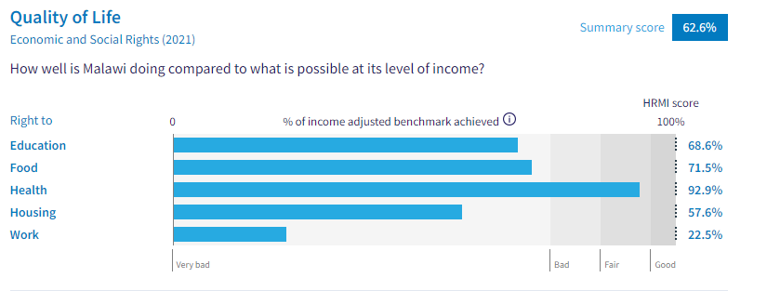
6. Malawi’s scores for 2021 are as follows:
▪ Overall Quality of Life score = 62.6%
▪ Right to education = 68.6%
▪ Right to food = 71.5%
▪ Right to health = 92.9%
▪ Right to housing = 57.6%
▪ Right to work = 22.5%
7. These scores fall in the ‘very bad’ and ‘fair’ ranges, with none reaching the ‘good’ range.
8. Malawi scores 62.6% on Quality of Life when scored against the 'Income adjusted' benchmark. This score takes into account Malawi's resources and how well it is using them to make sure its people's Quality of Life rights are fulfilled.
9. This score tells us that Malawi is only doing 62.6% of what should be possible right now with the resources it has. This score may seem positive, however, since anything less than 100% indicates that a country is not meeting its current duty under international human rights law, our assessment is that Malawi has a long way to go to meet its immediate economic and social rights duty.
10. Compared with other countries in Sub-Saharan Africa, Malawi is performing lower than average on Quality of Life rights.
IV. Right to Education
11. HRMI defines the right to education in accordance with ICESCR Article 13 and CESCR General Comments 11 and 13. In the case of low- and middle-income countries, such as Malawi, HRMI further breaks down the right to education into three areas of measurement: primary school enrolment, secondary school enrolment, and quality of education. Our scores show significant challenges in the secondary and quality education areas.
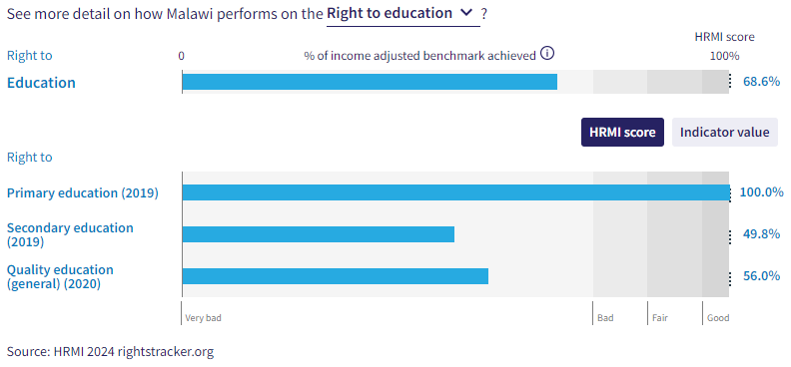

12. Malawi is leading within Africa and the rest of the world in terms of primary education as it is one of only 5 countries who are achieving 100% of what is possible with their available resources. Malawi has maintained an excellent HRMI score of 100% across two decades and is therefore meeting its immediate obligations under international law.
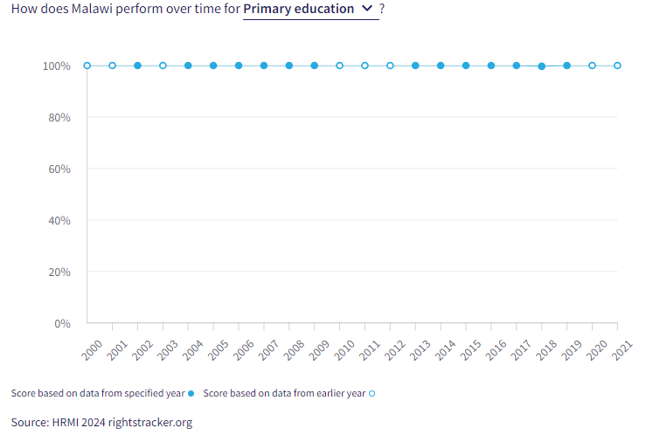
13. Secondary education is faring far worse as only 30.0% of children were enrolled in secondary education in 2019. Malawi’s secondary education score has been varied, with several rises and falls across the past two decades. The HRMI score reached a peak of 72.8% in 2014 but has since decreased to 49.8% in 2021. The current HRMI score of 49.8% falls into the ‘very bad’ range, and when compared to 170 other countries, Malawi is 24th from the bottom.
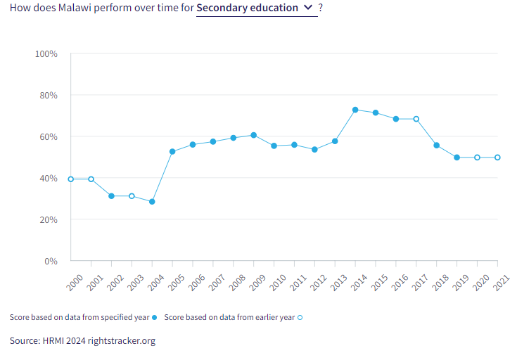
14. The quality of education score is also in the ‘very bad’ range. Malawi is achieving only 56.0% of what we calculate ought to be possible in terms of quality of education. However, progress has been made over the 2009-2021 period as the HRMI score increased from 36.8%.
V. Right to Food
15. HRMI defines the right to food in accordance with ICESCR Article 11 and CESCR General Comment 12. For low- and middle-income countries, such as Malawi, HRMI first uses a bellwether indicator of how many children are growing well (are not stunted). Malawi’s score for the right to food is 71.5% and falls in the ‘very bad’ range. This means that Malawi is doing 71.5% of what ought to be possible to ensure the right to food for its people. This score draws on indicator data on child stunting rates published by the UNICEF-WHO-World Bank: Joint child malnutrition (JME) database.
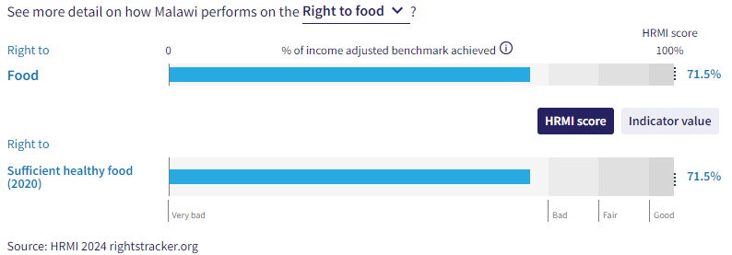
16. We have a supplemental HRMI score of only 16.2% on the right to food security, placing Malawi at the bottom of the ‘very bad’ range. Malawi is ranked 6th from the bottom when compared to 146 other countries.
17. Malawi is currently achieving 71.5% of what is possible regarding the right to sufficient healthy food. Whilst this score is still within the ‘very bad’ range, Malawi has made significant improvement over the past two decades. In 2000, the HRMI score for the right to food was only 41.0%.
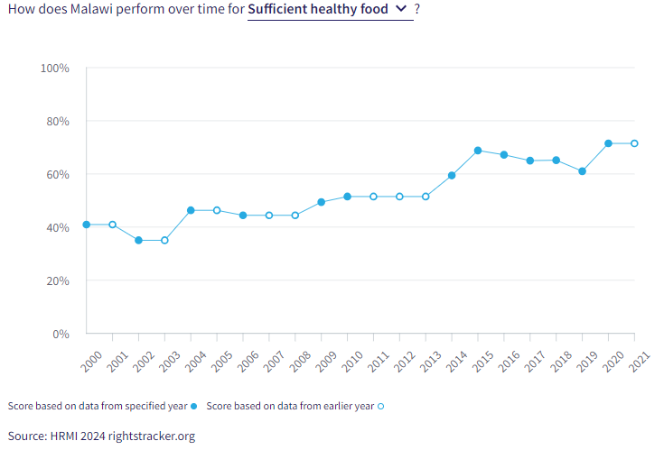

VI. Right to Health

19. HRMI defines the right to health in accordance with ICESCR Article 12.1 and CESCR General Comment 14. In the case of low- and middle-income countries, such as Malawi, HRMI uses three indicators to measure the country’s achievement in child health, adult health, and reproductive health. Malawi is allocating 100% of its available resources to child and reproductive health, yet the HRMI score for adult health lies in the ‘bad’ range.

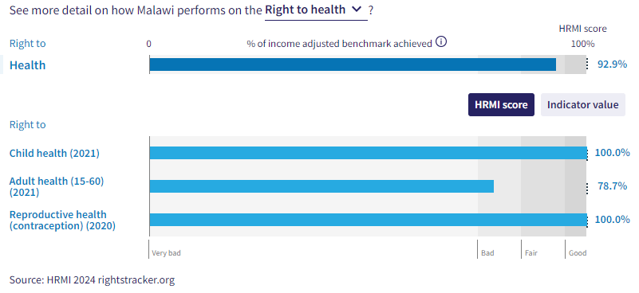
20. The overall right to health has a HRMI score of 92.9% and sits within the ‘fair’ range. Over the past two decades, the right to health has been rising steadily from a low of 58.1% in 2000. However, there has been a decline over the 2020-2021 period.

21. Malawi is one of only six countries that with a 100% score for the right to reproductive health, indicating that it is efficiently turning its resources into good outcomes for its people. Malawi has been able to rise from a HRMI score of only 69.4% in 2000 to 100% in two decades. Although there was a decline in 2010 to 93.5%, Malawi has been able to bounce back and has maintained a score of 100% since 2014.

22. Child health has increased greatly for Malawi over the course of two decades. The HRMI score has risen from only 61.4% in 2000 to 100% in 2016, which has been steadily maintained ever since. Malawi is one of only nine countries that has achieved this.

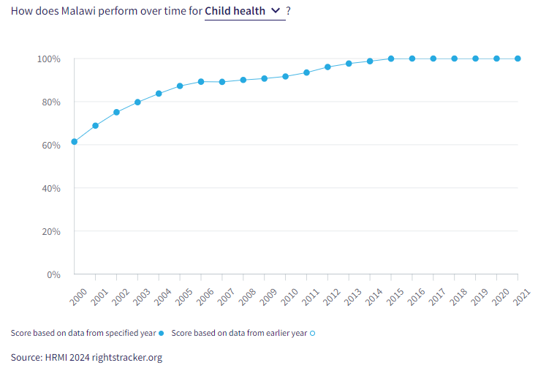

23. Malawi has achieved full progressive realisation of child and reproductive health rights and is meeting its immediate human rights obligations under international law. To make further progress in absolute (not income-adjusted) terms, more income will be required.

VII. Right to Housing

24. HRMI defines the right to housing in accordance with ICESCR Article 11.1 and CESCR General Comment 4. In the case of low- and middle-income countries, such as Malawi, HRMI uses an assessment standard that measures the right to water on premises and ‘basic’ sanitation (each household having its own improved toilet facilities). For basic sanitation, Malawi has a score within the ‘bad’ range, and for water, its score is falling in the bottom of the ‘very bad’ range. The overall HRMI score for the right to housing is 57.6%, falling within the ‘very bad’ range.

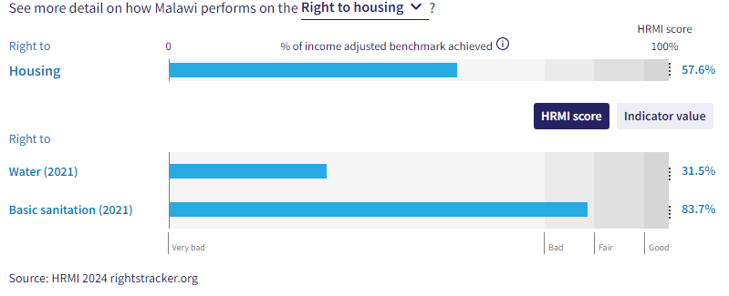

25. In Malawi, only 17.1% of households have water on premises as of 2021. Given what other countries with the same level of income have shown to be possible, these statistics lead to a HRMI score of 31.5% for the right to water. However, the HRMI score has risen slowly from 19.1% in 2000 to the current score of 31.5% in 2021. Many more people in Malawi would have access to these necessities if Malawi was using its maximum available resources towards progressive realisation of these rights.

26. There have been significant improvements regarding basic sanitation over the past two decades, as Malawi was only doing 26.8% of what was possible in 2000, but that score has now risen to 83.7% in 2021. While Malawi is still not achieving 100% of what is possible, Malawi’s progress in the realm of right to basic sanitation is very encouraging.

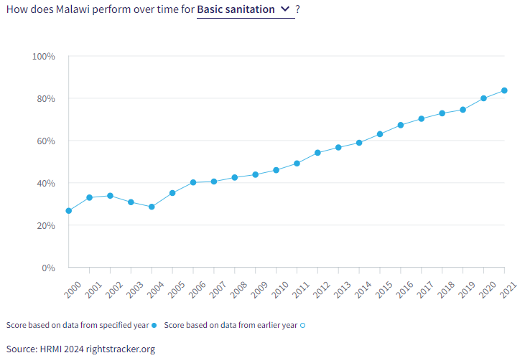

VIII. Right to Work and Social Security

27. HRMI measures the right to work in accordance with ICESCR Articles 6 and 7. For low and middle-income countries, such as Malawi, HRMI measures the right to work and social security using a subsistence income indicator. According to the World Bank PovcalNet in 2019, in Malawi, the percentage of people who are not absolutely poor is only 10.9%, leading to a low HRMI score of 22.5%, which falls at the bottom of the ‘very bad’ range, indicating that Malawi has a long way to go to meet its immediate obligations.
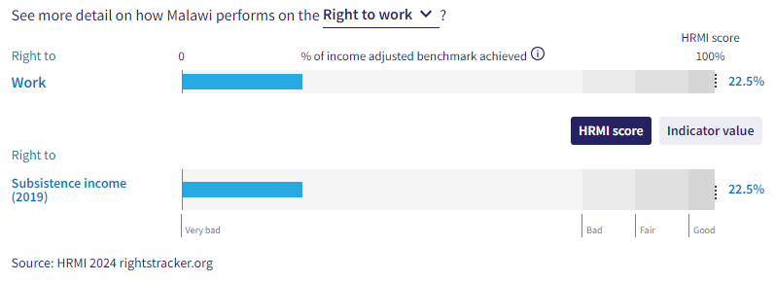
28. Over the course of the last two decades, Malawi has had a consistent decline regarding this right. The peak score was 51.2% over the 2000-2003 period and has been declining ever since, now residing at 22.5% since 2019.
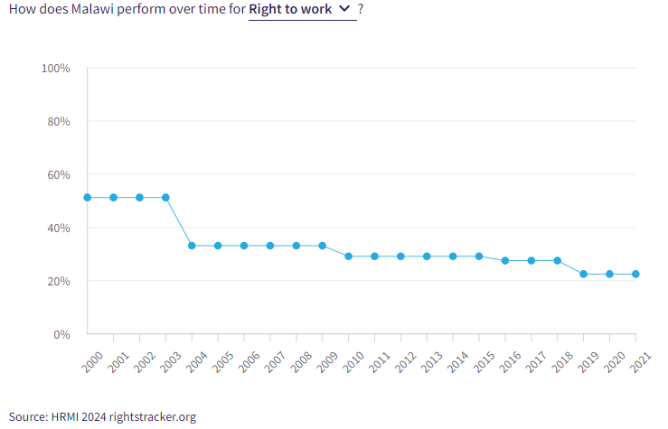
X. Concluding Remarks

29. HRMI respectfully submits its data and findings on the fulfilment of economic and social rights in Malawi. We hope that this Submission will serve as a useful resource to the Committee on Economic, Social and Cultural Rights for drafting specific and meaningful questions to Honduras during the CESCR’s 76th Pre-Sessional Working Group.

Visit HRMI’s website to learn more about our mission and work, https://humanrightsmeasurement.org/.
This content represents the opinions of the Human Rights Measurements Initiative. It carries no endorsement of the University of Georgia.
See HRMI’s methodology for measuring economic and social rights: https://humanrightsmeasurement.org/methodology and https://rightstracker.org/page/methodology.
Ibid
Ibid
HRMI 2024 Rights Tracker, https://rightstracker.org/
See Human Rights Measurement Initiative (HRMI) Digital Public Good Certificate, https://app.digitalpublicgoods.net/a/11781 The Digital Public Goods Alliance is endorsed by the UN Secretary General’s “Roadmap for Digital Cooperation,” https://www.un.org/en/content/digital-cooperationroadmap/assets/pdf/Roadmap_for_Digital_Cooperation_EN.pdf. It defines digital public goods as: “open source software, open data, open AI models, open standards and open content that adhere to privacy and other applicable laws and best practices, do no harm, and help attain the SDGs,” https://digitalpublicgoods.net/standard/.
HRMI 2024 Rights Tracker, https://rightstracker.org/country/MWI?qolFdScore=hrmi&as=core&tab=report-esr
The labels on the country charts of good, fair, bad, and very bad are used to give a general indication of how to understand the scores. HRMI’s income adjusted Quality of Life scores can be broadly interpreted as showing the percentage of the country’s obligation it has met, compared to what the best performing countries have achieved at each income level. A country scoring below 75% with a label of “Very bad” is failing to put in place the kinds of structures and policies that help people claim the right concerned, but the structures and policies in place most likely prevent many people from claiming their rights. See HRMI’s methodology for measuring human rights, https://rightstracker.org/page/methodology.
HRMI 2024 Rights Tracker, https://rightstracker.org/country/MWI?qolFdScore=hrmi&as=core&tab=report-esr
HRMI 2024 Rights Tracker, https://rightstracker.org/metric/esr?tab=report-esr&region=sub-saharan-africa
HRMI 2024 Rights Tracker, https://rightstracker.org/metric/education.
HRMI 2024 Rights Tracker, https://rightstracker.org/country/MWI?qolFdScore=hrmi&as=core&tab=report-esr
Ibid
HRMI 2024 Rights Tracker, https://rightstracker.org/metric/tot-sec-enrol?tab=report-esr
HRMI 2024 Rights Tracker, https://rightstracker.org/country/MWI?qolFdScore=hrmi&as=core&tab=report-esr
HRMI 2024 Rights Tracker, https://rightstracker.org/country/MWI?qolFdScore=hrmi&as=core&tab=report-esr
HRMI 2024 Rights Tracker, https://rightstracker.org/metric/not-stunted.
HRMI Rights Tracker, https://rightstracker.org/metric/food-security?tab=report-esr
HRMI 2024 Rights Tracker, https://rightstracker.org/country/MWI?qolFdScore=hrmi&as=core&tab=report-esr
HRMI 2024 Rights Tracker, https://rightstracker.org/country/MWI?qolFdScore=hrmi&as=core&tab=report-esr
Ibid
HRMI 2024 Rights Tracker, https://rightstracker.org/metric/contraception?tab=report-esr
HRMI 2024 Rights Tracker, https://rightstracker.org/metric/under-5-survival?tab=report-esr
HRMI 2024 Rights Tracker, https://rightstracker.org/country/MWI?qolFdScore=hrmi&as=core&tab=report-esr
Ibid
Ibid
HRMI 2024 Rights Tracker, https://rightstracker.org/country/MWI?qolFdScore=hrmi&as=core&tab=report-esr

